Assessment Task 3 – ROS2 Line Follower – Sheehan Latade 20128963
Option A – Line Follower (Original Task)
1. Component Identification
Webots_ros2 repository by Cyberbotics – in this repository I used webots_ros2_driver to implement Webots-ROS2 interface, which automatically creates ROS2 topics, services, and parameters from the Webot Robot model(e-puck). In my system, the URDF file allowed me to configure the ROS2 interface. For example, I have a plugin driver file to make the e-puck move.
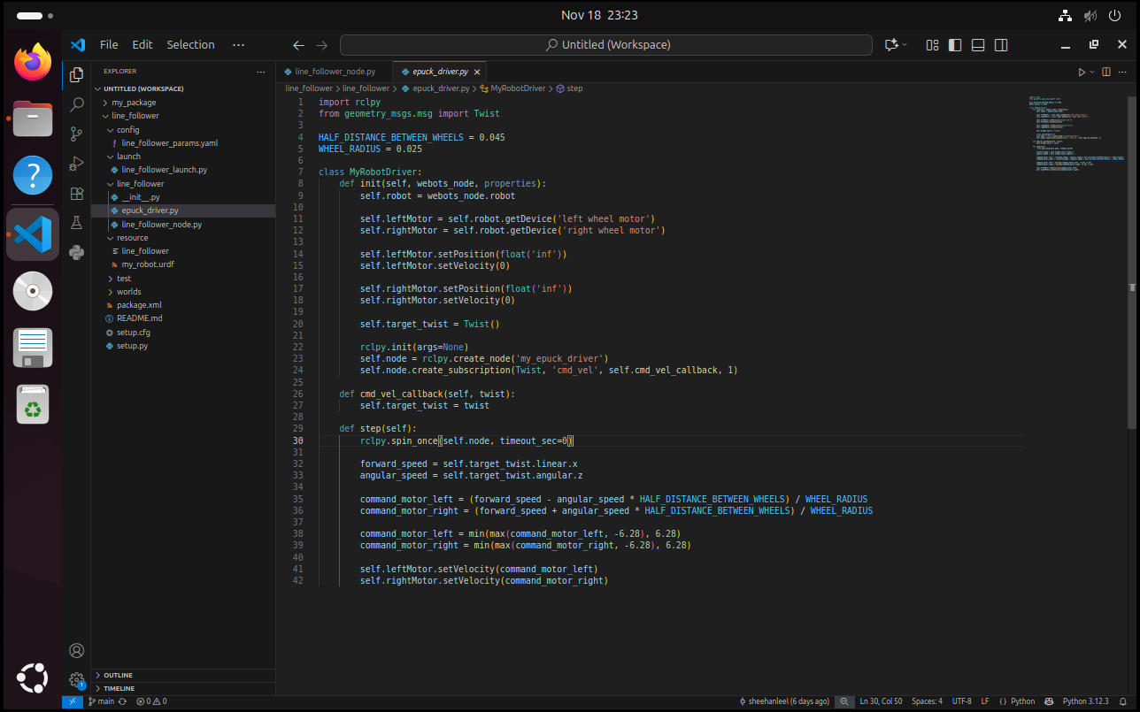
To connect it to the webots robot, I first configured the e-puck in the webots world simulation. I set the controller of the e-puck to <extern> and made sure that its name is exactly ‘e-puck’.
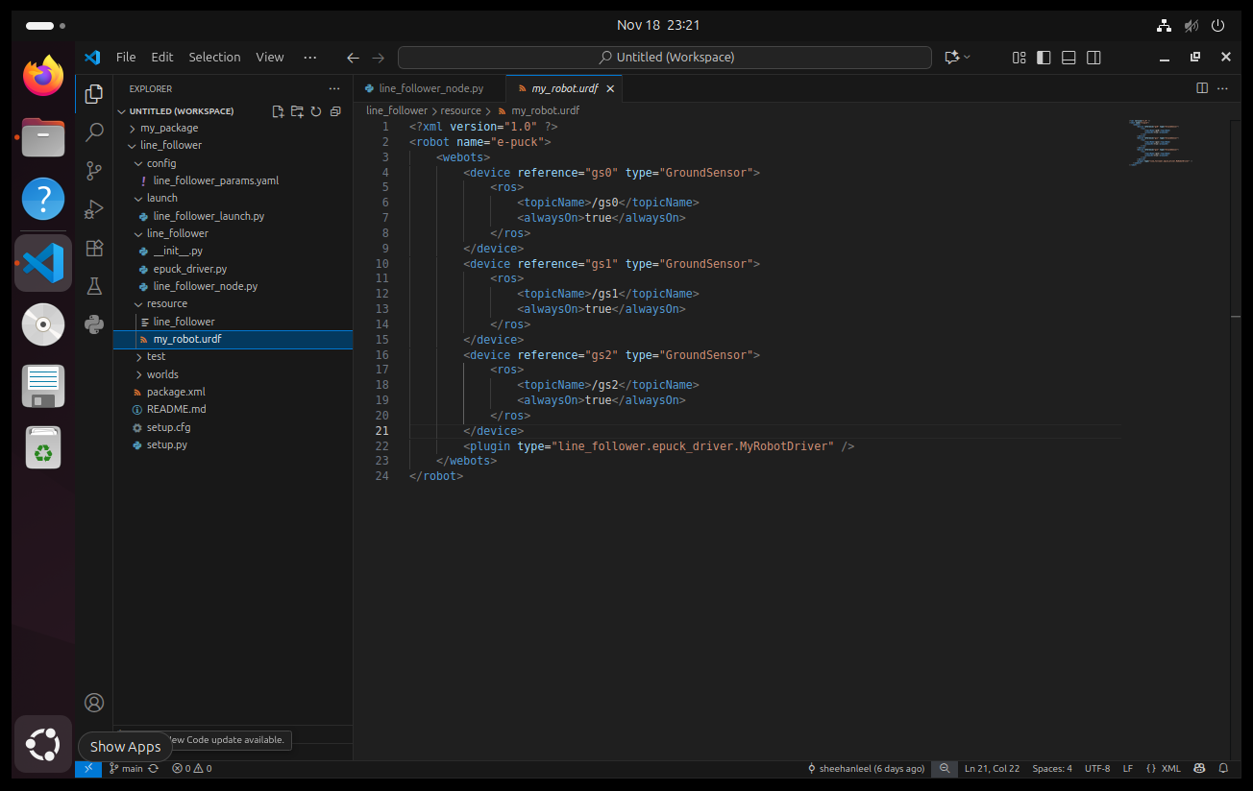
In the URDF file, I first declared the robot’s name which is e-puck then the plugin which is the epuck_driver.MyRobotDriver. I also declared the ground sensors to use later and fetch data from it to achieve the line following behavior. With the URDF file configured, all that is left now is to use the pre-existing component in the launch file to successfully connect the robot to the driver plugin.
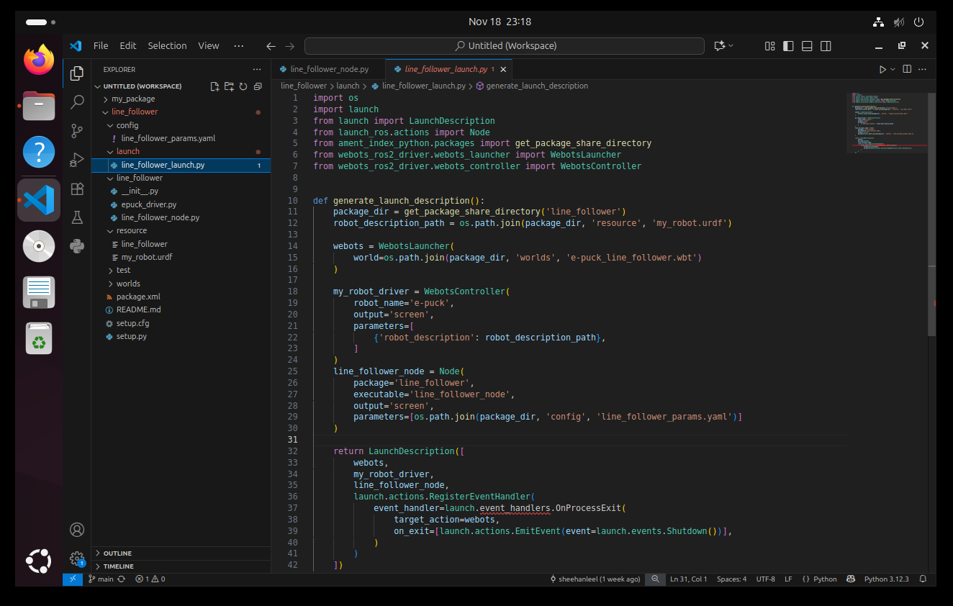
The launch file consists of 3 parts. First are the imports or dependencies that I need to use to successfully open the webot’s world file and connect the plugin to the e-puck in the world simulation. Second is completing the launch descriptions, declaring where the package is, the URDF file, webots world location and the 2 important things ‘WebotsLauncher’ and ‘WebotsController’ from the pre-existing component webots_ros2_driver. With webots_ros2_driver allowed me to launch the world file through ros2 terminal and also set parameters to connect the plugin to the e-pucks <extern> controller.
Pre-requisites:
ROS2 – used to create the pkg, launch the webots world, control the robot, and send commands.
Colcon build – used to build packages to use using ROS2, complies all package which in my case is the line_follower in my workspace and install it directly into the install directory.
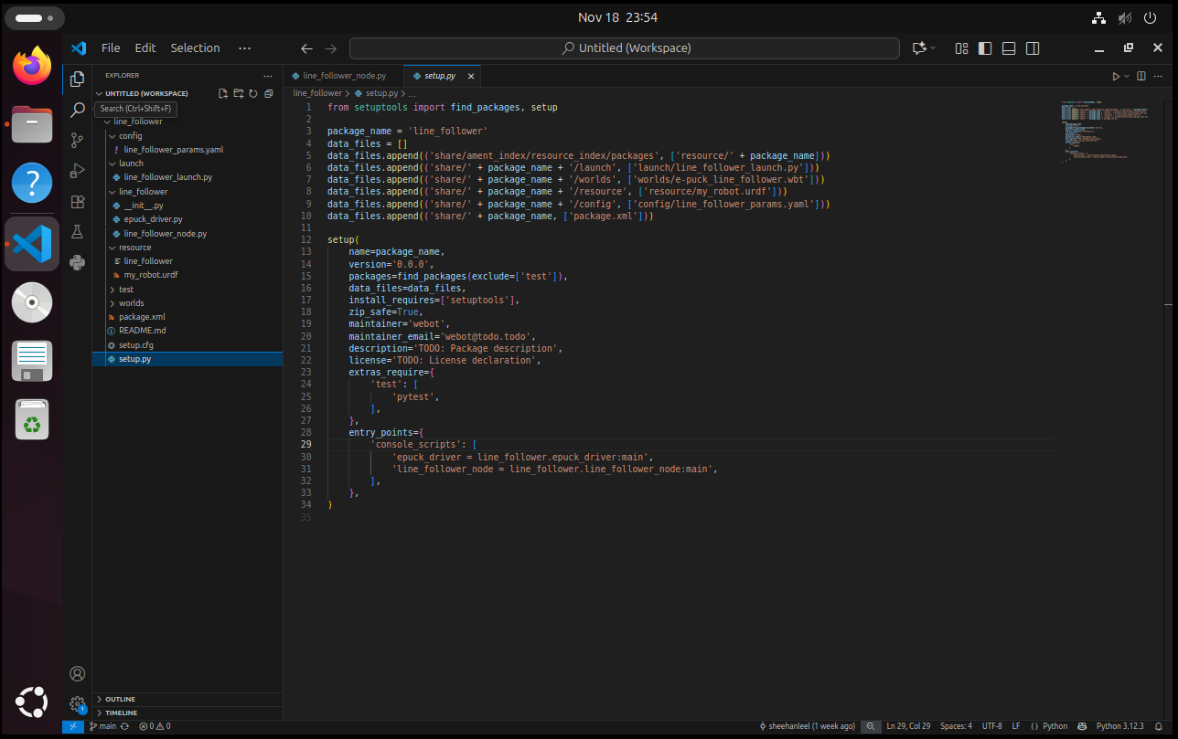
Setup.py is to declare which files are included into my package and have it installed to the install directory.
2. Component Evaluation
I used geometry_msgs/Twist as it’s the standard ROS message type for movement commands. In this assessment the e-puck is only going to move in 2D plane where it is just going to forward and turn to follow the line so linear.x and angular.z are makes it a natural fit for publishing topics to the node created /cmd_vel. I did consider just simply setting the speed of the robot like what I did in lab 2 but that doesn’t fulfill the requirement of using ros2. I used the webots_ros2_driver because it provides a direct connection between webots and ros2. The driver takes the Webots API and exposes it to ros2, thus enabling control over robots’ sensors and read sensor data, send commands through ros topics and services.
About licensing, ros2 and webots_ros2_driver use Apache 2.0 to encourage improvements and collaboration in academic sectors. Apache 2.0 is commercially available and friendly, the user can use, modify, distribute and even sell software under it. There is no obligation to release new works as an open source. It is also compatible with MIT and BSD, which are open-sources licenses.
Pre-existing components come with libraries, drivers and frameworks like ROS or webots_ros2 come with built-in functionality and community-tested reliability as it’s open source thus it’s well-documented, widely used and bugs are more likely known and resolved by the community. Using a pre-existing component like webots_ros2_driver sped up my development as I didn’t need to create my own libraries that have functionalities which are out of my skills scope yet as a learning programmer. I didn’t need to pay as open sources are free, thus if it’s used commercially, it will minimize licensing and development expenses.
3. Integration Process
I first created ROS node such as /cmd_vel to handle the e-puck’s movement. This allowed me to publish linear.x or angular.z which successfully let me turn and make the e-puck go forward. I used geometry twist to publish as it’s the standard ROS message for motion. With the webots_ros2_driver initializing the ground sensors (g0-g2), I just simply declared it to the urdf file and then created a line_following_node where it subcribes to the ground sensors, takes the data from the sensors then retrieves it and use it to my line following logic. Then the logic will send angular twist commands to /cmd_vel so the e-puck will be able to repond on time if it needs to turn. The package is licensed under Apache 2.0 to encourage improvements and collaboration.
There are some technical challenges that I faced was the ros2 plugin controller was not connecting properly to the webot’s e-puck <extern> controller. I was able to fix this by making sure that the dependencies are all installed (forgot to install webots_ros2 repo at the start) and double check the documentation and used that as a reference to make it work. I was able to fix it by ensuring by simply following the instructions in the documentation by Cyberbotics making sure that the robots name is the same between the webots world file, URDF and the launch file.
When I was able to connect the plugin controller to the e-puck and move it forward, I headed to the next step which was integrating the line following behavior. I declared the ground sensors in the URDF file to load it and use it for the line following behavior.
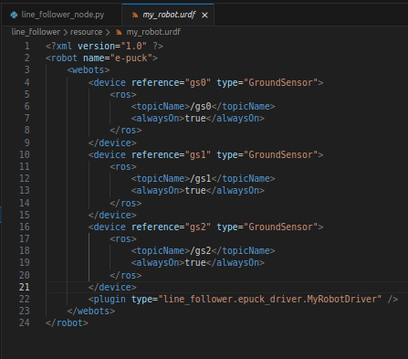
With the ground sensors loaded, I was able to test what the output of the e-puck is when running through the black line and white space. I was able to figure out the threshold where if the output is lower than 0.006 means that the ground sensor is on white space. With that information I was able to create the line following logic (same as lab 2) then retrieve the data from the sensors and use it to send an angular cmd_vel publish to make the robot follow the line.
As I followed the documentation from Cyberbotics, I did not encounter any compatibility issues and I’ve just simply updated my launch file’s entry point to add line_following_node to fetch and send data through ros2.

Part B: Visual Evidence
- ros2 pkg list showing installed ROS2 packages
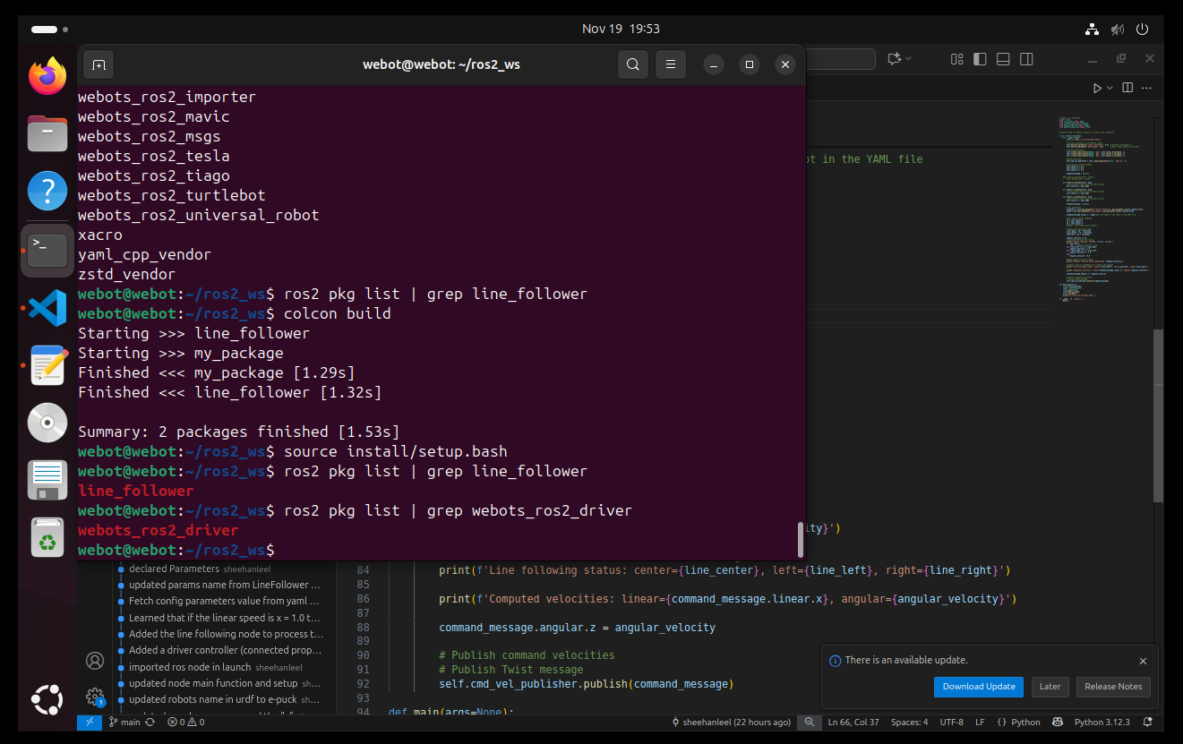
- ros2 topic echo /cmd_vel – showing the linear and the angular turn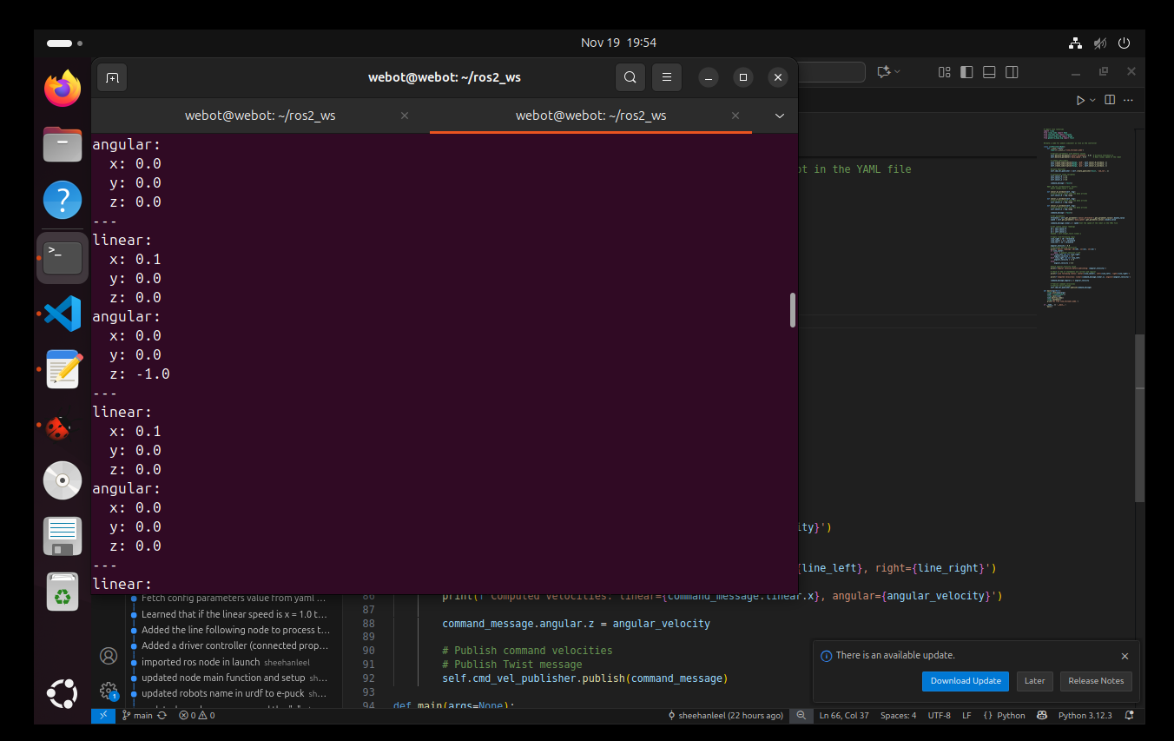
- rqt_graph diagram
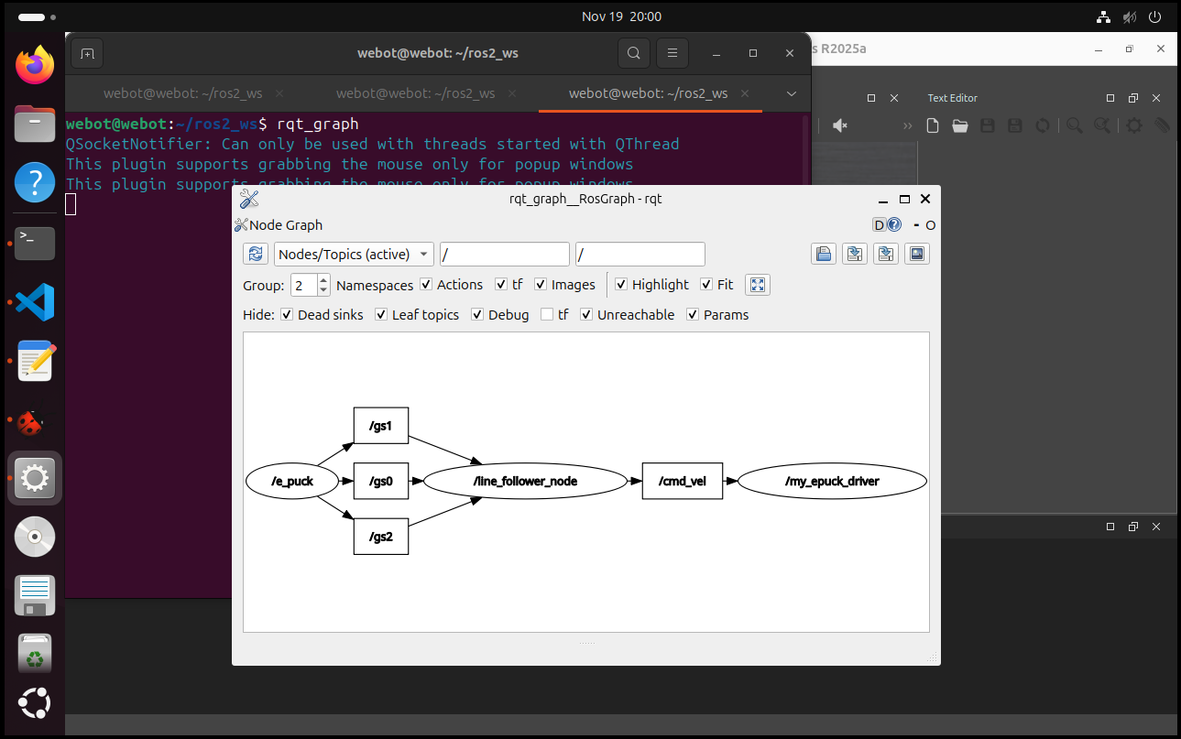
- Evidence of testing pre-existing components
  - Line follower: ground sensor output
gs0
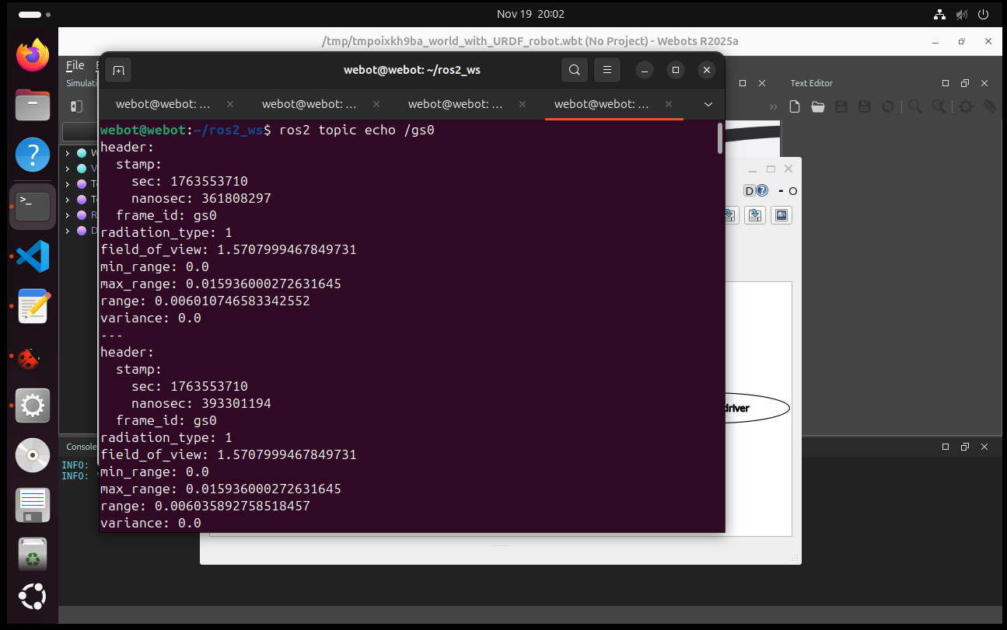
gs1
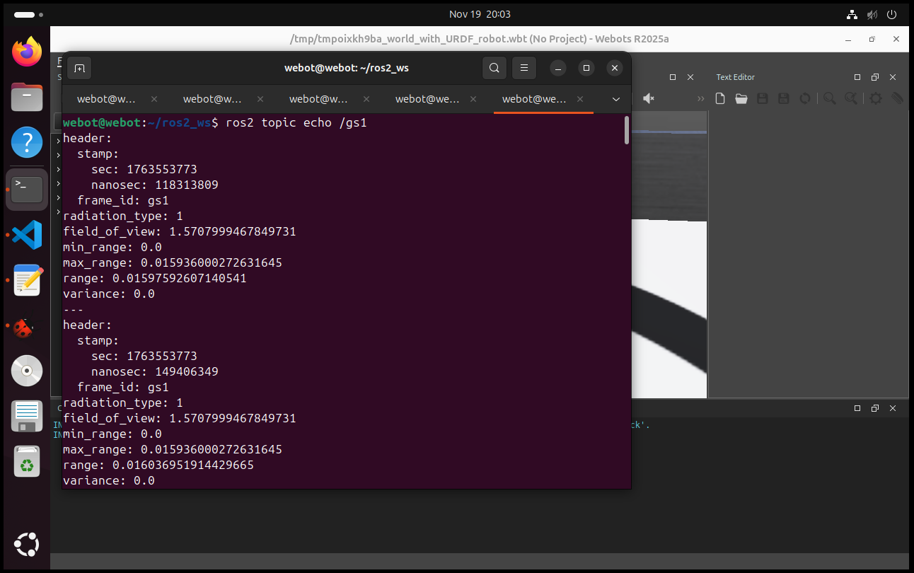
gs2
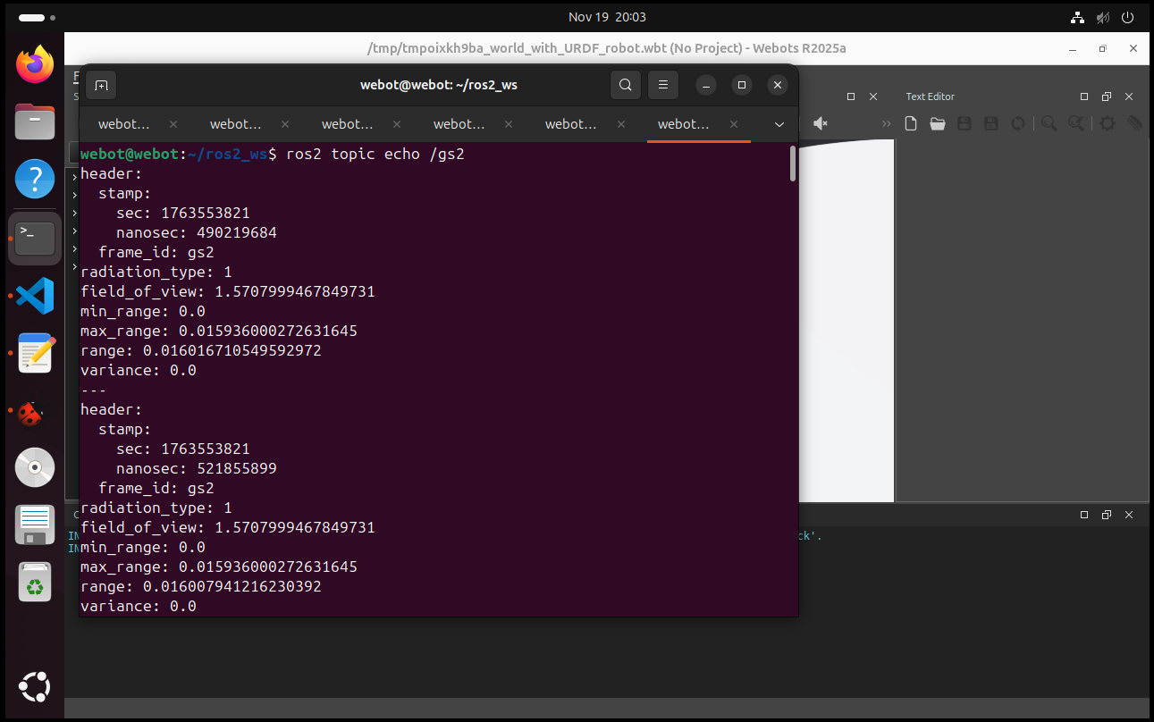

Video Requirements
The video demo is in the GitHub repo as well as uploaded into blackboard too.
https://github.com/sheehanleel/line_follower
Thanks!

