# Chapter 5: Testing

## 5.1 Introduction

Testing is the strategy which is finished during the advancement procedure. It additionally measure item quality. Here, necessity need to meet and functions true to form result. To distinguish the contrasts between given information and anticipated yield, testing is utilized.

## 5. 2 Importance

The following points are the importance of testing:

1. It is a steady framework and easy to use.
2. It is utilized to discover bugs and furthermore imperfection of the framework.
3. It saves money.

## 5.3 Types of testing

1) Black-Box Testing.

2) White-Box Testing.

3) Unit Testing.

4) Regression Testing.

5) Acceptance Testing.

6) Integration Testing.

**Among them, I have done Black-Box testing and Unit testing for my project.**

## 5.4 Black-Box Testing

Black-Box testing is a software testing which don’t peered with internal structure, only observes application functionality. Software system input and output is only focused by this testing.

Following are the test plan for the Black-Box testing.

1. **Checking validation of empty registration.**

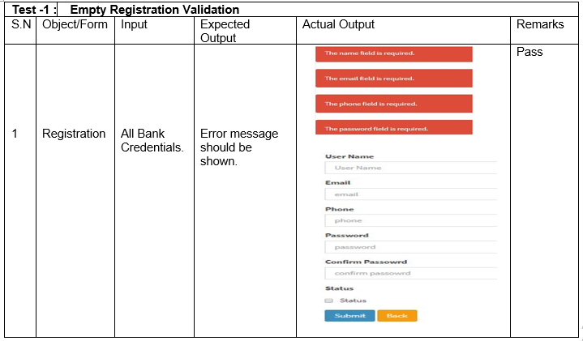

1. **Checking validation of email.**

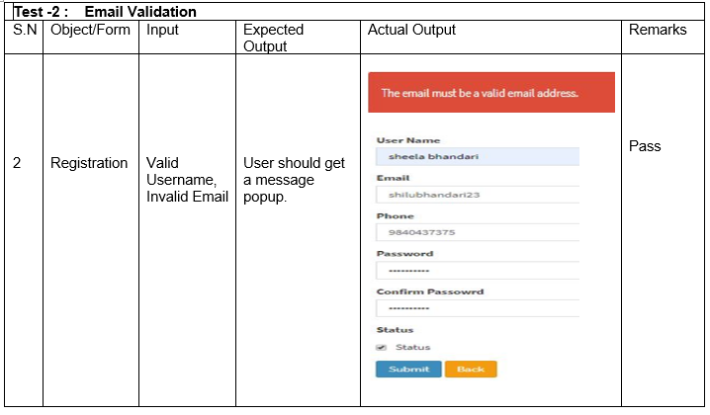

1. **Mismatching Password.**

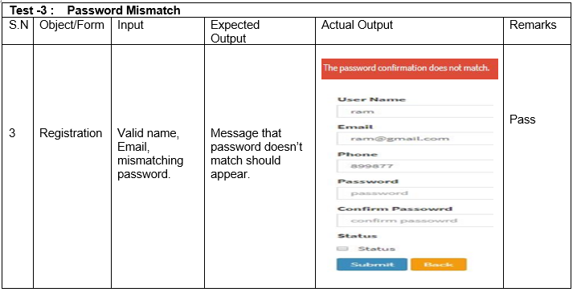

1. **Validation of password length**

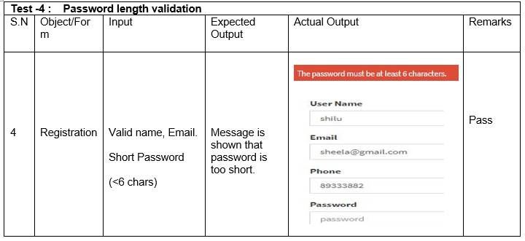

1. **Register**

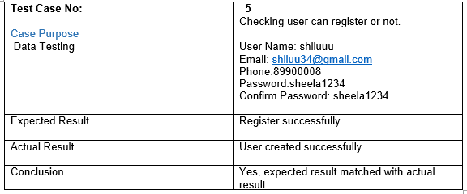

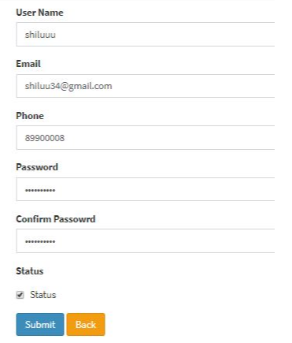

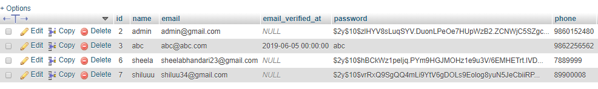



1. **Email and password checking.**

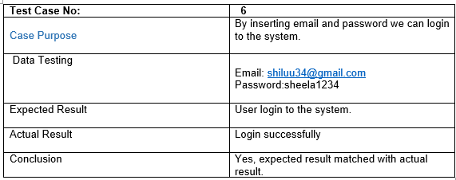

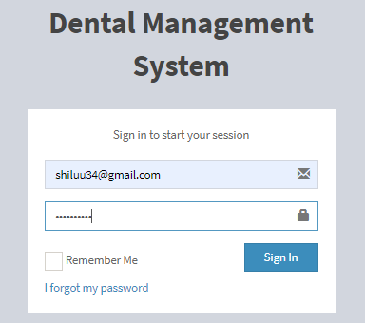

1. **Admin login successful.**

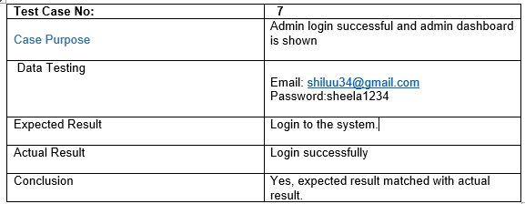

* **Dashboard page**

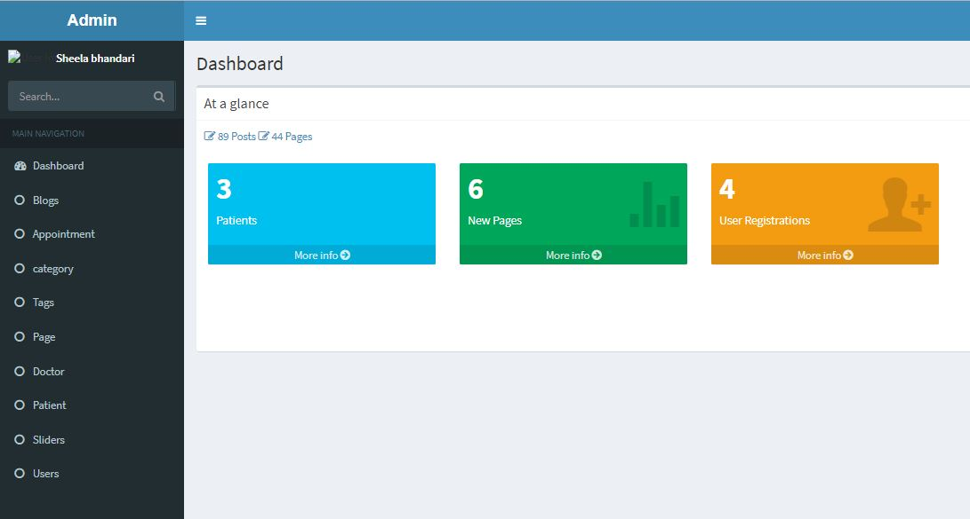

1. **Checking invalid credentials.**

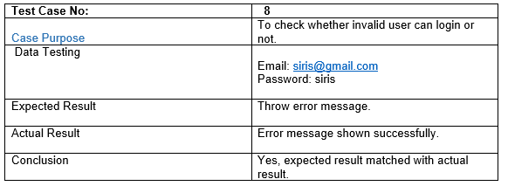

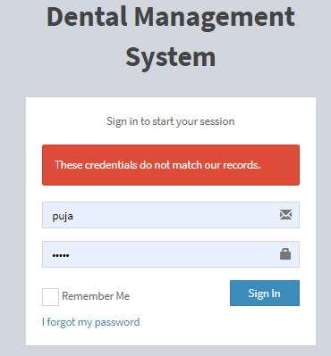

1. **Add patient**

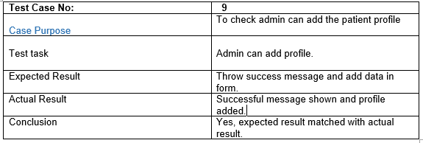

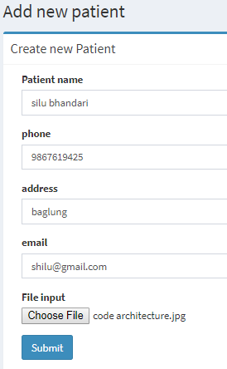

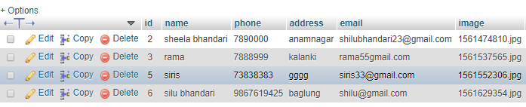



1. **Edit patient profile**

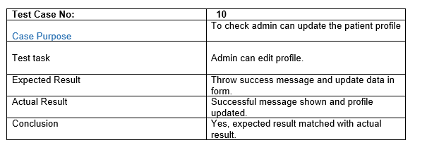

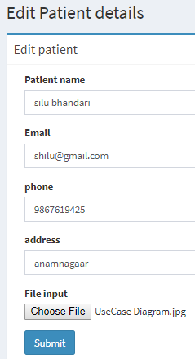

Address is updated





1. **Delete patient profile**

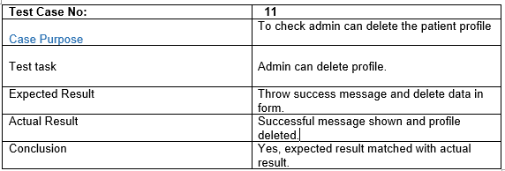



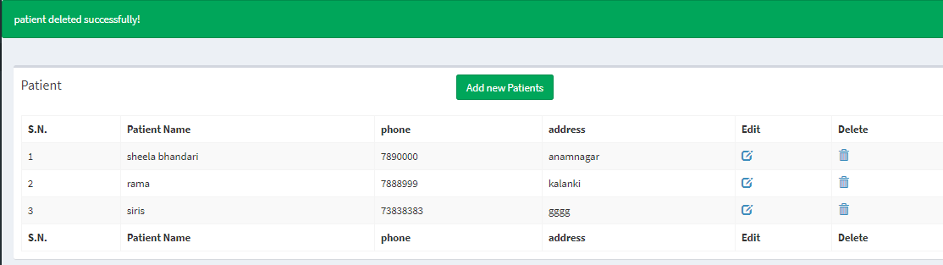



1. **Book Appointment**

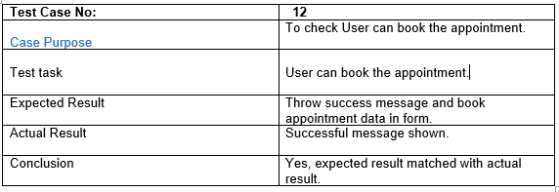

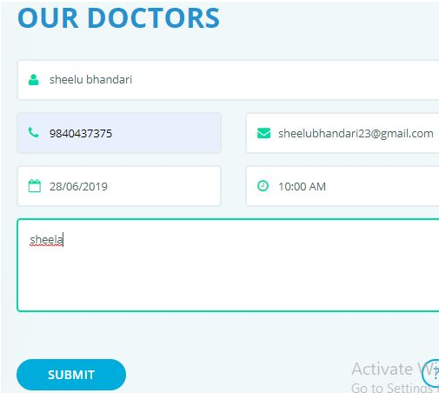

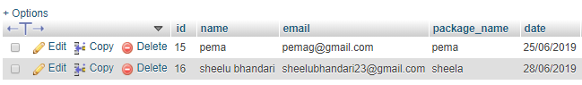



1. **Delete appointment list**

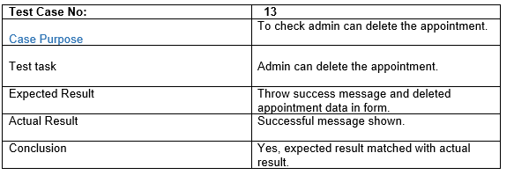



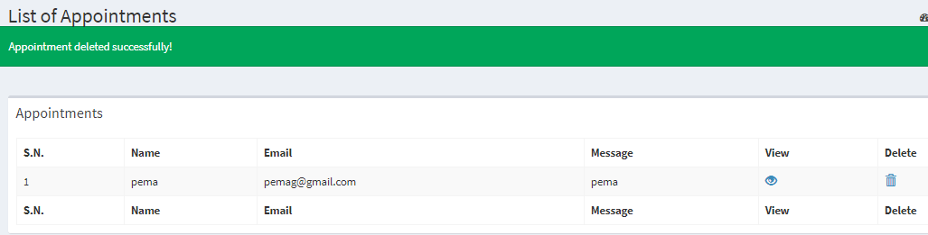

No data of sheelu

1. **Add doctor**

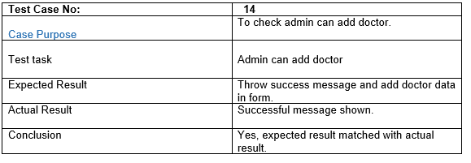

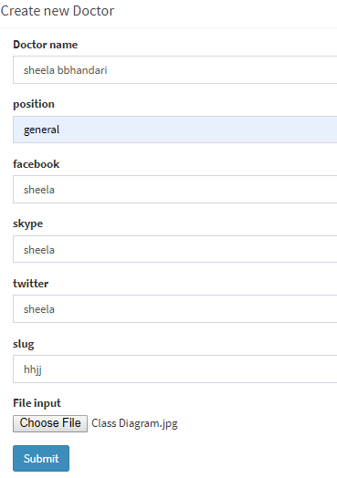

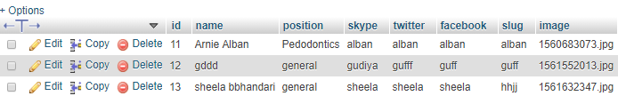



1. **Edit doctor profile**

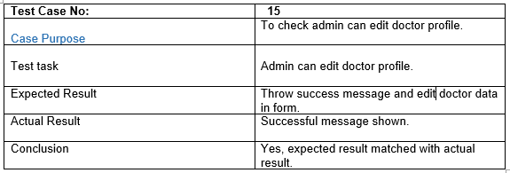

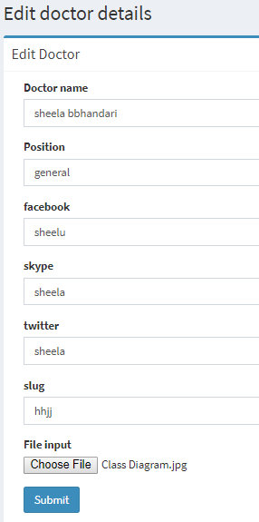

Facebook is updated



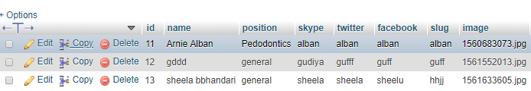

Updated data

1. **Delete doctor profile.**

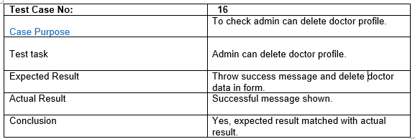



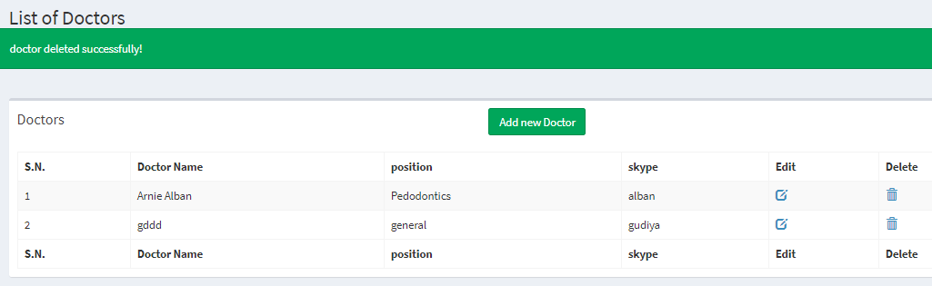

1. **User can contact us.**

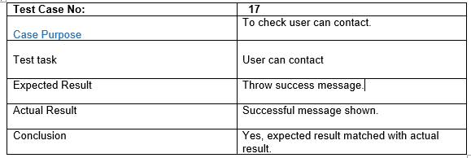

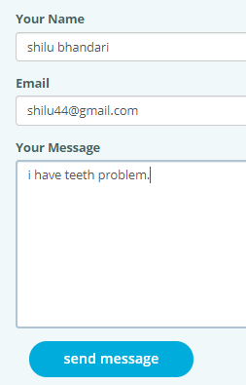

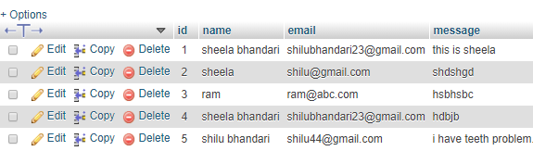

User name is successfully added.

1. **Admin can add the blogs.**

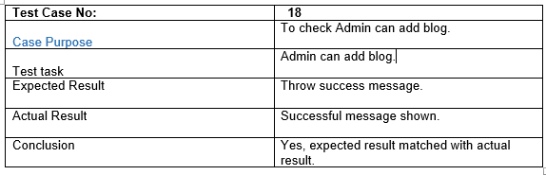

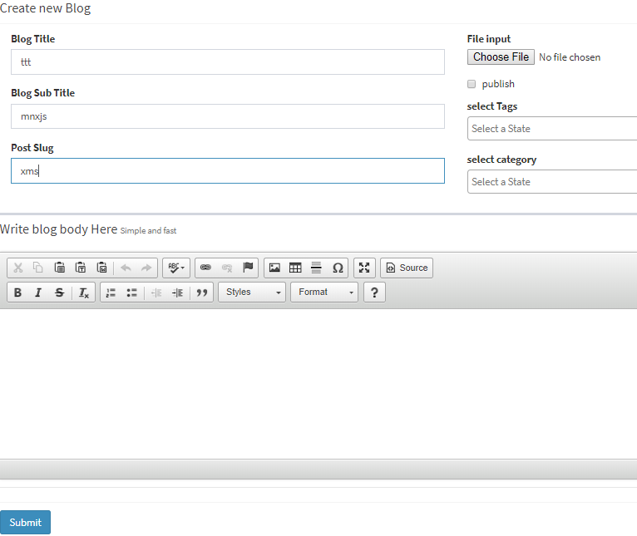

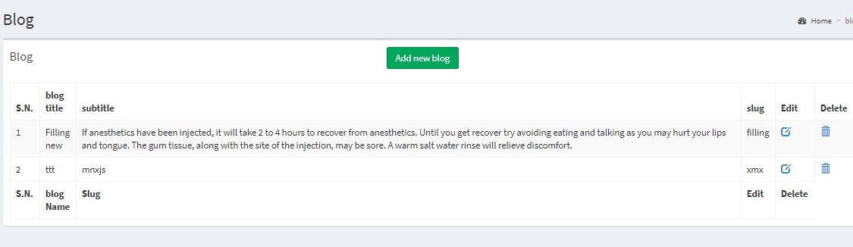

## 5.5 Unit Testing.

Unit testing is a software development process where units which is the smallest test of application is tested. It also determines the characteristics which perform the unit under test. Unit testing is often automated but usually can do manual way. (Rouse, 2016)

Following are the test plan for unit testing:

**Test Name: Register**

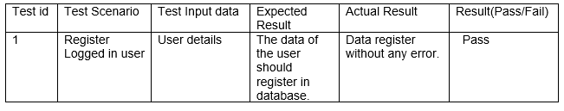

**Spec:**

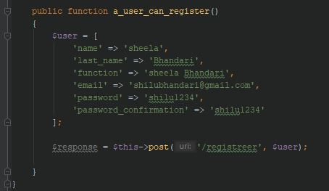

**Result:**

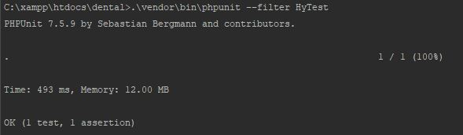

**Test Name: Login**

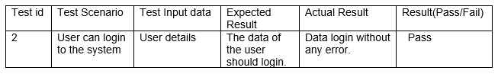

**Spec:**

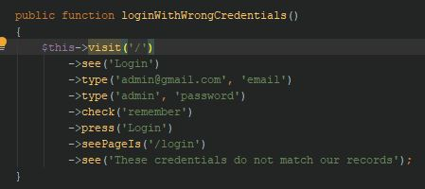

**Result:**



**Test Name: User can request a message to delete.**

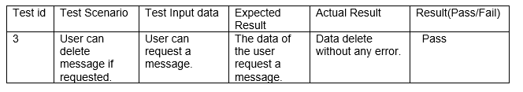

**Spec:**

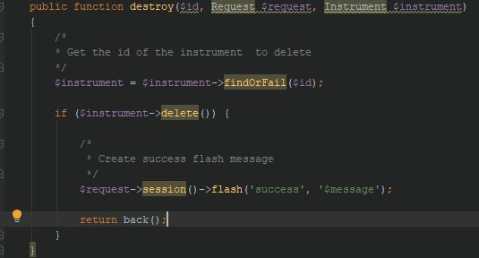

**Result:**



**Task Name: User can change password, if current password is correct.**

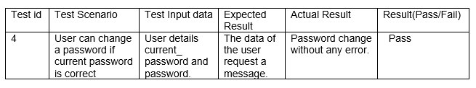

**Spec:**

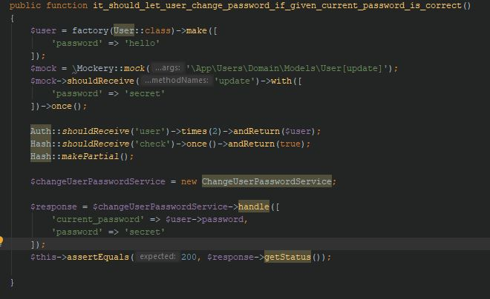

**Result:**



# References

Rouse, M. (2016). *What is unit testing? - Definition from WhatIs.com*. [Online] SearchSoftwareQuality. Available at: https://searchsoftwarequality.techtarget.com/definition/unit-testing [Accessed 2 Jul. 2019].