**PRODUCT SALESANALYSIS**

TEAM MEMBER

**SHEELA M**

Phase 2 Submission Document

**PROJECT TITLE :** **PRODUCT SALES ANALYSIS**

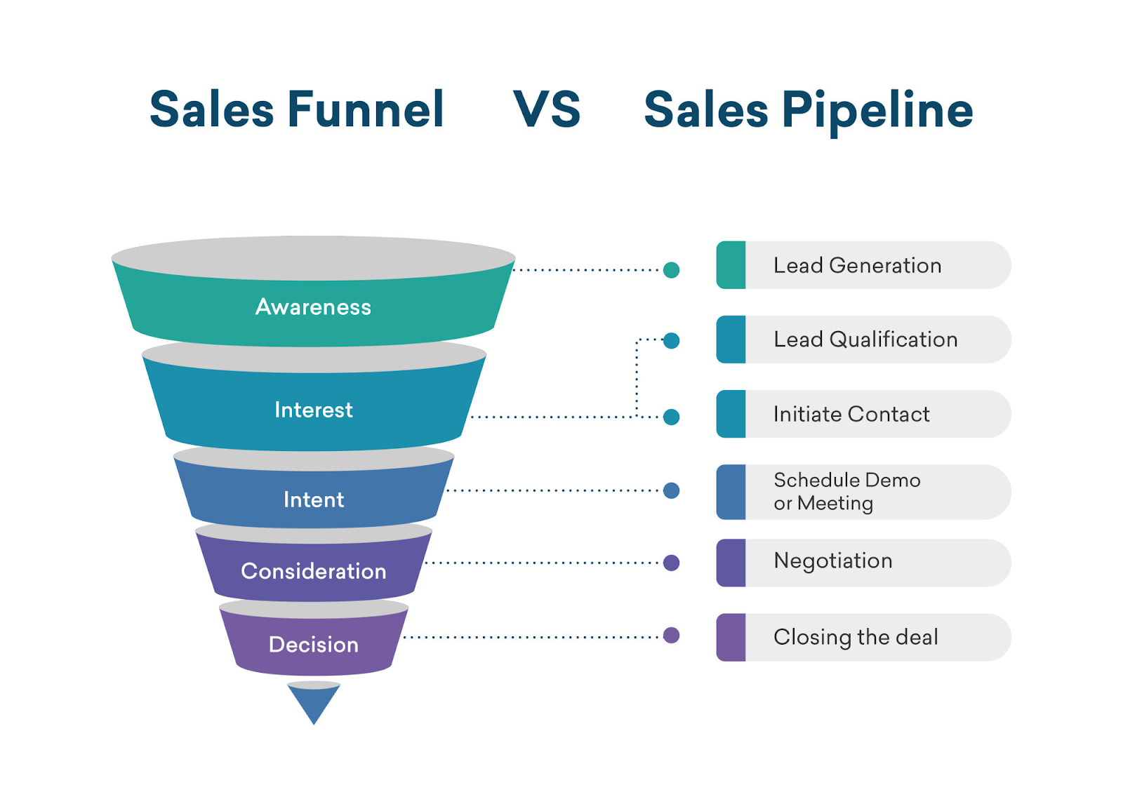

**Introduction:**

* A sales analysis is the process of analyzing the sales revenue generated from a business within a period of time. It looks at various factors such as consumer demographics, products sold, time of sale, region and many more.

**Awareness for sales funnel:**

* The first of the sales funnel stages is called the “awareness” level, because it's where people first become aware of your product or service. They may hear about you from your advertising, social media, even word of mouth.
* Awareness is the uppermost stage of the marketing funnel. Potential customers are drawn into this stage through marketing campaigns and consumer research and discovery.
* This updated sales funnel includes five stages: Awareness: making buyers aware of your product as a solution to a specific pain point or problem. Consideration: buyers are considering your solution instead of competitors' solutions. Conversion: customer makes a final purchase decision.
* When someone becomes aware of your brand and turns into a potential customer. Interest: When a potential customer becomes interested in your brand's offerings. Desire: When a potential customer's interest becomes a desire for your brand's offerings.
* the primary goals of marketing at the top of the funnel are awareness and lead generation.

**Interest for sales funnel:**

* Funnels are usually made of stainless steel, aluminium, glass, or plastic. The material used in its construction should be sturdy enough to withstand the weight of the substance being transferred, and it should not react with the substance.
* A sales funnel helps you understand what potential customers are thinking and doing at each stage of the purchasing journey. These insights allow you to invest in the right marketing activities and channels, create the most relevant messaging during each stage and turn more prospects into paying customers.
* Good sales funnels must have a customer-first approach. The best place to start when creating or optimizing your funnel is researching your prospects' recurring problems, questions, behaviors, and decision-making processes. Make sure you take the time to understand your audience or audiences
* Action. The most important stage of the funnel — whether the prospect makes a purchase or not. If they don't buy from you now, that doesn't mean the deal is lost forever. You can create nurture campaigns to make sure you stay on top of their mind for any future needs.
* Marketing funnels are a useful tool to help you visualize the path customers take from first finding out about your brand to converting. Understanding them provides valuable insight into why some customers convert — and some don't. Understanding how — and when — consumers interact with your brand is crucial.
* The marketing funnel is based on the Awareness-Interest-Desire-Action (AIDA) model, first developed in 1898 by E. St. Elmo Lewis, an advertising advocate.
* If you aren't bringing in enough traffic, then your sales funnel has no chance to work. If you don't have enough visitors to your website or landing pages, then you won't have enough subscribers. If you don't have enough subscribers, then you won't have enough (or any) sales.

**INTENT:**

Intent. At the Intent stage, your prospect makes the transition to the lower funnel. They're now interested in buying your product, but haven't made the purchase just yet. They might indicate their interest by taking a survey, watching a product demo, or placing an item in their shopping cart.

**Four sales funnel stages**

* Step 1 — Define your audience's needs
* Step 2 — Create something valuable to offer
* Step 3 — Build a landing page
* Step 4 — Establish lead nurturing strategies

A sales funnel helps you understand what potential customers are thinking and doing at each stage of the purchasing journey. These insights allow you to invest in the right marketing activities and channels, create the most relevant messaging during each stage and turn more prospects into paying customers.

**The five stages of a sales funnel include:**

1. Awareness. A sales funnel starts when someone first becomes aware of your company, product or service
2. Interest. Once a person becomes aware of your brand, the next funnel stage is to develop their interest in your business and learn about your offers
3. Desire
4. Action
5. Loyalty

**Consideration:**

* At the consideration stage, consumers interested in your business and its offerings are considering whether or not to buy. Depending on your business, this could include guides, webinars, reviews, white papers, case studies, comparison charts, and much more.
* Representing the top of the funnel, this stage includes the most people. Consideration stage: The prospective buyer now wants to find and compare solutions to their problem, and they are looking for a solution that they can trust.
* What are consideration objectives? Consideration objectives sit in the middle of your marketing funnel. Campaigns like these are for people who know who you are and want to learn more. Their purpose is to motivate your audience to take a low level, easy action, like visiting your website or joining your email list.
* The consideration stage is essentially where your potential buyers consider your product or services as a possible option to solve the problem that you helped identify in the awareness stage.
* Once people have learned about your brand, they're likely to take an interest in it. At this point, you've hooked the fish, but you haven't yet reeled it in – which makes it one of the most important stages in the sales funnel.
* The consideration stage of the brand funnel measures how many people or the percentage of those who are aware of your brand, would actually consider making a purchase. Only brands that have a compelling offer which aligns with and can deliver on the goals of the target market will be considered.

Decision :

* .Third sales funnel stage. The customer is ready to buy and may consider several options before purchasing. They'll compare pricing, packages and other factors to find the best option. At this stage, you should make your best offer.
* Good sales funnels must have a customer-first approach. *The best* place *to* start when *creating or optimizing your funnel is* researching your prospects' recurring problems, questions, behaviors, and decision-making processes. Make sure you take the time to understand *your audience or audiences*

**sales funnel stages:**

* Stage 1: Awareness

The first of the sales funnel stages is called the “awareness” level, because it's where people first become aware of your product or service

* Stage 2: Interest
* Stage 3: Decision
* Stage 4: Action
* Build a landing page
* Offer something of value
* Start nurturing
* Upsell