**SCREENSHOTS:**

**A PERSONAL FINANACE MANAGEMENT APP**

**Screenshot-1:**

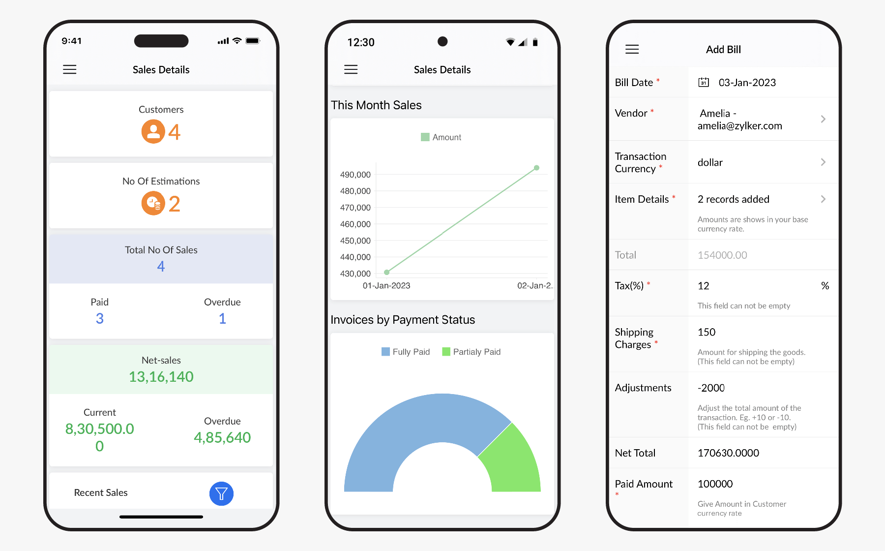

**Screenshot-2:**

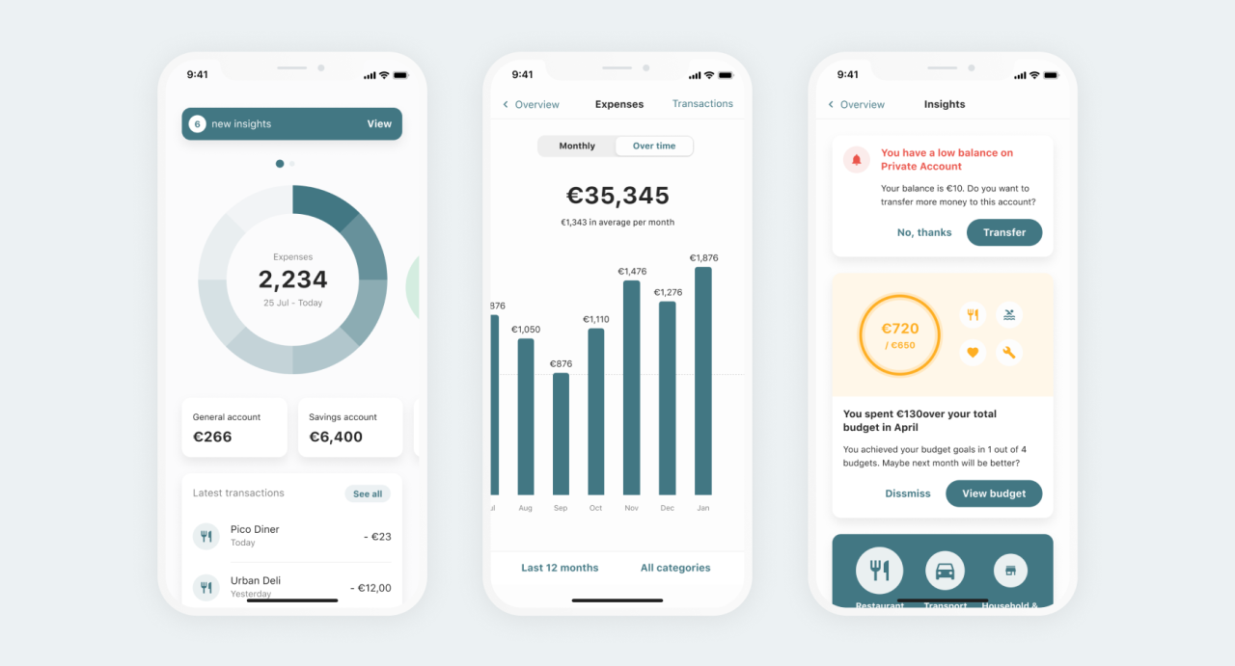

**Screenshot-3:**

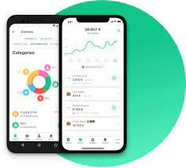

**Screenshot-4:**

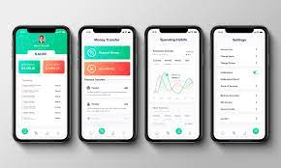

**Screenshot-5:**

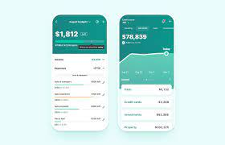

**Screenshot-6:**

