STATISTICS
Complete Study Notes

Topics Covered
Basics of Statistics
Data & Measurement
Descriptive Statistics
Shape of Distribution
Probability Basics
Distributions
Bernoulli · Binomial · Uniform · Poisson
Relationships in Data
Central Limit Theorem
Z-Score · Covariance · Multicollinearity

01 Basics of Statistics

Statistics is the science of collecting, organising, analysing, interpreting, and presenting data. It helps us make sense of the world by turning raw numbers into meaningful insights — whether in business, research, healthcare, or everyday life.
💡 Key Idea: Think of statistics as a toolbox: some tools describe what already happened (descriptive), while others help you make educated guesses about the future or a wider group (inferential).

Types of Statistics
Descriptive Statistics | Summarises and describes the main features of a dataset. It answers: "What does my data look like?" — using averages, charts, and spread measures.
Inferential Statistics | Uses a sample to make inferences (predictions/conclusions) about a larger population. It answers: "What can I conclude beyond my data?"

02 Data & Measurement

Types of Data
Numerical (Quantitative) | Data expressed as numbers that can be measured or counted. Sub-types: Discrete (countable: 1, 2, 3…) and Continuous (any value in a range: 1.75 m, 98.6°F).
Categorical (Qualitative) | Data that represents categories or groups. E.g. colours, gender, country. Cannot be meaningfully averaged.

Levels of Measurement
Understanding the level of measurement tells you which statistical operations are valid on your data.
Nominal |  | Named categories with no order or ranking. E.g. blood type (A, B, O), eye colour. Only mode is meaningful.
Ordinal |  | Categories with a meaningful order but unequal intervals. E.g. movie ratings (1–5 stars), education level. Mode & median valid.
Interval |  | Ordered data with equal intervals but NO true zero. E.g. temperature in °C, calendar year. No meaningful ratio (20°C is not "twice" 10°C). Mean, SD valid.
Ratio |  | Like interval but WITH a true zero. E.g. height, weight, income, age. All operations valid — ratios are meaningful (80 kg is twice 40 kg).
 | 🧠 Memory Trick: Memory trick — NOIR: Nominal → Ordinal → Interval → Ratio. Each level adds capabilities to the previous.

03 Descriptive Statistics

Measures of Central Tendency
Central tendency tells us where the "centre" of the data is — the most typical or representative value.

Mean
The arithmetic average. Add all values and divide by the number of values.
Mean (μ or x̄) = Σx / n
Example: Scores: 70, 80, 90, 100 → Mean = (70+80+90+100)/4 = 85
⚠️ Note: Sensitive to outliers. A single very large or small value can pull the mean away from the typical value.

Median
The middle value when data is sorted in order. If there is an even number of values, the median is the average of the two middle values.
Example: Sorted: 70, 80, 90, 100 → Median = (80+90)/2 = 85 | Odd set: 70, 80, 90 → Median = 80
✅ When to Use: Robust to outliers! Use the median when data is skewed (e.g., house prices, salaries).

Mode
The most frequently occurring value. A dataset can have one mode (unimodal), two modes (bimodal), or more (multimodal). Categorical data can only use mode.
Example: Data: 4, 4, 7, 9, 9, 9 → Mode = 9 | Bimodal: 4, 4, 7, 9, 9 → Modes = 4 and 9

Measures of Dispersion (Spread)
Dispersion tells us how spread out or varied the data values are around the centre. Two datasets can have the same mean but very different spreads.

Range
The simplest measure of spread — the difference between the maximum and minimum values.
Range = Maximum value − Minimum value
Example: Data: 10, 20, 35, 50 → Range = 50 − 10 = 40
⚠️ Limitation: Very sensitive to outliers. One extreme value can make the range large even if most data is closely packed.

Variance
The average of the squared differences from the mean. Squaring ensures negative deviations do not cancel out positive ones.
Population Variance (σ²) = Σ(xᵢ − μ)² / N
Sample Variance (s²) = Σ(xᵢ − x̄)² / (n−1)
We divide by (n−1) for sample variance (Bessel's correction) to get an unbiased estimate of the population variance.

Standard Deviation (SD)
The square root of the variance. It is in the same unit as the original data, making it much easier to interpret than variance.
Population SD (σ) = √σ²
Sample SD (s) = √s²
Example: If variance = 25, then SD = √25 = 5. This means data values typically deviate about 5 units from the mean.
📌 Interpretation: A small SD means data points are clustered tightly around the mean. A large SD means data is widely spread.

04 Shape of Distribution

Skewness
Skewness describes the asymmetry of a distribution. It tells us whether the tail of the distribution is stretched more to the left or to the right.
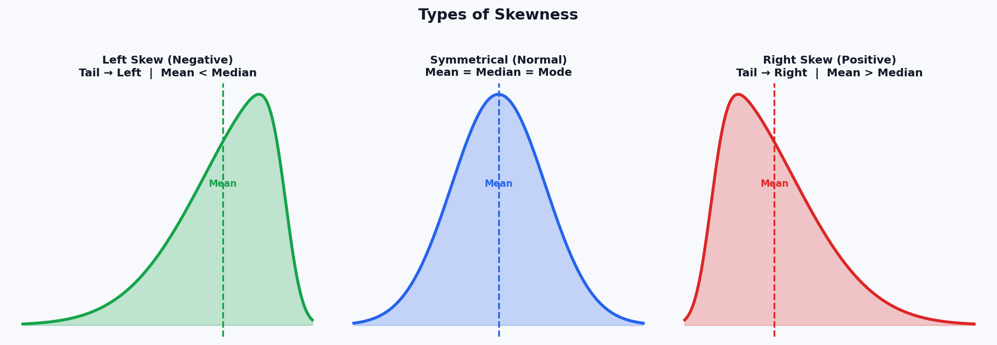
Symmetrical |  | Mean = Median = Mode. Data is evenly distributed on both sides. A perfect normal distribution is symmetrical.
Right Skew (Positive) |  | Tail stretches to the RIGHT. Most data clusters on the left. Mean > Median > Mode. Common in: income distributions, house prices.
Left Skew (Negative) |  | Tail stretches to the LEFT. Most data clusters on the right. Mean < Median < Mode. Common in: age at death, exam scores near ceiling.
 | ✅ Tip: In a skewed distribution, the median is a better measure of central tendency than the mean, because the mean is pulled toward the long tail.

05 Probability Basics

What is Probability?
Probability measures how likely an event is to occur. It is a number between 0 and 1 (or 0% and 100%).
P(Event) = Number of favourable outcomes / Total possible outcomes
P = 0 | Impossible event (will never happen)
P = 0.5 | 50/50 chance (equally likely to happen or not)
P = 1 | Certain event (will always happen)

Probability Density Function (PDF)
A PDF describes the relative likelihood of a continuous random variable taking on a given value. Unlike discrete probability, we cannot assign probability to exact points — instead, probability is the area under the curve over an interval.
Key Property: The total area under any PDF curve always equals 1 (representing 100% probability).
P(a ≤ X ≤ b) = ∫[a to b] f(x) dx
⚠️ Important: For continuous distributions, P(X = exact value) = 0. We always talk about ranges, e.g., P(1.5 ≤ X ≤ 2.5).

06 Normal Distribution

The Bell Curve
The Normal Distribution is the most important distribution in statistics. It is symmetric, bell-shaped, and fully described by just two parameters: mean (μ) and standard deviation (σ).
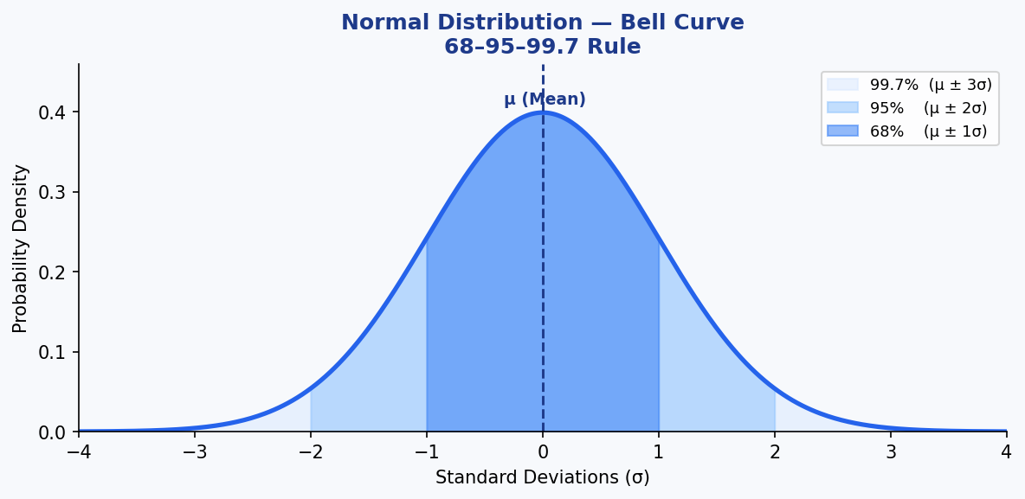

Properties of Normal Distribution
- Perfectly symmetrical around the mean
- Mean = Median = Mode (all at the centre)
- The curve extends infinitely in both directions but never touches the x-axis
- Total area under the curve = 1

The 68–95–99.7 Rule (Empirical Rule)
This rule tells us what percentage of data falls within certain standard deviations of the mean in a normal distribution:
μ ± 1σ (Within 1 SD) |  | ≈ 68% of all data falls here
μ ± 2σ (Within 2 SD) |  | ≈ 95% of all data falls here
μ ± 3σ (Within 3 SD) |  | ≈ 99.7% of all data falls here
 | 📘 Example: Example: If exam scores are normally distributed with μ=70 and σ=10, then about 68% of students scored between 60 and 80, and 95% between 50 and 90.

Standard Normal Distribution & Z-Score
The Standard Normal Distribution is a special case of the normal distribution where Mean (μ) = 0 and Standard Deviation (σ) = 1. Any normal distribution can be converted to standard normal using the Z-score formula.
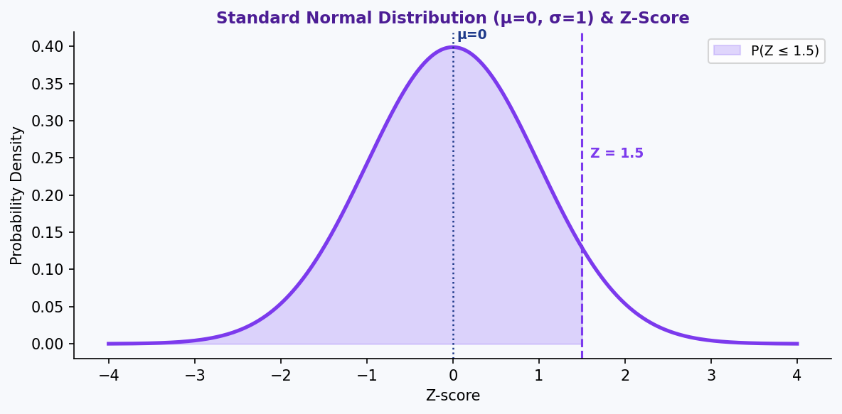

Z-Score
The Z-score tells you how many standard deviations a data point is away from the mean.
Z = (X − μ) / σ
X | Your individual data point value
μ (mu) | Population mean
σ (sigma) | Population standard deviation
Z | Number of SDs from the mean (positive = above, negative = below)
Example: μ=70, σ=10, X=85 → Z = (85−70)/10 = 1.5 → This score is 1.5 standard deviations above the mean.
✅ Why Z-Score? Z-scores allow you to compare values from different datasets. A student scoring Z=2 in maths and Z=1.5 in science performed relatively better in maths.

07 Important Probability Distributions

Bernoulli Distribution
The simplest distribution — models a single experiment with exactly two outcomes: Success (1) or Failure (0).
P(X=1) = p P(X=0) = 1−p (= q)
Parameter p | Probability of success (0 ≤ p ≤ 1)
Mean | p
Variance | p(1−p)
Real-world example | Single coin flip. Single yes/no question. Will a customer click an ad? (p = click-through rate)

Binomial Distribution
Models the number of successes in n independent Bernoulli trials. Each trial has the same probability of success p.
P(X=k) = C(n,k) × p^k × (1−p)^(n−k)
n | Number of independent trials
k | Number of successes we are interested in
p | Probability of success on each trial
C(n,k) | Binomial coefficient = n! / [k!(n−k)!] (ways to choose k from n)
Mean | np
Variance | np(1−p)
Real-world example | Number of heads in 10 coin flips. Number of defective items in a batch of 50.
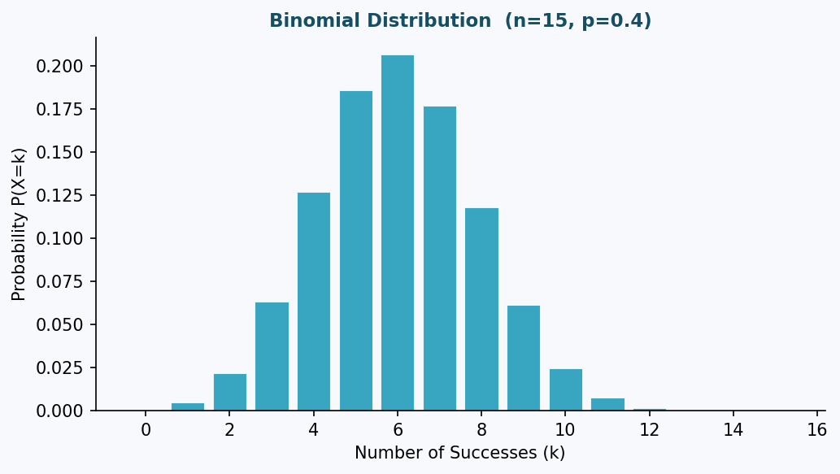

Uniform Distribution
All outcomes in a given range are equally likely. The probability is constant across the entire range.
f(x) = 1 / (b − a) for a ≤ x ≤ b
Parameters |  | a = minimum, b = maximum
Mean |  | (a + b) / 2
Variance |  | (b − a)² / 12
Real-world example |  | Rolling a fair die (discrete uniform). Random number generator output. Bus arrival time within a 10-minute window.
 | 📌 Shape: The graph of a continuous uniform distribution is a flat horizontal line — every value in the range has the same probability density.

Poisson Distribution
Models the number of events occurring within a fixed interval of time or space, given a known average rate (λ), when events occur independently.
P(X=k) = (e^(−λ) × λ^k) / k!
λ (lambda) | Average number of events in the interval
k | Actual number of events (0, 1, 2, 3, …)
Mean | λ
Variance | λ (mean = variance — a unique property!)
Real-world example | Calls received at a call centre per hour. Number of typos per page. Earthquakes per year in a region.
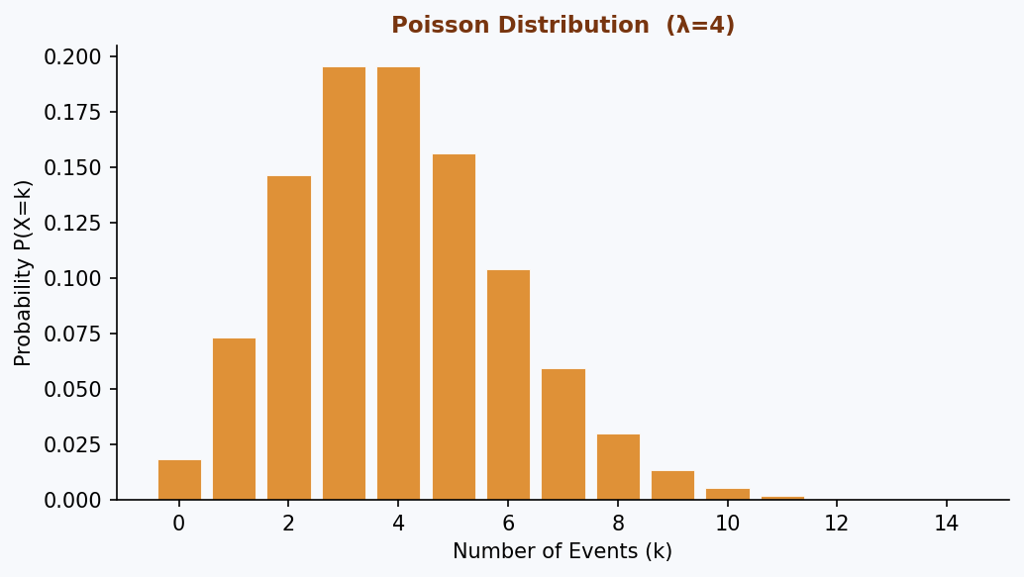
✅ When to Use: Use Poisson when: (1) Events are independent, (2) Average rate λ is constant, (3) Two events cannot occur at exactly the same instant.

08 Relationships in Data

Covariance
Covariance measures how two variables move together. It tells us the direction of the linear relationship between two variables.
Cov(X,Y) = Σ[(xᵢ − x̄)(yᵢ − ȳ)] / (n−1)
Cov > 0 (Positive) |  | Variables move in the SAME direction. When X increases, Y tends to increase.
Cov < 0 (Negative) |  | Variables move in OPPOSITE directions. When X increases, Y tends to decrease.
Cov ≈ 0 |  | Little to no linear relationship between X and Y.
 | ⚠️ Important: Limitation: Covariance values depend on the units of measurement, making them hard to compare across different datasets. Use Correlation (r) for a standardised version: r = Cov(X,Y) / (σX × σY) → always between −1 and +1.

Collinearity & Multicollinearity
Collinearity occurs when two predictor (independent) variables in a regression model are highly correlated with each other. Multicollinearity is when three or more predictors are highly inter-correlated.
Problem |  | It becomes difficult to determine the individual effect of each predictor on the outcome. Coefficients become unstable and unreliable.
Detection |  | Variance Inflation Factor (VIF). VIF > 5 or > 10 indicates serious multicollinearity.
Solution |  | Remove one of the correlated variables, combine them (e.g. PCA), or use regularisation techniques (Ridge, Lasso).
 | 📘 Example: Example: In a model predicting house price, including both "number of rooms" and "square footage" is likely to cause multicollinearity because larger houses tend to have more rooms.

09 Central Limit Theorem (CLT)

What is the Central Limit Theorem?
The Central Limit Theorem is one of the most powerful and important theorems in statistics. It states:
📐 CLT Statement: Regardless of the shape of the population distribution, the distribution of sample means will approach a Normal Distribution as the sample size n becomes large enough (typically n ≥ 30).

Key Properties of CLT
- The population can have ANY distribution — skewed, uniform, bimodal, etc.
- As we take more and larger samples, their means form a bell curve
- The mean of the sampling distribution equals the population mean (μ)
- The standard deviation of the sampling distribution (Standard Error) = σ/√n
Standard Error (SE) = σ / √n

Why CLT Matters
The CLT is the theoretical foundation for many statistical methods including:
Hypothesis Testing | We can test claims about population parameters using sample statistics because sample means are normally distributed (via CLT).
Confidence Intervals | We can construct intervals around sample means to estimate population means with known confidence levels.
Large Sample Methods | Methods like t-tests and z-tests rely on CLT when working with means from large samples.
Example: Even if individual exam scores follow a skewed distribution, if we repeatedly take samples of 50 students and compute the mean, those sample means will be approximately normally distributed.
💡 Big Picture: The CLT explains why the normal distribution appears so frequently in nature and in data analysis. It is not that everything is normal — it is that averages tend to be!

Quick Reference — Formulas & Definitions
Measure | Formula | When to Use
Mean | Σx / n | Symmetric data, no outliers
Median | Middle value (sorted) | Skewed data or outliers present
Mode | Most frequent value | Categorical data; finding most common
Range | Max − Min | Quick rough spread estimate
Variance | Σ(xᵢ−μ)² / N | Measuring overall dispersion
Std Deviation | √Variance | Spread in original units
Z-score | (X − μ) / σ | Comparing across distributions
Covariance | Σ(xᵢ−x̄)(yᵢ−ȳ) / (n−1) | Direction of relationship
Correlation r | Cov(X,Y) / (σX·σY) | Strength + direction (−1 to +1)
Std Error | σ / √n | Precision of sample mean
Binomial P(k) | C(n,k)·p^k·(1−p)^(n−k) | k successes in n trials
Poisson P(k) | e^(−λ)·λ^k / k! | Events in fixed time/space

End of Statistics Notes

