Retrieval-Augmented Generation (RAG)
Complete Architecture Notes

1. What is RAG?
RAG stands for Retrieval-Augmented Generation. It is a modern AI architecture that combines two things: an information retrieval system and a large language model (LLM). Instead of the AI answering purely from memory, it first searches and retrieves relevant information from external sources — such as documents, databases, or websites — and then uses that information to generate an accurate, context-aware response.

Simple Analogy
Think of RAG like an open-book exam. A traditional LLM answers from memory alone (closed-book). A RAG system first opens the reference book, finds the right page, and then answers based on what it actually read. This makes responses far more accurate and current.

1.1 Where is RAG Used?
- AI chatbots and virtual assistants
- Enterprise search systems inside companies
- Internal knowledge base assistants
- Customer support automation
- Medical and legal knowledge systems
- AI-powered document analysis tools

2. What is an LLM?
LLM stands for Large Language Model. An LLM is a deep-learning model trained on vast amounts of text data. Through training, it learns to understand language, reason, and generate human-like responses. Popular examples include OpenAI GPT, Google Gemini, Anthropic Claude, and Meta Llama.

2.1 What Can an LLM Do?
- Answer questions based on its training knowledge
- Write, edit, and summarize text
- Translate between languages
- Generate and explain code
- Perform logical reasoning and analysis

2.2 Limitations of a Standalone LLM
LLMs are powerful but have important limitations that RAG is specifically designed to solve:

Limitation | Explanation
Knowledge cutoff | An LLM only knows what existed in its training data. It has no awareness of new events, new documents, or real-time information.
Hallucination | LLMs sometimes generate confident but completely incorrect answers. They can invent facts, fake citations, or wrong policies.
No private data access | A standard LLM cannot read your company PDFs, internal databases, Excel sheets, or private documents.

3. Why Was RAG Created?
RAG was created to overcome the three limitations described above. By adding a retrieval step before generation, the system can answer with real, current, private information rather than relying on memorised training data alone.

3.1 Benefits of RAG
- Provides real-time and up-to-date information
- Can work with private and proprietary documents
- Significantly reduces hallucinations by grounding answers in retrieved text
- Improves factual accuracy of responses
- Scales across enormous document collections
- Makes AI suitable for enterprise and regulated industries

4. RAG Architecture — The Full Picture
The RAG architecture is built on two main pipelines that work together. The first pipeline runs once to prepare and index your data. The second pipeline runs every time a user asks a question.

4.1 Pipeline 1 — Data Injection (Indexing Phase)
Before any user can ask a question, all of your source documents must be processed and stored in a way the system can search efficiently. This preparation is called the Data Injection Pipeline or Indexing Phase.

Step-by-Step Flow:

PDFs / Documents | → | Extract Data | → | Split into Chunks | → | Embedding API | → | Build Semantic Index (Vector DB)

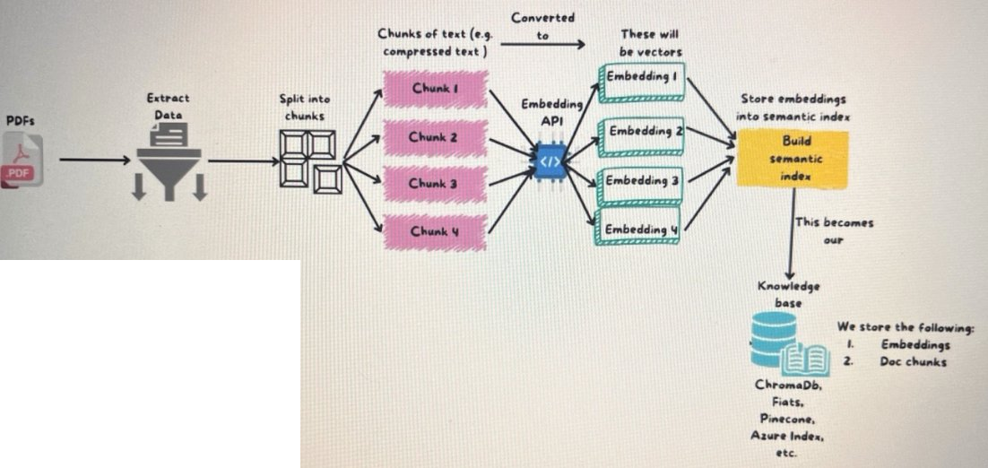
Figure 1: Data Injection Pipeline — from source documents to vector knowledge base

Detailed Step Explanation:
- Load Source Documents — Gather all documents you want the AI to know about. These can be PDFs, Word files, web pages, spreadsheets, or any text-based source.
- Extract Data — Parse and extract the raw text content from those documents so the system can process it.
- Split into Chunks — Break the large text into smaller, manageable pieces. This is called chunking. Smaller chunks allow for more precise retrieval. For example, a 100-page PDF might become 400 individual chunks.
- Embedding API — Pass each text chunk through an embedding model. The embedding model converts text into a list of numbers (called a vector) that mathematically represents the meaning of that chunk. Chunks with similar meanings produce similar numbers.
- Build Semantic Index — Store all the vectors and their original text chunks inside a vector database. This becomes your Knowledge Base. Every time a user asks a question, the system will search this index to find the most relevant chunks.

What is stored in the Knowledge Base?
- The vector embeddings — numerical representations of each chunk
- The original document chunks — the actual text content
Common vector databases: ChromaDB, FAISS, Pinecone, Azure AI Search, Weaviate

4.2 Pipeline 2 — Retrieval and Generation Phase
This pipeline runs every time a user sends a query. It uses the knowledge base built in Pipeline 1 to retrieve relevant information and generate an accurate answer.

Step-by-Step Flow:

User Query | → | Query Embedding | → | Semantic Search in Vector DB | → | Retrieve Ranked Results | → | Add Context to Prompt → LLM | → | Final Answer

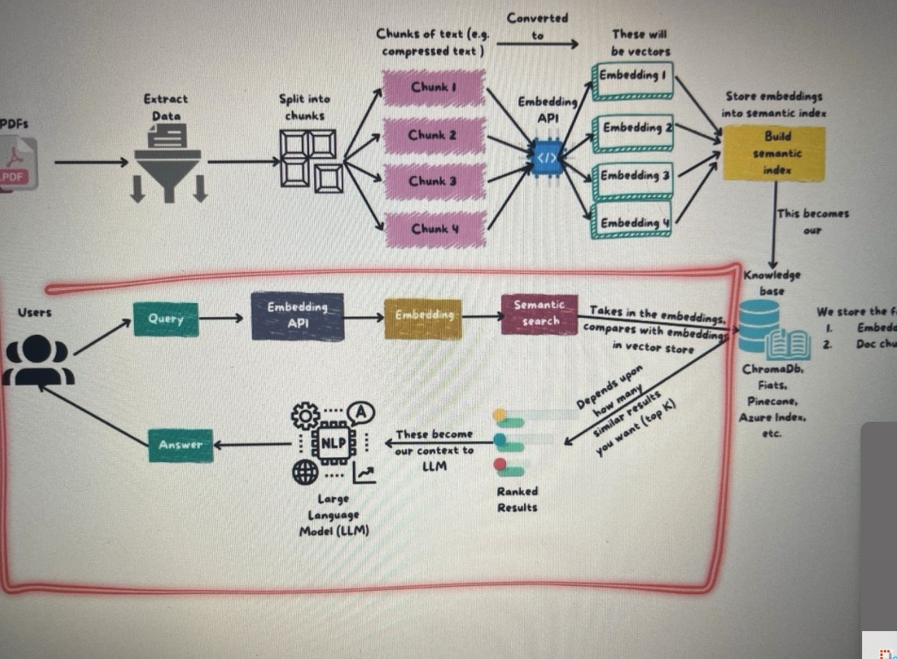
Figure 2: Retrieval and Generation Pipeline — from user query to final AI response

Detailed Step Explanation:
- User Sends a Query — A user types a question or request into the system.
- Query Embedding — The user's question is passed through the same embedding model used during indexing. This converts the question into a vector so it can be compared against the stored document vectors.
- Semantic Search — The system compares the query vector against all stored vectors in the vector database. It is not looking for exact keyword matches — it is looking for chunks whose meaning is most similar to the question.

Semantic Search Example
If the user asks: "What are heart attack symptoms?"
The system may retrieve documents about "cardiac arrest" or "myocardial infarction" — because these topics carry the same meaning, even though the exact words are different. This is the key advantage of semantic search over traditional keyword search.

- Retrieve Ranked Results — The vector database returns the top-K most relevant document chunks. These chunks are called the context. The number of chunks returned can be configured (e.g., top 3, top 5).
- Augmentation — Instead of sending only the user's question to the LLM, the system builds an enriched prompt that contains both the original user query and all the retrieved context chunks. This step is called augmentation.
- LLM Generates the Final Answer — The LLM reads the enriched prompt and generates a response that is grounded in the actual retrieved information rather than its training memory alone. This response is returned to the user.

Why is it called RAG?
Retrieval — finding relevant information from the knowledge base
Augmentation — adding retrieved context to the prompt before sending to the LLM
Generation — the LLM uses both the query and context to generate the final answer

5. Important RAG Components

5.1 Chunking
Chunking is the process of splitting large documents into smaller, manageable pieces before storing them. It is one of the most important decisions in building a RAG system because it directly affects retrieval quality.

Why Chunking Matters:
- Smaller chunks allow the system to pinpoint the exact relevant section of a document
- Embedding smaller pieces produces more focused and accurate vectors
- Keeps content within the token limits of LLMs
- Speeds up similarity search in the vector database

Types of Chunking:

Type | How It Works | Best Used When
Fixed Size | Splits text after a fixed number of characters or tokens. Example: every 500 words. | Documents are uniform and consistent in structure.
Recursive | Splits first by paragraphs, then sentences, then characters — respecting the natural structure of the document. | Most document types. This is the most commonly used method.
Semantic | Splits based on topic or meaning changes, not just size. | Rich content where meaning shifts between sections.
Sliding Window | Chunks overlap partially. Example: Chunk 1 covers lines 1–100, Chunk 2 covers lines 80–180. | When context continuity between chunks is critical.

5.2 Embeddings
An embedding is a numerical representation of a piece of text. When a sentence or paragraph is passed through an embedding model, it is converted into an array of numbers — called a vector. The key property of embeddings is that text with similar meanings produces similar vectors, and text with different meanings produces very different vectors.

Example
"doctor" → [0.82, 0.15, 0.67, 0.44, ...]
"physician" → [0.81, 0.14, 0.68, 0.43, ...] ← very similar numbers, same meaning
"pizza" → [0.12, 0.91, 0.05, 0.88, ...] ← very different numbers, different topic

5.3 Vector Database
A vector database is a specialised database designed to store and search through vector embeddings. Unlike traditional SQL databases that match exact keywords, a vector database searches by mathematical similarity — it finds embeddings (and therefore text chunks) that are closest in meaning to the query.

Traditional Database | Vector Database
Stores rows and columns of structured data | Stores high-dimensional numerical vectors
Searches by exact keyword match | Searches by semantic (meaning) similarity
Cannot understand context or meaning | Understands meaning and intent behind queries

6. Types of RAG

6.1 Naive RAG (Basic RAG)
This is the simplest form of RAG. The flow is completely linear and fixed:

User Query → Retrieve Relevant Chunks → Add to Prompt → LLM Generates Answer

Naive RAG works well for simple, well-defined question-answering tasks. However, it has limitations: it retrieves a fixed number of chunks regardless of whether they are truly relevant, and it does not validate or reason about the retrieved information before generating an answer.

6.2 Advanced RAG
Advanced RAG improves on Naive RAG by adding steps before and after retrieval to improve quality:

- Pre-retrieval improvements — better query reformulation, query expansion, and metadata filtering before searching the vector database
- Improved retrieval — re-ranking retrieved chunks by relevance, hybrid search (combining keyword search with semantic search)
- Post-retrieval improvements — compressing retrieved context, filtering out irrelevant chunks before sending to the LLM

Advanced RAG produces more accurate, relevant answers compared to Naive RAG, especially for complex or ambiguous queries.

6.3 Agentic RAG
Agentic RAG is the most advanced form of RAG. It adds AI agents into the workflow to make the system intelligent, adaptive, and autonomous — rather than following a fixed, predetermined sequence of steps.

How Agentic RAG Differs from Normal RAG:
In a normal RAG system, the flow is always the same: query → retrieve → generate. In Agentic RAG, an AI agent takes control of the workflow. The agent analyses the user's query, decides what information is needed, chooses which tools or data sources to use, coordinates retrieval, and may even call external APIs or run sub-tasks before producing the final answer.

Agentic RAG Flow:

User Query | → | AI Agent (Decision Maker) | → | RAG Retrieval | → | Agent Reasoning & Tool Use | → | Additional Agent Collaboration (optional) | → | Synthesise Results | → | Final Answer

What Can the Agent Do?
- Break a complex question into multiple smaller sub-questions
- Decide which documents or data sources are most relevant
- Validate retrieved information before using it
- Call external APIs or tools to gather additional data
- Coordinate multiple agents working in parallel on different tasks
- Reason step-by-step before generating the final answer

Normal RAG vs. Agentic RAG — Comparison:

Normal RAG | Agentic RAG
Fixed, linear workflow | Dynamic, adaptive workflow controlled by an agent
Retrieves and generates in one pass | Plans, reasons, retrieves, validates, then generates
Cannot call external tools | Can call APIs, search engines, databases, and tools
Single retrieval step | May perform multiple retrieval rounds as needed
Best for simple Q&A | Best for complex, multi-step reasoning tasks

7. Important Libraries and Frameworks
The following tools are the most widely used in building RAG systems:

7.1 LangChain
LangChain is the most popular framework for building RAG pipelines and AI applications. It provides ready-made components for connecting LLMs, vector databases, retrievers, agents, and tools into complete workflows.
- Building end-to-end RAG pipelines
- Prompt chaining — connecting multiple prompts in sequence
- Agent and tool integrations
- Conversation memory management
- Connecting to APIs, databases, and search engines

7.2 LangGraph
LangGraph is built on top of LangChain and is specifically designed for multi-agent and stateful AI workflows. It is the go-to tool for building Agentic RAG systems.
- Multi-agent orchestration
- Stateful AI systems that remember context across steps
- Complex reasoning and decision-making pipelines

7.3 LlamaIndex
LlamaIndex specialises in connecting data sources to LLMs. It is particularly strong at document indexing and building efficient retrieval pipelines over large document collections.
- Document loading and indexing
- Building efficient retrieval pipelines
- Connecting structured and unstructured data to LLMs

7.4 FAISS
FAISS (Facebook AI Similarity Search) is a high-performance vector similarity search library developed by Meta. It is optimised for searching through millions of vectors at high speed on local hardware.
- Fast nearest-neighbour vector search
- Used locally within larger systems
- Best for high-throughput, large-scale similarity search

7.5 ChromaDB
ChromaDB is a lightweight, open-source vector database that is easy to install and use. It is a popular choice for local development and prototyping of RAG systems.
- Simple setup — runs locally with no infrastructure
- Supports metadata filtering alongside vector search
- Good for development, testing, and small-scale applications

7.6 Pinecone
Pinecone is a fully managed, cloud-based vector database built for production-scale applications. It handles all infrastructure automatically, making it easy to scale to billions of vectors.
- Fully managed cloud service — no server management needed
- Highly scalable for enterprise production workloads
- Built-in high availability and automatic scaling

Framework Comparison Summary:

Tool | Type | Primary Use
LangChain | AI Framework | Building complete RAG pipelines and agent workflows
LangGraph | Agent Framework | Multi-agent and stateful AI systems
LlamaIndex | Data Framework | Document indexing and data-to-LLM connection
FAISS | Vector Search Library | Fast local similarity search at large scale
ChromaDB | Vector Database | Local development and prototyping
Pinecone | Cloud Vector Database | Production-scale managed vector search

8. Summary — The Complete RAG Story
RAG was created to solve the fundamental limitations of standalone LLMs: outdated knowledge, hallucination, and inability to access private data. By combining a retrieval system with an LLM, RAG produces responses that are accurate, current, and grounded in real information.

Complete RAG Flow in Plain Words
PREPARATION (runs once):
- Load your source documents
- Split them into chunks
- Convert each chunk into a vector embedding
- Store all embeddings and original chunks in a vector database
LIVE ANSWERING (runs every time a user asks):
- User sends a query
- Convert the query into a vector embedding
- Perform semantic search in the vector database
- Retrieve the top-matching document chunks (context)
- Build an enriched prompt: original query + retrieved context
- Send the enriched prompt to the LLM
- LLM generates a final, accurate, context-aware answer

End of RAG Architecture Notes

