Advanced Programming II
Task: A Natural Language Interface to Database (NLIDB)

Objectives
Python Programming
Object Oriented Concepts in Python
Python and Web Interfaces in CGI
Python and Database Connectivity
Python and Socket Programming
Natural Language Interface to Databases

Background

Natural Language Processing (NLP) is an interesting research area. It is about teaching Computers the language of Men and making the computer think and understand the language that we humans talk in daily life. Why would anyone want to do that! Once a computer starts understanding the language we speak, synthesize and generate the same language and speak back to us, the immediate change would be observed in the area of Robotics, Human Computer Interaction and Artificial Intelligence.
In this task we dwell into one of the sub-areas of this vast area of NLP called Question Answering Systems and in particular we would be building a Natural Language Interface to Databases (NLIDB). Databases are everywhere, they are used in almost every software application that is seen today – Railway enquiry, Library Management, Student Information System etc. Most often people are restricted to query and see what the Programmer who designed and developed the Information System has decided and programmed in. The reason being - there are 1000’s of combinations of queries that are possible on any database and all of them can not be put into the system. How about a system that understands what the end user asks for and converts it into the relevant SQL statement and executes it, then presents it to the user? Another by-benefit of such a system would be that we now don’t have to understand SQL to extract information out of it!

Investigation

The flow:
1) Query is posed by the end-user
2) Phrase grouping of the query
3) Stop word removal from the phrase-grouped query
4) Identifying the required database table and attributes
5) Generating the SQL query
6) Executing the query and display the values to the user

Architecture:
Here is a guiding architecture for the system.
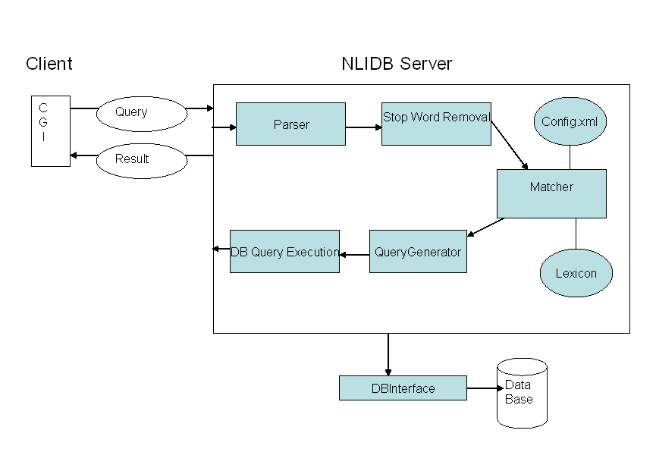

Classes in the NLIDB system:
Here is the listing of classes required in the system. Please see that the system you build is as close as possible to this design, as the main objective of this course is to understand Python and OOPS. A big chunk of the grade would be assigned to the style of programming, modularity and the object oriented concepts manifested in the code.

- Query: The query entered by the user is held in this class. Necessary steps like Phrase-grouping and stop word removal are performed in this class and the query is mutated accordingly.
- StopWords: This class contains the necessary information to judge whether a word is a stop word or not. It exposes a function isStopWord()
- Parser: This class should take in a string, run it over the parser (phrase-grouper in our case) and return back the necessary relations.
- Matcher: This class is the crux of the system. It loads in a file called the “mapping.xml”, “foreignkeys.xml” which contains a mapping of the Question words to the Database relations and attributes. It should do the mapping and finally decide the arguments that would go into the “SELECT “statement of the SQL query.
- QueryGenerator: The query generator should have access to “foreignkeys.xml” and “mapping.xml” and the mappings created by the Matcher above. It generates a SQL query which can then be executed.
The SELECT portion of the query contains the database elements paired with wh-words; the WHERE portion contains a conjunction of attributes and their values, and the FROM portion contains the relevant relation name for the attributes in WHERE.In the case of multi-relation queries, the generator applies the knowledge of the FOREIGN KEY relations and adds join conditions to the WHERE clause, which reflect a join path that contains all the relations implicitly invoked by attributes in the query.
- DB Interface: All the interactions with the Database should be done through a DB Interface class.
- Lexicon: The Lexicon is a data structure that holds all the elements in the database. Distinction between Relation tokens (table names), Attribute tokens (column names), and Value tokens (values) should be made. So ensure that the data structure you chose is apt for such a scenario.

Resources for NLIDB

- Data Set:
- Parser (Phrase grouper and Part of Speech Tagger)
- Stop Word list
- Config.xml

Deliverables

Task 1: Develop an NLIDB system in PYTHON on the lines mentioned above.

Task 2:
- Wrap the NLIDB system as a Server component and set it running on port 2560 (say). The reason for this is two fold.
  - QA Systems take up lot of resources during start up. For every single question that is posed we do not have the luxury of loading the resources always. Setting up on a server would ensure the start up is done only once.
  - We could allow various other clients to talk to us as long as they follow and understand the protocol that the server enforces.
- Create a simple website in PYTHON CGI and set it running where people could login and query the database. You would then gather the query and post it to the NLIDB Server in the protocol that it understands. For all possible queries that the NLIDB generates display the same to the user.

Duration: 3 weeks
Submission: To be submitted on Friday 15th April, 2016

Resources for the TASK

Python Tutorial:
http://docs.python.org/tut/tut.html

Python CGI:
http://www.cs.virginia.edu/~lab2q/

Python DB API:
http://www.python.org/peps/pep-0249.html
http://www.python.org/topics/database/modules.html

Python Socket Programming: http://www.amk.ca/python/howto/sockets/

