1. RC Integrator:

Tau = R*C = 10k * 0.1u = 1m

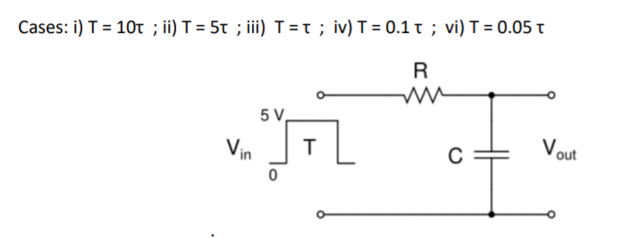

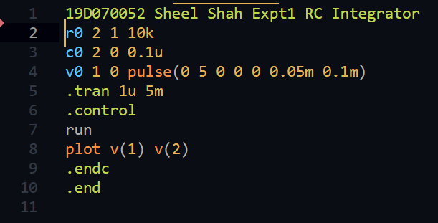

T = 0.05*tau: (good integrator)

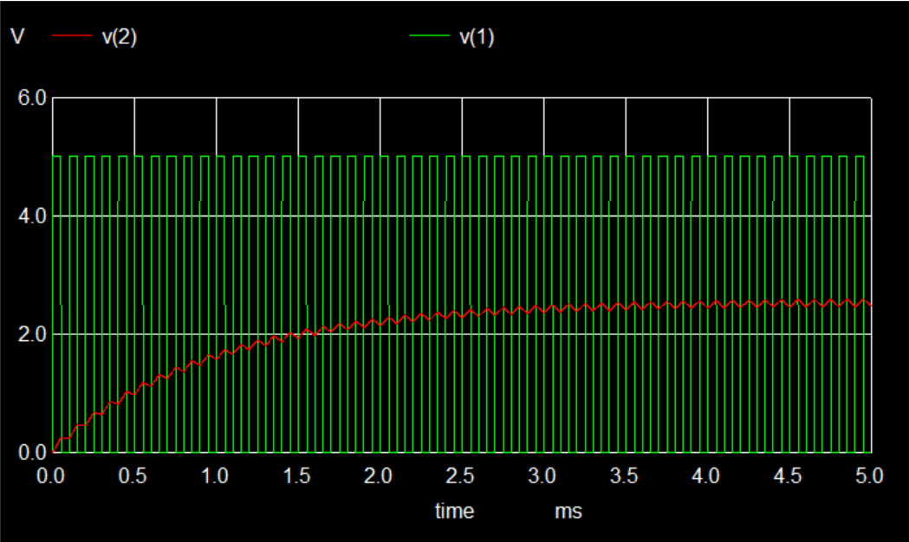

T = 10*tau: (bad integrator)

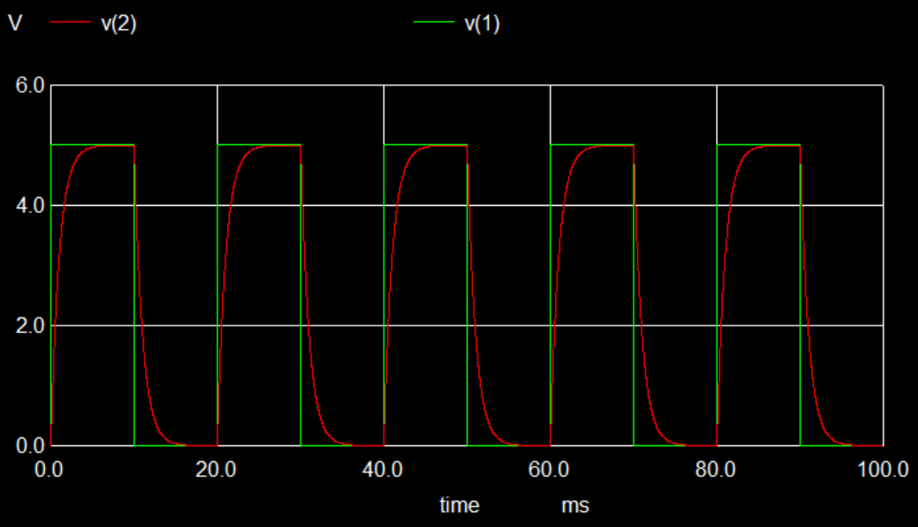

1. RC Differentiator:

Tau is same as calculated above.

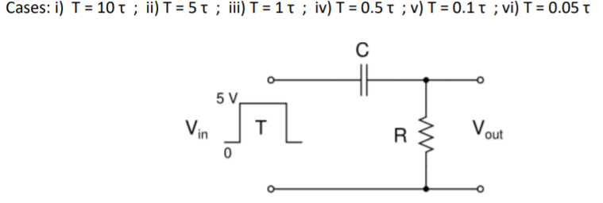

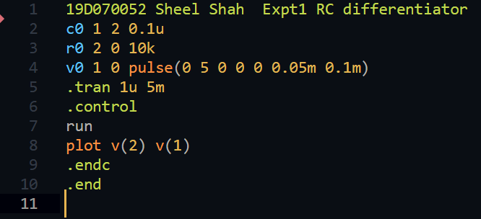

T = 10*tau: (good differentiator)

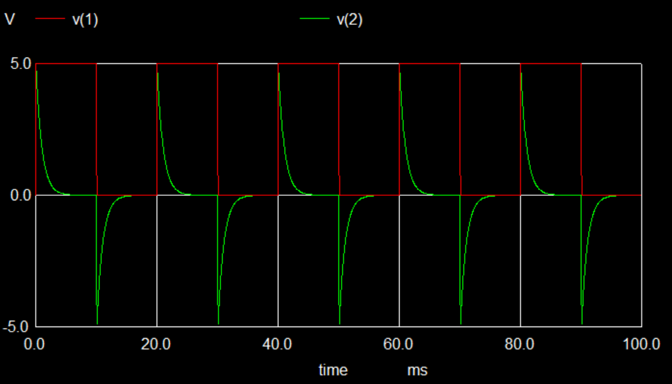

T = 0.05*tau: (bad differentiator)

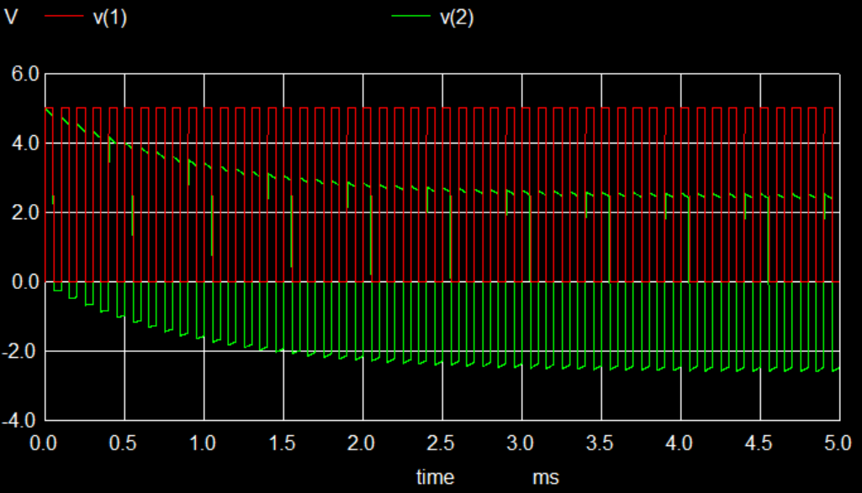

1. RC Lowpass filter

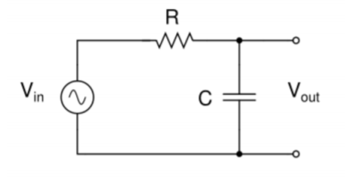

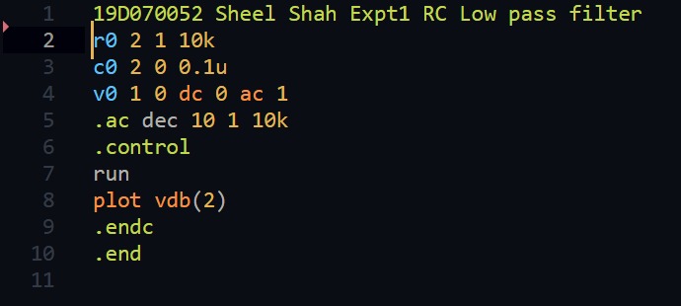

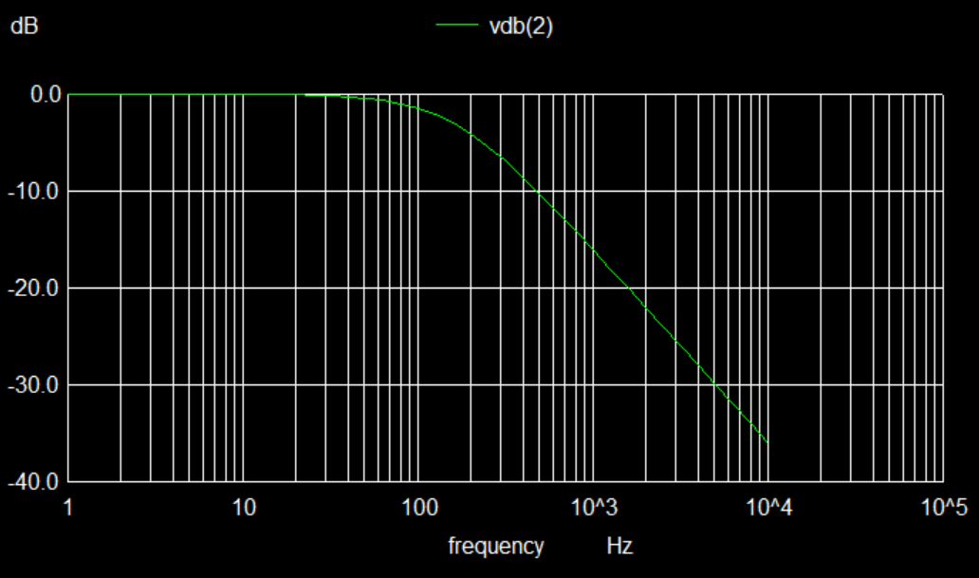

1. RC Highpass filter

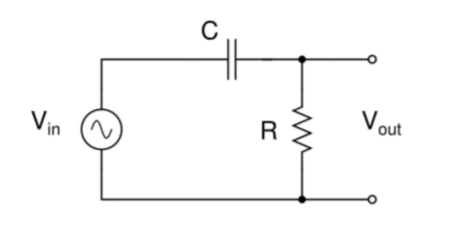

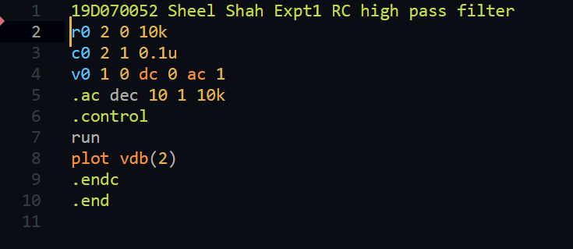

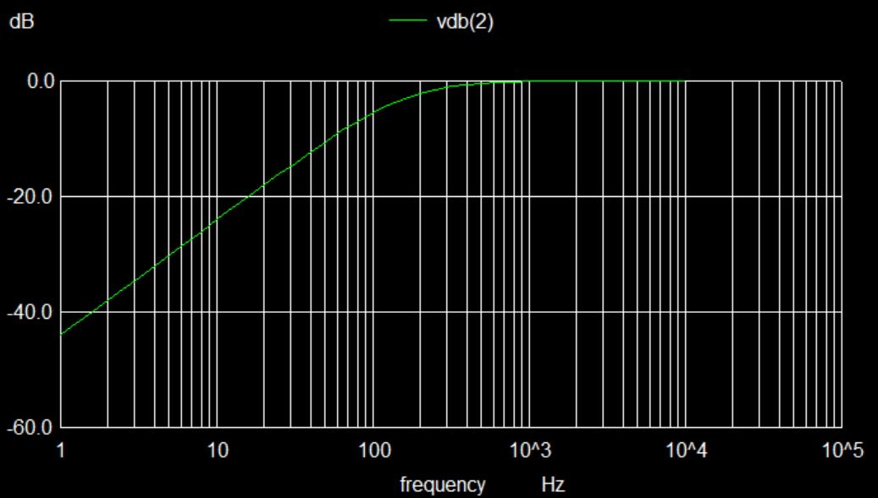

1. RC bandpass filter

Trivial analysis gives us the transfer function T(s) as sRC / (1 + (s*s*R*C)^2 + 3sRC)

For peak, we set the real part of the denominator to 0 => w_peak = 1 / (RC)

F_peak = w_peak / 2pi = 159 Hz

For -3dB points, magnitude is 1/root(2)

Hence 1 –(wRC)^2 = +/- 3wRC

Hence w_l = (root(13) – 3) / (2RC) and w_h = (root(13) + 3) / (2RC)

This gives fl = 48Hz, fh = 526Hz

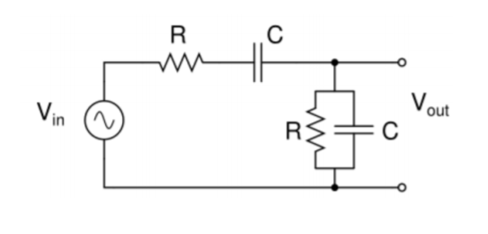

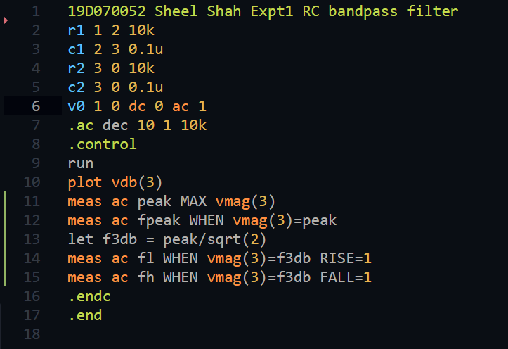

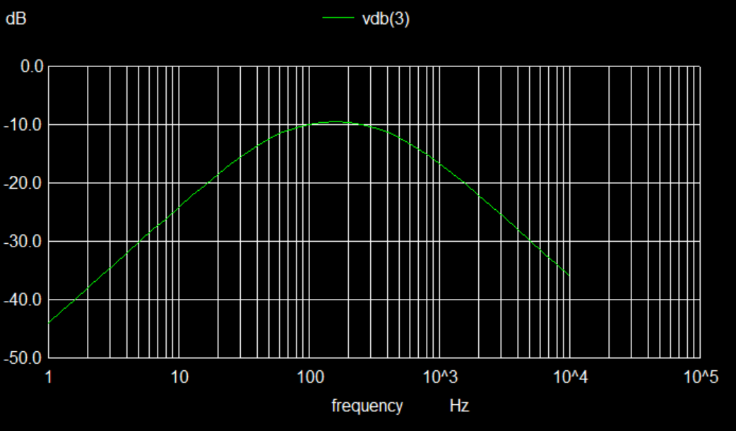

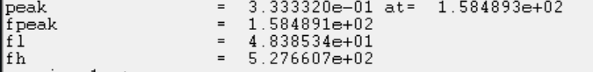

1. RLC bandpass filter

Transfer function is: Vout = R* Vin / (R + s*L + (1 / (s*C)))

So: T(s) = (s / (s^2 + (R/L)*s + 1/(L*C))) * (R/L)

Now with s = j*w we have T(jw) = (Rjw/L)(1 / ((Rjw/L) + (1/LC – w^2)))

Maxima is attained when the denominator is minimum and hence (1/LC -w^2) is 0

Hence w_peak = 1/root(LC) = 31.6 krad/s => f_peak is 5.035 kHz

At f_l and f_h, magnitude should be -3db or 1/root(2).

Hence (1/LC -w^2) is +/- Rw/L

Solving this quadratic gives

w_l = root((R/2L)^2 + 1/LC) – R/2L

w_h = root((R/2L)^2 + 1/LC) + R/2L

Hence fl = 1458Hz, 17373 Hz

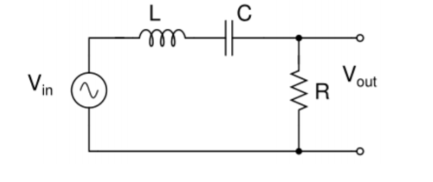

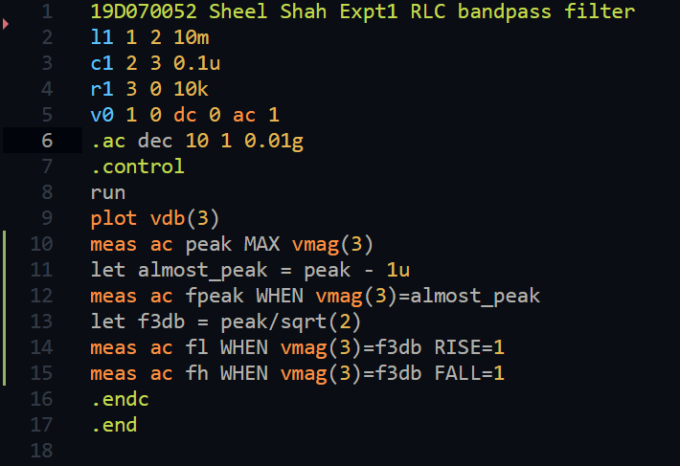

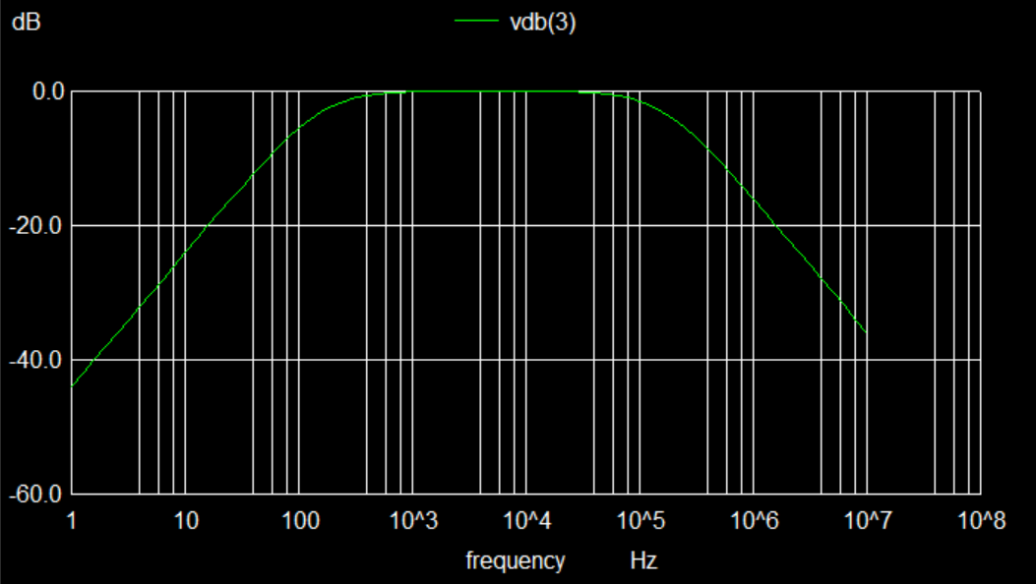

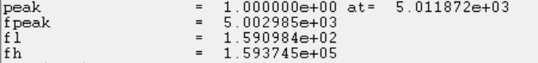

Major learnings:

I really came to like ngSpice and found the method fairly intuitive. It was good to see that mathematical analysis matched so close to simulations. I also understood (hands on) that mathematical analysis was not perfect, and that in the experiment, it would deviate even more than the simulation.

Challenges faced:

I did not like the plain look of .cir files, and hence wrote Sublime Text syntax highlighting for it. This took quite some time, and a lot of effort but I can’t really complain as this was my personal choice. The report also took quite some time, and it looks really bad too. However I don’t know how Latex works so this was my only choice.

Questions/Clarifications:

If you want to see the code/the plots in.ps, please contact me at [19D070052@iitb.ac.in](mailto:19D070052@iitb.ac.in) and I will share a zip.