19D070052, Sheel Shah, Expt2 Report

Q1.  
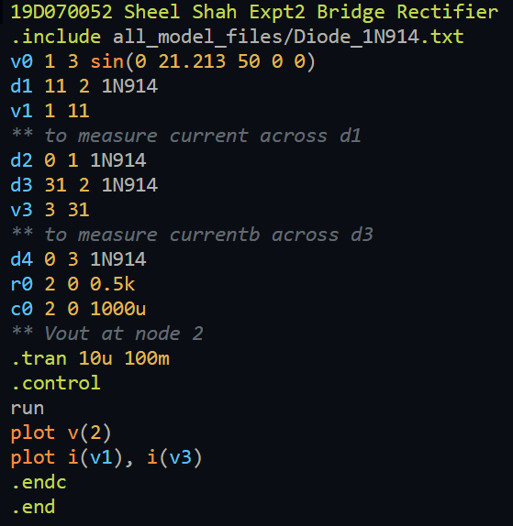

Rl = 1k, C = 100u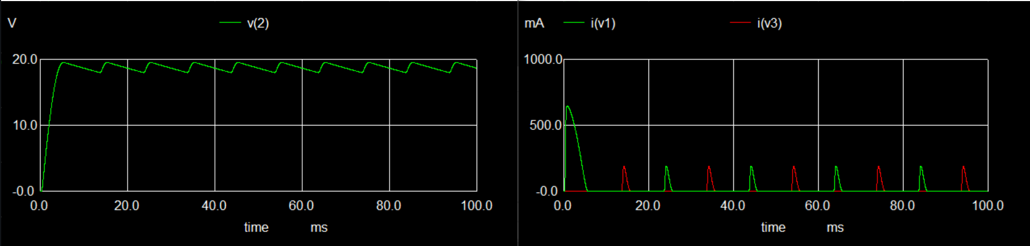

Rl = 0.5k, C = 1000u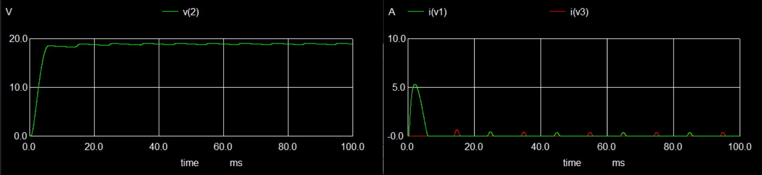

Learnings:

Capacitors are good at making the output almost DC, but if too large a capacitance is used, it leads to excess currents in the diode causing them to burn. The large currents are due to the charge required by the capacitor to charge. Hence a medium capacitor along with some other mechanism to stabilize the DC output should be used.

Q2.  
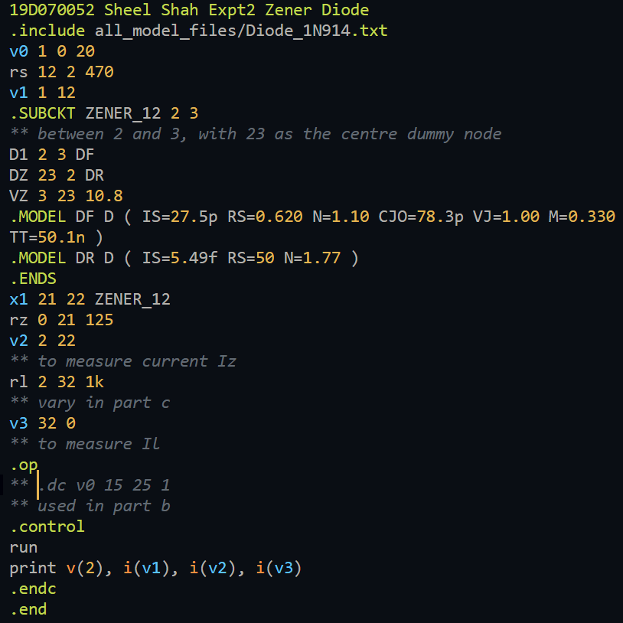

Part A:  
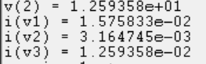

Part B:  
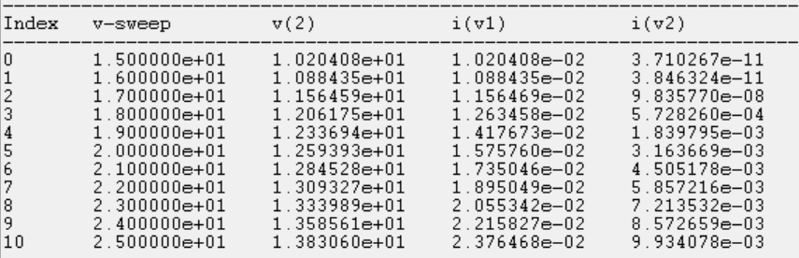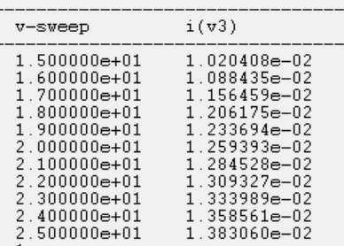  
For V_in <= 17V, V_out drops rapidly below 12V, as the Zener diode is not active for V_in less than 17.64V (from theory)

Part C:  
Via trial and error, the minimum R_l was found to be 720 ohms, which is close to the theoretic value 705 ohms (ignoring Zener resistance)

Learnings:  
The Zener diode method does well for a good amount of change in V_in. It won’t work for applications where R_l/V_in is likely to vary a lot.

Q3.  
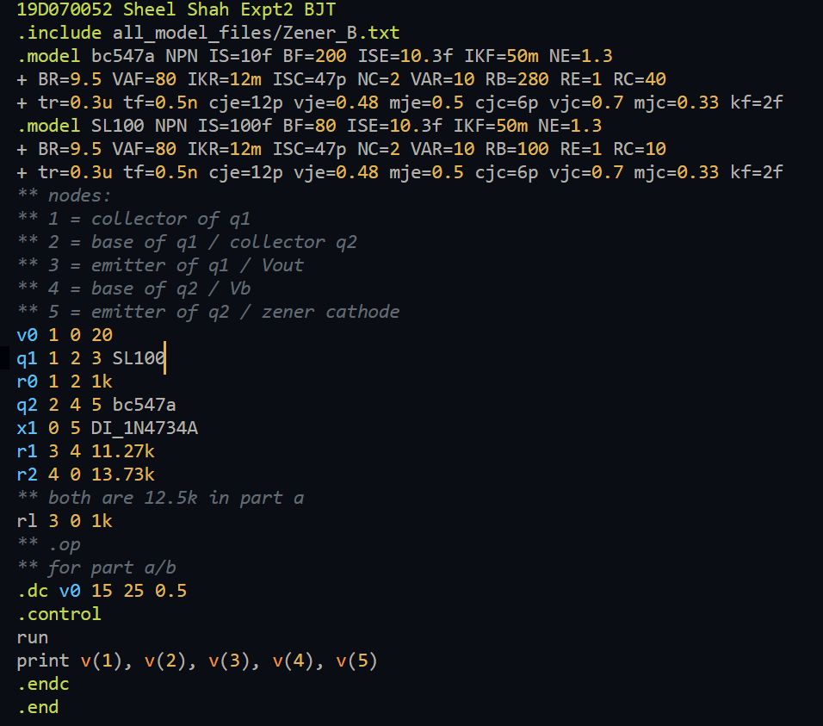

Part A:  
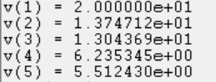

Part B:  
Resistor values are in the code above

Part C: (refer to comments in the code to see what each node is)  
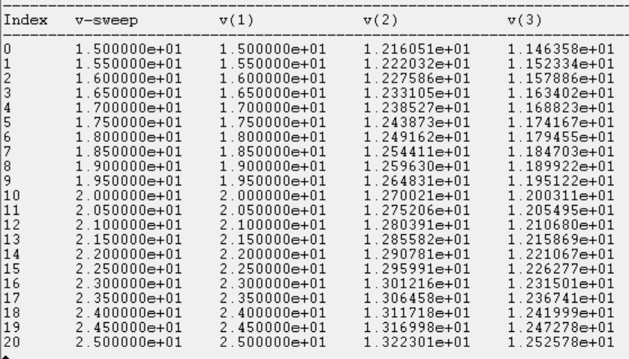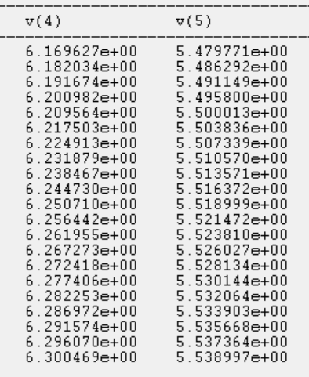

Learnings:  
This does much better than the Zener diode method, and the output is within +- 0.6V of 12V which is really good as V_in varies over +- 5V of 20V