Sheel Shah, 19D070052, Expt4

Q1.

Analysis:  
Vb = Vcc – Vz = 6.4. Ve = 6.4 + 0.7 = 7.1. Ie = (Vcc-Ve)/Re = 1.04mA.  
Ic= Ie, as Ib = 0. Hence Iout = 1.04mA.

Code:  
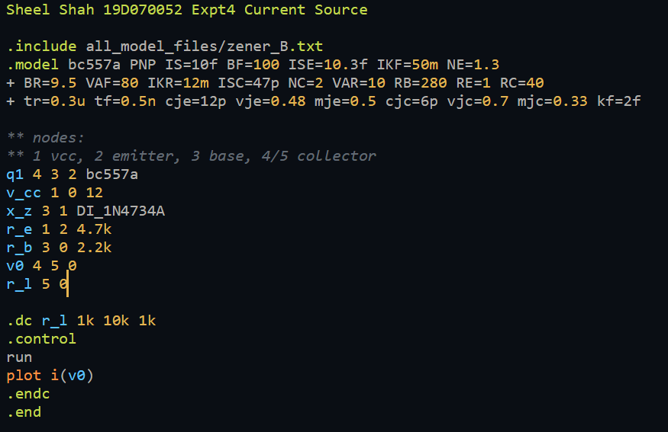

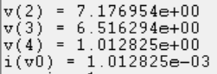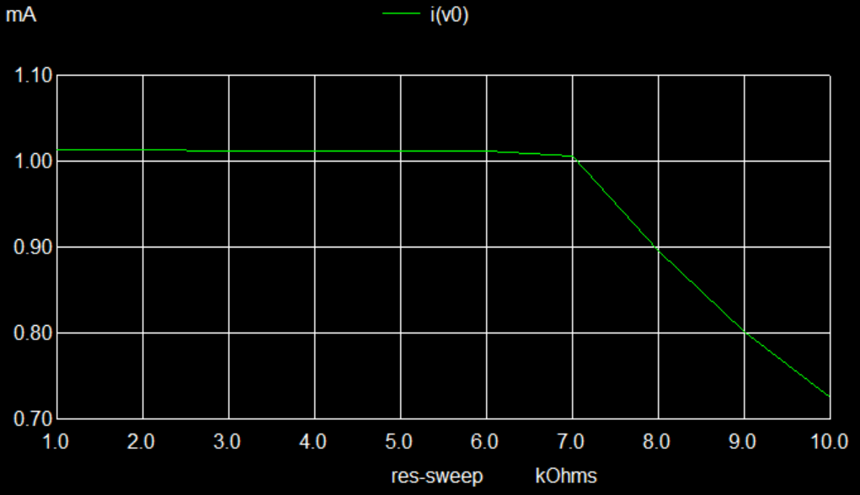

Learnings:

1. I learned about the BJT current source, and saw that our analysis matched well.
2. R_l has an upper limit beyond which the BJT enters saturation, and I_l drops

Q2.

Analysis:  
Iref = 12 – 0.7 / 10k = 1.13mA  
Iout/Iref = (1/(1+2/beta))*(1 + (Vo – Vbe)/Va)  
Substituting: case 1 – 1.167mA. case 2 – 1.1317mA

Code:  
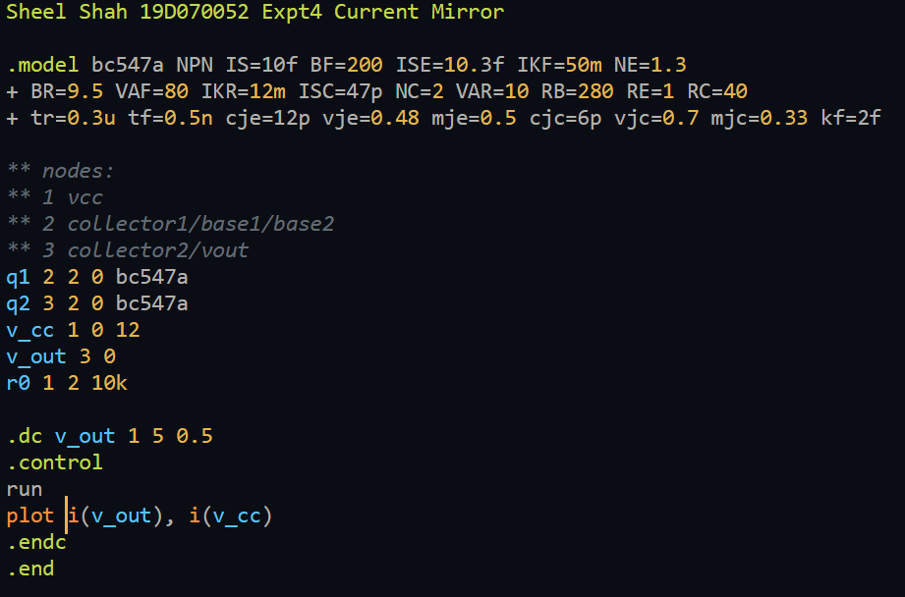

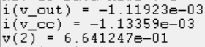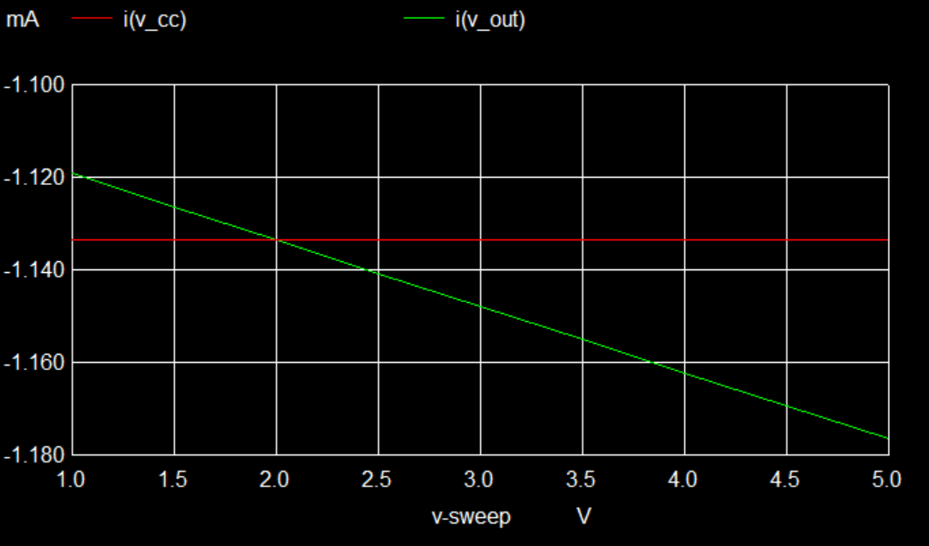

The currents are negative as I avoided using a dummy voltage source to measure the current, and directly used the voltage sources already in the circuit.

Learnings:

The effect of V_a(early voltage) is very clearly visible as we see increasing Iout for increasing Vout. We usually assume Vbe as 0.7 and this is not very accurate.

Q3.  
A:

Analysis:  
Vb = 0 => Ve = -0.7. Ie = 12 – 0.7 /Re = 1.13mA.  
Ic1 =Ic2 = Ie/2 = 0.565mA. Vc1 = Vc2 = 12 -IcRc = 8.158V

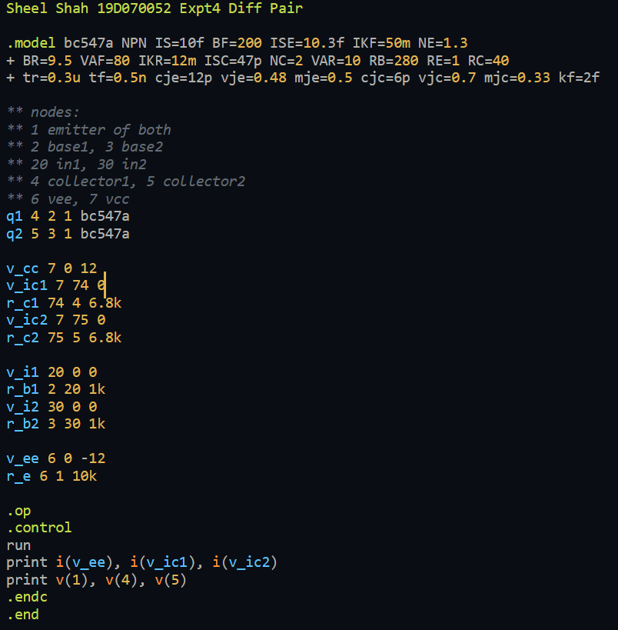

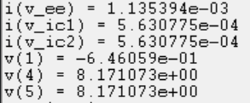

The code for the following parts is very similar and hasn’t been included.

B:

Analysis:  
Gm = Ic/Vt = 0.0217. Single ended gain at Vo1 = -Gm*Rc/2 = -73.9 V/V. At Vo2: +73.9V/V

Simulation:

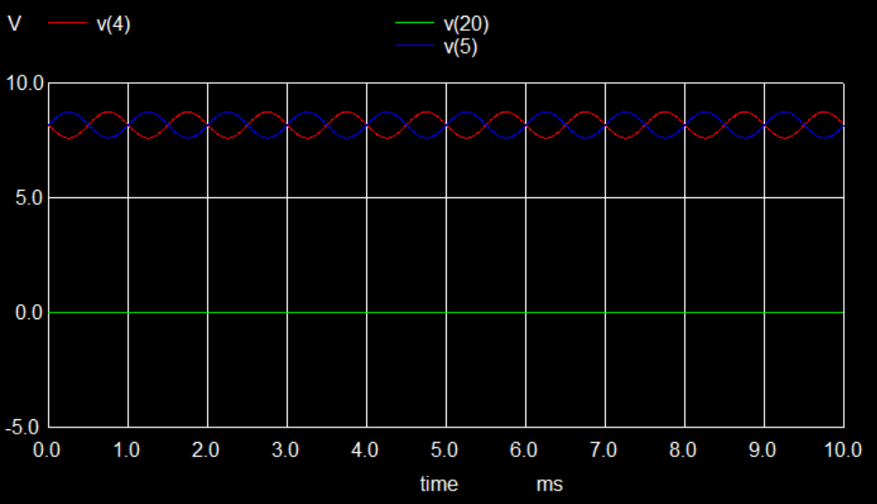

Gain Seen = 5.668392e+01  
Code used:  
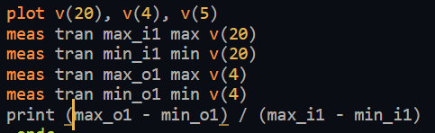

C:

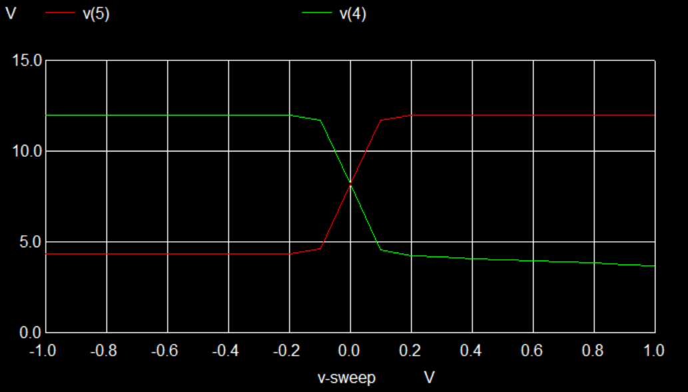

Learnings:

Vo1 and Vo2 are perfectly out of phase, and our theoretic formulae approximate the gain fairly well. There is however asymmetry in the final plot, and I don’t know the reason behind it