Sheel Shah, 19D070052, Expt5

Q1.

Code:

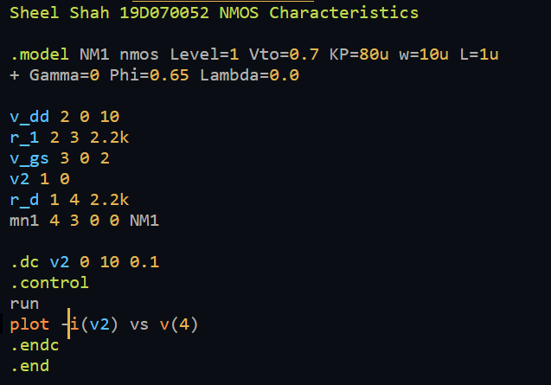

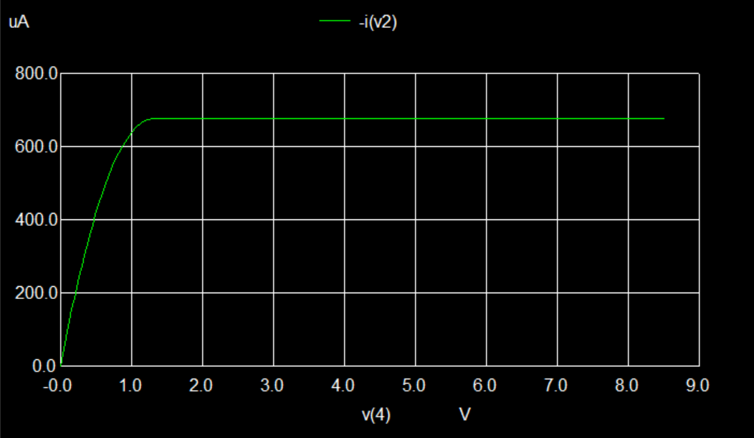

Learnings:

1. I learned about implementing NMOS models and using them in a circuit
2. I revised what the characteristic looked like

Q2.

Code:

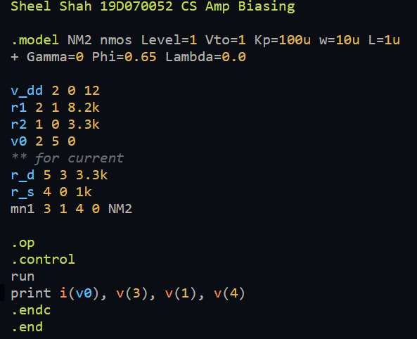

Results:

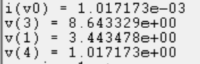

Learnings:

I looked at the biasing circuit and saw that simulation results matched fairly well with analytical ones.

Q3.  
Code:

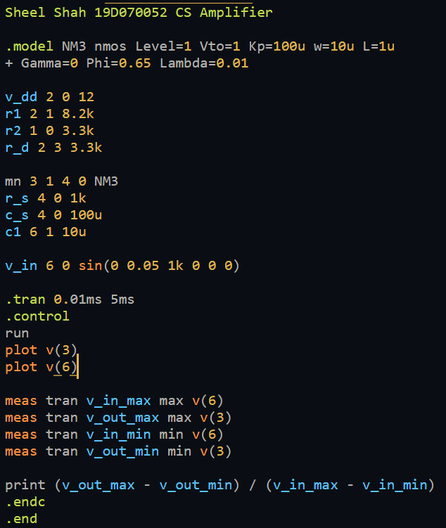

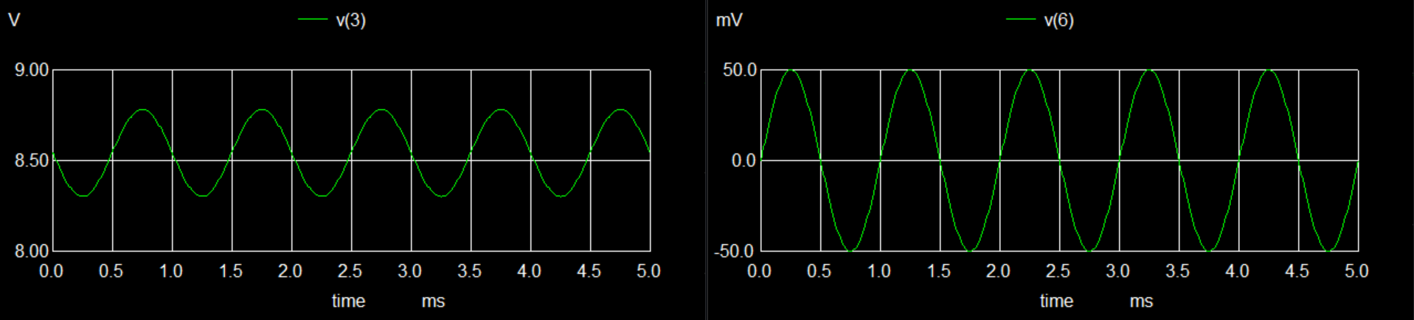

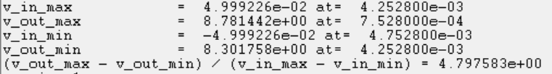

Learnings:

I understood the working of he common source NMOS amplifier and saw the gain matching well with our simulations.

Q4.

Code:

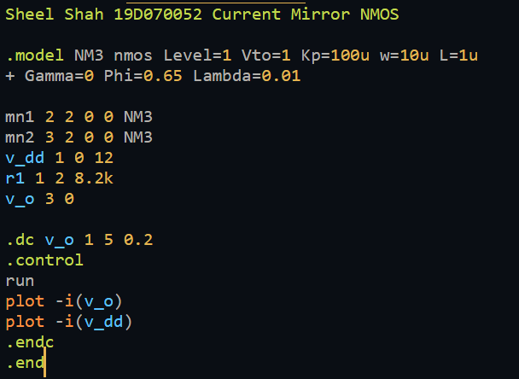

Results:

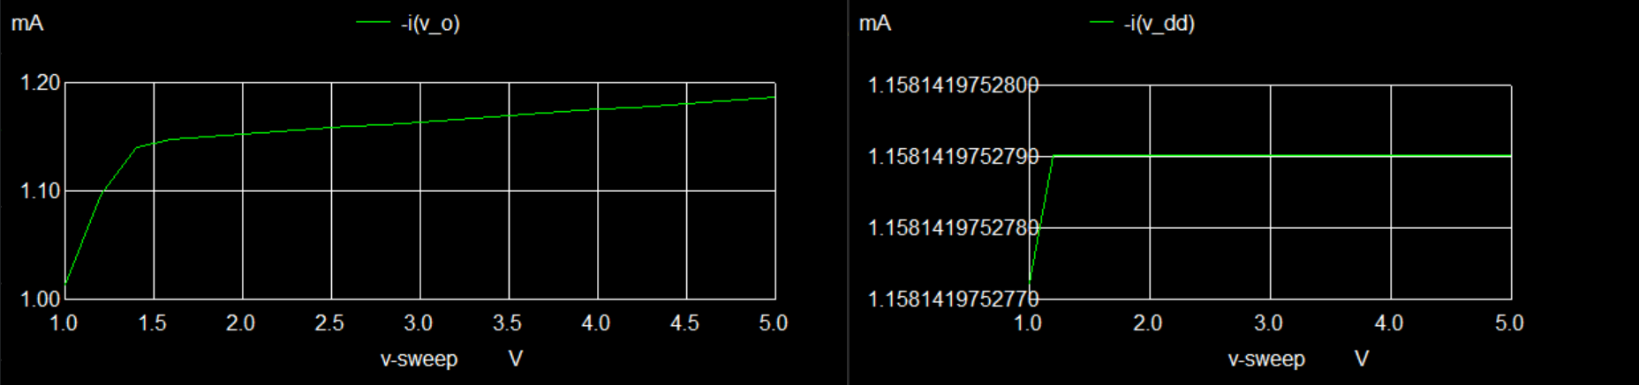

Learnings:

I learned about the NMOS equivalent of a current mirror, about its design and its implementation.