Sheel Shah, 19D070052, Expt5

Q1. Inverting Amplifier

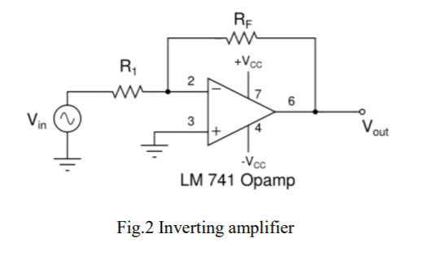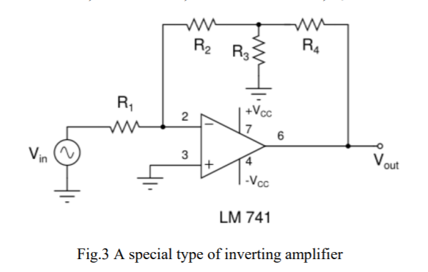

* Unique features of inverting amplifier:
  + The output is out of phase with the input and this helps improve stability and reduce oscillations.
  + The gain can theoretically be of any magnitude, and can be less than 1.
  + The output won’t clip due to common mode offset.
* Limitations of inverting amplifier:
  + Input resistance is R1, which is a major drawback.
  + The input must be noiseless, as the noise as well as the dc component get amplified, and this might lead to clipping of the output.
* Applications of inverting amplifier:
  + A summer, where the gains are independent. A summer can be used in audio systems etc.
  + The small feedback resistance can decrease distortion.
* Advantages of the special amplifier:
  + R2 need not be too large for large gains, as R3 and R4 help too.
  + We can use it as a current amplifier too, with a different gain.

Q2. Non-inverting Amplifier

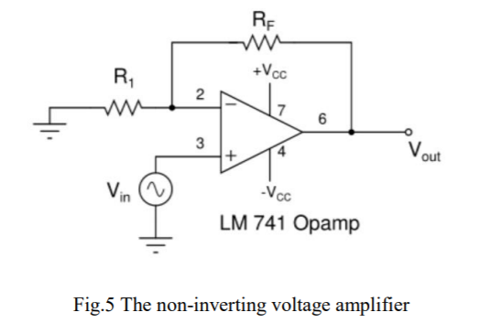

* Unique features of non-inverting amplifier:
  + The input resistance is very high, and the output resistance is very low.
  + The gain is always be positive and greater than 1.
* Limitations of non-inverting amplifier:
  + Input resistance and output resistance vary with the op-amp used.
  + Gain can’t be less than 1.
* Applications of inverting amplifier:
  + Voltage follower, due to high R_in.
  + Isolating two circuits that the op-amp is connecting.

Q3. Differential Amplifier

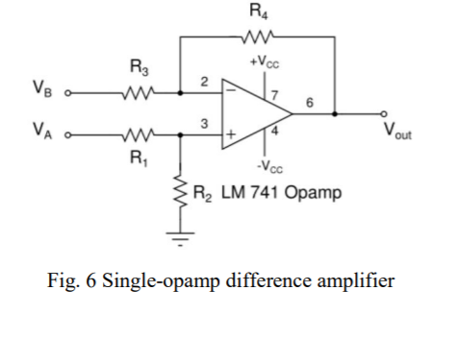

* Features of differential amplifier useful in applications:
  + If the resistances are matched, the common mode gain is very low (~0).
  + Signals with noise can be processed as common noise gets cancelled.
  + We can configure a linear amplifier very easily by passing the output in negative feedback tpo one of the inputs.
* Limitations of differential amplifier:
  + The size is large, due to more resistors and complexity
  + Input impedance is only moderately high.
  + If the resistors are not well matched, common mode amplification is seen.

Q4. Applications of Differential Amplifier

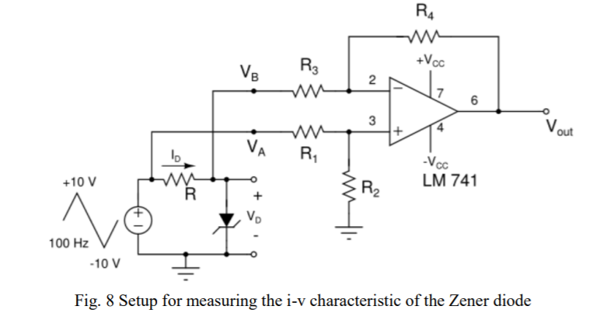

* Why is a triangular signal used:
  + We are plotting I vs V, and we want our x-axis(V) to be linear, and hence a triangular input is used.
  + If a sinusoid input is used, the IV characteristic will get distorted, and for a square input, we only see the I values for the extreme ends of the V values.
* Why is frequency low:
  + At high frequency, the op-amp might start to slew and not be exactly in sync with the I values.
* Difference in LEDS:
  + The semiconductor used is different, and the energy gap lies in the visible spectrum, unlike the Si/Ge diodes.
  + The different cutoff voltages for different colors is because of the difference in frequency of light of the different colors emitted (and hence different energy bands).

Learnings:

* I learned about the uses of different types of op-amp based amplifiers.
* I understood the pros and cons between the different types, and about what type of amp would be most suited for which application.
* I learned a ingenious technique for plotting the I-V characteristics of diodes.