**Sheel Shah**

19D070052

*Expt10*

Q1. Wein Bridge Oscillator

Code, result and circuit diagram:  
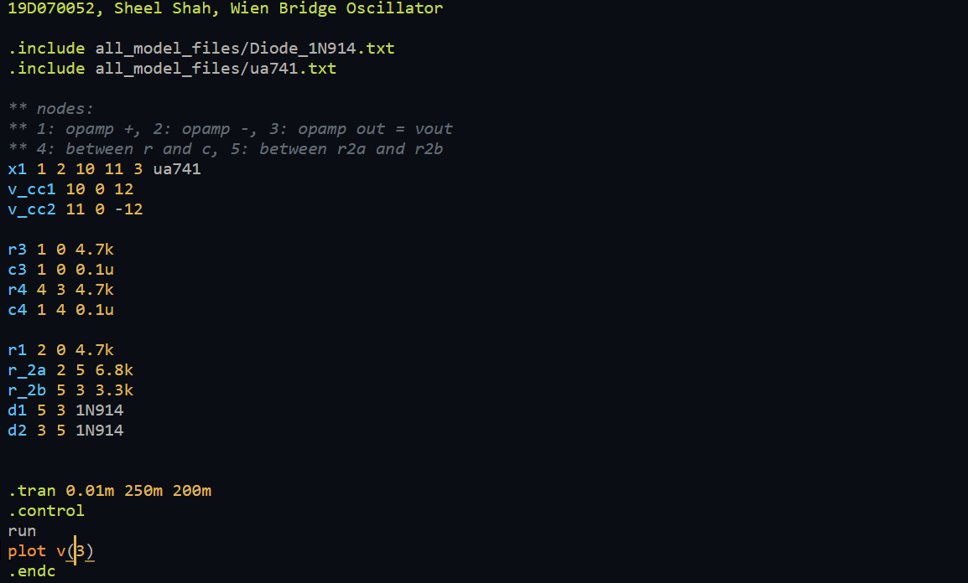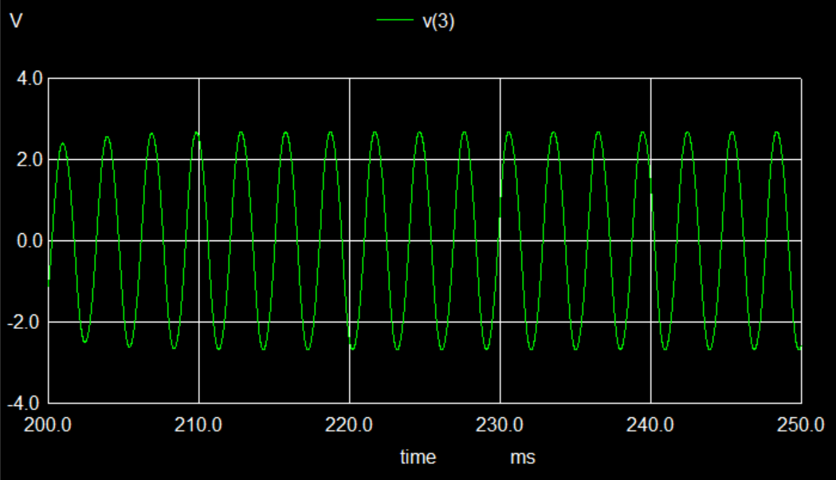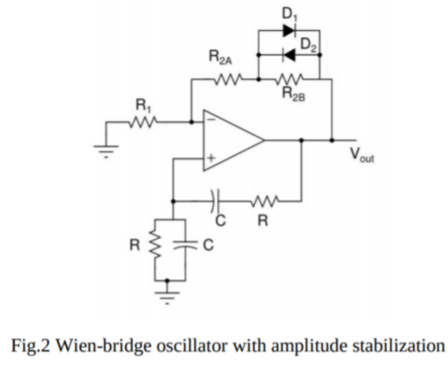

Learnings:  
I understood the basic mechanism of the Wein bridge oscillator. We have f_0 = 1 / (2piRC).

Q2. Phase shift oscillator

Code, results, and circuit diagram:  
 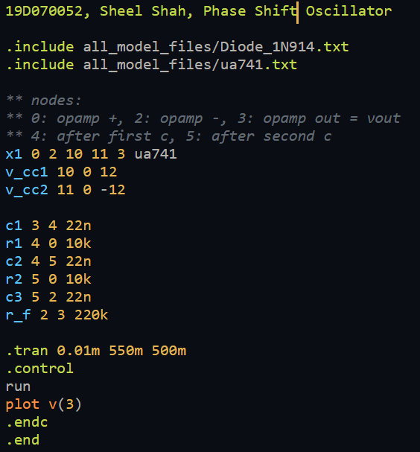  
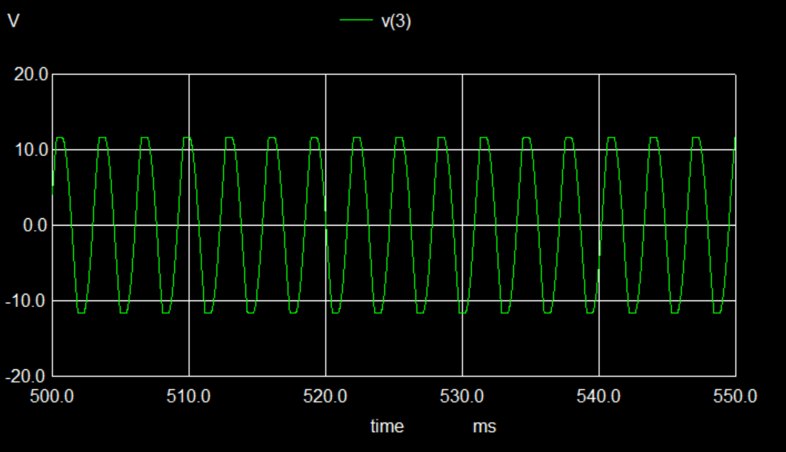 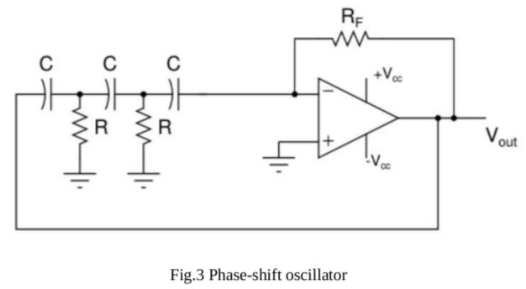

Learnings:  
I learned about the idea behind phase shift oscillator. We have f_0 = 1 / (2piRC*sqrt(6)).

Q3. Astable Multivibrator

Code, results, and circuit diagram:  
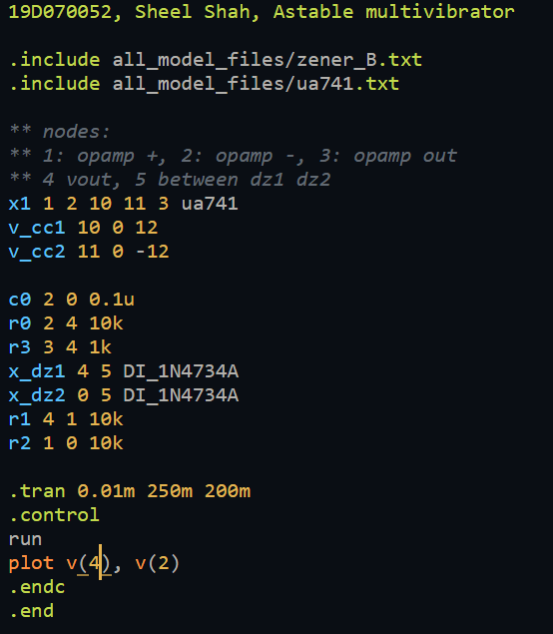  
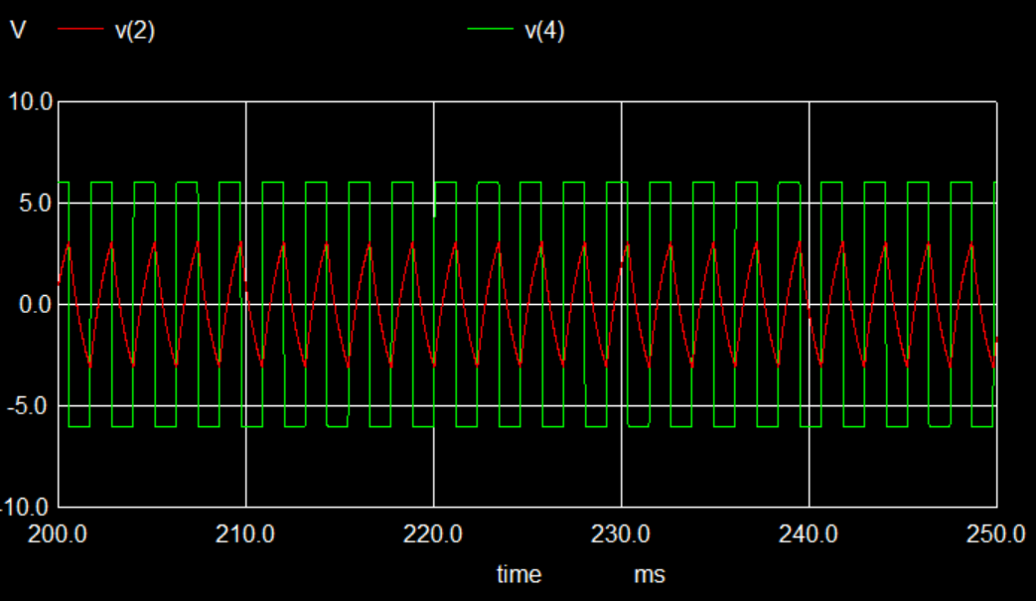 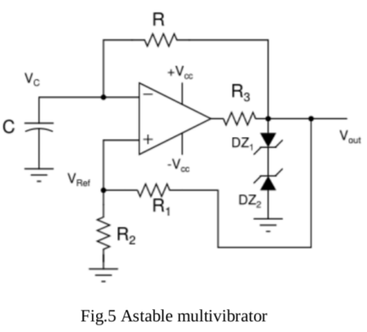

Learnings:  
I understood how the astable multivibrator works and how we can calculate t_high, t_low, and the corresponding voltage values .