**Sheel Shah**

19D070052

*Expt7*

Q1. Three Op-Amp Amplifier

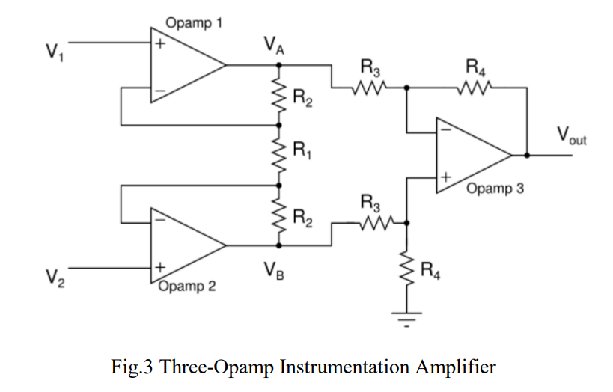

* Q1. In Sec 3.2 and 3.3, even under no-load conditions Vout was found to be non-zero. Give one or two reasons for this:
  + The reason is that the wheatstone bridge isn’t perfectly ideal. Therefore even under no load, Vout will be non-zero due to imperfectly matched resistances.
* Q2. Give two or three major advantages of the three-Op Amp instrumentation amplifier as compared to the single-Op Amp difference amplifier of Experiment 6:
  + Input resistance is much higher compared to the difference amplifier.
  + Gains of higher magnitude can be achieved.
  + In order to vary the gain, we can vary R1. This is better than vary 2 resistors in ratio, and ensuring matching as in the case of the differential amplifier.

Q2. Non-inverting Amplifier

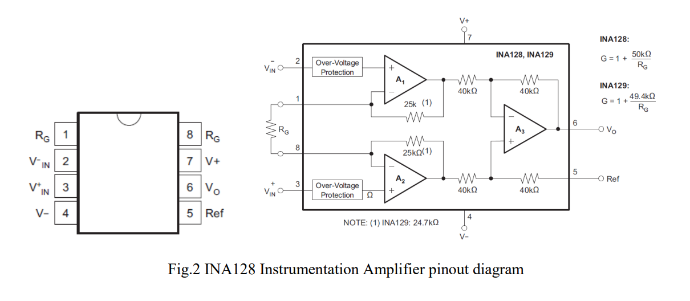

* Q3. Look at the data sheets of TL084 and INA128. Identify the major differences between these two ICs – i.e. Op Amp parameters crucial for difference amplifier applications, such as the Loadcell application discussed in this experiment:
  + Offset voltage is lower and matching is better for INA128. Hence no-load output is closer to 0.
  + The gain is larger for INA128.
* Q4. Identify one or two parameters of the INA128 that makes it superior to the TL084 based instrumentation amplifier.:
  + The offset voltage of INA128 is significantly lower than that of TL084 (50 uV vs 3mV)
  + The common mode gain is also much lower for INA128, and hence the CMRR is higher (120dB).

Learnings:

* I learned how instrumentation amplifiers are a better alternative to differential amplifiers.
* I understood the advantages of INA128 over TL084.