**Sheel Shah**

19D070052

*Expt8*

Q1. Improved half wave rectifier A

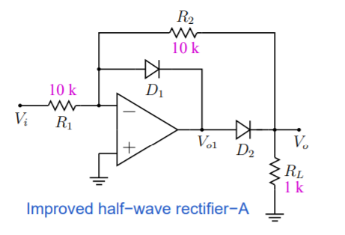

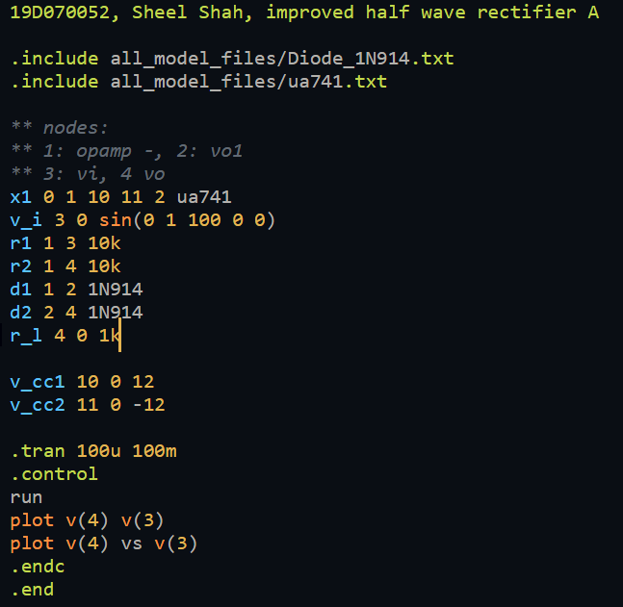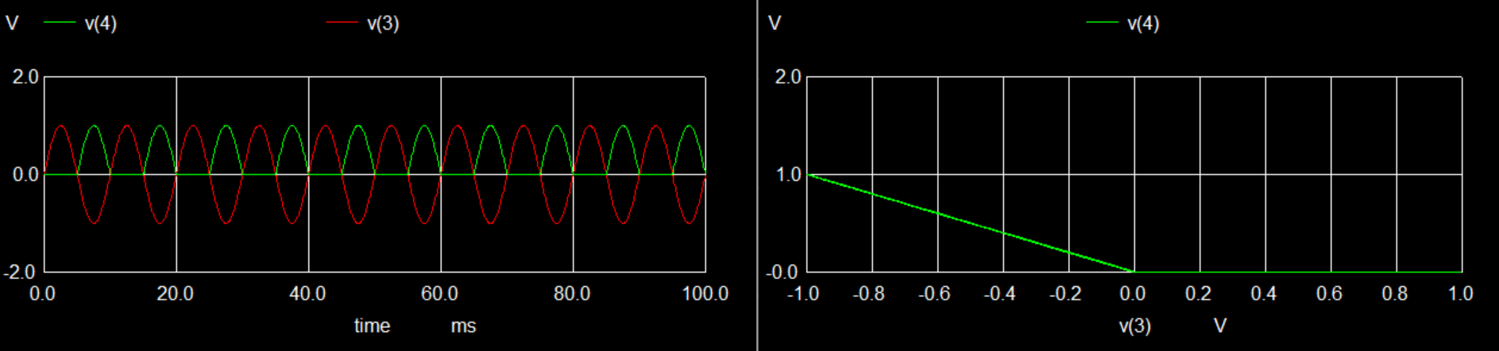

Learnings:

* The improved circuit has a better response and there is no delay when input switches from negative, as op amp is never saturated.

Q2. Full wave rectifier

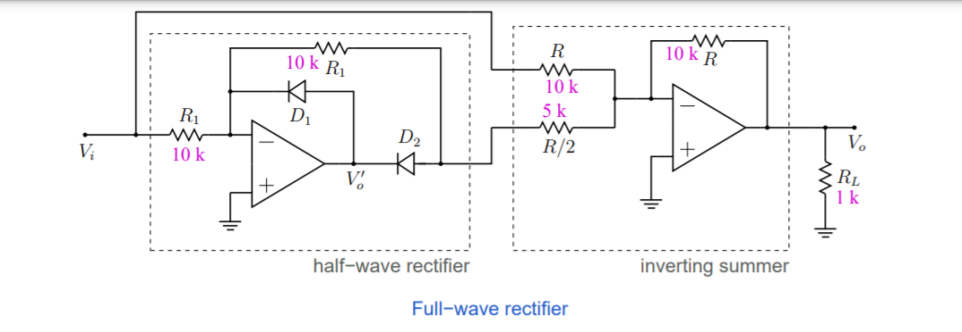

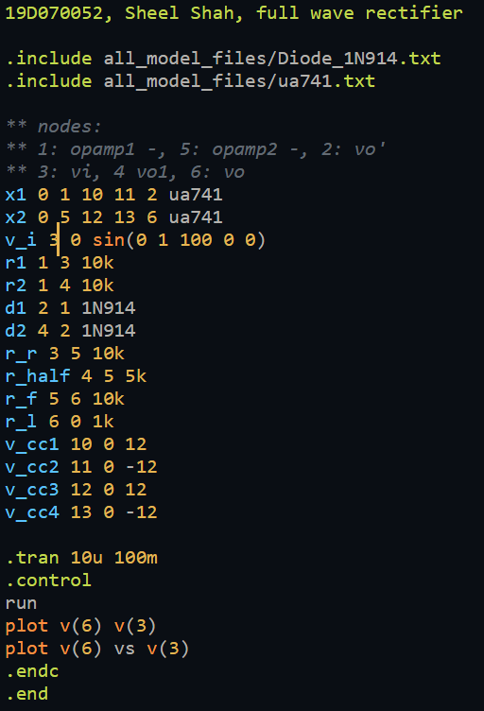

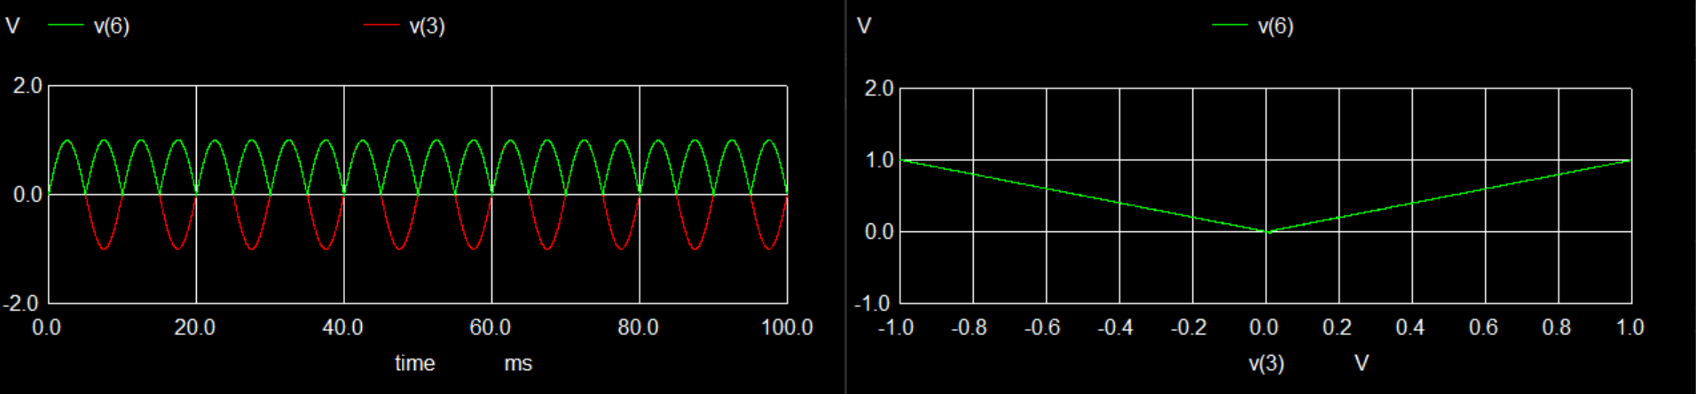Learnings:

* There is no saturation and the output is very good.

Q3. Single pole high pass filter

F_c = 1 / (2*pi1*r_a*c_a) = 338.6 Hz

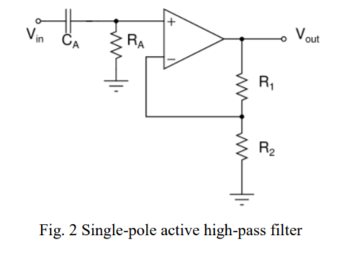

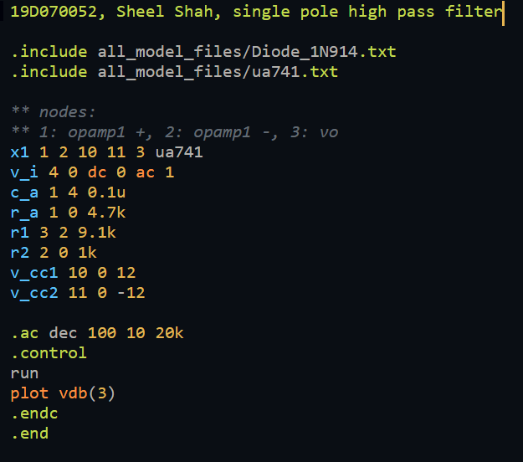

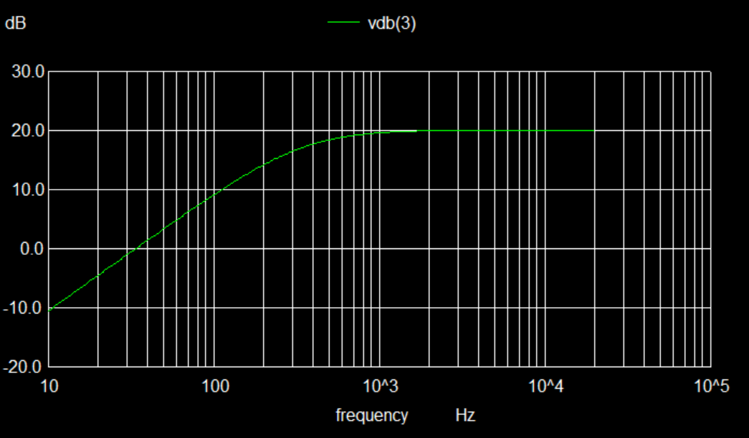

Learnings:

* Expected plot from analysis matches with the simulated plot.

Q4. Sallen Key low pass filter

F_c = 1 / (2 * pi * sqrt(ra * rb * ca * cb)) = 338.6 Hz

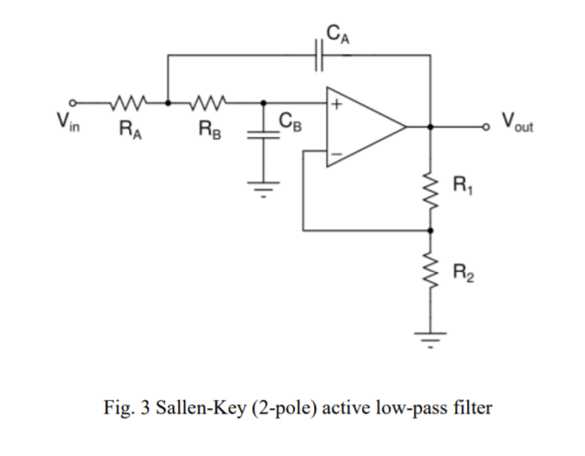

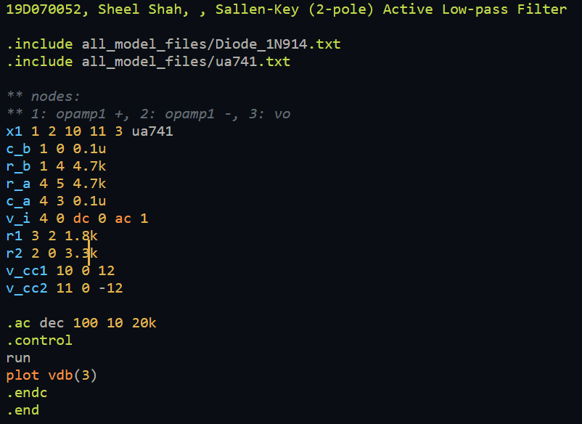

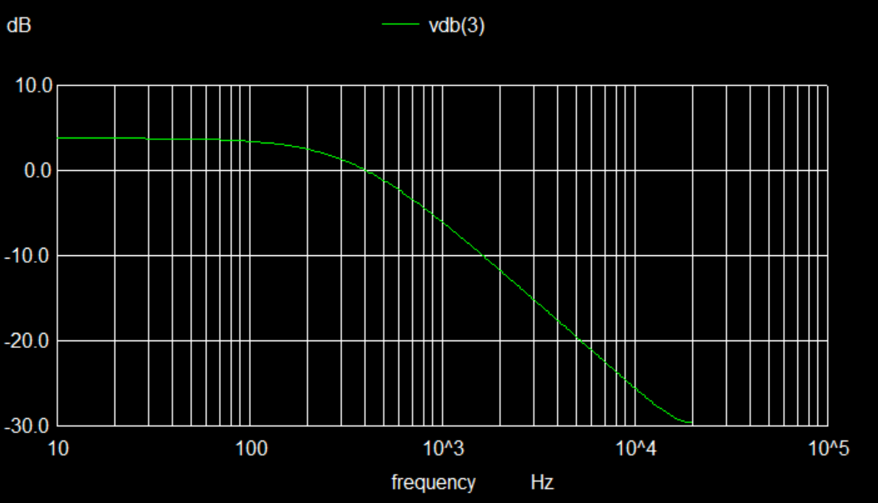

Learnings:

* Expected plot from analysis matches with the simulated plot.