**Sheel Shah**

19D070052

*Expt9*

Q1. Measuring input offset voltage

Circuit diagram:  
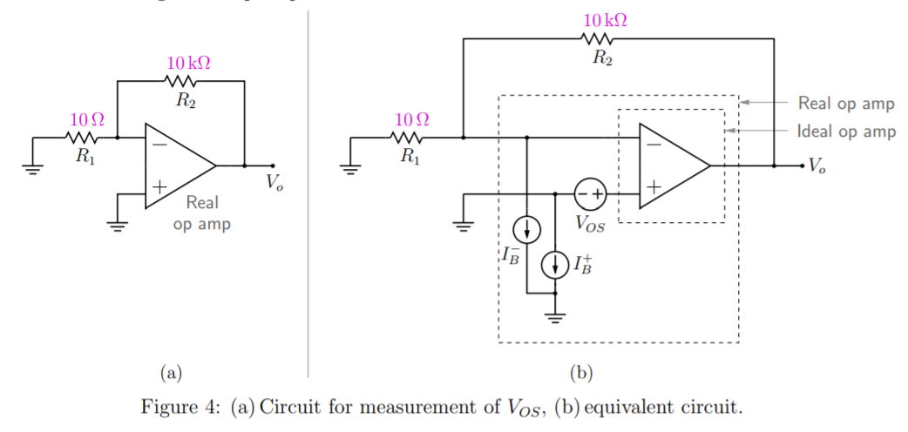

Formula obtained:  
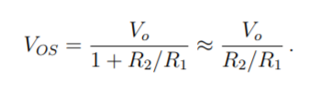

Q2. Measuring input bias current

Circuit diagrams: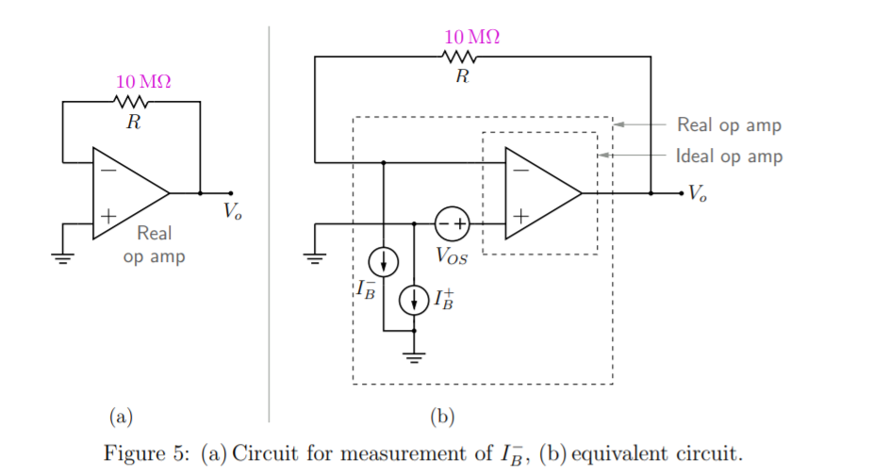  
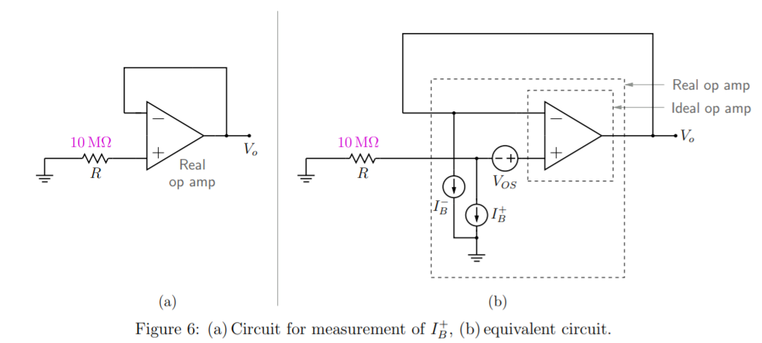

Formulae obtained:  
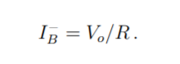  
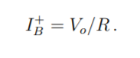

Learnings:  
The idea of inverting/non-inverting amplifiers is used perfectly to magnify the effect of exactly one imperfection, so that it can be measured.

Q3. Measuring DC open loop gain

Circuit diagram:  
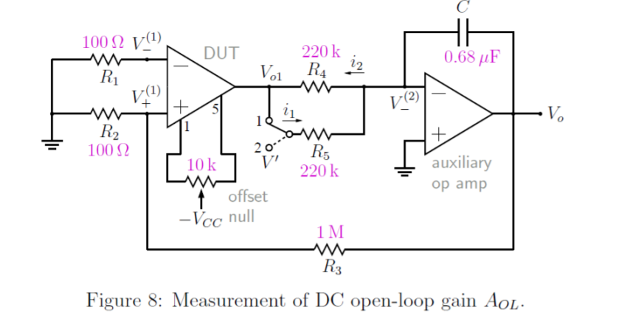

Formula for open loop gain:  
A_ol = (Vo1/Vo) * (R3 / R2)

Learnings:  
The opamp is kept in linear region via the feedback loop, and then open loop gain measurement becomes straightforward. A_ol = Vo1/V+(1)

Q4. Comparison of DC parameters

|  |  |  |  |
| --- | --- | --- | --- |
| Parameter | uA741 | LM324 | TL084 |
| Input Offset Voltage | 1mV | 3mV | 3mV |
| Input Bias Current | 80nA | 20nA | 20pA |
| Input Offset Current | 20nA | 2nA | 5pA |
| DC Open Loop Gain | 200 V/mV | 100 V/mV | 200 V/mV |