19D070052, 236 quiz1 report

Q1.
netlist in submission
plot of vout:
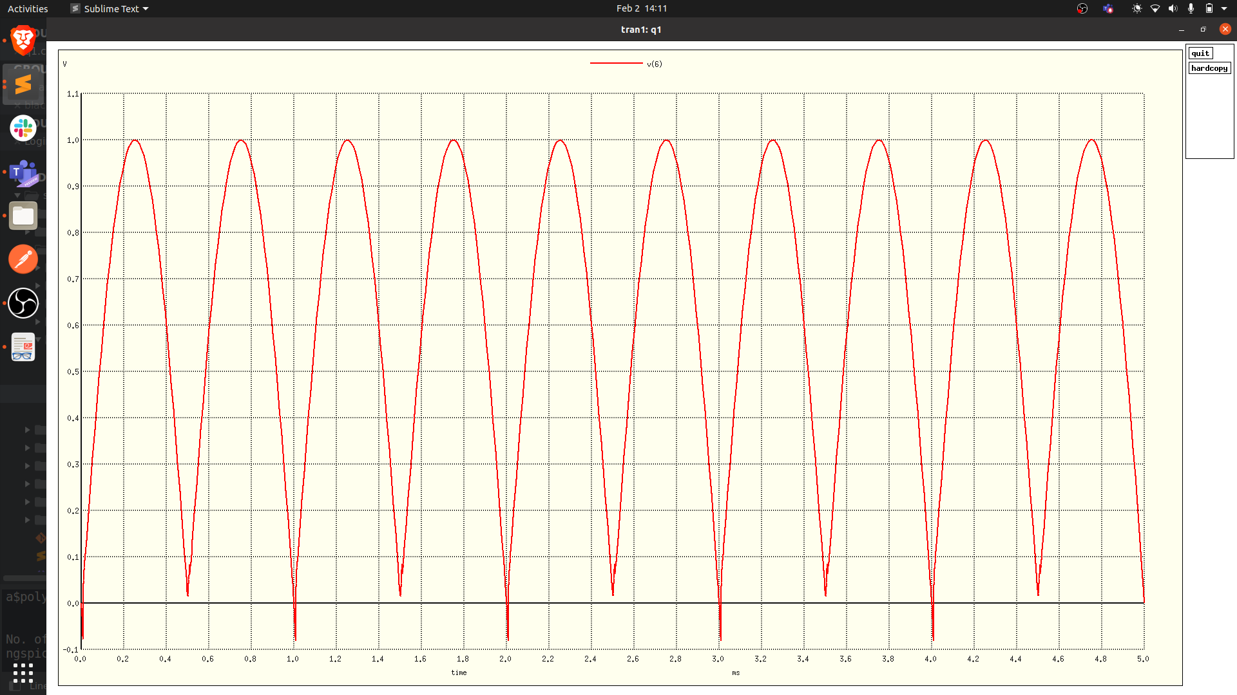
plot of vout vs vin:
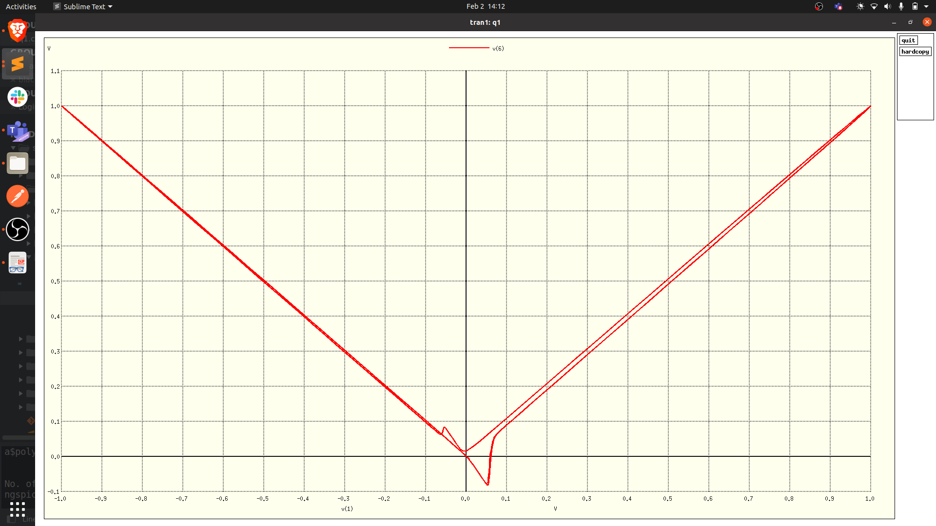
we see that v_out/v_in ratio is exactly 1 for high v_in => there is no diode drop, unlike full wave rectifier. However, there is some non-linearity close to zero => the new rectifier retains some voltage and hence v??_out isnt 0 when v_in is 0.
Q2.
plot of IV charcteristic:
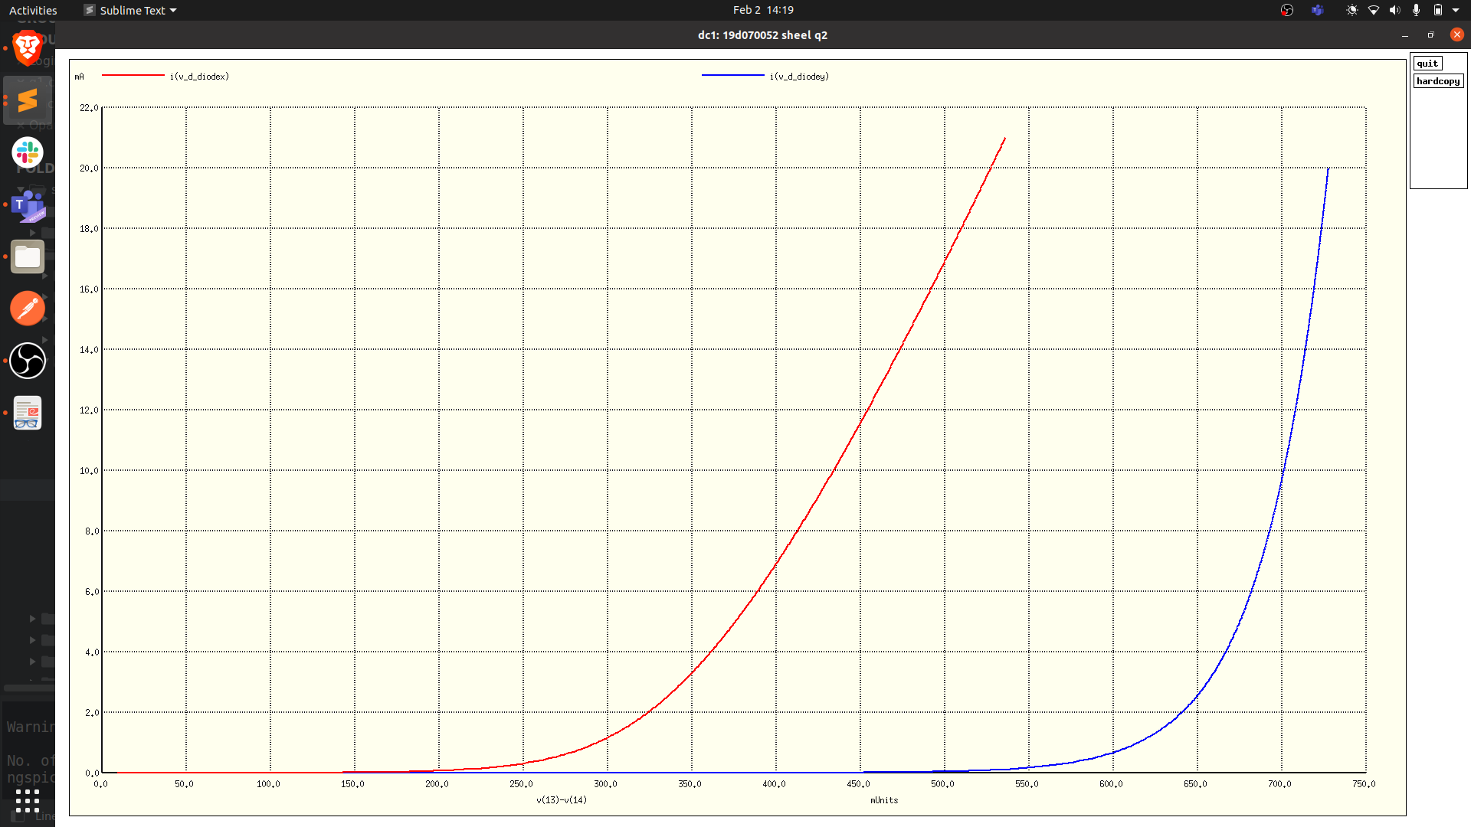
values derived using the method of lab1:
(1 is diode X, 2 is Y, eta is ideality_factor, vd is forward voltage, isat is reverse saturation current, piv is peak inverse voltage)
eta1 = 1.310782e+00
eta2 = 1.447548e+00
vd1 = 0.293
vd2 = 0.616
isat1 = 2.00004e-07
isat2 = -8.14376e-11
piv1 = -76V
piv2 = -1000V

Plots used were I vs V, ln(I) vs V, I vs V(with line at 1mA), I vs V (with large negative values for V). Since code is similar, only one has been included in submission.

Germanium diode has lower forward drop and hence can be used in rectifiers where v_out is needed to be as high as possible.

Q3.
C_dut vs |V_dut|:
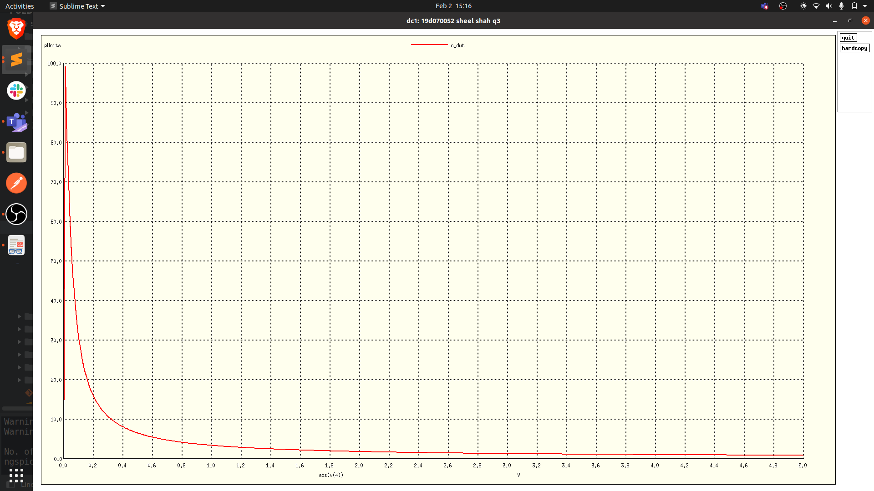
we see that the curve is like that of 1/x^2 and hence 1/c_dut^2 should be linear. This is also intuitive because c should decrease as the reverse potential is increased.

1/C^2 vs V_dut:

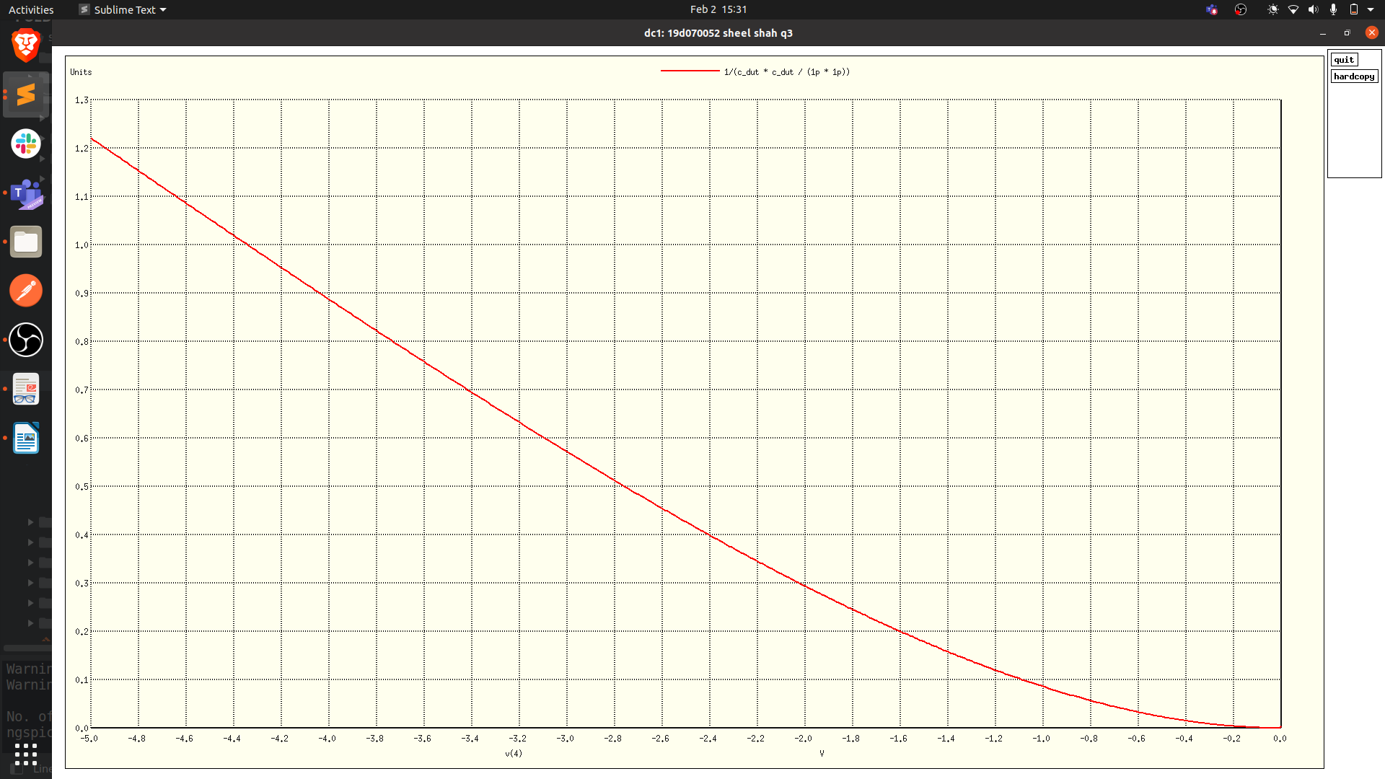
we see that it is linear
the slope is -0.32.
Comparing with equation gives Nd = 3.8 * 10^23 atoms/cm^3
Extrapolating linear region gives V_bi = -1.21 V

