Crime and Demographics in Tower Hamlets
S. Usmani 21/05/2026
Executive summary
Crime is prevalent across many geographical locations and age ranges. This study investigates two publicly available datasets to answer the following questions:
- Are certain age groups more likely to be associated with certain crimes during a stop and search?
- What is the relationship between stop and searches and crimes across different locations?
By answering these questions, local law enforcement can be informed of more efficient resource allocation.
To answer the first question, a stop-and-search dataset was explored using visualisations and k-means clustering. It was found that minors (10–17-year-olds) show a higher-than-average association with theft and a lower association with controlled drugs and weapons. The 18–34 age group shows a stronger association with weapons, whilst those aged 34+ are more associated with stolen goods and controlled drugs. However, clustering was limited by the small number of observations, so findings should be treated as indicative rather than definitive.
The second question combined an additional crime dataset with the stop-and-search data based on location. A choropleth map and scatterplot revealed a positive relationship between crime and stop-and-search activity. However, choropleth maps require visual comparison across multiple maps, which can make patterns difficult to identify.
The findings suggest that age is an important factor in crime and that preventative strategies should be tailored to specific age groups. They also indicate that stop-and-search activity generally aligns with crime hotspots, reflecting reactive policing strategies. However, data limitations reduce confidence in the strength of these conclusions.
Law enforcement could improve outcomes through age-specific interventions, such as theft prevention programmes for minors. The effectiveness of increasing stop-and-search activity in crime hotspots should also be evaluated.
Future work should apply clustering methods better suited to categorical data and incorporate socioeconomic and behavioural factors. This could help transform stop and search from a reactive approach into a predictive prevention system that more effectively reduces crime.
(309 words)
Aims and Objectives
This study is aimed at local law enforcements. Specifically, the study aims to answer:
- Are certain age groups more likely to be associated with certain crimes during a stop and search?
- What is the relationship between stop and searches and crimes across different locations?
The value of the findings lie in an improvement in resource efficiency, including targeted interventions. By combining the two datasets on location and outcome, we can examine crime distribution and law enforcement activity at an area level. Additionally, the data sets’ structure supports aggregation which makes them suitable for visualisations.
Background to the investigation
One of the justifications for stop and search are drug offences. However, the efficiency of this method is questionable. Bradford and Tiratelli (2019) concluded that an investigative measure such as stop and searches cannot prevent crime, albeit having a minor effect. They argue that some law enforcements can manage by carrying out fewer searches, so what is the need for other forces to execute so many? In this study we will focus only on relationships and correlations between crimes and stop and searches, not causation. However, Bradford and Tiratelli (2019) support the idea of reorganising resources as suggested in this study.
Targeted interventions is a method used to prevent crime in certain groups. Heller, et al. (2013) found that with mentoring, activities and cognitive behavioural therapy, children from disadvantaged backgrounds, living in neighbourhood with high crime rates, had a reduction of 44% violent-crime arrests. This emphasises the importance of providing tailored programmes for minors for the prevention of future crimes. Additionally, Hazebroek et al. (2025) argues that children with early delinquency develop offending habits that persist into adulthood. Therefore, identifying patterns in specific age groups through stop and search data is valuable, as it allows police and local authorities to provide intervention earlier and tailor programmes to the needs of different groups. If minors are disproportionately associated with crimes, targeted support may help prevent criminal behaviour from becoming habitual over time.
Scope and sources of data
Both datasets used in this investigation were obtained from the publicly available UK Police Database, under the Open Government Licence v3, under which, I am free to:
- ‘copy, publish, distribute and transmit’ the data
- ‘adapt’ the data
- ‘exploit’ the data, including ‘combining’ with other information
However, the source must be ‘acknowledged’ by providing a link to both the source and license. For both mentioned, see the Reference list.
We also require a set of boundaries of London’s Lower Super Output Areas (LSOAs). We reuse the boundaries from TMA02.
In this investigation, we manipulate and adapt data available to portray a result and combine it with another dataset, which is in line with the above restrictions.
All data provided in the datasets have been anonymised. Locations have been approximated, dates have been truncated, categories of crimes have been mapped to broader categories, and ages appear as age groups. However, the information from both datasets could be used to potentially match individuals in local papers or magistrate records and identify them. This leads to ethical concerns of loss of privacy. There is also the risk of stereotypes being reinforced if data is interpreted without context. Successful reidentification of individuals could lead to a loss of trust in data providers and law enforcement agencies.
However, the likelihood of reidentification is low. This is because police-recorded crime data is difficult to track through the Criminal Justice System. As a result, criminal justice agencies rely on ‘fuzzy matching’ (Home Office, no date) to link police records to court outcomes. Therefore, after anonymisation, it would be extremely difficult to match records from these datasets to magistrate records.
In conclusion, the analysis of the proposed questions is legal and ethical, given that the results are not used to infer identities or judge individuals.
The analysis pipeline
To start off, data was imported in-memory using the provided API and cleaned. Empty or null values were removed, along with all unnecessary data. Many columns were to be normalised. That is, columns containing columns were separated. For both datasets, cleaning did not affect the number of rows.
A file-based CSV storage system was used to store the data. This provides a simple and efficient solution for an unchanging dataset.
Age Groups, Crimes and Searches
We start with 422 rows in the dataset.
A representation of the data was required in a form where all age groups had a count of each item they were searched for. To obtain a representation like this, age ranges were grouped and columns for each object of search were counted. The category ‘Evidence of offences under the Act’ was removed as it may refer to crimes that could belong to other categories. This produced a dataset containing 4 rows.
Crimes, Searches and Locations
The crime dataset contains 3421 rows.
The stop and search dataset must be combined with the crime dataset on location and outcome. Although it does not seem rational to join on outcome, this is done to ensure that crimes related to drugs are joined with searches related to drugs.
Before joining the two datasets, summing the number of crimes and searches is sensible. This is accomplished by grouping by location and outcome whilst summing the number of crimes and searches in the individual datasets. After grouping and summing, the individual crimes and searches datasets are left with 1221 and 257 rows respectively. After merging the datasets, we obtain one dataset with 1347 rows.
To create a choropleth map, the individual locations of crimes and searches must be mapped to a LSOA. This is achieved by firstly identifying the LSOA of a point, then adding the required boundaries for correct geographical mapping.
Findings
Age Groups, Crimes and Searches
Before performing analysis methods, we use visualisations to understand the data.
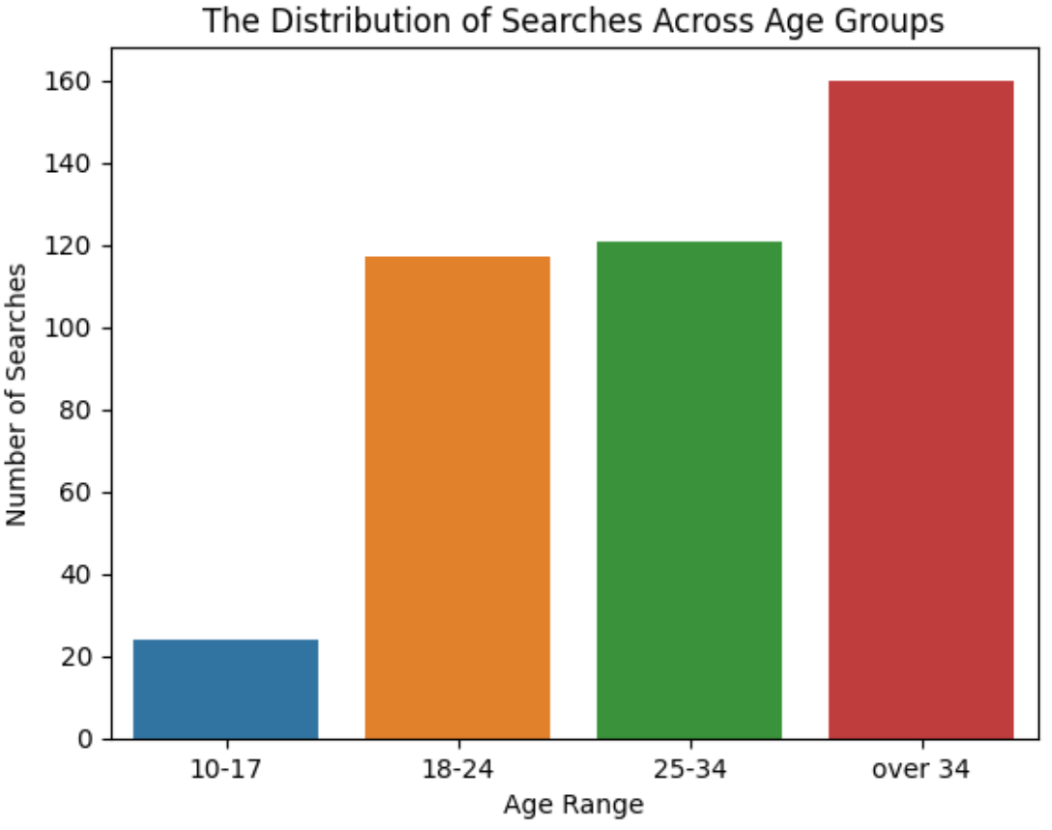
Figure 1: a bar chart showing the distribution of stop and searches across different age groups.
Figure 1 shows that more data is available for over 34s compared to 10–17-year-olds. Although the small number of observations for 10–17-year-olds may affect the results of the study, this may reflect the real-world context, where minors are searched less frequently than adults. Hence, the smaller dataset for minors is expected and should not significantly distort the overall results.
The data was used to perform k-means clustering to identify hidden categories within the dataset. K-means clustering calculates distances between points and groups them into a chosen number of k clusters. For this investigation, grouping between different age ranges was analysed, meaning the aggregated age-group dataset was used as input to the model. The StandardScaler function was applied to ensure all features were comparable, improving the performance of the k-means algorithm. The scaled results were also used to create a heatmap, which is useful for identifying patterns in the data.
This analysis assumes that the stop and search records are representative of actual policing activity and that the age ranges provided are detailed enough to capture meaningful differences between groups. It is also assumed that the categorisation of searched items is applied consistently across all observations.
After applying k-means clustering, it was found that three clusters were optimal for grouping the age groups. This was supported by the silhouette score, which measures how similar a point is to other points in its cluster. Although the silhouette score for 10–17s and over 34s is zero, this is because these points form their own clusters. That is, each cluster consists of a single point.
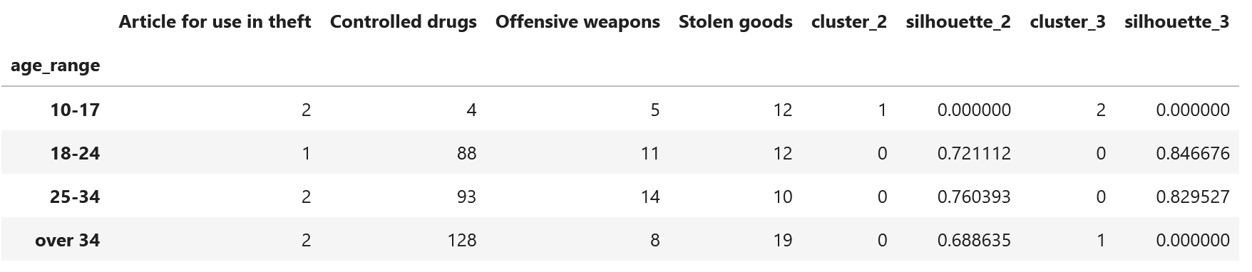
Figure 2: Cluster classification of searches by age group.
Using k=3, we find that the age ranges 18–24 and 25–34 are grouped within the same cluster. This indicates that they are searched for similar categories of crime, whereas 10–17 and over 34s form individual clusters. This suggests that these age ranges are associated with different search patterns and offences. This implies that stop and search activity is not uniform across all age groups, but instead reflects distinct behavioural profiles depending on age. However, clustering cannot reveal causation or explain the reasons for these patterns. Complex behaviour is simplified into groups, meaning variation between individuals is lost.
To understand the searches associated with these groups, the centroids of the clusters are examined. The centroids help identify which cluster is more strongly associated with each feature.
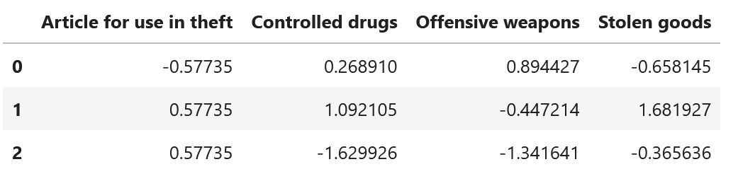
Figure 3: Centroids of the clusters in Figure 1.
From the table above, 10–17-year-olds (cluster 2) have a greater association with theft, and the least association with drugs. 18–34-year-olds (cluster 0) have a stronger relation with weapons and the weakest relation with stolen goods. Over 34s (cluster 1) have the strongest relation to drugs and the weakest relation to weapons. However, because the data was anonymised and put into ranges, k-means has only four rows to work with. This has impacted the results as the algorithm has very few data points, reducing the accuracy of the clustering and increasing the likelihood of patterns being overly simplified.
These findings are further supported by the following heatmap. Note that the heatmap treats each age range individually, which may lead to some mismatch between results of clustering and the following visual.

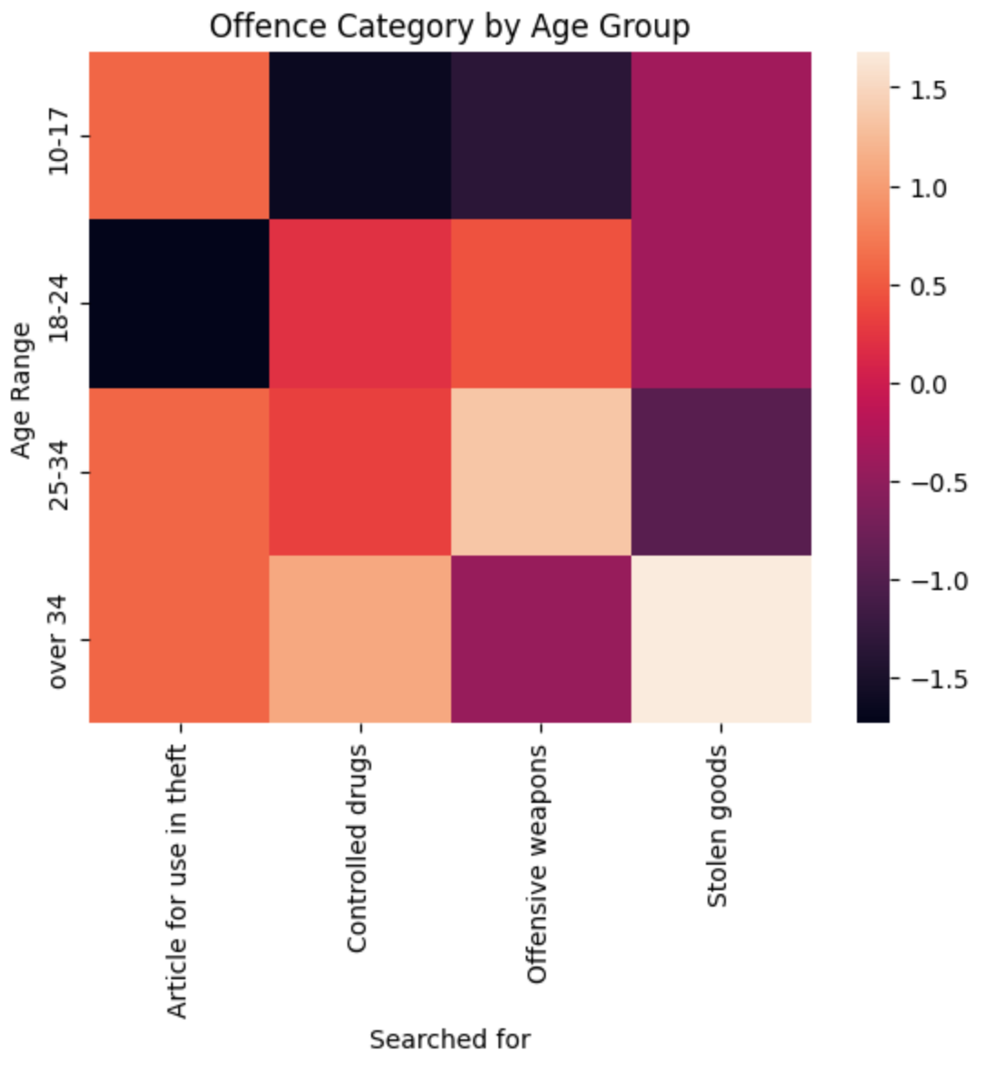
Figure 4: A heatmap of searched items by age group
The above heatmap displays similar results as k-means clustering. However, k-means clustering grouped together 18–25s and 25–34s, causing the correlation values to be an average of both groups. The heatmap above shows that both groups have the greatest association with offensive weapons, however, different least associations. 18–24-year-olds have the weakest relation with items used in theft, whereas 25–34-year-olds have the weakest relation with stolen goods. This heatmap also reveals another disadvantage of using k-means clustering in this context. Grouping already-grouped data results in losing variation between groups. However, this was the consequence of anonymising personal information, which could not have been avoided.
Now, we discuss some confounding factors. Some confounding factors include:
- Population demographics: age groups may not be equally distributed across areas. For example, there may be more people ages 18–34 in areas where stop and searches are common. This suggests that the analysis may not account for the population demographics of each age group. That is, if a large portion of the population falls within a specific age group, the age group will naturally appear more in stop and searches. This has a significant impact on the results, as it may lead to overestimating the associations between age groups and stop and search categories.
- Socioeconomic factors: unemployment, education and income levels may influence crimes and stop and searches. These factors influence both likelihoods of involvement in crime and stop and searches. Hence, the associations found above may be explained by socioeconomic factors, rather than age. However, as findings have been presented as associations rather than cause, the effect of this factor is reduced.
Therefore, the findings provide evidence of associations between age groups and stop-and-search categories, but the limited number of observations and potential confounding factors reduces accuracy in drawing definitive conclusions.
Crimes, Searches and locations
Before performing analysis methods, it is important to investigate the distribution of the data and identify outliers. However, in the case of crime and location, it is likely that some areas will have a larger number of criminal offences compared to others. Therefore, we will not explore any outliers.
This analysis assumes that the anonymised locations are geographically representative of the areas in which incidents occurred.
The choropleth maps produced after the analysis described earlier are shown below.
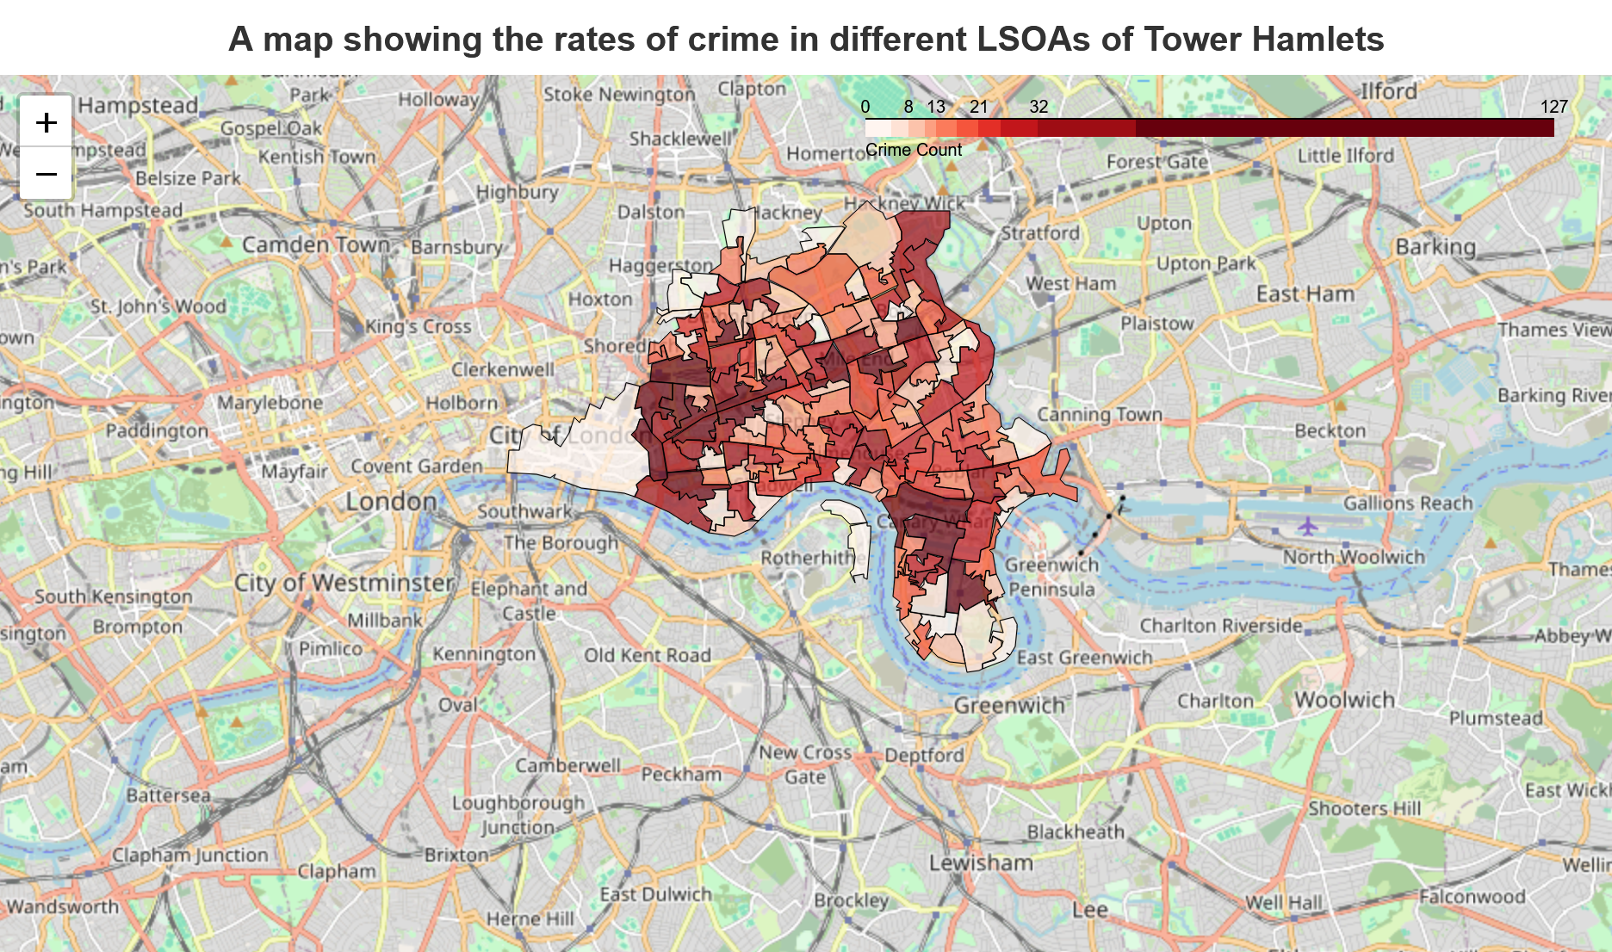
Figure 5: a map showing the rates of crime in different LSOAs of Tower Hamlets, London.
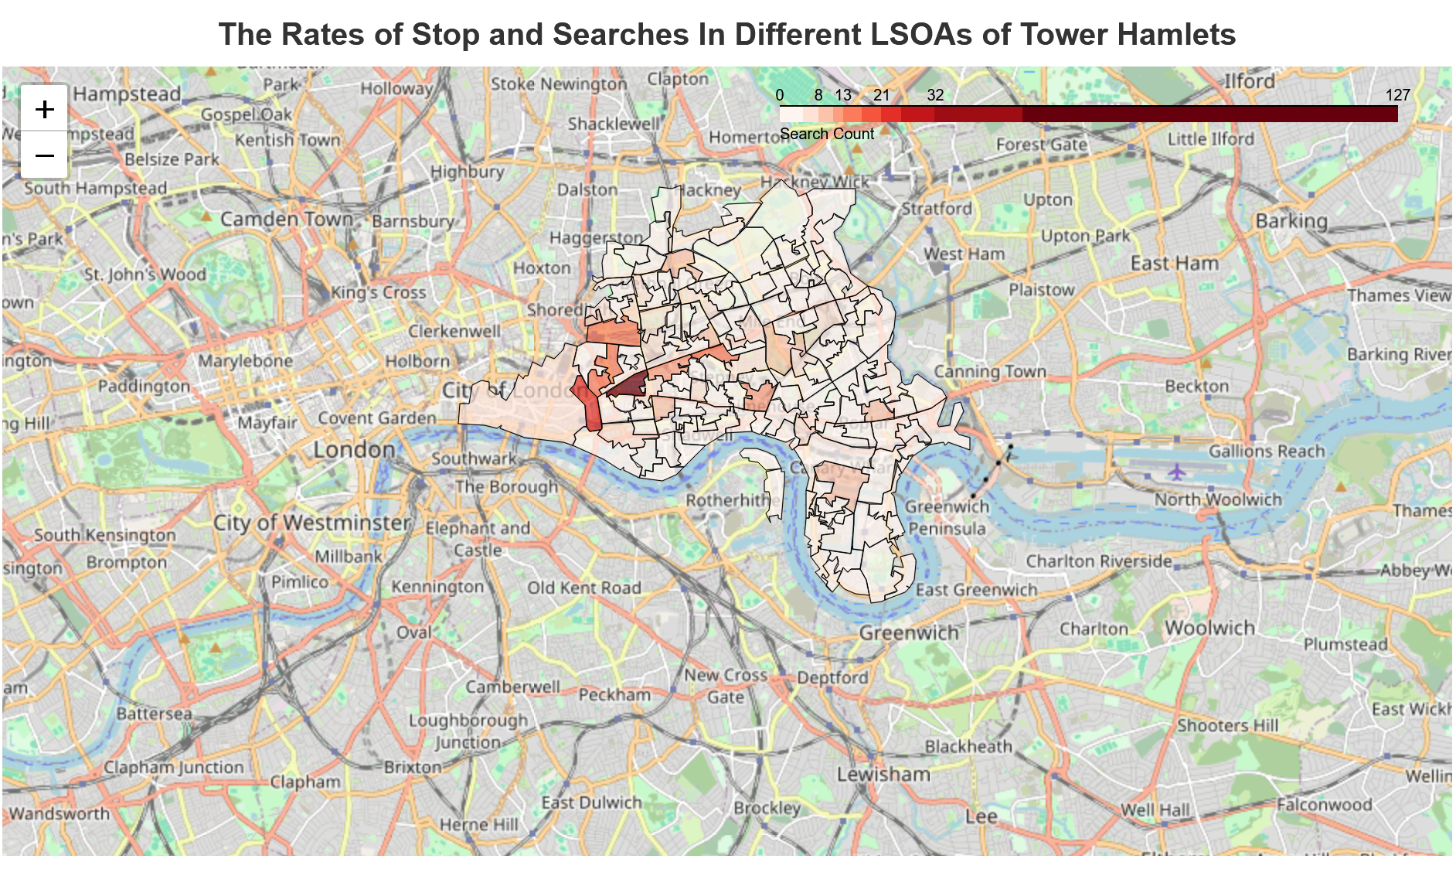
Figure 6: a map showing the rates of stop and searches in different LSOAs of Tower Hamlets, London.
By using deciles as intervals for the intensity of the rates, we can visually compare which areas have a greater concentration of activity. This allows patterns of high and low incidences to be identified clearly across the different regions.
The maps above show a positive correlation between crimes and stop and searches. This can be seen from the dark-red colour on the stop and searches map corresponding to high rates of crime in the same areas. Areas with low rates of crime also report low rates of stop-and-searches.
This is further supported by a plot of crime and search counts.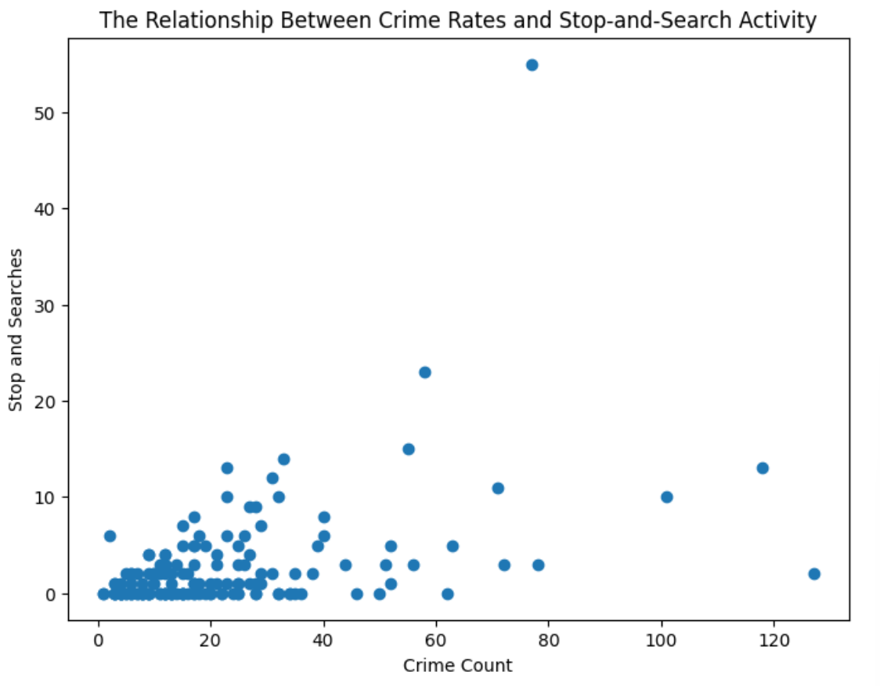
Figure 7: a scatterplot showing the relationship between crime rates and stop and search activity.
Using the scatterplot above, there is some positive correlation between searches and crime counts. This supports the idea that law enforcements used reactive strategies for stop and search.
Now, we discuss some confounding factors. Some confounding factors include:
- Population density: an area with a greater population density will have more opportunities for crime and will also increase the likelihood of stop and searches. The study does not account for differences in population density across locations. As a result, the positive relationship observed may be explained by population density rather than a direct relationship between the two variables. This significantly impacts the findings as the two variables increase without a direct relation to one another.
- Reporting rates: some areas may report crime more frequently than others, which can affect crime statistics. This means that recorded crime does not fully reflect crime levels in all areas. Hence, the relationship found may be distorted as differences in reporting could strengthen or weaken the relation between the two variables.
Therefore, while the analysis identifies a positive relationship between crime and stop-and-search activity across locations, confounding factors mean the strength of this relationship should be interpreted with caution.
Conclusions and recommendations
Despite the limitations and confounding factors, the findings provide useful insights that can help law enforcement understand patterns within crime and stop-and-search data.
Rather than applying uniform enforcement across all age groups, the clustering results suggest that age groups should be divided into behavioural profiles. This enables more focused preventative strategies, effective resource allocation, and evidence-based policing decisions.
Using the choropleth maps, local law enforcement can:
- Allocate resources to crime-heavy LSOAs
- Evaluate whether searches in high-crime areas lead to positive outcomes
- Reduce searches in areas with consistently negative outcomes
- Combine policing tactics with social and youth outreach programmes
- Use targeted interventions to prevent antisocial behaviour

Future work should investigate deprivation and income levels, as these factors may influence both crime and stop-and-search activity. Areas identified as high risk could then receive targeted interventions, such as youth programmes and community clubs.
Technical reflection
Both datasets were stored as CSV files and extracted into in-memory pandas DataFrames. A file-based system was preferred due to its simplicity and suitability for a small, static dataset. Alternative systems, such as MongoDB, require additional configuration and maintenance, introducing unnecessary complexity and resource use.
Now, we discuss the limitations of the data. After researching, I found that some records may be duplicated. However, it would not be possible to reliably identify and remove all duplicates. It would also be unsuitable to remove all duplication, as some crimes may genuinely have occurred at similar locations and times. Therefore, the results should be interpreted with a degree of scepticism.
Additionally, the location accuracy of recorded crimes before anonymisation is 60–97%. After anonymisation, this accuracy is reduced, making the precision of location data questionable. However, this study focuses on broader geographical areas rather than individual points, reducing the impact of imprecise location records.
Furthermore, the British Transport Police does not record outcome data for many incidents. This may affect the results, as the dataset lacks outcomes for a significant number of observations, creating potential gaps in the analysis.
Despite these limitations, it is assumed that the data provides a reasonably accurate representation of real-world crimes and outcomes and is sufficient to identify general patterns and trends.
When combining the datasets, I found that crime outcomes differed from stop-and-search outcomes. To address this, a universal outcomes list was created. Five outcomes matched directly, while the remainder were grouped under the broader category of ‘court’, as all relate to the justice system.
After standardising the outcomes, I attempted to merge the datasets. However, the default merge excluded locations where crime or search counts were zero. Therefore, an outer merge was used.

Reference list
Home Office (2024) Police stop and search data. Police.uk. Available at: https://data.police.uk/api/stops-street/date?2024-01/poly? 51.536508,-0.021129:51.507804,0.005502:51.508336,0.004562:51.505108,-0.005711:51.487091,-0.008352:51.487045,-0.010779:51.489810,-0.024926:51.502368,-0.029234:51.509395,-0.045493:51.502902,-0.061207:51.506404,-0.073998:51.505460,-0.074663:51.521512,-0.078529:51.535532,-0.062434:51.543330,-0.016550 (Accessed: 1 June 2026).

Home Office (2024) Police outcomes data. Available at: https://data.police.uk/api/outcomes-at-location?date=2024-01&poly=51.536508,-0.021129:51.507804,0.005502:51.508336,0.004562:51.505108,-0.005711:51.487091,-0.008352:51.487045,-0.010779:51.489810,-0.024926:51.502368,-0.029234:51.509395,-0.045493:51.502902,-0.061207:51.506404,-0.073998:51.505460,-0.074663:51.521512,-0.078529:51.535532,-0.062434:51.543330,-0.016550 (Accessed: 1 June 2026)
Home Office (No date) Available at: https://data.police.uk/about/#quality (Accessed: 1 June 2026)
The National Archives (2016) Open Government Licence for public sector information, version 3.0. Available at: https://www.nationalarchives.gov.uk/doc/open-government-licence/version/3/ (Accessed: 1 June 2026).
Bradford, B., Tiratelli, M. (2019) Does stop and search reduce crime? London: Centre for Crime and Justice Studies. Available at: https://www.crimeandjustice.org.uk/sites/default/files/Does%20stop%20and%20search%20reduce%20crime.pdf (Accessed: 1 June 2026)
Heller S., Pollack H., Ander R., Ludwig J. (2013) Preventing Youth Violence and Dropout: A Randomized Field Experiment National Bureau of Economic Research. Available at: https://www.nber.org/papers/w19014 (Accessed: 1 June 2026)
van Hazebroek, B.C.M, van Domburgh, L., Blokland, A.A.J., De Keijser, J.W., Popma, A., Wermink, H.T. (2025) ‘A Test of the Dual Taxonomy Explanation of Life-Course-Persistent Offending: Individual Risk, Social Bonds, and Within-Individual Change in Delinquency in Children With Early Police Contact’ Criminal Justice and Behaviour, 52(11) Available at: https://journals.sagepub.com/doi/10.1177/00938548251350120 (Accessed 1 June 2026)

Appendix: Notebooks and data
Cleaning_Data_EMA.ipynb
Data_Investigation_Q1.ipynb
Data_Investigation_Q2.ipynb
Crimes_and_outcomes.csv
Stop_and_search.csv
LSOA_Dec_2011_Boundaries.geojson

Final word count of report sections: 2999

