Chapter 1
INTRODUCTION
Food, clothing, and housing are the primary requirements of life. The availability of these requirements increases the physical efficiency and productivity of the people. So housing is a factor of prime importance in human resource development. At one point in life, everybody has to deal with the housing dilemma. For many people housing is one of the major investment of their life, people pay their fortune to buy the dream house.
Housing for All by 2022 project by Union government pushes the investment towards an affordable housing. Government policies like the Real Estate Regulatory Authority (RERA) have influenced fresh buyer condense into the real estate sector. First-time home-buyers are finally making purchase decisions for homes that meet their budgets. The availability of cheap nance is also driving the demand for a portable housing. It might seem strange that massive demand and massive unsold residential inventory can co-exist, but this is the result of pricing mismatch. Day by day the gap between massive demand and massive unsold residential inventory is increasing considerably. Price of the house can’t be known to a buyer since it renders taking into account many features which is too complex and time-consuming. This works as an advantage to the agents and they manipulate the price and increase their own profits. The home buyers are exploited, as their investments are ruined. Thus creating a fear in the peer of buyers, that buying a house is a risky decision. Then, in turn, the houses of the developers are unsold in the market. Hence a great market is turned into a bad market because of the inappropriate pricing of the houses and the greed of the middleman i.e. agents.
A good housing price prediction will better prepare them for what to expect before they make one of the most important financial decisions in their lives. A recent report from the Zillow Group, a popular housing database website, indicates that house sellers and buyers are increasingly turning to online research in order to estimate house price before contacting real estate agents. Researching how much the house you are interested in is worth on your own can be difficult for multiple reasons. One particular reason is that there many factors that influence the potential price of a house, making it more complicated for an individual to decide how much a house is worth on their own without external help. This can lead to people making poorly informed decisions about whether to buy or sell their houses and which prices are reasonable. Because houses are long term investments, it is imperative that people make their decisions with the most accurate information possible.
In our current project, we are developing a better, efficient and accurate house price prediction system. It is a supervised learning method in which we are following a sequence of steps: First step is Data Collection, the second step is developing a model for the dataset, the third step is finding out the relationship among the various features and its respective price. And last is to predict the price of a particular house. In this study, we will try to find out more accurate house prices based on various features that influence the Indian buyer's decision.
The objective of the project is to predict the prices of houses by considering various such as square feet area, no of bedrooms, type of flooring, lift availability, furnishing condition, parking availability etc. These features will be specified by the customer based on his interests. This will help the people to make their decisions accurately.

Chapter 2
DETAILED LITERATURE SURVEY
2.1 House Price Prediction Using Machine Learning And Neural Networks [2018]
The most competitive and least transparent industry in our ecosystem is Real estate. The prices of the houses keep changing day in and day out and sometimes are hyped rather than being based on valuation. Predicting housing prices with real factors is the main crux. In this paper, various regression techniques are used and the results are not the sole determination of one technique, rather it is the weighted mean of various techniques to give the most accurate results. The results proved that this approach yields minimum error and maximum accuracy than applying an individual algorithm.
2.1.1 Getting the data:
The crucial element in machine learning task for which attention should be clearly taken is the data. Indeed the results will be highly influenced by the data based on where did we find them, how are they formatted and so on. Machine learning means providing valid dataset and further predictions are based on that, the machine itself learns how much importance a particular event may have on the entire system based on its pre-loaded data and accordingly predicts the result. In this paper, Mumbai is chosen as the primary location and real-time house prices are predicted for various localities in and around Mumbai and the parameters used are: 'square feet area', 'no. of Bedrooms', 'No of Bathrooms', 'Type of Flooring', 'Lift availability' ,'Parking availability' ,'Furnishing condition'. A verified dataset is taken into account with diversity so as give accurate results for all the conditions.
2.1.2 Proposed System
The dataset comprises of various essential parameters and data mining has been at the root of our system. Each parameter is weighed based on its importance in determining the price of the system. Three different machine learning algorithms are shortlisted along with neural network. The system is tested with different combinations of these learning algorithms to guarantee the best possible reliability of the results. To increase the accuracy, nearby local amenities such as railway station, supermarket, school, hospital, temple, parks etc. can be searched while calculating the price. To counter this need, we can use Google maps API for locality search narrowed down on a radius of 0.5 km. Now if we find any such public places in the circle we increase the value of the property correspondingly.
2.1.3 Machine Learning Algorithms:
Three different machine learning algorithms: Linear regression, Forest regression and Boosted regression and Neural Networks are used.
2.1.3.1 Linear Regression
The most simple method for prediction is Linear regression. It uses two things as variables which are the dependent variable and the independent variables. These regression estimates are used to explain the relationship between one dependent variable and one or more independent variables. The regression equation with one dependent and one independent variable is defined by the formula:
y= w*x + c
where, y = estimated dependent variable score,
c = constant,
x = regression coefficient,
w = score on the independent variable.
This equation is similar to the equation of the straight line and when it is plotted, it gives a straight line on the graph as shown in Figure 2.1.3.1

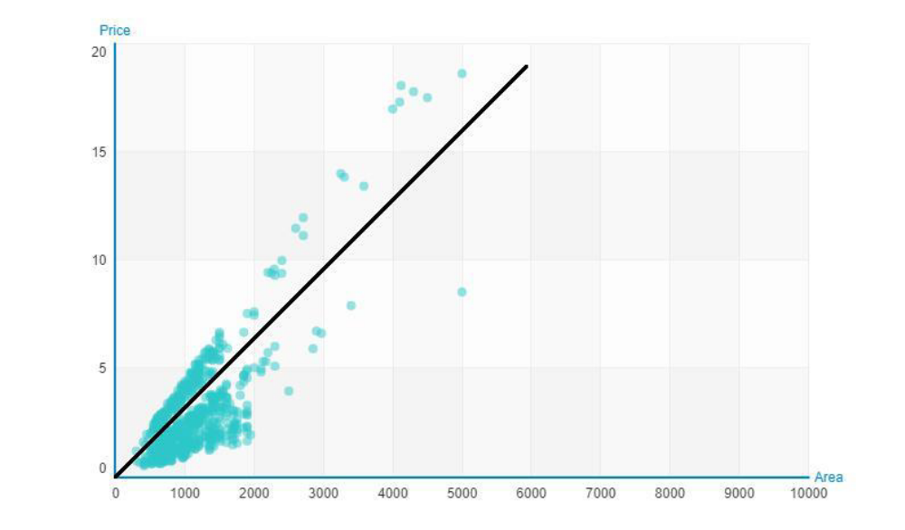
Figure 1: Linear regression scatter plot
2.1.3.2 Forest Regression
Forest regression uses the technique called as Bagging of trees. Bagging of trees is also called as Bootstrap Aggregating. In this technique, multiple predictions are combined to increase the accuracy. Given a training set X = x1,..., xn with responses Y = y1,..., yn, bagging repeatedly (B times) selects a random sample with replacement of the training set and fits trees to these samples.
For b = 1,..., B:
1. Select a sample, with replacement (randomly), having n training examples from X, Y. We will call these as Xb, Yb.
2. Train a classification or regression tree fb on Xb, Yb.
After training, predictions for unseen samples a' can be made by averaging the predictions from all the individual regression trees on a'.

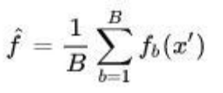
Additionally, an estimate of the uncertainty of the prediction can be made as the standard deviation of the predictions from all the individual regression trees on a':
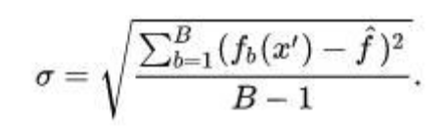
2.1.3.3 Boosted Regression
The term boosting means that each tree is dependent on the prior trees. Boosted regression is a type of learning technique which produces prediction with the help of decision trees that usually ensemble a number of weak prediction models.
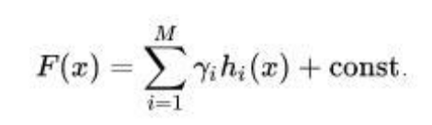
This Boosting algorithm assumes a real life value y and seeks an approximation F(x) in the form of a weighted sum of hi(x) from class H called weak learners.
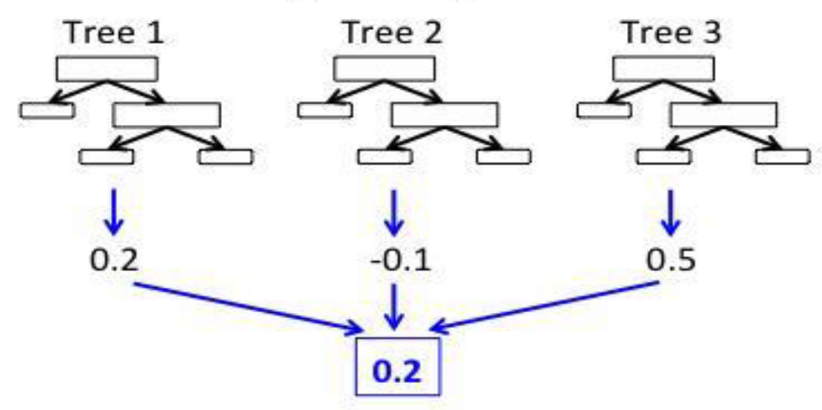
Figure 2: Boosted Regression Model

2.1.3.3 Neural Networks
The results of all the above algorithms are fed as input to the neural network. We use neural network applied with boosted regression to increase the accuracy of the result. Neural network compares all the predictions and computes them to display the most accurate result.
2.1.4 Working of the system:
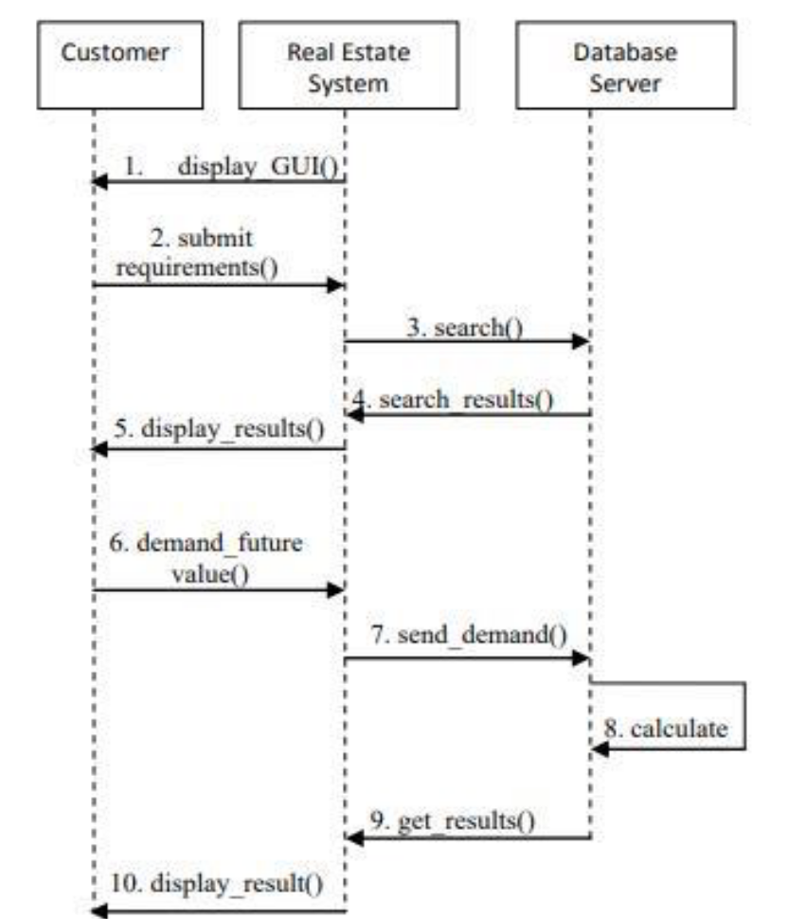
Figure 3: Sequence Diagram

2.2 Housing Price Prediction Using Machine Learning Algorithms: The Case of Melbourne City, Australia [2018]
The goal of study in this paper is through analyzing a real historical transactional dataset to derive valuable insight into the housing market in Melbourne city. It seeks useful models to predict the value of a house given a set of its characteristics. Effective models could allow home buyers, or real estate agents to make better decisions. Moreover, it could benefit the projection of future house prices and the policymaking process for the real estate market.
2.2.1 Getting the data
The data used in this study is the Melbourne Housing Market dataset downloaded from Kaggle website. The original dataset has 34,857 observations and 21 variables. Each observation presents a real sold house transaction in the city of Melbourne from 2016 to 2018.
These variables can be categorized into 3 groups:
• Transactional variables: Price, Date, Method, Seller, Property count.
• Related location predictors: Address, Suburbs, Distance to CBD, Postcode, Building Area, Council Area, Region name, Longitude, Latitude
• Other house features: House Type, Number of Bedrooms, Number of Bathrooms, Number of Car slots, and Land size.
The outcome of house value prediction is the price which is a continuous value.

2.2.2 Data Preparation
The dataset is pre-processed and the missing patterns are found rigorously because they play an important role in deciding the suitable methods for handling the missing data. Columns with more than 55% values missing are removed from the original dataset. The many rows with missing values of the outcome variable (Price). Observations with missing values of the Price column are deleted. Longitude and Latitude are imputed from house addresses using a Google map’s Application Programming Interface (API).
2.2.3 Methodologies
2.2.3.1 Linear Regression
It is based on Mean Squared Error (MSE) calculated on the dataset.
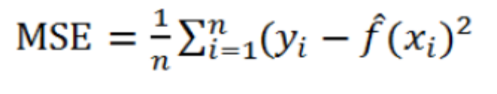

Where, n = no of observations
2.2.3.2 Polynomial Regression

It is an extension of linear regression.
For a simple regression model:
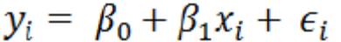
To a polynomial formation with d degree:

Fig. 7 indicates that three is the optimal degree for Polynomial Regression.
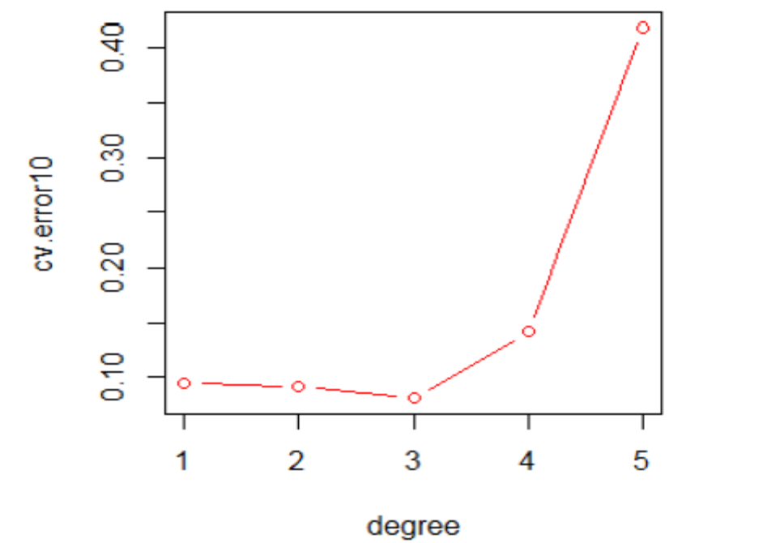
Figure 3: The plot of polynomial degree and MSE

2.2.3.3. Neural Network
The idea of a neural network is a connected network of nodes or units with related weights and bias. These units are confined into different layers. A neural network normally has one input layer, one output layer, and one or more hidden layers. As the number of hidden layers or the numbers of units increase, the complexity increases. The network learns by adjusting the weights to reduce the prediction error. Initially, all weights and bias are allocated randomly. The algorithm then runs iteratively, and each iteration comprises two steps: forward feeding and backpropagation.
Feed Forwarding:
The output of each unit is calculated from outputs of nodes from the previous layer as shown in Figure . The prediction of the output layer is then compared to the observed outcome to derive the learning rate and errors.
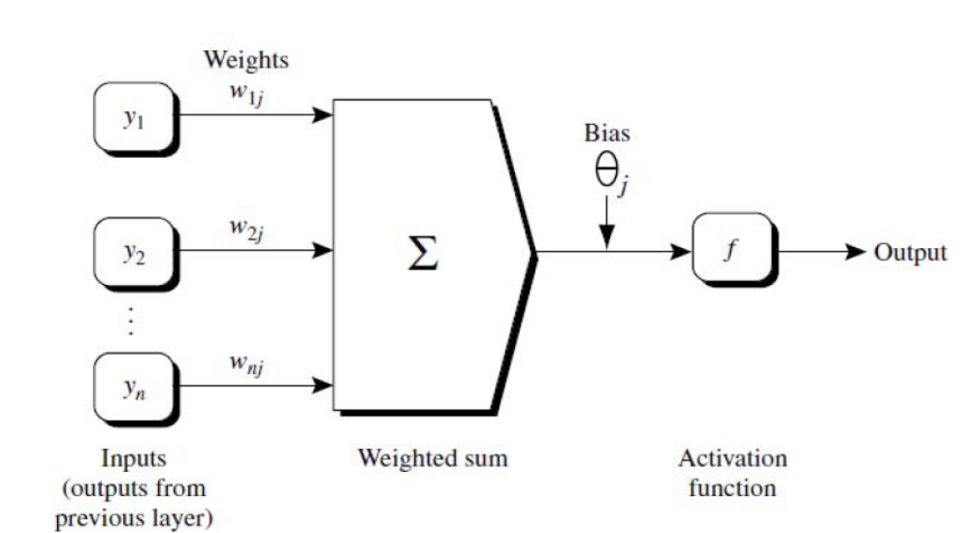
Figure 3: A neural network unit

Backpropagation:
On giving the learning rate and errors, it recalculates the weights and bias in hidden layers and makes appropriate changes to reduce prediction errors. Results demonstrate that the neural network with two hidden layers has the smallest Mean Squared Error.

2.2.2 Estimated Budget Construction Housing Using Linear Regression Model Easy And Fast Solutions Accurate [2017]

It is difficult to estimate construction costs quickly and accurately at the planning stage, when the things are incomplete. The solution of this difficulty is using the model - an easy, fast and accurate way. For example: We want to build a house with three bedrooms, Guests, dining room, kitchen, toilets, terrace by using the model can be predicted how much the construction cost is required. Indonesia is used for getting the dataset.
2.2.2.1 Representation of the model
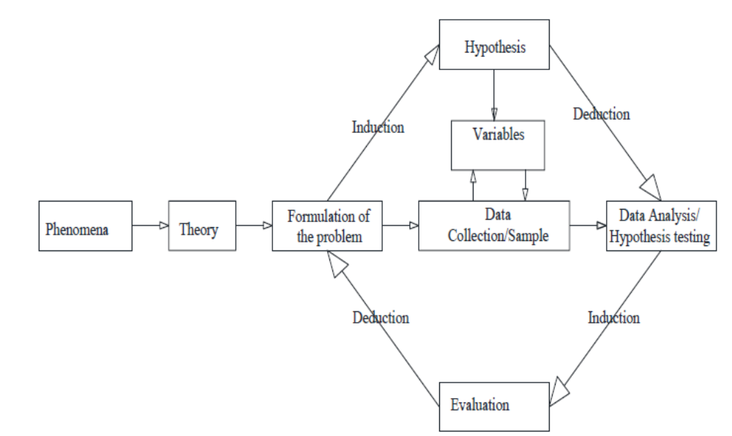

1. Phenomena
Phenomenon is a problem that often or ever we meet or feel, mindmapping techniques can be relied upon to identify the phenomenon into the formulation of the problem.

2. Theory
Theory includes the methods that have been used and acknowledged by the scientists in their field. These theories are backed by phenomena in conducting the research to get the conclusion.

3. Formulation of the Problem
The formulation of the problem is the basis of problem solving and it is in the form of questions or desires. For example, how to calculate an easy and practical residential cost budget plan.

4. Hypothesis
Hypothesis is a temporary answer to the research problem formulation. It is said temporarily because the given answer is based only on theory and not yet using facts. Therefore, any research conducted has a hypothesis or a tentative answer to the research to be performed. According to the authors' hypothesis all building component variables will be represented by one variable that is building area, so to make the model of budget plan of house can be determined dependent variable (y) budget plan, and independent variable (x) building area. For example, calculate the residential cost budget plan using equation:
Y=a+b.x
where, Y - Dependent variable, a - constant, x - Independent variable, b - parameter value.

5. Data Collection
Based on the literature review and hypothesis, data of Detailed Budget Plan, individual who have done construction of residential house and data obtained from construction service company is collected.

6. Variables
The variables are dependent variable y (budgeting cost plan) and independent variable x (building area), where the dependent variable will be influenced by the free variable, the variables are determined based on the hypothesis taken from the data / sample.

7. Hypothesis Testing
The hypothesis is analysed through three stages of analysis: Statistic description, Statistical Correlation and Linear Regression. After analyzing, the analysis test is done by comparing the result of analysis with factual data. If there is an error, then re-analysis is done by reducing or adding data and when it is okay, then the conclusion is made.
2.2.2 The Prediction Of The Chance Of Selling Of Houses As A Factor Of Finanacial Stability
In this paper, the selling chance of houses in the market is estimated. The housing market is very important for financial stability. The database of our approach consists of the price of the houses and their quality indicators as the repair level, distance from the city centre, projects of the building, the place of the flat in a building and so on. G score is calculated and if the computed G value is equal to 0.39 and greater than one, it is classified as the high chance of selling the house, but in the case of being less than 0.39 it is classified as none selling chance. The banks will be able to estimate the probability of the realization of mortgaged houses.
2.2.4.1 Methodology
In this paper, the approach consists of two steps. In the first step we have defined the independent variables of our model and used Hedonic price method. The second cornerstone of our approach is to take the score as the dependent variable of our approach.
Hedonic price method
The characteristics of the houses have influenced their prices. This method is called hedonic price method. Hedonic price method assists in defining the influence of these properties on the price of houses. Robert J. Hill, Erwin Diewert, Saeed Heravi, and Mick Silver etc. have investigated the price of the houses as a function on their characteristic properties. But the price of houses isn't a dependent variable in our analysis. It will be independent variable as the price of per sq. m. along with other qualitative and quantitative variables. The qualitative properties of the houses are the independent variables for statistical analyses. So, the independent variables of our approach are: to be furnished with gas, the distance from the city centre, the price of per sq m., to be near the metro station, availability of the documents of building and to be without repair.
The dependent variable will be the G-score which is coded as the 0 when the house hasn't been sold during the period, otherwise is coded as 1.
Using these two approaches, the model is constructed as:
Where, β = the parameters of the model
X1 = to be furnished with gas
X2 = log of the distance from the city centre
X3 = log of the price of per sq. m.
X4 = to be near the metro station
X5 = availability of the documents of building
X6 = to be without repair
G = the dependent variable of our model will be the score which is coded as 0 when the house hasn't been sold during the period, otherwise is coded as 1
If the computed G value found by using the equation is equal to 0.39 and greater than 1, it is classified as the high chance of selling the house and if it is less than 0.39 it is classified as none selling chance.
Errors:
I Type error: The houses which are classified as the high chance of selling but in actual have none selling status. For example: 5 out of 93 houses fall in this category.
II Type error: The houses which are classified as the none chance of selling but in actual have high chance of selling. For example: 14 out of 141 houses fall in this category.
 | Selling | Non-selling | Total
Selling | 127 | 14 | 14
Non-selling | 5 | 88 | 93
Total | 132 | 102 | 234
Selling% | 90.1 | 9.9 | 100,0
Non-selling% | 5.4 | 94.6 | 100,0

I Type error = 5/234*100=2.14%
II Type error = 14/234*100=5.98%
Total error occurred = 2.14% + 5.98% = 8.12%
Therefore, our prediction will be correct with 91.88% probability.
For checking the predictability power Cohen's Kappa test statistics is useful.
The Cohen's Kappa test statistics is as follows:
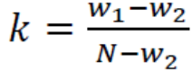
Where,
w1 = 127+88=215
= 79.58+40.5
= 120.1
Therefore, k = (215-120.1)/(234-120.1)=0.833
There are 6 significance intervals for the decision about the result of kappa test. These intervals are as follows:
k ≤ 0 (Very small compliance)

o < k ≤ 0.2 (Small compliance)

0.2 < k ≤ 0.4 (Acceptable compliance)

0.4 <k≤ 0.6 (Medium strong compliance)

0.6 <k≤ 0.8 (Significant compliance)

0.81 <k (Almost perfect compliance)

Therefore, the result of the test should be more than 0.81 otherwise it is not significant. And our value is greater than 0.81. Hence we have got the perfect compliance.

Chapter 3
METHODOLOGY
Machine Learning:
It is a field of study that gives computers the ability without being explicitly programmed. Here supervised machine learning algorithm is used.
Supervised Learning:
In this algorithm, labelled dataset having output values is given for training. The algorithm has to produce ouput values for the new input values. It is further grouped into Regression and Classification problem.
Regression:
It deals with the prediction of the continuous valued attribute i.e. the output is a value instead of 0 (no) or 1 (yes).
Representation of the Model:
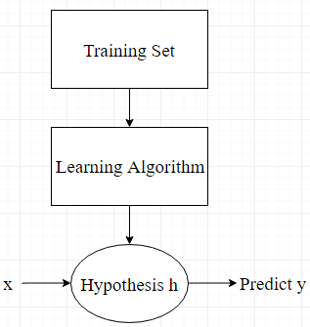
Training Set:
m – No of training examples in the training set
x’s – input variable or features
y’s – output variable or target
(x,y) – one training example
(x(i),y(i)) – ith training example

Hypothesis function:
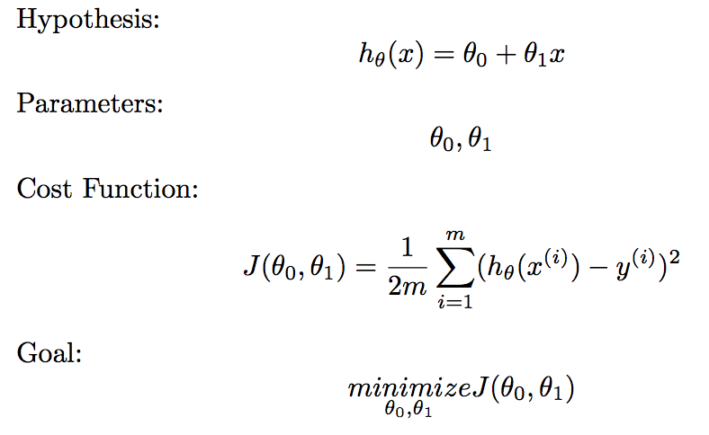
Here we have considered only one feature which is denoted by x. It can be no of bedrooms, no of floors etc. It is similar to the equation of a straight line and thus, it gives a straight line on being plotted.
Parameters:
Cost Function:
It is also known as squared error function. Accuracy of the hypothesis function is measured by the cost function. Accuracy here means how well the straight line of the hypothesis function fits the data.
Goal:
Our goal is to minimize the cost function i.e. minimize the squared error function, denoted as:
Gradient Descent Algorithm:
To achieve above goal, we use the gradient descent algorithm. We will estimate the parameters in the hypothesis function such that J has the minimum value.
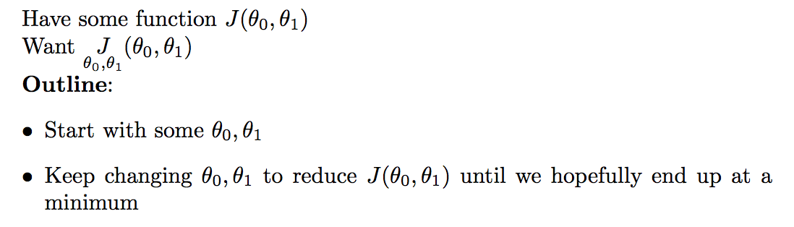
We can represent this algorithm as:
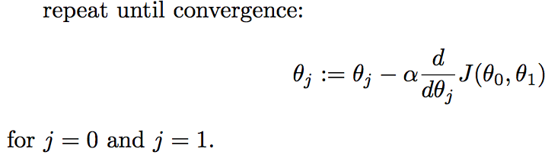
where,
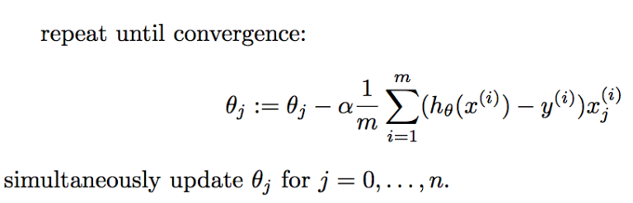 - Learning rate and it controls how big a particular step will be.
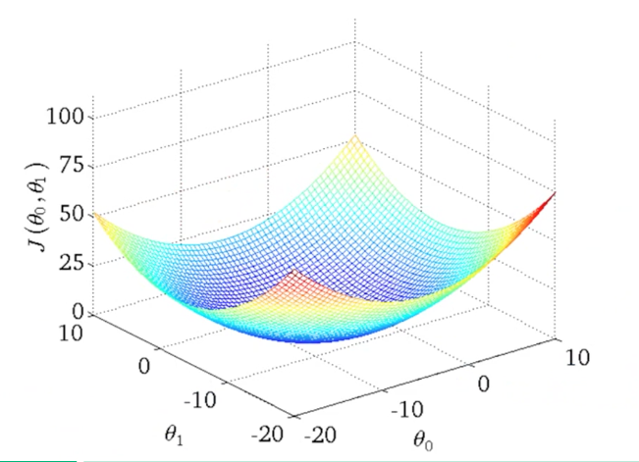
Figure: Squared Error Cost Function
Figure show the cost function for linear regression and it is always going to be a bowl shaped function i.e. convex because it’s equation is in the form of polynomial function. It has only local optimum which will be the global optimum. We will always converge to the global optimum because there are no other local optimum than global optimum.
We are running gradient descent algorithm, choosing the parameters of cost function, moving step-by-step in the cost function and corresponding to that, our line plotted will also change in the hypothesis function. When we will reach global optimum, we’ll get a line in the hypothesis function which will fit the data well.
Implementation:
We combine cost function with the gradient descent algorithm. After a little bit calculus deduction, it’s not hard to get the following formulas:
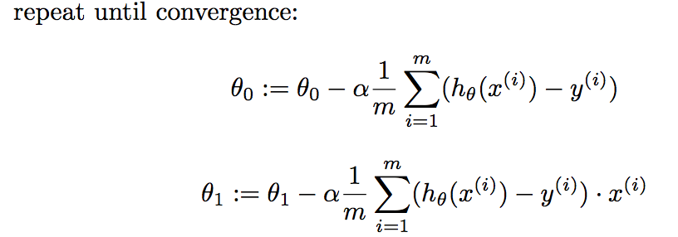
We can use these formulas to solve the problem of linear regression.
The above calculations can be extended to multiple features as well.
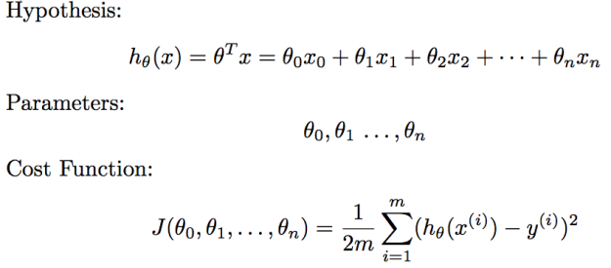
where,
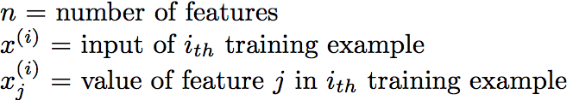
Gradient descent algorithm:
We will obtain a plot as shown in the figure where straight line indicates
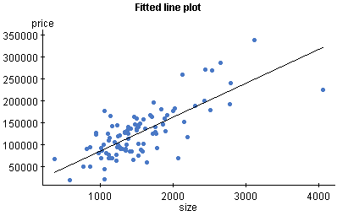
Neural Networks:
A neural network consists of input layer, hidden layers and output layer.
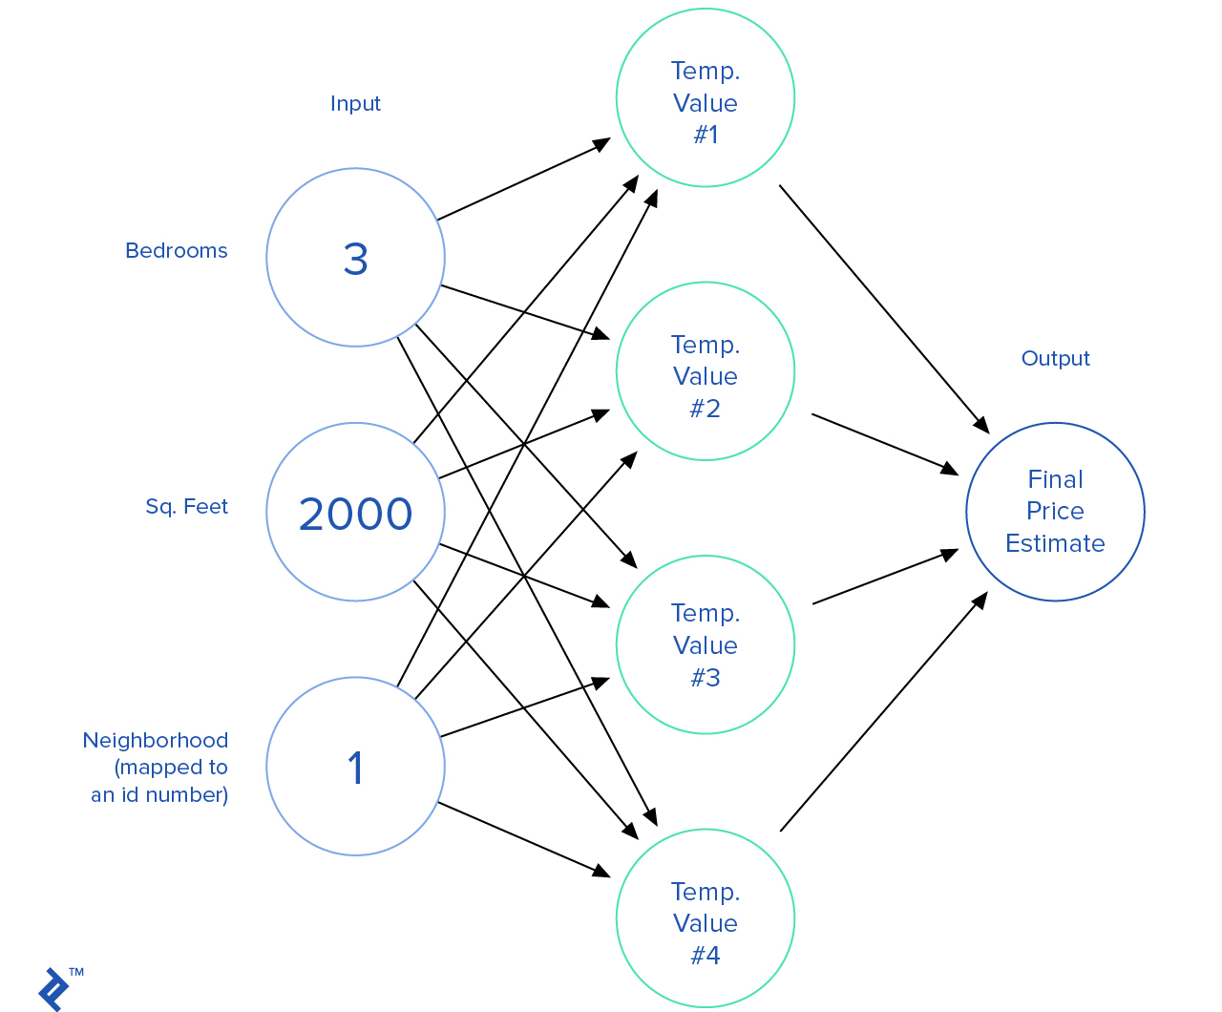
Figure : Neural network
In the figure, Input layer includes the features specified by the customer. For eg: No of bedrooms, sq. feet , neighborhood etc. The temp values are the parameters. This neural network will perform all the computations of the algorithm and predicts the output i.e. the price of the house.
Results:
Consider an example:

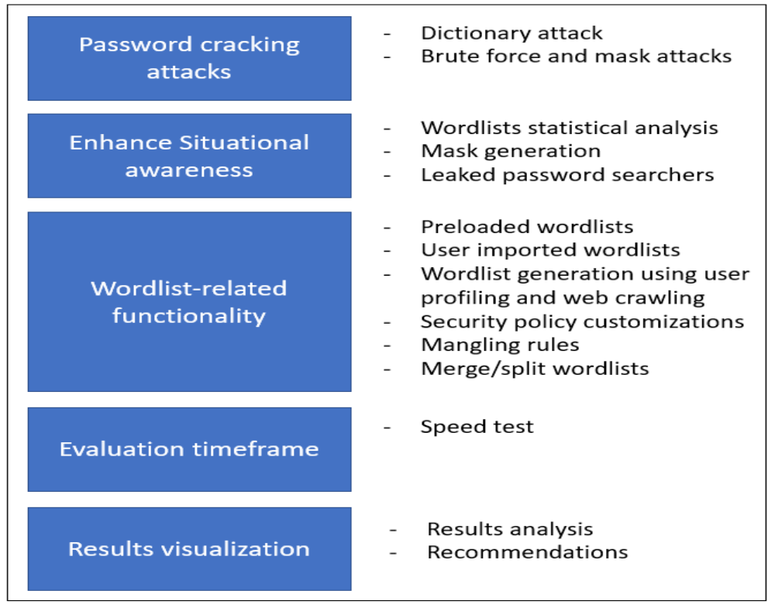
Fig 3.1 Proposed password auditing functionality

Password cracking attacks:
The toolkit should support the main password cracking attacks, that is, the dictionary, brute force and mask attacks. The common key element that is utilized as input to perform these attacks is a wordlist, typically constructed from common words and/or randomly created. The dictionary attack considers a wordlist with predefined words to test the passwords under consideration; the brute force attack considers all possible combinations out of the available char sets and can be customized with masks that represent specific patterns to construct candidate passwords.
Enhancing situational awareness:
A key aspect of optimizing password auditing is having a good understanding of users’ habits and practices with regards to password selection. Defenders need to be able to enhance their awareness with regards to this situation. Leaked passwords from previous data breaches is a good way to understand users’ mindset as to the password selection they make. Enhancing defenders’ situational awareness and facilitating the optimization of password auditing process can be supported through: statistical analysis of existing wordlists, mask generation and leaked passwords’ searches. With regards to the statistical analysis of wordlists, the toolkit should support such a feature and inform defenders of users’ password selection trends and attributes such as: password length statistics, common passwords, complexity composition, etc. If a wordlist that is utilized for password auditing successfully leads to guessing passwords, defenders can have an indication of the practices utilized and can take informed decisions on the follow up actions to address the situation, such as training and awareness activities. Moreover, the analysis can reveal common password patterns, thus, the toolkit should generate appropriate masks that can be utilized to customize the brute force attack and further enhance chances for optimizing the auditing task.
Defenders can also act proactively by investigating whether an employee’s credentials have already been compromised. On the web there are large sets of leaked passwords that are linked to email addresses. Defenders can search whether the organizations employees’ credentials have been compromised. If such a case is identified, defenders will have to notify the affected employees and instruct them to change their passwords. Also, given that users reuse their passwords, there is a chance that employees are reusing their credentials across multiple accounts. Enhancing awareness on this issue can assist in increasing the overall security in an organization.
Wordlist related functionality:
As previously mentioned, a key element in password cracking is a wordlist containing candidate passwords. If defenders have the means to generate a customized wordlist, this may increase their chances to guess passwords within the specified evaluation time. Several studies indicated users’ tendency to use personal information, e.g. names, dates, location, hobbies, school, etc., in their password. Often, these data can be easily collected through various means such as social engineering attacks and internet searches. New toolkits should allow defenders to construct customized wordlists taking into consideration personal information that can be inputted manually or retrieved through web crawling. Web crawling is a useful feature to be implemented by auditing toolkits as it can retrieve words, e.g. from personal blogs, social media, corporate website, etc., that can be utilized in a wordlist. The toolkit should also come with preloaded wordlists, preferable from latest data breaches, and also allow the user to import wordlists.
New wordlists should also be generated using masks that can be specified through statistical analysis of existing password lists. The wordlists should be further processed by applying mangling rules based on known bad practices, such as specific symbols to substitute specific characters (@ to replace a), etc. The target is to create more powerful wordlists, closer to users’ mindset, and increase chances for successful cracking.
The wordlists can be further optimized if considering a specific password security policy. Typically, password security policies contain rules such as the minimum password length, number of capitals/symbols, etc., that need to be considered when selecting a password. Since defenders will have to audit passwords in a specific timeframe, they should have the means to process the wordlists to include candidate passwords that fall under the password security policy. Another useful feature includes merging wordlists into a single file to create a more powerful one. By having all these alternatives, the toolkit can enhance defenders’ capabilities to use customized wordlists that have better chances to guess passwords.
Evaluation timeframe evaluation:
Typically, defenders need to perform password auditing within a specific timeframe. If passwords can be guessed within this period, it means that the risk of compromise is high and actions need to be taken to prohibit it. Wordlists can hold millions of entries; thus, password cracking time can vary depending on the wordlist size and the computational capabilities of the system. The toolkit should allow defenders to run a speed test on the given system and specify the average number of passwords that can be tested per second. By selecting a specific wordlist, an indicative evaluation timeframe can be calculated. Then defenders can have a view of the required timing that will be required to conclude the auditing. If the estimated timing does not meet defenders’ evaluation timeframe, then further processing can be applied on the wordlists to facilitate the task. Specifically, the toolkit should support a feature to split wordlists into smaller parts. This can allow defenders to use a subset of the original password set that can be tested within the required evaluation timeframe. Defenders can continue with the auditing at a later stage or even decide to run a distributed password auditing.
Results visualization:
Once the password auditing process concludes, results should be presented to defenders in a clear and useful approach. For example, the toolkit can analyze the cracked passwords versus specific wordlists and identify the weal elements, e.g. if it is among the 10 top bad passwords, if it utilizes a common pattern, etc. Based on the identified weak elements, the toolkit should recommend were training and awareness efforts should be concentrating, e.g. educate users on specific bad practices, with the objective of enhancing users’ perception of what should constitute a strong password.

Chapter 4
Results and discussion
In order to maximize the benefits from password auditing, an appropriate password auditing policy needs to be specified and applied. Moreover, password auditing yields privacy and ethical concerns that need to be taken into consideration by organizations when writing the auditing policy. In the case where passwords are cracked, this means that the users’ privacy can be breached. Defenders should have clear directions how to perform password auditing in an ethical way and also have a clear plan of the follow up actions they need to take, depending on the auditing results. The password auditing policy should specify the following:
- How often the password auditing should be performed.
- The user/system accounts that should be audited. It is advised to create different auditing profiles depending on the role function of people/criticality of the data been accessed, so that different rules can be applied. For example, a rule can specify when auditing should be performed taking into consideration different conditions, e.g. a recent attack, previous password auditing results, etc.
- The tools utilized and relevant configurations. For example, in the case of the dictionary attack, the policy can specify how to select/generate wordlists. A good approach is to search for latest password leaks and consider them in a custom wordlist.
- How employees are notified that this task is taking place as a proactive measure to decrease the risk of compromise.
- That defenders are not allowed to exploit users’ accounts once they identify users’ passwords.
The password auditing policy should also include guidelines of the follow up actions in case passwords are guessed:
- Employees of which their passwords have been cracked should be immediately informed to change their password, stating the reasons why these passwords are weak.
- Appropriate guidelines should be provided to these employees reminding them of best practices when constructing their passwords. The guidelines delivery can be made through means that should be specified by the organization, e.g. one-to-one meetings with an IT/cyber security expert, guidelines through email, etc.
- An auditing log should be kept, listing the accounts that have been compromised and the reasons that the passwords are considered weak, e.g. common word, known pattern, etc. The log can be utilized to support decision-making, e.g. launch a training/awareness corporate campaign.
- The cracked passwords should be included in a custom wordlist to be utilized for next auditing iteration. In the case where the user is using a new password that is similar to the one that has been cracked, password auditing will indicate if it can be easily identified by an attacker, given that the attacker has guessed the original password.
- If a number of passwords are cracked, then the next auditing should be performed sooner than what has been specified. The policy can specify whether there is a threshold on the number of cracked passwords that fall under a certain auditing profile (if it exists).
- Also, if an intrusion detection system reports an attack attempt, then it is advised to initiate a password audit.
- Based on the audit logs, training/awareness activities should be designed taking into consideration the reasons of weaknesses. Activities may target certain user groups that their passwords are often cracked, to enhance their awareness on the topic.
- Revise the password security policy. For example, there might be a need to increase the password history, to increase the number of capitals/symbols included in a password, etc.

Chapter 5
Advantages and Disadvantages
Advantages
- Enhancing situational awareness can assist defenders to take informed decisions to decrease the risk of cyber-attack.
- If the user is using a new password that is similar to the one that has been cracked, password auditing will indicate if it can be easily identified by an attacker, given that the attacker has guessed the original password.
- Employees will be asked to change their password if their password has been compromised.
Disadvantages
- Password auditing tools are focusing mostly on cracking the passwords rather than optimizing the process.
- Password auditing is not an easy task to perform; expert knowledge is required to optimize the password auditing process and to increase the chance to check for weak passwords within a given evaluation timeframe.

Chapter 6
Applications
- Security: Password auditing tools will help organizations to prevent cyber-attacks.
- Better Passwords: Password auditing tools will inform users if their passwords are weak and prompt them to change their passwords immediately.
- Enhancing Situational Awareness: A key aspect of optimizing password auditing is having a good understanding of users’ habits and practices with regards to password selection. Defenders need to be able to enhance their awareness with regards to this situation. Leaked passwords from previous data breaches is a good way to understand users’ mindset as to the password selection they make. Enhancing defenders’ situational awareness and facilitating the optimization of password auditing process can be supported through: statistical analysis of existing wordlists, mask generation and leaked passwords’ searches.

Conclusion
Password auditing should be part of all organizations’ cyber defense strategy. It only takes one user account to be compromised to expose the entire corporate network environment to external threats. Cyber defenders should regularly perform password auditing to avoid this situation. This is not an easy task to perform; expert knowledge is required to optimize the password auditing process and to increase the chance to check for weak passwords within a given evaluation timeframe. Password auditing tools are focusing mostly on cracking the passwords rather than optimizing the process. The knowledge to optimize the process is scatter and can hinder the tasks of novice, event more experienced, defenders. Therefore, the need to upscale the design of password auditing tools to support holistic features that will allow defenders to effectively and efficiently perform password audits and enhance their awareness of the situation. Enhancing situational awareness can assist defenders to take informed decisions to decrease the risk of attacks. This work has proposed a set of essential features that should be integrated together to form a powerful password auditing tool. Appropriate guidelines to specify a password auditing policy are also proposed. Future work will include the development of a toolkit based on the proposed features.

REFERENCES
- Eliana Stavrou, “Enhancing Cyber Situational Awareness: A New Perspective of Password Auditing Tools”, 2018 International Conference On Cyber Situational Awareness, Data Analytics And Assessment (Cyber SA)
- Matteo Dell’Amico, Pietro Michiardi and Yves Roudier, “Password Strength: An Empirical Analysis”, 2017 IEEE INFOCOM 2010
- Jesus Molina and Michel Cukier, “Evaluating Files to Audit for Detecting Intrusions in File System Data”, 2018 Eighth IEEE International Symposium on Network Computing and Applications
- Symantec, “Internet Security Threat Report (ISTR),” 2017.
- Raytheon, “Future Warfare - Cultivating Emerging Technologies,” 2016.
- OpenWall, “John the Ripper password cracker,” [Online]. Available: http://www.openwall.com/john/. [Accessed 20 February 2018].

