install.packages("devtools")

library(devtools)

install_github("mkarikom/RSoptSC")

library(RSoptSC)

data = read.csv("D:\\Masters\\Datasets\\Baron-Mouse Pancreas\\MouseD2NormWithColNamesRowNames.csv", check.names = FALSE)

row.names(data) = data[,c(1)]

data = subset(data, select = -c(1))

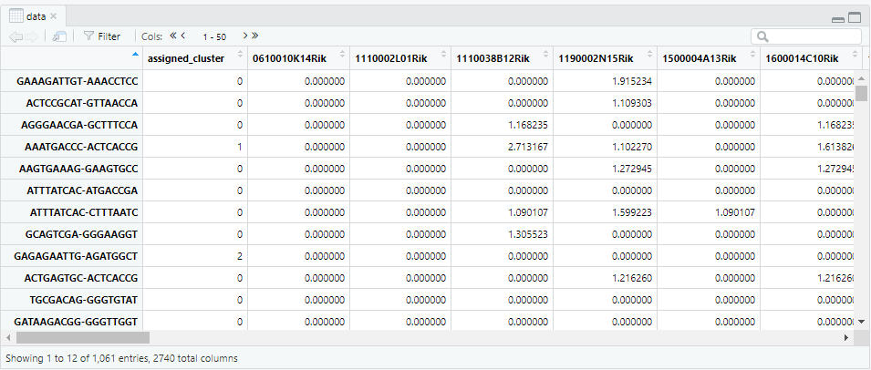

df = subset(data, select = -c(assigned_cluster))

df = abs(df)

df = t(df)

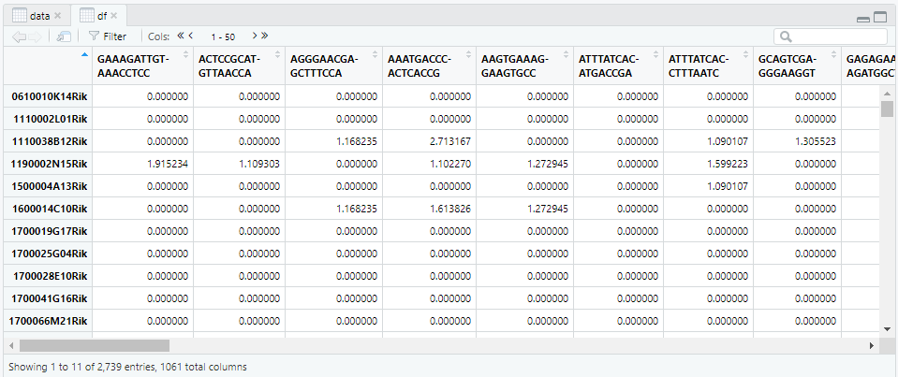

data_m = data.matrix(df)

S <- SimilarityM(lambda = 0.05,

data = data_m,

dims = 3,

pre_embed_method = 'tsne',

perplexity = 20,

pca_center = TRUE,

pca_scale = TRUE)

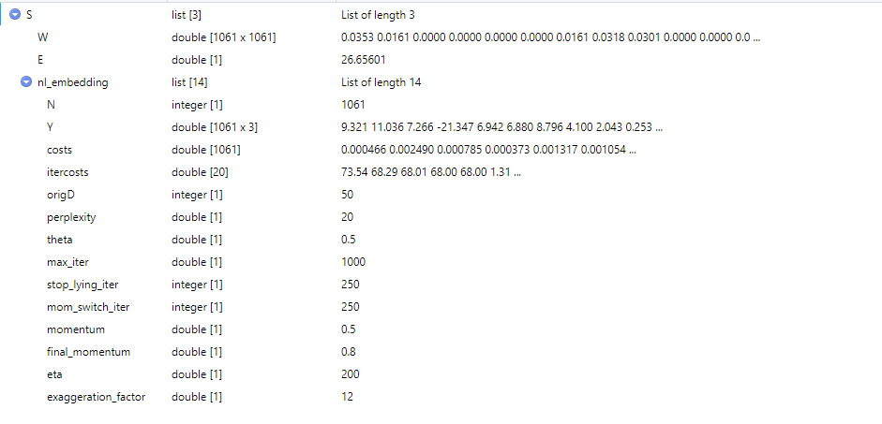

low_dim_mapping <- RepresentationMap(similarity_matrix = S$W,

flat_embedding_method = 'tsne',

join_components = TRUE,

perplexity = 35,

theta = 0.5,

normalize = FALSE,

pca = TRUE,

pca_center = TRUE,

pca_scale = TRUE,

dims = 2,

initial_dims = 2)

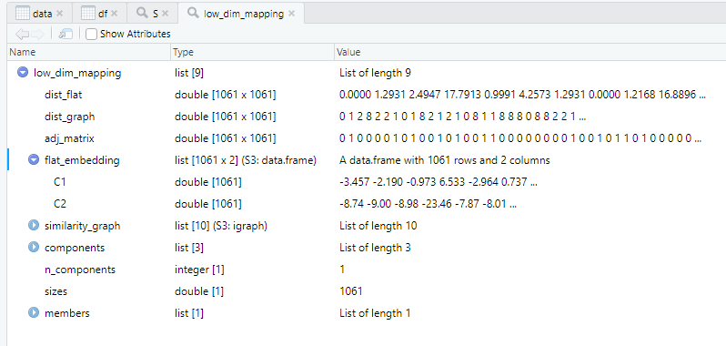

library(igraph)

adj = low_dim_mapping$adj_matrix

row.names(adj) = colnames(df)

colnames(adj) = colnames(df)

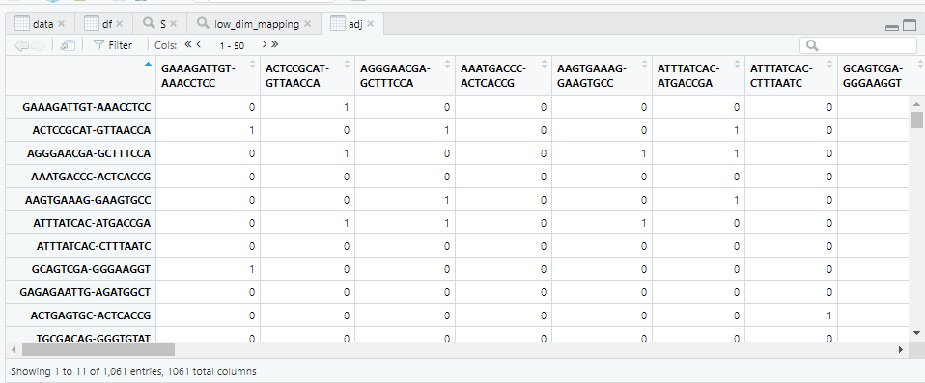

graph = graph_from_adjacency_matrix(adj)

edgelist = get.edgelist(graph)

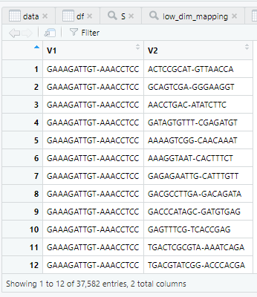

write.csv(edgelist,"D:\\Masters\\My_thesis\\Code\\RSoptSC\\MouseD2\\edgelist_MouseD2.csv")

write.csv(adj,"D:\\Masters\\My_thesis\\Code\\RSoptSC\\MouseD2\\adjacencymatrix_MouseD2.csv")

write.csv(colnames(adj),"D:\\Masters\\My_thesis\\Code\\RSoptSC\\MouseD2\\cellnames_MouseD2.csv")