Schema cbml-location-types.xsd

schema location: | cbml-location-types.xsd
attribute form default: | unqualified
element form default: | qualified
targetNamespace: | http://www.sisostds.org/schemas/c-bml/1.0

Complex types
CartesianPoint
CartesianPointRef
ConeVolume
ConeVolumeRef
CorridorArea
CorridorAreaRef
Ellipse
EllipseRef
FanArea
FanAreaRef
GeographicPoint
GeographicPointRef
Line
LineRef
ObjectReference
ObjectReferenceRef
OrbitArea
OrbitAreaRef
OtherLocation
OtherLocationRef
PointReference
PointReferenceRef
PolyarcArea
PolyarcAreaRef
PolygonArea
PolygonAreaRef
RelativePoint
RelativePointRef
SphereVolume
SphereVolumeRef
SurfaceVolume
SurfaceVolumeRef
TrackArea
TrackAreaRef

complexType CartesianPoint
diagram | 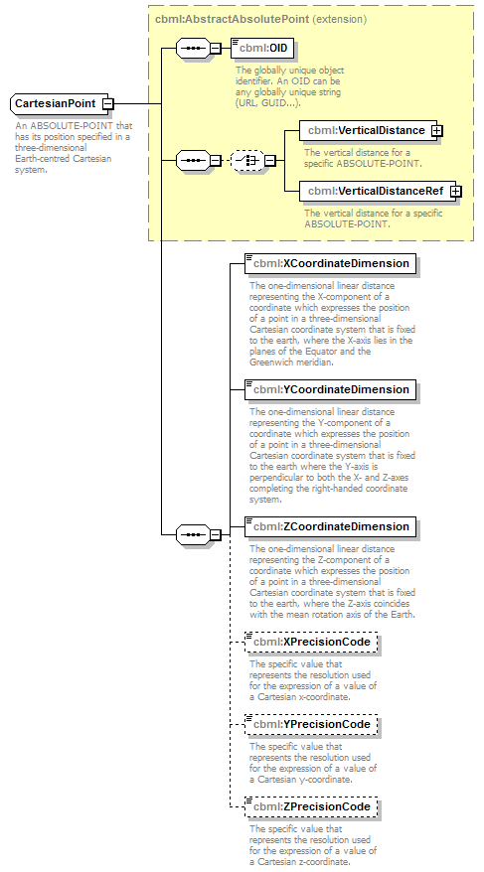
namespace | http://www.sisostds.org/schemas/c-bml/1.0
type | extension of cbml:AbstractAbsolutePoint
properties
  base | cbml:AbstractAbsolutePoint
children | cbml:OID cbml:VerticalDistance cbml:VerticalDistanceRef cbml:XCoordinateDimension cbml:YCoordinateDimension cbml:ZCoordinateDimension cbml:XPrecisionCode cbml:YPrecisionCode cbml:ZPrecisionCode
annotation
  documentation
  An ABSOLUTE-POINT that has its position specified in a three-dimensional Earth-centred Cartesian system.
source | <xs:complexType name="CartesianPoint">  <xs:annotation>  <xs:documentation xml:lang="en">An ABSOLUTE-POINT that has its position specified in a three-dimensional Earth-centred Cartesian system.</xs:documentation>  </xs:annotation>  <xs:complexContent>  <xs:extension base="cbml:AbstractAbsolutePoint">  <xs:sequence>  <xs:element name="XCoordinateDimension" type="jc3iedm:DimensionType12_3">  <xs:annotation>  <xs:documentation xml:lang="en">The one-dimensional linear distance representing the X-component of a coordinate which expresses the position of a point in a three-dimensional Cartesian coordinate system that is fixed to the earth, where the X-axis lies in the planes of the Equator and the Greenwich meridian.</xs:documentation>  </xs:annotation>  </xs:element>  <xs:element name="YCoordinateDimension" type="jc3iedm:DimensionType12_3">  <xs:annotation>  <xs:documentation xml:lang="en">The one-dimensional linear distance representing the Y-component of a coordinate which expresses the position of a point in a three-dimensional Cartesian coordinate system that is fixed to the earth where the Y-axis is perpendicular to both the X- and Z-axes completing the right-handed coordinate system.</xs:documentation>  </xs:annotation>  </xs:element>  <xs:element name="ZCoordinateDimension" type="jc3iedm:DimensionType12_3">  <xs:annotation>  <xs:documentation xml:lang="en">The one-dimensional linear distance representing the Z-component of a coordinate which expresses the position of a point in a three-dimensional Cartesian coordinate system that is fixed to the earth, where the Z-axis coincides with the mean rotation axis of the Earth.</xs:documentation>  </xs:annotation>  </xs:element>  <xs:element name="XPrecisionCode" type="jc3iedm:DistancePrecisionCode" minOccurs="0">  <xs:annotation>  <xs:documentation xml:lang="en">The specific value that represents the resolution used for the expression of a value of a Cartesian x-coordinate.</xs:documentation>  </xs:annotation>  </xs:element>  <xs:element name="YPrecisionCode" type="jc3iedm:DistancePrecisionCode" minOccurs="0">  <xs:annotation>  <xs:documentation xml:lang="en">The specific value that represents the resolution used for the expression of a value of a Cartesian y-coordinate.</xs:documentation>  </xs:annotation>  </xs:element>  <xs:element name="ZPrecisionCode" type="jc3iedm:DistancePrecisionCode" minOccurs="0">  <xs:annotation>  <xs:documentation xml:lang="en">The specific value that represents the resolution used for the expression of a value of a Cartesian z-coordinate.</xs:documentation>  </xs:annotation>  </xs:element>  </xs:sequence>  </xs:extension>  </xs:complexContent>  </xs:complexType>

element CartesianPoint/XCoordinateDimension
diagram | 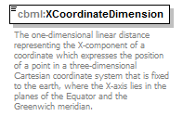
namespace | http://www.sisostds.org/schemas/c-bml/1.0
type | jc3iedm:DimensionType12_3
properties
  isRef | 0
  content | simple
facets
  Kind | Value | annotation
  minInclusive | -999999999.999
  maxInclusive | 999999999.999
  totalDigits | 12
  fractionDigits | 3
annotation
  documentation
  The one-dimensional linear distance representing the X-component of a coordinate which expresses the position of a point in a three-dimensional Cartesian coordinate system that is fixed to the earth, where the X-axis lies in the planes of the Equator and the Greenwich meridian.
source | <xs:element name="XCoordinateDimension" type="jc3iedm:DimensionType12_3">  <xs:annotation>  <xs:documentation xml:lang="en">The one-dimensional linear distance representing the X-component of a coordinate which expresses the position of a point in a three-dimensional Cartesian coordinate system that is fixed to the earth, where the X-axis lies in the planes of the Equator and the Greenwich meridian.</xs:documentation>  </xs:annotation>  </xs:element>

element CartesianPoint/YCoordinateDimension
diagram | 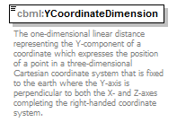
namespace | http://www.sisostds.org/schemas/c-bml/1.0
type | jc3iedm:DimensionType12_3
properties
  isRef | 0
  content | simple
facets
  Kind | Value | annotation
  minInclusive | -999999999.999
  maxInclusive | 999999999.999
  totalDigits | 12
  fractionDigits | 3
annotation
  documentation
  The one-dimensional linear distance representing the Y-component of a coordinate which expresses the position of a point in a three-dimensional Cartesian coordinate system that is fixed to the earth where the Y-axis is perpendicular to both the X- and Z-axes completing the right-handed coordinate system.
source | <xs:element name="YCoordinateDimension" type="jc3iedm:DimensionType12_3">  <xs:annotation>  <xs:documentation xml:lang="en">The one-dimensional linear distance representing the Y-component of a coordinate which expresses the position of a point in a three-dimensional Cartesian coordinate system that is fixed to the earth where the Y-axis is perpendicular to both the X- and Z-axes completing the right-handed coordinate system.</xs:documentation>  </xs:annotation>  </xs:element>

element CartesianPoint/ZCoordinateDimension
diagram | 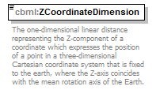
namespace | http://www.sisostds.org/schemas/c-bml/1.0
type | jc3iedm:DimensionType12_3
properties
  isRef | 0
  content | simple
facets
  Kind | Value | annotation
  minInclusive | -999999999.999
  maxInclusive | 999999999.999
  totalDigits | 12
  fractionDigits | 3
annotation
  documentation
  The one-dimensional linear distance representing the Z-component of a coordinate which expresses the position of a point in a three-dimensional Cartesian coordinate system that is fixed to the earth, where the Z-axis coincides with the mean rotation axis of the Earth.
source | <xs:element name="ZCoordinateDimension" type="jc3iedm:DimensionType12_3">  <xs:annotation>  <xs:documentation xml:lang="en">The one-dimensional linear distance representing the Z-component of a coordinate which expresses the position of a point in a three-dimensional Cartesian coordinate system that is fixed to the earth, where the Z-axis coincides with the mean rotation axis of the Earth.</xs:documentation>  </xs:annotation>  </xs:element>

element CartesianPoint/XPrecisionCode
diagram | 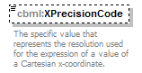
namespace | http://www.sisostds.org/schemas/c-bml/1.0
type | jc3iedm:DistancePrecisionCode
properties
  isRef | 0
  minOcc | 0
  maxOcc | 1
  content | simple
facets
  Kind | Value | annotation
  enumeration | 100FT
    documentation
    <Definition xml:lang="en">A linear measure (distance, length) is defined to the precision of 100 feet (30.48 metres).</Definition>
    appinfo
    <DisplayValue xml:lang="en">100 feet</DisplayValue>
  enumeration | 100MTR
    documentation
    <Definition xml:lang="en">A linear measure (distance, length) is defined to the precision of 100 metres.</Definition>
    appinfo
    <DisplayValue xml:lang="en">100 metres</DisplayValue>
  enumeration | 10FT
    documentation
    <Definition xml:lang="en">A linear measure (distance, length) is defined to the precision of 10 feet (3.048 metres).</Definition>
    appinfo
    <DisplayValue xml:lang="en">10 feet</DisplayValue>
  enumeration | 10MTR
    documentation
    <Definition xml:lang="en">A linear measure (distance, length) is defined to the precision of 10 metres.</Definition>
    appinfo
    <DisplayValue xml:lang="en">10 metres</DisplayValue>
  enumeration | 300MTR
    documentation
    <Definition xml:lang="en">A linear measure (distance, length) is defined to the precision of 300 metres.</Definition>
    appinfo
    <DisplayValue xml:lang="en">300 metres</DisplayValue>
  enumeration | 30MTR
    documentation
    <Definition xml:lang="en">A linear measure (distance, length) is defined to the precision of 30 metres.</Definition>
    appinfo
    <DisplayValue xml:lang="en">30 metres</DisplayValue>
  enumeration | 3MTR
    documentation
    <Definition xml:lang="en">A linear measure (distance, length) is defined to the precision of 3 metres.</Definition>
    appinfo
    <DisplayValue xml:lang="en">3 metres</DisplayValue>
  enumeration | CM
    documentation
    <Definition xml:lang="en">A linear measure (distance, length) is defined to the precision of 0.01 metre.</Definition>
    appinfo
    <DisplayValue xml:lang="en">Centimetre</DisplayValue>
  enumeration | FOOT
    documentation
    <Definition xml:lang="en">A linear measure (distance, length) is defined to the precision of one foot (0.3048 metres).</Definition>
    appinfo
    <DisplayValue xml:lang="en">Foot</DisplayValue>
  enumeration | INCH
    documentation
    <Definition xml:lang="en">A linear measure (distance, length) is defined to the precision of one inch (0.0254 metres).</Definition>
    appinfo
    <DisplayValue xml:lang="en">Inch</DisplayValue>
  enumeration | KILYRD
    documentation
    <Definition xml:lang="en">A linear measure (distance, length) is defined to the precision of a kiloyard (914,4 metres).</Definition>
    appinfo
    <DisplayValue xml:lang="en">Kiloyard</DisplayValue>
  enumeration | KM
    documentation
    <Definition xml:lang="en">A linear measure (distance, length) is defined to the precision of 1000 metres.</Definition>
    appinfo
    <DisplayValue xml:lang="en">Kilometre</DisplayValue>
  enumeration | METRE
    documentation
    <Definition xml:lang="en">A linear measure (distance, length) is defined to the precision of one metre.</Definition>
    appinfo
    <DisplayValue xml:lang="en">Metre</DisplayValue>
  enumeration | MILE
    documentation
    <Definition xml:lang="en">A linear measure (distance, length) is defined to the precision of one mile (1609.344 metres).</Definition>
    appinfo
    <DisplayValue xml:lang="en">Mile</DisplayValue>
  enumeration | MM
    documentation
    <Definition xml:lang="en">A linear measure (distance, length) is defined to the precision of one millimetre.</Definition>
    appinfo
    <DisplayValue xml:lang="en">Millimetre</DisplayValue>
  enumeration | NM
    documentation
    <Definition xml:lang="en">A linear measure (distance, length) is defined to the precision of a nautical mile (1852 metres).</Definition>
    appinfo
    <DisplayValue xml:lang="en">Nautical mile</DisplayValue>
  enumeration | YARD
    documentation
    <Definition xml:lang="en">A linear measure (distance, length) is defined to the precision of a yard (0.9144 metres).</Definition>
    appinfo
    <DisplayValue xml:lang="en">Yard</DisplayValue>
annotation
  documentation
  The specific value that represents the resolution used for the expression of a value of a Cartesian x-coordinate.
source | <xs:element name="XPrecisionCode" type="jc3iedm:DistancePrecisionCode" minOccurs="0">  <xs:annotation>  <xs:documentation xml:lang="en">The specific value that represents the resolution used for the expression of a value of a Cartesian x-coordinate.</xs:documentation>  </xs:annotation>  </xs:element>

element CartesianPoint/YPrecisionCode
diagram | 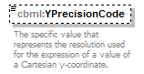
namespace | http://www.sisostds.org/schemas/c-bml/1.0
type | jc3iedm:DistancePrecisionCode
properties
  isRef | 0
  minOcc | 0
  maxOcc | 1
  content | simple
facets
  Kind | Value | annotation
  enumeration | 100FT
    documentation
    <Definition xml:lang="en">A linear measure (distance, length) is defined to the precision of 100 feet (30.48 metres).</Definition>
    appinfo
    <DisplayValue xml:lang="en">100 feet</DisplayValue>
  enumeration | 100MTR
    documentation
    <Definition xml:lang="en">A linear measure (distance, length) is defined to the precision of 100 metres.</Definition>
    appinfo
    <DisplayValue xml:lang="en">100 metres</DisplayValue>
  enumeration | 10FT
    documentation
    <Definition xml:lang="en">A linear measure (distance, length) is defined to the precision of 10 feet (3.048 metres).</Definition>
    appinfo
    <DisplayValue xml:lang="en">10 feet</DisplayValue>
  enumeration | 10MTR
    documentation
    <Definition xml:lang="en">A linear measure (distance, length) is defined to the precision of 10 metres.</Definition>
    appinfo
    <DisplayValue xml:lang="en">10 metres</DisplayValue>
  enumeration | 300MTR
    documentation
    <Definition xml:lang="en">A linear measure (distance, length) is defined to the precision of 300 metres.</Definition>
    appinfo
    <DisplayValue xml:lang="en">300 metres</DisplayValue>
  enumeration | 30MTR
    documentation
    <Definition xml:lang="en">A linear measure (distance, length) is defined to the precision of 30 metres.</Definition>
    appinfo
    <DisplayValue xml:lang="en">30 metres</DisplayValue>
  enumeration | 3MTR
    documentation
    <Definition xml:lang="en">A linear measure (distance, length) is defined to the precision of 3 metres.</Definition>
    appinfo
    <DisplayValue xml:lang="en">3 metres</DisplayValue>
  enumeration | CM
    documentation
    <Definition xml:lang="en">A linear measure (distance, length) is defined to the precision of 0.01 metre.</Definition>
    appinfo
    <DisplayValue xml:lang="en">Centimetre</DisplayValue>
  enumeration | FOOT
    documentation
    <Definition xml:lang="en">A linear measure (distance, length) is defined to the precision of one foot (0.3048 metres).</Definition>
    appinfo
    <DisplayValue xml:lang="en">Foot</DisplayValue>
  enumeration | INCH
    documentation
    <Definition xml:lang="en">A linear measure (distance, length) is defined to the precision of one inch (0.0254 metres).</Definition>
    appinfo
    <DisplayValue xml:lang="en">Inch</DisplayValue>
  enumeration | KILYRD
    documentation
    <Definition xml:lang="en">A linear measure (distance, length) is defined to the precision of a kiloyard (914,4 metres).</Definition>
    appinfo
    <DisplayValue xml:lang="en">Kiloyard</DisplayValue>
  enumeration | KM
    documentation
    <Definition xml:lang="en">A linear measure (distance, length) is defined to the precision of 1000 metres.</Definition>
    appinfo
    <DisplayValue xml:lang="en">Kilometre</DisplayValue>
  enumeration | METRE
    documentation
    <Definition xml:lang="en">A linear measure (distance, length) is defined to the precision of one metre.</Definition>
    appinfo
    <DisplayValue xml:lang="en">Metre</DisplayValue>
  enumeration | MILE
    documentation
    <Definition xml:lang="en">A linear measure (distance, length) is defined to the precision of one mile (1609.344 metres).</Definition>
    appinfo
    <DisplayValue xml:lang="en">Mile</DisplayValue>
  enumeration | MM
    documentation
    <Definition xml:lang="en">A linear measure (distance, length) is defined to the precision of one millimetre.</Definition>
    appinfo
    <DisplayValue xml:lang="en">Millimetre</DisplayValue>
  enumeration | NM
    documentation
    <Definition xml:lang="en">A linear measure (distance, length) is defined to the precision of a nautical mile (1852 metres).</Definition>
    appinfo
    <DisplayValue xml:lang="en">Nautical mile</DisplayValue>
  enumeration | YARD
    documentation
    <Definition xml:lang="en">A linear measure (distance, length) is defined to the precision of a yard (0.9144 metres).</Definition>
    appinfo
    <DisplayValue xml:lang="en">Yard</DisplayValue>
annotation
  documentation
  The specific value that represents the resolution used for the expression of a value of a Cartesian y-coordinate.
source | <xs:element name="YPrecisionCode" type="jc3iedm:DistancePrecisionCode" minOccurs="0">  <xs:annotation>  <xs:documentation xml:lang="en">The specific value that represents the resolution used for the expression of a value of a Cartesian y-coordinate.</xs:documentation>  </xs:annotation>  </xs:element>

element CartesianPoint/ZPrecisionCode
diagram | 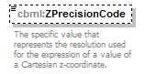
namespace | http://www.sisostds.org/schemas/c-bml/1.0
type | jc3iedm:DistancePrecisionCode
properties
  isRef | 0
  minOcc | 0
  maxOcc | 1
  content | simple
facets
  Kind | Value | annotation
  enumeration | 100FT
    documentation
    <Definition xml:lang="en">A linear measure (distance, length) is defined to the precision of 100 feet (30.48 metres).</Definition>
    appinfo
    <DisplayValue xml:lang="en">100 feet</DisplayValue>
  enumeration | 100MTR
    documentation
    <Definition xml:lang="en">A linear measure (distance, length) is defined to the precision of 100 metres.</Definition>
    appinfo
    <DisplayValue xml:lang="en">100 metres</DisplayValue>
  enumeration | 10FT
    documentation
    <Definition xml:lang="en">A linear measure (distance, length) is defined to the precision of 10 feet (3.048 metres).</Definition>
    appinfo
    <DisplayValue xml:lang="en">10 feet</DisplayValue>
  enumeration | 10MTR
    documentation
    <Definition xml:lang="en">A linear measure (distance, length) is defined to the precision of 10 metres.</Definition>
    appinfo
    <DisplayValue xml:lang="en">10 metres</DisplayValue>
  enumeration | 300MTR
    documentation
    <Definition xml:lang="en">A linear measure (distance, length) is defined to the precision of 300 metres.</Definition>
    appinfo
    <DisplayValue xml:lang="en">300 metres</DisplayValue>
  enumeration | 30MTR
    documentation
    <Definition xml:lang="en">A linear measure (distance, length) is defined to the precision of 30 metres.</Definition>
    appinfo
    <DisplayValue xml:lang="en">30 metres</DisplayValue>
  enumeration | 3MTR
    documentation
    <Definition xml:lang="en">A linear measure (distance, length) is defined to the precision of 3 metres.</Definition>
    appinfo
    <DisplayValue xml:lang="en">3 metres</DisplayValue>
  enumeration | CM
    documentation
    <Definition xml:lang="en">A linear measure (distance, length) is defined to the precision of 0.01 metre.</Definition>
    appinfo
    <DisplayValue xml:lang="en">Centimetre</DisplayValue>
  enumeration | FOOT
    documentation
    <Definition xml:lang="en">A linear measure (distance, length) is defined to the precision of one foot (0.3048 metres).</Definition>
    appinfo
    <DisplayValue xml:lang="en">Foot</DisplayValue>
  enumeration | INCH
    documentation
    <Definition xml:lang="en">A linear measure (distance, length) is defined to the precision of one inch (0.0254 metres).</Definition>
    appinfo
    <DisplayValue xml:lang="en">Inch</DisplayValue>
  enumeration | KILYRD
    documentation
    <Definition xml:lang="en">A linear measure (distance, length) is defined to the precision of a kiloyard (914,4 metres).</Definition>
    appinfo
    <DisplayValue xml:lang="en">Kiloyard</DisplayValue>
  enumeration | KM
    documentation
    <Definition xml:lang="en">A linear measure (distance, length) is defined to the precision of 1000 metres.</Definition>
    appinfo
    <DisplayValue xml:lang="en">Kilometre</DisplayValue>
  enumeration | METRE
    documentation
    <Definition xml:lang="en">A linear measure (distance, length) is defined to the precision of one metre.</Definition>
    appinfo
    <DisplayValue xml:lang="en">Metre</DisplayValue>
  enumeration | MILE
    documentation
    <Definition xml:lang="en">A linear measure (distance, length) is defined to the precision of one mile (1609.344 metres).</Definition>
    appinfo
    <DisplayValue xml:lang="en">Mile</DisplayValue>
  enumeration | MM
    documentation
    <Definition xml:lang="en">A linear measure (distance, length) is defined to the precision of one millimetre.</Definition>
    appinfo
    <DisplayValue xml:lang="en">Millimetre</DisplayValue>
  enumeration | NM
    documentation
    <Definition xml:lang="en">A linear measure (distance, length) is defined to the precision of a nautical mile (1852 metres).</Definition>
    appinfo
    <DisplayValue xml:lang="en">Nautical mile</DisplayValue>
  enumeration | YARD
    documentation
    <Definition xml:lang="en">A linear measure (distance, length) is defined to the precision of a yard (0.9144 metres).</Definition>
    appinfo
    <DisplayValue xml:lang="en">Yard</DisplayValue>
annotation
  documentation
  The specific value that represents the resolution used for the expression of a value of a Cartesian z-coordinate.
source | <xs:element name="ZPrecisionCode" type="jc3iedm:DistancePrecisionCode" minOccurs="0">  <xs:annotation>  <xs:documentation xml:lang="en">The specific value that represents the resolution used for the expression of a value of a Cartesian z-coordinate.</xs:documentation>  </xs:annotation>  </xs:element>

complexType CartesianPointRef
diagram | 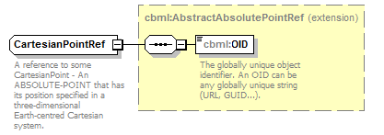
namespace | http://www.sisostds.org/schemas/c-bml/1.0
type | extension of cbml:AbstractAbsolutePointRef
properties
  base | cbml:AbstractAbsolutePointRef
children | cbml:OID
annotation
  documentation
  A reference to some CartesianPoint - An ABSOLUTE-POINT that has its position specified in a three-dimensional Earth-centred Cartesian system.
source | <xs:complexType name="CartesianPointRef">  <xs:annotation>  <xs:documentation xml:lang="en">A reference to some CartesianPoint - An ABSOLUTE-POINT that has its position specified in a three-dimensional Earth-centred Cartesian system.</xs:documentation>  </xs:annotation>  <xs:complexContent>  <xs:extension base="cbml:AbstractAbsolutePointRef"/>  </xs:complexContent>  </xs:complexType>

complexType ConeVolume
diagram | 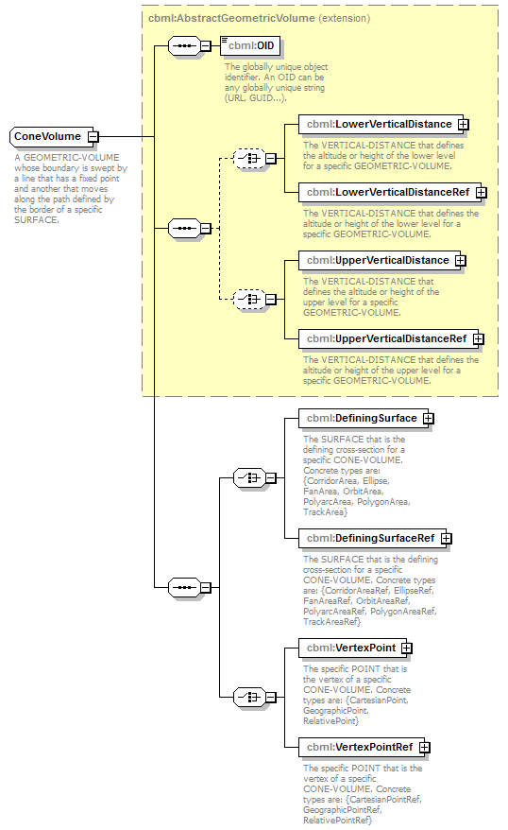
namespace | http://www.sisostds.org/schemas/c-bml/1.0
type | extension of cbml:AbstractGeometricVolume
properties
  base | cbml:AbstractGeometricVolume
children | cbml:OID cbml:LowerVerticalDistance cbml:LowerVerticalDistanceRef cbml:UpperVerticalDistance cbml:UpperVerticalDistanceRef cbml:DefiningSurface cbml:DefiningSurfaceRef cbml:VertexPoint cbml:VertexPointRef
annotation
  documentation
  A GEOMETRIC-VOLUME whose boundary is swept by a line that has a fixed point and another that moves along the path defined by the border of a specific SURFACE.
source | <xs:complexType name="ConeVolume">  <xs:annotation>  <xs:documentation xml:lang="en">A GEOMETRIC-VOLUME whose boundary is swept by a line that has a fixed point and another that moves along the path defined by the border of a specific SURFACE.</xs:documentation>  </xs:annotation>  <xs:complexContent>  <xs:extension base="cbml:AbstractGeometricVolume">  <xs:sequence>  <xs:choice>  <xs:element name="DefiningSurface" type="cbml:AbstractSurface">  <xs:annotation>  <xs:documentation xml:lang="en">The SURFACE that is the defining cross-section for a specific CONE-VOLUME. Concrete types are: {CorridorArea, Ellipse, FanArea, OrbitArea, PolyarcArea, PolygonArea, TrackArea}</xs:documentation>  </xs:annotation>  </xs:element>  <xs:element name="DefiningSurfaceRef" type="cbml:AbstractSurfaceRef">  <xs:annotation>  <xs:documentation xml:lang="en">The SURFACE that is the defining cross-section for a specific CONE-VOLUME. Concrete types are: {CorridorAreaRef, EllipseRef, FanAreaRef, OrbitAreaRef, PolyarcAreaRef, PolygonAreaRef, TrackAreaRef}</xs:documentation>  </xs:annotation>  </xs:element>  </xs:choice>  <xs:choice>  <xs:element name="VertexPoint" type="cbml:AbstractPoint">  <xs:annotation>  <xs:documentation xml:lang="en">The specific POINT that is the vertex of a specific CONE-VOLUME. Concrete types are: {CartesianPoint, GeographicPoint, RelativePoint}</xs:documentation>  </xs:annotation>  </xs:element>  <xs:element name="VertexPointRef" type="cbml:AbstractPointRef">  <xs:annotation>  <xs:documentation xml:lang="en">The specific POINT that is the vertex of a specific CONE-VOLUME. Concrete types are: {CartesianPointRef, GeographicPointRef, RelativePointRef}</xs:documentation>  </xs:annotation>  </xs:element>  </xs:choice>  </xs:sequence>  </xs:extension>  </xs:complexContent>  </xs:complexType>

element ConeVolume/DefiningSurface
diagram | 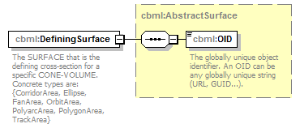
namespace | http://www.sisostds.org/schemas/c-bml/1.0
type | cbml:AbstractSurface
properties
  isRef | 0
  content | complex
children | cbml:OID
annotation
  documentation
  The SURFACE that is the defining cross-section for a specific CONE-VOLUME. Concrete types are: {CorridorArea, Ellipse, FanArea, OrbitArea, PolyarcArea, PolygonArea, TrackArea}
source | <xs:element name="DefiningSurface" type="cbml:AbstractSurface">  <xs:annotation>  <xs:documentation xml:lang="en">The SURFACE that is the defining cross-section for a specific CONE-VOLUME. Concrete types are: {CorridorArea, Ellipse, FanArea, OrbitArea, PolyarcArea, PolygonArea, TrackArea}</xs:documentation>  </xs:annotation>  </xs:element>

element ConeVolume/DefiningSurfaceRef
diagram | 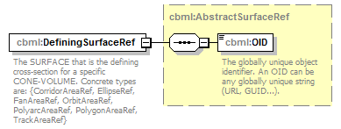
namespace | http://www.sisostds.org/schemas/c-bml/1.0
type | cbml:AbstractSurfaceRef
properties
  isRef | 0
  content | complex
children | cbml:OID
annotation
  documentation
  The SURFACE that is the defining cross-section for a specific CONE-VOLUME. Concrete types are: {CorridorAreaRef, EllipseRef, FanAreaRef, OrbitAreaRef, PolyarcAreaRef, PolygonAreaRef, TrackAreaRef}
source | <xs:element name="DefiningSurfaceRef" type="cbml:AbstractSurfaceRef">  <xs:annotation>  <xs:documentation xml:lang="en">The SURFACE that is the defining cross-section for a specific CONE-VOLUME. Concrete types are: {CorridorAreaRef, EllipseRef, FanAreaRef, OrbitAreaRef, PolyarcAreaRef, PolygonAreaRef, TrackAreaRef}</xs:documentation>  </xs:annotation>  </xs:element>

element ConeVolume/VertexPoint
diagram | 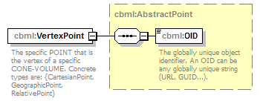
namespace | http://www.sisostds.org/schemas/c-bml/1.0
type | cbml:AbstractPoint
properties
  isRef | 0
  content | complex
children | cbml:OID
annotation
  documentation
  The specific POINT that is the vertex of a specific CONE-VOLUME. Concrete types are: {CartesianPoint, GeographicPoint, RelativePoint}
source | <xs:element name="VertexPoint" type="cbml:AbstractPoint">  <xs:annotation>  <xs:documentation xml:lang="en">The specific POINT that is the vertex of a specific CONE-VOLUME. Concrete types are: {CartesianPoint, GeographicPoint, RelativePoint}</xs:documentation>  </xs:annotation>  </xs:element>

element ConeVolume/VertexPointRef
diagram | 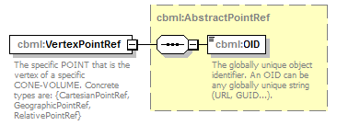
namespace | http://www.sisostds.org/schemas/c-bml/1.0
type | cbml:AbstractPointRef
properties
  isRef | 0
  content | complex
children | cbml:OID
annotation
  documentation
  The specific POINT that is the vertex of a specific CONE-VOLUME. Concrete types are: {CartesianPointRef, GeographicPointRef, RelativePointRef}
source | <xs:element name="VertexPointRef" type="cbml:AbstractPointRef">  <xs:annotation>  <xs:documentation xml:lang="en">The specific POINT that is the vertex of a specific CONE-VOLUME. Concrete types are: {CartesianPointRef, GeographicPointRef, RelativePointRef}</xs:documentation>  </xs:annotation>  </xs:element>

complexType ConeVolumeRef
diagram | 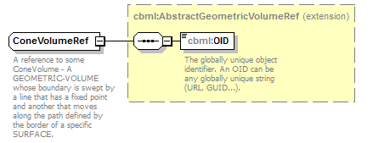
namespace | http://www.sisostds.org/schemas/c-bml/1.0
type | extension of cbml:AbstractGeometricVolumeRef
properties
  base | cbml:AbstractGeometricVolumeRef
children | cbml:OID
annotation
  documentation
  A reference to some ConeVolume - A GEOMETRIC-VOLUME whose boundary is swept by a line that has a fixed point and another that moves along the path defined by the border of a specific SURFACE.
source | <xs:complexType name="ConeVolumeRef">  <xs:annotation>  <xs:documentation xml:lang="en">A reference to some ConeVolume - A GEOMETRIC-VOLUME whose boundary is swept by a line that has a fixed point and another that moves along the path defined by the border of a specific SURFACE.</xs:documentation>  </xs:annotation>  <xs:complexContent>  <xs:extension base="cbml:AbstractGeometricVolumeRef"/>  </xs:complexContent>  </xs:complexType>

complexType CorridorArea
diagram | 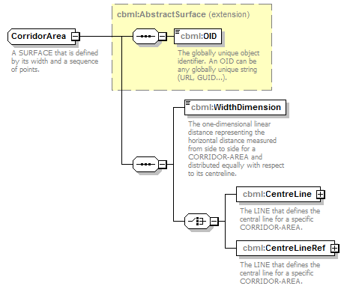
namespace | http://www.sisostds.org/schemas/c-bml/1.0
type | extension of cbml:AbstractSurface
properties
  base | cbml:AbstractSurface
children | cbml:OID cbml:WidthDimension cbml:CentreLine cbml:CentreLineRef
annotation
  documentation
  A SURFACE that is defined by its width and a sequence of points.
source | <xs:complexType name="CorridorArea">  <xs:annotation>  <xs:documentation xml:lang="en">A SURFACE that is defined by its width and a sequence of points.</xs:documentation>  </xs:annotation>  <xs:complexContent>  <xs:extension base="cbml:AbstractSurface">  <xs:sequence>  <xs:element name="WidthDimension" type="jc3iedm:DimensionType12_3">  <xs:annotation>  <xs:documentation xml:lang="en">The one-dimensional linear distance representing the horizontal distance measured from side to side for a CORRIDOR-AREA and distributed equally with respect to its centreline.</xs:documentation>  </xs:annotation>  </xs:element>  <xs:choice>  <xs:element name="CentreLine" type="cbml:Line">  <xs:annotation>  <xs:documentation xml:lang="en">The LINE that defines the central line for a specific CORRIDOR-AREA.</xs:documentation>  </xs:annotation>  </xs:element>  <xs:element name="CentreLineRef" type="cbml:LineRef">  <xs:annotation>  <xs:documentation xml:lang="en">The LINE that defines the central line for a specific CORRIDOR-AREA.</xs:documentation>  </xs:annotation>  </xs:element>  </xs:choice>  </xs:sequence>  </xs:extension>  </xs:complexContent>  </xs:complexType>

element CorridorArea/WidthDimension
diagram | 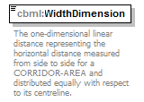
namespace | http://www.sisostds.org/schemas/c-bml/1.0
type | jc3iedm:DimensionType12_3
properties
  isRef | 0
  content | simple
facets
  Kind | Value | annotation
  minInclusive | -999999999.999
  maxInclusive | 999999999.999
  totalDigits | 12
  fractionDigits | 3
annotation
  documentation
  The one-dimensional linear distance representing the horizontal distance measured from side to side for a CORRIDOR-AREA and distributed equally with respect to its centreline.
source | <xs:element name="WidthDimension" type="jc3iedm:DimensionType12_3">  <xs:annotation>  <xs:documentation xml:lang="en">The one-dimensional linear distance representing the horizontal distance measured from side to side for a CORRIDOR-AREA and distributed equally with respect to its centreline.</xs:documentation>  </xs:annotation>  </xs:element>

element CorridorArea/CentreLine
diagram | 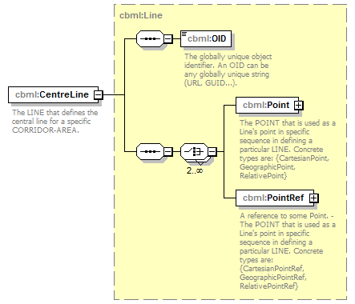
namespace | http://www.sisostds.org/schemas/c-bml/1.0
type | cbml:Line
properties
  isRef | 0
  content | complex
children | cbml:OID cbml:Point cbml:PointRef
annotation
  documentation
  The LINE that defines the central line for a specific CORRIDOR-AREA.
source | <xs:element name="CentreLine" type="cbml:Line">  <xs:annotation>  <xs:documentation xml:lang="en">The LINE that defines the central line for a specific CORRIDOR-AREA.</xs:documentation>  </xs:annotation>  </xs:element>

element CorridorArea/CentreLineRef
diagram | 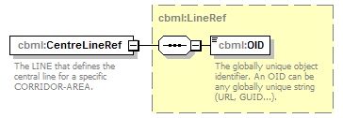
namespace | http://www.sisostds.org/schemas/c-bml/1.0
type | cbml:LineRef
properties
  isRef | 0
  content | complex
children | cbml:OID
annotation
  documentation
  The LINE that defines the central line for a specific CORRIDOR-AREA.
source | <xs:element name="CentreLineRef" type="cbml:LineRef">  <xs:annotation>  <xs:documentation xml:lang="en">The LINE that defines the central line for a specific CORRIDOR-AREA.</xs:documentation>  </xs:annotation>  </xs:element>

complexType CorridorAreaRef
diagram | 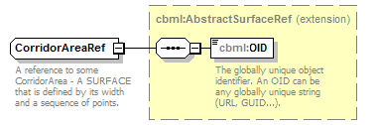
namespace | http://www.sisostds.org/schemas/c-bml/1.0
type | extension of cbml:AbstractSurfaceRef
properties
  base | cbml:AbstractSurfaceRef
children | cbml:OID
annotation
  documentation
  A reference to some CorridorArea - A SURFACE that is defined by its width and a sequence of points.
source | <xs:complexType name="CorridorAreaRef">  <xs:annotation>  <xs:documentation xml:lang="en">A reference to some CorridorArea - A SURFACE that is defined by its width and a sequence of points.</xs:documentation>  </xs:annotation>  <xs:complexContent>  <xs:extension base="cbml:AbstractSurfaceRef"/>  </xs:complexContent>  </xs:complexType>

complexType Ellipse
diagram | 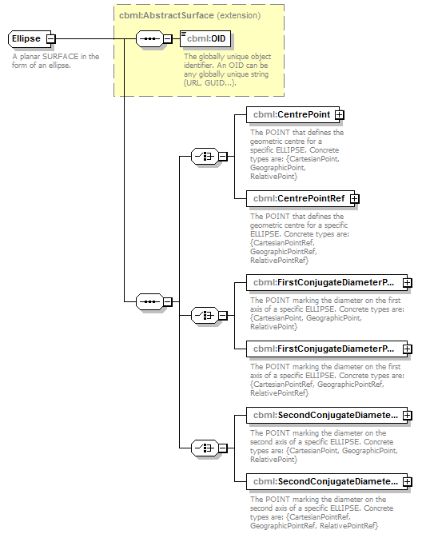
namespace | http://www.sisostds.org/schemas/c-bml/1.0
type | extension of cbml:AbstractSurface
properties
  base | cbml:AbstractSurface
children | cbml:OID cbml:CentrePoint cbml:CentrePointRef cbml:FirstConjugateDiameterPoint cbml:FirstConjugateDiameterPointRef cbml:SecondConjugateDiameterPoint cbml:SecondConjugateDiameterPointRef
annotation
  documentation
  A planar SURFACE in the form of an ellipse.
source | <xs:complexType name="Ellipse">  <xs:annotation>  <xs:documentation xml:lang="en">A planar SURFACE in the form of an ellipse.</xs:documentation>  </xs:annotation>  <xs:complexContent>  <xs:extension base="cbml:AbstractSurface">  <xs:sequence>  <xs:choice>  <xs:element name="CentrePoint" type="cbml:AbstractPoint">  <xs:annotation>  <xs:documentation xml:lang="en">The POINT that defines the geometric centre for a specific ELLIPSE. Concrete types are: {CartesianPoint, GeographicPoint, RelativePoint}</xs:documentation>  </xs:annotation>  </xs:element>  <xs:element name="CentrePointRef" type="cbml:AbstractPointRef">  <xs:annotation>  <xs:documentation xml:lang="en">The POINT that defines the geometric centre for a specific ELLIPSE. Concrete types are: {CartesianPointRef, GeographicPointRef, RelativePointRef}</xs:documentation>  </xs:annotation>  </xs:element>  </xs:choice>  <xs:choice>  <xs:element name="FirstConjugateDiameterPoint" type="cbml:AbstractPoint">  <xs:annotation>  <xs:documentation xml:lang="en">The POINT marking the diameter on the first axis of a specific ELLIPSE. Concrete types are: {CartesianPoint, GeographicPoint, RelativePoint}</xs:documentation>  </xs:annotation>  </xs:element>  <xs:element name="FirstConjugateDiameterPointRef" type="cbml:AbstractPointRef">  <xs:annotation>  <xs:documentation xml:lang="en">The POINT marking the diameter on the first axis of a specific ELLIPSE. Concrete types are: {CartesianPointRef, GeographicPointRef, RelativePointRef}</xs:documentation>  </xs:annotation>  </xs:element>  </xs:choice>  <xs:choice>  <xs:element name="SecondConjugateDiameterPoint" type="cbml:AbstractPoint">  <xs:annotation>  <xs:documentation xml:lang="en">The POINT marking the diameter on the second axis of a specific ELLIPSE. Concrete types are: {CartesianPoint, GeographicPoint, RelativePoint}</xs:documentation>  </xs:annotation>  </xs:element>  <xs:element name="SecondConjugateDiameterPointRef" type="cbml:AbstractPointRef">  <xs:annotation>  <xs:documentation xml:lang="en">The POINT marking the diameter on the second axis of a specific ELLIPSE. Concrete types are: {CartesianPointRef, GeographicPointRef, RelativePointRef}</xs:documentation>  </xs:annotation>  </xs:element>  </xs:choice>  </xs:sequence>  </xs:extension>  </xs:complexContent>  </xs:complexType>

element Ellipse/CentrePoint
diagram | 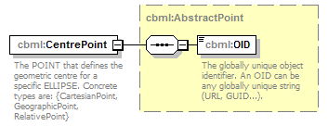
namespace | http://www.sisostds.org/schemas/c-bml/1.0
type | cbml:AbstractPoint
properties
  isRef | 0
  content | complex
children | cbml:OID
annotation
  documentation
  The POINT that defines the geometric centre for a specific ELLIPSE. Concrete types are: {CartesianPoint, GeographicPoint, RelativePoint}
source | <xs:element name="CentrePoint" type="cbml:AbstractPoint">  <xs:annotation>  <xs:documentation xml:lang="en">The POINT that defines the geometric centre for a specific ELLIPSE. Concrete types are: {CartesianPoint, GeographicPoint, RelativePoint}</xs:documentation>  </xs:annotation>  </xs:element>

element Ellipse/CentrePointRef
diagram | 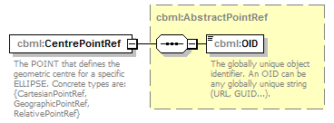
namespace | http://www.sisostds.org/schemas/c-bml/1.0
type | cbml:AbstractPointRef
properties
  isRef | 0
  content | complex
children | cbml:OID
annotation
  documentation
  The POINT that defines the geometric centre for a specific ELLIPSE. Concrete types are: {CartesianPointRef, GeographicPointRef, RelativePointRef}
source | <xs:element name="CentrePointRef" type="cbml:AbstractPointRef">  <xs:annotation>  <xs:documentation xml:lang="en">The POINT that defines the geometric centre for a specific ELLIPSE. Concrete types are: {CartesianPointRef, GeographicPointRef, RelativePointRef}</xs:documentation>  </xs:annotation>  </xs:element>

element Ellipse/FirstConjugateDiameterPoint
diagram | 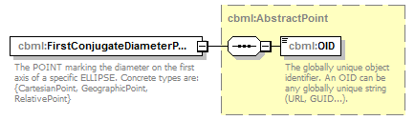
namespace | http://www.sisostds.org/schemas/c-bml/1.0
type | cbml:AbstractPoint
properties
  isRef | 0
  content | complex
children | cbml:OID
annotation
  documentation
  The POINT marking the diameter on the first axis of a specific ELLIPSE. Concrete types are: {CartesianPoint, GeographicPoint, RelativePoint}
source | <xs:element name="FirstConjugateDiameterPoint" type="cbml:AbstractPoint">  <xs:annotation>  <xs:documentation xml:lang="en">The POINT marking the diameter on the first axis of a specific ELLIPSE. Concrete types are: {CartesianPoint, GeographicPoint, RelativePoint}</xs:documentation>  </xs:annotation>  </xs:element>

element Ellipse/FirstConjugateDiameterPointRef
diagram | 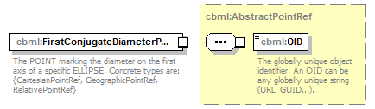
namespace | http://www.sisostds.org/schemas/c-bml/1.0
type | cbml:AbstractPointRef
properties
  isRef | 0
  content | complex
children | cbml:OID
annotation
  documentation
  The POINT marking the diameter on the first axis of a specific ELLIPSE. Concrete types are: {CartesianPointRef, GeographicPointRef, RelativePointRef}
source | <xs:element name="FirstConjugateDiameterPointRef" type="cbml:AbstractPointRef">  <xs:annotation>  <xs:documentation xml:lang="en">The POINT marking the diameter on the first axis of a specific ELLIPSE. Concrete types are: {CartesianPointRef, GeographicPointRef, RelativePointRef}</xs:documentation>  </xs:annotation>  </xs:element>

element Ellipse/SecondConjugateDiameterPoint
diagram | 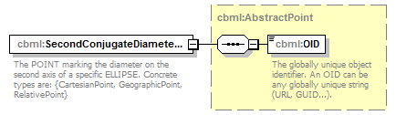
namespace | http://www.sisostds.org/schemas/c-bml/1.0
type | cbml:AbstractPoint
properties
  isRef | 0
  content | complex
children | cbml:OID
annotation
  documentation
  The POINT marking the diameter on the second axis of a specific ELLIPSE. Concrete types are: {CartesianPoint, GeographicPoint, RelativePoint}
source | <xs:element name="SecondConjugateDiameterPoint" type="cbml:AbstractPoint">  <xs:annotation>  <xs:documentation xml:lang="en">The POINT marking the diameter on the second axis of a specific ELLIPSE. Concrete types are: {CartesianPoint, GeographicPoint, RelativePoint}</xs:documentation>  </xs:annotation>  </xs:element>

element Ellipse/SecondConjugateDiameterPointRef
diagram | 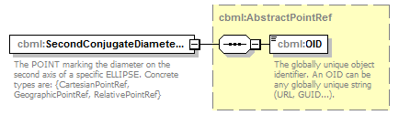
namespace | http://www.sisostds.org/schemas/c-bml/1.0
type | cbml:AbstractPointRef
properties
  isRef | 0
  content | complex
children | cbml:OID
annotation
  documentation
  The POINT marking the diameter on the second axis of a specific ELLIPSE. Concrete types are: {CartesianPointRef, GeographicPointRef, RelativePointRef}
source | <xs:element name="SecondConjugateDiameterPointRef" type="cbml:AbstractPointRef">  <xs:annotation>  <xs:documentation xml:lang="en">The POINT marking the diameter on the second axis of a specific ELLIPSE. Concrete types are: {CartesianPointRef, GeographicPointRef, RelativePointRef}</xs:documentation>  </xs:annotation>  </xs:element>

complexType EllipseRef
diagram | 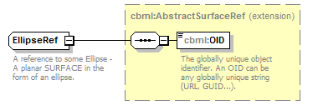
namespace | http://www.sisostds.org/schemas/c-bml/1.0
type | extension of cbml:AbstractSurfaceRef
properties
  base | cbml:AbstractSurfaceRef
children | cbml:OID
annotation
  documentation
  A reference to some Ellipse - A planar SURFACE in the form of an ellipse.
source | <xs:complexType name="EllipseRef">  <xs:annotation>  <xs:documentation xml:lang="en">A reference to some Ellipse - A planar SURFACE in the form of an ellipse.</xs:documentation>  </xs:annotation>  <xs:complexContent>  <xs:extension base="cbml:AbstractSurfaceRef"/>  </xs:complexContent>  </xs:complexType>

complexType FanArea
diagram | 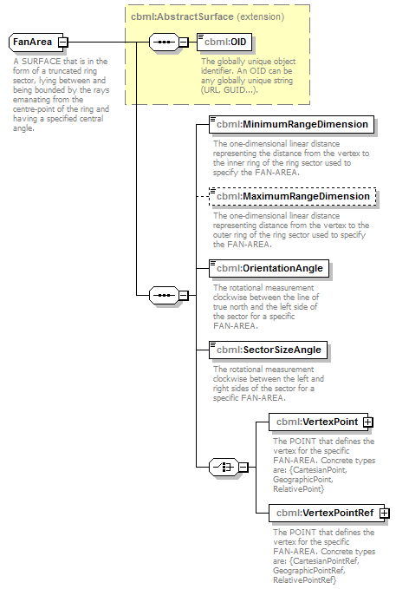
namespace | http://www.sisostds.org/schemas/c-bml/1.0
type | extension of cbml:AbstractSurface
properties
  base | cbml:AbstractSurface
children | cbml:OID cbml:MinimumRangeDimension cbml:MaximumRangeDimension cbml:OrientationAngle cbml:SectorSizeAngle cbml:VertexPoint cbml:VertexPointRef
annotation
  documentation
  A SURFACE that is in the form of a truncated ring sector, lying between and being bounded by the rays emanating from the centre-point of the ring and having a specified central angle.
source | <xs:complexType name="FanArea">  <xs:annotation>  <xs:documentation xml:lang="en">A SURFACE that is in the form of a truncated ring sector, lying between and being bounded by the rays emanating from the centre-point of the ring and having a specified central angle.</xs:documentation>  </xs:annotation>  <xs:complexContent>  <xs:extension base="cbml:AbstractSurface">  <xs:sequence>  <xs:element name="MinimumRangeDimension" type="jc3iedm:DimensionType12_3">  <xs:annotation>  <xs:documentation xml:lang="en">The one-dimensional linear distance representing the distance from the vertex to the inner ring of the ring sector used to specify the FAN-AREA.</xs:documentation>  </xs:annotation>  </xs:element>  <xs:element name="MaximumRangeDimension" type="jc3iedm:DimensionType12_3" minOccurs="0">  <xs:annotation>  <xs:documentation xml:lang="en">The one-dimensional linear distance representing distance from the vertex to the outer ring of the ring sector used to specify the FAN-AREA.</xs:documentation>  </xs:annotation>  </xs:element>  <xs:element name="OrientationAngle" type="jc3iedm:AngleTypeRangeAngle7_4">  <xs:annotation>  <xs:documentation xml:lang="en">The rotational measurement clockwise between the line of true north and the left side of the sector for a specific FAN-AREA.</xs:documentation>  </xs:annotation>  </xs:element>  <xs:element name="SectorSizeAngle" type="jc3iedm:AngleTypeRangeAngle7_4">  <xs:annotation>  <xs:documentation xml:lang="en">The rotational measurement clockwise between the left and right sides of the sector for a specific FAN-AREA.</xs:documentation>  </xs:annotation>  </xs:element>  <xs:choice>  <xs:element name="VertexPoint" type="cbml:AbstractPoint">  <xs:annotation>  <xs:documentation xml:lang="en">The POINT that defines the vertex for the specific FAN-AREA. Concrete types are: {CartesianPoint, GeographicPoint, RelativePoint}</xs:documentation>  </xs:annotation>  </xs:element>  <xs:element name="VertexPointRef" type="cbml:AbstractPointRef">  <xs:annotation>  <xs:documentation xml:lang="en">The POINT that defines the vertex for the specific FAN-AREA. Concrete types are: {CartesianPointRef, GeographicPointRef, RelativePointRef}</xs:documentation>  </xs:annotation>  </xs:element>  </xs:choice>  </xs:sequence>  </xs:extension>  </xs:complexContent>  </xs:complexType>

element FanArea/MinimumRangeDimension
diagram | 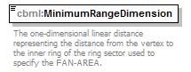
namespace | http://www.sisostds.org/schemas/c-bml/1.0
type | jc3iedm:DimensionType12_3
properties
  isRef | 0
  content | simple
facets
  Kind | Value | annotation
  minInclusive | -999999999.999
  maxInclusive | 999999999.999
  totalDigits | 12
  fractionDigits | 3
annotation
  documentation
  The one-dimensional linear distance representing the distance from the vertex to the inner ring of the ring sector used to specify the FAN-AREA.
source | <xs:element name="MinimumRangeDimension" type="jc3iedm:DimensionType12_3">  <xs:annotation>  <xs:documentation xml:lang="en">The one-dimensional linear distance representing the distance from the vertex to the inner ring of the ring sector used to specify the FAN-AREA.</xs:documentation>  </xs:annotation>  </xs:element>

element FanArea/MaximumRangeDimension
diagram | 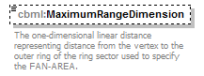
namespace | http://www.sisostds.org/schemas/c-bml/1.0
type | jc3iedm:DimensionType12_3
properties
  isRef | 0
  minOcc | 0
  maxOcc | 1
  content | simple
facets
  Kind | Value | annotation
  minInclusive | -999999999.999
  maxInclusive | 999999999.999
  totalDigits | 12
  fractionDigits | 3
annotation
  documentation
  The one-dimensional linear distance representing distance from the vertex to the outer ring of the ring sector used to specify the FAN-AREA.
source | <xs:element name="MaximumRangeDimension" type="jc3iedm:DimensionType12_3" minOccurs="0">  <xs:annotation>  <xs:documentation xml:lang="en">The one-dimensional linear distance representing distance from the vertex to the outer ring of the ring sector used to specify the FAN-AREA.</xs:documentation>  </xs:annotation>  </xs:element>

element FanArea/OrientationAngle
diagram | 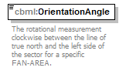
namespace | http://www.sisostds.org/schemas/c-bml/1.0
type | jc3iedm:AngleTypeRangeAngle7_4
properties
  isRef | 0
  content | simple
facets
  Kind | Value | annotation
  minInclusive | 0.0000
  maxInclusive | 359.9999
  totalDigits | 7
  fractionDigits | 4
annotation
  documentation
  The rotational measurement clockwise between the line of true north and the left side of the sector for a specific FAN-AREA.
source | <xs:element name="OrientationAngle" type="jc3iedm:AngleTypeRangeAngle7_4">  <xs:annotation>  <xs:documentation xml:lang="en">The rotational measurement clockwise between the line of true north and the left side of the sector for a specific FAN-AREA.</xs:documentation>  </xs:annotation>  </xs:element>

element FanArea/SectorSizeAngle
diagram | 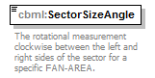
namespace | http://www.sisostds.org/schemas/c-bml/1.0
type | jc3iedm:AngleTypeRangeAngle7_4
properties
  isRef | 0
  content | simple
facets
  Kind | Value | annotation
  minInclusive | 0.0000
  maxInclusive | 359.9999
  totalDigits | 7
  fractionDigits | 4
annotation
  documentation
  The rotational measurement clockwise between the left and right sides of the sector for a specific FAN-AREA.
source | <xs:element name="SectorSizeAngle" type="jc3iedm:AngleTypeRangeAngle7_4">  <xs:annotation>  <xs:documentation xml:lang="en">The rotational measurement clockwise between the left and right sides of the sector for a specific FAN-AREA.</xs:documentation>  </xs:annotation>  </xs:element>

element FanArea/VertexPoint
diagram | 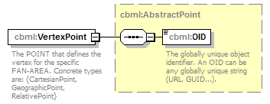
namespace | http://www.sisostds.org/schemas/c-bml/1.0
type | cbml:AbstractPoint
properties
  isRef | 0
  content | complex
children | cbml:OID
annotation
  documentation
  The POINT that defines the vertex for the specific FAN-AREA. Concrete types are: {CartesianPoint, GeographicPoint, RelativePoint}
source | <xs:element name="VertexPoint" type="cbml:AbstractPoint">  <xs:annotation>  <xs:documentation xml:lang="en">The POINT that defines the vertex for the specific FAN-AREA. Concrete types are: {CartesianPoint, GeographicPoint, RelativePoint}</xs:documentation>  </xs:annotation>  </xs:element>

element FanArea/VertexPointRef
diagram | 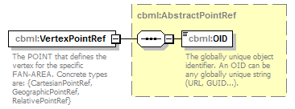
namespace | http://www.sisostds.org/schemas/c-bml/1.0
type | cbml:AbstractPointRef
properties
  isRef | 0
  content | complex
children | cbml:OID
annotation
  documentation
  The POINT that defines the vertex for the specific FAN-AREA. Concrete types are: {CartesianPointRef, GeographicPointRef, RelativePointRef}
source | <xs:element name="VertexPointRef" type="cbml:AbstractPointRef">  <xs:annotation>  <xs:documentation xml:lang="en">The POINT that defines the vertex for the specific FAN-AREA. Concrete types are: {CartesianPointRef, GeographicPointRef, RelativePointRef}</xs:documentation>  </xs:annotation>  </xs:element>

complexType FanAreaRef
diagram | 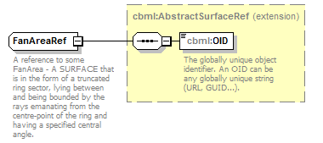
namespace | http://www.sisostds.org/schemas/c-bml/1.0
type | extension of cbml:AbstractSurfaceRef
properties
  base | cbml:AbstractSurfaceRef
children | cbml:OID
annotation
  documentation
  A reference to some FanArea - A SURFACE that is in the form of a truncated ring sector, lying between and being bounded by the rays emanating from the centre-point of the ring and having a specified central angle.
source | <xs:complexType name="FanAreaRef">  <xs:annotation>  <xs:documentation xml:lang="en">A reference to some FanArea - A SURFACE that is in the form of a truncated ring sector, lying between and being bounded by the rays emanating from the centre-point of the ring and having a specified central angle.</xs:documentation>  </xs:annotation>  <xs:complexContent>  <xs:extension base="cbml:AbstractSurfaceRef"/>  </xs:complexContent>  </xs:complexType>

complexType GeographicPoint
diagram | 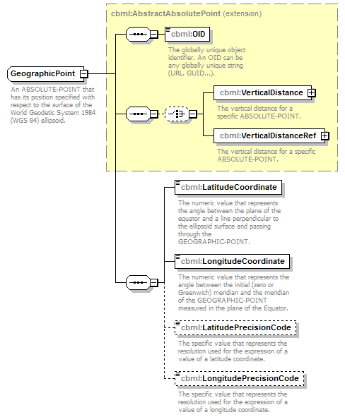
namespace | http://www.sisostds.org/schemas/c-bml/1.0
type | extension of cbml:AbstractAbsolutePoint
properties
  base | cbml:AbstractAbsolutePoint
children | cbml:OID cbml:VerticalDistance cbml:VerticalDistanceRef cbml:LatitudeCoordinate cbml:LongitudeCoordinate cbml:LatitudePrecisionCode cbml:LongitudePrecisionCode
annotation
  documentation
  An ABSOLUTE-POINT that has its position specified with respect to the surface of the World Geodetic System 1984 (WGS 84) ellipsoid.
source | <xs:complexType name="GeographicPoint">  <xs:annotation>  <xs:documentation xml:lang="en">An ABSOLUTE-POINT that has its position specified with respect to the surface of the World Geodetic System 1984 (WGS 84) ellipsoid.</xs:documentation>  </xs:annotation>  <xs:complexContent>  <xs:extension base="cbml:AbstractAbsolutePoint">  <xs:sequence>  <xs:element name="LatitudeCoordinate" type="jc3iedm:LatitudeCoordinateTypeRangeLatitude9_6">  <xs:annotation>  <xs:documentation xml:lang="en">The numeric value that represents the angle between the plane of the equator and a line perpendicular to the ellipsoid surface and passing through the GEOGRAPHIC-POINT.</xs:documentation>  </xs:annotation>  </xs:element>  <xs:element name="LongitudeCoordinate" type="jc3iedm:LongitudeCoordinateTypeRangeLongitude10_6">  <xs:annotation>  <xs:documentation xml:lang="en">The numeric value that represents the angle between the initial (zero or Greenwich) meridian and the meridian of the GEOGRAPHIC-POINT measured in the plane of the Equator.</xs:documentation>  </xs:annotation>  </xs:element>  <xs:element name="LatitudePrecisionCode" type="jc3iedm:AnglePrecisionCode" minOccurs="0">  <xs:annotation>  <xs:documentation xml:lang="en">The specific value that represents the resolution used for the expression of a value of a latitude coordinate.</xs:documentation>  </xs:annotation>  </xs:element>  <xs:element name="LongitudePrecisionCode" type="jc3iedm:AnglePrecisionCode" minOccurs="0">  <xs:annotation>  <xs:documentation xml:lang="en">The specific value that represents the resolution used for the expression of a value of a longitude coordinate.</xs:documentation>  </xs:annotation>  </xs:element>  </xs:sequence>  </xs:extension>  </xs:complexContent>  </xs:complexType>

element GeographicPoint/LatitudeCoordinate
diagram | 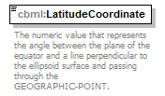
namespace | http://www.sisostds.org/schemas/c-bml/1.0
type | jc3iedm:LatitudeCoordinateTypeRangeLatitude9_6
properties
  isRef | 0
  content | simple
facets
  Kind | Value | annotation
  minInclusive | -90.000000
  maxInclusive | 90.000000
  totalDigits | 9
  fractionDigits | 6
annotation
  documentation
  The numeric value that represents the angle between the plane of the equator and a line perpendicular to the ellipsoid surface and passing through the GEOGRAPHIC-POINT.
source | <xs:element name="LatitudeCoordinate" type="jc3iedm:LatitudeCoordinateTypeRangeLatitude9_6">  <xs:annotation>  <xs:documentation xml:lang="en">The numeric value that represents the angle between the plane of the equator and a line perpendicular to the ellipsoid surface and passing through the GEOGRAPHIC-POINT.</xs:documentation>  </xs:annotation>  </xs:element>

element GeographicPoint/LongitudeCoordinate
diagram | 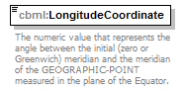
namespace | http://www.sisostds.org/schemas/c-bml/1.0
type | jc3iedm:LongitudeCoordinateTypeRangeLongitude10_6
properties
  isRef | 0
  content | simple
facets
  Kind | Value | annotation
  minInclusive | -180.000000
  maxInclusive | 180.000000
  totalDigits | 10
  fractionDigits | 6
annotation
  documentation
  The numeric value that represents the angle between the initial (zero or Greenwich) meridian and the meridian of the GEOGRAPHIC-POINT measured in the plane of the Equator.
source | <xs:element name="LongitudeCoordinate" type="jc3iedm:LongitudeCoordinateTypeRangeLongitude10_6">  <xs:annotation>  <xs:documentation xml:lang="en">The numeric value that represents the angle between the initial (zero or Greenwich) meridian and the meridian of the GEOGRAPHIC-POINT measured in the plane of the Equator.</xs:documentation>  </xs:annotation>  </xs:element>

element GeographicPoint/LatitudePrecisionCode
diagram | 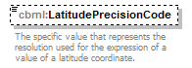
namespace | http://www.sisostds.org/schemas/c-bml/1.0
type | jc3iedm:AnglePrecisionCode
properties
  isRef | 0
  minOcc | 0
  maxOcc | 1
  content | simple
facets
  Kind | Value | annotation
  enumeration | 1000MN
    documentation
    <Definition xml:lang="en">Angular precision is expressed to the precision of 1/1000 of a minute.</Definition>
    appinfo
    <DisplayValue xml:lang="en">1/1000 minute</DisplayValue>
  enumeration | 100MN
    documentation
    <Definition xml:lang="en">Angular precision is expressed to the precision of 1/100 of a minute (centiminute).</Definition>
    appinfo
    <DisplayValue xml:lang="en">1/100 minute</DisplayValue>
  enumeration | 100SEC
    documentation
    <Definition xml:lang="en">Angular precision is expressed to the precision of 1/100 of a second.</Definition>
    appinfo
    <DisplayValue xml:lang="en">1/100 second</DisplayValue>
  enumeration | 10DEG
    documentation
    <Definition xml:lang="en">Angular precision is expressed to the precision of 1/10 of a degree.</Definition>
    appinfo
    <DisplayValue xml:lang="en">1/10 degree</DisplayValue>
  enumeration | 10MN
    documentation
    <Definition xml:lang="en">Angular precision is expressed to the precision of 1/10 of a minute.</Definition>
    appinfo
    <DisplayValue xml:lang="en">1/10 minute</DisplayValue>
  enumeration | 10SEC
    documentation
    <Definition xml:lang="en">Angular precision is expressed to the precision of 1/10 of a second.</Definition>
    appinfo
    <DisplayValue xml:lang="en">1/10 second</DisplayValue>
  enumeration | DEGREE
    documentation
    <Definition xml:lang="en">Angular precision is expressed to the precision of a degree (60 minutes).</Definition>
    appinfo
    <DisplayValue xml:lang="en">Degree</DisplayValue>
  enumeration | MIL
    documentation
    <Definition xml:lang="en">Angular precision is expressed to the precision of 1 mil (1/6400 of a full circle).</Definition>
    appinfo
    <DisplayValue xml:lang="en">Mil</DisplayValue>
  enumeration | MINUTE
    documentation
    <Definition xml:lang="en">Angular precision is expressed to the precision of a minute (60 seconds).</Definition>
    appinfo
    <DisplayValue xml:lang="en">Minute</DisplayValue>
  enumeration | SECOND
    documentation
    <Definition xml:lang="en">Angular precision is expressed to the precision of a second.</Definition>
    appinfo
    <DisplayValue xml:lang="en">Second</DisplayValue>
annotation
  documentation
  The specific value that represents the resolution used for the expression of a value of a latitude coordinate.
source | <xs:element name="LatitudePrecisionCode" type="jc3iedm:AnglePrecisionCode" minOccurs="0">  <xs:annotation>  <xs:documentation xml:lang="en">The specific value that represents the resolution used for the expression of a value of a latitude coordinate.</xs:documentation>  </xs:annotation>  </xs:element>

element GeographicPoint/LongitudePrecisionCode
diagram | 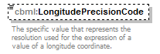
namespace | http://www.sisostds.org/schemas/c-bml/1.0
type | jc3iedm:AnglePrecisionCode
properties
  isRef | 0
  minOcc | 0
  maxOcc | 1
  content | simple
facets
  Kind | Value | annotation
  enumeration | 1000MN
    documentation
    <Definition xml:lang="en">Angular precision is expressed to the precision of 1/1000 of a minute.</Definition>
    appinfo
    <DisplayValue xml:lang="en">1/1000 minute</DisplayValue>
  enumeration | 100MN
    documentation
    <Definition xml:lang="en">Angular precision is expressed to the precision of 1/100 of a minute (centiminute).</Definition>
    appinfo
    <DisplayValue xml:lang="en">1/100 minute</DisplayValue>
  enumeration | 100SEC
    documentation
    <Definition xml:lang="en">Angular precision is expressed to the precision of 1/100 of a second.</Definition>
    appinfo
    <DisplayValue xml:lang="en">1/100 second</DisplayValue>
  enumeration | 10DEG
    documentation
    <Definition xml:lang="en">Angular precision is expressed to the precision of 1/10 of a degree.</Definition>
    appinfo
    <DisplayValue xml:lang="en">1/10 degree</DisplayValue>
  enumeration | 10MN
    documentation
    <Definition xml:lang="en">Angular precision is expressed to the precision of 1/10 of a minute.</Definition>
    appinfo
    <DisplayValue xml:lang="en">1/10 minute</DisplayValue>
  enumeration | 10SEC
    documentation
    <Definition xml:lang="en">Angular precision is expressed to the precision of 1/10 of a second.</Definition>
    appinfo
    <DisplayValue xml:lang="en">1/10 second</DisplayValue>
  enumeration | DEGREE
    documentation
    <Definition xml:lang="en">Angular precision is expressed to the precision of a degree (60 minutes).</Definition>
    appinfo
    <DisplayValue xml:lang="en">Degree</DisplayValue>
  enumeration | MIL
    documentation
    <Definition xml:lang="en">Angular precision is expressed to the precision of 1 mil (1/6400 of a full circle).</Definition>
    appinfo
    <DisplayValue xml:lang="en">Mil</DisplayValue>
  enumeration | MINUTE
    documentation
    <Definition xml:lang="en">Angular precision is expressed to the precision of a minute (60 seconds).</Definition>
    appinfo
    <DisplayValue xml:lang="en">Minute</DisplayValue>
  enumeration | SECOND
    documentation
    <Definition xml:lang="en">Angular precision is expressed to the precision of a second.</Definition>
    appinfo
    <DisplayValue xml:lang="en">Second</DisplayValue>
annotation
  documentation
  The specific value that represents the resolution used for the expression of a value of a longitude coordinate.
source | <xs:element name="LongitudePrecisionCode" type="jc3iedm:AnglePrecisionCode" minOccurs="0">  <xs:annotation>  <xs:documentation xml:lang="en">The specific value that represents the resolution used for the expression of a value of a longitude coordinate.</xs:documentation>  </xs:annotation>  </xs:element>

complexType GeographicPointRef
diagram | 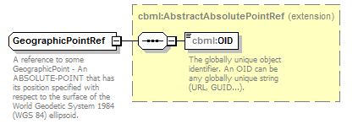
namespace | http://www.sisostds.org/schemas/c-bml/1.0
type | extension of cbml:AbstractAbsolutePointRef
properties
  base | cbml:AbstractAbsolutePointRef
children | cbml:OID
annotation
  documentation
  A reference to some GeographicPoint - An ABSOLUTE-POINT that has its position specified with respect to the surface of the World Geodetic System 1984 (WGS 84) ellipsoid.
source | <xs:complexType name="GeographicPointRef">  <xs:annotation>  <xs:documentation xml:lang="en">A reference to some GeographicPoint - An ABSOLUTE-POINT that has its position specified with respect to the surface of the World Geodetic System 1984 (WGS 84) ellipsoid.</xs:documentation>  </xs:annotation>  <xs:complexContent>  <xs:extension base="cbml:AbstractAbsolutePointRef"/>  </xs:complexContent>  </xs:complexType>

complexType Line
diagram | 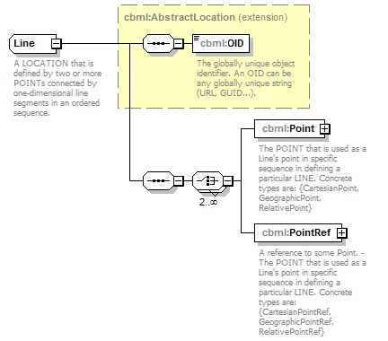
namespace | http://www.sisostds.org/schemas/c-bml/1.0
type | extension of cbml:AbstractLocation
properties
  base | cbml:AbstractLocation
children | cbml:OID cbml:Point cbml:PointRef
used by
  elements | PolygonArea/BoundingLine CorridorArea/CentreLine PolyarcArea/DefiningLine
annotation
  documentation
  A LOCATION that is defined by two or more POINTs connected by one-dimensional line segments in an ordered sequence.
source | <xs:complexType name="Line">  <xs:annotation>  <xs:documentation xml:lang="en">A LOCATION that is defined by two or more POINTs connected by one-dimensional line segments in an ordered sequence.</xs:documentation>  </xs:annotation>  <xs:complexContent>  <xs:extension base="cbml:AbstractLocation">  <xs:sequence>  <xs:choice minOccurs="2" maxOccurs="unbounded">  <xs:element name="Point" type="cbml:AbstractPoint">  <xs:annotation>  <xs:documentation xml:lang="en">The POINT that is used as a Line's point in specific sequence in defining a particular LINE. Concrete types are: {CartesianPoint, GeographicPoint, RelativePoint}</xs:documentation>  </xs:annotation>  </xs:element>  <xs:element name="PointRef" type="cbml:AbstractPointRef">  <xs:annotation>  <xs:documentation xml:lang="en">A reference to some Point. - The POINT that is used as a Line's point in specific sequence in defining a particular LINE. Concrete types are: {CartesianPointRef, GeographicPointRef, RelativePointRef}</xs:documentation>  </xs:annotation>  </xs:element>  </xs:choice>  </xs:sequence>  </xs:extension>  </xs:complexContent>  </xs:complexType>

element Line/Point
diagram | 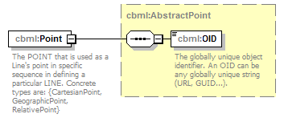
namespace | http://www.sisostds.org/schemas/c-bml/1.0
type | cbml:AbstractPoint
properties
  isRef | 0
  content | complex
children | cbml:OID
annotation
  documentation
  The POINT that is used as a Line's point in specific sequence in defining a particular LINE. Concrete types are: {CartesianPoint, GeographicPoint, RelativePoint}
source | <xs:element name="Point" type="cbml:AbstractPoint">  <xs:annotation>  <xs:documentation xml:lang="en">The POINT that is used as a Line's point in specific sequence in defining a particular LINE. Concrete types are: {CartesianPoint, GeographicPoint, RelativePoint}</xs:documentation>  </xs:annotation>  </xs:element>

element Line/PointRef
diagram | 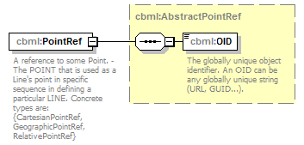
namespace | http://www.sisostds.org/schemas/c-bml/1.0
type | cbml:AbstractPointRef
properties
  isRef | 0
  content | complex
children | cbml:OID
annotation
  documentation
  A reference to some Point. - The POINT that is used as a Line's point in specific sequence in defining a particular LINE. Concrete types are: {CartesianPointRef, GeographicPointRef, RelativePointRef}
source | <xs:element name="PointRef" type="cbml:AbstractPointRef">  <xs:annotation>  <xs:documentation xml:lang="en">A reference to some Point. - The POINT that is used as a Line's point in specific sequence in defining a particular LINE. Concrete types are: {CartesianPointRef, GeographicPointRef, RelativePointRef}</xs:documentation>  </xs:annotation>  </xs:element>

complexType LineRef
diagram | 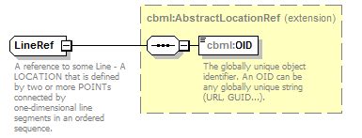
namespace | http://www.sisostds.org/schemas/c-bml/1.0
type | extension of cbml:AbstractLocationRef
properties
  base | cbml:AbstractLocationRef
children | cbml:OID
used by
  elements | PolygonArea/BoundingLineRef CorridorArea/CentreLineRef PolyarcArea/DefiningLineRef
annotation
  documentation
  A reference to some Line - A LOCATION that is defined by two or more POINTs connected by one-dimensional line segments in an ordered sequence.
source | <xs:complexType name="LineRef">  <xs:annotation>  <xs:documentation xml:lang="en">A reference to some Line - A LOCATION that is defined by two or more POINTs connected by one-dimensional line segments in an ordered sequence.</xs:documentation>  </xs:annotation>  <xs:complexContent>  <xs:extension base="cbml:AbstractLocationRef"/>  </xs:complexContent>  </xs:complexType>

complexType ObjectReference
diagram | 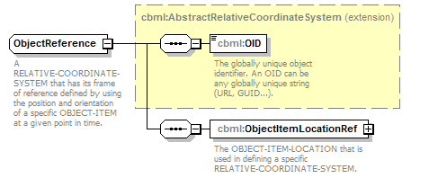
namespace | http://www.sisostds.org/schemas/c-bml/1.0
type | extension of cbml:AbstractRelativeCoordinateSystem
properties
  base | cbml:AbstractRelativeCoordinateSystem
children | cbml:OID cbml:ObjectItemLocationRef
annotation
  documentation
  A RELATIVE-COORDINATE-SYSTEM that has its frame of reference defined by using the position and orientation of a specific OBJECT-ITEM at a given point in time.
source | <xs:complexType name="ObjectReference">  <xs:annotation>  <xs:documentation xml:lang="en">A RELATIVE-COORDINATE-SYSTEM that has its frame of reference defined by using the position and orientation of a specific OBJECT-ITEM at a given point in time.</xs:documentation>  </xs:annotation>  <xs:complexContent>  <xs:extension base="cbml:AbstractRelativeCoordinateSystem">  <xs:sequence>  <xs:element name="ObjectItemLocationRef" type="cbml:ObjectItemLocationRef">  <xs:annotation>  <xs:documentation xml:lang="en">The OBJECT-ITEM-LOCATION that is used in defining a specific RELATIVE-COORDINATE-SYSTEM.</xs:documentation>  </xs:annotation>  </xs:element>  </xs:sequence>  </xs:extension>  </xs:complexContent>  </xs:complexType>

element ObjectReference/ObjectItemLocationRef
diagram | 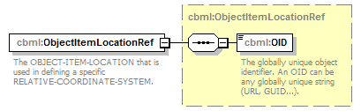
namespace | http://www.sisostds.org/schemas/c-bml/1.0
type | cbml:ObjectItemLocationRef
properties
  isRef | 0
  content | complex
children | cbml:OID
annotation
  documentation
  The OBJECT-ITEM-LOCATION that is used in defining a specific RELATIVE-COORDINATE-SYSTEM.
source | <xs:element name="ObjectItemLocationRef" type="cbml:ObjectItemLocationRef">  <xs:annotation>  <xs:documentation xml:lang="en">The OBJECT-ITEM-LOCATION that is used in defining a specific RELATIVE-COORDINATE-SYSTEM.</xs:documentation>  </xs:annotation>  </xs:element>

complexType ObjectReferenceRef
diagram | 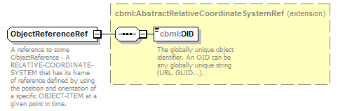
namespace | http://www.sisostds.org/schemas/c-bml/1.0
type | extension of cbml:AbstractRelativeCoordinateSystemRef
properties
  base | cbml:AbstractRelativeCoordinateSystemRef
children | cbml:OID
annotation
  documentation
  A reference to some ObjectReference - A RELATIVE-COORDINATE-SYSTEM that has its frame of reference defined by using the position and orientation of a specific OBJECT-ITEM at a given point in time.
source | <xs:complexType name="ObjectReferenceRef">  <xs:annotation>  <xs:documentation xml:lang="en">A reference to some ObjectReference - A RELATIVE-COORDINATE-SYSTEM that has its frame of reference defined by using the position and orientation of a specific OBJECT-ITEM at a given point in time.</xs:documentation>  </xs:annotation>  <xs:complexContent>  <xs:extension base="cbml:AbstractRelativeCoordinateSystemRef"/>  </xs:complexContent>  </xs:complexType>

complexType OrbitArea
diagram | 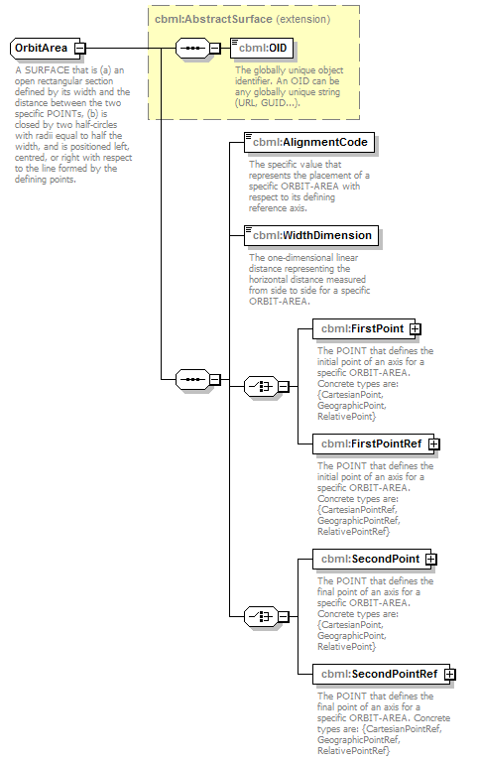
namespace | http://www.sisostds.org/schemas/c-bml/1.0
type | extension of cbml:AbstractSurface
properties
  base | cbml:AbstractSurface
children | cbml:OID cbml:AlignmentCode cbml:WidthDimension cbml:FirstPoint cbml:FirstPointRef cbml:SecondPoint cbml:SecondPointRef
annotation
  documentation
  A SURFACE that is (a) an open rectangular section defined by its width and the distance between the two specific POINTs, (b) is closed by two half-circles with radii equal to half the width, and is positioned left, centred, or right with respect to the line formed by the defining points.
source | <xs:complexType name="OrbitArea">  <xs:annotation>  <xs:documentation xml:lang="en">A SURFACE that is (a) an open rectangular section defined by its width and the distance between the two specific POINTs, (b) is closed by two half-circles with radii equal to half the width, and is positioned left, centred, or right with respect to the line formed by the defining points.</xs:documentation>  </xs:annotation>  <xs:complexContent>  <xs:extension base="cbml:AbstractSurface">  <xs:sequence>  <xs:element name="AlignmentCode" type="jc3iedm:OrbitAreaAlignmentCode">  <xs:annotation>  <xs:documentation xml:lang="en">The specific value that represents the placement of a specific ORBIT-AREA with respect to its defining reference axis.</xs:documentation>  </xs:annotation>  </xs:element>  <xs:element name="WidthDimension" type="jc3iedm:DimensionType12_3">  <xs:annotation>  <xs:documentation xml:lang="en">The one-dimensional linear distance representing the horizontal distance measured from side to side for a specific ORBIT-AREA.</xs:documentation>  </xs:annotation>  </xs:element>  <xs:choice>  <xs:element name="FirstPoint" type="cbml:AbstractPoint">  <xs:annotation>  <xs:documentation xml:lang="en">The POINT that defines the initial point of an axis for a specific ORBIT-AREA. Concrete types are: {CartesianPoint, GeographicPoint, RelativePoint}</xs:documentation>  </xs:annotation>  </xs:element>  <xs:element name="FirstPointRef" type="cbml:AbstractPointRef">  <xs:annotation>  <xs:documentation xml:lang="en">The POINT that defines the initial point of an axis for a specific ORBIT-AREA. Concrete types are: {CartesianPointRef, GeographicPointRef, RelativePointRef}</xs:documentation>  </xs:annotation>  </xs:element>  </xs:choice>  <xs:choice>  <xs:element name="SecondPoint" type="cbml:AbstractPoint">  <xs:annotation>  <xs:documentation xml:lang="en">The POINT that defines the final point of an axis for a specific ORBIT-AREA. Concrete types are: {CartesianPoint, GeographicPoint, RelativePoint}</xs:documentation>  </xs:annotation>  </xs:element>  <xs:element name="SecondPointRef" type="cbml:AbstractPointRef">  <xs:annotation>  <xs:documentation xml:lang="en">The POINT that defines the final point of an axis for a specific ORBIT-AREA. Concrete types are: {CartesianPointRef, GeographicPointRef, RelativePointRef}</xs:documentation>  </xs:annotation>  </xs:element>  </xs:choice>  </xs:sequence>  </xs:extension>  </xs:complexContent>  </xs:complexType>

element OrbitArea/AlignmentCode
diagram | 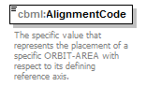
namespace | http://www.sisostds.org/schemas/c-bml/1.0
type | jc3iedm:OrbitAreaAlignmentCode
properties
  isRef | 0
  content | simple
facets
  Kind | Value | annotation
  enumeration | CENTRE
    documentation
    <Definition xml:lang="en">The sides of a specific ORBIT-AREA are equidistant from the reference axis.</Definition>
    appinfo
    <DisplayValue xml:lang="en">Centre</DisplayValue>
  enumeration | LEFT
    documentation
    <Definition xml:lang="en">The right side of a specific ORBIT-AREA coincides with the reference axis.</Definition>
    appinfo
    <DisplayValue xml:lang="en">Left</DisplayValue>
  enumeration | RIGHT
    documentation
    <Definition xml:lang="en">The left side of a specific ORBIT-AREA coincides with the reference axis.</Definition>
    appinfo
    <DisplayValue xml:lang="en">Right</DisplayValue>
annotation
  documentation
  The specific value that represents the placement of a specific ORBIT-AREA with respect to its defining reference axis.
source | <xs:element name="AlignmentCode" type="jc3iedm:OrbitAreaAlignmentCode">  <xs:annotation>  <xs:documentation xml:lang="en">The specific value that represents the placement of a specific ORBIT-AREA with respect to its defining reference axis.</xs:documentation>  </xs:annotation>  </xs:element>

element OrbitArea/WidthDimension
diagram | 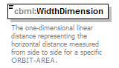
namespace | http://www.sisostds.org/schemas/c-bml/1.0
type | jc3iedm:DimensionType12_3
properties
  isRef | 0
  content | simple
facets
  Kind | Value | annotation
  minInclusive | -999999999.999
  maxInclusive | 999999999.999
  totalDigits | 12
  fractionDigits | 3
annotation
  documentation
  The one-dimensional linear distance representing the horizontal distance measured from side to side for a specific ORBIT-AREA.
source | <xs:element name="WidthDimension" type="jc3iedm:DimensionType12_3">  <xs:annotation>  <xs:documentation xml:lang="en">The one-dimensional linear distance representing the horizontal distance measured from side to side for a specific ORBIT-AREA.</xs:documentation>  </xs:annotation>  </xs:element>

element OrbitArea/FirstPoint
diagram | 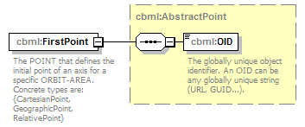
namespace | http://www.sisostds.org/schemas/c-bml/1.0
type | cbml:AbstractPoint
properties
  isRef | 0
  content | complex
children | cbml:OID
annotation
  documentation
  The POINT that defines the initial point of an axis for a specific ORBIT-AREA. Concrete types are: {CartesianPoint, GeographicPoint, RelativePoint}
source | <xs:element name="FirstPoint" type="cbml:AbstractPoint">  <xs:annotation>  <xs:documentation xml:lang="en">The POINT that defines the initial point of an axis for a specific ORBIT-AREA. Concrete types are: {CartesianPoint, GeographicPoint, RelativePoint}</xs:documentation>  </xs:annotation>  </xs:element>

element OrbitArea/FirstPointRef
diagram | 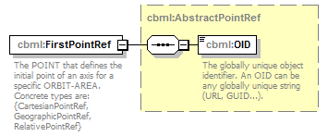
namespace | http://www.sisostds.org/schemas/c-bml/1.0
type | cbml:AbstractPointRef
properties
  isRef | 0
  content | complex
children | cbml:OID
annotation
  documentation
  The POINT that defines the initial point of an axis for a specific ORBIT-AREA. Concrete types are: {CartesianPointRef, GeographicPointRef, RelativePointRef}
source | <xs:element name="FirstPointRef" type="cbml:AbstractPointRef">  <xs:annotation>  <xs:documentation xml:lang="en">The POINT that defines the initial point of an axis for a specific ORBIT-AREA. Concrete types are: {CartesianPointRef, GeographicPointRef, RelativePointRef}</xs:documentation>  </xs:annotation>  </xs:element>

element OrbitArea/SecondPoint
diagram | 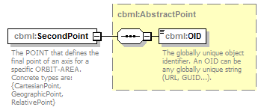
namespace | http://www.sisostds.org/schemas/c-bml/1.0
type | cbml:AbstractPoint
properties
  isRef | 0
  content | complex
children | cbml:OID
annotation
  documentation
  The POINT that defines the final point of an axis for a specific ORBIT-AREA. Concrete types are: {CartesianPoint, GeographicPoint, RelativePoint}
source | <xs:element name="SecondPoint" type="cbml:AbstractPoint">  <xs:annotation>  <xs:documentation xml:lang="en">The POINT that defines the final point of an axis for a specific ORBIT-AREA. Concrete types are: {CartesianPoint, GeographicPoint, RelativePoint}</xs:documentation>  </xs:annotation>  </xs:element>

element OrbitArea/SecondPointRef
diagram | 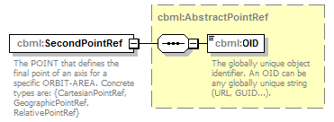
namespace | http://www.sisostds.org/schemas/c-bml/1.0
type | cbml:AbstractPointRef
properties
  isRef | 0
  content | complex
children | cbml:OID
annotation
  documentation
  The POINT that defines the final point of an axis for a specific ORBIT-AREA. Concrete types are: {CartesianPointRef, GeographicPointRef, RelativePointRef}
source | <xs:element name="SecondPointRef" type="cbml:AbstractPointRef">  <xs:annotation>  <xs:documentation xml:lang="en">The POINT that defines the final point of an axis for a specific ORBIT-AREA. Concrete types are: {CartesianPointRef, GeographicPointRef, RelativePointRef}</xs:documentation>  </xs:annotation>  </xs:element>

complexType OrbitAreaRef
diagram | 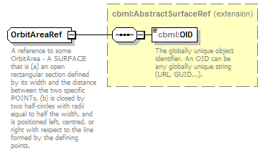
namespace | http://www.sisostds.org/schemas/c-bml/1.0
type | extension of cbml:AbstractSurfaceRef
properties
  base | cbml:AbstractSurfaceRef
children | cbml:OID
annotation
  documentation
  A reference to some OrbitArea - A SURFACE that is (a) an open rectangular section defined by its width and the distance between the two specific POINTs, (b) is closed by two half-circles with radii equal to half the width, and is positioned left, centred, or right with respect to the line formed by the defining points.
source | <xs:complexType name="OrbitAreaRef">  <xs:annotation>  <xs:documentation xml:lang="en">A reference to some OrbitArea - A SURFACE that is (a) an open rectangular section defined by its width and the distance between the two specific POINTs, (b) is closed by two half-circles with radii equal to half the width, and is positioned left, centred, or right with respect to the line formed by the defining points.</xs:documentation>  </xs:annotation>  <xs:complexContent>  <xs:extension base="cbml:AbstractSurfaceRef"/>  </xs:complexContent>  </xs:complexType>

complexType OtherLocation
diagram | 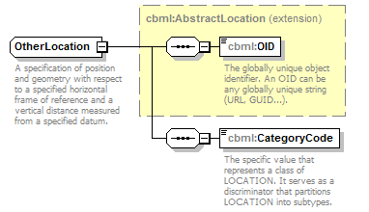
namespace | http://www.sisostds.org/schemas/c-bml/1.0
type | extension of cbml:AbstractLocation
properties
  base | cbml:AbstractLocation
children | cbml:OID cbml:CategoryCode
annotation
  documentation
  A specification of position and geometry with respect to a specified horizontal frame of reference and a vertical distance measured from a specified datum.
source | <xs:complexType name="OtherLocation">  <xs:annotation>  <xs:documentation xml:lang="en">A specification of position and geometry with respect to a specified horizontal frame of reference and a vertical distance measured from a specified datum.</xs:documentation>  </xs:annotation>  <xs:complexContent>  <xs:extension base="cbml:AbstractLocation">  <xs:sequence>  <xs:element name="CategoryCode" type="jc3iedm:LocationCategoryCode">  <xs:annotation>  <xs:documentation xml:lang="en">The specific value that represents a class of LOCATION. It serves as a discriminator that partitions LOCATION into subtypes.</xs:documentation>  </xs:annotation>  </xs:element>  </xs:sequence>  </xs:extension>  </xs:complexContent>  </xs:complexType>

element OtherLocation/CategoryCode
diagram | 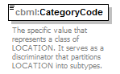
namespace | http://www.sisostds.org/schemas/c-bml/1.0
type | jc3iedm:LocationCategoryCode
properties
  isRef | 0
  content | simple
facets
  Kind | Value | annotation
  enumeration | LN
    documentation
    <Definition xml:lang="en">A LOCATION that is defined by two or more POINTs connected by one-dimensional line segments in an ordered sequence.</Definition>
    appinfo
    <DisplayValue xml:lang="en">LINE</DisplayValue>
  enumeration | PT
    documentation
    <Definition xml:lang="en">A zero-dimensional LOCATION.</Definition>
    appinfo
    <DisplayValue xml:lang="en">POINT</DisplayValue>
  enumeration | SURFAC
    documentation
    <Definition xml:lang="en">A two-dimensional LOCATION.</Definition>
    appinfo
    <DisplayValue xml:lang="en">SURFACE</DisplayValue>
  enumeration | UND
    documentation
    <Definition xml:lang="en">A LOCATION that refers to a position that cannot be determined.</Definition>
    appinfo
    <DisplayValue xml:lang="en">Undefined</DisplayValue>
  enumeration | VL
    documentation
    <Definition xml:lang="en">A specific LOCATION that is a three-dimensional bounded space.</Definition>
    appinfo
    <DisplayValue xml:lang="en">GEOMETRIC-VOLUME</DisplayValue>
annotation
  documentation
  The specific value that represents a class of LOCATION. It serves as a discriminator that partitions LOCATION into subtypes.
source | <xs:element name="CategoryCode" type="jc3iedm:LocationCategoryCode">  <xs:annotation>  <xs:documentation xml:lang="en">The specific value that represents a class of LOCATION. It serves as a discriminator that partitions LOCATION into subtypes.</xs:documentation>  </xs:annotation>  </xs:element>

complexType OtherLocationRef
diagram | 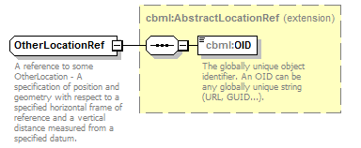
namespace | http://www.sisostds.org/schemas/c-bml/1.0
type | extension of cbml:AbstractLocationRef
properties
  base | cbml:AbstractLocationRef
children | cbml:OID
annotation
  documentation
  A reference to some OtherLocation - A specification of position and geometry with respect to a specified horizontal frame of reference and a vertical distance measured from a specified datum.
source | <xs:complexType name="OtherLocationRef">  <xs:annotation>  <xs:documentation xml:lang="en">A reference to some OtherLocation - A specification of position and geometry with respect to a specified horizontal frame of reference and a vertical distance measured from a specified datum.</xs:documentation>  </xs:annotation>  <xs:complexContent>  <xs:extension base="cbml:AbstractLocationRef"/>  </xs:complexContent>  </xs:complexType>

complexType PointReference
diagram | 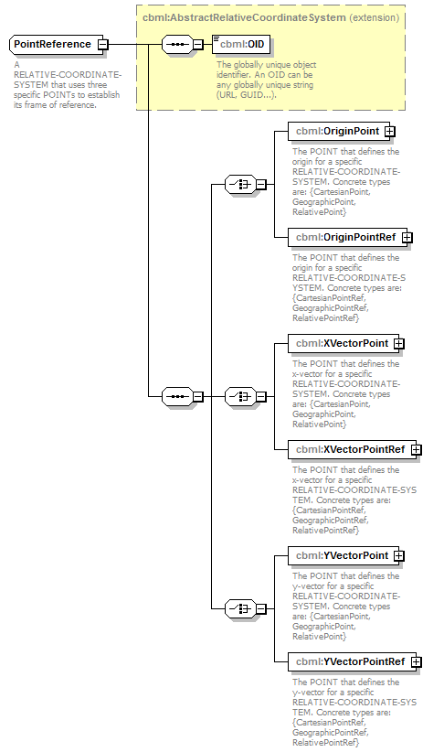
namespace | http://www.sisostds.org/schemas/c-bml/1.0
type | extension of cbml:AbstractRelativeCoordinateSystem
properties
  base | cbml:AbstractRelativeCoordinateSystem
children | cbml:OID cbml:OriginPoint cbml:OriginPointRef cbml:XVectorPoint cbml:XVectorPointRef cbml:YVectorPoint cbml:YVectorPointRef
annotation
  documentation
  A RELATIVE-COORDINATE-SYSTEM that uses three specific POINTs to establish its frame of reference.
source | <xs:complexType name="PointReference">  <xs:annotation>  <xs:documentation xml:lang="en">A RELATIVE-COORDINATE-SYSTEM that uses three specific POINTs to establish its frame of reference.</xs:documentation>  </xs:annotation>  <xs:complexContent>  <xs:extension base="cbml:AbstractRelativeCoordinateSystem">  <xs:sequence>  <xs:choice>  <xs:element name="OriginPoint" type="cbml:AbstractPoint">  <xs:annotation>  <xs:documentation xml:lang="en">The POINT that defines the origin for a specific RELATIVE-COORDINATE-SYSTEM. Concrete types are: {CartesianPoint, GeographicPoint, RelativePoint}</xs:documentation>  </xs:annotation>  </xs:element>  <xs:element name="OriginPointRef" type="cbml:AbstractPointRef">  <xs:annotation>  <xs:documentation xml:lang="en">The POINT that defines the origin for a specific RELATIVE-COORDINATE-SYSTEM. Concrete types are: {CartesianPointRef, GeographicPointRef, RelativePointRef}</xs:documentation>  </xs:annotation>  </xs:element>  </xs:choice>  <xs:choice>  <xs:element name="XVectorPoint" type="cbml:AbstractPoint">  <xs:annotation>  <xs:documentation xml:lang="en">The POINT that defines the x-vector for a specific RELATIVE-COORDINATE-SYSTEM. Concrete types are: {CartesianPoint, GeographicPoint, RelativePoint}</xs:documentation>  </xs:annotation>  </xs:element>  <xs:element name="XVectorPointRef" type="cbml:AbstractPointRef">  <xs:annotation>  <xs:documentation xml:lang="en">The POINT that defines the x-vector for a specific RELATIVE-COORDINATE-SYSTEM. Concrete types are: {CartesianPointRef, GeographicPointRef, RelativePointRef}</xs:documentation>  </xs:annotation>  </xs:element>  </xs:choice>  <xs:choice>  <xs:element name="YVectorPoint" type="cbml:AbstractPoint">  <xs:annotation>  <xs:documentation xml:lang="en">The POINT that defines the y-vector for a specific RELATIVE-COORDINATE-SYSTEM. Concrete types are: {CartesianPoint, GeographicPoint, RelativePoint}</xs:documentation>  </xs:annotation>  </xs:element>  <xs:element name="YVectorPointRef" type="cbml:AbstractPointRef">  <xs:annotation>  <xs:documentation xml:lang="en">The POINT that defines the y-vector for a specific RELATIVE-COORDINATE-SYSTEM. Concrete types are: {CartesianPointRef, GeographicPointRef, RelativePointRef}</xs:documentation>  </xs:annotation>  </xs:element>  </xs:choice>  </xs:sequence>  </xs:extension>  </xs:complexContent>  </xs:complexType>

element PointReference/OriginPoint
diagram | 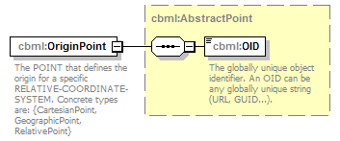
namespace | http://www.sisostds.org/schemas/c-bml/1.0
type | cbml:AbstractPoint
properties
  isRef | 0
  content | complex
children | cbml:OID
annotation
  documentation
  The POINT that defines the origin for a specific RELATIVE-COORDINATE-SYSTEM. Concrete types are: {CartesianPoint, GeographicPoint, RelativePoint}
source | <xs:element name="OriginPoint" type="cbml:AbstractPoint">  <xs:annotation>  <xs:documentation xml:lang="en">The POINT that defines the origin for a specific RELATIVE-COORDINATE-SYSTEM. Concrete types are: {CartesianPoint, GeographicPoint, RelativePoint}</xs:documentation>  </xs:annotation>  </xs:element>

element PointReference/OriginPointRef
diagram | 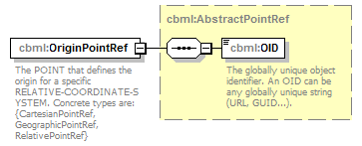
namespace | http://www.sisostds.org/schemas/c-bml/1.0
type | cbml:AbstractPointRef
properties
  isRef | 0
  content | complex
children | cbml:OID
annotation
  documentation
  The POINT that defines the origin for a specific RELATIVE-COORDINATE-SYSTEM. Concrete types are: {CartesianPointRef, GeographicPointRef, RelativePointRef}
source | <xs:element name="OriginPointRef" type="cbml:AbstractPointRef">  <xs:annotation>  <xs:documentation xml:lang="en">The POINT that defines the origin for a specific RELATIVE-COORDINATE-SYSTEM. Concrete types are: {CartesianPointRef, GeographicPointRef, RelativePointRef}</xs:documentation>  </xs:annotation>  </xs:element>

element PointReference/XVectorPoint
diagram | 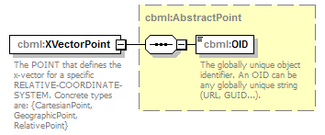
namespace | http://www.sisostds.org/schemas/c-bml/1.0
type | cbml:AbstractPoint
properties
  isRef | 0
  content | complex
children | cbml:OID
annotation
  documentation
  The POINT that defines the x-vector for a specific RELATIVE-COORDINATE-SYSTEM. Concrete types are: {CartesianPoint, GeographicPoint, RelativePoint}
source | <xs:element name="XVectorPoint" type="cbml:AbstractPoint">  <xs:annotation>  <xs:documentation xml:lang="en">The POINT that defines the x-vector for a specific RELATIVE-COORDINATE-SYSTEM. Concrete types are: {CartesianPoint, GeographicPoint, RelativePoint}</xs:documentation>  </xs:annotation>  </xs:element>

element PointReference/XVectorPointRef
diagram | 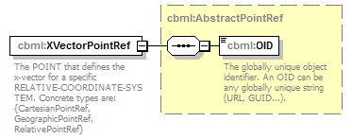
namespace | http://www.sisostds.org/schemas/c-bml/1.0
type | cbml:AbstractPointRef
properties
  isRef | 0
  content | complex
children | cbml:OID
annotation
  documentation
  The POINT that defines the x-vector for a specific RELATIVE-COORDINATE-SYSTEM. Concrete types are: {CartesianPointRef, GeographicPointRef, RelativePointRef}
source | <xs:element name="XVectorPointRef" type="cbml:AbstractPointRef">  <xs:annotation>  <xs:documentation xml:lang="en">The POINT that defines the x-vector for a specific RELATIVE-COORDINATE-SYSTEM. Concrete types are: {CartesianPointRef, GeographicPointRef, RelativePointRef}</xs:documentation>  </xs:annotation>  </xs:element>

element PointReference/YVectorPoint
diagram | 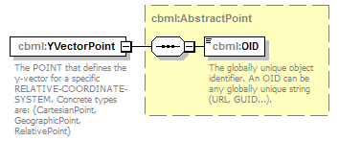
namespace | http://www.sisostds.org/schemas/c-bml/1.0
type | cbml:AbstractPoint
properties
  isRef | 0
  content | complex
children | cbml:OID
annotation
  documentation
  The POINT that defines the y-vector for a specific RELATIVE-COORDINATE-SYSTEM. Concrete types are: {CartesianPoint, GeographicPoint, RelativePoint}
source | <xs:element name="YVectorPoint" type="cbml:AbstractPoint">  <xs:annotation>  <xs:documentation xml:lang="en">The POINT that defines the y-vector for a specific RELATIVE-COORDINATE-SYSTEM. Concrete types are: {CartesianPoint, GeographicPoint, RelativePoint}</xs:documentation>  </xs:annotation>  </xs:element>

element PointReference/YVectorPointRef
diagram | 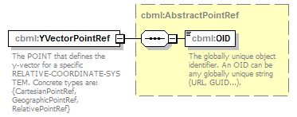
namespace | http://www.sisostds.org/schemas/c-bml/1.0
type | cbml:AbstractPointRef
properties
  isRef | 0
  content | complex
children | cbml:OID
annotation
  documentation
  The POINT that defines the y-vector for a specific RELATIVE-COORDINATE-SYSTEM. Concrete types are: {CartesianPointRef, GeographicPointRef, RelativePointRef}
source | <xs:element name="YVectorPointRef" type="cbml:AbstractPointRef">  <xs:annotation>  <xs:documentation xml:lang="en">The POINT that defines the y-vector for a specific RELATIVE-COORDINATE-SYSTEM. Concrete types are: {CartesianPointRef, GeographicPointRef, RelativePointRef}</xs:documentation>  </xs:annotation>  </xs:element>

complexType PointReferenceRef
diagram | 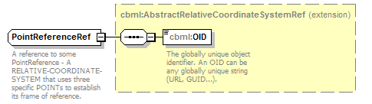
namespace | http://www.sisostds.org/schemas/c-bml/1.0
type | extension of cbml:AbstractRelativeCoordinateSystemRef
properties
  base | cbml:AbstractRelativeCoordinateSystemRef
children | cbml:OID
annotation
  documentation
  A reference to some PointReference - A RELATIVE-COORDINATE-SYSTEM that uses three specific POINTs to establish its frame of reference.
source | <xs:complexType name="PointReferenceRef">  <xs:annotation>  <xs:documentation xml:lang="en">A reference to some PointReference - A RELATIVE-COORDINATE-SYSTEM that uses three specific POINTs to establish its frame of reference.</xs:documentation>  </xs:annotation>  <xs:complexContent>  <xs:extension base="cbml:AbstractRelativeCoordinateSystemRef"/>  </xs:complexContent>  </xs:complexType>

complexType PolyarcArea
diagram | 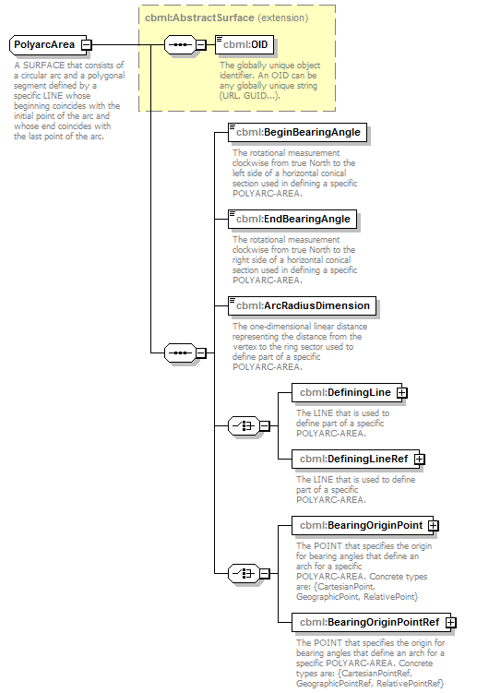
namespace | http://www.sisostds.org/schemas/c-bml/1.0
type | extension of cbml:AbstractSurface
properties
  base | cbml:AbstractSurface
children | cbml:OID cbml:BeginBearingAngle cbml:EndBearingAngle cbml:ArcRadiusDimension cbml:DefiningLine cbml:DefiningLineRef cbml:BearingOriginPoint cbml:BearingOriginPointRef
annotation
  documentation
  A SURFACE that consists of a circular arc and a polygonal segment defined by a specific LINE whose beginning coincides with the initial point of the arc and whose end coincides with the last point of the arc.
source | <xs:complexType name="PolyarcArea">  <xs:annotation>  <xs:documentation xml:lang="en">A SURFACE that consists of a circular arc and a polygonal segment defined by a specific LINE whose beginning coincides with the initial point of the arc and whose end coincides with the last point of the arc.</xs:documentation>  </xs:annotation>  <xs:complexContent>  <xs:extension base="cbml:AbstractSurface">  <xs:sequence>  <xs:element name="BeginBearingAngle" type="jc3iedm:AngleTypeRangeAngle7_4">  <xs:annotation>  <xs:documentation xml:lang="en">The rotational measurement clockwise from true North to the left side of a horizontal conical section used in defining a specific POLYARC-AREA.</xs:documentation>  </xs:annotation>  </xs:element>  <xs:element name="EndBearingAngle" type="jc3iedm:AngleTypeRangeAngle7_4">  <xs:annotation>  <xs:documentation xml:lang="en">The rotational measurement clockwise from true North to the right side of a horizontal conical section used in defining a specific POLYARC-AREA.</xs:documentation>  </xs:annotation>  </xs:element>  <xs:element name="ArcRadiusDimension" type="jc3iedm:DimensionType12_3">  <xs:annotation>  <xs:documentation xml:lang="en">The one-dimensional linear distance representing the distance from the vertex to the ring sector used to define part of a specific POLYARC-AREA.</xs:documentation>  </xs:annotation>  </xs:element>  <xs:choice>  <xs:element name="DefiningLine" type="cbml:Line">  <xs:annotation>  <xs:documentation xml:lang="en">The LINE that is used to define part of a specific POLYARC-AREA.</xs:documentation>  </xs:annotation>  </xs:element>  <xs:element name="DefiningLineRef" type="cbml:LineRef">  <xs:annotation>  <xs:documentation xml:lang="en">The LINE that is used to define part of a specific POLYARC-AREA.</xs:documentation>  </xs:annotation>  </xs:element>  </xs:choice>  <xs:choice>  <xs:element name="BearingOriginPoint" type="cbml:AbstractPoint">  <xs:annotation>  <xs:documentation xml:lang="en">The POINT that specifies the origin for bearing angles that define an arch for a specific POLYARC-AREA. Concrete types are: {CartesianPoint, GeographicPoint, RelativePoint}</xs:documentation>  </xs:annotation>  </xs:element>  <xs:element name="BearingOriginPointRef" type="cbml:AbstractPointRef">  <xs:annotation>  <xs:documentation xml:lang="en">The POINT that specifies the origin for bearing angles that define an arch for a specific POLYARC-AREA. Concrete types are: {CartesianPointRef, GeographicPointRef, RelativePointRef}</xs:documentation>  </xs:annotation>  </xs:element>  </xs:choice>  </xs:sequence>  </xs:extension>  </xs:complexContent>  </xs:complexType>

element PolyarcArea/BeginBearingAngle
diagram | 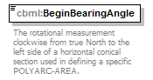
namespace | http://www.sisostds.org/schemas/c-bml/1.0
type | jc3iedm:AngleTypeRangeAngle7_4
properties
  isRef | 0
  content | simple
facets
  Kind | Value | annotation
  minInclusive | 0.0000
  maxInclusive | 359.9999
  totalDigits | 7
  fractionDigits | 4
annotation
  documentation
  The rotational measurement clockwise from true North to the left side of a horizontal conical section used in defining a specific POLYARC-AREA.
source | <xs:element name="BeginBearingAngle" type="jc3iedm:AngleTypeRangeAngle7_4">  <xs:annotation>  <xs:documentation xml:lang="en">The rotational measurement clockwise from true North to the left side of a horizontal conical section used in defining a specific POLYARC-AREA.</xs:documentation>  </xs:annotation>  </xs:element>

element PolyarcArea/EndBearingAngle
diagram | 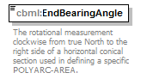
namespace | http://www.sisostds.org/schemas/c-bml/1.0
type | jc3iedm:AngleTypeRangeAngle7_4
properties
  isRef | 0
  content | simple
facets
  Kind | Value | annotation
  minInclusive | 0.0000
  maxInclusive | 359.9999
  totalDigits | 7
  fractionDigits | 4
annotation
  documentation
  The rotational measurement clockwise from true North to the right side of a horizontal conical section used in defining a specific POLYARC-AREA.
source | <xs:element name="EndBearingAngle" type="jc3iedm:AngleTypeRangeAngle7_4">  <xs:annotation>  <xs:documentation xml:lang="en">The rotational measurement clockwise from true North to the right side of a horizontal conical section used in defining a specific POLYARC-AREA.</xs:documentation>  </xs:annotation>  </xs:element>

element PolyarcArea/ArcRadiusDimension
diagram | 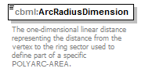
namespace | http://www.sisostds.org/schemas/c-bml/1.0
type | jc3iedm:DimensionType12_3
properties
  isRef | 0
  content | simple
facets
  Kind | Value | annotation
  minInclusive | -999999999.999
  maxInclusive | 999999999.999
  totalDigits | 12
  fractionDigits | 3
annotation
  documentation
  The one-dimensional linear distance representing the distance from the vertex to the ring sector used to define part of a specific POLYARC-AREA.
source | <xs:element name="ArcRadiusDimension" type="jc3iedm:DimensionType12_3">  <xs:annotation>  <xs:documentation xml:lang="en">The one-dimensional linear distance representing the distance from the vertex to the ring sector used to define part of a specific POLYARC-AREA.</xs:documentation>  </xs:annotation>  </xs:element>

element PolyarcArea/DefiningLine
diagram | 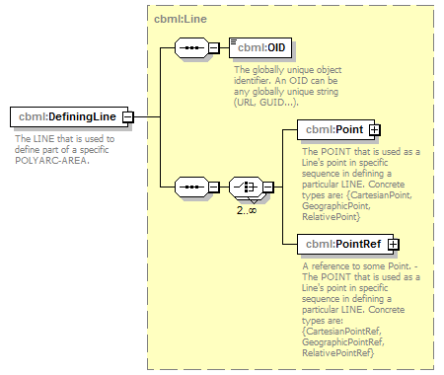
namespace | http://www.sisostds.org/schemas/c-bml/1.0
type | cbml:Line
properties
  isRef | 0
  content | complex
children | cbml:OID cbml:Point cbml:PointRef
annotation
  documentation
  The LINE that is used to define part of a specific POLYARC-AREA.
source | <xs:element name="DefiningLine" type="cbml:Line">  <xs:annotation>  <xs:documentation xml:lang="en">The LINE that is used to define part of a specific POLYARC-AREA.</xs:documentation>  </xs:annotation>  </xs:element>

element PolyarcArea/DefiningLineRef
diagram | 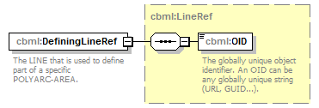
namespace | http://www.sisostds.org/schemas/c-bml/1.0
type | cbml:LineRef
properties
  isRef | 0
  content | complex
children | cbml:OID
annotation
  documentation
  The LINE that is used to define part of a specific POLYARC-AREA.
source | <xs:element name="DefiningLineRef" type="cbml:LineRef">  <xs:annotation>  <xs:documentation xml:lang="en">The LINE that is used to define part of a specific POLYARC-AREA.</xs:documentation>  </xs:annotation>  </xs:element>

element PolyarcArea/BearingOriginPoint
diagram | 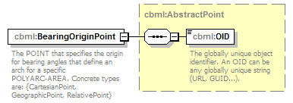
namespace | http://www.sisostds.org/schemas/c-bml/1.0
type | cbml:AbstractPoint
properties
  isRef | 0
  content | complex
children | cbml:OID
annotation
  documentation
  The POINT that specifies the origin for bearing angles that define an arch for a specific POLYARC-AREA. Concrete types are: {CartesianPoint, GeographicPoint, RelativePoint}
source | <xs:element name="BearingOriginPoint" type="cbml:AbstractPoint">  <xs:annotation>  <xs:documentation xml:lang="en">The POINT that specifies the origin for bearing angles that define an arch for a specific POLYARC-AREA. Concrete types are: {CartesianPoint, GeographicPoint, RelativePoint}</xs:documentation>  </xs:annotation>  </xs:element>

element PolyarcArea/BearingOriginPointRef
diagram | 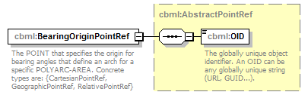
namespace | http://www.sisostds.org/schemas/c-bml/1.0
type | cbml:AbstractPointRef
properties
  isRef | 0
  content | complex
children | cbml:OID
annotation
  documentation
  The POINT that specifies the origin for bearing angles that define an arch for a specific POLYARC-AREA. Concrete types are: {CartesianPointRef, GeographicPointRef, RelativePointRef}
source | <xs:element name="BearingOriginPointRef" type="cbml:AbstractPointRef">  <xs:annotation>  <xs:documentation xml:lang="en">The POINT that specifies the origin for bearing angles that define an arch for a specific POLYARC-AREA. Concrete types are: {CartesianPointRef, GeographicPointRef, RelativePointRef}</xs:documentation>  </xs:annotation>  </xs:element>

complexType PolyarcAreaRef
diagram | 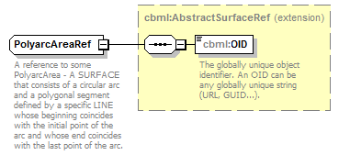
namespace | http://www.sisostds.org/schemas/c-bml/1.0
type | extension of cbml:AbstractSurfaceRef
properties
  base | cbml:AbstractSurfaceRef
children | cbml:OID
annotation
  documentation
  A reference to some PolyarcArea - A SURFACE that consists of a circular arc and a polygonal segment defined by a specific LINE whose beginning coincides with the initial point of the arc and whose end coincides with the last point of the arc.
source | <xs:complexType name="PolyarcAreaRef">  <xs:annotation>  <xs:documentation xml:lang="en">A reference to some PolyarcArea - A SURFACE that consists of a circular arc and a polygonal segment defined by a specific LINE whose beginning coincides with the initial point of the arc and whose end coincides with the last point of the arc.</xs:documentation>  </xs:annotation>  <xs:complexContent>  <xs:extension base="cbml:AbstractSurfaceRef"/>  </xs:complexContent>  </xs:complexType>

complexType PolygonArea
diagram | 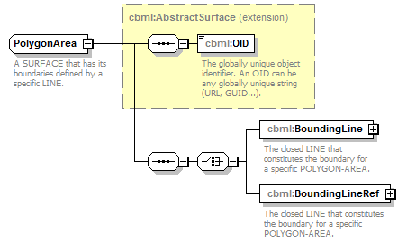
namespace | http://www.sisostds.org/schemas/c-bml/1.0
type | extension of cbml:AbstractSurface
properties
  base | cbml:AbstractSurface
children | cbml:OID cbml:BoundingLine cbml:BoundingLineRef
annotation
  documentation
  A SURFACE that has its boundaries defined by a specific LINE.
source | <xs:complexType name="PolygonArea">  <xs:annotation>  <xs:documentation xml:lang="en">A SURFACE that has its boundaries defined by a specific LINE.</xs:documentation>  </xs:annotation>  <xs:complexContent>  <xs:extension base="cbml:AbstractSurface">  <xs:sequence>  <xs:choice>  <xs:element name="BoundingLine" type="cbml:Line">  <xs:annotation>  <xs:documentation xml:lang="en">The closed LINE that constitutes the boundary for a specific POLYGON-AREA.</xs:documentation>  </xs:annotation>  </xs:element>  <xs:element name="BoundingLineRef" type="cbml:LineRef">  <xs:annotation>  <xs:documentation xml:lang="en">The closed LINE that constitutes the boundary for a specific POLYGON-AREA.</xs:documentation>  </xs:annotation>  </xs:element>  </xs:choice>  </xs:sequence>  </xs:extension>  </xs:complexContent>  </xs:complexType>

element PolygonArea/BoundingLine
diagram | 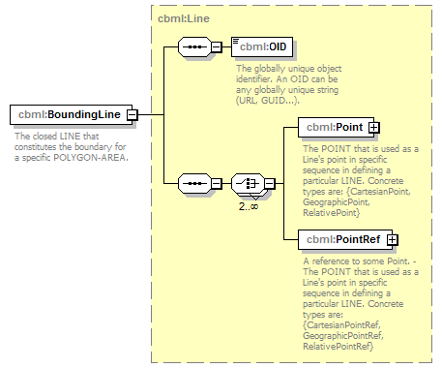
namespace | http://www.sisostds.org/schemas/c-bml/1.0
type | cbml:Line
properties
  isRef | 0
  content | complex
children | cbml:OID cbml:Point cbml:PointRef
annotation
  documentation
  The closed LINE that constitutes the boundary for a specific POLYGON-AREA.
source | <xs:element name="BoundingLine" type="cbml:Line">  <xs:annotation>  <xs:documentation xml:lang="en">The closed LINE that constitutes the boundary for a specific POLYGON-AREA.</xs:documentation>  </xs:annotation>  </xs:element>

element PolygonArea/BoundingLineRef
diagram | 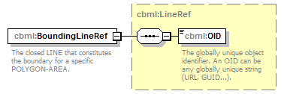
namespace | http://www.sisostds.org/schemas/c-bml/1.0
type | cbml:LineRef
properties
  isRef | 0
  content | complex
children | cbml:OID
annotation
  documentation
  The closed LINE that constitutes the boundary for a specific POLYGON-AREA.
source | <xs:element name="BoundingLineRef" type="cbml:LineRef">  <xs:annotation>  <xs:documentation xml:lang="en">The closed LINE that constitutes the boundary for a specific POLYGON-AREA.</xs:documentation>  </xs:annotation>  </xs:element>

complexType PolygonAreaRef
diagram | 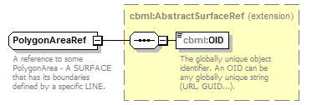
namespace | http://www.sisostds.org/schemas/c-bml/1.0
type | extension of cbml:AbstractSurfaceRef
properties
  base | cbml:AbstractSurfaceRef
children | cbml:OID
annotation
  documentation
  A reference to some PolygonArea - A SURFACE that has its boundaries defined by a specific LINE.
source | <xs:complexType name="PolygonAreaRef">  <xs:annotation>  <xs:documentation xml:lang="en">A reference to some PolygonArea - A SURFACE that has its boundaries defined by a specific LINE.</xs:documentation>  </xs:annotation>  <xs:complexContent>  <xs:extension base="cbml:AbstractSurfaceRef"/>  </xs:complexContent>  </xs:complexType>

complexType RelativePoint
diagram | 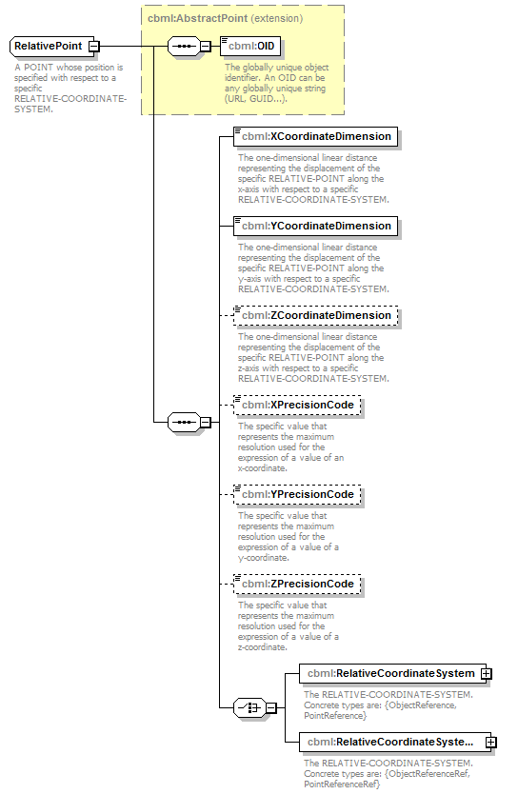
namespace | http://www.sisostds.org/schemas/c-bml/1.0
type | extension of cbml:AbstractPoint
properties
  base | cbml:AbstractPoint
children | cbml:OID cbml:XCoordinateDimension cbml:YCoordinateDimension cbml:ZCoordinateDimension cbml:XPrecisionCode cbml:YPrecisionCode cbml:ZPrecisionCode cbml:RelativeCoordinateSystem cbml:RelativeCoordinateSystemRef
annotation
  documentation
  A POINT whose position is specified with respect to a specific RELATIVE-COORDINATE-SYSTEM.
source | <xs:complexType name="RelativePoint">  <xs:annotation>  <xs:documentation xml:lang="en">A POINT whose position is specified with respect to a specific RELATIVE-COORDINATE-SYSTEM.</xs:documentation>  </xs:annotation>  <xs:complexContent>  <xs:extension base="cbml:AbstractPoint">  <xs:sequence>  <xs:element name="XCoordinateDimension" type="jc3iedm:DimensionType12_3">  <xs:annotation>  <xs:documentation xml:lang="en">The one-dimensional linear distance representing the displacement of the specific RELATIVE-POINT along the x-axis with respect to a specific RELATIVE-COORDINATE-SYSTEM.</xs:documentation>  </xs:annotation>  </xs:element>  <xs:element name="YCoordinateDimension" type="jc3iedm:DimensionType12_3">  <xs:annotation>  <xs:documentation xml:lang="en">The one-dimensional linear distance representing the displacement of the specific RELATIVE-POINT along the y-axis with respect to a specific RELATIVE-COORDINATE-SYSTEM.</xs:documentation>  </xs:annotation>  </xs:element>  <xs:element name="ZCoordinateDimension" type="jc3iedm:DimensionType12_3" minOccurs="0">  <xs:annotation>  <xs:documentation xml:lang="en">The one-dimensional linear distance representing the displacement of the specific RELATIVE-POINT along the z-axis with respect to a specific RELATIVE-COORDINATE-SYSTEM.</xs:documentation>  </xs:annotation>  </xs:element>  <xs:element name="XPrecisionCode" type="jc3iedm:DistancePrecisionCode" minOccurs="0">  <xs:annotation>  <xs:documentation xml:lang="en">The specific value that represents the maximum resolution used for the expression of a value of an x-coordinate.</xs:documentation>  </xs:annotation>  </xs:element>  <xs:element name="YPrecisionCode" type="jc3iedm:DistancePrecisionCode" minOccurs="0">  <xs:annotation>  <xs:documentation xml:lang="en">The specific value that represents the maximum resolution used for the expression of a value of a y-coordinate.</xs:documentation>  </xs:annotation>  </xs:element>  <xs:element name="ZPrecisionCode" type="jc3iedm:DistancePrecisionCode" minOccurs="0">  <xs:annotation>  <xs:documentation xml:lang="en">The specific value that represents the maximum resolution used for the expression of a value of a z-coordinate.</xs:documentation>  </xs:annotation>  </xs:element>  <xs:choice>  <xs:element name="RelativeCoordinateSystem" type="cbml:AbstractRelativeCoordinateSystem">  <xs:annotation>  <xs:documentation xml:lang="en">The RELATIVE-COORDINATE-SYSTEM. Concrete types are: {ObjectReference, PointReference}</xs:documentation>  </xs:annotation>  </xs:element>  <xs:element name="RelativeCoordinateSystemRef" type="cbml:AbstractRelativeCoordinateSystemRef">  <xs:annotation>  <xs:documentation xml:lang="en">The RELATIVE-COORDINATE-SYSTEM. Concrete types are: {ObjectReferenceRef, PointReferenceRef}</xs:documentation>  </xs:annotation>  </xs:element>  </xs:choice>  </xs:sequence>  </xs:extension>  </xs:complexContent>  </xs:complexType>

element RelativePoint/XCoordinateDimension
diagram | 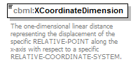
namespace | http://www.sisostds.org/schemas/c-bml/1.0
type | jc3iedm:DimensionType12_3
properties
  isRef | 0
  content | simple
facets
  Kind | Value | annotation
  minInclusive | -999999999.999
  maxInclusive | 999999999.999
  totalDigits | 12
  fractionDigits | 3
annotation
  documentation
  The one-dimensional linear distance representing the displacement of the specific RELATIVE-POINT along the x-axis with respect to a specific RELATIVE-COORDINATE-SYSTEM.
source | <xs:element name="XCoordinateDimension" type="jc3iedm:DimensionType12_3">  <xs:annotation>  <xs:documentation xml:lang="en">The one-dimensional linear distance representing the displacement of the specific RELATIVE-POINT along the x-axis with respect to a specific RELATIVE-COORDINATE-SYSTEM.</xs:documentation>  </xs:annotation>  </xs:element>

element RelativePoint/YCoordinateDimension
diagram | 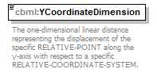
namespace | http://www.sisostds.org/schemas/c-bml/1.0
type | jc3iedm:DimensionType12_3
properties
  isRef | 0
  content | simple
facets
  Kind | Value | annotation
  minInclusive | -999999999.999
  maxInclusive | 999999999.999
  totalDigits | 12
  fractionDigits | 3
annotation
  documentation
  The one-dimensional linear distance representing the displacement of the specific RELATIVE-POINT along the y-axis with respect to a specific RELATIVE-COORDINATE-SYSTEM.
source | <xs:element name="YCoordinateDimension" type="jc3iedm:DimensionType12_3">  <xs:annotation>  <xs:documentation xml:lang="en">The one-dimensional linear distance representing the displacement of the specific RELATIVE-POINT along the y-axis with respect to a specific RELATIVE-COORDINATE-SYSTEM.</xs:documentation>  </xs:annotation>  </xs:element>

element RelativePoint/ZCoordinateDimension
diagram | 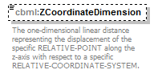
namespace | http://www.sisostds.org/schemas/c-bml/1.0
type | jc3iedm:DimensionType12_3
properties
  isRef | 0
  minOcc | 0
  maxOcc | 1
  content | simple
facets
  Kind | Value | annotation
  minInclusive | -999999999.999
  maxInclusive | 999999999.999
  totalDigits | 12
  fractionDigits | 3
annotation
  documentation
  The one-dimensional linear distance representing the displacement of the specific RELATIVE-POINT along the z-axis with respect to a specific RELATIVE-COORDINATE-SYSTEM.
source | <xs:element name="ZCoordinateDimension" type="jc3iedm:DimensionType12_3" minOccurs="0">  <xs:annotation>  <xs:documentation xml:lang="en">The one-dimensional linear distance representing the displacement of the specific RELATIVE-POINT along the z-axis with respect to a specific RELATIVE-COORDINATE-SYSTEM.</xs:documentation>  </xs:annotation>  </xs:element>

element RelativePoint/XPrecisionCode
diagram | 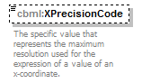
namespace | http://www.sisostds.org/schemas/c-bml/1.0
type | jc3iedm:DistancePrecisionCode
properties
  isRef | 0
  minOcc | 0
  maxOcc | 1
  content | simple
facets
  Kind | Value | annotation
  enumeration | 100FT
    documentation
    <Definition xml:lang="en">A linear measure (distance, length) is defined to the precision of 100 feet (30.48 metres).</Definition>
    appinfo
    <DisplayValue xml:lang="en">100 feet</DisplayValue>
  enumeration | 100MTR
    documentation
    <Definition xml:lang="en">A linear measure (distance, length) is defined to the precision of 100 metres.</Definition>
    appinfo
    <DisplayValue xml:lang="en">100 metres</DisplayValue>
  enumeration | 10FT
    documentation
    <Definition xml:lang="en">A linear measure (distance, length) is defined to the precision of 10 feet (3.048 metres).</Definition>
    appinfo
    <DisplayValue xml:lang="en">10 feet</DisplayValue>
  enumeration | 10MTR
    documentation
    <Definition xml:lang="en">A linear measure (distance, length) is defined to the precision of 10 metres.</Definition>
    appinfo
    <DisplayValue xml:lang="en">10 metres</DisplayValue>
  enumeration | 300MTR
    documentation
    <Definition xml:lang="en">A linear measure (distance, length) is defined to the precision of 300 metres.</Definition>
    appinfo
    <DisplayValue xml:lang="en">300 metres</DisplayValue>
  enumeration | 30MTR
    documentation
    <Definition xml:lang="en">A linear measure (distance, length) is defined to the precision of 30 metres.</Definition>
    appinfo
    <DisplayValue xml:lang="en">30 metres</DisplayValue>
  enumeration | 3MTR
    documentation
    <Definition xml:lang="en">A linear measure (distance, length) is defined to the precision of 3 metres.</Definition>
    appinfo
    <DisplayValue xml:lang="en">3 metres</DisplayValue>
  enumeration | CM
    documentation
    <Definition xml:lang="en">A linear measure (distance, length) is defined to the precision of 0.01 metre.</Definition>
    appinfo
    <DisplayValue xml:lang="en">Centimetre</DisplayValue>
  enumeration | FOOT
    documentation
    <Definition xml:lang="en">A linear measure (distance, length) is defined to the precision of one foot (0.3048 metres).</Definition>
    appinfo
    <DisplayValue xml:lang="en">Foot</DisplayValue>
  enumeration | INCH
    documentation
    <Definition xml:lang="en">A linear measure (distance, length) is defined to the precision of one inch (0.0254 metres).</Definition>
    appinfo
    <DisplayValue xml:lang="en">Inch</DisplayValue>
  enumeration | KILYRD
    documentation
    <Definition xml:lang="en">A linear measure (distance, length) is defined to the precision of a kiloyard (914,4 metres).</Definition>
    appinfo
    <DisplayValue xml:lang="en">Kiloyard</DisplayValue>
  enumeration | KM
    documentation
    <Definition xml:lang="en">A linear measure (distance, length) is defined to the precision of 1000 metres.</Definition>
    appinfo
    <DisplayValue xml:lang="en">Kilometre</DisplayValue>
  enumeration | METRE
    documentation
    <Definition xml:lang="en">A linear measure (distance, length) is defined to the precision of one metre.</Definition>
    appinfo
    <DisplayValue xml:lang="en">Metre</DisplayValue>
  enumeration | MILE
    documentation
    <Definition xml:lang="en">A linear measure (distance, length) is defined to the precision of one mile (1609.344 metres).</Definition>
    appinfo
    <DisplayValue xml:lang="en">Mile</DisplayValue>
  enumeration | MM
    documentation
    <Definition xml:lang="en">A linear measure (distance, length) is defined to the precision of one millimetre.</Definition>
    appinfo
    <DisplayValue xml:lang="en">Millimetre</DisplayValue>
  enumeration | NM
    documentation
    <Definition xml:lang="en">A linear measure (distance, length) is defined to the precision of a nautical mile (1852 metres).</Definition>
    appinfo
    <DisplayValue xml:lang="en">Nautical mile</DisplayValue>
  enumeration | YARD
    documentation
    <Definition xml:lang="en">A linear measure (distance, length) is defined to the precision of a yard (0.9144 metres).</Definition>
    appinfo
    <DisplayValue xml:lang="en">Yard</DisplayValue>
annotation
  documentation
  The specific value that represents the maximum resolution used for the expression of a value of an x-coordinate.
source | <xs:element name="XPrecisionCode" type="jc3iedm:DistancePrecisionCode" minOccurs="0">  <xs:annotation>  <xs:documentation xml:lang="en">The specific value that represents the maximum resolution used for the expression of a value of an x-coordinate.</xs:documentation>  </xs:annotation>  </xs:element>

element RelativePoint/YPrecisionCode
diagram | 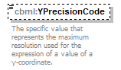
namespace | http://www.sisostds.org/schemas/c-bml/1.0
type | jc3iedm:DistancePrecisionCode
properties
  isRef | 0
  minOcc | 0
  maxOcc | 1
  content | simple
facets
  Kind | Value | annotation
  enumeration | 100FT
    documentation
    <Definition xml:lang="en">A linear measure (distance, length) is defined to the precision of 100 feet (30.48 metres).</Definition>
    appinfo
    <DisplayValue xml:lang="en">100 feet</DisplayValue>
  enumeration | 100MTR
    documentation
    <Definition xml:lang="en">A linear measure (distance, length) is defined to the precision of 100 metres.</Definition>
    appinfo
    <DisplayValue xml:lang="en">100 metres</DisplayValue>
  enumeration | 10FT
    documentation
    <Definition xml:lang="en">A linear measure (distance, length) is defined to the precision of 10 feet (3.048 metres).</Definition>
    appinfo
    <DisplayValue xml:lang="en">10 feet</DisplayValue>
  enumeration | 10MTR
    documentation
    <Definition xml:lang="en">A linear measure (distance, length) is defined to the precision of 10 metres.</Definition>
    appinfo
    <DisplayValue xml:lang="en">10 metres</DisplayValue>
  enumeration | 300MTR
    documentation
    <Definition xml:lang="en">A linear measure (distance, length) is defined to the precision of 300 metres.</Definition>
    appinfo
    <DisplayValue xml:lang="en">300 metres</DisplayValue>
  enumeration | 30MTR
    documentation
    <Definition xml:lang="en">A linear measure (distance, length) is defined to the precision of 30 metres.</Definition>
    appinfo
    <DisplayValue xml:lang="en">30 metres</DisplayValue>
  enumeration | 3MTR
    documentation
    <Definition xml:lang="en">A linear measure (distance, length) is defined to the precision of 3 metres.</Definition>
    appinfo
    <DisplayValue xml:lang="en">3 metres</DisplayValue>
  enumeration | CM
    documentation
    <Definition xml:lang="en">A linear measure (distance, length) is defined to the precision of 0.01 metre.</Definition>
    appinfo
    <DisplayValue xml:lang="en">Centimetre</DisplayValue>
  enumeration | FOOT
    documentation
    <Definition xml:lang="en">A linear measure (distance, length) is defined to the precision of one foot (0.3048 metres).</Definition>
    appinfo
    <DisplayValue xml:lang="en">Foot</DisplayValue>
  enumeration | INCH
    documentation
    <Definition xml:lang="en">A linear measure (distance, length) is defined to the precision of one inch (0.0254 metres).</Definition>
    appinfo
    <DisplayValue xml:lang="en">Inch</DisplayValue>
  enumeration | KILYRD
    documentation
    <Definition xml:lang="en">A linear measure (distance, length) is defined to the precision of a kiloyard (914,4 metres).</Definition>
    appinfo
    <DisplayValue xml:lang="en">Kiloyard</DisplayValue>
  enumeration | KM
    documentation
    <Definition xml:lang="en">A linear measure (distance, length) is defined to the precision of 1000 metres.</Definition>
    appinfo
    <DisplayValue xml:lang="en">Kilometre</DisplayValue>
  enumeration | METRE
    documentation
    <Definition xml:lang="en">A linear measure (distance, length) is defined to the precision of one metre.</Definition>
    appinfo
    <DisplayValue xml:lang="en">Metre</DisplayValue>
  enumeration | MILE
    documentation
    <Definition xml:lang="en">A linear measure (distance, length) is defined to the precision of one mile (1609.344 metres).</Definition>
    appinfo
    <DisplayValue xml:lang="en">Mile</DisplayValue>
  enumeration | MM
    documentation
    <Definition xml:lang="en">A linear measure (distance, length) is defined to the precision of one millimetre.</Definition>
    appinfo
    <DisplayValue xml:lang="en">Millimetre</DisplayValue>
  enumeration | NM
    documentation
    <Definition xml:lang="en">A linear measure (distance, length) is defined to the precision of a nautical mile (1852 metres).</Definition>
    appinfo
    <DisplayValue xml:lang="en">Nautical mile</DisplayValue>
  enumeration | YARD
    documentation
    <Definition xml:lang="en">A linear measure (distance, length) is defined to the precision of a yard (0.9144 metres).</Definition>
    appinfo
    <DisplayValue xml:lang="en">Yard</DisplayValue>
annotation
  documentation
  The specific value that represents the maximum resolution used for the expression of a value of a y-coordinate.
source | <xs:element name="YPrecisionCode" type="jc3iedm:DistancePrecisionCode" minOccurs="0">  <xs:annotation>  <xs:documentation xml:lang="en">The specific value that represents the maximum resolution used for the expression of a value of a y-coordinate.</xs:documentation>  </xs:annotation>  </xs:element>

element RelativePoint/ZPrecisionCode
diagram | 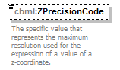
namespace | http://www.sisostds.org/schemas/c-bml/1.0
type | jc3iedm:DistancePrecisionCode
properties
  isRef | 0
  minOcc | 0
  maxOcc | 1
  content | simple
facets
  Kind | Value | annotation
  enumeration | 100FT
    documentation
    <Definition xml:lang="en">A linear measure (distance, length) is defined to the precision of 100 feet (30.48 metres).</Definition>
    appinfo
    <DisplayValue xml:lang="en">100 feet</DisplayValue>
  enumeration | 100MTR
    documentation
    <Definition xml:lang="en">A linear measure (distance, length) is defined to the precision of 100 metres.</Definition>
    appinfo
    <DisplayValue xml:lang="en">100 metres</DisplayValue>
  enumeration | 10FT
    documentation
    <Definition xml:lang="en">A linear measure (distance, length) is defined to the precision of 10 feet (3.048 metres).</Definition>
    appinfo
    <DisplayValue xml:lang="en">10 feet</DisplayValue>
  enumeration | 10MTR
    documentation
    <Definition xml:lang="en">A linear measure (distance, length) is defined to the precision of 10 metres.</Definition>
    appinfo
    <DisplayValue xml:lang="en">10 metres</DisplayValue>
  enumeration | 300MTR
    documentation
    <Definition xml:lang="en">A linear measure (distance, length) is defined to the precision of 300 metres.</Definition>
    appinfo
    <DisplayValue xml:lang="en">300 metres</DisplayValue>
  enumeration | 30MTR
    documentation
    <Definition xml:lang="en">A linear measure (distance, length) is defined to the precision of 30 metres.</Definition>
    appinfo
    <DisplayValue xml:lang="en">30 metres</DisplayValue>
  enumeration | 3MTR
    documentation
    <Definition xml:lang="en">A linear measure (distance, length) is defined to the precision of 3 metres.</Definition>
    appinfo
    <DisplayValue xml:lang="en">3 metres</DisplayValue>
  enumeration | CM
    documentation
    <Definition xml:lang="en">A linear measure (distance, length) is defined to the precision of 0.01 metre.</Definition>
    appinfo
    <DisplayValue xml:lang="en">Centimetre</DisplayValue>
  enumeration | FOOT
    documentation
    <Definition xml:lang="en">A linear measure (distance, length) is defined to the precision of one foot (0.3048 metres).</Definition>
    appinfo
    <DisplayValue xml:lang="en">Foot</DisplayValue>
  enumeration | INCH
    documentation
    <Definition xml:lang="en">A linear measure (distance, length) is defined to the precision of one inch (0.0254 metres).</Definition>
    appinfo
    <DisplayValue xml:lang="en">Inch</DisplayValue>
  enumeration | KILYRD
    documentation
    <Definition xml:lang="en">A linear measure (distance, length) is defined to the precision of a kiloyard (914,4 metres).</Definition>
    appinfo
    <DisplayValue xml:lang="en">Kiloyard</DisplayValue>
  enumeration | KM
    documentation
    <Definition xml:lang="en">A linear measure (distance, length) is defined to the precision of 1000 metres.</Definition>
    appinfo
    <DisplayValue xml:lang="en">Kilometre</DisplayValue>
  enumeration | METRE
    documentation
    <Definition xml:lang="en">A linear measure (distance, length) is defined to the precision of one metre.</Definition>
    appinfo
    <DisplayValue xml:lang="en">Metre</DisplayValue>
  enumeration | MILE
    documentation
    <Definition xml:lang="en">A linear measure (distance, length) is defined to the precision of one mile (1609.344 metres).</Definition>
    appinfo
    <DisplayValue xml:lang="en">Mile</DisplayValue>
  enumeration | MM
    documentation
    <Definition xml:lang="en">A linear measure (distance, length) is defined to the precision of one millimetre.</Definition>
    appinfo
    <DisplayValue xml:lang="en">Millimetre</DisplayValue>
  enumeration | NM
    documentation
    <Definition xml:lang="en">A linear measure (distance, length) is defined to the precision of a nautical mile (1852 metres).</Definition>
    appinfo
    <DisplayValue xml:lang="en">Nautical mile</DisplayValue>
  enumeration | YARD
    documentation
    <Definition xml:lang="en">A linear measure (distance, length) is defined to the precision of a yard (0.9144 metres).</Definition>
    appinfo
    <DisplayValue xml:lang="en">Yard</DisplayValue>
annotation
  documentation
  The specific value that represents the maximum resolution used for the expression of a value of a z-coordinate.
source | <xs:element name="ZPrecisionCode" type="jc3iedm:DistancePrecisionCode" minOccurs="0">  <xs:annotation>  <xs:documentation xml:lang="en">The specific value that represents the maximum resolution used for the expression of a value of a z-coordinate.</xs:documentation>  </xs:annotation>  </xs:element>

element RelativePoint/RelativeCoordinateSystem
diagram | 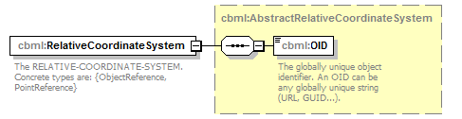
namespace | http://www.sisostds.org/schemas/c-bml/1.0
type | cbml:AbstractRelativeCoordinateSystem
properties
  isRef | 0
  content | complex
children | cbml:OID
annotation
  documentation
  The RELATIVE-COORDINATE-SYSTEM. Concrete types are: {ObjectReference, PointReference}
source | <xs:element name="RelativeCoordinateSystem" type="cbml:AbstractRelativeCoordinateSystem">  <xs:annotation>  <xs:documentation xml:lang="en">The RELATIVE-COORDINATE-SYSTEM. Concrete types are: {ObjectReference, PointReference}</xs:documentation>  </xs:annotation>  </xs:element>

element RelativePoint/RelativeCoordinateSystemRef
diagram | 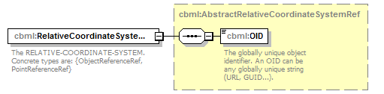
namespace | http://www.sisostds.org/schemas/c-bml/1.0
type | cbml:AbstractRelativeCoordinateSystemRef
properties
  isRef | 0
  content | complex
children | cbml:OID
annotation
  documentation
  The RELATIVE-COORDINATE-SYSTEM. Concrete types are: {ObjectReferenceRef, PointReferenceRef}
source | <xs:element name="RelativeCoordinateSystemRef" type="cbml:AbstractRelativeCoordinateSystemRef">  <xs:annotation>  <xs:documentation xml:lang="en">The RELATIVE-COORDINATE-SYSTEM. Concrete types are: {ObjectReferenceRef, PointReferenceRef}</xs:documentation>  </xs:annotation>  </xs:element>

complexType RelativePointRef
diagram | 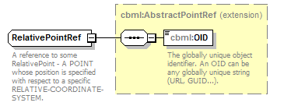
namespace | http://www.sisostds.org/schemas/c-bml/1.0
type | extension of cbml:AbstractPointRef
properties
  base | cbml:AbstractPointRef
children | cbml:OID
annotation
  documentation
  A reference to some RelativePoint - A POINT whose position is specified with respect to a specific RELATIVE-COORDINATE-SYSTEM.
source | <xs:complexType name="RelativePointRef">  <xs:annotation>  <xs:documentation xml:lang="en">A reference to some RelativePoint - A POINT whose position is specified with respect to a specific RELATIVE-COORDINATE-SYSTEM.</xs:documentation>  </xs:annotation>  <xs:complexContent>  <xs:extension base="cbml:AbstractPointRef"/>  </xs:complexContent>  </xs:complexType>

complexType SphereVolume
diagram | 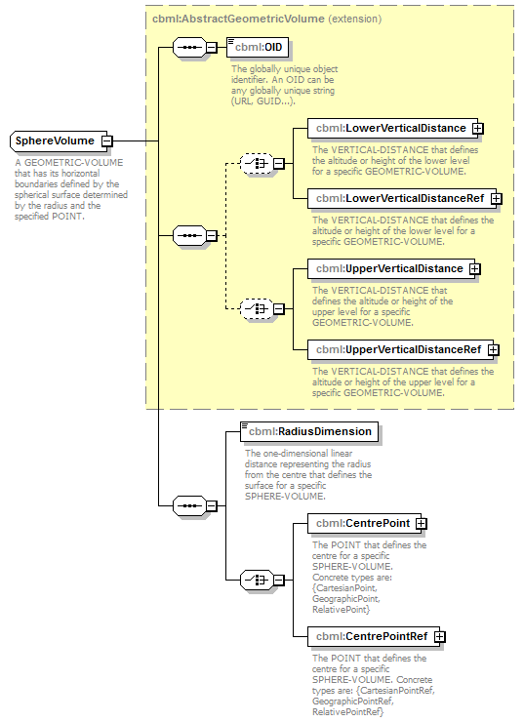
namespace | http://www.sisostds.org/schemas/c-bml/1.0
type | extension of cbml:AbstractGeometricVolume
properties
  base | cbml:AbstractGeometricVolume
children | cbml:OID cbml:LowerVerticalDistance cbml:LowerVerticalDistanceRef cbml:UpperVerticalDistance cbml:UpperVerticalDistanceRef cbml:RadiusDimension cbml:CentrePoint cbml:CentrePointRef
annotation
  documentation
  A GEOMETRIC-VOLUME that has its horizontal boundaries defined by the spherical surface determined by the radius and the specified POINT.
source | <xs:complexType name="SphereVolume">  <xs:annotation>  <xs:documentation xml:lang="en">A GEOMETRIC-VOLUME that has its horizontal boundaries defined by the spherical surface determined by the radius and the specified POINT.</xs:documentation>  </xs:annotation>  <xs:complexContent>  <xs:extension base="cbml:AbstractGeometricVolume">  <xs:sequence>  <xs:element name="RadiusDimension" type="jc3iedm:DimensionType12_3">  <xs:annotation>  <xs:documentation xml:lang="en">The one-dimensional linear distance representing the radius from the centre that defines the surface for a specific SPHERE-VOLUME.</xs:documentation>  </xs:annotation>  </xs:element>  <xs:choice>  <xs:element name="CentrePoint" type="cbml:AbstractPoint">  <xs:annotation>  <xs:documentation xml:lang="en">The POINT that defines the centre for a specific SPHERE-VOLUME. Concrete types are: {CartesianPoint, GeographicPoint, RelativePoint}</xs:documentation>  </xs:annotation>  </xs:element>  <xs:element name="CentrePointRef" type="cbml:AbstractPointRef">  <xs:annotation>  <xs:documentation xml:lang="en">The POINT that defines the centre for a specific SPHERE-VOLUME. Concrete types are: {CartesianPointRef, GeographicPointRef, RelativePointRef}</xs:documentation>  </xs:annotation>  </xs:element>  </xs:choice>  </xs:sequence>  </xs:extension>  </xs:complexContent>  </xs:complexType>

element SphereVolume/RadiusDimension
diagram | 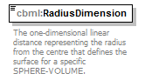
namespace | http://www.sisostds.org/schemas/c-bml/1.0
type | jc3iedm:DimensionType12_3
properties
  isRef | 0
  content | simple
facets
  Kind | Value | annotation
  minInclusive | -999999999.999
  maxInclusive | 999999999.999
  totalDigits | 12
  fractionDigits | 3
annotation
  documentation
  The one-dimensional linear distance representing the radius from the centre that defines the surface for a specific SPHERE-VOLUME.
source | <xs:element name="RadiusDimension" type="jc3iedm:DimensionType12_3">  <xs:annotation>  <xs:documentation xml:lang="en">The one-dimensional linear distance representing the radius from the centre that defines the surface for a specific SPHERE-VOLUME.</xs:documentation>  </xs:annotation>  </xs:element>

element SphereVolume/CentrePoint
diagram | 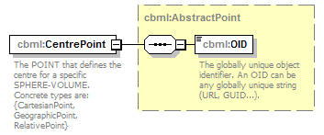
namespace | http://www.sisostds.org/schemas/c-bml/1.0
type | cbml:AbstractPoint
properties
  isRef | 0
  content | complex
children | cbml:OID
annotation
  documentation
  The POINT that defines the centre for a specific SPHERE-VOLUME. Concrete types are: {CartesianPoint, GeographicPoint, RelativePoint}
source | <xs:element name="CentrePoint" type="cbml:AbstractPoint">  <xs:annotation>  <xs:documentation xml:lang="en">The POINT that defines the centre for a specific SPHERE-VOLUME. Concrete types are: {CartesianPoint, GeographicPoint, RelativePoint}</xs:documentation>  </xs:annotation>  </xs:element>

element SphereVolume/CentrePointRef
diagram | 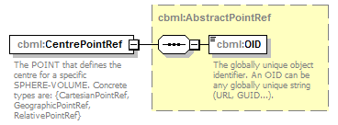
namespace | http://www.sisostds.org/schemas/c-bml/1.0
type | cbml:AbstractPointRef
properties
  isRef | 0
  content | complex
children | cbml:OID
annotation
  documentation
  The POINT that defines the centre for a specific SPHERE-VOLUME. Concrete types are: {CartesianPointRef, GeographicPointRef, RelativePointRef}
source | <xs:element name="CentrePointRef" type="cbml:AbstractPointRef">  <xs:annotation>  <xs:documentation xml:lang="en">The POINT that defines the centre for a specific SPHERE-VOLUME. Concrete types are: {CartesianPointRef, GeographicPointRef, RelativePointRef}</xs:documentation>  </xs:annotation>  </xs:element>

complexType SphereVolumeRef
diagram | 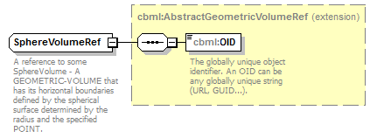
namespace | http://www.sisostds.org/schemas/c-bml/1.0
type | extension of cbml:AbstractGeometricVolumeRef
properties
  base | cbml:AbstractGeometricVolumeRef
children | cbml:OID
annotation
  documentation
  A reference to some SphereVolume - A GEOMETRIC-VOLUME that has its horizontal boundaries defined by the spherical surface determined by the radius and the specified POINT.
source | <xs:complexType name="SphereVolumeRef">  <xs:annotation>  <xs:documentation xml:lang="en">A reference to some SphereVolume - A GEOMETRIC-VOLUME that has its horizontal boundaries defined by the spherical surface determined by the radius and the specified POINT.</xs:documentation>  </xs:annotation>  <xs:complexContent>  <xs:extension base="cbml:AbstractGeometricVolumeRef"/>  </xs:complexContent>  </xs:complexType>

complexType SurfaceVolume
diagram | 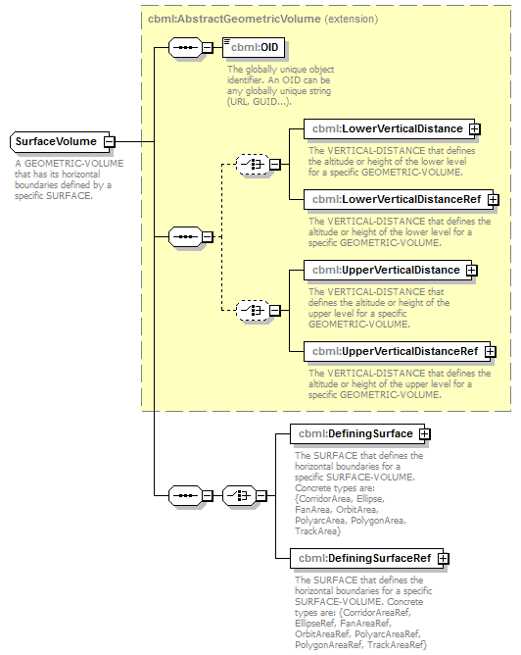
namespace | http://www.sisostds.org/schemas/c-bml/1.0
type | extension of cbml:AbstractGeometricVolume
properties
  base | cbml:AbstractGeometricVolume
children | cbml:OID cbml:LowerVerticalDistance cbml:LowerVerticalDistanceRef cbml:UpperVerticalDistance cbml:UpperVerticalDistanceRef cbml:DefiningSurface cbml:DefiningSurfaceRef
annotation
  documentation
  A GEOMETRIC-VOLUME that has its horizontal boundaries defined by a specific SURFACE.
source | <xs:complexType name="SurfaceVolume">  <xs:annotation>  <xs:documentation xml:lang="en">A GEOMETRIC-VOLUME that has its horizontal boundaries defined by a specific SURFACE.</xs:documentation>  </xs:annotation>  <xs:complexContent>  <xs:extension base="cbml:AbstractGeometricVolume">  <xs:sequence>  <xs:choice>  <xs:element name="DefiningSurface" type="cbml:AbstractSurface">  <xs:annotation>  <xs:documentation xml:lang="en">The SURFACE that defines the horizontal boundaries for a specific SURFACE-VOLUME. Concrete types are: {CorridorArea, Ellipse, FanArea, OrbitArea, PolyarcArea, PolygonArea, TrackArea}</xs:documentation>  </xs:annotation>  </xs:element>  <xs:element name="DefiningSurfaceRef" type="cbml:AbstractSurfaceRef">  <xs:annotation>  <xs:documentation xml:lang="en">The SURFACE that defines the horizontal boundaries for a specific SURFACE-VOLUME. Concrete types are: {CorridorAreaRef, EllipseRef, FanAreaRef, OrbitAreaRef, PolyarcAreaRef, PolygonAreaRef, TrackAreaRef}</xs:documentation>  </xs:annotation>  </xs:element>  </xs:choice>  </xs:sequence>  </xs:extension>  </xs:complexContent>  </xs:complexType>

element SurfaceVolume/DefiningSurface
diagram | 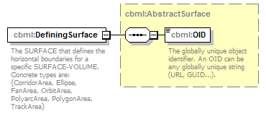
namespace | http://www.sisostds.org/schemas/c-bml/1.0
type | cbml:AbstractSurface
properties
  isRef | 0
  content | complex
children | cbml:OID
annotation
  documentation
  The SURFACE that defines the horizontal boundaries for a specific SURFACE-VOLUME. Concrete types are: {CorridorArea, Ellipse, FanArea, OrbitArea, PolyarcArea, PolygonArea, TrackArea}
source | <xs:element name="DefiningSurface" type="cbml:AbstractSurface">  <xs:annotation>  <xs:documentation xml:lang="en">The SURFACE that defines the horizontal boundaries for a specific SURFACE-VOLUME. Concrete types are: {CorridorArea, Ellipse, FanArea, OrbitArea, PolyarcArea, PolygonArea, TrackArea}</xs:documentation>  </xs:annotation>  </xs:element>

element SurfaceVolume/DefiningSurfaceRef
diagram | 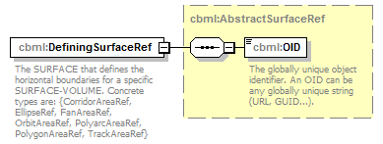
namespace | http://www.sisostds.org/schemas/c-bml/1.0
type | cbml:AbstractSurfaceRef
properties
  isRef | 0
  content | complex
children | cbml:OID
annotation
  documentation
  The SURFACE that defines the horizontal boundaries for a specific SURFACE-VOLUME. Concrete types are: {CorridorAreaRef, EllipseRef, FanAreaRef, OrbitAreaRef, PolyarcAreaRef, PolygonAreaRef, TrackAreaRef}
source | <xs:element name="DefiningSurfaceRef" type="cbml:AbstractSurfaceRef">  <xs:annotation>  <xs:documentation xml:lang="en">The SURFACE that defines the horizontal boundaries for a specific SURFACE-VOLUME. Concrete types are: {CorridorAreaRef, EllipseRef, FanAreaRef, OrbitAreaRef, PolyarcAreaRef, PolygonAreaRef, TrackAreaRef}</xs:documentation>  </xs:annotation>  </xs:element>

complexType SurfaceVolumeRef
diagram | 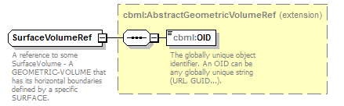
namespace | http://www.sisostds.org/schemas/c-bml/1.0
type | extension of cbml:AbstractGeometricVolumeRef
properties
  base | cbml:AbstractGeometricVolumeRef
children | cbml:OID
annotation
  documentation
  A reference to some SurfaceVolume - A GEOMETRIC-VOLUME that has its horizontal boundaries defined by a specific SURFACE.
source | <xs:complexType name="SurfaceVolumeRef">  <xs:annotation>  <xs:documentation xml:lang="en">A reference to some SurfaceVolume - A GEOMETRIC-VOLUME that has its horizontal boundaries defined by a specific SURFACE.</xs:documentation>  </xs:annotation>  <xs:complexContent>  <xs:extension base="cbml:AbstractGeometricVolumeRef"/>  </xs:complexContent>  </xs:complexType>

complexType TrackArea
diagram | 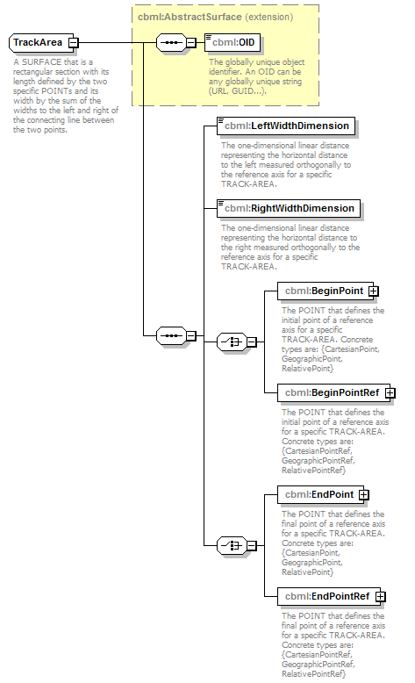
namespace | http://www.sisostds.org/schemas/c-bml/1.0
type | extension of cbml:AbstractSurface
properties
  base | cbml:AbstractSurface
children | cbml:OID cbml:LeftWidthDimension cbml:RightWidthDimension cbml:BeginPoint cbml:BeginPointRef cbml:EndPoint cbml:EndPointRef
annotation
  documentation
  A SURFACE that is a rectangular section with its length defined by the two specific POINTs and its width by the sum of the widths to the left and right of the connecting line between the two points.
source | <xs:complexType name="TrackArea">  <xs:annotation>  <xs:documentation xml:lang="en">A SURFACE that is a rectangular section with its length defined by the two specific POINTs and its width by the sum of the widths to the left and right of the connecting line between the two points.</xs:documentation>  </xs:annotation>  <xs:complexContent>  <xs:extension base="cbml:AbstractSurface">  <xs:sequence>  <xs:element name="LeftWidthDimension" type="jc3iedm:DimensionType12_3">  <xs:annotation>  <xs:documentation xml:lang="en">The one-dimensional linear distance representing the horizontal distance to the left measured orthogonally to the reference axis for a specific TRACK-AREA.</xs:documentation>  </xs:annotation>  </xs:element>  <xs:element name="RightWidthDimension" type="jc3iedm:DimensionType12_3">  <xs:annotation>  <xs:documentation xml:lang="en">The one-dimensional linear distance representing the horizontal distance to the right measured orthogonally to the reference axis for a specific TRACK-AREA.</xs:documentation>  </xs:annotation>  </xs:element>  <xs:choice>  <xs:element name="BeginPoint" type="cbml:AbstractPoint">  <xs:annotation>  <xs:documentation xml:lang="en">The POINT that defines the initial point of a reference axis for a specific TRACK-AREA. Concrete types are: {CartesianPoint, GeographicPoint, RelativePoint}</xs:documentation>  </xs:annotation>  </xs:element>  <xs:element name="BeginPointRef" type="cbml:AbstractPointRef">  <xs:annotation>  <xs:documentation xml:lang="en">The POINT that defines the initial point of a reference axis for a specific TRACK-AREA. Concrete types are: {CartesianPointRef, GeographicPointRef, RelativePointRef}</xs:documentation>  </xs:annotation>  </xs:element>  </xs:choice>  <xs:choice>  <xs:element name="EndPoint" type="cbml:AbstractPoint">  <xs:annotation>  <xs:documentation xml:lang="en">The POINT that defines the final point of a reference axis for a specific TRACK-AREA. Concrete types are: {CartesianPoint, GeographicPoint, RelativePoint}</xs:documentation>  </xs:annotation>  </xs:element>  <xs:element name="EndPointRef" type="cbml:AbstractPointRef">  <xs:annotation>  <xs:documentation xml:lang="en">The POINT that defines the final point of a reference axis for a specific TRACK-AREA. Concrete types are: {CartesianPointRef, GeographicPointRef, RelativePointRef}</xs:documentation>  </xs:annotation>  </xs:element>  </xs:choice>  </xs:sequence>  </xs:extension>  </xs:complexContent>  </xs:complexType>

element TrackArea/LeftWidthDimension
diagram | 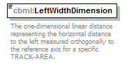
namespace | http://www.sisostds.org/schemas/c-bml/1.0
type | jc3iedm:DimensionType12_3
properties
  isRef | 0
  content | simple
facets
  Kind | Value | annotation
  minInclusive | -999999999.999
  maxInclusive | 999999999.999
  totalDigits | 12
  fractionDigits | 3
annotation
  documentation
  The one-dimensional linear distance representing the horizontal distance to the left measured orthogonally to the reference axis for a specific TRACK-AREA.
source | <xs:element name="LeftWidthDimension" type="jc3iedm:DimensionType12_3">  <xs:annotation>  <xs:documentation xml:lang="en">The one-dimensional linear distance representing the horizontal distance to the left measured orthogonally to the reference axis for a specific TRACK-AREA.</xs:documentation>  </xs:annotation>  </xs:element>

element TrackArea/RightWidthDimension
diagram | 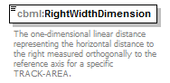
namespace | http://www.sisostds.org/schemas/c-bml/1.0
type | jc3iedm:DimensionType12_3
properties
  isRef | 0
  content | simple
facets
  Kind | Value | annotation
  minInclusive | -999999999.999
  maxInclusive | 999999999.999
  totalDigits | 12
  fractionDigits | 3
annotation
  documentation
  The one-dimensional linear distance representing the horizontal distance to the right measured orthogonally to the reference axis for a specific TRACK-AREA.
source | <xs:element name="RightWidthDimension" type="jc3iedm:DimensionType12_3">  <xs:annotation>  <xs:documentation xml:lang="en">The one-dimensional linear distance representing the horizontal distance to the right measured orthogonally to the reference axis for a specific TRACK-AREA.</xs:documentation>  </xs:annotation>  </xs:element>

element TrackArea/BeginPoint
diagram | 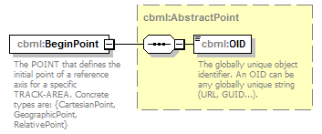
namespace | http://www.sisostds.org/schemas/c-bml/1.0
type | cbml:AbstractPoint
properties
  isRef | 0
  content | complex
children | cbml:OID
annotation
  documentation
  The POINT that defines the initial point of a reference axis for a specific TRACK-AREA. Concrete types are: {CartesianPoint, GeographicPoint, RelativePoint}
source | <xs:element name="BeginPoint" type="cbml:AbstractPoint">  <xs:annotation>  <xs:documentation xml:lang="en">The POINT that defines the initial point of a reference axis for a specific TRACK-AREA. Concrete types are: {CartesianPoint, GeographicPoint, RelativePoint}</xs:documentation>  </xs:annotation>  </xs:element>

element TrackArea/BeginPointRef
diagram | 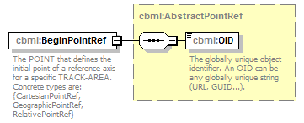
namespace | http://www.sisostds.org/schemas/c-bml/1.0
type | cbml:AbstractPointRef
properties
  isRef | 0
  content | complex
children | cbml:OID
annotation
  documentation
  The POINT that defines the initial point of a reference axis for a specific TRACK-AREA. Concrete types are: {CartesianPointRef, GeographicPointRef, RelativePointRef}
source | <xs:element name="BeginPointRef" type="cbml:AbstractPointRef">  <xs:annotation>  <xs:documentation xml:lang="en">The POINT that defines the initial point of a reference axis for a specific TRACK-AREA. Concrete types are: {CartesianPointRef, GeographicPointRef, RelativePointRef}</xs:documentation>  </xs:annotation>  </xs:element>

element TrackArea/EndPoint
diagram | 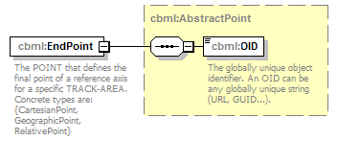
namespace | http://www.sisostds.org/schemas/c-bml/1.0
type | cbml:AbstractPoint
properties
  isRef | 0
  content | complex
children | cbml:OID
annotation
  documentation
  The POINT that defines the final point of a reference axis for a specific TRACK-AREA. Concrete types are: {CartesianPoint, GeographicPoint, RelativePoint}
source | <xs:element name="EndPoint" type="cbml:AbstractPoint">  <xs:annotation>  <xs:documentation xml:lang="en">The POINT that defines the final point of a reference axis for a specific TRACK-AREA. Concrete types are: {CartesianPoint, GeographicPoint, RelativePoint}</xs:documentation>  </xs:annotation>  </xs:element>

element TrackArea/EndPointRef
diagram | 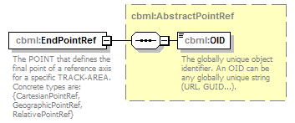
namespace | http://www.sisostds.org/schemas/c-bml/1.0
type | cbml:AbstractPointRef
properties
  isRef | 0
  content | complex
children | cbml:OID
annotation
  documentation
  The POINT that defines the final point of a reference axis for a specific TRACK-AREA. Concrete types are: {CartesianPointRef, GeographicPointRef, RelativePointRef}
source | <xs:element name="EndPointRef" type="cbml:AbstractPointRef">  <xs:annotation>  <xs:documentation xml:lang="en">The POINT that defines the final point of a reference axis for a specific TRACK-AREA. Concrete types are: {CartesianPointRef, GeographicPointRef, RelativePointRef}</xs:documentation>  </xs:annotation>  </xs:element>

complexType TrackAreaRef
diagram | 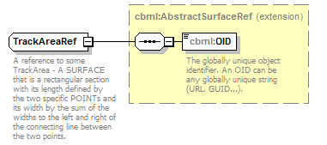
namespace | http://www.sisostds.org/schemas/c-bml/1.0
type | extension of cbml:AbstractSurfaceRef
properties
  base | cbml:AbstractSurfaceRef
children | cbml:OID
annotation
  documentation
  A reference to some TrackArea - A SURFACE that is a rectangular section with its length defined by the two specific POINTs and its width by the sum of the widths to the left and right of the connecting line between the two points.
source | <xs:complexType name="TrackAreaRef">  <xs:annotation>  <xs:documentation xml:lang="en">A reference to some TrackArea - A SURFACE that is a rectangular section with its length defined by the two specific POINTs and its width by the sum of the widths to the left and right of the connecting line between the two points.</xs:documentation>  </xs:annotation>  <xs:complexContent>  <xs:extension base="cbml:AbstractSurfaceRef"/>  </xs:complexContent>  </xs:complexType>

XML Schema documentation generated by XMLSpy Schema Editor http://www.altova.com/xmlspy

