Schema cbml-organisation-types.xsd

schema location: | cbml-organisation-types.xsd
attribute form default: | unqualified
element form default: | qualified
targetNamespace: | http://www.sisostds.org/schemas/c-bml/1.0

Complex types
CivilianPostType
CivilianPostTypeRef
Convoy
ConvoyRef
ExecutiveMilitaryOrganisationType
ExecutiveMilitaryOrganisationTypeRef
GroupOrganisationType
GroupOrganisationTypeRef
MilitaryPostType
MilitaryPostTypeRef
OrganisationStatus
OtherGovernmentOrganisationType
OtherGovernmentOrganisationTypeRef
OtherMilitaryOrganisationType
OtherMilitaryOrganisationTypeRef
OtherOrganisation
OtherOrganisationRef
OtherOrganisationType
OtherOrganisationTypeRef
PrivateSectorOrganisationType
PrivateSectorOrganisationTypeRef
TaskFormationType
TaskFormationTypeRef
Unit
UnitRef
UnitType
UnitTypeRef

complexType CivilianPostType
diagram | 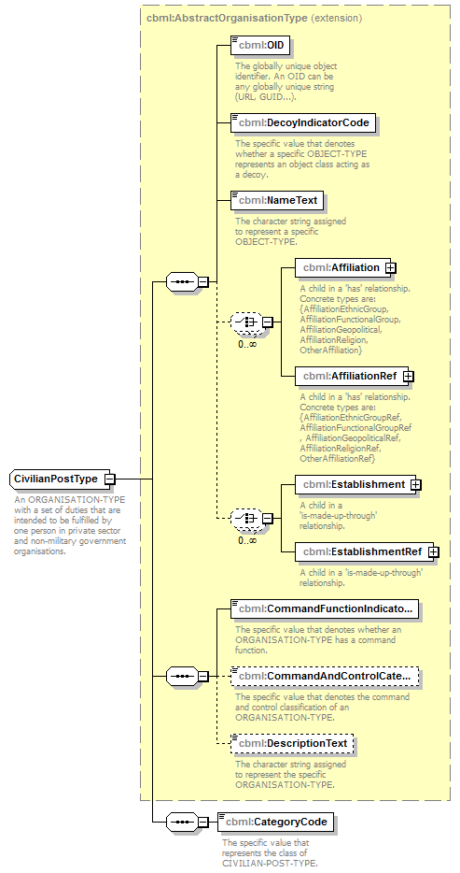
namespace | http://www.sisostds.org/schemas/c-bml/1.0
type | extension of cbml:AbstractOrganisationType
properties
  base | cbml:AbstractOrganisationType
children | cbml:OID cbml:DecoyIndicatorCode cbml:NameText cbml:Affiliation cbml:AffiliationRef cbml:Establishment cbml:EstablishmentRef cbml:CommandFunctionIndicatorCode cbml:CommandAndControlCategoryCode cbml:DescriptionText cbml:CategoryCode
annotation
  documentation
  An ORGANISATION-TYPE with a set of duties that are intended to be fulfilled by one person in private sector and non-military government organisations.
source | <xs:complexType name="CivilianPostType">  <xs:annotation>  <xs:documentation xml:lang="en">An ORGANISATION-TYPE with a set of duties that are intended to be fulfilled by one person in private sector and non-military government organisations.</xs:documentation>  </xs:annotation>  <xs:complexContent>  <xs:extension base="cbml:AbstractOrganisationType">  <xs:sequence>  <xs:element name="CategoryCode" type="jc3iedm:CivilianPostTypeCategoryCode">  <xs:annotation>  <xs:documentation xml:lang="en">The specific value that represents the class of CIVILIAN-POST-TYPE.</xs:documentation>  </xs:annotation>  </xs:element>  </xs:sequence>  </xs:extension>  </xs:complexContent>  </xs:complexType>

element CivilianPostType/CategoryCode
diagram | 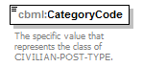
namespace | http://www.sisostds.org/schemas/c-bml/1.0
type | jc3iedm:CivilianPostTypeCategoryCode
properties
  isRef | 0
  content | simple
facets
  Kind | Value | annotation
  enumeration | AIDADM
    documentation
    <Definition xml:lang="en">A CIVILIAN-POST-TYPE whose job is to manage or direct the affairs of an organisation that provides relief services.</Definition>
    appinfo
    <DisplayValue xml:lang="en">Aid administrator</DisplayValue>
  enumeration | ALDRMN
    documentation
    <Definition xml:lang="en">A CIVILIAN-POST-TYPE whose job entails the participation in the legislative body of town or city governments.</Definition>
    appinfo
    <DisplayValue xml:lang="en">Alderman</DisplayValue>
  enumeration | COREXC
    documentation
    <Definition xml:lang="en">A CIVILIAN-POST-TYPE whose job entails the leadership in an executive or administrative function in a private sector business.</Definition>
    appinfo
    <DisplayValue xml:lang="en">Corporate executive</DisplayValue>
  enumeration | DEPTHD
    documentation
    <Definition xml:lang="en">A CIVILIAN-POST-TYPE whose job entails the leadership of a separate division or branch of an organisation.</Definition>
    appinfo
    <DisplayValue xml:lang="en">Department head</DisplayValue>
  enumeration | GOVMST
    documentation
    <Definition xml:lang="en">A CIVILIAN-POST-TYPE whose job entails the lower level executive duties of the government.</Definition>
    appinfo
    <DisplayValue xml:lang="en">Government minister</DisplayValue>
  enumeration | GOVRNR
    documentation
    <Definition xml:lang="en">A CIVILIAN-POST-TYPE whose job is the executive leadership and administrative control over a group of people.</Definition>
    appinfo
    <DisplayValue xml:lang="en">Governor</DisplayValue>
  enumeration | HEADST
    documentation
    <Definition xml:lang="en">A CIVILIAN-POST-TYPE whose job is the supreme executive magistracy of a country.</Definition>
    appinfo
    <DisplayValue xml:lang="en">Head of state</DisplayValue>
  enumeration | MAYOR
    documentation
    <Definition xml:lang="en">A CIVILIAN-POST-TYPE whose job is the chief officer of the municipal corporation of a city or borough.</Definition>
    appinfo
    <DisplayValue xml:lang="en">Mayor</DisplayValue>
  enumeration | NOS
    documentation
    <Definition xml:lang="en">The appropriate value is not in the set of specified values.</Definition>
    appinfo
    <DisplayValue xml:lang="en">Not otherwise specified</DisplayValue>
  enumeration | POLCHF
    documentation
    <Definition xml:lang="en">A CIVILIAN-POST-TYPE whose job is the chief officer of a civil force to which is entrusted the duty of maintaining public order, enforcing regulations and detecting crime.</Definition>
    appinfo
    <DisplayValue xml:lang="en">Police chief</DisplayValue>
  enumeration | PUBLSR
    documentation
    <Definition xml:lang="en">A CIVILIAN-POST-TYPE whose business is the issuing of books, newspapers, music, engravings, videos or the like, as the agent of the author or owner.</Definition>
    appinfo
    <DisplayValue xml:lang="en">Publisher</DisplayValue>
  enumeration | REGADM
    documentation
    <Definition xml:lang="en">A CIVILIAN-POST-TYPE whose job is to manage or direct the affairs of a regional organisation.</Definition>
    appinfo
    <DisplayValue xml:lang="en">Regional administrator</DisplayValue>
  enumeration | RELATH
    documentation
    <Definition xml:lang="en">A CIVILIAN-POST-TYPE whose job is to authorize the release of a product or information.</Definition>
    appinfo
    <DisplayValue xml:lang="en">Release authority</DisplayValue>
annotation
  documentation
  The specific value that represents the class of CIVILIAN-POST-TYPE.
source | <xs:element name="CategoryCode" type="jc3iedm:CivilianPostTypeCategoryCode">  <xs:annotation>  <xs:documentation xml:lang="en">The specific value that represents the class of CIVILIAN-POST-TYPE.</xs:documentation>  </xs:annotation>  </xs:element>

complexType CivilianPostTypeRef
diagram | 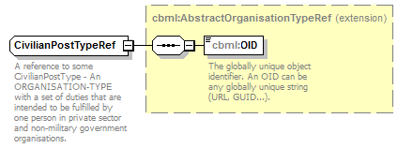
namespace | http://www.sisostds.org/schemas/c-bml/1.0
type | extension of cbml:AbstractOrganisationTypeRef
properties
  base | cbml:AbstractOrganisationTypeRef
children | cbml:OID
annotation
  documentation
  A reference to some CivilianPostType - An ORGANISATION-TYPE with a set of duties that are intended to be fulfilled by one person in private sector and non-military government organisations.
source | <xs:complexType name="CivilianPostTypeRef">  <xs:annotation>  <xs:documentation xml:lang="en">A reference to some CivilianPostType - An ORGANISATION-TYPE with a set of duties that are intended to be fulfilled by one person in private sector and non-military government organisations.</xs:documentation>  </xs:annotation>  <xs:complexContent>  <xs:extension base="cbml:AbstractOrganisationTypeRef"/>  </xs:complexContent>  </xs:complexType>

complexType Convoy
diagram | 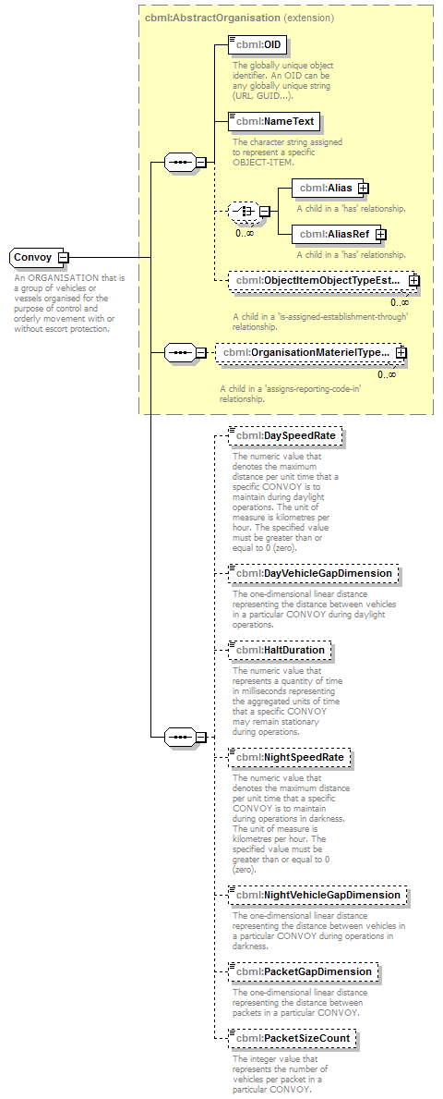
namespace | http://www.sisostds.org/schemas/c-bml/1.0
type | extension of cbml:AbstractOrganisation
properties
  base | cbml:AbstractOrganisation
children | cbml:OID cbml:NameText cbml:Alias cbml:AliasRef cbml:ObjectItemObjectTypeEstablishmentInObjectItem cbml:OrganisationMaterielTypeAssociationInOrganisation cbml:DaySpeedRate cbml:DayVehicleGapDimension cbml:HaltDuration cbml:NightSpeedRate cbml:NightVehicleGapDimension cbml:PacketGapDimension cbml:PacketSizeCount
annotation
  documentation
  An ORGANISATION that is a group of vehicles or vessels organised for the purpose of control and orderly movement with or without escort protection.
source | <xs:complexType name="Convoy">  <xs:annotation>  <xs:documentation xml:lang="en">An ORGANISATION that is a group of vehicles or vessels organised for the purpose of control and orderly movement with or without escort protection.</xs:documentation>  </xs:annotation>  <xs:complexContent>  <xs:extension base="cbml:AbstractOrganisation">  <xs:sequence>  <xs:element name="DaySpeedRate" type="jc3iedm:RateType8_4" minOccurs="0">  <xs:annotation>  <xs:documentation xml:lang="en">The numeric value that denotes the maximum distance per unit time that a specific CONVOY is to maintain during daylight operations. The unit of measure is kilometres per hour. The specified value must be greater than or equal to 0 (zero).</xs:documentation>  </xs:annotation>  </xs:element>  <xs:element name="DayVehicleGapDimension" type="jc3iedm:DimensionType12_3" minOccurs="0">  <xs:annotation>  <xs:documentation xml:lang="en">The one-dimensional linear distance representing the distance between vehicles in a particular CONVOY during daylight operations.</xs:documentation>  </xs:annotation>  </xs:element>  <xs:element name="HaltDuration" type="jc3iedm:DurationType19" minOccurs="0">  <xs:annotation>  <xs:documentation xml:lang="en">The numeric value that represents a quantity of time in milliseconds representing the aggregated units of time that a specific CONVOY may remain stationary during operations.</xs:documentation>  </xs:annotation>  </xs:element>  <xs:element name="NightSpeedRate" type="jc3iedm:RateType8_4" minOccurs="0">  <xs:annotation>  <xs:documentation xml:lang="en">The numeric value that denotes the maximum distance per unit time that a specific CONVOY is to maintain during operations in darkness. The unit of measure is kilometres per hour. The specified value must be greater than or equal to 0 (zero).</xs:documentation>  </xs:annotation>  </xs:element>  <xs:element name="NightVehicleGapDimension" type="jc3iedm:DimensionType12_3" minOccurs="0">  <xs:annotation>  <xs:documentation xml:lang="en">The one-dimensional linear distance representing the distance between vehicles in a particular CONVOY during operations in darkness.</xs:documentation>  </xs:annotation>  </xs:element>  <xs:element name="PacketGapDimension" type="jc3iedm:DimensionType12_3" minOccurs="0">  <xs:annotation>  <xs:documentation xml:lang="en">The one-dimensional linear distance representing the distance between packets in a particular CONVOY.</xs:documentation>  </xs:annotation>  </xs:element>  <xs:element name="PacketSizeCount" type="jc3iedm:CountType9" minOccurs="0">  <xs:annotation>  <xs:documentation xml:lang="en">The integer value that represents the number of vehicles per packet in a particular CONVOY.</xs:documentation>  </xs:annotation>  </xs:element>  </xs:sequence>  </xs:extension>  </xs:complexContent>  </xs:complexType>

element Convoy/DaySpeedRate
diagram | 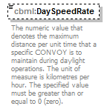
namespace | http://www.sisostds.org/schemas/c-bml/1.0
type | jc3iedm:RateType8_4
properties
  isRef | 0
  minOcc | 0
  maxOcc | 1
  content | simple
facets
  Kind | Value | annotation
  minInclusive | -9999.9999
  maxInclusive | 9999.9999
  totalDigits | 8
  fractionDigits | 4
annotation
  documentation
  The numeric value that denotes the maximum distance per unit time that a specific CONVOY is to maintain during daylight operations. The unit of measure is kilometres per hour. The specified value must be greater than or equal to 0 (zero).
source | <xs:element name="DaySpeedRate" type="jc3iedm:RateType8_4" minOccurs="0">  <xs:annotation>  <xs:documentation xml:lang="en">The numeric value that denotes the maximum distance per unit time that a specific CONVOY is to maintain during daylight operations. The unit of measure is kilometres per hour. The specified value must be greater than or equal to 0 (zero).</xs:documentation>  </xs:annotation>  </xs:element>

element Convoy/DayVehicleGapDimension
diagram | 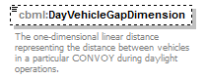
namespace | http://www.sisostds.org/schemas/c-bml/1.0
type | jc3iedm:DimensionType12_3
properties
  isRef | 0
  minOcc | 0
  maxOcc | 1
  content | simple
facets
  Kind | Value | annotation
  minInclusive | -999999999.999
  maxInclusive | 999999999.999
  totalDigits | 12
  fractionDigits | 3
annotation
  documentation
  The one-dimensional linear distance representing the distance between vehicles in a particular CONVOY during daylight operations.
source | <xs:element name="DayVehicleGapDimension" type="jc3iedm:DimensionType12_3" minOccurs="0">  <xs:annotation>  <xs:documentation xml:lang="en">The one-dimensional linear distance representing the distance between vehicles in a particular CONVOY during daylight operations.</xs:documentation>  </xs:annotation>  </xs:element>

element Convoy/HaltDuration
diagram | 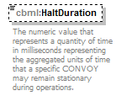
namespace | http://www.sisostds.org/schemas/c-bml/1.0
type | jc3iedm:DurationType19
properties
  isRef | 0
  minOcc | 0
  maxOcc | 1
  content | simple
facets
  Kind | Value | annotation
  minInclusive | -9999999999999999999
  maxInclusive | 9999999999999999999
annotation
  documentation
  The numeric value that represents a quantity of time in milliseconds representing the aggregated units of time that a specific CONVOY may remain stationary during operations.
source | <xs:element name="HaltDuration" type="jc3iedm:DurationType19" minOccurs="0">  <xs:annotation>  <xs:documentation xml:lang="en">The numeric value that represents a quantity of time in milliseconds representing the aggregated units of time that a specific CONVOY may remain stationary during operations.</xs:documentation>  </xs:annotation>  </xs:element>

element Convoy/NightSpeedRate
diagram | 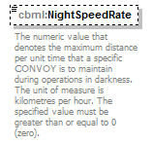
namespace | http://www.sisostds.org/schemas/c-bml/1.0
type | jc3iedm:RateType8_4
properties
  isRef | 0
  minOcc | 0
  maxOcc | 1
  content | simple
facets
  Kind | Value | annotation
  minInclusive | -9999.9999
  maxInclusive | 9999.9999
  totalDigits | 8
  fractionDigits | 4
annotation
  documentation
  The numeric value that denotes the maximum distance per unit time that a specific CONVOY is to maintain during operations in darkness. The unit of measure is kilometres per hour. The specified value must be greater than or equal to 0 (zero).
source | <xs:element name="NightSpeedRate" type="jc3iedm:RateType8_4" minOccurs="0">  <xs:annotation>  <xs:documentation xml:lang="en">The numeric value that denotes the maximum distance per unit time that a specific CONVOY is to maintain during operations in darkness. The unit of measure is kilometres per hour. The specified value must be greater than or equal to 0 (zero).</xs:documentation>  </xs:annotation>  </xs:element>

element Convoy/NightVehicleGapDimension
diagram | 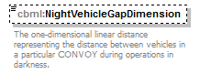
namespace | http://www.sisostds.org/schemas/c-bml/1.0
type | jc3iedm:DimensionType12_3
properties
  isRef | 0
  minOcc | 0
  maxOcc | 1
  content | simple
facets
  Kind | Value | annotation
  minInclusive | -999999999.999
  maxInclusive | 999999999.999
  totalDigits | 12
  fractionDigits | 3
annotation
  documentation
  The one-dimensional linear distance representing the distance between vehicles in a particular CONVOY during operations in darkness.
source | <xs:element name="NightVehicleGapDimension" type="jc3iedm:DimensionType12_3" minOccurs="0">  <xs:annotation>  <xs:documentation xml:lang="en">The one-dimensional linear distance representing the distance between vehicles in a particular CONVOY during operations in darkness.</xs:documentation>  </xs:annotation>  </xs:element>

element Convoy/PacketGapDimension
diagram | 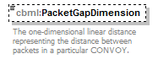
namespace | http://www.sisostds.org/schemas/c-bml/1.0
type | jc3iedm:DimensionType12_3
properties
  isRef | 0
  minOcc | 0
  maxOcc | 1
  content | simple
facets
  Kind | Value | annotation
  minInclusive | -999999999.999
  maxInclusive | 999999999.999
  totalDigits | 12
  fractionDigits | 3
annotation
  documentation
  The one-dimensional linear distance representing the distance between packets in a particular CONVOY.
source | <xs:element name="PacketGapDimension" type="jc3iedm:DimensionType12_3" minOccurs="0">  <xs:annotation>  <xs:documentation xml:lang="en">The one-dimensional linear distance representing the distance between packets in a particular CONVOY.</xs:documentation>  </xs:annotation>  </xs:element>

element Convoy/PacketSizeCount
diagram | 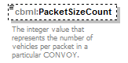
namespace | http://www.sisostds.org/schemas/c-bml/1.0
type | jc3iedm:CountType9
properties
  isRef | 0
  minOcc | 0
  maxOcc | 1
  content | simple
facets
  Kind | Value | annotation
  minInclusive | -999999999
  maxInclusive | 999999999
annotation
  documentation
  The integer value that represents the number of vehicles per packet in a particular CONVOY.
source | <xs:element name="PacketSizeCount" type="jc3iedm:CountType9" minOccurs="0">  <xs:annotation>  <xs:documentation xml:lang="en">The integer value that represents the number of vehicles per packet in a particular CONVOY.</xs:documentation>  </xs:annotation>  </xs:element>

complexType ConvoyRef
diagram | 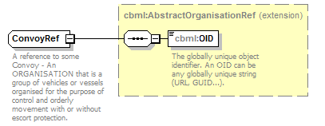
namespace | http://www.sisostds.org/schemas/c-bml/1.0
type | extension of cbml:AbstractOrganisationRef
properties
  base | cbml:AbstractOrganisationRef
children | cbml:OID
annotation
  documentation
  A reference to some Convoy - An ORGANISATION that is a group of vehicles or vessels organised for the purpose of control and orderly movement with or without escort protection.
source | <xs:complexType name="ConvoyRef">  <xs:annotation>  <xs:documentation xml:lang="en">A reference to some Convoy - An ORGANISATION that is a group of vehicles or vessels organised for the purpose of control and orderly movement with or without escort protection.</xs:documentation>  </xs:annotation>  <xs:complexContent>  <xs:extension base="cbml:AbstractOrganisationRef"/>  </xs:complexContent>  </xs:complexType>

complexType ExecutiveMilitaryOrganisationType
diagram | 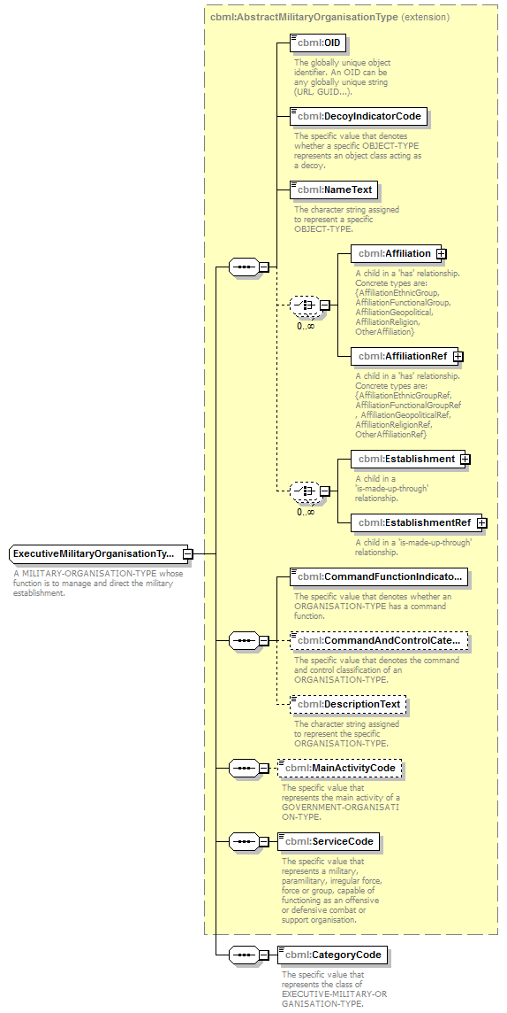
namespace | http://www.sisostds.org/schemas/c-bml/1.0
type | extension of cbml:AbstractMilitaryOrganisationType
properties
  base | cbml:AbstractMilitaryOrganisationType
children | cbml:OID cbml:DecoyIndicatorCode cbml:NameText cbml:Affiliation cbml:AffiliationRef cbml:Establishment cbml:EstablishmentRef cbml:CommandFunctionIndicatorCode cbml:CommandAndControlCategoryCode cbml:DescriptionText cbml:MainActivityCode cbml:ServiceCode cbml:CategoryCode
annotation
  documentation
  A MILITARY-ORGANISATION-TYPE whose function is to manage and direct the military establishment.
source | <xs:complexType name="ExecutiveMilitaryOrganisationType">  <xs:annotation>  <xs:documentation xml:lang="en">A MILITARY-ORGANISATION-TYPE whose function is to manage and direct the military establishment.</xs:documentation>  </xs:annotation>  <xs:complexContent>  <xs:extension base="cbml:AbstractMilitaryOrganisationType">  <xs:sequence>  <xs:element name="CategoryCode" type="jc3iedm:ExecutiveMilitaryOrganisationTypeCategoryCode">  <xs:annotation>  <xs:documentation xml:lang="en">The specific value that represents the class of EXECUTIVE-MILITARY-ORGANISATION-TYPE.</xs:documentation>  </xs:annotation>  </xs:element>  </xs:sequence>  </xs:extension>  </xs:complexContent>  </xs:complexType>

element ExecutiveMilitaryOrganisationType/CategoryCode
diagram | 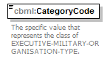
namespace | http://www.sisostds.org/schemas/c-bml/1.0
type | jc3iedm:ExecutiveMilitaryOrganisationTypeCategoryCode
properties
  isRef | 0
  content | simple
facets
  Kind | Value | annotation
  enumeration | HQ
    documentation
    <Definition xml:lang="en">An EXECUTIVE-MILITARY-ORGANISATION-TYPE that performs the management functions of an international, national, strategic or service headquarters.</Definition>
    appinfo
    <DisplayValue xml:lang="en">Headquarters</DisplayValue>
  enumeration | LOG
    documentation
    <Definition xml:lang="en">An EXECUTIVE-MILITARY-ORGANISATION-TYPE that provides management of logistics services.</Definition>
    appinfo
    <DisplayValue xml:lang="en">Logistics</DisplayValue>
  enumeration | MILSVC
    documentation
    <Definition xml:lang="en">An EXECUTIVE-MILITARY-ORGANISATION-TYPE, other than police, that manages the training, equipping, manning, and operating of an armed uniformed force.</Definition>
    appinfo
    <DisplayValue xml:lang="en">Military service</DisplayValue>
  enumeration | NOS
    documentation
    <Definition xml:lang="en">The appropriate value is not in the set of specified values.</Definition>
    appinfo
    <DisplayValue xml:lang="en">Not otherwise specified</DisplayValue>
  enumeration | PRSNL
    documentation
    <Definition xml:lang="en">An EXECUTIVE-MILITARY-ORGANISATION-TYPE that provides management of personnel services.</Definition>
    appinfo
    <DisplayValue xml:lang="en">Personnel</DisplayValue>
  enumeration | SUPPLY
    documentation
    <Definition xml:lang="en">An EXECUTIVE-MILITARY-ORGANISATION-TYPE that provides management of supply services.</Definition>
    appinfo
    <DisplayValue xml:lang="en">Supply</DisplayValue>
  enumeration | TRNPTN
    documentation
    <Definition xml:lang="en">An EXECUTIVE-MILITARY-ORGANISATION-TYPE that provides management of transportation services.</Definition>
    appinfo
    <DisplayValue xml:lang="en">Transportation</DisplayValue>
annotation
  documentation
  The specific value that represents the class of EXECUTIVE-MILITARY-ORGANISATION-TYPE.
source | <xs:element name="CategoryCode" type="jc3iedm:ExecutiveMilitaryOrganisationTypeCategoryCode">  <xs:annotation>  <xs:documentation xml:lang="en">The specific value that represents the class of EXECUTIVE-MILITARY-ORGANISATION-TYPE.</xs:documentation>  </xs:annotation>  </xs:element>

complexType ExecutiveMilitaryOrganisationTypeRef
diagram | 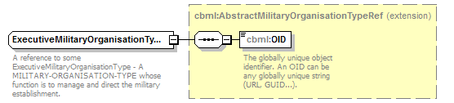
namespace | http://www.sisostds.org/schemas/c-bml/1.0
type | extension of cbml:AbstractMilitaryOrganisationTypeRef
properties
  base | cbml:AbstractMilitaryOrganisationTypeRef
children | cbml:OID
annotation
  documentation
  A reference to some ExecutiveMilitaryOrganisationType - A MILITARY-ORGANISATION-TYPE whose function is to manage and direct the military establishment.
source | <xs:complexType name="ExecutiveMilitaryOrganisationTypeRef">  <xs:annotation>  <xs:documentation xml:lang="en">A reference to some ExecutiveMilitaryOrganisationType - A MILITARY-ORGANISATION-TYPE whose function is to manage and direct the military establishment.</xs:documentation>  </xs:annotation>  <xs:complexContent>  <xs:extension base="cbml:AbstractMilitaryOrganisationTypeRef"/>  </xs:complexContent>  </xs:complexType>

complexType GroupOrganisationType
diagram | 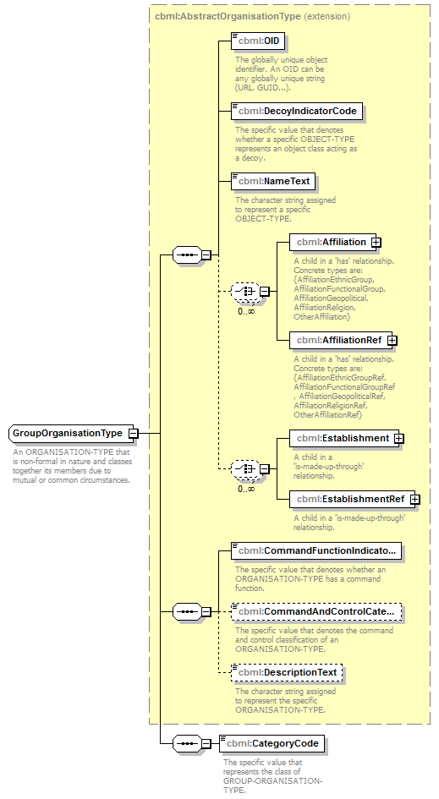
namespace | http://www.sisostds.org/schemas/c-bml/1.0
type | extension of cbml:AbstractOrganisationType
properties
  base | cbml:AbstractOrganisationType
children | cbml:OID cbml:DecoyIndicatorCode cbml:NameText cbml:Affiliation cbml:AffiliationRef cbml:Establishment cbml:EstablishmentRef cbml:CommandFunctionIndicatorCode cbml:CommandAndControlCategoryCode cbml:DescriptionText cbml:CategoryCode
annotation
  documentation
  An ORGANISATION-TYPE that is non-formal in nature and classes together its members due to mutual or common circumstances.
source | <xs:complexType name="GroupOrganisationType">  <xs:annotation>  <xs:documentation xml:lang="en">An ORGANISATION-TYPE that is non-formal in nature and classes together its members due to mutual or common circumstances.</xs:documentation>  </xs:annotation>  <xs:complexContent>  <xs:extension base="cbml:AbstractOrganisationType">  <xs:sequence>  <xs:element name="CategoryCode" type="jc3iedm:GroupOrganisationTypeCategoryCode">  <xs:annotation>  <xs:documentation xml:lang="en">The specific value that represents the class of GROUP-ORGANISATION-TYPE.</xs:documentation>  </xs:annotation>  </xs:element>  </xs:sequence>  </xs:extension>  </xs:complexContent>  </xs:complexType>

element GroupOrganisationType/CategoryCode
diagram | 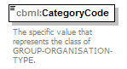
namespace | http://www.sisostds.org/schemas/c-bml/1.0
type | jc3iedm:GroupOrganisationTypeCategoryCode
properties
  isRef | 0
  content | simple
facets
  Kind | Value | annotation
  enumeration | CIVCON
    documentation
    <Definition xml:lang="en">A class of civilian convoys.</Definition>
    appinfo
    <DisplayValue xml:lang="en">Civilian-convoy-type</DisplayValue>
  enumeration | CRIMIN
    documentation
    <Definition xml:lang="en">A GROUP-ORGANISATION-TYPE that comprises persons who attempt to profit by violating the law.</Definition>
    appinfo
    <DisplayValue xml:lang="en">Criminal</DisplayValue>
  enumeration | DSPLPR
    documentation
    <Definition xml:lang="en">A GROUP-ORGANISATION-TYPE that comprises persons removed from their home country by military or political pressure.</Definition>
    appinfo
    <DisplayValue xml:lang="en">Displaced person</DisplayValue>
  enumeration | GANG
    documentation
    <Definition xml:lang="en">A GROUP-ORGANISATION-TYPE that comprises persons that go together or act in concert.</Definition>
    appinfo
    <DisplayValue xml:lang="en">Gang</DisplayValue>
  enumeration | INTLCT
    documentation
    <Definition xml:lang="en">A GROUP-ORGANISATION-TYPE that comprises intellectual beings possessing superior powers of intellect.</Definition>
    appinfo
    <DisplayValue xml:lang="en">Intellectual</DisplayValue>
  enumeration | JRNLST
    documentation
    <Definition xml:lang="en">A GROUP-ORGANISATION-TYPE that comprises persons that earn their living by editing or writing for a public journal.</Definition>
    appinfo
    <DisplayValue xml:lang="en">Journalist</DisplayValue>
  enumeration | LNDOWN
    documentation
    <Definition xml:lang="en">A GROUP-ORGANISATION-TYPE that comprises persons that are owners or proprietors of land.</Definition>
    appinfo
    <DisplayValue xml:lang="en">Landowner</DisplayValue>
  enumeration | LOCINH
    documentation
    <Definition xml:lang="en">A GROUP-ORGANISATION-TYPE of a particular place regarded with reference to that place.</Definition>
    appinfo
    <DisplayValue xml:lang="en">Local inhabitant</DisplayValue>
  enumeration | MEDINT
    documentation
    <Definition xml:lang="en">A GROUP-ORGANISATION-TYPE that comprises persons that report for international mass communications, but do not take part in the actions.</Definition>
    appinfo
    <DisplayValue xml:lang="en">Media, international</DisplayValue>
  enumeration | MEDLCL
    documentation
    <Definition xml:lang="en">A GROUP-ORGANISATION-TYPE that comprises persons that report for local mass communications, but do not take part in the actions.</Definition>
    appinfo
    <DisplayValue xml:lang="en">Media, local</DisplayValue>
  enumeration | MEDNAT
    documentation
    <Definition xml:lang="en">A GROUP-ORGANISATION-TYPE that comprises persons that report for national mass communications, but do not take part in the actions.</Definition>
    appinfo
    <DisplayValue xml:lang="en">Media, national</DisplayValue>
  enumeration | MEDNOS
    documentation
    <Definition xml:lang="en">A GROUP-ORGANISATION-TYPE that comprises persons that report for mass communications (especially television, radio, and newspapers) of an origin not specified.</Definition>
    appinfo
    <DisplayValue xml:lang="en">Media, not otherwise specified</DisplayValue>
  enumeration | MRCHNT
    documentation
    <Definition xml:lang="en">A GROUP-ORGANISATION-TYPE that comprises persons whose occupation is the purchase and sale of marketable commodities for profit.</Definition>
    appinfo
    <DisplayValue xml:lang="en">Merchant</DisplayValue>
  enumeration | NOS
    documentation
    <Definition xml:lang="en">The appropriate value is not in the set of specified values.</Definition>
    appinfo
    <DisplayValue xml:lang="en">Not otherwise specified</DisplayValue>
  enumeration | POLCHF
    documentation
    <Definition xml:lang="en">A GROUP-ORGANISATION-TYPE that comprises persons that have the responsibility for the regulation, discipline, and control of a community for the enforcement of law and public order.</Definition>
    appinfo
    <DisplayValue xml:lang="en">Police chief</DisplayValue>
  enumeration | POW
    documentation
    <Definition xml:lang="en">A GROUP-ORGANISATION-TYPE that comprises persons that have fallen in the hands of or surrendered to an opponent.</Definition>
    appinfo
    <DisplayValue xml:lang="en">Prisoner of war</DisplayValue>
  enumeration | PRSNR
    documentation
    <Definition xml:lang="en">A GROUP-ORGANISATION-TYPE in custody on a criminal charge and on trial.</Definition>
    appinfo
    <DisplayValue xml:lang="en">Prisoner</DisplayValue>
  enumeration | REFUGE
    documentation
    <Definition xml:lang="en">A GROUP-ORGANISATION-TYPE that comprises persons who, owing to religious persecution or political troubles, seek refuge.</Definition>
    appinfo
    <DisplayValue xml:lang="en">Refugee</DisplayValue>
  enumeration | TERRST
    documentation
    <Definition xml:lang="en">A GROUP-ORGANISATION-TYPE that comprises persons that attempt to further their views by a system of coercive intimidation.</Definition>
    appinfo
    <DisplayValue xml:lang="en">Terrorist</DisplayValue>
  enumeration | VILELD
    documentation
    <Definition xml:lang="en">A GROUP-ORGANISATION-TYPE that comprises persons that are of ripe years and experience whose counsel is therefore sought and valued.</Definition>
    appinfo
    <DisplayValue xml:lang="en">Village elder</DisplayValue>
  enumeration | WRITER
    documentation
    <Definition xml:lang="en">A GROUP-ORGANISATION-TYPE that comprises persons that practice or perform writing.</Definition>
    appinfo
    <DisplayValue xml:lang="en">Writer</DisplayValue>
annotation
  documentation
  The specific value that represents the class of GROUP-ORGANISATION-TYPE.
source | <xs:element name="CategoryCode" type="jc3iedm:GroupOrganisationTypeCategoryCode">  <xs:annotation>  <xs:documentation xml:lang="en">The specific value that represents the class of GROUP-ORGANISATION-TYPE.</xs:documentation>  </xs:annotation>  </xs:element>

complexType GroupOrganisationTypeRef
diagram | 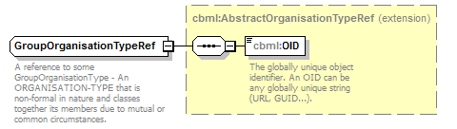
namespace | http://www.sisostds.org/schemas/c-bml/1.0
type | extension of cbml:AbstractOrganisationTypeRef
properties
  base | cbml:AbstractOrganisationTypeRef
children | cbml:OID
annotation
  documentation
  A reference to some GroupOrganisationType - An ORGANISATION-TYPE that is non-formal in nature and classes together its members due to mutual or common circumstances.
source | <xs:complexType name="GroupOrganisationTypeRef">  <xs:annotation>  <xs:documentation xml:lang="en">A reference to some GroupOrganisationType - An ORGANISATION-TYPE that is non-formal in nature and classes together its members due to mutual or common circumstances.</xs:documentation>  </xs:annotation>  <xs:complexContent>  <xs:extension base="cbml:AbstractOrganisationTypeRef"/>  </xs:complexContent>  </xs:complexType>

complexType MilitaryPostType
diagram | 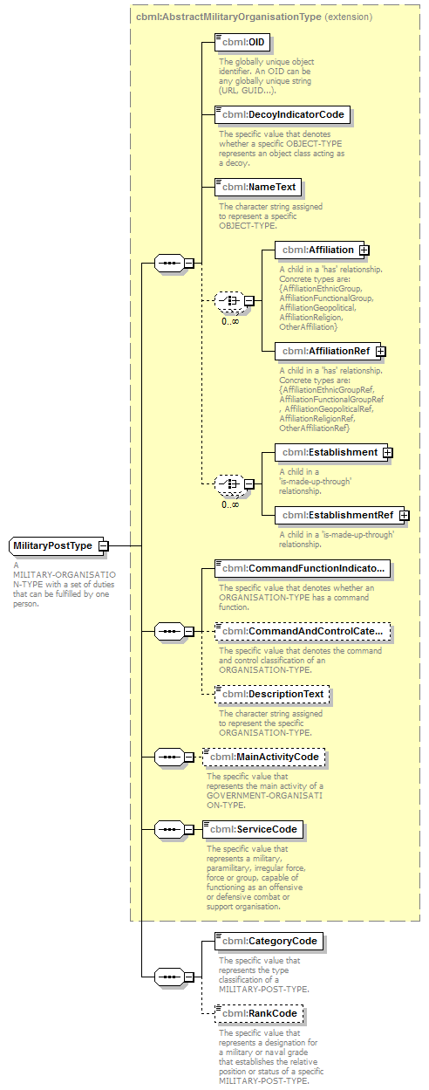
namespace | http://www.sisostds.org/schemas/c-bml/1.0
type | extension of cbml:AbstractMilitaryOrganisationType
properties
  base | cbml:AbstractMilitaryOrganisationType
children | cbml:OID cbml:DecoyIndicatorCode cbml:NameText cbml:Affiliation cbml:AffiliationRef cbml:Establishment cbml:EstablishmentRef cbml:CommandFunctionIndicatorCode cbml:CommandAndControlCategoryCode cbml:DescriptionText cbml:MainActivityCode cbml:ServiceCode cbml:CategoryCode cbml:RankCode
annotation
  documentation
  A MILITARY-ORGANISATION-TYPE with a set of duties that can be fulfilled by one person.
source | <xs:complexType name="MilitaryPostType">  <xs:annotation>  <xs:documentation xml:lang="en">A MILITARY-ORGANISATION-TYPE with a set of duties that can be fulfilled by one person.</xs:documentation>  </xs:annotation>  <xs:complexContent>  <xs:extension base="cbml:AbstractMilitaryOrganisationType">  <xs:sequence>  <xs:element name="CategoryCode" type="jc3iedm:MilitaryPostTypeCategoryCode">  <xs:annotation>  <xs:documentation xml:lang="en">The specific value that represents the type classification of a MILITARY-POST-TYPE.</xs:documentation>  </xs:annotation>  </xs:element>  <xs:element name="RankCode" type="jc3iedm:MilitaryPostTypeRankCode" minOccurs="0">  <xs:annotation>  <xs:documentation xml:lang="en">The specific value that represents a designation for a military or naval grade that establishes the relative position or status of a specific MILITARY-POST-TYPE.</xs:documentation>  </xs:annotation>  </xs:element>  </xs:sequence>  </xs:extension>  </xs:complexContent>  </xs:complexType>

element MilitaryPostType/CategoryCode
diagram | 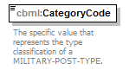
namespace | http://www.sisostds.org/schemas/c-bml/1.0
type | jc3iedm:MilitaryPostTypeCategoryCode
properties
  isRef | 0
  content | simple
facets
  Kind | Value | annotation
  enumeration | AHLCDR
    documentation
    <Definition xml:lang="en">A MILITARY-POST-TYPE that is identified as the designated commander of an attack helicopter unit.</Definition>
    appinfo
    <DisplayValue xml:lang="en">Attack helicopter commander</DisplayValue>
  enumeration | AIRLSN
    documentation
    <Definition xml:lang="en">A tactical air force or naval aviation officer attached to a ground or naval unit or formation as the advisor on tactical air operation matters.</Definition>
    appinfo
    <DisplayValue xml:lang="en">Air liaison officer</DisplayValue>
  enumeration | AJAATC
    documentation
    <Definition xml:lang="en">A MILITARY-POST-TYPE that is identified as the designated alternate controller of a Joint Air Attack Team.</Definition>
    appinfo
    <DisplayValue xml:lang="en">Alternative JAAT controller</DisplayValue>
  enumeration | ANSPHY
    documentation
    <Definition xml:lang="en">A MILITARY-POST-TYPE that is identified as a physician specialising in Anaesthetics.</Definition>
    appinfo
    <DisplayValue xml:lang="en">Anaesthetics physician</DisplayValue>
  enumeration | APAUTH
    documentation
    <Definition xml:lang="en">A MILITARY-POST-TYPE that is identified as the authority with the right and power to approve plans, orders or other official documents.</Definition>
    appinfo
    <DisplayValue xml:lang="en">Approving authority</DisplayValue>
  enumeration | ARBNMC
    documentation
    <Definition xml:lang="en">A MILITARY-POST-TYPE that executes component’s rescue coordination centre (RCC) and coordinates the combat search and rescue (CSAR) effort between the combat search and rescue task force (CSARTF) and the RCC (or joint search and rescue centre) by monitoring the status of all CSARTF elements, requesting additional assets when needed, and ensuring the recovery and supporting forces arrive at their designated areas to accomplish the CSAR mission.</Definition>
    appinfo
    <DisplayValue xml:lang="en">Airborne mission commander</DisplayValue>
  enumeration | ASCAIR
    documentation
    <Definition xml:lang="en">A MILITARY-POST-TYPE that provides air coordination and control during helicopter operations within the Marine Air Command and Control System (MACCS). Serves as an extension of Direct Air Support Centre (DASC) or Helicopter Direction Centre (HDC) in support of the air mission commander.</Definition>
    appinfo
    <DisplayValue xml:lang="en">Assault support coordinator, airborne</DisplayValue>
  enumeration | AUTCDR
    documentation
    <Definition xml:lang="en">A MILITARY-POST-TYPE that is identified as the duly appointed officer in charge of a unit, post, camp, or operation.</Definition>
    appinfo
    <DisplayValue xml:lang="en">Authorised commander</DisplayValue>
  enumeration | DNTPHY
    documentation
    <Definition xml:lang="en">A MILITARY-POST-TYPE that is identified as a physician specialising in Dentistry.</Definition>
    appinfo
    <DisplayValue xml:lang="en">Dentistry physician</DisplayValue>
  enumeration | FAC
    documentation
    <Definition xml:lang="en">A MILITARY-POST-TYPE that is identified as the member of the tactical air control party who, from a forward ground or airborne position, controls aircraft in close air support of ground troops.</Definition>
    appinfo
    <DisplayValue xml:lang="en">Forward air controller</DisplayValue>
  enumeration | FACAIR
    documentation
    <Definition xml:lang="en">A MILITARY-POST-TYPE that is a specifically trained and qualified aviation officer who exercises control from the air of aircraft engaged in close air support of ground troops. The forward air controller (airborne) is normally an airborne extension of the tactical air control party.</Definition>
    appinfo
    <DisplayValue xml:lang="en">Forward air controller, airborne</DisplayValue>
  enumeration | FOOAOP
    documentation
    <Definition xml:lang="en">A MILITARY-POST-TYPE that is identified as the observer operating with front line troops on the ground or in the air and trained to adjust ground or naval gunfire and pass back battlespace information.</Definition>
    appinfo
    <DisplayValue xml:lang="en">Forward observation officer/air observation post</DisplayValue>
  enumeration | GMCDR
    documentation
    <Definition xml:lang="en">A MILITARY-POST-TYPE that is identified as the designated commander of a ground manoeuvre unit.</Definition>
    appinfo
    <DisplayValue xml:lang="en">Ground manoeuvre commander</DisplayValue>
  enumeration | GUNNER
    documentation
    <Definition xml:lang="en">A MILITARY-POST-TYPE that is identified as one who operates a gun.</Definition>
    appinfo
    <DisplayValue xml:lang="en">Gunner</DisplayValue>
  enumeration | GYNPHY
    documentation
    <Definition xml:lang="en">A MILITARY-POST-TYPE that is identified as a physician specialising in Gynaecology.</Definition>
    appinfo
    <DisplayValue xml:lang="en">Gynaecology physician</DisplayValue>
  enumeration | HDNPHY
    documentation
    <Definition xml:lang="en">A MILITARY-POST-TYPE that is identified as a physician specialising in Head/neck.</Definition>
    appinfo
    <DisplayValue xml:lang="en">Head/neck physician</DisplayValue>
  enumeration | INMPHY
    documentation
    <Definition xml:lang="en">A MILITARY-POST-TYPE that is identified as a physician specialising in Internal medicine.</Definition>
    appinfo
    <DisplayValue xml:lang="en">Internal medicine physician</DisplayValue>
  enumeration | INTOFF
    documentation
    <Definition xml:lang="en">A MILITARY-POST-TYPE that is identified as the officer who is responsible for activities relating to gathering and analysing information about an actual or potential foe.</Definition>
    appinfo
    <DisplayValue xml:lang="en">Intelligence officer</DisplayValue>
  enumeration | JAATC
    documentation
    <Definition xml:lang="en">A MILITARY-POST-TYPE that is identified as the designated controller of a Joint Air Attack Team.</Definition>
    appinfo
    <DisplayValue xml:lang="en">JAAT controller</DisplayValue>
  enumeration | LIAISN
    documentation
    <Definition xml:lang="en">A MILITARY-POST-TYPE responsible for liaison duties.</Definition>
    appinfo
    <DisplayValue xml:lang="en">Liaison officer</DisplayValue>
  enumeration | MANTCH
    documentation
    <Definition xml:lang="en">A MILITARY-POST-TYPE that is identified as the person specialised to take all actions to retain materiel in or to restore it to a specified condition.</Definition>
    appinfo
    <DisplayValue xml:lang="en">Maintenance technician</DisplayValue>
  enumeration | MCKNET
    documentation
    <Definition xml:lang="en">A MILITARY-POST-TYPE that is identified as the HAVE QUICK Mickey net controller.</Definition>
    appinfo
    <DisplayValue xml:lang="en">Mickey net controller</DisplayValue>
  enumeration | NOS
    documentation
    <Definition xml:lang="en">The appropriate value is not in the set of specified values.</Definition>
    appinfo
    <DisplayValue xml:lang="en">Not otherwise specified</DisplayValue>
  enumeration | OPSOFF
    documentation
    <Definition xml:lang="en">A MILITARY-POST-TYPE that is identified as the officer who is responsible for activities relating to planning and directing military operations.</Definition>
    appinfo
    <DisplayValue xml:lang="en">Operations officer</DisplayValue>
  enumeration | ORTPHY
    documentation
    <Definition xml:lang="en">A MILITARY-POST-TYPE that is identified as a physician specialising in Orthopaedics.</Definition>
    appinfo
    <DisplayValue xml:lang="en">Orthopaedics physician</DisplayValue>
  enumeration | OTHPHY
    documentation
    <Definition xml:lang="en">A MILITARY-POST-TYPE that is identified as a physician with an unidentified speciality.</Definition>
    appinfo
    <DisplayValue xml:lang="en">Other physician</DisplayValue>
  enumeration | POC
    documentation
    <Definition xml:lang="en">A MILITARY-POST-TYPE responsible to coordinate details for each element of support required.</Definition>
    appinfo
    <DisplayValue xml:lang="en">Point of contact</DisplayValue>
  enumeration | PRCPHY
    documentation
    <Definition xml:lang="en">A MILITARY-POST-TYPE that is identified as a physician specialising in Primary care.</Definition>
    appinfo
    <DisplayValue xml:lang="en">Primary care physician</DisplayValue>
  enumeration | PSYPHY
    documentation
    <Definition xml:lang="en">A MILITARY-POST-TYPE that is identified as a physician specialising in Psychology.</Definition>
    appinfo
    <DisplayValue xml:lang="en">Psychology physician</DisplayValue>
  enumeration | PTHPHY
    documentation
    <Definition xml:lang="en">A MILITARY-POST-TYPE that is identified as a physician specialising in Pathology.</Definition>
    appinfo
    <DisplayValue xml:lang="en">Pathology physician</DisplayValue>
  enumeration | RADPHY
    documentation
    <Definition xml:lang="en">A MILITARY-POST-TYPE that is identified as a physician specialising in Radiology.</Definition>
    appinfo
    <DisplayValue xml:lang="en">Radiology physician</DisplayValue>
  enumeration | RFLEMN
    documentation
    <Definition xml:lang="en">A MILITARY-POST-TYPE that is identified as a soldier armed with a rifle.</Definition>
    appinfo
    <DisplayValue xml:lang="en">Rifleman</DisplayValue>
  enumeration | SAPPER
    documentation
    <Definition xml:lang="en">A MILITARY-POST-TYPE that is identified as one who designs and constructs military works for attack or defence.</Definition>
    appinfo
    <DisplayValue xml:lang="en">Sapper</DisplayValue>
  enumeration | SCOUT
    documentation
    <Definition xml:lang="en">A MILITARY-POST-TYPE that is identified as one sent out ahead of the main force in order to reconnoitre the position and movement of the enemy.</Definition>
    appinfo
    <DisplayValue xml:lang="en">Scout</DisplayValue>
  enumeration | SNIPER
    documentation
    <Definition xml:lang="en">A MILITARY-POST-TYPE that is identified as one who snipes, or shoots from concealment.</Definition>
    appinfo
    <DisplayValue xml:lang="en">Sniper</DisplayValue>
  enumeration | SURPHY
    documentation
    <Definition xml:lang="en">A MILITARY-POST-TYPE that is identified as a physician specialising in Surgery.</Definition>
    appinfo
    <DisplayValue xml:lang="en">Surgical physician</DisplayValue>
  enumeration | TAC
    documentation
    <Definition xml:lang="en">A MILITARY-POST-TYPE that is a subordinate operational component of a tactical air control system designed to provide air liaison to land forces and for the control of aircraft.</Definition>
    appinfo
    <DisplayValue xml:lang="en">Tactical air controller</DisplayValue>
  enumeration | TACAIR
    documentation
    <Definition xml:lang="en">A MILITARY-POST-TYPE that is an officer who coordinates, from an aircraft, the action of combat aircraft engaged in close support of ground or sea forces.</Definition>
    appinfo
    <DisplayValue xml:lang="en">Tactical air coordinator, airborne</DisplayValue>
annotation
  documentation
  The specific value that represents the type classification of a MILITARY-POST-TYPE.
source | <xs:element name="CategoryCode" type="jc3iedm:MilitaryPostTypeCategoryCode">  <xs:annotation>  <xs:documentation xml:lang="en">The specific value that represents the type classification of a MILITARY-POST-TYPE.</xs:documentation>  </xs:annotation>  </xs:element>

element MilitaryPostType/RankCode
diagram | 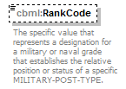
namespace | http://www.sisostds.org/schemas/c-bml/1.0
type | jc3iedm:MilitaryPostTypeRankCode
properties
  isRef | 0
  minOcc | 0
  maxOcc | 1
  content | simple
facets
  Kind | Value | annotation
  enumeration | EPTE
    documentation
    <Definition xml:lang="en">The specification of a MILITARY-POST-TYPE as being appropriate for an individual in the armed forces without an officer's commission, warrant or other rank conferring leadership over other servicemen.</Definition>
    appinfo
    <DisplayValue xml:lang="en">Enlisted private</DisplayValue>
  enumeration | NCO
    documentation
    <Definition xml:lang="en">The specification of a MILITARY-POST-TYPE as being appropriate for an enlisted member of the armed forces appointed to a rank conferring leadership over other servicemen.</Definition>
    appinfo
    <DisplayValue xml:lang="en">NCO, not otherwise specified</DisplayValue>
  enumeration | NKN
    documentation
    <Definition xml:lang="en">It is not possible to determine which value is most applicable.</Definition>
    appinfo
    <DisplayValue xml:lang="en">Not known</DisplayValue>
  enumeration | OF1
    documentation
    <Definition xml:lang="en">The specification of a MILITARY-POST-TYPE as being appropriate for the officer rank of Lieutenant/Second Lieutenant/Midshipman/Sub-Lieutenant/Pilot Officer/Flying Officer.</Definition>
    appinfo
    <DisplayValue xml:lang="en">OF-1</DisplayValue>
  enumeration | OF10
    documentation
    <Definition xml:lang="en">The specification of a MILITARY-POST-TYPE as being appropriate for the officer rank of Field Marshal/Fleet Admiral/General of the Air Force.</Definition>
    appinfo
    <DisplayValue xml:lang="en">OF-10</DisplayValue>
  enumeration | OF2
    documentation
    <Definition xml:lang="en">The specification of a MILITARY-POST-TYPE as being appropriate for the officer rank of Captain/Lieutenant/Flight Lieutenant.</Definition>
    appinfo
    <DisplayValue xml:lang="en">OF-2</DisplayValue>
  enumeration | OF3
    documentation
    <Definition xml:lang="en">The specification of a MILITARY-POST-TYPE as being appropriate for the officer rank of Major/Lieutenant-Commander/Squadron Leader.</Definition>
    appinfo
    <DisplayValue xml:lang="en">OF-3</DisplayValue>
  enumeration | OF4
    documentation
    <Definition xml:lang="en">The specification of a MILITARY-POST-TYPE as being appropriate for the officer rank of Lieutenant Colonel/Commander/Wing Commander.</Definition>
    appinfo
    <DisplayValue xml:lang="en">OF-4</DisplayValue>
  enumeration | OF5
    documentation
    <Definition xml:lang="en">The specification of a MILITARY-POST-TYPE as being appropriate for the officer rank of Colonel/Captain (under 6 years of seniority)/Group Captain.</Definition>
    appinfo
    <DisplayValue xml:lang="en">OF-5</DisplayValue>
  enumeration | OF6
    documentation
    <Definition xml:lang="en">The specification of a MILITARY-POST-TYPE as being appropriate for the officer rank of Brigadier Captain (over 6 years seniority)/Air Commodore.</Definition>
    appinfo
    <DisplayValue xml:lang="en">OF-6</DisplayValue>
  enumeration | OF7
    documentation
    <Definition xml:lang="en">The specification of a MILITARY-POST-TYPE as being appropriate for the officer rank of Major General/Rear Admiral/Air Vice Marshal.</Definition>
    appinfo
    <DisplayValue xml:lang="en">OF-7</DisplayValue>
  enumeration | OF8
    documentation
    <Definition xml:lang="en">The specification of a MILITARY-POST-TYPE as being appropriate for the officer rank of Lieutenant General/Vice Admiral/Air Marshall.</Definition>
    appinfo
    <DisplayValue xml:lang="en">OF-8</DisplayValue>
  enumeration | OF9
    documentation
    <Definition xml:lang="en">The specification of a MILITARY-POST-TYPE as being appropriate for the officer rank of General/Admiral/Air Chief Marshal.</Definition>
    appinfo
    <DisplayValue xml:lang="en">OF-9</DisplayValue>
  enumeration | OFFR
    documentation
    <Definition xml:lang="en">The specification of a MILITARY-POST-TYPE as being appropriate for an individual who is invested with authority by means of a commission in the armed forces.</Definition>
    appinfo
    <DisplayValue xml:lang="en">Officer, not otherwise specified</DisplayValue>
  enumeration | OR1
    documentation
    <Definition xml:lang="en">The specification of a MILITARY-POST-TYPE as being appropriate for the rank of Private (Class 4)/Seaman Recruit/Basic Airman.</Definition>
    appinfo
    <DisplayValue xml:lang="en">OR-1</DisplayValue>
  enumeration | OR2
    documentation
    <Definition xml:lang="en">The specification of a MILITARY-POST-TYPE as being appropriate for the rank of Private (Class 1-3)/Seaman Apprentice/Airman.</Definition>
    appinfo
    <DisplayValue xml:lang="en">OR-2</DisplayValue>
  enumeration | OR3
    documentation
    <Definition xml:lang="en">The specification of a MILITARY-POST-TYPE as being appropriate for the rank of Lance Corporal/Seaman/Airman First Class.</Definition>
    appinfo
    <DisplayValue xml:lang="en">OR-3</DisplayValue>
  enumeration | OR4
    documentation
    <Definition xml:lang="en">The specification of a MILITARY-POST-TYPE as being appropriate for the rank of Corporal/Petty Officer Third Class/Senior Airman/Sergeant.</Definition>
    appinfo
    <DisplayValue xml:lang="en">OR-4</DisplayValue>
  enumeration | OR5
    documentation
    <Definition xml:lang="en">The specification of a MILITARY-POST-TYPE as being appropriate for the rank of Sergeant (Junior)/Petty Officer second Class/Staff Sergeant.</Definition>
    appinfo
    <DisplayValue xml:lang="en">OR-5</DisplayValue>
  enumeration | OR6
    documentation
    <Definition xml:lang="en">The specification of a MILITARY-POST-TYPE as being appropriate for the rank of Sergeant (3 Years Seniority)/Petty Officer First Class/Technical Sergeant.</Definition>
    appinfo
    <DisplayValue xml:lang="en">OR-6</DisplayValue>
  enumeration | OR7
    documentation
    <Definition xml:lang="en">The specification of a MILITARY-POST-TYPE as being appropriate for the rank of Staff Sergeant/Chief Petty Officer First Class/Master Sergeant.</Definition>
    appinfo
    <DisplayValue xml:lang="en">OR-7</DisplayValue>
  enumeration | OR8
    documentation
    <Definition xml:lang="en">The specification of a MILITARY-POST-TYPE as being appropriate for the rank of Warrant Officer Class 2/Senior Chief Petty Officer/Senior Master Sergeant.</Definition>
    appinfo
    <DisplayValue xml:lang="en">OR-8</DisplayValue>
  enumeration | OR9
    documentation
    <Definition xml:lang="en">The specification of a MILITARY-POST-TYPE as being appropriate for the rank of Warrant Officer Class 1/Master Chief Petty Officer/Chief Master Sergeant.</Definition>
    appinfo
    <DisplayValue xml:lang="en">OR-9</DisplayValue>
  enumeration | OTHR
    documentation
    <Definition xml:lang="en">The specification of a MILITARY-POST-TYPE as being appropriate for an individual who does not hold an officer's commission in the armed forces.</Definition>
    appinfo
    <DisplayValue xml:lang="en">Other ranks</DisplayValue>
annotation
  documentation
  The specific value that represents a designation for a military or naval grade that establishes the relative position or status of a specific MILITARY-POST-TYPE.
source | <xs:element name="RankCode" type="jc3iedm:MilitaryPostTypeRankCode" minOccurs="0">  <xs:annotation>  <xs:documentation xml:lang="en">The specific value that represents a designation for a military or naval grade that establishes the relative position or status of a specific MILITARY-POST-TYPE.</xs:documentation>  </xs:annotation>  </xs:element>

complexType MilitaryPostTypeRef
diagram | 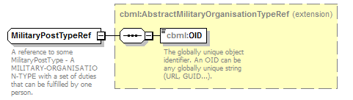
namespace | http://www.sisostds.org/schemas/c-bml/1.0
type | extension of cbml:AbstractMilitaryOrganisationTypeRef
properties
  base | cbml:AbstractMilitaryOrganisationTypeRef
children | cbml:OID
annotation
  documentation
  A reference to some MilitaryPostType - A MILITARY-ORGANISATION-TYPE with a set of duties that can be fulfilled by one person.
source | <xs:complexType name="MilitaryPostTypeRef">  <xs:annotation>  <xs:documentation xml:lang="en">A reference to some MilitaryPostType - A MILITARY-ORGANISATION-TYPE with a set of duties that can be fulfilled by one person.</xs:documentation>  </xs:annotation>  <xs:complexContent>  <xs:extension base="cbml:AbstractMilitaryOrganisationTypeRef"/>  </xs:complexContent>  </xs:complexType>

complexType OrganisationStatus
diagram | 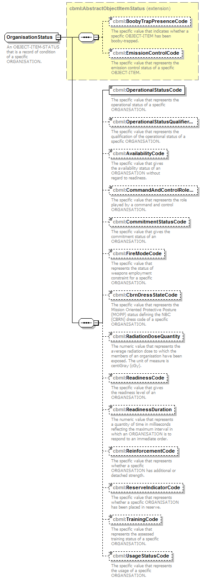
namespace | http://www.sisostds.org/schemas/c-bml/1.0
type | extension of cbml:AbstractObjectItemStatus
properties
  base | cbml:AbstractObjectItemStatus
children | cbml:BoobyTrapPresenceCode cbml:EmissionControlCode cbml:OperationalStatusCode cbml:OperationalStatusQualifierCode cbml:AvailabilityCode cbml:CommandAndControlRoleCode cbml:CommitmentStatusCode cbml:FireModeCode cbml:CbrnDressStateCode cbml:RadiationDoseQuantity cbml:ReadinessCode cbml:ReadinessDuration cbml:ReinforcementCode cbml:ReserveIndicatorCode cbml:TrainingCode cbml:UsageStatusCode
annotation
  documentation
  An OBJECT-ITEM-STATUS that is a record of condition of a specific ORGANISATION.
source | <xs:complexType name="OrganisationStatus">  <xs:annotation>  <xs:documentation xml:lang="en">An OBJECT-ITEM-STATUS that is a record of condition of a specific ORGANISATION.</xs:documentation>  </xs:annotation>  <xs:complexContent>  <xs:extension base="cbml:AbstractObjectItemStatus">  <xs:sequence>  <xs:element name="OperationalStatusCode" type="jc3iedm:OrganisationStatusOperationalStatusCode">  <xs:annotation>  <xs:documentation xml:lang="en">The specific value that represents the operational status of a specific ORGANISATION.</xs:documentation>  </xs:annotation>  </xs:element>  <xs:element name="OperationalStatusQualifierCode" type="jc3iedm:OrganisationStatusOperationalStatusQualifierCode" minOccurs="0">  <xs:annotation>  <xs:documentation xml:lang="en">The specific value that represents the qualification of the operational status of a specific ORGANISATION.</xs:documentation>  </xs:annotation>  </xs:element>  <xs:element name="AvailabilityCode" type="jc3iedm:OrganisationStatusAvailabilityCode" minOccurs="0">  <xs:annotation>  <xs:documentation xml:lang="en">The specific value that gives the availability status of an ORGANISATION without regard to readiness.</xs:documentation>  </xs:annotation>  </xs:element>  <xs:element name="CommandAndControlRoleCode" type="jc3iedm:OrganisationStatusCommandAndControlRoleCode" minOccurs="0">  <xs:annotation>  <xs:documentation xml:lang="en">The specific value that represents the role played by a command and control ORGANISATION.</xs:documentation>  </xs:annotation>  </xs:element>  <xs:element name="CommitmentStatusCode" type="jc3iedm:OrganisationStatusCommitmentStatusCode" minOccurs="0">  <xs:annotation>  <xs:documentation xml:lang="en">The specific value that gives the commitment status of an ORGANISATION.</xs:documentation>  </xs:annotation>  </xs:element>  <xs:element name="FireModeCode" type="jc3iedm:OrganisationStatusFireModeCode" minOccurs="0">  <xs:annotation>  <xs:documentation xml:lang="en">The specific value that represents the status of weapons employment constraint for a specific ORGANISATION.</xs:documentation>  </xs:annotation>  </xs:element>  <xs:element name="CbrnDressStateCode" type="jc3iedm:OrganisationStatusCbrnDressStateCode" minOccurs="0">  <xs:annotation>  <xs:documentation xml:lang="en">The specific value that represents the Mission Oriented Protective Posture (MOPP) status defining the NBC (CBRN) dress code of a specific ORGANISATION.</xs:documentation>  </xs:annotation>  </xs:element>  <xs:element name="RadiationDoseQuantity" type="jc3iedm:QuantityType6" minOccurs="0">  <xs:annotation>  <xs:documentation xml:lang="en">The numeric value that represents the average radiation dose to which the members of an organisation have been exposed. The unit of measure is centiGray (cGy).</xs:documentation>  </xs:annotation>  </xs:element>  <xs:element name="ReadinessCode" type="jc3iedm:OrganisationStatusReadinessCode" minOccurs="0">  <xs:annotation>  <xs:documentation xml:lang="en">The specific value that gives the readiness level of an ORGANISATION.</xs:documentation>  </xs:annotation>  </xs:element>  <xs:element name="ReadinessDuration" type="jc3iedm:DurationType19" minOccurs="0">  <xs:annotation>  <xs:documentation xml:lang="en">The numeric value that represents a quantity of time in milliseconds reflecting the maximum interval in which an ORGANISATION is to respond to an immediate order.</xs:documentation>  </xs:annotation>  </xs:element>  <xs:element name="ReinforcementCode" type="jc3iedm:OrganisationStatusReinforcementCode" minOccurs="0">  <xs:annotation>  <xs:documentation xml:lang="en">The specific value that represents whether a specific ORGANISATION has additional or detached strength.</xs:documentation>  </xs:annotation>  </xs:element>  <xs:element name="ReserveIndicatorCode" type="jc3iedm:OrganisationStatusReserveIndicatorCode" minOccurs="0">  <xs:annotation>  <xs:documentation xml:lang="en">The specific value that represents whether a specific ORGANISATION has been placed in reserve.</xs:documentation>  </xs:annotation>  </xs:element>  <xs:element name="TrainingCode" type="jc3iedm:OrganisationStatusTrainingCode" minOccurs="0">  <xs:annotation>  <xs:documentation xml:lang="en">The specific value that represents the assessed training status of a specific ORGANISATION.</xs:documentation>  </xs:annotation>  </xs:element>  <xs:element name="UsageStatusCode" type="jc3iedm:OrganisationStatusUsageStatusCode" minOccurs="0">  <xs:annotation>  <xs:documentation xml:lang="en">The specific value that represents the usage of a specific ORGANISATION.</xs:documentation>  </xs:annotation>  </xs:element>  </xs:sequence>  </xs:extension>  </xs:complexContent>  </xs:complexType>

element OrganisationStatus/OperationalStatusCode
diagram | 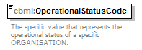
namespace | http://www.sisostds.org/schemas/c-bml/1.0
type | jc3iedm:OrganisationStatusOperationalStatusCode
properties
  isRef | 0
  content | simple
facets
  Kind | Value | annotation
  enumeration | MOPS
    documentation
    <Definition xml:lang="en">Subjectively judged by the reporting organisation to be marginally capable of performing the missions or functions for which it is created.</Definition>
    appinfo
    <DisplayValue xml:lang="en">Marginally operational</DisplayValue>
  enumeration | NKN
    documentation
    <Definition xml:lang="en">It is not possible to determine which value is most applicable.</Definition>
    appinfo
    <DisplayValue xml:lang="en">Not known</DisplayValue>
  enumeration | NOP
    documentation
    <Definition xml:lang="en">Subjectively judged by the reporting organisation to be permanently not capable of performing the missions or functions for which it is created.</Definition>
    appinfo
    <DisplayValue xml:lang="en">Not operational</DisplayValue>
  enumeration | OPR
    documentation
    <Definition xml:lang="en">Subjectively judged by the reporting organisation to be fully capable of performing the missions or functions for which it is created.</Definition>
    appinfo
    <DisplayValue xml:lang="en">Operational</DisplayValue>
  enumeration | SOPS
    documentation
    <Definition xml:lang="en">Subjectively judged by the reporting organisation to have minor deficiencies which limit its capability to perform the missions or functions for which it is created.</Definition>
    appinfo
    <DisplayValue xml:lang="en">Substantially operational</DisplayValue>
  enumeration | TNOPS
    documentation
    <Definition xml:lang="en">Subjectively judged by the reporting organisation to be temporarily not capable of performing the missions or functions for which it is created.</Definition>
    appinfo
    <DisplayValue xml:lang="en">Temporarily not operational</DisplayValue>
annotation
  documentation
  The specific value that represents the operational status of a specific ORGANISATION.
source | <xs:element name="OperationalStatusCode" type="jc3iedm:OrganisationStatusOperationalStatusCode">  <xs:annotation>  <xs:documentation xml:lang="en">The specific value that represents the operational status of a specific ORGANISATION.</xs:documentation>  </xs:annotation>  </xs:element>

element OrganisationStatus/OperationalStatusQualifierCode
diagram | 
namespace | http://www.sisostds.org/schemas/c-bml/1.0
type | jc3iedm:OrganisationStatusOperationalStatusQualifierCode
properties
  isRef | 0
  minOcc | 0
  maxOcc | 1
  content | simple
facets
  Kind | Value | annotation
  enumeration | DSTRYD
    documentation
    <Definition xml:lang="en">Subjectively judged by the reporting organisation that an ORGANISATION is not, and not expected ever to be, capable of performing the missions or functions for which it is created.</Definition>
    appinfo
    <DisplayValue xml:lang="en">Destroyed</DisplayValue>
  enumeration | HVYDAM
    documentation
    <Definition xml:lang="en">Subjectively judged by the reporting organisation to be heavily damaged.</Definition>
    appinfo
    <DisplayValue xml:lang="en">Heavily damaged</DisplayValue>
  enumeration | LGTDAM
    documentation
    <Definition xml:lang="en">Subjectively judged by the reporting organisation to be only lightly damaged.</Definition>
    appinfo
    <DisplayValue xml:lang="en">Lightly damaged</DisplayValue>
  enumeration | LST
    documentation
    <Definition xml:lang="en">Subjectively judged by the reporting organisation that a specific organisation is missing under unknown circumstances.</Definition>
    appinfo
    <DisplayValue xml:lang="en">Lost</DisplayValue>
  enumeration | LVR
    documentation
    <Definition xml:lang="en">Subjectively judged by the reporting organisation that an ORGANISATION is deficient or lacking of some mission-critical resources (e.g., fuel, ammunition).</Definition>
    appinfo
    <DisplayValue xml:lang="en">Lacking vital resources</DisplayValue>
  enumeration | MODDAM
    documentation
    <Definition xml:lang="en">Subjectively judged by the reporting organisation to be moderately damaged.</Definition>
    appinfo
    <DisplayValue xml:lang="en">Moderately damaged</DisplayValue>
  enumeration | NKN
    documentation
    <Definition xml:lang="en">It is not possible to determine which value is most applicable.</Definition>
    appinfo
    <DisplayValue xml:lang="en">Not known</DisplayValue>
annotation
  documentation
  The specific value that represents the qualification of the operational status of a specific ORGANISATION.
source | <xs:element name="OperationalStatusQualifierCode" type="jc3iedm:OrganisationStatusOperationalStatusQualifierCode" minOccurs="0">  <xs:annotation>  <xs:documentation xml:lang="en">The specific value that represents the qualification of the operational status of a specific ORGANISATION.</xs:documentation>  </xs:annotation>  </xs:element>

element OrganisationStatus/AvailabilityCode
diagram | 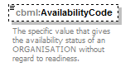
namespace | http://www.sisostds.org/schemas/c-bml/1.0
type | jc3iedm:OrganisationStatusAvailabilityCode
properties
  isRef | 0
  minOcc | 0
  maxOcc | 1
  content | simple
facets
  Kind | Value | annotation
  enumeration | AFT30D
    documentation
    <Definition xml:lang="en">An availability status of an ORGANISATION indicating that the ORGANISATION can be available for use after 30 days.</Definition>
    appinfo
    <DisplayValue xml:lang="en">After 30 days</DisplayValue>
  enumeration | BTW163
    documentation
    <Definition xml:lang="en">An availability status of an ORGANISATION indicating that the ORGANISATION can be available for use in between 16 and 30 days.</Definition>
    appinfo
    <DisplayValue xml:lang="en">Between 16 and 30 days</DisplayValue>
  enumeration | BTW484
    documentation
    <Definition xml:lang="en">An availability status of an ORGANISATION indicating that the ORGANISATION can be available for use in between 48 hours and 4 days.</Definition>
    appinfo
    <DisplayValue xml:lang="en">Between 48 hours and 4 days</DisplayValue>
  enumeration | BTW515
    documentation
    <Definition xml:lang="en">An availability status of an ORGANISATION indicating that the ORGANISATION can be available for use in between 5 and 15 days.</Definition>
    appinfo
    <DisplayValue xml:lang="en">Between 5 and 15 days</DisplayValue>
  enumeration | NA
    documentation
    <Definition xml:lang="en">An availability status of an ORGANISATION indicating that the ORGANISATION is not available.</Definition>
    appinfo
    <DisplayValue xml:lang="en">Not available</DisplayValue>
  enumeration | WTN48H
    documentation
    <Definition xml:lang="en">An availability status of an ORGANISATION indicating that the ORGANISATION can be available for use within 48 hours.</Definition>
    appinfo
    <DisplayValue xml:lang="en">Within 48 hours</DisplayValue>
annotation
  documentation
  The specific value that gives the availability status of an ORGANISATION without regard to readiness.
source | <xs:element name="AvailabilityCode" type="jc3iedm:OrganisationStatusAvailabilityCode" minOccurs="0">  <xs:annotation>  <xs:documentation xml:lang="en">The specific value that gives the availability status of an ORGANISATION without regard to readiness.</xs:documentation>  </xs:annotation>  </xs:element>

element OrganisationStatus/CommandAndControlRoleCode
diagram | 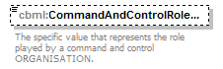
namespace | http://www.sisostds.org/schemas/c-bml/1.0
type | jc3iedm:OrganisationStatusCommandAndControlRoleCode
properties
  isRef | 0
  minOcc | 0
  maxOcc | 1
  content | simple
facets
  Kind | Value | annotation
  enumeration | ADVNCP
    documentation
    <Definition xml:lang="en">The advanced command post of a unit/formation.</Definition>
    appinfo
    <DisplayValue xml:lang="en">Advanced command post</DisplayValue>
  enumeration | FRWDHQ
    documentation
    <Definition xml:lang="en">The organisation performs the functions of a forward headquarters.</Definition>
    appinfo
    <DisplayValue xml:lang="en">Forward headquarters</DisplayValue>
  enumeration | LOGCP
    documentation
    <Definition xml:lang="en">No definition provided in ADatP-3 Baseline 13.1 FFIRN/FUD 1284/2.</Definition>
    appinfo
    <DisplayValue xml:lang="en">Logistic command post</DisplayValue>
  enumeration | LPFRGE
    documentation
    <Definition xml:lang="en">The organisation performs the functions of a leapfrog element.</Definition>
    appinfo
    <DisplayValue xml:lang="en">Leapfrog element</DisplayValue>
  enumeration | MAINCP
    documentation
    <Definition xml:lang="en">A command post that includes those staff activities involved in controlling and sustaining current operations and in planning future operations.</Definition>
    appinfo
    <DisplayValue xml:lang="en">Main command post</DisplayValue>
  enumeration | MOBLCP
    documentation
    <Definition xml:lang="en">The mobile command post of a unit/formation.</Definition>
    appinfo
    <DisplayValue xml:lang="en">Mobile command post</DisplayValue>
  enumeration | MOBLHQ
    documentation
    <Definition xml:lang="en">The organisation performs the functions of a mobile war headquarters.</Definition>
    appinfo
    <DisplayValue xml:lang="en">Mobile war headquarters</DisplayValue>
  enumeration | NATLHQ
    documentation
    <Definition xml:lang="en">The organisation performs the functions of a national headquarters.</Definition>
    appinfo
    <DisplayValue xml:lang="en">National headquarters</DisplayValue>
  enumeration | NKN
    documentation
    <Definition xml:lang="en">It is not possible to determine which value is most applicable.</Definition>
    appinfo
    <DisplayValue xml:lang="en">Not known</DisplayValue>
  enumeration | PEACCP
    documentation
    <Definition xml:lang="en">The peacetime command post of a unit/formation.</Definition>
    appinfo
    <DisplayValue xml:lang="en">Peacetime command post</DisplayValue>
  enumeration | PEACHQ
    documentation
    <Definition xml:lang="en">The organisation performs the functions of a peace headquarters.</Definition>
    appinfo
    <DisplayValue xml:lang="en">Peace headquarters</DisplayValue>
  enumeration | PRWRHQ
    documentation
    <Definition xml:lang="en">The organisation performs the functions of a primary war headquarters.</Definition>
    appinfo
    <DisplayValue xml:lang="en">Primary war headquarters</DisplayValue>
  enumeration | REARCP
    documentation
    <Definition xml:lang="en">Those staff activities concerned primarily with combat service support of the force, administrative support of the headquarters and other activities not immediately concerned with current operations.</Definition>
    appinfo
    <DisplayValue xml:lang="en">Rear command post</DisplayValue>
  enumeration | RESVCP
    documentation
    <Definition xml:lang="en">A command post that is only activated when required.</Definition>
    appinfo
    <DisplayValue xml:lang="en">Reserve command post</DisplayValue>
  enumeration | STATCP
    documentation
    <Definition xml:lang="en">The static command post of a unit/formation.</Definition>
    appinfo
    <DisplayValue xml:lang="en">Static command post</DisplayValue>
  enumeration | STATHQ
    documentation
    <Definition xml:lang="en">The organisation performs the functions of a static war headquarters.</Definition>
    appinfo
    <DisplayValue xml:lang="en">Static war headquarters</DisplayValue>
  enumeration | STUPCP
    documentation
    <Definition xml:lang="en">Any location designated by a commander to assume command post functions in the event the main or rear command post becomes inoperative.</Definition>
    appinfo
    <DisplayValue xml:lang="en">Step up/alternate command post</DisplayValue>
  enumeration | STUPHQ
    documentation
    <Definition xml:lang="en">The organisation performs the functions of a step up headquarters.</Definition>
    appinfo
    <DisplayValue xml:lang="en">Step up headquarters</DisplayValue>
  enumeration | TACTCP
    documentation
    <Definition xml:lang="en">A small, mobile headquarters capable of serving the requirements of the commander (but usually not the staff) for short periods.</Definition>
    appinfo
    <DisplayValue xml:lang="en">Tactical command post</DisplayValue>
  enumeration | TACTHQ
    documentation
    <Definition xml:lang="en">The organisation performs the functions of a tactical headquarters.</Definition>
    appinfo
    <DisplayValue xml:lang="en">Tactical headquarters</DisplayValue>
annotation
  documentation
  The specific value that represents the role played by a command and control ORGANISATION.
source | <xs:element name="CommandAndControlRoleCode" type="jc3iedm:OrganisationStatusCommandAndControlRoleCode" minOccurs="0">  <xs:annotation>  <xs:documentation xml:lang="en">The specific value that represents the role played by a command and control ORGANISATION.</xs:documentation>  </xs:annotation>  </xs:element>

element OrganisationStatus/CommitmentStatusCode
diagram | 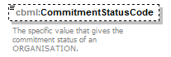
namespace | http://www.sisostds.org/schemas/c-bml/1.0
type | jc3iedm:OrganisationStatusCommitmentStatusCode
properties
  isRef | 0
  minOcc | 0
  maxOcc | 1
  content | simple
facets
  Kind | Value | annotation
  enumeration | COMM
    documentation
    <Definition xml:lang="en">A status indicating that an ORGANISATION is currently tasked.</Definition>
    appinfo
    <DisplayValue xml:lang="en">Committed</DisplayValue>
  enumeration | UNCOMM
    documentation
    <Definition xml:lang="en">A status indicating that an ORGANISATION is not currently tasked and is available for tasking.</Definition>
    appinfo
    <DisplayValue xml:lang="en">Uncommitted</DisplayValue>
annotation
  documentation
  The specific value that gives the commitment status of an ORGANISATION.
source | <xs:element name="CommitmentStatusCode" type="jc3iedm:OrganisationStatusCommitmentStatusCode" minOccurs="0">  <xs:annotation>  <xs:documentation xml:lang="en">The specific value that gives the commitment status of an ORGANISATION.</xs:documentation>  </xs:annotation>  </xs:element>

element OrganisationStatus/FireModeCode
diagram | 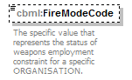
namespace | http://www.sisostds.org/schemas/c-bml/1.0
type | jc3iedm:OrganisationStatusFireModeCode
properties
  isRef | 0
  minOcc | 0
  maxOcc | 1
  content | simple
facets
  Kind | Value | annotation
  enumeration | HLDFIR
    documentation
    <Definition xml:lang="en">An emergency order to stop firing; missiles in flight must be prevented from intercepting, if technically possible.</Definition>
    appinfo
    <DisplayValue xml:lang="en">Hold fire</DisplayValue>
  enumeration | NKN
    documentation
    <Definition xml:lang="en">It is not possible to determine which value is most applicable.</Definition>
    appinfo
    <DisplayValue xml:lang="en">Not known</DisplayValue>
  enumeration | WPNFRE
    documentation
    <Definition xml:lang="en">A weapon control order imposing a status whereby weapons systems may be fired at any target not positively identified as friendly.</Definition>
    appinfo
    <DisplayValue xml:lang="en">Weapons free</DisplayValue>
  enumeration | WPNTGT
    documentation
    <Definition xml:lang="en">A weapon control order imposing a status whereby weapons systems may be fired only at targets recognised as hostile.</Definition>
    appinfo
    <DisplayValue xml:lang="en">Weapons tight</DisplayValue>
  enumeration | WPNHLD
    documentation
    <Definition xml:lang="en">A weapon control order imposing a status whereby weapons systems may only be fired in self defence or in response to a formal order.</Definition>
    appinfo
    <DisplayValue xml:lang="en">Weapons hold</DisplayValue>
annotation
  documentation
  The specific value that represents the status of weapons employment constraint for a specific ORGANISATION.
source | <xs:element name="FireModeCode" type="jc3iedm:OrganisationStatusFireModeCode" minOccurs="0">  <xs:annotation>  <xs:documentation xml:lang="en">The specific value that represents the status of weapons employment constraint for a specific ORGANISATION.</xs:documentation>  </xs:annotation>  </xs:element>

element OrganisationStatus/CbrnDressStateCode
diagram | 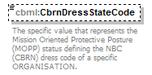
namespace | http://www.sisostds.org/schemas/c-bml/1.0
type | jc3iedm:OrganisationStatusCbrnDressStateCode
properties
  isRef | 0
  minOcc | 0
  maxOcc | 1
  content | simple
facets
  Kind | Value | annotation
  enumeration | MOPP0
    documentation
    <Definition xml:lang="en">Mask is carried. Individual protection equipment is immediately available.</Definition>
    appinfo
    <DisplayValue xml:lang="en">MOPP 0</DisplayValue>
  enumeration | MOPP1
    documentation
    <Definition xml:lang="en">Mask is carried. Suit worn, boots and gloves are carried.</Definition>
    appinfo
    <DisplayValue xml:lang="en">MOPP 1</DisplayValue>
  enumeration | MOPP2
    documentation
    <Definition xml:lang="en">Mask is carried. Suit and boots worn, gloves are carried.</Definition>
    appinfo
    <DisplayValue xml:lang="en">MOPP 2</DisplayValue>
  enumeration | MOPP3
    documentation
    <Definition xml:lang="en">Mask is carried. Suit, boots and gloves are worn.</Definition>
    appinfo
    <DisplayValue xml:lang="en">MOPP 3</DisplayValue>
  enumeration | MOPPRY
    documentation
    <Definition xml:lang="en">Mask is carried. First set individual protection equipment is available within 2 hours, second set individual protection equipment is available within 6 hours.</Definition>
    appinfo
    <DisplayValue xml:lang="en">MOPP Ready</DisplayValue>
annotation
  documentation
  The specific value that represents the Mission Oriented Protective Posture (MOPP) status defining the NBC (CBRN) dress code of a specific ORGANISATION.
source | <xs:element name="CbrnDressStateCode" type="jc3iedm:OrganisationStatusCbrnDressStateCode" minOccurs="0">  <xs:annotation>  <xs:documentation xml:lang="en">The specific value that represents the Mission Oriented Protective Posture (MOPP) status defining the NBC (CBRN) dress code of a specific ORGANISATION.</xs:documentation>  </xs:annotation>  </xs:element>

element OrganisationStatus/RadiationDoseQuantity
diagram | 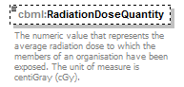
namespace | http://www.sisostds.org/schemas/c-bml/1.0
type | jc3iedm:QuantityType6
properties
  isRef | 0
  minOcc | 0
  maxOcc | 1
  content | simple
facets
  Kind | Value | annotation
  minInclusive | -999999
  maxInclusive | 999999
annotation
  documentation
  The numeric value that represents the average radiation dose to which the members of an organisation have been exposed. The unit of measure is centiGray (cGy).
source | <xs:element name="RadiationDoseQuantity" type="jc3iedm:QuantityType6" minOccurs="0">  <xs:annotation>  <xs:documentation xml:lang="en">The numeric value that represents the average radiation dose to which the members of an organisation have been exposed. The unit of measure is centiGray (cGy).</xs:documentation>  </xs:annotation>  </xs:element>

element OrganisationStatus/ReadinessCode
diagram | 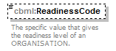
namespace | http://www.sisostds.org/schemas/c-bml/1.0
type | jc3iedm:OrganisationStatusReadinessCode
properties
  isRef | 0
  minOcc | 0
  maxOcc | 1
  content | simple
facets
  Kind | Value | annotation
  enumeration | AIRALR
    documentation
    <Definition xml:lang="en">A readiness level of an ORGANISATION wherein combat-equipped aircraft are airborne and ready for immediate action.</Definition>
    appinfo
    <DisplayValue xml:lang="en">Airborne alert</DisplayValue>
  enumeration | BTLSTN
    documentation
    <Definition xml:lang="en">A readiness level of an ORGANISATION where the aircrews will be in cockpits of their fighters and be capable of starting their engines and becoming airborne in the minimum practicable time.</Definition>
    appinfo
    <DisplayValue xml:lang="en">Battle stations</DisplayValue>
  enumeration | GRDALR
    documentation
    <Definition xml:lang="en">A readiness level of an ORGANISATION wherein aircraft on the ground/deck are fully serviced and armed, with combat crews in readiness to take off within a specified short period of time (usually 15 minutes) after receipt of a mission order.</Definition>
    appinfo
    <DisplayValue xml:lang="en">Ground alert</DisplayValue>
  enumeration | NKN
    documentation
    <Definition xml:lang="en">It is not possible to determine which value is most applicable.</Definition>
    appinfo
    <DisplayValue xml:lang="en">Not known</DisplayValue>
  enumeration | NOS
    documentation
    <Definition xml:lang="en">The appropriate value is not in the set of specified values.</Definition>
    appinfo
    <DisplayValue xml:lang="en">Not otherwise specified</DisplayValue>
  enumeration | NRD12H
    documentation
    <Definition xml:lang="en">A readiness state of an ORGANISATION indicating that the ORGANISATION cannot be ready within 12 hours.</Definition>
    appinfo
    <DisplayValue xml:lang="en">Not ready within 12 hours</DisplayValue>
  enumeration | RDNS1
    documentation
    <Definition xml:lang="en">Readiness state 1, in line with definitions provided by "Shape Standing Defence Plan (SDP) 10901D - ANGRY HASP" [NC] and by the "Comairnorth Supplan 24600D Constant Effort" for the Northern Region Integrated Air Defence System (NRIADS), Annex h dated 15 FEB 2000 [NC].</Definition>
    appinfo
    <DisplayValue xml:lang="en">Readiness state 1</DisplayValue>
  enumeration | RDNS2
    documentation
    <Definition xml:lang="en">Readiness state 2, in line with definitions provided by "Shape Standing Defence Plan (SDP) 10901D - ANGRY HASP" [NC] and by the "Comairnorth Supplan 24600D Constant Effort" for the Northern Region Integrated Air Defence System (NRIADS), Annex h dated 15 FEB 2000 [NC].</Definition>
    appinfo
    <DisplayValue xml:lang="en">Readiness state 2</DisplayValue>
  enumeration | RDNS3
    documentation
    <Definition xml:lang="en">Readiness state 3, in line with definitions provided by "Shape Standing Defence Plan (SDP) 10901D - ANGRY HASP" [NC] and by the "Comairnorth Supplan 24600D Constant Effort" for the Northern Region Integrated Air Defence System (NRIADS), Annex h dated 15 FEB 2000 [NC].</Definition>
    appinfo
    <DisplayValue xml:lang="en">Readiness state 3</DisplayValue>
  enumeration | RDNS4
    documentation
    <Definition xml:lang="en">Readiness state 4, in line with definitions provided by "Shape Standing Defence Plan (SDP) 10901D - ANGRY HASP" [NC] and by the "Comairnorth Supplan 24600D Constant Effort" for the Northern Region Integrated Air Defence System (NRIADS), Annex h dated 15 FEB 2000 [NC].</Definition>
    appinfo
    <DisplayValue xml:lang="en">Readiness state 4</DisplayValue>
  enumeration | RDNS5
    documentation
    <Definition xml:lang="en">Readiness state 5, in line with definitions provided by "Shape Standing Defence Plan (SDP) 10901D - ANGRY HASP" [NC] and by the "Comairnorth Supplan 24600D Constant Effort" for the Northern Region Integrated Air Defence System (NRIADS), Annex h dated 15 FEB 2000 [NC].</Definition>
    appinfo
    <DisplayValue xml:lang="en">Readiness state 5</DisplayValue>
  enumeration | RDNS6
    documentation
    <Definition xml:lang="en">Readiness state 6, in line with definitions provided by "Shape Standing Defence Plan (SDP) 10901D - ANGRY HASP" [NC] and by the "Comairnorth Supplan 24600D Constant Effort" for the Northern Region Integrated Air Defence System (NRIADS), Annex h dated 15 FEB 2000 [NC].</Definition>
    appinfo
    <DisplayValue xml:lang="en">Readiness state 6</DisplayValue>
  enumeration | RDNS7
    documentation
    <Definition xml:lang="en">Readiness state 7, in line with definitions provided by "Shape Standing Defence Plan (SDP) 10901D - ANGRY HASP" [NC] and by the "Comairnorth Supplan 24600D Constant Effort" for the Northern Region Integrated Air Defence System (NRIADS), Annex h dated 15 FEB 2000 [NC].</Definition>
    appinfo
    <DisplayValue xml:lang="en">Readiness state 7</DisplayValue>
  enumeration | RDNS8
    documentation
    <Definition xml:lang="en">Readiness state 8, in line with definitions provided by "Shape Standing Defence Plan (SDP) 10901D - ANGRY HASP" [NC] and by the "Comairnorth Supplan 24600D Constant Effort" for the Northern Region Integrated Air Defence System (NRIADS), Annex h dated 15 FEB 2000 [NC].</Definition>
    appinfo
    <DisplayValue xml:lang="en">Readiness state 8</DisplayValue>
  enumeration | RDNS9
    documentation
    <Definition xml:lang="en">Readiness state 9, in line with definitions provided by "Shape Standing Defence Plan (SDP) 10901D - ANGRY HASP" [NC] and by the "Comairnorth Supplan 24600D Constant Effort" for the Northern Region Integrated Air Defence System (NRIADS), Annex h dated 15 FEB 2000 [NC].</Definition>
    appinfo
    <DisplayValue xml:lang="en">Readiness state 9</DisplayValue>
  enumeration | RDY10M
    documentation
    <Definition xml:lang="en">A readiness state of an ORGANISATION indicating that the ORGANISATION can be ready within 10 minutes.</Definition>
    appinfo
    <DisplayValue xml:lang="en">Ready within 10 minutes</DisplayValue>
  enumeration | RDY12H
    documentation
    <Definition xml:lang="en">A readiness state of an ORGANISATION indicating that the ORGANISATION can be ready within 12 hours.</Definition>
    appinfo
    <DisplayValue xml:lang="en">Ready within 12 hours</DisplayValue>
  enumeration | RDY15M
    documentation
    <Definition xml:lang="en">A readiness state of an ORGANISATION indicating that the ORGANISATION can be ready within 15 minutes.</Definition>
    appinfo
    <DisplayValue xml:lang="en">Ready within 15 minutes</DisplayValue>
  enumeration | RDY20M
    documentation
    <Definition xml:lang="en">A readiness state of an ORGANISATION indicating that the ORGANISATION can be ready within 20 minutes.</Definition>
    appinfo
    <DisplayValue xml:lang="en">Ready within 20 minutes (US)</DisplayValue>
  enumeration | RDY2H
    documentation
    <Definition xml:lang="en">A readiness state of an ORGANISATION indicating that the ORGANISATION can be ready within 2 hours.</Definition>
    appinfo
    <DisplayValue xml:lang="en">Ready within 2 hours</DisplayValue>
  enumeration | RDY30M
    documentation
    <Definition xml:lang="en">A readiness state of an ORGANISATION indicating that the ORGANISATION can be ready within 30 minutes.</Definition>
    appinfo
    <DisplayValue xml:lang="en">Ready within 30 minutes</DisplayValue>
  enumeration | RDY3H
    documentation
    <Definition xml:lang="en">A readiness state of an ORGANISATION indicating that the ORGANISATION can be ready within 3 hours.</Definition>
    appinfo
    <DisplayValue xml:lang="en">Ready within 3 hours</DisplayValue>
  enumeration | RDY5M
    documentation
    <Definition xml:lang="en">A readiness state of an ORGANISATION indicating that the ORGANISATION can be ready within 5 minutes.</Definition>
    appinfo
    <DisplayValue xml:lang="en">Ready within 5 minutes</DisplayValue>
  enumeration | RDY60M
    documentation
    <Definition xml:lang="en">A readiness state of an ORGANISATION indicating that the ORGANISATION can be ready within 60 minutes.</Definition>
    appinfo
    <DisplayValue xml:lang="en">Ready within 60 minutes</DisplayValue>
  enumeration | RDY6H
    documentation
    <Definition xml:lang="en">A readiness state of an ORGANISATION indicating that the ORGANISATION can be ready within 6 hours.</Definition>
    appinfo
    <DisplayValue xml:lang="en">Ready within 6 hours</DisplayValue>
  enumeration | RDYL5M
    documentation
    <Definition xml:lang="en">A readiness state of an ORGANISATION indicating that the ORGANISATION can be ready within less than 5 minutes.</Definition>
    appinfo
    <DisplayValue xml:lang="en">Ready within less than 5 minutes</DisplayValue>
  enumeration | RED
    documentation
    <Definition xml:lang="en">A readiness level of a "Marine Unit" type ORGANISATION where the troops must be able to open fire in 2 to 5 minutes.</Definition>
    appinfo
    <DisplayValue xml:lang="en">Red</DisplayValue>
  enumeration | RNYALR
    documentation
    <Definition xml:lang="en">A readiness level of an ORGANISATION where the aircrews will be in the cockpits with the applicable checks completed and the aircraft will be located on or near the runway with engines running ready for take off.</Definition>
    appinfo
    <DisplayValue xml:lang="en">Runway alert</DisplayValue>
  enumeration | WHITE
    documentation
    <Definition xml:lang="en">A readiness level of a "Marine Unit" type ORGANISATION where the troops must be able to open fire in 30 to 60 minutes.</Definition>
    appinfo
    <DisplayValue xml:lang="en">White</DisplayValue>
  enumeration | WT10D
    documentation
    <Definition xml:lang="en">A readiness level of an ORGANISATION where the troops will be able to be engaged in action, defence or protection within 10 days.</Definition>
    appinfo
    <DisplayValue xml:lang="en">Within 10 days</DisplayValue>
  enumeration | WT180D
    documentation
    <Definition xml:lang="en">A readiness level of an ORGANISATION where the troops will be able to be engaged in action, defence or protection within 180 days.</Definition>
    appinfo
    <DisplayValue xml:lang="en">Within 180 days</DisplayValue>
  enumeration | WT20D
    documentation
    <Definition xml:lang="en">A readiness level of an ORGANISATION where the troops will be able to be engaged in action, defence or protection within 20 days.</Definition>
    appinfo
    <DisplayValue xml:lang="en">Within 20 days</DisplayValue>
  enumeration | WT2D
    documentation
    <Definition xml:lang="en">A readiness level of an ORGANISATION where the troops will be able to be engaged in action, defence or protection within 2 days.</Definition>
    appinfo
    <DisplayValue xml:lang="en">Within 2 days</DisplayValue>
  enumeration | WT30D
    documentation
    <Definition xml:lang="en">A readiness level of an ORGANISATION where the troops will be able to be engaged in action, defence or protection within 30 days.</Definition>
    appinfo
    <DisplayValue xml:lang="en">Within 30 days</DisplayValue>
  enumeration | WT365D
    documentation
    <Definition xml:lang="en">A readiness level of an ORGANISATION where the troops will be able to be engaged in action, defence or protection within 365 days.</Definition>
    appinfo
    <DisplayValue xml:lang="en">Within 365 days</DisplayValue>
  enumeration | WT5D
    documentation
    <Definition xml:lang="en">A readiness level of an ORGANISATION where the troops will be able to be engaged in action, defence or protection within 5 days.</Definition>
    appinfo
    <DisplayValue xml:lang="en">Within 5 days</DisplayValue>
  enumeration | WT60D
    documentation
    <Definition xml:lang="en">A readiness level of an ORGANISATION where the troops will be able to be engaged in action, defence or protection within 60 days.</Definition>
    appinfo
    <DisplayValue xml:lang="en">Within 60 days</DisplayValue>
  enumeration | WT90D
    documentation
    <Definition xml:lang="en">A readiness level of an ORGANISATION where the troops will be able to be engaged in action, defence or protection within 90 days.</Definition>
    appinfo
    <DisplayValue xml:lang="en">Within 90 days</DisplayValue>
  enumeration | YELLOW
    documentation
    <Definition xml:lang="en">A readiness level of a "Marine Unit" type ORGANISATION where the troops must be able to open fire in 15 minutes.</Definition>
    appinfo
    <DisplayValue xml:lang="en">Yellow</DisplayValue>
annotation
  documentation
  The specific value that gives the readiness level of an ORGANISATION.
source | <xs:element name="ReadinessCode" type="jc3iedm:OrganisationStatusReadinessCode" minOccurs="0">  <xs:annotation>  <xs:documentation xml:lang="en">The specific value that gives the readiness level of an ORGANISATION.</xs:documentation>  </xs:annotation>  </xs:element>

element OrganisationStatus/ReadinessDuration
diagram | 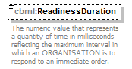
namespace | http://www.sisostds.org/schemas/c-bml/1.0
type | jc3iedm:DurationType19
properties
  isRef | 0
  minOcc | 0
  maxOcc | 1
  content | simple
facets
  Kind | Value | annotation
  minInclusive | -9999999999999999999
  maxInclusive | 9999999999999999999
annotation
  documentation
  The numeric value that represents a quantity of time in milliseconds reflecting the maximum interval in which an ORGANISATION is to respond to an immediate order.
source | <xs:element name="ReadinessDuration" type="jc3iedm:DurationType19" minOccurs="0">  <xs:annotation>  <xs:documentation xml:lang="en">The numeric value that represents a quantity of time in milliseconds reflecting the maximum interval in which an ORGANISATION is to respond to an immediate order.</xs:documentation>  </xs:annotation>  </xs:element>

element OrganisationStatus/ReinforcementCode
diagram | 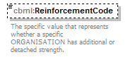
namespace | http://www.sisostds.org/schemas/c-bml/1.0
type | jc3iedm:OrganisationStatusReinforcementCode
properties
  isRef | 0
  minOcc | 0
  maxOcc | 1
  content | simple
facets
  Kind | Value | annotation
  enumeration | DETD
    documentation
    <Definition xml:lang="en">The UNIT in question has sub-UNITs detached.</Definition>
    appinfo
    <DisplayValue xml:lang="en">Detached only</DisplayValue>
  enumeration | NKN
    documentation
    <Definition xml:lang="en">It is not possible to determine which value is most applicable.</Definition>
    appinfo
    <DisplayValue xml:lang="en">Not known</DisplayValue>
  enumeration | NORM
    documentation
    <Definition xml:lang="en">The UNIT in question has no attachments or detachments.</Definition>
    appinfo
    <DisplayValue xml:lang="en">Normal strength</DisplayValue>
  enumeration | REIN
    documentation
    <Definition xml:lang="en">The UNIT in question has additional UNITs attached.</Definition>
    appinfo
    <DisplayValue xml:lang="en">Reinforced only</DisplayValue>
  enumeration | RIDT
    documentation
    <Definition xml:lang="en">The UNIT in question has UNITs attached and sub-UNITs detached.</Definition>
    appinfo
    <DisplayValue xml:lang="en">Reinforced and detached</DisplayValue>
annotation
  documentation
  The specific value that represents whether a specific ORGANISATION has additional or detached strength.
source | <xs:element name="ReinforcementCode" type="jc3iedm:OrganisationStatusReinforcementCode" minOccurs="0">  <xs:annotation>  <xs:documentation xml:lang="en">The specific value that represents whether a specific ORGANISATION has additional or detached strength.</xs:documentation>  </xs:annotation>  </xs:element>

element OrganisationStatus/ReserveIndicatorCode
diagram | 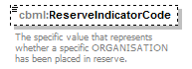
namespace | http://www.sisostds.org/schemas/c-bml/1.0
type | jc3iedm:OrganisationStatusReserveIndicatorCode
properties
  isRef | 0
  minOcc | 0
  maxOcc | 1
  content | simple
facets
  Kind | Value | annotation
  enumeration | NO
    documentation
    <Definition xml:lang="en">The specific ORGANISATION is not in reserve status.</Definition>
    appinfo
    <DisplayValue xml:lang="en">No</DisplayValue>
  enumeration | YES
    documentation
    <Definition xml:lang="en">The specific ORGANISATION is currently in reserve status.</Definition>
    appinfo
    <DisplayValue xml:lang="en">Yes</DisplayValue>
annotation
  documentation
  The specific value that represents whether a specific ORGANISATION has been placed in reserve.
source | <xs:element name="ReserveIndicatorCode" type="jc3iedm:OrganisationStatusReserveIndicatorCode" minOccurs="0">  <xs:annotation>  <xs:documentation xml:lang="en">The specific value that represents whether a specific ORGANISATION has been placed in reserve.</xs:documentation>  </xs:annotation>  </xs:element>

element OrganisationStatus/TrainingCode
diagram | 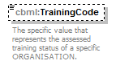
namespace | http://www.sisostds.org/schemas/c-bml/1.0
type | jc3iedm:OrganisationStatusTrainingCode
properties
  isRef | 0
  minOcc | 0
  maxOcc | 1
  content | simple
facets
  Kind | Value | annotation
  enumeration | AMBER
    documentation
    <Definition xml:lang="en">A status indicating that the training level of an ORGANISATION is between 60% and 80%.</Definition>
    appinfo
    <DisplayValue xml:lang="en">Amber</DisplayValue>
  enumeration | GREEN
    documentation
    <Definition xml:lang="en">A status indicating that the training level of an ORGANISATION is greater than 80%.</Definition>
    appinfo
    <DisplayValue xml:lang="en">Green</DisplayValue>
  enumeration | NKN
    documentation
    <Definition xml:lang="en">It is not possible to determine which value is most applicable.</Definition>
    appinfo
    <DisplayValue xml:lang="en">Not known</DisplayValue>
  enumeration | RED
    documentation
    <Definition xml:lang="en">A status indicating that the training level of an ORGANISATION is less than 60%.</Definition>
    appinfo
    <DisplayValue xml:lang="en">Red</DisplayValue>
annotation
  documentation
  The specific value that represents the assessed training status of a specific ORGANISATION.
source | <xs:element name="TrainingCode" type="jc3iedm:OrganisationStatusTrainingCode" minOccurs="0">  <xs:annotation>  <xs:documentation xml:lang="en">The specific value that represents the assessed training status of a specific ORGANISATION.</xs:documentation>  </xs:annotation>  </xs:element>

element OrganisationStatus/UsageStatusCode
diagram | 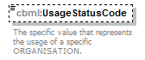
namespace | http://www.sisostds.org/schemas/c-bml/1.0
type | jc3iedm:OrganisationStatusUsageStatusCode
properties
  isRef | 0
  minOcc | 0
  maxOcc | 1
  content | simple
facets
  Kind | Value | annotation
  enumeration | INACT
    documentation
    <Definition xml:lang="en">A status indicating that an ORGANISATION is performing its operational mission.</Definition>
    appinfo
    <DisplayValue xml:lang="en">In action</DisplayValue>
  enumeration | NKN
    documentation
    <Definition xml:lang="en">It is not possible to determine which value is most applicable.</Definition>
    appinfo
    <DisplayValue xml:lang="en">Not known</DisplayValue>
  enumeration | OUTACT
    documentation
    <Definition xml:lang="en">A status indicating that an ORGANISATION is not performing its operational mission.</Definition>
    appinfo
    <DisplayValue xml:lang="en">Out of action</DisplayValue>
annotation
  documentation
  The specific value that represents the usage of a specific ORGANISATION.
source | <xs:element name="UsageStatusCode" type="jc3iedm:OrganisationStatusUsageStatusCode" minOccurs="0">  <xs:annotation>  <xs:documentation xml:lang="en">The specific value that represents the usage of a specific ORGANISATION.</xs:documentation>  </xs:annotation>  </xs:element>

complexType OtherGovernmentOrganisationType
diagram | 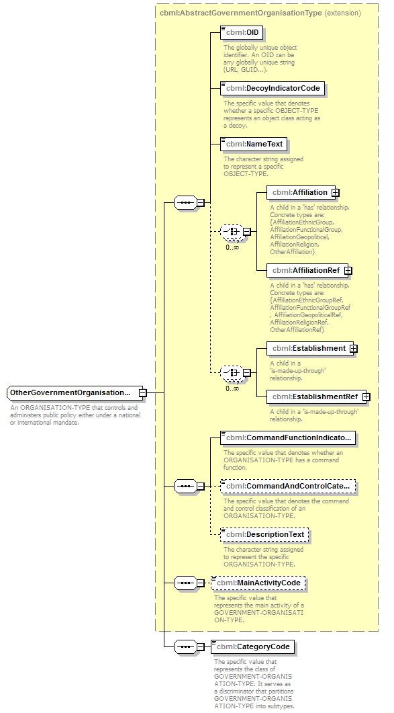
namespace | http://www.sisostds.org/schemas/c-bml/1.0
type | extension of cbml:AbstractGovernmentOrganisationType
properties
  base | cbml:AbstractGovernmentOrganisationType
children | cbml:OID cbml:DecoyIndicatorCode cbml:NameText cbml:Affiliation cbml:AffiliationRef cbml:Establishment cbml:EstablishmentRef cbml:CommandFunctionIndicatorCode cbml:CommandAndControlCategoryCode cbml:DescriptionText cbml:MainActivityCode cbml:CategoryCode
annotation
  documentation
  An ORGANISATION-TYPE that controls and administers public policy either under a national or international mandate.
source | <xs:complexType name="OtherGovernmentOrganisationType">  <xs:annotation>  <xs:documentation xml:lang="en">An ORGANISATION-TYPE that controls and administers public policy either under a national or international mandate.</xs:documentation>  </xs:annotation>  <xs:complexContent>  <xs:extension base="cbml:AbstractGovernmentOrganisationType">  <xs:sequence>  <xs:element name="CategoryCode" type="jc3iedm:GovernmentOrganisationTypeCategoryCode">  <xs:annotation>  <xs:documentation xml:lang="en">The specific value that represents the class of GOVERNMENT-ORGANISATION-TYPE. It serves as a discriminator that partitions GOVERNMENT-ORGANISATION-TYPE into subtypes.</xs:documentation>  </xs:annotation>  </xs:element>  </xs:sequence>  </xs:extension>  </xs:complexContent>  </xs:complexType>

element OtherGovernmentOrganisationType/CategoryCode
diagram | 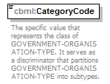
namespace | http://www.sisostds.org/schemas/c-bml/1.0
type | jc3iedm:GovernmentOrganisationTypeCategoryCode
properties
  isRef | 0
  content | simple
facets
  Kind | Value | annotation
  enumeration | INTCIV
    documentation
    <Definition xml:lang="en">A GOVERNMENT-ORGANISATION-TYPE that is officially involved in international civil affairs.</Definition>
    appinfo
    <DisplayValue xml:lang="en">International civil</DisplayValue>
  enumeration | INTCMI
    documentation
    <Definition xml:lang="en">A GOVERNMENT-ORGANISATION-TYPE that is officially involved in international affairs that include both civil and military elements.</Definition>
    appinfo
    <DisplayValue xml:lang="en">International civil/military</DisplayValue>
  enumeration | MILORG
    documentation
    <Definition xml:lang="en">A GOVERNMENT-ORGANISATION-TYPE that is officially sanctioned and is trained and equipped to exert force.</Definition>
    appinfo
    <DisplayValue xml:lang="en">MILITARY-ORGANISATION-TYPE</DisplayValue>
  enumeration | NATCIV
    documentation
    <Definition xml:lang="en">A GOVERNMENT-ORGANISATION-TYPE that is officially involved in national civil affairs.</Definition>
    appinfo
    <DisplayValue xml:lang="en">National civil</DisplayValue>
  enumeration | NOS
    documentation
    <Definition xml:lang="en">The appropriate value is not in the set of specified values.</Definition>
    appinfo
    <DisplayValue xml:lang="en">Not otherwise specified</DisplayValue>
annotation
  documentation
  The specific value that represents the class of GOVERNMENT-ORGANISATION-TYPE. It serves as a discriminator that partitions GOVERNMENT-ORGANISATION-TYPE into subtypes.
source | <xs:element name="CategoryCode" type="jc3iedm:GovernmentOrganisationTypeCategoryCode">  <xs:annotation>  <xs:documentation xml:lang="en">The specific value that represents the class of GOVERNMENT-ORGANISATION-TYPE. It serves as a discriminator that partitions GOVERNMENT-ORGANISATION-TYPE into subtypes.</xs:documentation>  </xs:annotation>  </xs:element>

complexType OtherGovernmentOrganisationTypeRef
diagram | 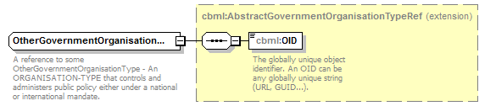
namespace | http://www.sisostds.org/schemas/c-bml/1.0
type | extension of cbml:AbstractGovernmentOrganisationTypeRef
properties
  base | cbml:AbstractGovernmentOrganisationTypeRef
children | cbml:OID
annotation
  documentation
  A reference to some OtherGovernmentOrganisationType - An ORGANISATION-TYPE that controls and administers public policy either under a national or international mandate.
source | <xs:complexType name="OtherGovernmentOrganisationTypeRef">  <xs:annotation>  <xs:documentation xml:lang="en">A reference to some OtherGovernmentOrganisationType - An ORGANISATION-TYPE that controls and administers public policy either under a national or international mandate.</xs:documentation>  </xs:annotation>  <xs:complexContent>  <xs:extension base="cbml:AbstractGovernmentOrganisationTypeRef"/>  </xs:complexContent>  </xs:complexType>

complexType OtherMilitaryOrganisationType
diagram | 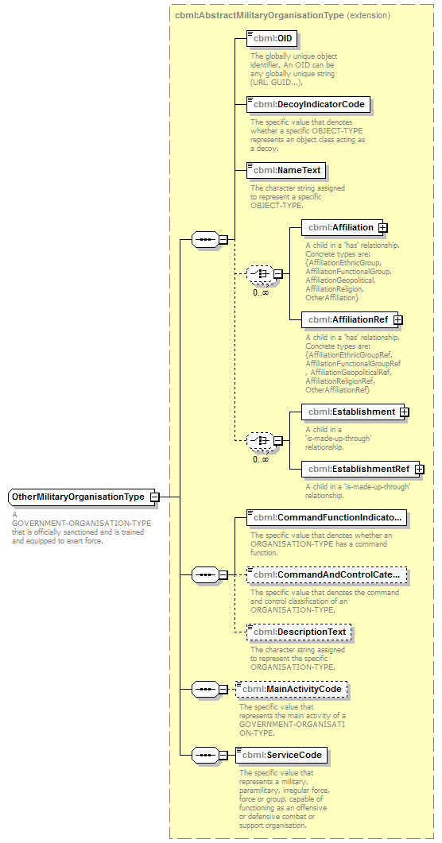
namespace | http://www.sisostds.org/schemas/c-bml/1.0
type | extension of cbml:AbstractMilitaryOrganisationType
properties
  base | cbml:AbstractMilitaryOrganisationType
children | cbml:OID cbml:DecoyIndicatorCode cbml:NameText cbml:Affiliation cbml:AffiliationRef cbml:Establishment cbml:EstablishmentRef cbml:CommandFunctionIndicatorCode cbml:CommandAndControlCategoryCode cbml:DescriptionText cbml:MainActivityCode cbml:ServiceCode
annotation
  documentation
  A GOVERNMENT-ORGANISATION-TYPE that is officially sanctioned and is trained and equipped to exert force.
source | <xs:complexType name="OtherMilitaryOrganisationType">  <xs:annotation>  <xs:documentation xml:lang="en">A GOVERNMENT-ORGANISATION-TYPE that is officially sanctioned and is trained and equipped to exert force.</xs:documentation>  </xs:annotation>  <xs:complexContent>  <xs:extension base="cbml:AbstractMilitaryOrganisationType"/>  </xs:complexContent>  </xs:complexType>

complexType OtherMilitaryOrganisationTypeRef
diagram | 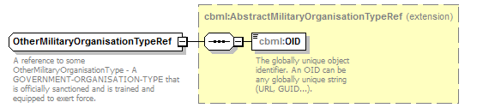
namespace | http://www.sisostds.org/schemas/c-bml/1.0
type | extension of cbml:AbstractMilitaryOrganisationTypeRef
properties
  base | cbml:AbstractMilitaryOrganisationTypeRef
children | cbml:OID
annotation
  documentation
  A reference to some OtherMilitaryOrganisationType - A GOVERNMENT-ORGANISATION-TYPE that is officially sanctioned and is trained and equipped to exert force.
source | <xs:complexType name="OtherMilitaryOrganisationTypeRef">  <xs:annotation>  <xs:documentation xml:lang="en">A reference to some OtherMilitaryOrganisationType - A GOVERNMENT-ORGANISATION-TYPE that is officially sanctioned and is trained and equipped to exert force.</xs:documentation>  </xs:annotation>  <xs:complexContent>  <xs:extension base="cbml:AbstractMilitaryOrganisationTypeRef"/>  </xs:complexContent>  </xs:complexType>

complexType OtherOrganisation
diagram | 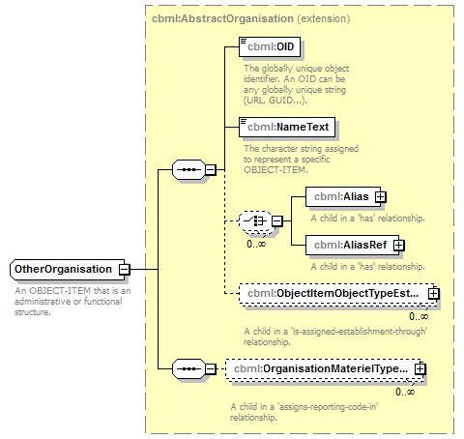
namespace | http://www.sisostds.org/schemas/c-bml/1.0
type | extension of cbml:AbstractOrganisation
properties
  base | cbml:AbstractOrganisation
children | cbml:OID cbml:NameText cbml:Alias cbml:AliasRef cbml:ObjectItemObjectTypeEstablishmentInObjectItem cbml:OrganisationMaterielTypeAssociationInOrganisation
annotation
  documentation
  An OBJECT-ITEM that is an administrative or functional structure.
source | <xs:complexType name="OtherOrganisation">  <xs:annotation>  <xs:documentation xml:lang="en">An OBJECT-ITEM that is an administrative or functional structure.</xs:documentation>  </xs:annotation>  <xs:complexContent>  <xs:extension base="cbml:AbstractOrganisation"/>  </xs:complexContent>  </xs:complexType>

complexType OtherOrganisationRef
diagram | 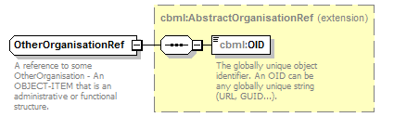
namespace | http://www.sisostds.org/schemas/c-bml/1.0
type | extension of cbml:AbstractOrganisationRef
properties
  base | cbml:AbstractOrganisationRef
children | cbml:OID
annotation
  documentation
  A reference to some OtherOrganisation - An OBJECT-ITEM that is an administrative or functional structure.
source | <xs:complexType name="OtherOrganisationRef">  <xs:annotation>  <xs:documentation xml:lang="en">A reference to some OtherOrganisation - An OBJECT-ITEM that is an administrative or functional structure.</xs:documentation>  </xs:annotation>  <xs:complexContent>  <xs:extension base="cbml:AbstractOrganisationRef"/>  </xs:complexContent>  </xs:complexType>

complexType OtherOrganisationType
diagram | 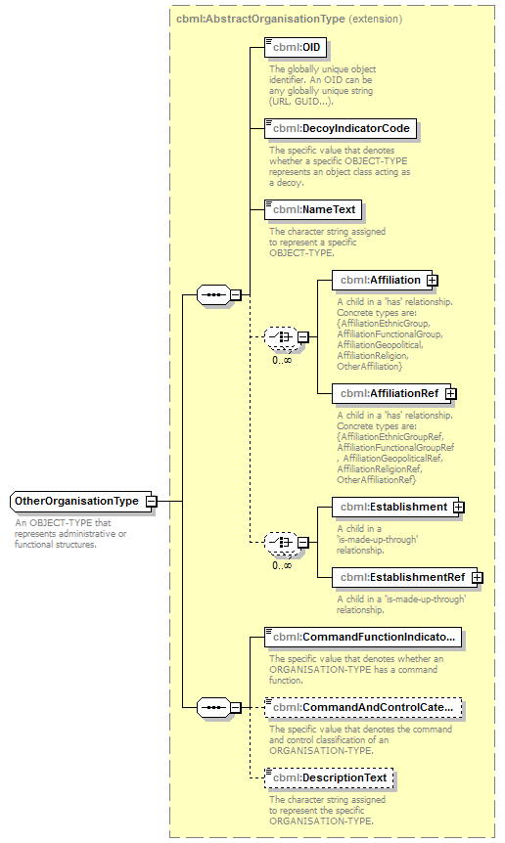
namespace | http://www.sisostds.org/schemas/c-bml/1.0
type | extension of cbml:AbstractOrganisationType
properties
  base | cbml:AbstractOrganisationType
children | cbml:OID cbml:DecoyIndicatorCode cbml:NameText cbml:Affiliation cbml:AffiliationRef cbml:Establishment cbml:EstablishmentRef cbml:CommandFunctionIndicatorCode cbml:CommandAndControlCategoryCode cbml:DescriptionText
annotation
  documentation
  An OBJECT-TYPE that represents administrative or functional structures.
source | <xs:complexType name="OtherOrganisationType">  <xs:annotation>  <xs:documentation xml:lang="en">An OBJECT-TYPE that represents administrative or functional structures.</xs:documentation>  </xs:annotation>  <xs:complexContent>  <xs:extension base="cbml:AbstractOrganisationType"/>  </xs:complexContent>  </xs:complexType>

complexType OtherOrganisationTypeRef
diagram | 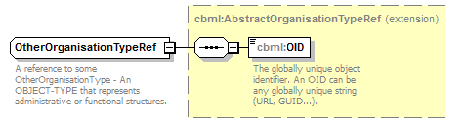
namespace | http://www.sisostds.org/schemas/c-bml/1.0
type | extension of cbml:AbstractOrganisationTypeRef
properties
  base | cbml:AbstractOrganisationTypeRef
children | cbml:OID
annotation
  documentation
  A reference to some OtherOrganisationType - An OBJECT-TYPE that represents administrative or functional structures.
source | <xs:complexType name="OtherOrganisationTypeRef">  <xs:annotation>  <xs:documentation xml:lang="en">A reference to some OtherOrganisationType - An OBJECT-TYPE that represents administrative or functional structures.</xs:documentation>  </xs:annotation>  <xs:complexContent>  <xs:extension base="cbml:AbstractOrganisationTypeRef"/>  </xs:complexContent>  </xs:complexType>

complexType PrivateSectorOrganisationType
diagram | 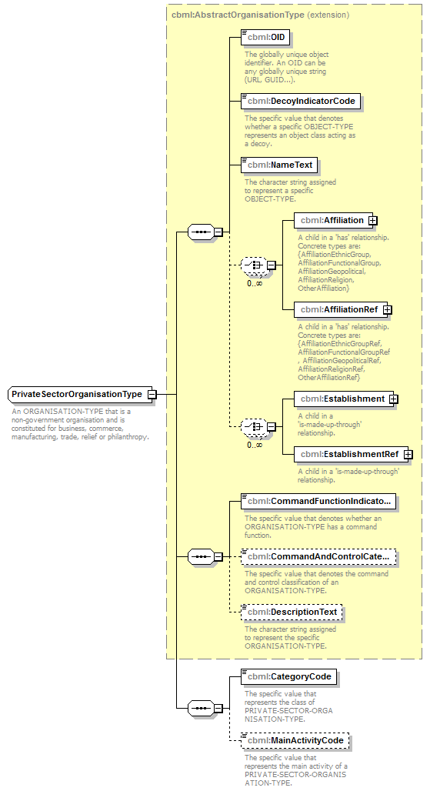
namespace | http://www.sisostds.org/schemas/c-bml/1.0
type | extension of cbml:AbstractOrganisationType
properties
  base | cbml:AbstractOrganisationType
children | cbml:OID cbml:DecoyIndicatorCode cbml:NameText cbml:Affiliation cbml:AffiliationRef cbml:Establishment cbml:EstablishmentRef cbml:CommandFunctionIndicatorCode cbml:CommandAndControlCategoryCode cbml:DescriptionText cbml:CategoryCode cbml:MainActivityCode
annotation
  documentation
  An ORGANISATION-TYPE that is a non-government organisation and is constituted for business, commerce, manufacturing, trade, relief or philanthropy.
source | <xs:complexType name="PrivateSectorOrganisationType">  <xs:annotation>  <xs:documentation xml:lang="en">An ORGANISATION-TYPE that is a non-government organisation and is constituted for business, commerce, manufacturing, trade, relief or philanthropy.</xs:documentation>  </xs:annotation>  <xs:complexContent>  <xs:extension base="cbml:AbstractOrganisationType">  <xs:sequence>  <xs:element name="CategoryCode" type="jc3iedm:PrivateSectorOrganisationTypeCategoryCode">  <xs:annotation>  <xs:documentation xml:lang="en">The specific value that represents the class of PRIVATE-SECTOR-ORGANISATION-TYPE.</xs:documentation>  </xs:annotation>  </xs:element>  <xs:element name="MainActivityCode" type="jc3iedm:MainActivityCode" minOccurs="0">  <xs:annotation>  <xs:documentation xml:lang="en">The specific value that represents the main activity of a PRIVATE-SECTOR-ORGANISATION-TYPE.</xs:documentation>  </xs:annotation>  </xs:element>  </xs:sequence>  </xs:extension>  </xs:complexContent>  </xs:complexType>

element PrivateSectorOrganisationType/CategoryCode
diagram | 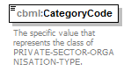
namespace | http://www.sisostds.org/schemas/c-bml/1.0
type | jc3iedm:PrivateSectorOrganisationTypeCategoryCode
properties
  isRef | 0
  content | simple
facets
  Kind | Value | annotation
  enumeration | AGRCTL
    documentation
    <Definition xml:lang="en">A PRIVATE-SECTOR-ORGANISATION-TYPE whose predominant business is the production and processing of agricultural products.</Definition>
    appinfo
    <DisplayValue xml:lang="en">Agricultural</DisplayValue>
  enumeration | DEFIND
    documentation
    <Definition xml:lang="en">A PRIVATE-SECTOR-ORGANISATION-TYPE whose predominant business is defence in nature.</Definition>
    appinfo
    <DisplayValue xml:lang="en">Defence industry</DisplayValue>
  enumeration | FSHIND
    documentation
    <Definition xml:lang="en">A PRIVATE-SECTOR-ORGANISATION-TYPE whose predominant business is the production and processing of seafood products.</Definition>
    appinfo
    <DisplayValue xml:lang="en">Fishing industry</DisplayValue>
  enumeration | MFG
    documentation
    <Definition xml:lang="en">A PRIVATE-SECTOR-ORGANISATION-TYPE whose predominant business is manufacturing in nature.</Definition>
    appinfo
    <DisplayValue xml:lang="en">Manufacturing</DisplayValue>
  enumeration | MULTIN
    documentation
    <Definition xml:lang="en">A PRIVATE-SECTOR-ORGANISATION-TYPE whose predominant business is multi-national in scope and nature.</Definition>
    appinfo
    <DisplayValue xml:lang="en">Multi-national</DisplayValue>
  enumeration | NEWSMD
    documentation
    <Definition xml:lang="en">A PRIVATE-SECTOR-ORGANISATION-TYPE whose predominant business is the gathering and dissemination of news.</Definition>
    appinfo
    <DisplayValue xml:lang="en">News media</DisplayValue>
  enumeration | NOS
    documentation
    <Definition xml:lang="en">The appropriate value is not in the set of specified values.</Definition>
    appinfo
    <DisplayValue xml:lang="en">Not otherwise specified</DisplayValue>
  enumeration | PHLNTP
    documentation
    <Definition xml:lang="en">A PRIVATE-SECTOR-ORGANISATION-TYPE whose predominant business is philanthropic in nature.</Definition>
    appinfo
    <DisplayValue xml:lang="en">Philanthropic</DisplayValue>
  enumeration | RETAIL
    documentation
    <Definition xml:lang="en">A PRIVATE-SECTOR-ORGANISATION-TYPE whose predominant business is retail in nature.</Definition>
    appinfo
    <DisplayValue xml:lang="en">Retail</DisplayValue>
  enumeration | TRADE
    documentation
    <Definition xml:lang="en">A PRIVATE-SECTOR-ORGANISATION-TYPE whose predominant business is trade in nature.</Definition>
    appinfo
    <DisplayValue xml:lang="en">Trade</DisplayValue>
annotation
  documentation
  The specific value that represents the class of PRIVATE-SECTOR-ORGANISATION-TYPE.
source | <xs:element name="CategoryCode" type="jc3iedm:PrivateSectorOrganisationTypeCategoryCode">  <xs:annotation>  <xs:documentation xml:lang="en">The specific value that represents the class of PRIVATE-SECTOR-ORGANISATION-TYPE.</xs:documentation>  </xs:annotation>  </xs:element>

element PrivateSectorOrganisationType/MainActivityCode
diagram | 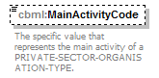
namespace | http://www.sisostds.org/schemas/c-bml/1.0
type | jc3iedm:MainActivityCode
properties
  isRef | 0
  minOcc | 0
  maxOcc | 1
  content | simple
facets
  Kind | Value | annotation
  enumeration | AGRCPR
    documentation
    <Definition xml:lang="en">The activity that deals with providing agriculture services.</Definition>
    appinfo
    <DisplayValue xml:lang="en">Agriculture programs</DisplayValue>
  enumeration | EDUCPR
    documentation
    <Definition xml:lang="en">The activity that deals with providing education services.</Definition>
    appinfo
    <DisplayValue xml:lang="en">Education programs</DisplayValue>
  enumeration | FOODPR
    documentation
    <Definition xml:lang="en">The activity that deals with distribution of food.</Definition>
    appinfo
    <DisplayValue xml:lang="en">Food programs</DisplayValue>
  enumeration | HLTHPR
    documentation
    <Definition xml:lang="en">The activity that deals with providing health care services.</Definition>
    appinfo
    <DisplayValue xml:lang="en">Health programs</DisplayValue>
  enumeration | INFSPR
    documentation
    <Definition xml:lang="en">The activity that deals with providing infrastructure and construction repair services.</Definition>
    appinfo
    <DisplayValue xml:lang="en">Infrastructure and construction repair programs</DisplayValue>
  enumeration | NOS
    documentation
    <Definition xml:lang="en">The appropriate value is not in the set of specified values.</Definition>
    appinfo
    <DisplayValue xml:lang="en">Not otherwise specified</DisplayValue>
  enumeration | SOCLPR
    documentation
    <Definition xml:lang="en">The activity that deals with providing social programs.</Definition>
    appinfo
    <DisplayValue xml:lang="en">Social programs</DisplayValue>
annotation
  documentation
  The specific value that represents the main activity of a PRIVATE-SECTOR-ORGANISATION-TYPE.
source | <xs:element name="MainActivityCode" type="jc3iedm:MainActivityCode" minOccurs="0">  <xs:annotation>  <xs:documentation xml:lang="en">The specific value that represents the main activity of a PRIVATE-SECTOR-ORGANISATION-TYPE.</xs:documentation>  </xs:annotation>  </xs:element>

complexType PrivateSectorOrganisationTypeRef
diagram | 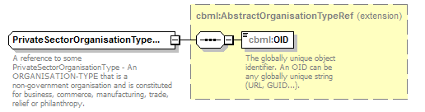
namespace | http://www.sisostds.org/schemas/c-bml/1.0
type | extension of cbml:AbstractOrganisationTypeRef
properties
  base | cbml:AbstractOrganisationTypeRef
children | cbml:OID
annotation
  documentation
  A reference to some PrivateSectorOrganisationType - An ORGANISATION-TYPE that is a non-government organisation and is constituted for business, commerce, manufacturing, trade, relief or philanthropy.
source | <xs:complexType name="PrivateSectorOrganisationTypeRef">  <xs:annotation>  <xs:documentation xml:lang="en">A reference to some PrivateSectorOrganisationType - An ORGANISATION-TYPE that is a non-government organisation and is constituted for business, commerce, manufacturing, trade, relief or philanthropy.</xs:documentation>  </xs:annotation>  <xs:complexContent>  <xs:extension base="cbml:AbstractOrganisationTypeRef"/>  </xs:complexContent>  </xs:complexType>

complexType TaskFormationType
diagram | 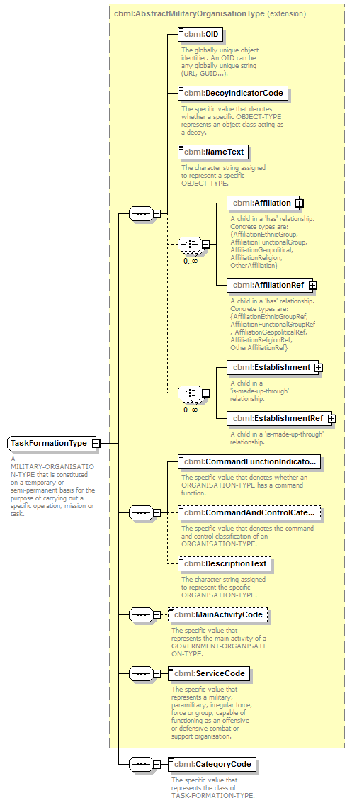
namespace | http://www.sisostds.org/schemas/c-bml/1.0
type | extension of cbml:AbstractMilitaryOrganisationType
properties
  base | cbml:AbstractMilitaryOrganisationType
children | cbml:OID cbml:DecoyIndicatorCode cbml:NameText cbml:Affiliation cbml:AffiliationRef cbml:Establishment cbml:EstablishmentRef cbml:CommandFunctionIndicatorCode cbml:CommandAndControlCategoryCode cbml:DescriptionText cbml:MainActivityCode cbml:ServiceCode cbml:CategoryCode
annotation
  documentation
  A MILITARY-ORGANISATION-TYPE that is constituted on a temporary or semi-permanent basis for the purpose of carrying out a specific operation, mission or task.
source | <xs:complexType name="TaskFormationType">  <xs:annotation>  <xs:documentation xml:lang="en">A MILITARY-ORGANISATION-TYPE that is constituted on a temporary or semi-permanent basis for the purpose of carrying out a specific operation, mission or task.</xs:documentation>  </xs:annotation>  <xs:complexContent>  <xs:extension base="cbml:AbstractMilitaryOrganisationType">  <xs:sequence>  <xs:element name="CategoryCode" type="jc3iedm:TaskFormationTypeCategoryCode">  <xs:annotation>  <xs:documentation xml:lang="en">The specific value that represents the class of TASK-FORMATION-TYPE.</xs:documentation>  </xs:annotation>  </xs:element>  </xs:sequence>  </xs:extension>  </xs:complexContent>  </xs:complexType>

element TaskFormationType/CategoryCode
diagram | 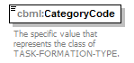
namespace | http://www.sisostds.org/schemas/c-bml/1.0
type | jc3iedm:TaskFormationTypeCategoryCode
properties
  isRef | 0
  content | simple
facets
  Kind | Value | annotation
  enumeration | AIRFMN
    documentation
    <Definition xml:lang="en">An ordered arrangement of two or more aircraft proceeding together under a commander.</Definition>
    appinfo
    <DisplayValue xml:lang="en">Air formation</DisplayValue>
  enumeration | AIRTF
    documentation
    <Definition xml:lang="en">A temporary grouping of units, under one commander, formed for the purpose of carrying out a specific air operation or mission.</Definition>
    appinfo
    <DisplayValue xml:lang="en">Air task force</DisplayValue>
  enumeration | AMPHTF
    documentation
    <Definition xml:lang="en">A temporary grouping of units, under one commander, formed for the purpose of carrying out a specific amphibious operation or mission.</Definition>
    appinfo
    <DisplayValue xml:lang="en">Amphibious task force</DisplayValue>
  enumeration | CMBCTM
    documentation
    <Definition xml:lang="en">A TASK-FORMATION-TYPE that consists of parachute and combat diver qualified personnel trained and equipped to rapidly establish and control drop, landing, and extraction zone air traffic in austere or hostile conditions. They survey and establish terminal airheads as well as provide guidance to aircraft for airlift operations. They provide command and control, and conduct reconnaissance, surveillance, and survey assessments of potential objective airfields or assault zones.</Definition>
    appinfo
    <DisplayValue xml:lang="en">Combat control team</DisplayValue>
  enumeration | FLOTLA
    documentation
    <Definition xml:lang="en">A small fleet; a fleet of boats or small vessels.</Definition>
    appinfo
    <DisplayValue xml:lang="en">Flotilla</DisplayValue>
  enumeration | GRNAVY
    documentation
    <Definition xml:lang="en">A TASK-FORMATION-TYPE that consists of a number of ships and/or aircraft, normally a subdivision of a force, assigned for a specific purpose.</Definition>
    appinfo
    <DisplayValue xml:lang="en">Group (navy)</DisplayValue>
  enumeration | INTGTM
    documentation
    <Definition xml:lang="en">A TASK-FORMATION-TYPE that provides electronic, mechanical, visual, or other assistance given an aircraft pilot to facilitate arrival at, operation within or over, landing upon, or departure from an air landing or airdrop facility.</Definition>
    appinfo
    <DisplayValue xml:lang="en">Initial terminal guidance team</DisplayValue>
  enumeration | JNTTF
    documentation
    <Definition xml:lang="en">A temporary grouping of units, under one commander, formed for the purpose of carrying out a specific joint operation or mission.</Definition>
    appinfo
    <DisplayValue xml:lang="en">Joint task force</DisplayValue>
  enumeration | LANDTF
    documentation
    <Definition xml:lang="en">A temporary grouping of units, under one commander, formed for the purpose of carrying out a specific land operation or mission.</Definition>
    appinfo
    <DisplayValue xml:lang="en">Land task force</DisplayValue>
  enumeration | LNDFMN
    documentation
    <Definition xml:lang="en">An ordered arrangement of troops and/or vehicles for a specific purpose.</Definition>
    appinfo
    <DisplayValue xml:lang="en">Land formation</DisplayValue>
  enumeration | MLCNVY
    documentation
    <Definition xml:lang="en">A TASK-FORMATION-TYPE that is a land or maritime convoy that is controlled and reported as a military unit.</Definition>
    appinfo
    <DisplayValue xml:lang="en">Military-convoy-type</DisplayValue>
  enumeration | MRATCD
    documentation
    <Definition xml:lang="en">A TASK-FORMATION-TYPE, subordinate to the U.S. Marine TACC, that controls local airspace/aircraft in and around a Marine Air Ground Task Force (MAGTF) airfields and provides precision approach control for MAGTF aircraft.</Definition>
    appinfo
    <DisplayValue xml:lang="en">Marine air traffic control detachment</DisplayValue>
  enumeration | MRATCM
    documentation
    <Definition xml:lang="en">A TASK-FORMATION-TYPE, subordinate to the U. S. Marine TACC, that controls local airspace/aircraft in and around Marine Air Ground Task Force (MAGTF) airfields and provides precision approach control for MAGTF aircraft.</Definition>
    appinfo
    <DisplayValue xml:lang="en">Marine air traffic control mobile team</DisplayValue>
  enumeration | NAVFMN
    documentation
    <Definition xml:lang="en">An ordered arrangement of two or more ships, units or aircraft proceeding together under a commander.</Definition>
    appinfo
    <DisplayValue xml:lang="en">Naval formation</DisplayValue>
  enumeration | NAVLTE
    documentation
    <Definition xml:lang="en">A TASK-FORMATION-TYPE that is a component of a task unit organized by the commander of the task unit or higher authority for accomplishing a specific task.</Definition>
    appinfo
    <DisplayValue xml:lang="en">Naval task element</DisplayValue>
  enumeration | NAVLTF
    documentation
    <Definition xml:lang="en">A TASK-FORMATION-TYPE that is a component of a fleet organized by the commander of a task fleet or higher authority for the accomplishment of a specific task or tasks.</Definition>
    appinfo
    <DisplayValue xml:lang="en">Naval task force</DisplayValue>
  enumeration | NAVLTG
    documentation
    <Definition xml:lang="en">A TASK-FORMATION-TYPE that is a component of a task force organized by the commander of the task force or higher authority for accomplishing specific tasks.</Definition>
    appinfo
    <DisplayValue xml:lang="en">Naval task group</DisplayValue>
  enumeration | NAVLTU
    documentation
    <Definition xml:lang="en">A TASK-FORMATION-TYPE that is a component of a task group organized by the commander of a task group or higher authority for accomplishing specific tasks.</Definition>
    appinfo
    <DisplayValue xml:lang="en">Naval task unit</DisplayValue>
  enumeration | NOS
    documentation
    <Definition xml:lang="en">The appropriate value is not in the set of specified values.</Definition>
    appinfo
    <DisplayValue xml:lang="en">Not otherwise specified</DisplayValue>
  enumeration | PATROL
    documentation
    <Definition xml:lang="en">A TASK-FORMATION-TYPE that is a detachment of ground, sea, or air forces sent out for the purpose of gathering information or carrying out a destructive, harassing, mopping-up, or security mission.</Definition>
    appinfo
    <DisplayValue xml:lang="en">Patrol</DisplayValue>
  enumeration | WRKPTY
    documentation
    <Definition xml:lang="en">A group of people who come together to carry out a piece of work.</Definition>
    appinfo
    <DisplayValue xml:lang="en">Work party</DisplayValue>
annotation
  documentation
  The specific value that represents the class of TASK-FORMATION-TYPE.
source | <xs:element name="CategoryCode" type="jc3iedm:TaskFormationTypeCategoryCode">  <xs:annotation>  <xs:documentation xml:lang="en">The specific value that represents the class of TASK-FORMATION-TYPE.</xs:documentation>  </xs:annotation>  </xs:element>

complexType TaskFormationTypeRef
diagram | 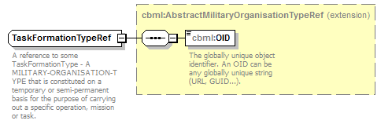
namespace | http://www.sisostds.org/schemas/c-bml/1.0
type | extension of cbml:AbstractMilitaryOrganisationTypeRef
properties
  base | cbml:AbstractMilitaryOrganisationTypeRef
children | cbml:OID
annotation
  documentation
  A reference to some TaskFormationType - A MILITARY-ORGANISATION-TYPE that is constituted on a temporary or semi-permanent basis for the purpose of carrying out a specific operation, mission or task.
source | <xs:complexType name="TaskFormationTypeRef">  <xs:annotation>  <xs:documentation xml:lang="en">A reference to some TaskFormationType - A MILITARY-ORGANISATION-TYPE that is constituted on a temporary or semi-permanent basis for the purpose of carrying out a specific operation, mission or task.</xs:documentation>  </xs:annotation>  <xs:complexContent>  <xs:extension base="cbml:AbstractMilitaryOrganisationTypeRef"/>  </xs:complexContent>  </xs:complexType>

complexType Unit
diagram | 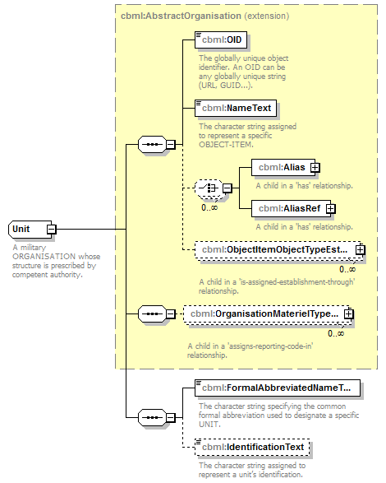
namespace | http://www.sisostds.org/schemas/c-bml/1.0
type | extension of cbml:AbstractOrganisation
properties
  base | cbml:AbstractOrganisation
children | cbml:OID cbml:NameText cbml:Alias cbml:AliasRef cbml:ObjectItemObjectTypeEstablishmentInObjectItem cbml:OrganisationMaterielTypeAssociationInOrganisation cbml:FormalAbbreviatedNameText cbml:IdentificationText
annotation
  documentation
  A military ORGANISATION whose structure is prescribed by competent authority.
source | <xs:complexType name="Unit">  <xs:annotation>  <xs:documentation xml:lang="en">A military ORGANISATION whose structure is prescribed by competent authority.</xs:documentation>  </xs:annotation>  <xs:complexContent>  <xs:extension base="cbml:AbstractOrganisation">  <xs:sequence>  <xs:element name="FormalAbbreviatedNameText" type="jc3iedm:TextTypeVar100">  <xs:annotation>  <xs:documentation xml:lang="en">The character string specifying the common formal abbreviation used to designate a specific UNIT.</xs:documentation>  </xs:annotation>  </xs:element>  <xs:element name="IdentificationText" type="jc3iedm:TextTypeVar15" minOccurs="0">  <xs:annotation>  <xs:documentation xml:lang="en">The character string assigned to represent a unit’s identification.</xs:documentation>  </xs:annotation>  </xs:element>  </xs:sequence>  </xs:extension>  </xs:complexContent>  </xs:complexType>

element Unit/FormalAbbreviatedNameText
diagram | 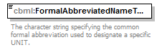
namespace | http://www.sisostds.org/schemas/c-bml/1.0
type | jc3iedm:TextTypeVar100
properties
  isRef | 0
  content | simple
facets
  Kind | Value | annotation
  minLength | 0
  maxLength | 100
annotation
  documentation
  The character string specifying the common formal abbreviation used to designate a specific UNIT.
source | <xs:element name="FormalAbbreviatedNameText" type="jc3iedm:TextTypeVar100">  <xs:annotation>  <xs:documentation xml:lang="en">The character string specifying the common formal abbreviation used to designate a specific UNIT.</xs:documentation>  </xs:annotation>  </xs:element>

element Unit/IdentificationText
diagram | 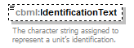
namespace | http://www.sisostds.org/schemas/c-bml/1.0
type | jc3iedm:TextTypeVar15
properties
  isRef | 0
  minOcc | 0
  maxOcc | 1
  content | simple
facets
  Kind | Value | annotation
  minLength | 0
  maxLength | 15
annotation
  documentation
  The character string assigned to represent a unit’s identification.
source | <xs:element name="IdentificationText" type="jc3iedm:TextTypeVar15" minOccurs="0">  <xs:annotation>  <xs:documentation xml:lang="en">The character string assigned to represent a unit’s identification.</xs:documentation>  </xs:annotation>  </xs:element>

complexType UnitRef
diagram | 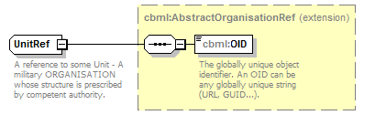
namespace | http://www.sisostds.org/schemas/c-bml/1.0
type | extension of cbml:AbstractOrganisationRef
properties
  base | cbml:AbstractOrganisationRef
children | cbml:OID
annotation
  documentation
  A reference to some Unit - A military ORGANISATION whose structure is prescribed by competent authority.
source | <xs:complexType name="UnitRef">  <xs:annotation>  <xs:documentation xml:lang="en">A reference to some Unit - A military ORGANISATION whose structure is prescribed by competent authority.</xs:documentation>  </xs:annotation>  <xs:complexContent>  <xs:extension base="cbml:AbstractOrganisationRef"/>  </xs:complexContent>  </xs:complexType>

complexType UnitType
diagram | 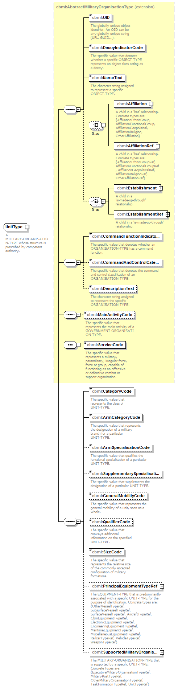
namespace | http://www.sisostds.org/schemas/c-bml/1.0
type | extension of cbml:AbstractMilitaryOrganisationType
properties
  base | cbml:AbstractMilitaryOrganisationType
children | cbml:OID cbml:DecoyIndicatorCode cbml:NameText cbml:Affiliation cbml:AffiliationRef cbml:Establishment cbml:EstablishmentRef cbml:CommandFunctionIndicatorCode cbml:CommandAndControlCategoryCode cbml:DescriptionText cbml:MainActivityCode cbml:ServiceCode cbml:CategoryCode cbml:ArmCategoryCode cbml:ArmSpecialisationCode cbml:SupplementarySpecialisationCode cbml:GeneralMobilityCode cbml:QualifierCode cbml:SizeCode cbml:PrincipalEquipmentTypeRef cbml:SupportedMilitaryOrganisationTypeRef
annotation
  documentation
  A MILITARY-ORGANISATION-TYPE whose structure is prescribed by competent authority.
source | <xs:complexType name="UnitType">  <xs:annotation>  <xs:documentation xml:lang="en">A MILITARY-ORGANISATION-TYPE whose structure is prescribed by competent authority.</xs:documentation>  </xs:annotation>  <xs:complexContent>  <xs:extension base="cbml:AbstractMilitaryOrganisationType">  <xs:sequence>  <xs:element name="CategoryCode" type="jc3iedm:UnitTypeCategoryCode">  <xs:annotation>  <xs:documentation xml:lang="en">The specific value that represents the class of UNIT-TYPE.</xs:documentation>  </xs:annotation>  </xs:element>  <xs:element name="ArmCategoryCode" type="jc3iedm:UnitTypeArmCategoryCode">  <xs:annotation>  <xs:documentation xml:lang="en">The specific value that represents the designation of a military branch for a particular UNIT-TYPE.</xs:documentation>  </xs:annotation>  </xs:element>  <xs:element name="ArmSpecialisationCode" type="jc3iedm:UnitTypeArmSpecialisationCode" minOccurs="0">  <xs:annotation>  <xs:documentation xml:lang="en">The specific value that qualifies the functional specialisation of a particular UNIT-TYPE.</xs:documentation>  </xs:annotation>  </xs:element>  <xs:element name="SupplementarySpecialisationCode" type="jc3iedm:UnitTypeSupplementarySpecialisationCode" minOccurs="0">  <xs:annotation>  <xs:documentation xml:lang="en">The specific value that supplements the designation of a particular UNIT-TYPE.</xs:documentation>  </xs:annotation>  </xs:element>  <xs:element name="GeneralMobilityCode" type="jc3iedm:UnitTypeGeneralMobilityCode" minOccurs="0">  <xs:annotation>  <xs:documentation xml:lang="en">The specific value that represents the general mobility of a unit, seen as a whole.</xs:documentation>  </xs:annotation>  </xs:element>  <xs:element name="QualifierCode" type="jc3iedm:UnitTypeQualifierCode" minOccurs="0">  <xs:annotation>  <xs:documentation xml:lang="en">The specific value that conveys additional information on the specified UNIT-TYPE.</xs:documentation>  </xs:annotation>  </xs:element>  <xs:element name="SizeCode" type="jc3iedm:EchelonSizeCode">  <xs:annotation>  <xs:documentation xml:lang="en">The specific value that represents the relative size of the commonly accepted configuration of military formations.</xs:documentation>  </xs:annotation>  </xs:element>  <xs:element name="PrincipalEquipmentTypeRef" type="cbml:AbstractEquipmentTypeRef" minOccurs="0">  <xs:annotation>  <xs:documentation xml:lang="en">The EQUIPMENT-TYPE that is predominantly associated with a specific UNIT-TYPE for the purpose of identification. Concrete types are: {OtherVesselTypeRef, SubsurfaceVesselTypeRef, SurfaceVesselTypeRef, AircraftTypeRef, CbrnEquipmentTypeRef, ElectronicEquipmentTypeRef, EngineeringEquipmentTypeRef, MaritimeEquipmentTypeRef, MiscellaneousEquipmentTypeRef, RailcarTypeRef, VehicleTypeRef, WeaponTypeRef}</xs:documentation>  </xs:annotation>  </xs:element>  <xs:element name="SupportedMilitaryOrganisationTypeRef" type="cbml:AbstractMilitaryOrganisationTypeRef" minOccurs="0">  <xs:annotation>  <xs:documentation xml:lang="en">The MILITARY-ORGANISATION-TYPE that is supported by a specific UNIT-TYPE. Concrete types are: {ExecutiveMilitaryOrganisationTypeRef, MilitaryPostTypeRef, OtherMilitaryOrganisationTypeRef, TaskFormationTypeRef, UnitTypeRef}</xs:documentation>  </xs:annotation>  </xs:element>  </xs:sequence>  </xs:extension>  </xs:complexContent>  </xs:complexType>

element UnitType/CategoryCode
diagram | 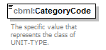
namespace | http://www.sisostds.org/schemas/c-bml/1.0
type | jc3iedm:UnitTypeCategoryCode
properties
  isRef | 0
  content | simple
facets
  Kind | Value | annotation
  enumeration | COMBAT
    documentation
    <Definition xml:lang="en">A UNIT-TYPE who closes with and destroys enemy forces or provides firepower and destructive capabilities in the battlespace.</Definition>
    appinfo
    <DisplayValue xml:lang="en">Combat</DisplayValue>
  enumeration | COMSER
    documentation
    <Definition xml:lang="en">A UNIT-TYPE tasked to provide support to combat forces, primarily in the fields of administration and logistics.</Definition>
    appinfo
    <DisplayValue xml:lang="en">Combat service support</DisplayValue>
  enumeration | COMSPT
    documentation
    <Definition xml:lang="en">A UNIT-TYPE that provides critical combat functions in conjunction with combat arms units and soldiers.</Definition>
    appinfo
    <DisplayValue xml:lang="en">Combat support</DisplayValue>
  enumeration | NKN
    documentation
    <Definition xml:lang="en">It is not possible to determine which value is most applicable.</Definition>
    appinfo
    <DisplayValue xml:lang="en">Not known</DisplayValue>
  enumeration | SOF
    documentation
    <Definition xml:lang="en">A UNIT-TYPE that provides unique capabilities of special reconnaissance, direct action and military assistance in order to undertake difficult, dangerous and sometimes politically sensitive missions for the theatre commander.</Definition>
    appinfo
    <DisplayValue xml:lang="en">Special operations forces</DisplayValue>
annotation
  documentation
  The specific value that represents the class of UNIT-TYPE.
source | <xs:element name="CategoryCode" type="jc3iedm:UnitTypeCategoryCode">  <xs:annotation>  <xs:documentation xml:lang="en">The specific value that represents the class of UNIT-TYPE.</xs:documentation>  </xs:annotation>  </xs:element>

element UnitType/ArmCategoryCode
diagram | 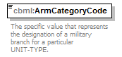
namespace | http://www.sisostds.org/schemas/c-bml/1.0
type | jc3iedm:UnitTypeArmCategoryCode
properties
  isRef | 0
  content | simple
facets
  Kind | Value | annotation
  enumeration | AARMOR
    documentation
    <Definition xml:lang="en">A UNIT-TYPE whose principal designation is the employment of direct fire weapon systems against armoured vehicles.</Definition>
    appinfo
    <DisplayValue xml:lang="en">Anti-armour</DisplayValue>
  enumeration | ADMIN
    documentation
    <Definition xml:lang="en">A UNIT-TYPE whose principal designation the management and execution of all military matters not included in strategy or tactics.</Definition>
    appinfo
    <DisplayValue xml:lang="en">Administrative</DisplayValue>
  enumeration | AIRDEF
    documentation
    <Definition xml:lang="en">A UNIT-TYPE whose principal designation is the employment of weapon systems against hostile air assets.</Definition>
    appinfo
    <DisplayValue xml:lang="en">Air defence</DisplayValue>
  enumeration | ARMANT
    documentation
    <Definition xml:lang="en">A UNIT-TYPE equipped with armoured vehicles whose principal designation is the employment of direct fire weapon systems against armoured vehicles.</Definition>
    appinfo
    <DisplayValue xml:lang="en">Armoured anti armour</DisplayValue>
  enumeration | ARMOUR
    documentation
    <Definition xml:lang="en">A UNIT-TYPE whose principal designation is the employment of tanks or other armoured direct fire weapon systems.</Definition>
    appinfo
    <DisplayValue xml:lang="en">Armour</DisplayValue>
  enumeration | ARTLRY
    documentation
    <Definition xml:lang="en">A UNIT-TYPE whose principal designation is the employment of large guns, cannon or ordnance in support of manoeuvre units.</Definition>
    appinfo
    <DisplayValue xml:lang="en">Artillery</DisplayValue>
  enumeration | AV
    documentation
    <Definition xml:lang="en">A UNIT-TYPE whose principal designation is the employment of aircraft capable of performing a variety of battlespace functions, including reconnaissance, air operations, and tactical lift.</Definition>
    appinfo
    <DisplayValue xml:lang="en">Aviation</DisplayValue>
  enumeration | AVACOM
    documentation
    <Definition xml:lang="en">A UNIT-TYPE whose designation indicates employment of a mix of fixed wing, rotary wing and/or VSTOL aircraft.</Definition>
    appinfo
    <DisplayValue xml:lang="en">Aviation, composite</DisplayValue>
  enumeration | AVAFW
    documentation
    <Definition xml:lang="en">A UNIT-TYPE whose designation indicates employment of fixed-wing assets in the air regime.</Definition>
    appinfo
    <DisplayValue xml:lang="en">Aviation, fixed wing</DisplayValue>
  enumeration | AVARW
    documentation
    <Definition xml:lang="en">A UNIT-TYPE whose designation indicates employment of rotary-wing assets in the air regime.</Definition>
    appinfo
    <DisplayValue xml:lang="en">Aviation, rotary wing</DisplayValue>
  enumeration | AVAVST
    documentation
    <Definition xml:lang="en">A UNIT-TYPE whose designation indicates employment of vertical/short takeoff and landing assets in the air regime.</Definition>
    appinfo
    <DisplayValue xml:lang="en">Aviation, VSTOL</DisplayValue>
  enumeration | CBRN
    documentation
    <Definition xml:lang="en">A UNIT-TYPE whose principal designation is chemical, biological, radiological, or nuclear materiel defence.</Definition>
    appinfo
    <DisplayValue xml:lang="en">NBC</DisplayValue>
  enumeration | ENG
    documentation
    <Definition xml:lang="en">A UNIT-TYPE whose principal designation is major construction, demolition, and extensive camouflage projects.</Definition>
    appinfo
    <DisplayValue xml:lang="en">Engineer</DisplayValue>
  enumeration | EOD
    documentation
    <Definition xml:lang="en">A UNIT-TYPE whose principal designation is the detection, identification, field evaluation, rendering-safe, recovery and final disposal of unexploded explosive ordnance.</Definition>
    appinfo
    <DisplayValue xml:lang="en">Explosive ordnance disposal</DisplayValue>
  enumeration | FA
    documentation
    <Definition xml:lang="en">A UNIT-TYPE whose principal designation is the employment of tube artillery in support of manoeuvre units.</Definition>
    appinfo
    <DisplayValue xml:lang="en">Field artillery</DisplayValue>
  enumeration | FIRSPT
    documentation
    <Definition xml:lang="en">A UNIT-TYPE whose principal designation is the employment of fire, coordinated with the manoeuvre of forces, to destroy neutralize or suppress the enemy.</Definition>
    appinfo
    <DisplayValue xml:lang="en">Fire support</DisplayValue>
  enumeration | HQSIGS
    documentation
    <Definition xml:lang="en">A UNIT-TYPE whose principal designation is to provide staff and communication equipment to set up a command and control element.</Definition>
    appinfo
    <DisplayValue xml:lang="en">Headquarters and signals</DisplayValue>
  enumeration | HQSTF
    documentation
    <Definition xml:lang="en">A UNIT-TYPE whose principal designation is to provide staff to man a command and control element.</Definition>
    appinfo
    <DisplayValue xml:lang="en">Headquarters staff</DisplayValue>
  enumeration | INF
    documentation
    <Definition xml:lang="en">A UNIT-TYPE whose principal designation is the employment of non-mechanised or lorry-(truck-)borne infantry.</Definition>
    appinfo
    <DisplayValue xml:lang="en">Infantry</DisplayValue>
  enumeration | INFWAR
    documentation
    <Definition xml:lang="en">A UNIT-TYPE whose principal designation is to achieve information superiority by affecting a hostile's information, information-based processes and information systems, while defending one's own information, information-based processes and information systems.</Definition>
    appinfo
    <DisplayValue xml:lang="en">Information warfare</DisplayValue>
  enumeration | ISFRCE
    documentation
    <Definition xml:lang="en">A UNIT-TYPE whose principal designation is maintenance of a state of law and order prevailing within a nation.</Definition>
    appinfo
    <DisplayValue xml:lang="en">Internal security forces</DisplayValue>
  enumeration | LAWENF
    documentation
    <Definition xml:lang="en">A UNIT-TYPE whose principal designation is the provision of law enforcement services.</Definition>
    appinfo
    <DisplayValue xml:lang="en">Law enforcement</DisplayValue>
  enumeration | LNDSPT
    documentation
    <Definition xml:lang="en">A UNIT-TYPE whose principal designation is the provision of landing support services.</Definition>
    appinfo
    <DisplayValue xml:lang="en">Landing support</DisplayValue>
  enumeration | LOG
    documentation
    <Definition xml:lang="en">A UNIT-TYPE whose principal designation is the planning and support of the movement and maintenance of forces.</Definition>
    appinfo
    <DisplayValue xml:lang="en">Logistics</DisplayValue>
  enumeration | MAINT
    documentation
    <Definition xml:lang="en">A UNIT-TYPE whose principal designation is the repair and maintenance of equipment.</Definition>
    appinfo
    <DisplayValue xml:lang="en">Maintenance</DisplayValue>
  enumeration | MANOV
    documentation
    <Definition xml:lang="en">A UNIT-TYPE whose principal designation is the employment of forces in the battlespace through movement in combination with fire, or fire potential, to achieve a position of advantage in respect to the enemy in order to accomplish the mission.</Definition>
    appinfo
    <DisplayValue xml:lang="en">Manoeuvre</DisplayValue>
  enumeration | MEDCL
    documentation
    <Definition xml:lang="en">A UNIT-TYPE whose principal designation is the provision of medical and dental services and the evacuation of casualties.</Definition>
    appinfo
    <DisplayValue xml:lang="en">Medical</DisplayValue>
  enumeration | MILINT
    documentation
    <Definition xml:lang="en">A UNIT-TYPE whose principal designation is the processing of information concerning foreign nations, hostile or potentially hostile forces or elements, or areas of actual or potential operations.</Definition>
    appinfo
    <DisplayValue xml:lang="en">Military intelligence</DisplayValue>
  enumeration | MSL
    documentation
    <Definition xml:lang="en">A UNIT-TYPE whose principal designation is the employment of surface-based missiles to fire at surface targets.</Definition>
    appinfo
    <DisplayValue xml:lang="en">Missile, surface-to-surface</DisplayValue>
  enumeration | MSLSTA
    documentation
    <Definition xml:lang="en">A UNIT-TYPE whose principal designation is the employment of surface-based missiles to fire at air targets.</Definition>
    appinfo
    <DisplayValue xml:lang="en">Missile, surface-to-air</DisplayValue>
  enumeration | NKN
    documentation
    <Definition xml:lang="en">It is not possible to determine which value is most applicable.</Definition>
    appinfo
    <DisplayValue xml:lang="en">Not known</DisplayValue>
  enumeration | NOS
    documentation
    <Definition xml:lang="en">The appropriate value is not in the set of specified values.</Definition>
    appinfo
    <DisplayValue xml:lang="en">Not otherwise specified</DisplayValue>
  enumeration | RECCE
    documentation
    <Definition xml:lang="en">A UNIT-TYPE whose principal designation is to obtain, by visual observation or other detection methods, information about the activities and resources of an enemy or potential enemy; or to secure data concerning the meteorological, hydrographic, or geographic characteristics of a particular area.</Definition>
    appinfo
    <DisplayValue xml:lang="en">Reconnaissance</DisplayValue>
  enumeration | ROCKET
    documentation
    <Definition xml:lang="en">A UNIT-TYPE whose principal designation is the employment of rockets in support of manoeuvre units.</Definition>
    appinfo
    <DisplayValue xml:lang="en">Rocket</DisplayValue>
  enumeration | SIG
    documentation
    <Definition xml:lang="en">A UNIT-TYPE whose principal designation is the provision of communications bearer systems.</Definition>
    appinfo
    <DisplayValue xml:lang="en">Signal</DisplayValue>
  enumeration | SUPPLY
    documentation
    <Definition xml:lang="en">A UNIT-TYPE whose principal designation is the provision of all material and items used in the equipping, supporting and maintaining of military forces.</Definition>
    appinfo
    <DisplayValue xml:lang="en">Supply</DisplayValue>
  enumeration | TRNPTN
    documentation
    <Definition xml:lang="en">A UNIT-TYPE whose principal designation is the provision of transport for assets.</Definition>
    appinfo
    <DisplayValue xml:lang="en">Transportation</DisplayValue>
  enumeration | TRSSUP
    documentation
    <Definition xml:lang="en">A UNIT-TYPE whose principal designation is the provision of transport for assets and the distribution of supplies.</Definition>
    appinfo
    <DisplayValue xml:lang="en">Transportation and supply</DisplayValue>
annotation
  documentation
  The specific value that represents the designation of a military branch for a particular UNIT-TYPE.
source | <xs:element name="ArmCategoryCode" type="jc3iedm:UnitTypeArmCategoryCode">  <xs:annotation>  <xs:documentation xml:lang="en">The specific value that represents the designation of a military branch for a particular UNIT-TYPE.</xs:documentation>  </xs:annotation>  </xs:element>

element UnitType/ArmSpecialisationCode
diagram | 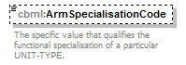
namespace | http://www.sisostds.org/schemas/c-bml/1.0
type | jc3iedm:UnitTypeArmSpecialisationCode
properties
  isRef | 0
  minOcc | 0
  maxOcc | 1
  content | simple
facets
  Kind | Value | annotation
  enumeration | ADCOMP
    documentation
    <Definition xml:lang="en">An air-defence UNIT-TYPE whose primary function is to combat aircraft by the means of both guns and missiles.</Definition>
    appinfo
    <DisplayValue xml:lang="en">Air defence, composite weapons</DisplayValue>
  enumeration | ADGUN
    documentation
    <Definition xml:lang="en">An air-defence UNIT-TYPE whose primary function is to combat aircraft by the means of guns.</Definition>
    appinfo
    <DisplayValue xml:lang="en">Air defence, gun</DisplayValue>
  enumeration | ADMSL
    documentation
    <Definition xml:lang="en">An air-defence UNIT-TYPE whose primary function is to combat aircraft by the means of missiles.</Definition>
    appinfo
    <DisplayValue xml:lang="en">Air defence, missile</DisplayValue>
  enumeration | AIREXP
    documentation
    <Definition xml:lang="en">A UNIT-TYPE whose primary function is to take full advantage of any information that was obtained from aerial sources.</Definition>
    appinfo
    <DisplayValue xml:lang="en">Aerial exploitation</DisplayValue>
  enumeration | ANTSUB
    documentation
    <Definition xml:lang="en">A UNIT-TYPE whose primary function is to combat submarines by the means of air assets.</Definition>
    appinfo
    <DisplayValue xml:lang="en">Antisubmarine warfare aviation</DisplayValue>
  enumeration | APOD
    documentation
    <Definition xml:lang="en">A UNIT-TYPE whose primary function is to provide transportation services at aerial ports where cargo or personnel arrive or depart.</Definition>
    appinfo
    <DisplayValue xml:lang="en">APOD/APOE</DisplayValue>
  enumeration | ARMREC
    documentation
    <Definition xml:lang="en">A UNIT-TYPE whose primary function is to recover armoured vehicles unable to move by their own means.</Definition>
    appinfo
    <DisplayValue xml:lang="en">Armour recovery</DisplayValue>
  enumeration | ARTSVY
    documentation
    <Definition xml:lang="en">A UNIT-TYPE whose primary function is to calculate the coordinates and altitude of object/point and from which the bearings/azimuths to a number of reference objects are also known.</Definition>
    appinfo
    <DisplayValue xml:lang="en">Artillery survey</DisplayValue>
  enumeration | ATTACK
    documentation
    <Definition xml:lang="en">An aviation UNIT-TYPE whose primary function is to perform an offensive mission.</Definition>
    appinfo
    <DisplayValue xml:lang="en">Attack aviation</DisplayValue>
  enumeration | AVASEC
    documentation
    <Definition xml:lang="en">A UNIT-TYPE whose primary function is to maintain a state of law and order within air facilities or assets.</Definition>
    appinfo
    <DisplayValue xml:lang="en">Aviation security forces</DisplayValue>
  enumeration | BIOLOG
    documentation
    <Definition xml:lang="en">A UNIT-TYPE whose primary function is to employ biological agents to produce casualties in man or animals and damage to plants or materiel; or defend against such employment.</Definition>
    appinfo
    <DisplayValue xml:lang="en">Biological</DisplayValue>
  enumeration | BIOREC
    documentation
    <Definition xml:lang="en">A UNIT-TYPE whose primary function is to obtain information about the presence, nature and concentration of biological agents in the environment.</Definition>
    appinfo
    <DisplayValue xml:lang="en">Biological reconnaissance</DisplayValue>
  enumeration | BRDGG
    documentation
    <Definition xml:lang="en">An engineer UNIT-TYPE whose primary function is to build bridges or to provide means to cross dry cuts or water courses.</Definition>
    appinfo
    <DisplayValue xml:lang="en">Bridging</DisplayValue>
  enumeration | BRDRPT
    documentation
    <Definition xml:lang="en">A UNIT-TYPE whose primary function is to provide patrol along the borders.</Definition>
    appinfo
    <DisplayValue xml:lang="en">Border patrol</DisplayValue>
  enumeration | C2AVA
    documentation
    <Definition xml:lang="en">A UNIT-TYPE whose primary function is to serve as a command and control element.</Definition>
    appinfo
    <DisplayValue xml:lang="en">C2 aviation</DisplayValue>
  enumeration | CAVLRY
    documentation
    <Definition xml:lang="en">A UNIT-TYPE whose primary function is to fight in armoured vehicles.</Definition>
    appinfo
    <DisplayValue xml:lang="en">Cavalry</DisplayValue>
  enumeration | CBRNRC
    documentation
    <Definition xml:lang="en">A UNIT-TYPE whose primary function is to obtain information about the presence, nature and concentration of CBRN agents in the environment.</Definition>
    appinfo
    <DisplayValue xml:lang="en">NBC reconnaissance</DisplayValue>
  enumeration | CHMCAL
    documentation
    <Definition xml:lang="en">A UNIT-TYPE whose primary function is to employ chemical agents to kill, injure, or incapacitate for a significant period of time, man or animals, and deny or hinder the use of areas, facilities or materiel; or defend against such employment.</Definition>
    appinfo
    <DisplayValue xml:lang="en">Chemical</DisplayValue>
  enumeration | CHMREC
    documentation
    <Definition xml:lang="en">A UNIT-TYPE whose primary function is to obtain information about the presence, nature and concentration of chemical agents in the environment.</Definition>
    appinfo
    <DisplayValue xml:lang="en">Chemical, reconnaissance</DisplayValue>
  enumeration | CHMSMD
    documentation
    <Definition xml:lang="en">A UNIT-TYPE whose primary function is to make any person, object, or area safe by absorbing, destroying, neutralizing, making harmless, or removing, chemical agents.</Definition>
    appinfo
    <DisplayValue xml:lang="en">Chemical, smoke/decontamination</DisplayValue>
  enumeration | CHMSMK
    documentation
    <Definition xml:lang="en">A UNIT-TYPE whose primary function is to employ chemical agents released as a cloud of smoke or defend against such employment.</Definition>
    appinfo
    <DisplayValue xml:lang="en">Chemical, smoke</DisplayValue>
  enumeration | CIVAFR
    documentation
    <Definition xml:lang="en">A UNIT-TYPE whose primary function is either to facilitate the relationships between the forces engaged on a theatre of operations and the civilian authorities of the countries in the theatre, the international organisations and the local populations, or to coordinate the actions led for the benefit of the concerned countries in order to preserve or restore the functioning of the institutions and public services as well as that of those services essential for the life of the populations of that country.</Definition>
    appinfo
    <DisplayValue xml:lang="en">Civil affairs</DisplayValue>
  enumeration | CIVLWE
    documentation
    <Definition xml:lang="en">A UNIT-TYPE whose primary function is to conduct civilian law enforcement operations.</Definition>
    appinfo
    <DisplayValue xml:lang="en">Civilian law enforcement</DisplayValue>
  enumeration | CNTINT
    documentation
    <Definition xml:lang="en">No definition provided in APP-6A.</Definition>
    appinfo
    <DisplayValue xml:lang="en">Central intelligence</DisplayValue>
  enumeration | CNTRIN
    documentation
    <Definition xml:lang="en">A UNIT-TYPE whose primary function is to conduct activities that are concerned with identifying and counteracting the threat to security posed by hostile intelligence services or organisations, or by individuals engaged in espionage, sabotage, subversion or terrorism.</Definition>
    appinfo
    <DisplayValue xml:lang="en">Counter intelligence</DisplayValue>
  enumeration | CSAR
    documentation
    <Definition xml:lang="en">A UNIT-TYPE whose primary function is to search for and rescue personnel in distress on land or sea in enemy-controlled territory.</Definition>
    appinfo
    <DisplayValue xml:lang="en">Combat search and rescue aviation</DisplayValue>
  enumeration | DECONT
    documentation
    <Definition xml:lang="en">A UNIT-TYPE whose primary function is to make any person, object, or area safe by absorbing, destroying, neutralizing, making harmless, or removing, chemical or biological agents, or by removing radioactive material clinging to or around it.</Definition>
    appinfo
    <DisplayValue xml:lang="en">Decontamination</DisplayValue>
  enumeration | DENTAL
    documentation
    <Definition xml:lang="en">A UNIT-TYPE whose primary function is to provide dental care.</Definition>
    appinfo
    <DisplayValue xml:lang="en">Dental</DisplayValue>
  enumeration | DISSEC
    documentation
    <Definition xml:lang="en">A UNIT-TYPE whose primary function is to maintain a state of law and order and whose primary mode of operation is on foot.</Definition>
    appinfo
    <DisplayValue xml:lang="en">Dismounted security forces</DisplayValue>
  enumeration | ENCNST
    documentation
    <Definition xml:lang="en">A UNIT-TYPE whose primary function is to build various facilities in direct support of military operations.</Definition>
    appinfo
    <DisplayValue xml:lang="en">Engineer, construction</DisplayValue>
  enumeration | ENGREC
    documentation
    <Definition xml:lang="en">A UNIT-TYPE whose primary function is to obtain, by visual observation or other detection methods, information required for site surveys prior to construction or demolition.</Definition>
    appinfo
    <DisplayValue xml:lang="en">Engineer, reconnaissance</DisplayValue>
  enumeration | ENGRRW
    documentation
    <Definition xml:lang="en">A UNIT-TYPE whose primary functions includes construction or demolition of roads and railways in support of military operations.</Definition>
    appinfo
    <DisplayValue xml:lang="en">Engineer, road/railways</DisplayValue>
  enumeration | EW
    documentation
    <Definition xml:lang="en">A UNIT-TYPE whose primary function is to use electromagnetic energy to determine, exploit, reduce, or prevent hostile use of the electromagnetic spectrum and to perform actions in order to retain its effective use by friendly forces.</Definition>
    appinfo
    <DisplayValue xml:lang="en">Electronic warfare</DisplayValue>
  enumeration | EWDF
    documentation
    <Definition xml:lang="en">A UNIT-TYPE whose primary function is to obtain bearings of radio frequency emitters by using a directional antenna and a display unit on an intercept receiver or ancillary equipment.</Definition>
    appinfo
    <DisplayValue xml:lang="en">Electronic warfare, direction finding</DisplayValue>
  enumeration | EWINTC
    documentation
    <Definition xml:lang="en">A UNIT-TYPE whose primary function is to intercept intentional or unintentional radiated electromagnetic energy for the purpose of immediate threat recognition.</Definition>
    appinfo
    <DisplayValue xml:lang="en">Electronic warfare, intercept</DisplayValue>
  enumeration | EWJAM
    documentation
    <Definition xml:lang="en">A UNIT-TYPE whose primary function is to deliver radiation, re-radiation or reflection of electromagnetic energy with the object of impairing the use of electronic devices, equipment or systems being used by an enemy.</Definition>
    appinfo
    <DisplayValue xml:lang="en">Electronic warfare, jamming</DisplayValue>
  enumeration | FAHOW
    documentation
    <Definition xml:lang="en">A UNIT-TYPE whose principal designation is the employment of howitzers or artillery guns in support of manoeuvre units.</Definition>
    appinfo
    <DisplayValue xml:lang="en">Field artillery, howitzer/gun</DisplayValue>
  enumeration | FAMLRS
    documentation
    <Definition xml:lang="en">A UNIT-TYPE whose principal designation is the employment of multi rocket launchers in support of manoeuvre units.</Definition>
    appinfo
    <DisplayValue xml:lang="en">Field artillery, multi rocket launcher</DisplayValue>
  enumeration | FAMORT
    documentation
    <Definition xml:lang="en">A UNIT-TYPE whose principal designation is the employment of mortars in support of manoeuvre units.</Definition>
    appinfo
    <DisplayValue xml:lang="en">Field artillery, mortar</DisplayValue>
  enumeration | FARCKL
    documentation
    <Definition xml:lang="en">A UNIT-TYPE whose principal designation is the employment of rocket launchers in support of manoeuvre units.</Definition>
    appinfo
    <DisplayValue xml:lang="en">Field artillery, rocket launcher</DisplayValue>
  enumeration | FASLRS
    documentation
    <Definition xml:lang="en">A UNIT-TYPE whose principal designation is the employment of single rocket launchers in support of manoeuvre units.</Definition>
    appinfo
    <DisplayValue xml:lang="en">Field artillery, single rocket launcher</DisplayValue>
  enumeration | FINANC
    documentation
    <Definition xml:lang="en">A UNIT-TYPE whose primary function is to provide financial services.</Definition>
    appinfo
    <DisplayValue xml:lang="en">Finance</DisplayValue>
  enumeration | HNDLDG
    documentation
    <Definition xml:lang="en">A UNIT-TYPE whose primary function is to transfer materiel in or out of transportation means such as trains, ships or planes.</Definition>
    appinfo
    <DisplayValue xml:lang="en">Handling, loading/unloading</DisplayValue>
  enumeration | INTERO
    documentation
    <Definition xml:lang="en">A UNIT-TYPE whose primary function is to procure information by direct questioning of a person under the control of a questioner.</Definition>
    appinfo
    <DisplayValue xml:lang="en">Interrogation</DisplayValue>
  enumeration | JNTINT
    documentation
    <Definition xml:lang="en">A UNIT-TYPE whose primary function is to produce intelligence from elements of more than one Service.</Definition>
    appinfo
    <DisplayValue xml:lang="en">Joint intelligence</DisplayValue>
  enumeration | LABOUR
    documentation
    <Definition xml:lang="en">A UNIT-TYPE whose primary function is to provide labour services.</Definition>
    appinfo
    <DisplayValue xml:lang="en">Labour</DisplayValue>
  enumeration | LEGAL
    documentation
    <Definition xml:lang="en">A UNIT-TYPE whose primary function is to provide legal services.</Definition>
    appinfo
    <DisplayValue xml:lang="en">Legal services</DisplayValue>
  enumeration | MCMAVA
    documentation
    <Definition xml:lang="en">A UNIT-TYPE whose primary function is to prevent or reduce damage or danger from mines by using airborne means.</Definition>
    appinfo
    <DisplayValue xml:lang="en">Mine countermeasure aviation</DisplayValue>
  enumeration | MEDEVC
    documentation
    <Definition xml:lang="en">An aviation UNIT-TYPE whose primary function is to move patients by air means in a timely and efficient manner while providing en route medical care to and between medical treatment facilities.</Definition>
    appinfo
    <DisplayValue xml:lang="en">Medical evacuation aviation</DisplayValue>
  enumeration | MEDTRS
    documentation
    <Definition xml:lang="en">A UNIT-TYPE whose primary function is to move patients between medical treatment facilities while providing en route medical care.</Definition>
    appinfo
    <DisplayValue xml:lang="en">Medical transport</DisplayValue>
  enumeration | MEDTRT
    documentation
    <Definition xml:lang="en">A UNIT-TYPE whose primary function is to perform interventions or treatment under supervision of a physician.</Definition>
    appinfo
    <DisplayValue xml:lang="en">Medical treatment</DisplayValue>
  enumeration | METEO
    documentation
    <Definition xml:lang="en">A UNIT-TYPE whose primary function is to perform systematic observation of meteorological conditions and/or forecast future meteorological conditions.</Definition>
    appinfo
    <DisplayValue xml:lang="en">Meteorological</DisplayValue>
  enumeration | MILPOL
    documentation
    <Definition xml:lang="en">A UNIT-TYPE whose primary function is to provide police services.</Definition>
    appinfo
    <DisplayValue xml:lang="en">Military police</DisplayValue>
  enumeration | MIOPS
    documentation
    <Definition xml:lang="en">A military intelligence UNIT-TYPE whose primary function is to provide information required for the planning and conducting campaigns and major operations to accomplish strategic objectives within theatres or areas of operations.</Definition>
    appinfo
    <DisplayValue xml:lang="en">Military intelligence, operations</DisplayValue>
  enumeration | MNTELC
    documentation
    <Definition xml:lang="en">A UNIT-TYPE whose primary function is to maintain electronics and armament (materiel) in or to restore it to operational condition.</Definition>
    appinfo
    <DisplayValue xml:lang="en">Maintenance, electronics/armament</DisplayValue>
  enumeration | MNTELO
    documentation
    <Definition xml:lang="en">A UNIT-TYPE whose primary function is to maintain electro-optical materiel in or to restore it to operational condition.</Definition>
    appinfo
    <DisplayValue xml:lang="en">Maintenance, electro-optical</DisplayValue>
  enumeration | MNTHVY
    documentation
    <Definition xml:lang="en">A UNIT-TYPE whose primary function is to accomplish supply and repair actions necessary to keep the heavy equipment of a force in condition to carry out its mission.</Definition>
    appinfo
    <DisplayValue xml:lang="en">Maintenance, heavy</DisplayValue>
  enumeration | MNTMSL
    documentation
    <Definition xml:lang="en">A UNIT-TYPE whose primary function is to maintain ordnance missile (materiel) in or to restore it to operational condition.</Definition>
    appinfo
    <DisplayValue xml:lang="en">Maintenance, missile</DisplayValue>
  enumeration | MNTORD
    documentation
    <Definition xml:lang="en">A UNIT-TYPE whose primary function is to maintain ordnance (ammunition) in or to restore it to operational condition.</Definition>
    appinfo
    <DisplayValue xml:lang="en">Maintenance, ordnance</DisplayValue>
  enumeration | MRTGRR
    documentation
    <Definition xml:lang="en">A UNIT-TYPE whose primary function is to provide care and disposition of deceased personnel.</Definition>
    appinfo
    <DisplayValue xml:lang="en">Mortuary/graves registry</DisplayValue>
  enumeration | MVTCNT
    documentation
    <Definition xml:lang="en">A UNIT-TYPE whose primary function is to provide planning, routing, scheduling and control of personnel and freight movements over lines of communication.</Definition>
    appinfo
    <DisplayValue xml:lang="en">Movement control</DisplayValue>
  enumeration | MWR
    documentation
    <Definition xml:lang="en">A UNIT-TYPE whose primary function is to provide morale, welfare and recreation services in support of military personnel.</Definition>
    appinfo
    <DisplayValue xml:lang="en">Morale/welfare/recreation</DisplayValue>
  enumeration | NUCRAD
    documentation
    <Definition xml:lang="en">A UNIT-TYPE whose primary function is to defend or protect against radiological or nuclear materiel dangers.</Definition>
    appinfo
    <DisplayValue xml:lang="en">Nuclear</DisplayValue>
  enumeration | PERSVC
    documentation
    <Definition xml:lang="en">A UNIT-TYPE whose primary function is to provide services related to personnel administration.</Definition>
    appinfo
    <DisplayValue xml:lang="en">Personnel services</DisplayValue>
  enumeration | PIPELN
    documentation
    <Definition xml:lang="en">A UNIT-TYPE whose primary function is to construct, maintain or operate pipelines.</Definition>
    appinfo
    <DisplayValue xml:lang="en">Pipeline</DisplayValue>
  enumeration | POSTAL
    documentation
    <Definition xml:lang="en">A UNIT-TYPE whose primary function is to provide postal services.</Definition>
    appinfo
    <DisplayValue xml:lang="en">Postal</DisplayValue>
  enumeration | PSYCH
    documentation
    <Definition xml:lang="en">A UNIT-TYPE whose primary function is to provide treatment dealing with the mental and emotional state of a person.</Definition>
    appinfo
    <DisplayValue xml:lang="en">Psychological</DisplayValue>
  enumeration | PSYOP
    documentation
    <Definition xml:lang="en">A UNIT-TYPE whose primary function is to provide convey selected information and indicators to foreign audiences to influence their emotions, motives, objective reasoning, and ultimately the behaviour of foreign governments, organisations, groups, and individuals.</Definition>
    appinfo
    <DisplayValue xml:lang="en">Psychological operations</DisplayValue>
  enumeration | PUBAF
    documentation
    <Definition xml:lang="en">A UNIT-TYPE whose primary function is to provide public information, command information, and community relations activities directed towards the general public.</Definition>
    appinfo
    <DisplayValue xml:lang="en">Public affairs</DisplayValue>
  enumeration | PUBAFB
    documentation
    <Definition xml:lang="en">A UNIT-TYPE whose primary function is to provide public information, command information, and community relation activities over a broadcast medium, such as radio or TV, directed towards the general public.</Definition>
    appinfo
    <DisplayValue xml:lang="en">Public affairs, broadcast</DisplayValue>
  enumeration | PUBAFJ
    documentation
    <Definition xml:lang="en">A UNIT-TYPE whose primary function is to provide public information, command information, and community relations activities directed towards the general public in a joint services environment.</Definition>
    appinfo
    <DisplayValue xml:lang="en">Public affairs, joint information</DisplayValue>
  enumeration | QM
    documentation
    <Definition xml:lang="en">A UNIT-TYPE whose primary function is to provide lodging and rations for the troops.</Definition>
    appinfo
    <DisplayValue xml:lang="en">Quartermaster</DisplayValue>
  enumeration | RAILSE
    documentation
    <Definition xml:lang="en">A UNIT-TYPE whose primary function is to maintain a state of law and order within railway facilities or assets.</Definition>
    appinfo
    <DisplayValue xml:lang="en">Railway security forces</DisplayValue>
  enumeration | RANGER
    documentation
    <Definition xml:lang="en">A UNIT-TYPE of rapidly deployable airborne light infantry organized and trained to conduct highly complex joint direct action operations in coordination with or in support of other special operations units of all services.</Definition>
    appinfo
    <DisplayValue xml:lang="en">Ranger</DisplayValue>
  enumeration | RECAVA
    documentation
    <Definition xml:lang="en">A UNIT-TYPE whose primary function is to obtain, by airborne means and through visual observation or other detection methods, information about the activities and resources of an enemy or potential enemy, or to secure data concerning the meteorological, hydrographical, or geographic characteristics of a particular area.</Definition>
    appinfo
    <DisplayValue xml:lang="en">Reconnaissance aviation</DisplayValue>
  enumeration | RECOVR
    documentation
    <Definition xml:lang="en">A UNIT-TYPE whose primary function is to recover vehicles unable to move by their own means.</Definition>
    appinfo
    <DisplayValue xml:lang="en">Recovery</DisplayValue>
  enumeration | REFAVA
    documentation
    <Definition xml:lang="en">A UNIT-TYPE whose primary function is to deliver fuel to other aircraft while in flight.</Definition>
    appinfo
    <DisplayValue xml:lang="en">Refuel aviation</DisplayValue>
  enumeration | RELCHP
    documentation
    <Definition xml:lang="en">A UNIT-TYPE whose primary function is to provide religious services.</Definition>
    appinfo
    <DisplayValue xml:lang="en">Religious/chaplain</DisplayValue>
  enumeration | REPLHO
    documentation
    <Definition xml:lang="en">A UNIT-TYPE whose primary function is to provide personnel to take the place of other personnel who depart a unit.</Definition>
    appinfo
    <DisplayValue xml:lang="en">Replacement holding</DisplayValue>
  enumeration | RIVSEC
    documentation
    <Definition xml:lang="en">A UNIT-TYPE whose primary function is to maintain a state of law and order and that operates on or along a river.</Definition>
    appinfo
    <DisplayValue xml:lang="en">Riverine security forces</DisplayValue>
  enumeration | SARAVA
    documentation
    <Definition xml:lang="en">An aviation UNIT-TYPE whose primary function is to search for and rescue personnel in distress on land or sea.</Definition>
    appinfo
    <DisplayValue xml:lang="en">Search and rescue aviation</DisplayValue>
  enumeration | SCOUT
    documentation
    <Definition xml:lang="en">A UNIT-TYPE whose primary function is to patrol an area.</Definition>
    appinfo
    <DisplayValue xml:lang="en">Scout</DisplayValue>
  enumeration | SEAL
    documentation
    <Definition xml:lang="en">A UNIT-TYPE whose primary function is Sea Air Land operations.</Definition>
    appinfo
    <DisplayValue xml:lang="en">SEAL</DisplayValue>
  enumeration | SECPOL
    documentation
    <Definition xml:lang="en">A UNIT-TYPE whose primary function is to provide security police services for air-related facilities or assets.</Definition>
    appinfo
    <DisplayValue xml:lang="en">Security police, air</DisplayValue>
  enumeration | SGCMDO
    documentation
    <Definition xml:lang="en">No definition provided in APP-6A.</Definition>
    appinfo
    <DisplayValue xml:lang="en">Signal, command operations</DisplayValue>
  enumeration | SGELCR
    documentation
    <Definition xml:lang="en">A UNIT-TYPE whose primary function is to establish target distance electronically.</Definition>
    appinfo
    <DisplayValue xml:lang="en">Signal, electronic ranging</DisplayValue>
  enumeration | SGNC
    documentation
    <Definition xml:lang="en">A UNIT-TYPE whose primary function is to manage, operate and control a communications node centre.</Definition>
    appinfo
    <DisplayValue xml:lang="en">Signal, node centre</DisplayValue>
  enumeration | SGNLE
    documentation
    <Definition xml:lang="en">A UNIT-TYPE whose primary function is to manage, operate and control a communications large extension node.</Definition>
    appinfo
    <DisplayValue xml:lang="en">Signal, node, large extension</DisplayValue>
  enumeration | SGNSE
    documentation
    <Definition xml:lang="en">A UNIT-TYPE whose primary function is to manage, operate and control a communications small extension node.</Definition>
    appinfo
    <DisplayValue xml:lang="en">Signal, node, small extension</DisplayValue>
  enumeration | SGRAD
    documentation
    <Definition xml:lang="en">A UNIT-TYPE whose primary function is to manage, operate and control radio communications.</Definition>
    appinfo
    <DisplayValue xml:lang="en">Signal, radio</DisplayValue>
  enumeration | SGRDRL
    documentation
    <Definition xml:lang="en">A UNIT-TYPE whose primary function is to manage, operate and control a communications radio relay.</Definition>
    appinfo
    <DisplayValue xml:lang="en">Signal, radio relay</DisplayValue>
  enumeration | SGSPT
    documentation
    <Definition xml:lang="en">A UNIT-TYPE whose primary function is to provide personnel and equipment from other forces for the establishment of a special or supplementary communications system.</Definition>
    appinfo
    <DisplayValue xml:lang="en">Signal support</DisplayValue>
  enumeration | SGTACS
    documentation
    <Definition xml:lang="en">A UNIT-TYPE whose primary function is to manage, operate and control a tactical satellite terminal.</Definition>
    appinfo
    <DisplayValue xml:lang="en">Signal, tactical satellite</DisplayValue>
  enumeration | SGTELC
    documentation
    <Definition xml:lang="en">A UNIT-TYPE whose primary function is to manage, operate and control radio-teletype communications.</Definition>
    appinfo
    <DisplayValue xml:lang="en">Signal, teletype centre</DisplayValue>
  enumeration | SGTELS
    documentation
    <Definition xml:lang="en">A UNIT-TYPE whose primary function is to manage, operate and control a tactical telephone switch.</Definition>
    appinfo
    <DisplayValue xml:lang="en">Signal, telephone switch</DisplayValue>
  enumeration | SHRPAT
    documentation
    <Definition xml:lang="en">A UNIT-TYPE whose primary function is to provide shore patrol services.</Definition>
    appinfo
    <DisplayValue xml:lang="en">Shore patrol</DisplayValue>
  enumeration | SIGINT
    documentation
    <Definition xml:lang="en">A UNIT-TYPE whose primary function is to provide intelligence derived from communications, electronics, and instrumentation signals.</Definition>
    appinfo
    <DisplayValue xml:lang="en">Signals intelligence</DisplayValue>
  enumeration | SPBOAT
    documentation
    <Definition xml:lang="en">No definition provided in APP-6A.</Definition>
    appinfo
    <DisplayValue xml:lang="en">Special boat</DisplayValue>
  enumeration | SPCFOR
    documentation
    <Definition xml:lang="en">A UNIT-TYPE, selected, trained and organised to special levels, whose primary function is to be employed in pursuit of strategic objectives.</Definition>
    appinfo
    <DisplayValue xml:lang="en">Special forces</DisplayValue>
  enumeration | SPLC1
    documentation
    <Definition xml:lang="en">A UNIT-TYPE whose primary function is to provide combat/fresh rations, water and personal, health and welfare items.</Definition>
    appinfo
    <DisplayValue xml:lang="en">Supply, class I</DisplayValue>
  enumeration | SPLC2
    documentation
    <Definition xml:lang="en">A UNIT-TYPE whose primary function is to provide materiel.</Definition>
    appinfo
    <DisplayValue xml:lang="en">Supply, class II</DisplayValue>
  enumeration | SPLC3
    documentation
    <Definition xml:lang="en">A UNIT-TYPE whose primary function is to provide fuel and lubricants.</Definition>
    appinfo
    <DisplayValue xml:lang="en">Supply, class III</DisplayValue>
  enumeration | SPLC3A
    documentation
    <Definition xml:lang="en">A UNIT-TYPE whose primary function is to provide aviation fuel and lubricants.</Definition>
    appinfo
    <DisplayValue xml:lang="en">Supply, class III aviation</DisplayValue>
  enumeration | SPLC4
    documentation
    <Definition xml:lang="en">A UNIT-TYPE whose primary function is to provide construction materials.</Definition>
    appinfo
    <DisplayValue xml:lang="en">Supply, class IV</DisplayValue>
  enumeration | SPLC5
    documentation
    <Definition xml:lang="en">A UNIT-TYPE whose primary function is to provide ammunition, explosives and chemical agents.</Definition>
    appinfo
    <DisplayValue xml:lang="en">Supply, class V</DisplayValue>
  enumeration | SPLLDB
    documentation
    <Definition xml:lang="en">A UNIT-TYPE whose primary function is to provide laundry and/or bath services.</Definition>
    appinfo
    <DisplayValue xml:lang="en">Supply, laundry/bath</DisplayValue>
  enumeration | SPLWAT
    documentation
    <Definition xml:lang="en">A UNIT-TYPE whose primary function is to provide drinking water.</Definition>
    appinfo
    <DisplayValue xml:lang="en">Supply, water</DisplayValue>
  enumeration | SPOD
    documentation
    <Definition xml:lang="en">A UNIT-TYPE whose primary function is to provide transportation services at sea ports where cargo or personnel arrive or depart.</Definition>
    appinfo
    <DisplayValue xml:lang="en">SPOD/SPOE</DisplayValue>
  enumeration | SPOPSP
    documentation
    <Definition xml:lang="en">A UNIT-TYPE whose primary function is to support special operations forces.</Definition>
    appinfo
    <DisplayValue xml:lang="en">Special operations support</DisplayValue>
  enumeration | SPSSNR
    documentation
    <Definition xml:lang="en">No definition provided in APP-6A.</Definition>
    appinfo
    <DisplayValue xml:lang="en">Special SSNR</DisplayValue>
  enumeration | SRSNSC
    documentation
    <Definition xml:lang="en">No definition provided in APP-6A.</Definition>
    appinfo
    <DisplayValue xml:lang="en">Surveillance, sensor, SCM</DisplayValue>
  enumeration | SRV
    documentation
    <Definition xml:lang="en">A UNIT-TYPE whose primary function is to perform systematic observation of aerospace, surface or subsurface areas, places, persons, or things by visual, aural, electronic, photographic, or other means.</Definition>
    appinfo
    <DisplayValue xml:lang="en">Surveillance</DisplayValue>
  enumeration | SRVGSM
    documentation
    <Definition xml:lang="en">A UNIT-TYPE whose primary function is to manage and operate a ground module for a surveillance system.</Definition>
    appinfo
    <DisplayValue xml:lang="en">Surveillance, ground station module</DisplayValue>
  enumeration | SRVGSR
    documentation
    <Definition xml:lang="en">A UNIT-TYPE whose primary function is to manage and operate a ground radar for a surveillance system.</Definition>
    appinfo
    <DisplayValue xml:lang="en">Surveillance, ground surveillance radar</DisplayValue>
  enumeration | SRVLR
    documentation
    <Definition xml:lang="en">A UNIT-TYPE whose primary function is to perform, from long range, systematic observation of aerospace, surface or subsurface areas, places, persons, or things by visual, aural, electronic, photographic, or other means from a ground station.</Definition>
    appinfo
    <DisplayValue xml:lang="en">Surveillance, long range</DisplayValue>
  enumeration | SRVSEN
    documentation
    <Definition xml:lang="en">A UNIT-TYPE whose primary function is to manage and operate sensor surveillance assets.</Definition>
    appinfo
    <DisplayValue xml:lang="en">Surveillance, sensor</DisplayValue>
  enumeration | SURG
    documentation
    <Definition xml:lang="en">A UNIT-TYPE whose primary function is to provide surgical services.</Definition>
    appinfo
    <DisplayValue xml:lang="en">Surgical</DisplayValue>
  enumeration | TACEXP
    documentation
    <Definition xml:lang="en">A military intelligence UNIT-TYPE whose primary function is to use information required for the planning and conducting tactical operations.</Definition>
    appinfo
    <DisplayValue xml:lang="en">Tactical exploitation</DisplayValue>
  enumeration | TGTACQ
    documentation
    <Definition xml:lang="en">A UNIT-TYPE whose primary function is to manage and operate target acquisition assets.</Definition>
    appinfo
    <DisplayValue xml:lang="en">Target acquisition</DisplayValue>
  enumeration | TGTAOP
    documentation
    <Definition xml:lang="en">A UNIT-TYPE whose primary function is to manage and operate optical target acquisition assets.</Definition>
    appinfo
    <DisplayValue xml:lang="en">Target acquisition, optical</DisplayValue>
  enumeration | TGTARD
    documentation
    <Definition xml:lang="en">A UNIT-TYPE whose primary function is to manage and operate radar target acquisition assets.</Definition>
    appinfo
    <DisplayValue xml:lang="en">Target acquisition, radar</DisplayValue>
  enumeration | TGTASD
    documentation
    <Definition xml:lang="en">A UNIT-TYPE whose primary function is to manage and operate sound target acquisition assets.</Definition>
    appinfo
    <DisplayValue xml:lang="en">Target acquisition, sound</DisplayValue>
  enumeration | TGTNG
    documentation
    <Definition xml:lang="en">A UNIT-TYPE whose primary function is to provide targeting services.</Definition>
    appinfo
    <DisplayValue xml:lang="en">Targeting</DisplayValue>
  enumeration | TOPO
    documentation
    <Definition xml:lang="en">A UNIT-TYPE whose primary function is to produce maps and other topographical information.</Definition>
    appinfo
    <DisplayValue xml:lang="en">Topographical survey</DisplayValue>
  enumeration | TRNMSL
    documentation
    <Definition xml:lang="en">A UNIT-TYPE whose primary function is to provide equipment for transportation of missiles.</Definition>
    appinfo
    <DisplayValue xml:lang="en">Transportation, missile</DisplayValue>
  enumeration | TRNRLY
    documentation
    <Definition xml:lang="en">A UNIT-TYPE whose primary function is to provide transportation by means of railways.</Definition>
    appinfo
    <DisplayValue xml:lang="en">Transportation, railways</DisplayValue>
  enumeration | UAV
    documentation
    <Definition xml:lang="en">A UNIT-TYPE whose primary function is to utilise unmanned air assets.</Definition>
    appinfo
    <DisplayValue xml:lang="en">Unmanned aerial vehicle</DisplayValue>
  enumeration | UDT
    documentation
    <Definition xml:lang="en">A UNIT-TYPE whose primary function is to damage or destroy equipment or facilities laying totally or partially in water and that moves under the water surface to achieve this.</Definition>
    appinfo
    <DisplayValue xml:lang="en">Underwater demolition</DisplayValue>
  enumeration | UTLAVA
    documentation
    <Definition xml:lang="en">An aviation UNIT-TYPE whose primary function is to transport equipment or personnel.</Definition>
    appinfo
    <DisplayValue xml:lang="en">Utility aviation</DisplayValue>
  enumeration | VET
    documentation
    <Definition xml:lang="en">A UNIT-TYPE whose primary function is to provide medical or surgical treatment for animals.</Definition>
    appinfo
    <DisplayValue xml:lang="en">Veterinary</DisplayValue>
  enumeration | WATER
    documentation
    <Definition xml:lang="en">A UNIT-TYPE whose primary function is to provide clean potable drinking/bathing water.</Definition>
    appinfo
    <DisplayValue xml:lang="en">Water purification</DisplayValue>
annotation
  documentation
  The specific value that qualifies the functional specialisation of a particular UNIT-TYPE.
source | <xs:element name="ArmSpecialisationCode" type="jc3iedm:UnitTypeArmSpecialisationCode" minOccurs="0">  <xs:annotation>  <xs:documentation xml:lang="en">The specific value that qualifies the functional specialisation of a particular UNIT-TYPE.</xs:documentation>  </xs:annotation>  </xs:element>

element UnitType/SupplementarySpecialisationCode
diagram | 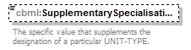
namespace | http://www.sisostds.org/schemas/c-bml/1.0
type | jc3iedm:UnitTypeSupplementarySpecialisationCode
properties
  isRef | 0
  minOcc | 0
  maxOcc | 1
  content | simple
facets
  Kind | Value | annotation
  enumeration | AIR
    documentation
    <Definition xml:lang="en">A UNIT-TYPE that, whatever its primary function is, employs principally air assets.</Definition>
    appinfo
    <DisplayValue xml:lang="en">Air</DisplayValue>
  enumeration | AIRBRN
    documentation
    <Definition xml:lang="en">A UNIT-TYPE that, whatever its primary function is, is specially trained to carry out operations, either by paradrop or air landing, following an air movement.</Definition>
    appinfo
    <DisplayValue xml:lang="en">Airborne</DisplayValue>
  enumeration | AMPH
    documentation
    <Definition xml:lang="en">A UNIT-TYPE that, whatever its primary function is, is able to conduct an operation launched from the sea by military forces against a hostile or potentially hostile shore.</Definition>
    appinfo
    <DisplayValue xml:lang="en">Amphibious</DisplayValue>
  enumeration | ARASLT
    documentation
    <Definition xml:lang="en">A UNIT-TYPE that, whatever its primary function is, employs helicopter assets as an integral element of its assault operations.</Definition>
    appinfo
    <DisplayValue xml:lang="en">Air assault</DisplayValue>
  enumeration | ARCTIC
    documentation
    <Definition xml:lang="en">A UNIT-TYPE that, whatever its primary function is, is able to perform a mission in arctic environment.</Definition>
    appinfo
    <DisplayValue xml:lang="en">Arctic</DisplayValue>
  enumeration | ARMORD
    documentation
    <Definition xml:lang="en">A UNIT-TYPE that, whatever its primary function is, employs principally armoured assets.</Definition>
    appinfo
    <DisplayValue xml:lang="en">Armoured</DisplayValue>
  enumeration | GROUND
    documentation
    <Definition xml:lang="en">A UNIT-TYPE that, whatever its primary function is, employs principally ground assets.</Definition>
    appinfo
    <DisplayValue xml:lang="en">Ground</DisplayValue>
  enumeration | LIGHT
    documentation
    <Definition xml:lang="en">A UNIT-TYPE that, whatever its primary function is, is equipped with materiel of small weight.</Definition>
    appinfo
    <DisplayValue xml:lang="en">Light unit</DisplayValue>
  enumeration | MARINE
    documentation
    <Definition xml:lang="en">A UNIT-TYPE that is capable of performing marine operations in addition to its primary function.</Definition>
    appinfo
    <DisplayValue xml:lang="en">Marine</DisplayValue>
  enumeration | MECH
    documentation
    <Definition xml:lang="en">A UNIT-TYPE that, whatever its primary function is, employs principally mechanised assets.</Definition>
    appinfo
    <DisplayValue xml:lang="en">Mechanised</DisplayValue>
  enumeration | MOUNTN
    documentation
    <Definition xml:lang="en">A UNIT-TYPE that, whatever its primary function is, is dedicated to conduct military operations in mountainous areas.</Definition>
    appinfo
    <DisplayValue xml:lang="en">Mountain</DisplayValue>
  enumeration | MTRSD
    documentation
    <Definition xml:lang="en">A UNIT-TYPE that, whatever its primary function is, employs principally motorised assets.</Definition>
    appinfo
    <DisplayValue xml:lang="en">Motorised</DisplayValue>
  enumeration | NAVAL
    documentation
    <Definition xml:lang="en">A UNIT-TYPE that, whatever its primary function is, is dedicated to conduct operations in a maritime environment.</Definition>
    appinfo
    <DisplayValue xml:lang="en">Naval</DisplayValue>
annotation
  documentation
  The specific value that supplements the designation of a particular UNIT-TYPE.
source | <xs:element name="SupplementarySpecialisationCode" type="jc3iedm:UnitTypeSupplementarySpecialisationCode" minOccurs="0">  <xs:annotation>  <xs:documentation xml:lang="en">The specific value that supplements the designation of a particular UNIT-TYPE.</xs:documentation>  </xs:annotation>  </xs:element>

element UnitType/GeneralMobilityCode
diagram | 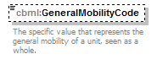
namespace | http://www.sisostds.org/schemas/c-bml/1.0
type | jc3iedm:UnitTypeGeneralMobilityCode
properties
  isRef | 0
  minOcc | 0
  maxOcc | 1
  content | simple
facets
  Kind | Value | annotation
  enumeration | AIR
    documentation
    <Definition xml:lang="en">The specified UNIT-TYPE moves generally through the air.</Definition>
    appinfo
    <DisplayValue xml:lang="en">Air</DisplayValue>
  enumeration | AIRCMP
    documentation
    <Definition xml:lang="en">The specified UNIT-TYPE moves generally through the air by means that combine deriving lift from fixed wings or from airfoils that rotate.</Definition>
    appinfo
    <DisplayValue xml:lang="en">Air, composite</DisplayValue>
  enumeration | AIRFW
    documentation
    <Definition xml:lang="en">The specified UNIT-TYPE moves generally through the air by deriving lift from fixed wings.</Definition>
    appinfo
    <DisplayValue xml:lang="en">Air, fixed wing</DisplayValue>
  enumeration | AIRRW
    documentation
    <Definition xml:lang="en">The specified UNIT-TYPE moves generally through the air by deriving lift from airfoils that rotate.</Definition>
    appinfo
    <DisplayValue xml:lang="en">Air, rotary wing</DisplayValue>
  enumeration | AIRVST
    documentation
    <Definition xml:lang="en">The specified UNIT-TYPE moves generally through the air by using aircraft able to take off and land on very short distances.</Definition>
    appinfo
    <DisplayValue xml:lang="en">Air, VSTOL</DisplayValue>
  enumeration | AMPH
    documentation
    <Definition xml:lang="en">The specified UNIT-TYPE moves generally both on land and in water.</Definition>
    appinfo
    <DisplayValue xml:lang="en">Amphibious</DisplayValue>
  enumeration | DSMNTD
    documentation
    <Definition xml:lang="en">The specified UNIT-TYPE moves generally on foot.</Definition>
    appinfo
    <DisplayValue xml:lang="en">Dismounted</DisplayValue>
  enumeration | HORSE
    documentation
    <Definition xml:lang="en">The specified UNIT-TYPE moves generally while carried by horses.</Definition>
    appinfo
    <DisplayValue xml:lang="en">Horse</DisplayValue>
  enumeration | LAND
    documentation
    <Definition xml:lang="en">The specified UNIT-TYPE moves generally on the ground.</Definition>
    appinfo
    <DisplayValue xml:lang="en">Land</DisplayValue>
  enumeration | LNDRAI
    documentation
    <Definition xml:lang="en">The specified UNIT-TYPE moves generally on the ground, along rails.</Definition>
    appinfo
    <DisplayValue xml:lang="en">Land, railed</DisplayValue>
  enumeration | LNDTRC
    documentation
    <Definition xml:lang="en">The specified UNIT-TYPE moves generally on the ground by means of vehicles using caterpillar treads.</Definition>
    appinfo
    <DisplayValue xml:lang="en">Land, tracked</DisplayValue>
  enumeration | LNDTWD
    documentation
    <Definition xml:lang="en">The main equipment of the specified UNIT-TYPE moves generally on the ground by means of external propulsion (mechanical or animal).</Definition>
    appinfo
    <DisplayValue xml:lang="en">Land, towed</DisplayValue>
  enumeration | LNDWHL
    documentation
    <Definition xml:lang="en">The specified UNIT-TYPE moves generally on the ground by means of vehicles using wheels.</Definition>
    appinfo
    <DisplayValue xml:lang="en">Land, wheeled</DisplayValue>
annotation
  documentation
  The specific value that represents the general mobility of a unit, seen as a whole.
source | <xs:element name="GeneralMobilityCode" type="jc3iedm:UnitTypeGeneralMobilityCode" minOccurs="0">  <xs:annotation>  <xs:documentation xml:lang="en">The specific value that represents the general mobility of a unit, seen as a whole.</xs:documentation>  </xs:annotation>  </xs:element>

element UnitType/QualifierCode
diagram | 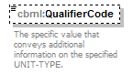
namespace | http://www.sisostds.org/schemas/c-bml/1.0
type | jc3iedm:UnitTypeQualifierCode
properties
  isRef | 0
  minOcc | 0
  maxOcc | 1
  content | simple
facets
  Kind | Value | annotation
  enumeration | CORPS
    documentation
    <Definition xml:lang="en">The specified UNIT-TYPE supports a force of Corps level.</Definition>
    appinfo
    <DisplayValue xml:lang="en">Corps</DisplayValue>
  enumeration | DIV
    documentation
    <Definition xml:lang="en">The specified UNIT-TYPE operates at Division level.</Definition>
    appinfo
    <DisplayValue xml:lang="en">Division</DisplayValue>
  enumeration | FORCE
    documentation
    <Definition xml:lang="en">The specified UNIT-TYPE operates at Force level.</Definition>
    appinfo
    <DisplayValue xml:lang="en">Force</DisplayValue>
  enumeration | HEAVY
    documentation
    <Definition xml:lang="en">No definition provided in APP-6A.</Definition>
    appinfo
    <DisplayValue xml:lang="en">Heavy</DisplayValue>
  enumeration | HMAD
    documentation
    <Definition xml:lang="en">The specified UNIT-TYPE major equipment is able to intercept threats flying at high or medium altitude.</Definition>
    appinfo
    <DisplayValue xml:lang="en">High/medium altitude air defence</DisplayValue>
  enumeration | LIGHT
    documentation
    <Definition xml:lang="en">No definition provided in APP-6A.</Definition>
    appinfo
    <DisplayValue xml:lang="en">Light</DisplayValue>
  enumeration | LR
    documentation
    <Definition xml:lang="en">No definition provided in APP-6A.</Definition>
    appinfo
    <DisplayValue xml:lang="en">Long range</DisplayValue>
  enumeration | MEDIUM
    documentation
    <Definition xml:lang="en">No definition provided in APP-6A.</Definition>
    appinfo
    <DisplayValue xml:lang="en">Medium</DisplayValue>
  enumeration | MR
    documentation
    <Definition xml:lang="en">No definition provided in APP-6A.</Definition>
    appinfo
    <DisplayValue xml:lang="en">Medium range</DisplayValue>
  enumeration | SR
    documentation
    <Definition xml:lang="en">No definition provided in APP-6A.</Definition>
    appinfo
    <DisplayValue xml:lang="en">Short range</DisplayValue>
  enumeration | STRTGC
    documentation
    <Definition xml:lang="en">The specified UNIT-TYPE operates at a strategic level of command.</Definition>
    appinfo
    <DisplayValue xml:lang="en">Strategic</DisplayValue>
  enumeration | TACTCL
    documentation
    <Definition xml:lang="en">The specified UNIT-TYPE operates at a tactical level of command.</Definition>
    appinfo
    <DisplayValue xml:lang="en">Tactical</DisplayValue>
  enumeration | THTRE
    documentation
    <Definition xml:lang="en">The specified UNIT-TYPE supports a force at Theatre level.</Definition>
    appinfo
    <DisplayValue xml:lang="en">Theatre</DisplayValue>
  enumeration | TMD
    documentation
    <Definition xml:lang="en">No definition provided in APP-6A.</Definition>
    appinfo
    <DisplayValue xml:lang="en">Theatre missile defence</DisplayValue>
  enumeration | VSR
    documentation
    <Definition xml:lang="en">No definition provided in APP-6A.</Definition>
    appinfo
    <DisplayValue xml:lang="en">Very short range</DisplayValue>
annotation
  documentation
  The specific value that conveys additional information on the specified UNIT-TYPE.
source | <xs:element name="QualifierCode" type="jc3iedm:UnitTypeQualifierCode" minOccurs="0">  <xs:annotation>  <xs:documentation xml:lang="en">The specific value that conveys additional information on the specified UNIT-TYPE.</xs:documentation>  </xs:annotation>  </xs:element>

element UnitType/SizeCode
diagram | 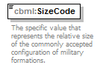
namespace | http://www.sisostds.org/schemas/c-bml/1.0
type | jc3iedm:EchelonSizeCode
properties
  isRef | 0
  content | simple
facets
  Kind | Value | annotation
  enumeration | AG
    documentation
    <Definition xml:lang="en">The largest formation of land forces, normally comprising two or more armies or army corps under a designated commander.</Definition>
    appinfo
    <DisplayValue xml:lang="en">Army group</DisplayValue>
  enumeration | ARMY
    documentation
    <Definition xml:lang="en">A formation larger than an army corps but smaller than an army group. It usually consists of two or more army corps.</Definition>
    appinfo
    <DisplayValue xml:lang="en">Army</DisplayValue>
  enumeration | BATGRP
    documentation
    <Definition xml:lang="en">An operational grouping which is based on either an infantry battalion or a tank regiment, each with at least a squadron or company of the other arm and with elements of other supporting arms and services allocated according to need.</Definition>
    appinfo
    <DisplayValue xml:lang="en">Battle group</DisplayValue>
  enumeration | BDE
    documentation
    <Definition xml:lang="en">Unit composed of a headquarters and two or more battalions. It may be part of an army and be charged with only tactical functions, or it may be a separate unit and be charged with both administrative and tactical functions.</Definition>
    appinfo
    <DisplayValue xml:lang="en">Brigade</DisplayValue>
  enumeration | BDEGRP
    documentation
    <Definition xml:lang="en">An operational grouping which is based on an infantry or armoured brigade and which has elements of other supporting arms and services allocated according to need.</Definition>
    appinfo
    <DisplayValue xml:lang="en">Brigade group</DisplayValue>
  enumeration | BN
    documentation
    <Definition xml:lang="en">Unit composed of a headquarters and two or more companies or batteries. It may be part of a regiment and be charged with only tactical functions, or it may be a separate unit and be charged with both administrative and tactical functions.</Definition>
    appinfo
    <DisplayValue xml:lang="en">Battalion</DisplayValue>
  enumeration | BNG
    documentation
    <Definition xml:lang="en">An operational grouping which is based on an infantry battalion and which has elements of other supporting arms and services allocated according to need.</Definition>
    appinfo
    <DisplayValue xml:lang="en">Battalion group</DisplayValue>
  enumeration | CORPS
    documentation
    <Definition xml:lang="en">A formation larger than a division but smaller than an army or army group. It usually consists to two or more divisions together with supporting arms and services.</Definition>
    appinfo
    <DisplayValue xml:lang="en">Corps</DisplayValue>
  enumeration | COY
    documentation
    <Definition xml:lang="en">Basic administrative and tactical unit in most arms and services of the Army. A company is on a command level below a battalion and above a platoon.</Definition>
    appinfo
    <DisplayValue xml:lang="en">Company</DisplayValue>
  enumeration | COYG
    documentation
    <Definition xml:lang="en">An operational grouping which is based on either an infantry company or a tank company, which has elements of other supporting arms and services allocated according to need.</Definition>
    appinfo
    <DisplayValue xml:lang="en">Company group</DisplayValue>
  enumeration | DIV
    documentation
    <Definition xml:lang="en">A tactical unit/formation that is a major administrative and tactical unit/formation that combines in itself the necessary arms and services required for sustained combat, larger than a regiment/brigade and smaller than a corps.</Definition>
    appinfo
    <DisplayValue xml:lang="en">Division</DisplayValue>
  enumeration | FLEET
    documentation
    <Definition xml:lang="en">An organisation of ships, aircraft, Marine forces, and shore-based fleet activities all under the command of a commander or commander in chief who may exercise operational as well as administrative control.</Definition>
    appinfo
    <DisplayValue xml:lang="en">Fleet</DisplayValue>
  enumeration | FLIGHT
    documentation
    <Definition xml:lang="en">A specified group of aircraft engaged in a common mission.</Definition>
    appinfo
    <DisplayValue xml:lang="en">Flight</DisplayValue>
  enumeration | NKN
    documentation
    <Definition xml:lang="en">It is not possible to determine which value is most applicable.</Definition>
    appinfo
    <DisplayValue xml:lang="en">Not known</DisplayValue>
  enumeration | NOS
    documentation
    <Definition xml:lang="en">The appropriate value is not in the set of specified values.</Definition>
    appinfo
    <DisplayValue xml:lang="en">Not otherwise specified</DisplayValue>
  enumeration | NTF
    documentation
    <Definition xml:lang="en">A component of a fleet organized by the commander of a task fleet or higher authority for the accomplishment of a specific task or tasks.</Definition>
    appinfo
    <DisplayValue xml:lang="en">Task force, Navy</DisplayValue>
  enumeration | NTG
    documentation
    <Definition xml:lang="en">A component of a task force organized by the commander of the task force or higher authority for accomplishing specific tasks.</Definition>
    appinfo
    <DisplayValue xml:lang="en">Task group, Navy</DisplayValue>
  enumeration | NTU
    documentation
    <Definition xml:lang="en">A component of a task group organized by the commander of a task group or higher authority for accomplishing specific tasks.</Definition>
    appinfo
    <DisplayValue xml:lang="en">Task unit, Navy</DisplayValue>
  enumeration | PLT
    documentation
    <Definition xml:lang="en">Basic administrative and tactical unit in most arms and services of the Army.</Definition>
    appinfo
    <DisplayValue xml:lang="en">Platoon</DisplayValue>
  enumeration | REGION
    documentation
    <Definition xml:lang="en">A grouping of two or more Army groups.</Definition>
    appinfo
    <DisplayValue xml:lang="en">Region</DisplayValue>
  enumeration | RGT
    documentation
    <Definition xml:lang="en">Administrative and tactical unit, on a command level below a division or brigade and above a battalion, the entire organisation of which is prescribed by table of organisation.</Definition>
    appinfo
    <DisplayValue xml:lang="en">Regiment</DisplayValue>
  enumeration | SECT
    documentation
    <Definition xml:lang="en">A small tactical unit.</Definition>
    appinfo
    <DisplayValue xml:lang="en">Section</DisplayValue>
  enumeration | SQDRNA
    documentation
    <Definition xml:lang="en">An administrative or tactical organisation normally but not necessarily composed of aircraft of the same type.</Definition>
    appinfo
    <DisplayValue xml:lang="en">Squadron, air</DisplayValue>
  enumeration | SQDRNM
    documentation
    <Definition xml:lang="en">An administrative or tactical organisation consisting of two or more divisions of ships, plus such additional ships as may be assigned as flagships or tenders.</Definition>
    appinfo
    <DisplayValue xml:lang="en">Squadron, maritime</DisplayValue>
  enumeration | SQUAD
    documentation
    <Definition xml:lang="en">A small number of men, a subdivision or section of a company, formed for drill.</Definition>
    appinfo
    <DisplayValue xml:lang="en">Squad</DisplayValue>
  enumeration | TEAM
    documentation
    <Definition xml:lang="en">Any unit smaller than a squad that will be denoted by a vehicle or weapon symbol in a graphical representation.</Definition>
    appinfo
    <DisplayValue xml:lang="en">Team/fire team/crew</DisplayValue>
  enumeration | TSKELN
    documentation
    <Definition xml:lang="en">A component of a task unit organized by the commander of the task unit or higher authority for accomplishing a specific task.</Definition>
    appinfo
    <DisplayValue xml:lang="en">Task element, Navy</DisplayValue>
  enumeration | WING
    documentation
    <Definition xml:lang="en">An aviation unit composed normally of one primary mission group and the necessary supporting organisations.</Definition>
    appinfo
    <DisplayValue xml:lang="en">Wing</DisplayValue>
annotation
  documentation
  The specific value that represents the relative size of the commonly accepted configuration of military formations.
source | <xs:element name="SizeCode" type="jc3iedm:EchelonSizeCode">  <xs:annotation>  <xs:documentation xml:lang="en">The specific value that represents the relative size of the commonly accepted configuration of military formations.</xs:documentation>  </xs:annotation>  </xs:element>

element UnitType/PrincipalEquipmentTypeRef
diagram | 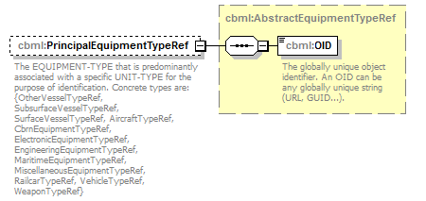
namespace | http://www.sisostds.org/schemas/c-bml/1.0
type | cbml:AbstractEquipmentTypeRef
properties
  isRef | 0
  minOcc | 0
  maxOcc | 1
  content | complex
children | cbml:OID
annotation
  documentation
  The EQUIPMENT-TYPE that is predominantly associated with a specific UNIT-TYPE for the purpose of identification. Concrete types are: {OtherVesselTypeRef, SubsurfaceVesselTypeRef, SurfaceVesselTypeRef, AircraftTypeRef, CbrnEquipmentTypeRef, ElectronicEquipmentTypeRef, EngineeringEquipmentTypeRef, MaritimeEquipmentTypeRef, MiscellaneousEquipmentTypeRef, RailcarTypeRef, VehicleTypeRef, WeaponTypeRef}
source | <xs:element name="PrincipalEquipmentTypeRef" type="cbml:AbstractEquipmentTypeRef" minOccurs="0">  <xs:annotation>  <xs:documentation xml:lang="en">The EQUIPMENT-TYPE that is predominantly associated with a specific UNIT-TYPE for the purpose of identification. Concrete types are: {OtherVesselTypeRef, SubsurfaceVesselTypeRef, SurfaceVesselTypeRef, AircraftTypeRef, CbrnEquipmentTypeRef, ElectronicEquipmentTypeRef, EngineeringEquipmentTypeRef, MaritimeEquipmentTypeRef, MiscellaneousEquipmentTypeRef, RailcarTypeRef, VehicleTypeRef, WeaponTypeRef}</xs:documentation>  </xs:annotation>  </xs:element>

element UnitType/SupportedMilitaryOrganisationTypeRef
diagram | 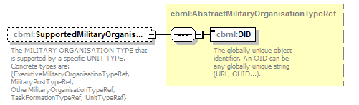
namespace | http://www.sisostds.org/schemas/c-bml/1.0
type | cbml:AbstractMilitaryOrganisationTypeRef
properties
  isRef | 0
  minOcc | 0
  maxOcc | 1
  content | complex
children | cbml:OID
annotation
  documentation
  The MILITARY-ORGANISATION-TYPE that is supported by a specific UNIT-TYPE. Concrete types are: {ExecutiveMilitaryOrganisationTypeRef, MilitaryPostTypeRef, OtherMilitaryOrganisationTypeRef, TaskFormationTypeRef, UnitTypeRef}
source | <xs:element name="SupportedMilitaryOrganisationTypeRef" type="cbml:AbstractMilitaryOrganisationTypeRef" minOccurs="0">  <xs:annotation>  <xs:documentation xml:lang="en">The MILITARY-ORGANISATION-TYPE that is supported by a specific UNIT-TYPE. Concrete types are: {ExecutiveMilitaryOrganisationTypeRef, MilitaryPostTypeRef, OtherMilitaryOrganisationTypeRef, TaskFormationTypeRef, UnitTypeRef}</xs:documentation>  </xs:annotation>  </xs:element>

complexType UnitTypeRef
diagram | 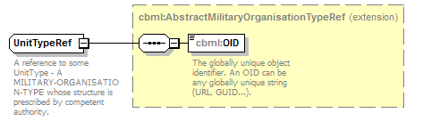
namespace | http://www.sisostds.org/schemas/c-bml/1.0
type | extension of cbml:AbstractMilitaryOrganisationTypeRef
properties
  base | cbml:AbstractMilitaryOrganisationTypeRef
children | cbml:OID
annotation
  documentation
  A reference to some UnitType - A MILITARY-ORGANISATION-TYPE whose structure is prescribed by competent authority.
source | <xs:complexType name="UnitTypeRef">  <xs:annotation>  <xs:documentation xml:lang="en">A reference to some UnitType - A MILITARY-ORGANISATION-TYPE whose structure is prescribed by competent authority.</xs:documentation>  </xs:annotation>  <xs:complexContent>  <xs:extension base="cbml:AbstractMilitaryOrganisationTypeRef"/>  </xs:complexContent>  </xs:complexType>

XML Schema documentation generated by XMLSpy Schema Editor http://www.altova.com/xmlspy

