Schema cbml-action-types.xsd

schema location: | cbml-action-types.xsd
attribute form default: | unqualified
element form default: | qualified
targetNamespace: | http://www.sisostds.org/schemas/c-bml/1.0

Complex types
ActionEffectItem
ActionEffectType
ActionObjectiveTask
ActionObjectiveTaskRef
ActionResourceItem
ActionResourceType
ChemicalBiologicalEvent
ChemicalBiologicalEventRef
NuclearWeaponEvent
NuclearWeaponEventRef
OtherActionEvent
OtherActionEventRef
OtherActionObjectiveItem
OtherActionObjectiveItemRef
OtherActionObjectiveType
OtherActionObjectiveTypeRef
OtherActionResourceEmployment
OtherActionTask
OtherActionTaskRef
OtherCbrnEvent
OtherCbrnEventRef
OtherNuclearEvent
OtherNuclearEventRef
OtherRadioactiveEvent
OtherRadioactiveEventRef
RadiologicalEvent
RadiologicalEventRef
Request
RequestAnswer
RequestRef
RequestWhatAnswerRefType
RequestWhatAnswerType
Target
TargetPersonnelProtectionRefType
TargetPersonnelProtectionType
TargetRef

complexType ActionEffectItem
diagram | 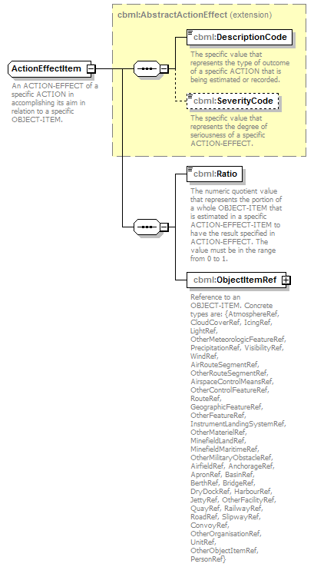
namespace | http://www.sisostds.org/schemas/c-bml/1.0
type | extension of cbml:AbstractActionEffect
properties
  base | cbml:AbstractActionEffect
children | cbml:DescriptionCode cbml:SeverityCode cbml:Ratio cbml:ObjectItemRef
annotation
  documentation
  An ACTION-EFFECT of a specific ACTION in accomplishing its aim in relation to a specific OBJECT-ITEM.
source | <xs:complexType name="ActionEffectItem">  <xs:annotation>  <xs:documentation xml:lang="en">An ACTION-EFFECT of a specific ACTION in accomplishing its aim in relation to a specific OBJECT-ITEM.</xs:documentation>  </xs:annotation>  <xs:complexContent>  <xs:extension base="cbml:AbstractActionEffect">  <xs:sequence>  <xs:element name="Ratio" type="jc3iedm:RatioType6_5">  <xs:annotation>  <xs:documentation xml:lang="en">The numeric quotient value that represents the portion of a whole OBJECT-ITEM that is estimated in a specific ACTION-EFFECT-ITEM to have the result specified in ACTION-EFFECT. The value must be in the range from 0 to 1.</xs:documentation>  </xs:annotation>  </xs:element>  <xs:element name="ObjectItemRef" type="cbml:AbstractObjectItemRef">  <xs:annotation>  <xs:documentation xml:lang="en">Reference to an OBJECT-ITEM. Concrete types are: {AtmosphereRef, CloudCoverRef, IcingRef, LightRef, OtherMeteorologicFeatureRef, PrecipitationRef, VisibilityRef, WindRef, AirRouteSegmentRef, OtherRouteSegmentRef, AirspaceControlMeansRef, OtherControlFeatureRef, RouteRef, GeographicFeatureRef, OtherFeatureRef, InstrumentLandingSystemRef, OtherMaterielRef, MinefieldLandRef, MinefieldMaritimeRef, OtherMilitaryObstacleRef, AirfieldRef, AnchorageRef, ApronRef, BasinRef, BerthRef, BridgeRef, DryDockRef, HarbourRef, JettyRef, OtherFacilityRef, QuayRef, RailwayRef, RoadRef, SlipwayRef, ConvoyRef, OtherOrganisationRef, UnitRef, OtherObjectItemRef, PersonRef}</xs:documentation>  </xs:annotation>  </xs:element>  </xs:sequence>  </xs:extension>  </xs:complexContent>  </xs:complexType>

element ActionEffectItem/Ratio
diagram | 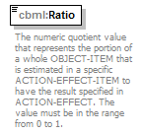
namespace | http://www.sisostds.org/schemas/c-bml/1.0
type | jc3iedm:RatioType6_5
properties
  isRef | 0
  content | simple
facets
  Kind | Value | annotation
  minInclusive | -9.99999
  maxInclusive | 9.99999
  totalDigits | 6
  fractionDigits | 5
annotation
  documentation
  The numeric quotient value that represents the portion of a whole OBJECT-ITEM that is estimated in a specific ACTION-EFFECT-ITEM to have the result specified in ACTION-EFFECT. The value must be in the range from 0 to 1.
source | <xs:element name="Ratio" type="jc3iedm:RatioType6_5">  <xs:annotation>  <xs:documentation xml:lang="en">The numeric quotient value that represents the portion of a whole OBJECT-ITEM that is estimated in a specific ACTION-EFFECT-ITEM to have the result specified in ACTION-EFFECT. The value must be in the range from 0 to 1.</xs:documentation>  </xs:annotation>  </xs:element>

element ActionEffectItem/ObjectItemRef
diagram | 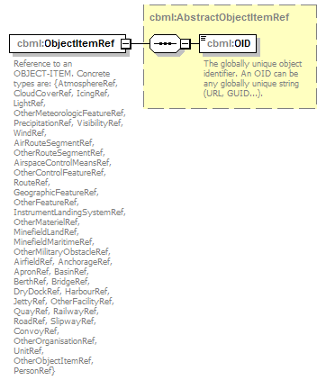
namespace | http://www.sisostds.org/schemas/c-bml/1.0
type | cbml:AbstractObjectItemRef
properties
  isRef | 0
  content | complex
children | cbml:OID
annotation
  documentation
  Reference to an OBJECT-ITEM. Concrete types are: {AtmosphereRef, CloudCoverRef, IcingRef, LightRef, OtherMeteorologicFeatureRef, PrecipitationRef, VisibilityRef, WindRef, AirRouteSegmentRef, OtherRouteSegmentRef, AirspaceControlMeansRef, OtherControlFeatureRef, RouteRef, GeographicFeatureRef, OtherFeatureRef, InstrumentLandingSystemRef, OtherMaterielRef, MinefieldLandRef, MinefieldMaritimeRef, OtherMilitaryObstacleRef, AirfieldRef, AnchorageRef, ApronRef, BasinRef, BerthRef, BridgeRef, DryDockRef, HarbourRef, JettyRef, OtherFacilityRef, QuayRef, RailwayRef, RoadRef, SlipwayRef, ConvoyRef, OtherOrganisationRef, UnitRef, OtherObjectItemRef, PersonRef}
source | <xs:element name="ObjectItemRef" type="cbml:AbstractObjectItemRef">  <xs:annotation>  <xs:documentation xml:lang="en">Reference to an OBJECT-ITEM. Concrete types are: {AtmosphereRef, CloudCoverRef, IcingRef, LightRef, OtherMeteorologicFeatureRef, PrecipitationRef, VisibilityRef, WindRef, AirRouteSegmentRef, OtherRouteSegmentRef, AirspaceControlMeansRef, OtherControlFeatureRef, RouteRef, GeographicFeatureRef, OtherFeatureRef, InstrumentLandingSystemRef, OtherMaterielRef, MinefieldLandRef, MinefieldMaritimeRef, OtherMilitaryObstacleRef, AirfieldRef, AnchorageRef, ApronRef, BasinRef, BerthRef, BridgeRef, DryDockRef, HarbourRef, JettyRef, OtherFacilityRef, QuayRef, RailwayRef, RoadRef, SlipwayRef, ConvoyRef, OtherOrganisationRef, UnitRef, OtherObjectItemRef, PersonRef}</xs:documentation>  </xs:annotation>  </xs:element>

complexType ActionEffectType
diagram | 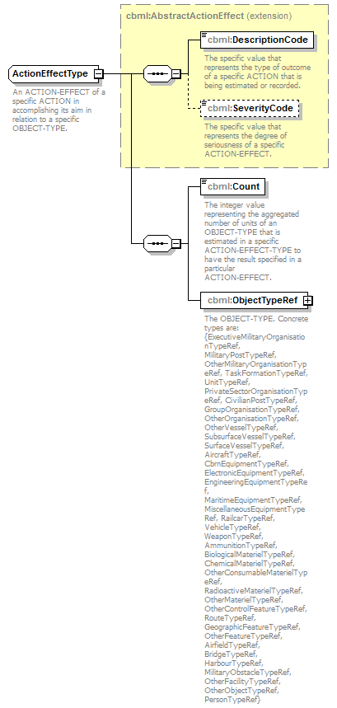
namespace | http://www.sisostds.org/schemas/c-bml/1.0
type | extension of cbml:AbstractActionEffect
properties
  base | cbml:AbstractActionEffect
children | cbml:DescriptionCode cbml:SeverityCode cbml:Count cbml:ObjectTypeRef
annotation
  documentation
  An ACTION-EFFECT of a specific ACTION in accomplishing its aim in relation to a specific OBJECT-TYPE.
source | <xs:complexType name="ActionEffectType">  <xs:annotation>  <xs:documentation xml:lang="en">An ACTION-EFFECT of a specific ACTION in accomplishing its aim in relation to a specific OBJECT-TYPE.</xs:documentation>  </xs:annotation>  <xs:complexContent>  <xs:extension base="cbml:AbstractActionEffect">  <xs:sequence>  <xs:element name="Count" type="jc3iedm:CountType6">  <xs:annotation>  <xs:documentation xml:lang="en">The integer value representing the aggregated number of units of an OBJECT-TYPE that is estimated in a specific ACTION-EFFECT-TYPE to have the result specified in a particular ACTION-EFFECT.</xs:documentation>  </xs:annotation>  </xs:element>  <xs:element name="ObjectTypeRef" type="cbml:AbstractObjectTypeRef">  <xs:annotation>  <xs:documentation xml:lang="en">The OBJECT-TYPE. Concrete types are: {ExecutiveMilitaryOrganisationTypeRef, MilitaryPostTypeRef, OtherMilitaryOrganisationTypeRef, TaskFormationTypeRef, UnitTypeRef, PrivateSectorOrganisationTypeRef, CivilianPostTypeRef, GroupOrganisationTypeRef, OtherOrganisationTypeRef, OtherVesselTypeRef, SubsurfaceVesselTypeRef, SurfaceVesselTypeRef, AircraftTypeRef, CbrnEquipmentTypeRef, ElectronicEquipmentTypeRef, EngineeringEquipmentTypeRef, MaritimeEquipmentTypeRef, MiscellaneousEquipmentTypeRef, RailcarTypeRef, VehicleTypeRef, WeaponTypeRef, AmmunitionTypeRef, BiologicalMaterielTypeRef, ChemicalMaterielTypeRef, OtherConsumableMaterielTypeRef, RadioactiveMaterielTypeRef, OtherMaterielTypeRef, OtherControlFeatureTypeRef, RouteTypeRef, GeographicFeatureTypeRef, OtherFeatureTypeRef, AirfieldTypeRef, BridgeTypeRef, HarbourTypeRef, MilitaryObstacleTypeRef, OtherFacilityTypeRef, OtherObjectTypeRef, PersonTypeRef}</xs:documentation>  </xs:annotation>  </xs:element>  <!-- CBML Rationale: Defined at the Expression level.  <xs:choice>  <xs:element name="ObjectType" type="cbml:AbstractObjectType">  <xs:annotation>  <xs:documentation xml:lang="en">The OBJECT-TYPE.</xs:documentation>  </xs:annotation>  </xs:element>  <xs:element name="ObjectTypeRef" type="cbml:AbstractObjectTypeRef">  <xs:annotation>  <xs:documentation xml:lang="en">The OBJECT-TYPE.</xs:documentation>  </xs:annotation>  </xs:element>  </xs:choice>-->  </xs:sequence>  </xs:extension>  </xs:complexContent>  </xs:complexType>

element ActionEffectType/Count
diagram | 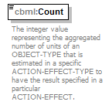
namespace | http://www.sisostds.org/schemas/c-bml/1.0
type | jc3iedm:CountType6
properties
  isRef | 0
  content | simple
facets
  Kind | Value | annotation
  minInclusive | -999999
  maxInclusive | 999999
annotation
  documentation
  The integer value representing the aggregated number of units of an OBJECT-TYPE that is estimated in a specific ACTION-EFFECT-TYPE to have the result specified in a particular ACTION-EFFECT.
source | <xs:element name="Count" type="jc3iedm:CountType6">  <xs:annotation>  <xs:documentation xml:lang="en">The integer value representing the aggregated number of units of an OBJECT-TYPE that is estimated in a specific ACTION-EFFECT-TYPE to have the result specified in a particular ACTION-EFFECT.</xs:documentation>  </xs:annotation>  </xs:element>

element ActionEffectType/ObjectTypeRef
diagram | 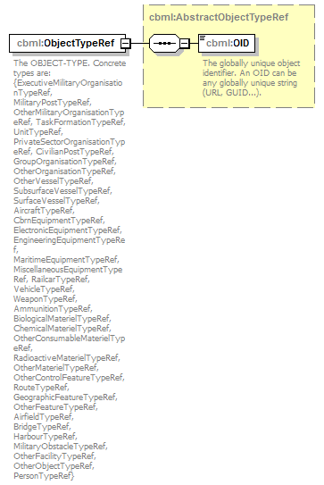
namespace | http://www.sisostds.org/schemas/c-bml/1.0
type | cbml:AbstractObjectTypeRef
properties
  isRef | 0
  content | complex
children | cbml:OID
annotation
  documentation
  The OBJECT-TYPE. Concrete types are: {ExecutiveMilitaryOrganisationTypeRef, MilitaryPostTypeRef, OtherMilitaryOrganisationTypeRef, TaskFormationTypeRef, UnitTypeRef, PrivateSectorOrganisationTypeRef, CivilianPostTypeRef, GroupOrganisationTypeRef, OtherOrganisationTypeRef, OtherVesselTypeRef, SubsurfaceVesselTypeRef, SurfaceVesselTypeRef, AircraftTypeRef, CbrnEquipmentTypeRef, ElectronicEquipmentTypeRef, EngineeringEquipmentTypeRef, MaritimeEquipmentTypeRef, MiscellaneousEquipmentTypeRef, RailcarTypeRef, VehicleTypeRef, WeaponTypeRef, AmmunitionTypeRef, BiologicalMaterielTypeRef, ChemicalMaterielTypeRef, OtherConsumableMaterielTypeRef, RadioactiveMaterielTypeRef, OtherMaterielTypeRef, OtherControlFeatureTypeRef, RouteTypeRef, GeographicFeatureTypeRef, OtherFeatureTypeRef, AirfieldTypeRef, BridgeTypeRef, HarbourTypeRef, MilitaryObstacleTypeRef, OtherFacilityTypeRef, OtherObjectTypeRef, PersonTypeRef}
source | <xs:element name="ObjectTypeRef" type="cbml:AbstractObjectTypeRef">  <xs:annotation>  <xs:documentation xml:lang="en">The OBJECT-TYPE. Concrete types are: {ExecutiveMilitaryOrganisationTypeRef, MilitaryPostTypeRef, OtherMilitaryOrganisationTypeRef, TaskFormationTypeRef, UnitTypeRef, PrivateSectorOrganisationTypeRef, CivilianPostTypeRef, GroupOrganisationTypeRef, OtherOrganisationTypeRef, OtherVesselTypeRef, SubsurfaceVesselTypeRef, SurfaceVesselTypeRef, AircraftTypeRef, CbrnEquipmentTypeRef, ElectronicEquipmentTypeRef, EngineeringEquipmentTypeRef, MaritimeEquipmentTypeRef, MiscellaneousEquipmentTypeRef, RailcarTypeRef, VehicleTypeRef, WeaponTypeRef, AmmunitionTypeRef, BiologicalMaterielTypeRef, ChemicalMaterielTypeRef, OtherConsumableMaterielTypeRef, RadioactiveMaterielTypeRef, OtherMaterielTypeRef, OtherControlFeatureTypeRef, RouteTypeRef, GeographicFeatureTypeRef, OtherFeatureTypeRef, AirfieldTypeRef, BridgeTypeRef, HarbourTypeRef, MilitaryObstacleTypeRef, OtherFacilityTypeRef, OtherObjectTypeRef, PersonTypeRef}</xs:documentation>  </xs:annotation>  </xs:element>

complexType ActionObjectiveTask
diagram | 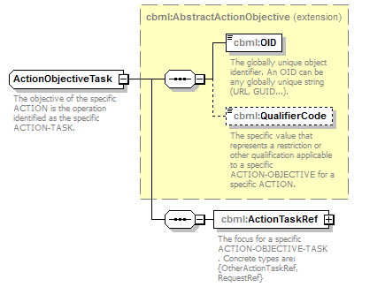
namespace | http://www.sisostds.org/schemas/c-bml/1.0
type | extension of cbml:AbstractActionObjective
properties
  base | cbml:AbstractActionObjective
children | cbml:OID cbml:QualifierCode cbml:ActionTaskRef
annotation
  documentation
  The objective of the specific ACTION is the operation identified as the specific ACTION-TASK.
source | <xs:complexType name="ActionObjectiveTask">  <xs:annotation>  <xs:documentation xml:lang="en">The objective of the specific ACTION is the operation identified as the specific ACTION-TASK.</xs:documentation>  </xs:annotation>  <xs:complexContent>  <xs:extension base="cbml:AbstractActionObjective">  <xs:sequence>  <xs:element name="ActionTaskRef" type="cbml:AbstractActionTaskRef">  <xs:annotation>  <xs:documentation xml:lang="en">The focus for a specific ACTION-OBJECTIVE-TASK. Concrete types are: {OtherActionTaskRef, RequestRef}</xs:documentation>  </xs:annotation>  </xs:element>  <!-- CBML Rationale: Action defined at the Task level.  <xs:choice>  <xs:element name="ActionTask" type="cbml:AbstractActionTask">  <xs:annotation>  <xs:documentation xml:lang="en">The focus for a specific ACTION-OBJECTIVE-TASK.</xs:documentation>  </xs:annotation>  </xs:element>  <xs:element name="ActionTaskRef" type="cbml:AbstractActionTaskRef">  <xs:annotation>  <xs:documentation xml:lang="en">The focus for a specific ACTION-OBJECTIVE-TASK.</xs:documentation>  </xs:annotation>  </xs:element>  </xs:choice>-->  </xs:sequence>  </xs:extension>  </xs:complexContent>  </xs:complexType>

element ActionObjectiveTask/ActionTaskRef
diagram | 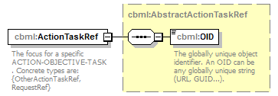
namespace | http://www.sisostds.org/schemas/c-bml/1.0
type | cbml:AbstractActionTaskRef
properties
  isRef | 0
  content | complex
children | cbml:OID
annotation
  documentation
  The focus for a specific ACTION-OBJECTIVE-TASK. Concrete types are: {OtherActionTaskRef, RequestRef}
source | <xs:element name="ActionTaskRef" type="cbml:AbstractActionTaskRef">  <xs:annotation>  <xs:documentation xml:lang="en">The focus for a specific ACTION-OBJECTIVE-TASK. Concrete types are: {OtherActionTaskRef, RequestRef}</xs:documentation>  </xs:annotation>  </xs:element>

complexType ActionObjectiveTaskRef
diagram | 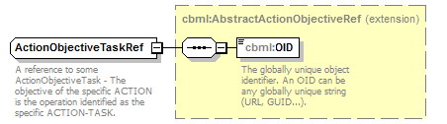
namespace | http://www.sisostds.org/schemas/c-bml/1.0
type | extension of cbml:AbstractActionObjectiveRef
properties
  base | cbml:AbstractActionObjectiveRef
children | cbml:OID
annotation
  documentation
  A reference to some ActionObjectiveTask - The objective of the specific ACTION is the operation identified as the specific ACTION-TASK.
source | <xs:complexType name="ActionObjectiveTaskRef">  <xs:annotation>  <xs:documentation xml:lang="en">A reference to some ActionObjectiveTask - The objective of the specific ACTION is the operation identified as the specific ACTION-TASK.</xs:documentation>  </xs:annotation>  <xs:complexContent>  <xs:extension base="cbml:AbstractActionObjectiveRef"/>  </xs:complexContent>  </xs:complexType>

complexType ActionResourceItem
diagram | 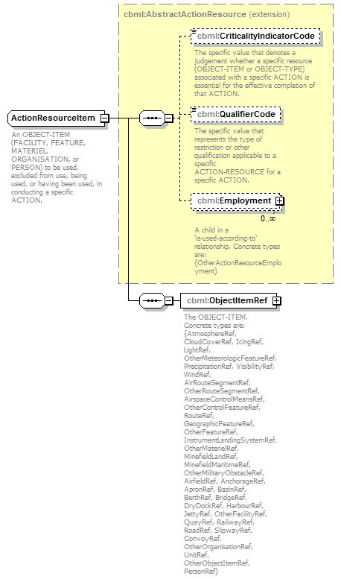
namespace | http://www.sisostds.org/schemas/c-bml/1.0
type | extension of cbml:AbstractActionResource
properties
  base | cbml:AbstractActionResource
children | cbml:CriticalityIndicatorCode cbml:QualifierCode cbml:Employment cbml:ObjectItemRef
annotation
  documentation
  An OBJECT-ITEM (FACILITY, FEATURE, MATERIEL, ORGANISATION, or PERSON) to be used, excluded from use, being used, or having been used, in conducting a specific ACTION.
source | <xs:complexType name="ActionResourceItem">  <xs:annotation>  <xs:documentation xml:lang="en">An OBJECT-ITEM (FACILITY, FEATURE, MATERIEL, ORGANISATION, or PERSON) to be used, excluded from use, being used, or having been used, in conducting a specific ACTION.</xs:documentation>  </xs:annotation>  <xs:complexContent>  <xs:extension base="cbml:AbstractActionResource">  <xs:sequence>  <xs:element name="ObjectItemRef" type="cbml:AbstractObjectItemRef">  <xs:annotation>  <xs:documentation xml:lang="en">The OBJECT-ITEM. Concrete types are: {AtmosphereRef, CloudCoverRef, IcingRef, LightRef, OtherMeteorologicFeatureRef, PrecipitationRef, VisibilityRef, WindRef, AirRouteSegmentRef, OtherRouteSegmentRef, AirspaceControlMeansRef, OtherControlFeatureRef, RouteRef, GeographicFeatureRef, OtherFeatureRef, InstrumentLandingSystemRef, OtherMaterielRef, MinefieldLandRef, MinefieldMaritimeRef, OtherMilitaryObstacleRef, AirfieldRef, AnchorageRef, ApronRef, BasinRef, BerthRef, BridgeRef, DryDockRef, HarbourRef, JettyRef, OtherFacilityRef, QuayRef, RailwayRef, RoadRef, SlipwayRef, ConvoyRef, OtherOrganisationRef, UnitRef, OtherObjectItemRef, PersonRef}</xs:documentation>  </xs:annotation>  </xs:element>  <!-- CBML Rationale: Defined by EntityTypeReport.  <xs:choice>  <xs:element name="ObjectItem" type="cbml:AbstractObjectItem">  <xs:annotation>  <xs:documentation xml:lang="en">The OBJECT-ITEM.</xs:documentation>  </xs:annotation>  </xs:element>  <xs:element name="ObjectItemRef" type="cbml:AbstractObjectItemRef">  <xs:annotation>  <xs:documentation xml:lang="en">The OBJECT-ITEM.</xs:documentation>  </xs:annotation>  </xs:element>  </xs:choice>-->  </xs:sequence>  </xs:extension>  </xs:complexContent>  </xs:complexType>

element ActionResourceItem/ObjectItemRef
diagram | 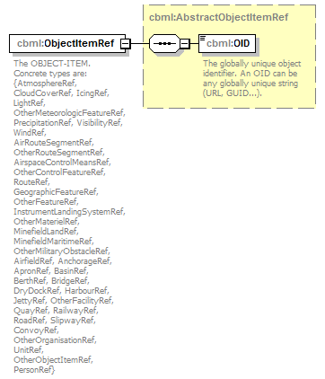
namespace | http://www.sisostds.org/schemas/c-bml/1.0
type | cbml:AbstractObjectItemRef
properties
  isRef | 0
  content | complex
children | cbml:OID
annotation
  documentation
  The OBJECT-ITEM. Concrete types are: {AtmosphereRef, CloudCoverRef, IcingRef, LightRef, OtherMeteorologicFeatureRef, PrecipitationRef, VisibilityRef, WindRef, AirRouteSegmentRef, OtherRouteSegmentRef, AirspaceControlMeansRef, OtherControlFeatureRef, RouteRef, GeographicFeatureRef, OtherFeatureRef, InstrumentLandingSystemRef, OtherMaterielRef, MinefieldLandRef, MinefieldMaritimeRef, OtherMilitaryObstacleRef, AirfieldRef, AnchorageRef, ApronRef, BasinRef, BerthRef, BridgeRef, DryDockRef, HarbourRef, JettyRef, OtherFacilityRef, QuayRef, RailwayRef, RoadRef, SlipwayRef, ConvoyRef, OtherOrganisationRef, UnitRef, OtherObjectItemRef, PersonRef}
source | <xs:element name="ObjectItemRef" type="cbml:AbstractObjectItemRef">  <xs:annotation>  <xs:documentation xml:lang="en">The OBJECT-ITEM. Concrete types are: {AtmosphereRef, CloudCoverRef, IcingRef, LightRef, OtherMeteorologicFeatureRef, PrecipitationRef, VisibilityRef, WindRef, AirRouteSegmentRef, OtherRouteSegmentRef, AirspaceControlMeansRef, OtherControlFeatureRef, RouteRef, GeographicFeatureRef, OtherFeatureRef, InstrumentLandingSystemRef, OtherMaterielRef, MinefieldLandRef, MinefieldMaritimeRef, OtherMilitaryObstacleRef, AirfieldRef, AnchorageRef, ApronRef, BasinRef, BerthRef, BridgeRef, DryDockRef, HarbourRef, JettyRef, OtherFacilityRef, QuayRef, RailwayRef, RoadRef, SlipwayRef, ConvoyRef, OtherOrganisationRef, UnitRef, OtherObjectItemRef, PersonRef}</xs:documentation>  </xs:annotation>  </xs:element>

complexType ActionResourceType
diagram | 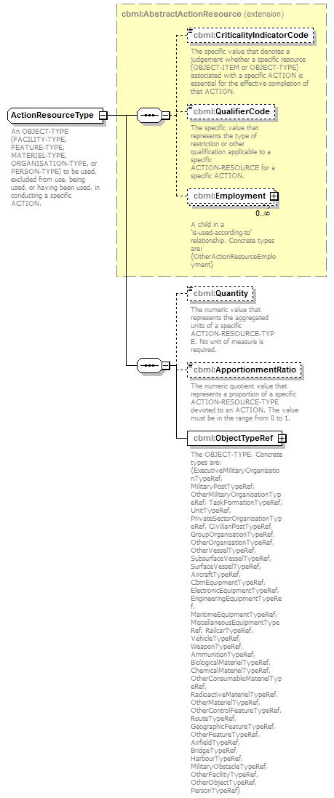
namespace | http://www.sisostds.org/schemas/c-bml/1.0
type | extension of cbml:AbstractActionResource
properties
  base | cbml:AbstractActionResource
children | cbml:CriticalityIndicatorCode cbml:QualifierCode cbml:Employment cbml:Quantity cbml:ApportionmentRatio cbml:ObjectTypeRef
annotation
  documentation
  An OBJECT-TYPE (FACILITY-TYPE, FEATURE-TYPE, MATERIEL-TYPE, ORGANISATION-TYPE, or PERSON-TYPE) to be used, excluded from use, being used, or having been used, in conducting a specific ACTION.
source | <xs:complexType name="ActionResourceType">  <xs:annotation>  <xs:documentation xml:lang="en">An OBJECT-TYPE (FACILITY-TYPE, FEATURE-TYPE, MATERIEL-TYPE, ORGANISATION-TYPE, or PERSON-TYPE) to be used, excluded from use, being used, or having been used, in conducting a specific ACTION.</xs:documentation>  </xs:annotation>  <xs:complexContent>  <xs:extension base="cbml:AbstractActionResource">  <xs:sequence>  <xs:element name="Quantity" type="jc3iedm:QuantityType9" minOccurs="0">  <xs:annotation>  <xs:documentation xml:lang="en">The numeric value that represents the aggregated units of a specific ACTION-RESOURCE-TYPE. No unit of measure is required.</xs:documentation>  </xs:annotation>  </xs:element>  <xs:element name="ApportionmentRatio" type="jc3iedm:RatioType6_5" minOccurs="0">  <xs:annotation>  <xs:documentation xml:lang="en">The numeric quotient value that represents a proportion of a specific ACTION-RESOURCE-TYPE devoted to an ACTION. The value must be in the range from 0 to 1.</xs:documentation>  </xs:annotation>  </xs:element>  <xs:element name="ObjectTypeRef" type="cbml:AbstractObjectTypeRef">  <xs:annotation>  <xs:documentation xml:lang="en">The OBJECT-TYPE. Concrete types are: {ExecutiveMilitaryOrganisationTypeRef, MilitaryPostTypeRef, OtherMilitaryOrganisationTypeRef, TaskFormationTypeRef, UnitTypeRef, PrivateSectorOrganisationTypeRef, CivilianPostTypeRef, GroupOrganisationTypeRef, OtherOrganisationTypeRef, OtherVesselTypeRef, SubsurfaceVesselTypeRef, SurfaceVesselTypeRef, AircraftTypeRef, CbrnEquipmentTypeRef, ElectronicEquipmentTypeRef, EngineeringEquipmentTypeRef, MaritimeEquipmentTypeRef, MiscellaneousEquipmentTypeRef, RailcarTypeRef, VehicleTypeRef, WeaponTypeRef, AmmunitionTypeRef, BiologicalMaterielTypeRef, ChemicalMaterielTypeRef, OtherConsumableMaterielTypeRef, RadioactiveMaterielTypeRef, OtherMaterielTypeRef, OtherControlFeatureTypeRef, RouteTypeRef, GeographicFeatureTypeRef, OtherFeatureTypeRef, AirfieldTypeRef, BridgeTypeRef, HarbourTypeRef, MilitaryObstacleTypeRef, OtherFacilityTypeRef, OtherObjectTypeRef, PersonTypeRef}</xs:documentation>  </xs:annotation>  </xs:element>  <!-- CBML Rationale: Defined at the Expression level.  <xs:choice>  <xs:element name="ObjectType" type="cbml:AbstractObjectType">  <xs:annotation>  <xs:documentation xml:lang="en">The OBJECT-TYPE.</xs:documentation>  </xs:annotation>  </xs:element>  <xs:element name="ObjectTypeRef" type="cbml:AbstractObjectTypeRef">  <xs:annotation>  <xs:documentation xml:lang="en">The OBJECT-TYPE.</xs:documentation>  </xs:annotation>  </xs:element>  </xs:choice>-->  </xs:sequence>  </xs:extension>  </xs:complexContent>  </xs:complexType>

element ActionResourceType/Quantity
diagram | 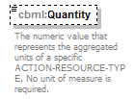
namespace | http://www.sisostds.org/schemas/c-bml/1.0
type | jc3iedm:QuantityType9
properties
  isRef | 0
  minOcc | 0
  maxOcc | 1
  content | simple
facets
  Kind | Value | annotation
  minInclusive | -999999999
  maxInclusive | 999999999
annotation
  documentation
  The numeric value that represents the aggregated units of a specific ACTION-RESOURCE-TYPE. No unit of measure is required.
source | <xs:element name="Quantity" type="jc3iedm:QuantityType9" minOccurs="0">  <xs:annotation>  <xs:documentation xml:lang="en">The numeric value that represents the aggregated units of a specific ACTION-RESOURCE-TYPE. No unit of measure is required.</xs:documentation>  </xs:annotation>  </xs:element>

element ActionResourceType/ApportionmentRatio
diagram | 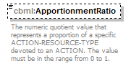
namespace | http://www.sisostds.org/schemas/c-bml/1.0
type | jc3iedm:RatioType6_5
properties
  isRef | 0
  minOcc | 0
  maxOcc | 1
  content | simple
facets
  Kind | Value | annotation
  minInclusive | -9.99999
  maxInclusive | 9.99999
  totalDigits | 6
  fractionDigits | 5
annotation
  documentation
  The numeric quotient value that represents a proportion of a specific ACTION-RESOURCE-TYPE devoted to an ACTION. The value must be in the range from 0 to 1.
source | <xs:element name="ApportionmentRatio" type="jc3iedm:RatioType6_5" minOccurs="0">  <xs:annotation>  <xs:documentation xml:lang="en">The numeric quotient value that represents a proportion of a specific ACTION-RESOURCE-TYPE devoted to an ACTION. The value must be in the range from 0 to 1.</xs:documentation>  </xs:annotation>  </xs:element>

element ActionResourceType/ObjectTypeRef
diagram
namespace | http://www.sisostds.org/schemas/c-bml/1.0
type | cbml:AbstractObjectTypeRef
properties
  isRef | 0
  content | complex
children | cbml:OID
annotation
  documentation
  The OBJECT-TYPE. Concrete types are: {ExecutiveMilitaryOrganisationTypeRef, MilitaryPostTypeRef, OtherMilitaryOrganisationTypeRef, TaskFormationTypeRef, UnitTypeRef, PrivateSectorOrganisationTypeRef, CivilianPostTypeRef, GroupOrganisationTypeRef, OtherOrganisationTypeRef, OtherVesselTypeRef, SubsurfaceVesselTypeRef, SurfaceVesselTypeRef, AircraftTypeRef, CbrnEquipmentTypeRef, ElectronicEquipmentTypeRef, EngineeringEquipmentTypeRef, MaritimeEquipmentTypeRef, MiscellaneousEquipmentTypeRef, RailcarTypeRef, VehicleTypeRef, WeaponTypeRef, AmmunitionTypeRef, BiologicalMaterielTypeRef, ChemicalMaterielTypeRef, OtherConsumableMaterielTypeRef, RadioactiveMaterielTypeRef, OtherMaterielTypeRef, OtherControlFeatureTypeRef, RouteTypeRef, GeographicFeatureTypeRef, OtherFeatureTypeRef, AirfieldTypeRef, BridgeTypeRef, HarbourTypeRef, MilitaryObstacleTypeRef, OtherFacilityTypeRef, OtherObjectTypeRef, PersonTypeRef}
source | <xs:element name="ObjectTypeRef" type="cbml:AbstractObjectTypeRef">  <xs:annotation>  <xs:documentation xml:lang="en">The OBJECT-TYPE. Concrete types are: {ExecutiveMilitaryOrganisationTypeRef, MilitaryPostTypeRef, OtherMilitaryOrganisationTypeRef, TaskFormationTypeRef, UnitTypeRef, PrivateSectorOrganisationTypeRef, CivilianPostTypeRef, GroupOrganisationTypeRef, OtherOrganisationTypeRef, OtherVesselTypeRef, SubsurfaceVesselTypeRef, SurfaceVesselTypeRef, AircraftTypeRef, CbrnEquipmentTypeRef, ElectronicEquipmentTypeRef, EngineeringEquipmentTypeRef, MaritimeEquipmentTypeRef, MiscellaneousEquipmentTypeRef, RailcarTypeRef, VehicleTypeRef, WeaponTypeRef, AmmunitionTypeRef, BiologicalMaterielTypeRef, ChemicalMaterielTypeRef, OtherConsumableMaterielTypeRef, RadioactiveMaterielTypeRef, OtherMaterielTypeRef, OtherControlFeatureTypeRef, RouteTypeRef, GeographicFeatureTypeRef, OtherFeatureTypeRef, AirfieldTypeRef, BridgeTypeRef, HarbourTypeRef, MilitaryObstacleTypeRef, OtherFacilityTypeRef, OtherObjectTypeRef, PersonTypeRef}</xs:documentation>  </xs:annotation>  </xs:element>

complexType ChemicalBiologicalEvent
diagram | 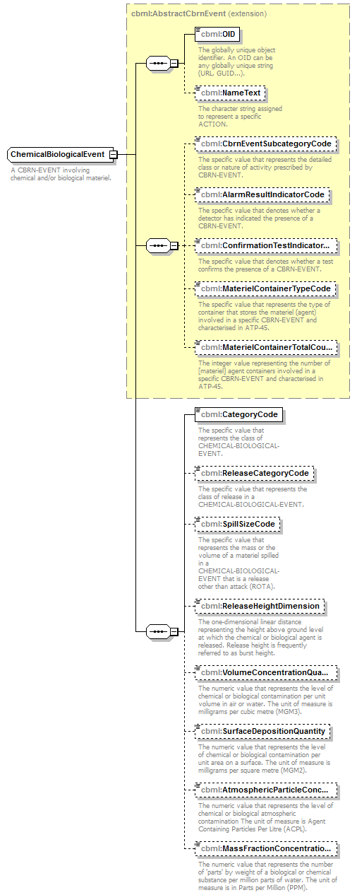
namespace | http://www.sisostds.org/schemas/c-bml/1.0
type | extension of cbml:AbstractCbrnEvent
properties
  base | cbml:AbstractCbrnEvent
children | cbml:OID cbml:NameText cbml:CbrnEventSubcategoryCode cbml:AlarmResultIndicatorCode cbml:ConfirmationTestIndicatorCode cbml:MaterielContainerTypeCode cbml:MaterielContainerTotalCount cbml:CategoryCode cbml:ReleaseCategoryCode cbml:SpillSizeCode cbml:ReleaseHeightDimension cbml:VolumeConcentrationQuantity cbml:SurfaceDepositionQuantity cbml:AtmosphericParticleConcentrationQuantity cbml:MassFractionConcentrationQuantity
annotation
  documentation
  A CBRN-EVENT involving chemical and/or biological materiel.
source | <xs:complexType name="ChemicalBiologicalEvent">  <xs:annotation>  <xs:documentation xml:lang="en">A CBRN-EVENT involving chemical and/or biological materiel.</xs:documentation>  </xs:annotation>  <xs:complexContent>  <xs:extension base="cbml:AbstractCbrnEvent">  <xs:sequence>  <xs:element name="CategoryCode" type="jc3iedm:ChemicalBiologicalEventCategoryCode">  <xs:annotation>  <xs:documentation xml:lang="en">The specific value that represents the class of CHEMICAL-BIOLOGICAL-EVENT.</xs:documentation>  </xs:annotation>  </xs:element>  <xs:element name="ReleaseCategoryCode" type="jc3iedm:ReleaseCategoryCode" minOccurs="0">  <xs:annotation>  <xs:documentation xml:lang="en">The specific value that represents the class of release in a CHEMICAL-BIOLOGICAL-EVENT.</xs:documentation>  </xs:annotation>  </xs:element>  <xs:element name="SpillSizeCode" type="jc3iedm:ChemicalBiologicalEventSpillSizeCode" minOccurs="0">  <xs:annotation>  <xs:documentation xml:lang="en">The specific value that represents the mass or the volume of a materiel spilled in a CHEMICAL-BIOLOGICAL-EVENT that is a release other than attack (ROTA).</xs:documentation>  </xs:annotation>  </xs:element>  <xs:element name="ReleaseHeightDimension" type="jc3iedm:DimensionType12_3" minOccurs="0">  <xs:annotation>  <xs:documentation xml:lang="en">The one-dimensional linear distance representing the height above ground level at which the chemical or biological agent is released. Release height is frequently referred to as burst height.</xs:documentation>  </xs:annotation>  </xs:element>  <xs:element name="VolumeConcentrationQuantity" type="jc3iedm:QuantityType14_6" minOccurs="0">  <xs:annotation>  <xs:documentation xml:lang="en">The numeric value that represents the level of chemical or biological contamination per unit volume in air or water. The unit of measure is milligrams per cubic metre (MGM3).</xs:documentation>  </xs:annotation>  </xs:element>  <xs:element name="SurfaceDepositionQuantity" type="jc3iedm:QuantityType14_6" minOccurs="0">  <xs:annotation>  <xs:documentation xml:lang="en">The numeric value that represents the level of chemical or biological contamination per unit area on a surface. The unit of measure is milligrams per square metre (MGM2).</xs:documentation>  </xs:annotation>  </xs:element>  <xs:element name="AtmosphericParticleConcentrationQuantity" type="jc3iedm:QuantityType14_6" minOccurs="0">  <xs:annotation>  <xs:documentation xml:lang="en">The numeric value that represents the level of chemical or biological atmospheric contamination The unit of measure is Agent Containing Particles Per Litre (ACPL).</xs:documentation>  </xs:annotation>  </xs:element>  <xs:element name="MassFractionConcentrationQuantity" type="jc3iedm:QuantityType14_6" minOccurs="0">  <xs:annotation>  <xs:documentation xml:lang="en">The numeric value that represents the number of 'parts' by weight of a biological or chemical substance per million parts of water. The unit of measure is in Parts per Million (PPM).</xs:documentation>  </xs:annotation>  </xs:element>  </xs:sequence>  </xs:extension>  </xs:complexContent>  </xs:complexType>

element ChemicalBiologicalEvent/CategoryCode
diagram | 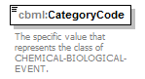
namespace | http://www.sisostds.org/schemas/c-bml/1.0
type | jc3iedm:ChemicalBiologicalEventCategoryCode
properties
  isRef | 0
  content | simple
facets
  Kind | Value | annotation
  enumeration | BIOALM
    documentation
    <Definition xml:lang="en">An action by which a biological detector is triggered or a group is warned.</Definition>
    appinfo
    <DisplayValue xml:lang="en">Biological alarm</DisplayValue>
  enumeration | BIOATT
    documentation
    <Definition xml:lang="en">Employing the use of biological materiel(s) [agent(s)] to kill, injure, or incapacitate, for a significant period of time, man or animals, and deny or hinder the use of areas, facilities or materiel, or defence against such employment.</Definition>
    appinfo
    <DisplayValue xml:lang="en">Biological attack</DisplayValue>
  enumeration | BIOSMP
    documentation
    <Definition xml:lang="en">The action of detecting a biological contaminant.</Definition>
    appinfo
    <DisplayValue xml:lang="en">Biological sampling</DisplayValue>
  enumeration | BIROTA
    documentation
    <Definition xml:lang="en">The release of a biological agent or toxin into the environment intentionally or accidentally but not for the intended purpose of conducting an attack.</Definition>
    appinfo
    <DisplayValue xml:lang="en">Biological release other than attack (ROTA)</DisplayValue>
  enumeration | CBFAC
    documentation
    <Definition xml:lang="en">An event that involves viable agent released to the atmosphere following a strike against a facility containing chemical warfare agent(s) and/or biological warfare agent(s).</Definition>
    appinfo
    <DisplayValue xml:lang="en">Chemical/biological facility event</DisplayValue>
  enumeration | CHMALM
    documentation
    <Definition xml:lang="en">An action by which a chemical detector is triggered or a group is warned.</Definition>
    appinfo
    <DisplayValue xml:lang="en">Chemical alarm</DisplayValue>
  enumeration | CHMATT
    documentation
    <Definition xml:lang="en">Employing the use of chemical materiel(s) [agent(s)] to produce casualties in man or animals and damage to plants or materiel; or defence against such employment.</Definition>
    appinfo
    <DisplayValue xml:lang="en">Chemical attack</DisplayValue>
  enumeration | CHMSMP
    documentation
    <Definition xml:lang="en">The action of detecting a chemical contaminant.</Definition>
    appinfo
    <DisplayValue xml:lang="en">Chemical sampling</DisplayValue>
  enumeration | CHROTA
    documentation
    <Definition xml:lang="en">The release of chemicals or chemical agents into the environment intentionally or accidentally but not for the intended purpose of conducting an attack.</Definition>
    appinfo
    <DisplayValue xml:lang="en">Chemical release other than attack (ROTA)</DisplayValue>
  enumeration | NKN
    documentation
    <Definition xml:lang="en">It is not possible to determine which value is most applicable.</Definition>
    appinfo
    <DisplayValue xml:lang="en">Not known</DisplayValue>
annotation
  documentation
  The specific value that represents the class of CHEMICAL-BIOLOGICAL-EVENT.
source | <xs:element name="CategoryCode" type="jc3iedm:ChemicalBiologicalEventCategoryCode">  <xs:annotation>  <xs:documentation xml:lang="en">The specific value that represents the class of CHEMICAL-BIOLOGICAL-EVENT.</xs:documentation>  </xs:annotation>  </xs:element>

element ChemicalBiologicalEvent/ReleaseCategoryCode
diagram | 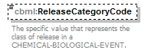
namespace | http://www.sisostds.org/schemas/c-bml/1.0
type | jc3iedm:ReleaseCategoryCode
properties
  isRef | 0
  minOcc | 0
  maxOcc | 1
  content | simple
facets
  Kind | Value | annotation
  enumeration | CONT
    documentation
    <Definition xml:lang="en">A continuous discharge of a contaminant release in a release other than attack (ROTA) event.</Definition>
    appinfo
    <DisplayValue xml:lang="en">Continuous</DisplayValue>
  enumeration | NKN
    documentation
    <Definition xml:lang="en">It is not possible to determine which value is most applicable.</Definition>
    appinfo
    <DisplayValue xml:lang="en">Not known</DisplayValue>
  enumeration | NOS
    documentation
    <Definition xml:lang="en">The appropriate value is not in the set of specified values.</Definition>
    appinfo
    <DisplayValue xml:lang="en">Not otherwise specified</DisplayValue>
  enumeration | PUFF
    documentation
    <Definition xml:lang="en">A single discharge of a contaminant release in a release other than attack (ROTA) event.</Definition>
    appinfo
    <DisplayValue xml:lang="en">Single release of a cloud</DisplayValue>
  enumeration | SPRAY
    documentation
    <Definition xml:lang="en">The spraying of a contaminant in a release other than attack (ROTA) event.</Definition>
    appinfo
    <DisplayValue xml:lang="en">Spraying</DisplayValue>
annotation
  documentation
  The specific value that represents the class of release in a CHEMICAL-BIOLOGICAL-EVENT.
source | <xs:element name="ReleaseCategoryCode" type="jc3iedm:ReleaseCategoryCode" minOccurs="0">  <xs:annotation>  <xs:documentation xml:lang="en">The specific value that represents the class of release in a CHEMICAL-BIOLOGICAL-EVENT.</xs:documentation>  </xs:annotation>  </xs:element>

element ChemicalBiologicalEvent/SpillSizeCode
diagram | 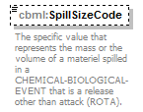
namespace | http://www.sisostds.org/schemas/c-bml/1.0
type | jc3iedm:ChemicalBiologicalEventSpillSizeCode
properties
  isRef | 0
  minOcc | 0
  maxOcc | 1
  content | simple
facets
  Kind | Value | annotation
  enumeration | LRG
    documentation
    <Definition xml:lang="en">Equal to or greater than 208 litres and less than or equal to 1500 litres in volume or equal to or greater than 200 kilograms and less than or equal to 1500 kilograms in mass.</Definition>
    appinfo
    <DisplayValue xml:lang="en">Large</DisplayValue>
  enumeration | NKN
    documentation
    <Definition xml:lang="en">It is not possible to determine which value is most applicable.</Definition>
    appinfo
    <DisplayValue xml:lang="en">Not known</DisplayValue>
  enumeration | SML
    documentation
    <Definition xml:lang="en">Less than 208 litres in volume or 200 kilograms in mass.</Definition>
    appinfo
    <DisplayValue xml:lang="en">Small</DisplayValue>
  enumeration | XLG
    documentation
    <Definition xml:lang="en">Greater than 1500 litres in volume or 1500 kilograms in mass.</Definition>
    appinfo
    <DisplayValue xml:lang="en">Extra large</DisplayValue>
annotation
  documentation
  The specific value that represents the mass or the volume of a materiel spilled in a CHEMICAL-BIOLOGICAL-EVENT that is a release other than attack (ROTA).
source | <xs:element name="SpillSizeCode" type="jc3iedm:ChemicalBiologicalEventSpillSizeCode" minOccurs="0">  <xs:annotation>  <xs:documentation xml:lang="en">The specific value that represents the mass or the volume of a materiel spilled in a CHEMICAL-BIOLOGICAL-EVENT that is a release other than attack (ROTA).</xs:documentation>  </xs:annotation>  </xs:element>

element ChemicalBiologicalEvent/ReleaseHeightDimension
diagram | 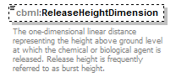
namespace | http://www.sisostds.org/schemas/c-bml/1.0
type | jc3iedm:DimensionType12_3
properties
  isRef | 0
  minOcc | 0
  maxOcc | 1
  content | simple
facets
  Kind | Value | annotation
  minInclusive | -999999999.999
  maxInclusive | 999999999.999
  totalDigits | 12
  fractionDigits | 3
annotation
  documentation
  The one-dimensional linear distance representing the height above ground level at which the chemical or biological agent is released. Release height is frequently referred to as burst height.
source | <xs:element name="ReleaseHeightDimension" type="jc3iedm:DimensionType12_3" minOccurs="0">  <xs:annotation>  <xs:documentation xml:lang="en">The one-dimensional linear distance representing the height above ground level at which the chemical or biological agent is released. Release height is frequently referred to as burst height.</xs:documentation>  </xs:annotation>  </xs:element>

element ChemicalBiologicalEvent/VolumeConcentrationQuantity
diagram | 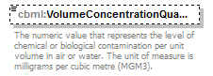
namespace | http://www.sisostds.org/schemas/c-bml/1.0
type | jc3iedm:QuantityType14_6
properties
  isRef | 0
  minOcc | 0
  maxOcc | 1
  content | simple
facets
  Kind | Value | annotation
  minInclusive | -99999999.999999
  maxInclusive | 99999999.999999
  totalDigits | 14
  fractionDigits | 6
annotation
  documentation
  The numeric value that represents the level of chemical or biological contamination per unit volume in air or water. The unit of measure is milligrams per cubic metre (MGM3).
source | <xs:element name="VolumeConcentrationQuantity" type="jc3iedm:QuantityType14_6" minOccurs="0">  <xs:annotation>  <xs:documentation xml:lang="en">The numeric value that represents the level of chemical or biological contamination per unit volume in air or water. The unit of measure is milligrams per cubic metre (MGM3).</xs:documentation>  </xs:annotation>  </xs:element>

element ChemicalBiologicalEvent/SurfaceDepositionQuantity
diagram | 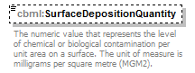
namespace | http://www.sisostds.org/schemas/c-bml/1.0
type | jc3iedm:QuantityType14_6
properties
  isRef | 0
  minOcc | 0
  maxOcc | 1
  content | simple
facets
  Kind | Value | annotation
  minInclusive | -99999999.999999
  maxInclusive | 99999999.999999
  totalDigits | 14
  fractionDigits | 6
annotation
  documentation
  The numeric value that represents the level of chemical or biological contamination per unit area on a surface. The unit of measure is milligrams per square metre (MGM2).
source | <xs:element name="SurfaceDepositionQuantity" type="jc3iedm:QuantityType14_6" minOccurs="0">  <xs:annotation>  <xs:documentation xml:lang="en">The numeric value that represents the level of chemical or biological contamination per unit area on a surface. The unit of measure is milligrams per square metre (MGM2).</xs:documentation>  </xs:annotation>  </xs:element>

element ChemicalBiologicalEvent/AtmosphericParticleConcentrationQuantity
diagram | 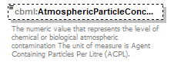
namespace | http://www.sisostds.org/schemas/c-bml/1.0
type | jc3iedm:QuantityType14_6
properties
  isRef | 0
  minOcc | 0
  maxOcc | 1
  content | simple
facets
  Kind | Value | annotation
  minInclusive | -99999999.999999
  maxInclusive | 99999999.999999
  totalDigits | 14
  fractionDigits | 6
annotation
  documentation
  The numeric value that represents the level of chemical or biological atmospheric contamination The unit of measure is Agent Containing Particles Per Litre (ACPL).
source | <xs:element name="AtmosphericParticleConcentrationQuantity" type="jc3iedm:QuantityType14_6" minOccurs="0">  <xs:annotation>  <xs:documentation xml:lang="en">The numeric value that represents the level of chemical or biological atmospheric contamination The unit of measure is Agent Containing Particles Per Litre (ACPL).</xs:documentation>  </xs:annotation>  </xs:element>

element ChemicalBiologicalEvent/MassFractionConcentrationQuantity
diagram | 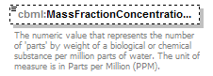
namespace | http://www.sisostds.org/schemas/c-bml/1.0
type | jc3iedm:QuantityType14_6
properties
  isRef | 0
  minOcc | 0
  maxOcc | 1
  content | simple
facets
  Kind | Value | annotation
  minInclusive | -99999999.999999
  maxInclusive | 99999999.999999
  totalDigits | 14
  fractionDigits | 6
annotation
  documentation
  The numeric value that represents the number of 'parts' by weight of a biological or chemical substance per million parts of water. The unit of measure is in Parts per Million (PPM).
source | <xs:element name="MassFractionConcentrationQuantity" type="jc3iedm:QuantityType14_6" minOccurs="0">  <xs:annotation>  <xs:documentation xml:lang="en">The numeric value that represents the number of 'parts' by weight of a biological or chemical substance per million parts of water. The unit of measure is in Parts per Million (PPM).</xs:documentation>  </xs:annotation>  </xs:element>

complexType ChemicalBiologicalEventRef
diagram | 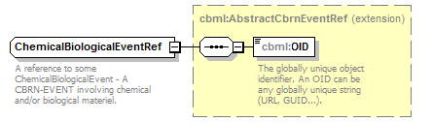
namespace | http://www.sisostds.org/schemas/c-bml/1.0
type | extension of cbml:AbstractCbrnEventRef
properties
  base | cbml:AbstractCbrnEventRef
children | cbml:OID
annotation
  documentation
  A reference to some ChemicalBiologicalEvent - A CBRN-EVENT involving chemical and/or biological materiel.
source | <xs:complexType name="ChemicalBiologicalEventRef">  <xs:annotation>  <xs:documentation xml:lang="en">A reference to some ChemicalBiologicalEvent - A CBRN-EVENT involving chemical and/or biological materiel.</xs:documentation>  </xs:annotation>  <xs:complexContent>  <xs:extension base="cbml:AbstractCbrnEventRef"/>  </xs:complexContent>  </xs:complexType>

complexType NuclearWeaponEvent
diagram | 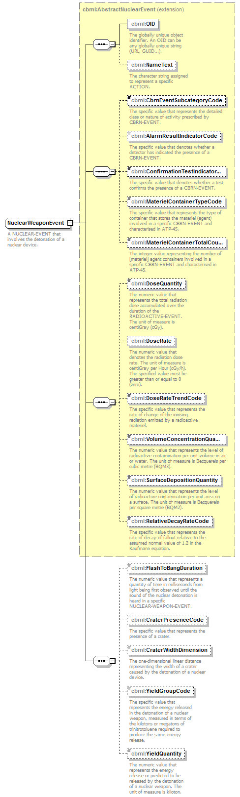
namespace | http://www.sisostds.org/schemas/c-bml/1.0
type | extension of cbml:AbstractNuclearEvent
properties
  base | cbml:AbstractNuclearEvent
children | cbml:OID cbml:NameText cbml:CbrnEventSubcategoryCode cbml:AlarmResultIndicatorCode cbml:ConfirmationTestIndicatorCode cbml:MaterielContainerTypeCode cbml:MaterielContainerTotalCount cbml:DoseQuantity cbml:DoseRate cbml:DoseRateTrendCode cbml:VolumeConcentrationQuantity cbml:SurfaceDepositionQuantity cbml:RelativeDecayRateCode cbml:FlashToBangDuration cbml:CraterPresenceCode cbml:CraterWidthDimension cbml:YieldGroupCode cbml:YieldQuantity
annotation
  documentation
  A NUCLEAR-EVENT that involves the detonation of a nuclear device.
source | <xs:complexType name="NuclearWeaponEvent">  <xs:annotation>  <xs:documentation xml:lang="en">A NUCLEAR-EVENT that involves the detonation of a nuclear device.</xs:documentation>  </xs:annotation>  <xs:complexContent>  <xs:extension base="cbml:AbstractNuclearEvent">  <xs:sequence>  <xs:element name="FlashToBangDuration" type="jc3iedm:DurationType19" minOccurs="0">  <xs:annotation>  <xs:documentation xml:lang="en">The numeric value that represents a quantity of time in milliseconds from light being first observed until the sound of the nuclear detonation is heard in a specific NUCLEAR-WEAPON-EVENT.</xs:documentation>  </xs:annotation>  </xs:element>  <xs:element name="CraterPresenceCode" type="jc3iedm:NuclearWeaponEventCraterPresenceCode" minOccurs="0">  <xs:annotation>  <xs:documentation xml:lang="en">The specific value that represents the presence of a crater.</xs:documentation>  </xs:annotation>  </xs:element>  <xs:element name="CraterWidthDimension" type="jc3iedm:DimensionType12_3" minOccurs="0">  <xs:annotation>  <xs:documentation xml:lang="en">The one-dimensional linear distance representing the width of a crater caused by the detonation of a nuclear device.</xs:documentation>  </xs:annotation>  </xs:element>  <xs:element name="YieldGroupCode" type="jc3iedm:NuclearYieldGroupCode" minOccurs="0">  <xs:annotation>  <xs:documentation xml:lang="en">The specific value that represents the energy released in the detonation of a nuclear weapon, measured in terms of the kilotons or megatons of trinitrotoluene required to produce the same energy release.</xs:documentation>  </xs:annotation>  </xs:element>  <xs:element name="YieldQuantity" type="jc3iedm:QuantityType4" minOccurs="0">  <xs:annotation>  <xs:documentation xml:lang="en">The numeric value that represents the energy release or predicted to be released by the detonation of a nuclear weapon. The unit of measure is kiloton.</xs:documentation>  </xs:annotation>  </xs:element>  </xs:sequence>  </xs:extension>  </xs:complexContent>  </xs:complexType>

element NuclearWeaponEvent/FlashToBangDuration
diagram | 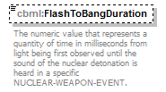
namespace | http://www.sisostds.org/schemas/c-bml/1.0
type | jc3iedm:DurationType19
properties
  isRef | 0
  minOcc | 0
  maxOcc | 1
  content | simple
facets
  Kind | Value | annotation
  minInclusive | -9999999999999999999
  maxInclusive | 9999999999999999999
annotation
  documentation
  The numeric value that represents a quantity of time in milliseconds from light being first observed until the sound of the nuclear detonation is heard in a specific NUCLEAR-WEAPON-EVENT.
source | <xs:element name="FlashToBangDuration" type="jc3iedm:DurationType19" minOccurs="0">  <xs:annotation>  <xs:documentation xml:lang="en">The numeric value that represents a quantity of time in milliseconds from light being first observed until the sound of the nuclear detonation is heard in a specific NUCLEAR-WEAPON-EVENT.</xs:documentation>  </xs:annotation>  </xs:element>

element NuclearWeaponEvent/CraterPresenceCode
diagram | 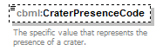
namespace | http://www.sisostds.org/schemas/c-bml/1.0
type | jc3iedm:NuclearWeaponEventCraterPresenceCode
properties
  isRef | 0
  minOcc | 0
  maxOcc | 1
  content | simple
facets
  Kind | Value | annotation
  enumeration | CRATER
    documentation
    <Definition xml:lang="en">There is a crater present.</Definition>
    appinfo
    <DisplayValue xml:lang="en">Crater present</DisplayValue>
  enumeration | NKN
    documentation
    <Definition xml:lang="en">It is not possible to determine which value is most applicable.</Definition>
    appinfo
    <DisplayValue xml:lang="en">Not known</DisplayValue>
  enumeration | NONE
    documentation
    <Definition xml:lang="en">There is a no crater present.</Definition>
    appinfo
    <DisplayValue xml:lang="en">No crater present</DisplayValue>
annotation
  documentation
  The specific value that represents the presence of a crater.
source | <xs:element name="CraterPresenceCode" type="jc3iedm:NuclearWeaponEventCraterPresenceCode" minOccurs="0">  <xs:annotation>  <xs:documentation xml:lang="en">The specific value that represents the presence of a crater.</xs:documentation>  </xs:annotation>  </xs:element>

element NuclearWeaponEvent/CraterWidthDimension
diagram | 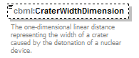
namespace | http://www.sisostds.org/schemas/c-bml/1.0
type | jc3iedm:DimensionType12_3
properties
  isRef | 0
  minOcc | 0
  maxOcc | 1
  content | simple
facets
  Kind | Value | annotation
  minInclusive | -999999999.999
  maxInclusive | 999999999.999
  totalDigits | 12
  fractionDigits | 3
annotation
  documentation
  The one-dimensional linear distance representing the width of a crater caused by the detonation of a nuclear device.
source | <xs:element name="CraterWidthDimension" type="jc3iedm:DimensionType12_3" minOccurs="0">  <xs:annotation>  <xs:documentation xml:lang="en">The one-dimensional linear distance representing the width of a crater caused by the detonation of a nuclear device.</xs:documentation>  </xs:annotation>  </xs:element>

element NuclearWeaponEvent/YieldGroupCode
diagram | 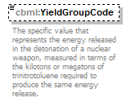
namespace | http://www.sisostds.org/schemas/c-bml/1.0
type | jc3iedm:NuclearYieldGroupCode
properties
  isRef | 0
  minOcc | 0
  maxOcc | 1
  content | simple
facets
  Kind | Value | annotation
  enumeration | ALFA
    documentation
    <Definition xml:lang="en">Yield Group ALFA is less than 2 KT.</Definition>
    appinfo
    <DisplayValue xml:lang="en">ALFA</DisplayValue>
  enumeration | BRAVO
    documentation
    <Definition xml:lang="en">Yield Group BRAVO is 2 KT to less than 5 KT.</Definition>
    appinfo
    <DisplayValue xml:lang="en">BRAVO</DisplayValue>
  enumeration | CHARLI
    documentation
    <Definition xml:lang="en">Yield Group CHARLIE is 5 KT to less than 30 KT.</Definition>
    appinfo
    <DisplayValue xml:lang="en">CHARLIE</DisplayValue>
  enumeration | DELTA
    documentation
    <Definition xml:lang="en">Yield Group DELTA is 30 KT to less than 100 KT.</Definition>
    appinfo
    <DisplayValue xml:lang="en">DELTA</DisplayValue>
  enumeration | ECHO
    documentation
    <Definition xml:lang="en">Yield Group ECHO is 100 KT to less than 300 KT.</Definition>
    appinfo
    <DisplayValue xml:lang="en">ECHO</DisplayValue>
  enumeration | FOXTRT
    documentation
    <Definition xml:lang="en">Yield Group FOXTROT is 300 KT to less than 1000 KT.</Definition>
    appinfo
    <DisplayValue xml:lang="en">FOXTROT</DisplayValue>
  enumeration | GOLF
    documentation
    <Definition xml:lang="en">Yield Group GOLF is 1000 KT to less than 3000 KT.</Definition>
    appinfo
    <DisplayValue xml:lang="en">GOLF</DisplayValue>
  enumeration | NKN
    documentation
    <Definition xml:lang="en">It is not possible to determine which value is most applicable.</Definition>
    appinfo
    <DisplayValue xml:lang="en">Not known</DisplayValue>
  enumeration | NOS
    documentation
    <Definition xml:lang="en">The appropriate value is not in the set of specified values.</Definition>
    appinfo
    <DisplayValue xml:lang="en">Not otherwise specified</DisplayValue>
annotation
  documentation
  The specific value that represents the energy released in the detonation of a nuclear weapon, measured in terms of the kilotons or megatons of trinitrotoluene required to produce the same energy release.
source | <xs:element name="YieldGroupCode" type="jc3iedm:NuclearYieldGroupCode" minOccurs="0">  <xs:annotation>  <xs:documentation xml:lang="en">The specific value that represents the energy released in the detonation of a nuclear weapon, measured in terms of the kilotons or megatons of trinitrotoluene required to produce the same energy release.</xs:documentation>  </xs:annotation>  </xs:element>

element NuclearWeaponEvent/YieldQuantity
diagram | 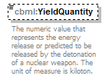
namespace | http://www.sisostds.org/schemas/c-bml/1.0
type | jc3iedm:QuantityType4
properties
  isRef | 0
  minOcc | 0
  maxOcc | 1
  content | simple
facets
  Kind | Value | annotation
  minInclusive | -9999
  maxInclusive | 9999
annotation
  documentation
  The numeric value that represents the energy release or predicted to be released by the detonation of a nuclear weapon. The unit of measure is kiloton.
source | <xs:element name="YieldQuantity" type="jc3iedm:QuantityType4" minOccurs="0">  <xs:annotation>  <xs:documentation xml:lang="en">The numeric value that represents the energy release or predicted to be released by the detonation of a nuclear weapon. The unit of measure is kiloton.</xs:documentation>  </xs:annotation>  </xs:element>

complexType NuclearWeaponEventRef
diagram | 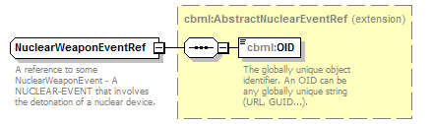
namespace | http://www.sisostds.org/schemas/c-bml/1.0
type | extension of cbml:AbstractNuclearEventRef
properties
  base | cbml:AbstractNuclearEventRef
children | cbml:OID
annotation
  documentation
  A reference to some NuclearWeaponEvent - A NUCLEAR-EVENT that involves the detonation of a nuclear device.
source | <xs:complexType name="NuclearWeaponEventRef">  <xs:annotation>  <xs:documentation xml:lang="en">A reference to some NuclearWeaponEvent - A NUCLEAR-EVENT that involves the detonation of a nuclear device.</xs:documentation>  </xs:annotation>  <xs:complexContent>  <xs:extension base="cbml:AbstractNuclearEventRef"/>  </xs:complexContent>  </xs:complexType>

complexType OtherActionEvent
diagram | 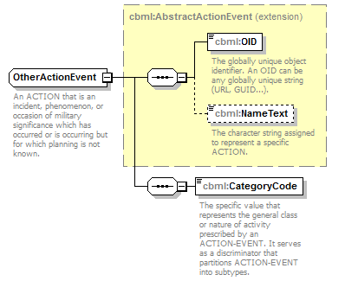
namespace | http://www.sisostds.org/schemas/c-bml/1.0
type | extension of cbml:AbstractActionEvent
properties
  base | cbml:AbstractActionEvent
children | cbml:OID cbml:NameText cbml:CategoryCode
annotation
  documentation
  An ACTION that is an incident, phenomenon, or occasion of military significance which has occurred or is occurring but for which planning is not known.
source | <xs:complexType name="OtherActionEvent">  <xs:annotation>  <xs:documentation xml:lang="en">An ACTION that is an incident, phenomenon, or occasion of military significance which has occurred or is occurring but for which planning is not known.</xs:documentation>  </xs:annotation>  <xs:complexContent>  <xs:extension base="cbml:AbstractActionEvent">  <xs:sequence>  <xs:element name="CategoryCode" type="jc3iedm:ActionEventCategoryCode">  <xs:annotation>  <xs:documentation xml:lang="en">The specific value that represents the general class or nature of activity prescribed by an ACTION-EVENT. It serves as a discriminator that partitions ACTION-EVENT into subtypes.</xs:documentation>  </xs:annotation>  </xs:element>  </xs:sequence>  </xs:extension>  </xs:complexContent>  </xs:complexType>

element OtherActionEvent/CategoryCode
diagram | 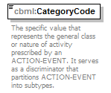
namespace | http://www.sisostds.org/schemas/c-bml/1.0
type | jc3iedm:ActionEventCategoryCode
properties
  isRef | 0
  content | simple
facets
  Kind | Value | annotation
  enumeration | ABDICA
    documentation
    <Definition xml:lang="en">The renouncement by a person of his official functions.</Definition>
    appinfo
    <DisplayValue xml:lang="en">Abdication</DisplayValue>
  enumeration | ACCAIR
    documentation
    <Definition xml:lang="en">An accident involving an aircraft during ground operations or maintenance.</Definition>
    appinfo
    <DisplayValue xml:lang="en">Accident, aircraft ground</DisplayValue>
  enumeration | ACCDNT
    documentation
    <Definition xml:lang="en">An unfortunate event, esp. one causing physical harm or damage, brought about unintentionally.</Definition>
    appinfo
    <DisplayValue xml:lang="en">Accident</DisplayValue>
  enumeration | ACCMNE
    documentation
    <Definition xml:lang="en">An accident involving unexploded ordnance.</Definition>
    appinfo
    <DisplayValue xml:lang="en">Accident, mine</DisplayValue>
  enumeration | ACCTRF
    documentation
    <Definition xml:lang="en">An accident involving at least one motor vehicle.</Definition>
    appinfo
    <DisplayValue xml:lang="en">Accident, traffic</DisplayValue>
  enumeration | ACCWPN
    documentation
    <Definition xml:lang="en">An accident involving a weapon.</Definition>
    appinfo
    <DisplayValue xml:lang="en">Accident, weapon</DisplayValue>
  enumeration | ACCWRK
    documentation
    <Definition xml:lang="en">An accident occurring at the workplace.</Definition>
    appinfo
    <DisplayValue xml:lang="en">Accident, workplace</DisplayValue>
  enumeration | ACRLOS
    documentation
    <Definition xml:lang="en">The unforeseen loss of an aircraft (and personnel), other than crash.</Definition>
    appinfo
    <DisplayValue xml:lang="en">Aircraft loss</DisplayValue>
  enumeration | ADVANC
    documentation
    <Definition xml:lang="en">Moving towards an objective in some form of tactical formation. This is a transitional phase between operations that may or may not result in contact with the enemy.</Definition>
    appinfo
    <DisplayValue xml:lang="en">Advancing</DisplayValue>
  enumeration | AERENG
    documentation
    <Definition xml:lang="en">The occurrence of a hostile encounter between military aircraft.</Definition>
    appinfo
    <DisplayValue xml:lang="en">Aerial engagement</DisplayValue>
  enumeration | AERSHO
    documentation
    <Definition xml:lang="en">The deliberate destruction of an aircraft.</Definition>
    appinfo
    <DisplayValue xml:lang="en">Aerial shoot down</DisplayValue>
  enumeration | AIRCRS
    documentation
    <Definition xml:lang="en">The unforeseen destruction or damage of an aircraft (and personnel).</Definition>
    appinfo
    <DisplayValue xml:lang="en">Aircraft crash</DisplayValue>
  enumeration | AIRLAU
    documentation
    <Definition xml:lang="en">The occurrence of one or more aircraft taking off.</Definition>
    appinfo
    <DisplayValue xml:lang="en">Aircraft launch activity</DisplayValue>
  enumeration | AIRLND
    documentation
    <Definition xml:lang="en">The action of approaching and alighting on the ground or some other surface after a flight.</Definition>
    appinfo
    <DisplayValue xml:lang="en">Aircraft landing</DisplayValue>
  enumeration | AIRVIO
    documentation
    <Definition xml:lang="en">The invasion of the declared own airspace by an aircraft.</Definition>
    appinfo
    <DisplayValue xml:lang="en">Airspace violation</DisplayValue>
  enumeration | ALRCAN
    documentation
    <Definition xml:lang="en">The end of a state of readiness.</Definition>
    appinfo
    <DisplayValue xml:lang="en">Alert cancellation</DisplayValue>
  enumeration | AMBUSH
    documentation
    <Definition xml:lang="en">A surprise attack by fire or other destructive means from concealed positions on a moving or temporarily halted force or group of personnel.</Definition>
    appinfo
    <DisplayValue xml:lang="en">Ambush</DisplayValue>
  enumeration | AMPH
    documentation
    <Definition xml:lang="en">Mounting an operation launched from the sea by naval and land forces against a hostile, or potentially hostile shore.</Definition>
    appinfo
    <DisplayValue xml:lang="en">Amphibious operation</DisplayValue>
  enumeration | ARASLT
    documentation
    <Definition xml:lang="en">Mounting an assault utilising a mixture of aviation and ground transport, the principal feature of which is the insertion of combat power.</Definition>
    appinfo
    <DisplayValue xml:lang="en">Air assault</DisplayValue>
  enumeration | ARBNAS
    documentation
    <Definition xml:lang="en">Mounting an airborne operation, a phase beginning with delivery by air of the assault echelon of the force into the objective area and extending through attack of assault objectives and consolidation of the initial airhead.</Definition>
    appinfo
    <DisplayValue xml:lang="en">Airborne assault</DisplayValue>
  enumeration | ARMPRD
    documentation
    <Definition xml:lang="en">An activity of, relating to or based on the production of arms.</Definition>
    appinfo
    <DisplayValue xml:lang="en">Arms production</DisplayValue>
  enumeration | ARMTRD
    documentation
    <Definition xml:lang="en">A happening of selling or buying of arms.</Definition>
    appinfo
    <DisplayValue xml:lang="en">Arms trade</DisplayValue>
  enumeration | ARRLGL
    documentation
    <Definition xml:lang="en">Seizing and detaining of a person under authority of the law.</Definition>
    appinfo
    <DisplayValue xml:lang="en">Arresting, legal</DisplayValue>
  enumeration | ARROBS
    documentation
    <Definition xml:lang="en">Stopping or checking of the motion, progress, growth, or spread of something.</Definition>
    appinfo
    <DisplayValue xml:lang="en">Arresting/obstructing</DisplayValue>
  enumeration | ARSON
    documentation
    <Definition xml:lang="en">The crime of maliciously setting fire to the property of another or of burning one's own property for an improper purpose, as to collect insurance.</Definition>
    appinfo
    <DisplayValue xml:lang="en">Arson</DisplayValue>
  enumeration | ARTFIR
    documentation
    <Definition xml:lang="en">The use of artillery fire.</Definition>
    appinfo
    <DisplayValue xml:lang="en">Artillery fire</DisplayValue>
  enumeration | ASSMBL
    documentation
    <Definition xml:lang="en">Joining together of multiple objects in the same area.</Definition>
    appinfo
    <DisplayValue xml:lang="en">Assembling</DisplayValue>
  enumeration | ASSNTN
    documentation
    <Definition xml:lang="en">Murder of a prominent person.</Definition>
    appinfo
    <DisplayValue xml:lang="en">Assassination</DisplayValue>
  enumeration | ASTCRM
    documentation
    <Definition xml:lang="en">Assisting or abetting a known criminal or terrorist.</Definition>
    appinfo
    <DisplayValue xml:lang="en">Assisting a criminal</DisplayValue>
  enumeration | ATMPOL
    documentation
    <Definition xml:lang="en">Contamination of the atmosphere caused by a poison or toxin.</Definition>
    appinfo
    <DisplayValue xml:lang="en">Atmospheric pollution</DisplayValue>
  enumeration | ATMRDR
    documentation
    <Definition xml:lang="en">The attempted act of unlawfully killing of one human being by another, especially with premeditated malice.</Definition>
    appinfo
    <DisplayValue xml:lang="en">Attempted murder</DisplayValue>
  enumeration | ATRAPE
    documentation
    <Definition xml:lang="en">The attempted act of forcing another person to submit to sexual intercourse.</Definition>
    appinfo
    <DisplayValue xml:lang="en">Attempted rape</DisplayValue>
  enumeration | ATRBRY
    documentation
    <Definition xml:lang="en">The attempted act of robbing a person or place.</Definition>
    appinfo
    <DisplayValue xml:lang="en">Attempted robbery</DisplayValue>
  enumeration | ATSCDE
    documentation
    <Definition xml:lang="en">The attempted act of killing oneself intentionally.</Definition>
    appinfo
    <DisplayValue xml:lang="en">Attempted suicide</DisplayValue>
  enumeration | ATTACK
    documentation
    <Definition xml:lang="en">Conducting an offensive operation characterised by coordinated employment of firepower and manoeuvre to close with and destroy or capture the enemy.</Definition>
    appinfo
    <DisplayValue xml:lang="en">Attack, not otherwise specified</DisplayValue>
  enumeration | ATTDVR
    documentation
    <Definition xml:lang="en">Conducting an attack wherein a force attacks, or threatens to attack, a target other than the main target for the purpose of drawing enemy defences away from the main effort.</Definition>
    appinfo
    <DisplayValue xml:lang="en">Attack, diversion</DisplayValue>
  enumeration | ATTEL
    documentation
    <Definition xml:lang="en">Conducting electronic warfare involving the use of electromagnetic energy, directed energy or anti-radiation weapons to attack personnel, facilities, or equipment with the intent of degrading, neutralizing, or destroying enemy combat capability and is considered a form of fires.</Definition>
    appinfo
    <DisplayValue xml:lang="en">Attack, electronic</DisplayValue>
  enumeration | ATTMN
    documentation
    <Definition xml:lang="en">Conducting the principal attack or effort into which the commander throws the full weight of the offensive power at his disposal. An attack directed against the chief objective of the campaign or battle.</Definition>
    appinfo
    <DisplayValue xml:lang="en">Attack, main</DisplayValue>
  enumeration | ATTSPT
    documentation
    <Definition xml:lang="en">Conducting an offensive operation carried out in conjunction with a main attack and designed to achieve one or more of the following: a. deceive the enemy; b. destroy or pin down enemy forces which could interfere with the main attack; c. control ground whose occupation by the enemy will hinder the main attack; or d. force the enemy to commit reserves prematurely or in an indecisive area.</Definition>
    appinfo
    <DisplayValue xml:lang="en">Attack, supporting</DisplayValue>
  enumeration | AVOIDN
    documentation
    <Definition xml:lang="en">Staying clear of a specified object.</Definition>
    appinfo
    <DisplayValue xml:lang="en">Avoiding</DisplayValue>
  enumeration | BBYTRD
    documentation
    <Definition xml:lang="en">The detection of a device intended to cause damage to unsuspecting people.</Definition>
    appinfo
    <DisplayValue xml:lang="en">Booby trap discovery</DisplayValue>
  enumeration | BCESC
    documentation
    <Definition xml:lang="en">A border crossing that is conducted under escort.</Definition>
    appinfo
    <DisplayValue xml:lang="en">Border crossing, escorted</DisplayValue>
  enumeration | BCFRCD
    documentation
    <Definition xml:lang="en">A border crossing that is conducted under pressure.</Definition>
    appinfo
    <DisplayValue xml:lang="en">Border crossing, forced</DisplayValue>
  enumeration | BCILGL
    documentation
    <Definition xml:lang="en">A border crossing that is forbidden by law.</Definition>
    appinfo
    <DisplayValue xml:lang="en">Border crossing, illegal</DisplayValue>
  enumeration | BCNTPL
    documentation
    <Definition xml:lang="en">A border crossing that is unplanned.</Definition>
    appinfo
    <DisplayValue xml:lang="en">Border crossing, not-planned</DisplayValue>
  enumeration | BCPLND
    documentation
    <Definition xml:lang="en">A border crossing that is known to have been planned ahead of time.</Definition>
    appinfo
    <DisplayValue xml:lang="en">Border crossing, planned</DisplayValue>
  enumeration | BCSRVL
    documentation
    <Definition xml:lang="en">A border crossing that is conducted under surveillance.</Definition>
    appinfo
    <DisplayValue xml:lang="en">Border crossing, surveilled</DisplayValue>
  enumeration | BLDUP
    documentation
    <Definition xml:lang="en">Attaining prescribed strength of units and prescribed levels of vehicles, equipment, stores and supplies.</Definition>
    appinfo
    <DisplayValue xml:lang="en">Build-up</DisplayValue>
  enumeration | BLOCKN
    documentation
    <Definition xml:lang="en">Denying of enemy access to an area or preventing his advance in a direction or along an avenue of approach.</Definition>
    appinfo
    <DisplayValue xml:lang="en">Blocking</DisplayValue>
  enumeration | BLYLND
    documentation
    <Definition xml:lang="en">An aircraft has landed without using the landing gear.</Definition>
    appinfo
    <DisplayValue xml:lang="en">Belly landing</DisplayValue>
  enumeration | BMBACC
    documentation
    <Definition xml:lang="en">An unfortunate bombing incident that happens unexpectedly and unintentionally.</Definition>
    appinfo
    <DisplayValue xml:lang="en">Bombing, accidental</DisplayValue>
  enumeration | BMBDLB
    documentation
    <Definition xml:lang="en">A deliberate and intentional bombing incident.</Definition>
    appinfo
    <DisplayValue xml:lang="en">Bombing, deliberate</DisplayValue>
  enumeration | BOMBNG
    documentation
    <Definition xml:lang="en">Attacking, damaging or destroying through the use of bombs.</Definition>
    appinfo
    <DisplayValue xml:lang="en">Bombing</DisplayValue>
  enumeration | BORINC
    documentation
    <Definition xml:lang="en">Moving a force or a group of people across a national or territorial border.</Definition>
    appinfo
    <DisplayValue xml:lang="en">Border incursion</DisplayValue>
  enumeration | BORRAI
    documentation
    <Definition xml:lang="en">A surprise attack by a force or a group of people across a national or territorial border (restricted to 25 km from the border).</Definition>
    appinfo
    <DisplayValue xml:lang="en">Border raid</DisplayValue>
  enumeration | BREACH
    documentation
    <Definition xml:lang="en">Breaking through or securing a passage through an enemy defence, obstacle, minefield, or fortification.</Definition>
    appinfo
    <DisplayValue xml:lang="en">Breaching</DisplayValue>
  enumeration | BRNOBJ
    documentation
    <Definition xml:lang="en">Complete destruction of an object by flames.</Definition>
    appinfo
    <DisplayValue xml:lang="en">Burned out object</DisplayValue>
  enumeration | BYPASS
    documentation
    <Definition xml:lang="en">Manoeuvring around an obstacle, position, or enemy force to maintain the momentum of advance.</Definition>
    appinfo
    <DisplayValue xml:lang="en">Bypass</DisplayValue>
  enumeration | CANLSE
    documentation
    <Definition xml:lang="en">Restricting operations to a narrow zone by use of existing or reinforcing obstacles or by fire or bombing.</Definition>
    appinfo
    <DisplayValue xml:lang="en">Canalise</DisplayValue>
  enumeration | CAPTUR
    documentation
    <Definition xml:lang="en">Taking possession of an object, normally by force; it frequently involves movement as a preliminary phase.</Definition>
    appinfo
    <DisplayValue xml:lang="en">Capture</DisplayValue>
  enumeration | CARLNC
    documentation
    <Definition xml:lang="en">Launching of aircraft by a naval platform.</Definition>
    appinfo
    <DisplayValue xml:lang="en">Carrier launch</DisplayValue>
  enumeration | CARREC
    documentation
    <Definition xml:lang="en">Aircraft recovery by a naval platform.</Definition>
    appinfo
    <DisplayValue xml:lang="en">Carrier recovery</DisplayValue>
  enumeration | CBRN
    documentation
    <Definition xml:lang="en">An ACTION-EVENT that involves chemical, biological, radiological, or nuclear materiel individually or in combination.</Definition>
    appinfo
    <DisplayValue xml:lang="en">CBRN-EVENT</DisplayValue>
  enumeration | CDWDEX
    documentation
    <Definition xml:lang="en">Initiating the codeword activity.</Definition>
    appinfo
    <DisplayValue xml:lang="en">Codeword execution</DisplayValue>
  enumeration | CEREMN
    documentation
    <Definition xml:lang="en">The formal gathering of a group of people in order to carry out an act or series of acts prescribed by ritual protocol or convention.</Definition>
    appinfo
    <DisplayValue xml:lang="en">Ceremony or parade</DisplayValue>
  enumeration | CIVDIS
    documentation
    <Definition xml:lang="en">The refusal to comply with certain laws or to pay taxes etc. as a peaceful form of political protest.</Definition>
    appinfo
    <DisplayValue xml:lang="en">Civil disobedience</DisplayValue>
  enumeration | CIVDMI
    documentation
    <Definition xml:lang="en">A public meeting or march illegally expressing protest or other opinion on an issue.</Definition>
    appinfo
    <DisplayValue xml:lang="en">Civil demonstration, illegal</DisplayValue>
  enumeration | CIVDML
    documentation
    <Definition xml:lang="en">A public meeting or march legally expressing protest or other opinion on an issue.</Definition>
    appinfo
    <DisplayValue xml:lang="en">Civil demonstration, legal</DisplayValue>
  enumeration | CIVUNR
    documentation
    <Definition xml:lang="en">A behaviour that results in the disturbance of the normal order of society that generally falls short of riots and/or property destruction in the civil population.</Definition>
    appinfo
    <DisplayValue xml:lang="en">Civil unrest</DisplayValue>
  enumeration | CIVWAR
    documentation
    <Definition xml:lang="en">A war among fellow-citizens or within the limits of one community.</Definition>
    appinfo
    <DisplayValue xml:lang="en">Civil war</DisplayValue>
  enumeration | CLRAIR
    documentation
    <Definition xml:lang="en">Clearing of the air to gain either temporary or permanent air superiority or control in a given sector.</Definition>
    appinfo
    <DisplayValue xml:lang="en">Clearing, air</DisplayValue>
  enumeration | CLRLND
    documentation
    <Definition xml:lang="en">Removing all enemy forces from a specific location, area, or zone.</Definition>
    appinfo
    <DisplayValue xml:lang="en">Clearing, land combat</DisplayValue>
  enumeration | CLROBS
    documentation
    <Definition xml:lang="en">Eliminating or neutralizing an obstacle.</Definition>
    appinfo
    <DisplayValue xml:lang="en">Clearing, obstacle</DisplayValue>
  enumeration | CLRRAD
    documentation
    <Definition xml:lang="en">Eliminating transmissions on a tactical radio net in order to allow a higher precedence transmission to occur.</Definition>
    appinfo
    <DisplayValue xml:lang="en">Clearing, radio net</DisplayValue>
  enumeration | CNDCNF
    documentation
    <Definition xml:lang="en">Conducting a meeting for discussion, esp. a regular one held by an association or organisation.</Definition>
    appinfo
    <DisplayValue xml:lang="en">Conducting conference</DisplayValue>
  enumeration | CNDMED
    documentation
    <Definition xml:lang="en">Conducting a conversation between a reporter etc. and a person of public interest, used as a basis of a broadcast or publication.</Definition>
    appinfo
    <DisplayValue xml:lang="en">Conducting media interview</DisplayValue>
  enumeration | CNDRCR
    documentation
    <Definition xml:lang="en">Conducting a refreshing or entertaining activity.</Definition>
    appinfo
    <DisplayValue xml:lang="en">Conducting recreational activities</DisplayValue>
  enumeration | CNDSCL
    documentation
    <Definition xml:lang="en">Conducting any social gathering, esp. one organised by a club or congregation.</Definition>
    appinfo
    <DisplayValue xml:lang="en">Conducting social events</DisplayValue>
  enumeration | CNDSPT
    documentation
    <Definition xml:lang="en">Conducting any game or competitive activity, especially an outdoor one involving physical exertion, e.g. cricket, football, racing, hunting.</Definition>
    appinfo
    <DisplayValue xml:lang="en">Conducting sporting events</DisplayValue>
  enumeration | CNFSTN
    documentation
    <Definition xml:lang="en">The seizure of property under public authority.</Definition>
    appinfo
    <DisplayValue xml:lang="en">Confiscation</DisplayValue>
  enumeration | CNFWPS
    documentation
    <Definition xml:lang="en">Moving an incoming force through another force that is currently in contact with the enemy in order for the incoming force to come into contact with the enemy.</Definition>
    appinfo
    <DisplayValue xml:lang="en">Conducting forward passage of lines</DisplayValue>
  enumeration | CNPRFR
    documentation
    <Definition xml:lang="en">Delivering fire on a target preparatory to an assault.</Definition>
    appinfo
    <DisplayValue xml:lang="en">Conducting preparatory fire</DisplayValue>
  enumeration | CNRDSV
    documentation
    <Definition xml:lang="en">Enabling the movement of a number of specific units.</Definition>
    appinfo
    <DisplayValue xml:lang="en">Conducting road service</DisplayValue>
  enumeration | CNRWPS
    documentation
    <Definition xml:lang="en">Moving a force through the defensive positions of another force behind it in order to break contact with the enemy.</Definition>
    appinfo
    <DisplayValue xml:lang="en">Conducting rearward passage of lines</DisplayValue>
  enumeration | CNSLDT
    documentation
    <Definition xml:lang="en">Re-organising and strengthening of a newly captured position so that it can be used against the enemy.</Definition>
    appinfo
    <DisplayValue xml:lang="en">Consolidating of a position</DisplayValue>
  enumeration | COLMID
    documentation
    <Definition xml:lang="en">In-flight collision of an aircraft with another aircraft.</Definition>
    appinfo
    <DisplayValue xml:lang="en">Collision, mid-air</DisplayValue>
  enumeration | COLOBS
    documentation
    <Definition xml:lang="en">In-flight collision of an aircraft with natural or man-made object (fixed or mobile) located on the ground.</Definition>
    appinfo
    <DisplayValue xml:lang="en">Collision, obstacle</DisplayValue>
  enumeration | COMACT
    documentation
    <Definition xml:lang="en">The enabling of transmission of information.</Definition>
    appinfo
    <DisplayValue xml:lang="en">Communications activation</DisplayValue>
  enumeration | COMDEA
    documentation
    <Definition xml:lang="en">The disabling of transmission of information.</Definition>
    appinfo
    <DisplayValue xml:lang="en">Communications deactivation</DisplayValue>
  enumeration | COMDIS
    documentation
    <Definition xml:lang="en">Interruption of the passage of communications by natural or man-made phenomena.</Definition>
    appinfo
    <DisplayValue xml:lang="en">Communications disruption</DisplayValue>
  enumeration | COMINT
    documentation
    <Definition xml:lang="en">Capturing electromagnetic communications signals.</Definition>
    appinfo
    <DisplayValue xml:lang="en">Communications interception</DisplayValue>
  enumeration | COMOUT
    documentation
    <Definition xml:lang="en">The failure of communications equipment due to a mechanical malfunction.</Definition>
    appinfo
    <DisplayValue xml:lang="en">Communications outage</DisplayValue>
  enumeration | COMRES
    documentation
    <Definition xml:lang="en">The reestablishment of the ability to communicate.</Definition>
    appinfo
    <DisplayValue xml:lang="en">Communications restoration</DisplayValue>
  enumeration | CONSTN
    documentation
    <Definition xml:lang="en">Building, digging or creating an object.</Definition>
    appinfo
    <DisplayValue xml:lang="en">Constructing</DisplayValue>
  enumeration | CONTAN
    documentation
    <Definition xml:lang="en">Restricting enemy forces by stopping, holding or surrounding them or compelling the enemy forces to centre activity on a given front and to prevent his withdrawing any part of his forces for use elsewhere.</Definition>
    appinfo
    <DisplayValue xml:lang="en">Containing</DisplayValue>
  enumeration | COOPER
    documentation
    <Definition xml:lang="en">Working or acting together.</Definition>
    appinfo
    <DisplayValue xml:lang="en">Cooperating</DisplayValue>
  enumeration | COUPDE
    documentation
    <Definition xml:lang="en">A violent or illegal seizure of power.</Definition>
    appinfo
    <DisplayValue xml:lang="en">Coup d’état</DisplayValue>
  enumeration | COVERN
    documentation
    <Definition xml:lang="en">Operating as a force apart from the main body to protect the main body by fighting to gain time while also observing and reporting information and preventing enemy ground observation of an direct fire against the main body.</Definition>
    appinfo
    <DisplayValue xml:lang="en">Covering</DisplayValue>
  enumeration | CRIMIN
    documentation
    <Definition xml:lang="en">A violation of law.</Definition>
    appinfo
    <DisplayValue xml:lang="en">Criminal incident</DisplayValue>
  enumeration | CRMHMN
    documentation
    <Definition xml:lang="en">Violation of the laws so gross in numbers affected that it is considered to affect all humans and not only individuals.</Definition>
    appinfo
    <DisplayValue xml:lang="en">Crime against humanity</DisplayValue>
  enumeration | CROSSN
    documentation
    <Definition xml:lang="en">Traversing a FEATURE or FACILITY.</Definition>
    appinfo
    <DisplayValue xml:lang="en">Crossing</DisplayValue>
  enumeration | CTRATK
    documentation
    <Definition xml:lang="en">Mounting an offensive operation in which an attack by a part or all of a defending force is made against an enemy attacking force, for such specific purposes as regaining ground lost, cutting off or destroying lead enemy units, and with the general objective of regaining the initiative and denying the enemy the attainment of his goal or purpose in attacking.</Definition>
    appinfo
    <DisplayValue xml:lang="en">Counter attack</DisplayValue>
  enumeration | CTRBYF
    documentation
    <Definition xml:lang="en">Fire delivered for the purpose of destroying or neutralizing indirect fire weapons systems.</Definition>
    appinfo
    <DisplayValue xml:lang="en">Counter-battery fire</DisplayValue>
  enumeration | CTRFIR
    documentation
    <Definition xml:lang="en">Denying the enemy his goal by using fire against an engagement area to defeat or destroy an enemy force.</Definition>
    appinfo
    <DisplayValue xml:lang="en">Counter attack by fire</DisplayValue>
  enumeration | DAZZLE
    documentation
    <Definition xml:lang="en">Causing a temporary loss of vision or a temporary reduction in visual acuity; may also be applied to effects on optics.</Definition>
    appinfo
    <DisplayValue xml:lang="en">Dazzle</DisplayValue>
  enumeration | DCPTEL
    documentation
    <Definition xml:lang="en">In electronic countermeasures, the deliberate radiation, re-radiation, alteration, absorption or reflection of electromagnetic energy in a manner intended to confuse, distract or seduce an enemy or his electronic systems.</Definition>
    appinfo
    <DisplayValue xml:lang="en">Deception, electronic</DisplayValue>
  enumeration | DCPTIN
    documentation
    <Definition xml:lang="en">Employing measures designed to mislead the enemy by manipulation, distortion, or falsification of evidence to induce him to react in a manner prejudicial to his interests.</Definition>
    appinfo
    <DisplayValue xml:lang="en">Deception</DisplayValue>
  enumeration | DEACST
    documentation
    <Definition xml:lang="en">Self-defined.</Definition>
    appinfo
    <DisplayValue xml:lang="en">Death of chief of state</DisplayValue>
  enumeration | DEASPL
    documentation
    <Definition xml:lang="en">Self-defined.</Definition>
    appinfo
    <DisplayValue xml:lang="en">Death of spiritual leader</DisplayValue>
  enumeration | DEFEAT
    documentation
    <Definition xml:lang="en">Diminution of the effectiveness of the enemy to the extent that he is unable to participate further in the battle or at least cannot fulfil his intention.</Definition>
    appinfo
    <DisplayValue xml:lang="en">Defeat</DisplayValue>
  enumeration | DEFEND
    documentation
    <Definition xml:lang="en">Protecting a defined object against an enemy attack.</Definition>
    appinfo
    <DisplayValue xml:lang="en">Defending</DisplayValue>
  enumeration | DEFLCT
    documentation
    <Definition xml:lang="en">Preventing an enemy force from following the intended course.</Definition>
    appinfo
    <DisplayValue xml:lang="en">Deflecting</DisplayValue>
  enumeration | DELAYN
    documentation
    <Definition xml:lang="en">Slowing the momentum of the enemy by conducting an operation in which the force under pressure trades time for space; the aim is to inflict the maximum damage on the enemy without becoming decisively engaged.</Definition>
    appinfo
    <DisplayValue xml:lang="en">Delaying</DisplayValue>
  enumeration | DEMO
    documentation
    <Definition xml:lang="en">The destruction of structures, facilities, or materiel by use of fire, water, explosives, mechanical, or other means.</Definition>
    appinfo
    <DisplayValue xml:lang="en">Demolition</DisplayValue>
  enumeration | DENYNG
    documentation
    <Definition xml:lang="en">Preventing access by blocking, disrupting, dislocating and/or bringing fire to bear.</Definition>
    appinfo
    <DisplayValue xml:lang="en">Denying</DisplayValue>
  enumeration | DEPLOY
    documentation
    <Definition xml:lang="en">Moving to and adopting a tactical formation or dispersal at a specific location.</Definition>
    appinfo
    <DisplayValue xml:lang="en">Deploying</DisplayValue>
  enumeration | DEPORT
    documentation
    <Definition xml:lang="en">The driving out or removing from a home or place of usual resort or continuance of a large number of people.</Definition>
    appinfo
    <DisplayValue xml:lang="en">Massive deportation/banishment</DisplayValue>
  enumeration | DISEAS
    documentation
    <Definition xml:lang="en">A disorder of structure or function in a human, animal, or plant, especially one that produces specific symptoms or that affects a specific part.</Definition>
    appinfo
    <DisplayValue xml:lang="en">Disease</DisplayValue>
  enumeration | DISENG
    documentation
    <Definition xml:lang="en">Breaking off an action.</Definition>
    appinfo
    <DisplayValue xml:lang="en">Disengaging</DisplayValue>
  enumeration | DIVRSN
    documentation
    <Definition xml:lang="en">Drawing the attention and forces of an enemy from the point of the principal operation; an attack, alarm, or feint that diverts attention.</Definition>
    appinfo
    <DisplayValue xml:lang="en">Diversion</DisplayValue>
  enumeration | DLBATK
    documentation
    <Definition xml:lang="en">Conducting an offensive operation characterised by pre-planned coordinated employment of firepower and manoeuvre to close with and destroy or capture the enemy.</Definition>
    appinfo
    <DisplayValue xml:lang="en">Attack, deliberate</DisplayValue>
  enumeration | DMNSTR
    documentation
    <Definition xml:lang="en">Conducting an offensive operation that is either an attack or a show of force on a front where a decision is not sought, made with the aim of deceiving the enemy. It is similar to a feint with the exception that no contact with the enemy is sought. In OOTW, an operation by military forces in sight of an actual or potential enemy to show military capabilities.</Definition>
    appinfo
    <DisplayValue xml:lang="en">Demonstration</DisplayValue>
  enumeration | DRGCNS
    documentation
    <Definition xml:lang="en">An action of consuming illegal drugs.</Definition>
    appinfo
    <DisplayValue xml:lang="en">Drug consumption, illegal</DisplayValue>
  enumeration | DRGDST
    documentation
    <Definition xml:lang="en">An action to distribute illegal drugs or to illegally distribute legal drugs.</Definition>
    appinfo
    <DisplayValue xml:lang="en">Drug distribution, illegal</DisplayValue>
  enumeration | DRGMNF
    documentation
    <Definition xml:lang="en">An action to manufacture illegal drugs or to illegally manufacture legal drugs.</Definition>
    appinfo
    <DisplayValue xml:lang="en">Drug manufacturing, illegal</DisplayValue>
  enumeration | DRGOPR
    documentation
    <Definition xml:lang="en">Illegal trafficking in drugs by a group or an organisation.</Definition>
    appinfo
    <DisplayValue xml:lang="en">Drug operation</DisplayValue>
  enumeration | DRGSTR
    documentation
    <Definition xml:lang="en">An action to store drugs.</Definition>
    appinfo
    <DisplayValue xml:lang="en">Drug storage</DisplayValue>
  enumeration | DRGTRN
    documentation
    <Definition xml:lang="en">An action to transport drugs.</Definition>
    appinfo
    <DisplayValue xml:lang="en">Drug transportation</DisplayValue>
  enumeration | DROUGH
    documentation
    <Definition xml:lang="en">A prolonged or chronic shortage of water.</Definition>
    appinfo
    <DisplayValue xml:lang="en">Drought</DisplayValue>
  enumeration | DRVSHT
    documentation
    <Definition xml:lang="en">The act of firing a weapon, usually at a person, from a passing vehicle.</Definition>
    appinfo
    <DisplayValue xml:lang="en">Drive-by shooting</DisplayValue>
  enumeration | DSRPTN
    documentation
    <Definition xml:lang="en">Breaking apart an enemy’s formation and tempo, interrupting the enemy’s time table, causing premature commitment of forces, and/or splintering their attack using integrated fire planning and obstacle effect.</Definition>
    appinfo
    <DisplayValue xml:lang="en">Disrupting</DisplayValue>
  enumeration | DSTRBT
    documentation
    <Definition xml:lang="en">Dividing or dispensing in portions.</Definition>
    appinfo
    <DisplayValue xml:lang="en">Distributing</DisplayValue>
  enumeration | DSTRYN
    documentation
    <Definition xml:lang="en">Physically rendering an enemy force combat-ineffective or damaging a target so that it cannot function as intended, nor be restored to a usable condition without being entirely rebuilt.</Definition>
    appinfo
    <DisplayValue xml:lang="en">Destroying</DisplayValue>
  enumeration | DTHNAT
    documentation
    <Definition xml:lang="en">Normal termination of life.</Definition>
    appinfo
    <DisplayValue xml:lang="en">Death, natural causes</DisplayValue>
  enumeration | EARTHQ
    documentation
    <Definition xml:lang="en">A convulsion of the earth's crust due to the release of accumulated stress as a result of faults in strata or volcanic action.</Definition>
    appinfo
    <DisplayValue xml:lang="en">Earthquake</DisplayValue>
  enumeration | EARWAR
    documentation
    <Definition xml:lang="en">Early notification of the launch or approach of weapons or weapons carriers.</Definition>
    appinfo
    <DisplayValue xml:lang="en">Early warning alert</DisplayValue>
  enumeration | ELCEMS
    documentation
    <Definition xml:lang="en">The radiation of electromagnetic energy.</Definition>
    appinfo
    <DisplayValue xml:lang="en">Electronic emission</DisplayValue>
  enumeration | ELCVIO
    documentation
    <Definition xml:lang="en">The occurrence of violent acts due to an election process.</Definition>
    appinfo
    <DisplayValue xml:lang="en">Election associated violence</DisplayValue>
  enumeration | ELCWAR
    documentation
    <Definition xml:lang="en">Military action to exploit the electro-magnetic spectrum encompassing the search for, interception and identification of electro-magnetic emissions, the employment of electro-magnetic energy, including directed energy, to reduce or prevent hostile use of the electro-magnetic spectrum, and actions to ensure its effective use by friendly forces.</Definition>
    appinfo
    <DisplayValue xml:lang="en">Electronic warfare</DisplayValue>
  enumeration | ENGAGE
    documentation
    <Definition xml:lang="en">Bringing the enemy under fire.</Definition>
    appinfo
    <DisplayValue xml:lang="en">Engaging</DisplayValue>
  enumeration | ENMCON
    documentation
    <Definition xml:lang="en">The situation when opposing forces are in sight of or in range of direct fire of each other's weapons.</Definition>
    appinfo
    <DisplayValue xml:lang="en">Enemy contact</DisplayValue>
  enumeration | ENVLPN
    documentation
    <Definition xml:lang="en">Manoeuvring by the main attacking force to pass around or over the enemy's principal defensive positions with the aim of securing objectives to the enemy's rear.</Definition>
    appinfo
    <DisplayValue xml:lang="en">Enveloping</DisplayValue>
  enumeration | EPEDEM
    documentation
    <Definition xml:lang="en">A widespread occurrence of a disease in a community at a particular time.</Definition>
    appinfo
    <DisplayValue xml:lang="en">Epidemic</DisplayValue>
  enumeration | EQPFAI
    documentation
    <Definition xml:lang="en">A cessation of proper functioning or performance of a piece of equipment.</Definition>
    appinfo
    <DisplayValue xml:lang="en">Equipment failure</DisplayValue>
  enumeration | ESCPNG
    documentation
    <Definition xml:lang="en">Breaking free from a restriction or control of a place, person, or organisation.</Definition>
    appinfo
    <DisplayValue xml:lang="en">Escaping</DisplayValue>
  enumeration | ESCRTN
    documentation
    <Definition xml:lang="en">Accompanying and protecting another force or convoy.</Definition>
    appinfo
    <DisplayValue xml:lang="en">Escorting</DisplayValue>
  enumeration | EVACTN
    documentation
    <Definition xml:lang="en">Clearing or removing materiel and personnel from a given locality.</Definition>
    appinfo
    <DisplayValue xml:lang="en">Evacuating</DisplayValue>
  enumeration | EXECTN
    documentation
    <Definition xml:lang="en">Putting a person to death, especially as a legal penalty.</Definition>
    appinfo
    <DisplayValue xml:lang="en">Execution</DisplayValue>
  enumeration | EXPLOS
    documentation
    <Definition xml:lang="en">A sudden release of any kind of energy.</Definition>
    appinfo
    <DisplayValue xml:lang="en">Explosion</DisplayValue>
  enumeration | EXPLTN
    documentation
    <Definition xml:lang="en">Taking advantage of a successful attack by mounting an offensive operation to follow-up and harass a dislocated enemy with the aim of further disorganising him in depth. This may provide the opportunity to capture ground that was not part of the objective of the original attack.</Definition>
    appinfo
    <DisplayValue xml:lang="en">Exploitation</DisplayValue>
  enumeration | FAMINE
    documentation
    <Definition xml:lang="en">An extreme scarcity of food.</Definition>
    appinfo
    <DisplayValue xml:lang="en">Famine</DisplayValue>
  enumeration | FIRE
    documentation
    <Definition xml:lang="en">A rapid, persistent chemical reaction that releases heat and light, especially the exothermic combination of a combustible substance with oxygen.</Definition>
    appinfo
    <DisplayValue xml:lang="en">Fire</DisplayValue>
  enumeration | FIX
    documentation
    <Definition xml:lang="en">Preventing the enemy from moving any part of his force from a specific location for a specific period of time.</Definition>
    appinfo
    <DisplayValue xml:lang="en">Fix</DisplayValue>
  enumeration | FIXACO
    documentation
    <Definition xml:lang="en">Determining a position using acoustic data.</Definition>
    appinfo
    <DisplayValue xml:lang="en">Fix, acoustic</DisplayValue>
  enumeration | FIXELM
    documentation
    <Definition xml:lang="en">Determining a position using electromagnetic data.</Definition>
    appinfo
    <DisplayValue xml:lang="en">Fix, electromagnetic</DisplayValue>
  enumeration | FIXELO
    documentation
    <Definition xml:lang="en">Determining a position using electro-optical data.</Definition>
    appinfo
    <DisplayValue xml:lang="en">Fix, electro-optical</DisplayValue>
  enumeration | FLOOD
    documentation
    <Definition xml:lang="en">The overflowing of a body of water onto dry land.</Definition>
    appinfo
    <DisplayValue xml:lang="en">Flood</DisplayValue>
  enumeration | FOLASS
    documentation
    <Definition xml:lang="en">Operating as a committed force that is following a force conducting an offensive operation and is prepared to continue the mission of the force it is following when that force is fixed, attrited, or otherwise unable to continue.</Definition>
    appinfo
    <DisplayValue xml:lang="en">Following and assuming</DisplayValue>
  enumeration | FOLSPT
    documentation
    <Definition xml:lang="en">Operating as a committed force that follows and supports the mission accomplishment of a force conducting an offensive operation.</Definition>
    appinfo
    <DisplayValue xml:lang="en">Following and supporting</DisplayValue>
  enumeration | FRCLND
    documentation
    <Definition xml:lang="en">An aircraft that by hostile act, or lack of vital resources is compelled to land.</Definition>
    appinfo
    <DisplayValue xml:lang="en">Forced landing</DisplayValue>
  enumeration | FRFGTN
    documentation
    <Definition xml:lang="en">The activity of extinguishing fires.</Definition>
    appinfo
    <DisplayValue xml:lang="en">Firefighting</DisplayValue>
  enumeration | FRNDFR
    documentation
    <Definition xml:lang="en">Accidental damage by Allied troops to one's own installations, aircraft or personnel.</Definition>
    appinfo
    <DisplayValue xml:lang="en">Friendly fire</DisplayValue>
  enumeration | GENCHS
    documentation
    <Definition xml:lang="en">Producing chemical smoke to act as a form of cover to protect ongoing operations.</Definition>
    appinfo
    <DisplayValue xml:lang="en">Generating chemical smoke</DisplayValue>
  enumeration | GENOCD
    documentation
    <Definition xml:lang="en">The deliberated and systematic destruction of a racial, political or cultural group.</Definition>
    appinfo
    <DisplayValue xml:lang="en">Genocide</DisplayValue>
  enumeration | GOVCOL
    documentation
    <Definition xml:lang="en">The sudden loss of force, effectiveness or authority of the governing organisation.</Definition>
    appinfo
    <DisplayValue xml:lang="en">Governmental collapse</DisplayValue>
  enumeration | GUARDN
    documentation
    <Definition xml:lang="en">Operating as a security element to protect the main body by fighting to gain time while also observing and reporting information.</Definition>
    appinfo
    <DisplayValue xml:lang="en">Guarding</DisplayValue>
  enumeration | GUNATA
    documentation
    <Definition xml:lang="en">The act of firing an air-to-air weapon, usually at an aircraft.</Definition>
    appinfo
    <DisplayValue xml:lang="en">Gunnery, air-to-air</DisplayValue>
  enumeration | HARASS
    documentation
    <Definition xml:lang="en">Conducting an operation or executing a fire plan designed to curtail movement and, by threat of losses, to lower the morale of enemy troops.</Definition>
    appinfo
    <DisplayValue xml:lang="en">Harassing</DisplayValue>
  enumeration | HASTY
    documentation
    <Definition xml:lang="en">In land operations, an attack in which preparation time is traded for speed in order to exploit an opportunity.</Definition>
    appinfo
    <DisplayValue xml:lang="en">Attack, hasty</DisplayValue>
  enumeration | HIDING
    documentation
    <Definition xml:lang="en">Concealing an object.</Definition>
    appinfo
    <DisplayValue xml:lang="en">Hiding</DisplayValue>
  enumeration | HIJACK
    documentation
    <Definition xml:lang="en">Seizure of a vehicle in order to go somewhere other than the scheduled destination.</Definition>
    appinfo
    <DisplayValue xml:lang="en">Hijacking, not otherwise specified</DisplayValue>
  enumeration | HJCKBT
    documentation
    <Definition xml:lang="en">Seizure of a boat or ship in order to go somewhere other than the scheduled destination.</Definition>
    appinfo
    <DisplayValue xml:lang="en">Hijacking, boat</DisplayValue>
  enumeration | HJCKLV
    documentation
    <Definition xml:lang="en">Seizure of a land vehicle in order to go somewhere other than the scheduled destination.</Definition>
    appinfo
    <DisplayValue xml:lang="en">Hijacking, land vehicle</DisplayValue>
  enumeration | HJCKPL
    documentation
    <Definition xml:lang="en">Seizure of an aircraft in order to go somewhere other than the scheduled destination.</Definition>
    appinfo
    <DisplayValue xml:lang="en">Hijacking, plane</DisplayValue>
  enumeration | HLDDEF
    documentation
    <Definition xml:lang="en">Maintaining or retaining possession by force a position or area in defensive operations.</Definition>
    appinfo
    <DisplayValue xml:lang="en">Hold, defensive</DisplayValue>
  enumeration | HLDOFF
    documentation
    <Definition xml:lang="en">Exerting sufficient pressure by means of combat power in an attack to prevent the movement or redeployment of enemy forces.</Definition>
    appinfo
    <DisplayValue xml:lang="en">Hold, offensive</DisplayValue>
  enumeration | HOLIDY
    documentation
    <Definition xml:lang="en">A day designated by a national authority as a day when work is not compulsory.</Definition>
    appinfo
    <DisplayValue xml:lang="en">National holiday</DisplayValue>
  enumeration | HRVIOL
    documentation
    <Definition xml:lang="en">The commitment of an act against human rights.</Definition>
    appinfo
    <DisplayValue xml:lang="en">Human rights violation</DisplayValue>
  enumeration | HSTTKN
    documentation
    <Definition xml:lang="en">Action to seize or hold a person as security for the fulfilment of a condition.</Definition>
    appinfo
    <DisplayValue xml:lang="en">Hostage taking</DisplayValue>
  enumeration | HUNTNG
    documentation
    <Definition xml:lang="en">The activity of hunting wild animals or game, especially for food or sport.</Definition>
    appinfo
    <DisplayValue xml:lang="en">Hunting</DisplayValue>
  enumeration | IDENT
    documentation
    <Definition xml:lang="en">Determining the identification of a particular class of object, recognising the friendly or enemy character of an object, or detecting the presence of an object.</Definition>
    appinfo
    <DisplayValue xml:lang="en">Identifying</DisplayValue>
  enumeration | ILLUMN
    documentation
    <Definition xml:lang="en">Providing battlespace lighting by employing searchlight or pyrotechnic illuminants using diffusion or reflection.</Definition>
    appinfo
    <DisplayValue xml:lang="en">Illumination</DisplayValue>
  enumeration | INDESP
    documentation
    <Definition xml:lang="en">The practice of spying or the use of spies to obtain information about the plans and activities of competitors.</Definition>
    appinfo
    <DisplayValue xml:lang="en">Industrial espionage incident</DisplayValue>
  enumeration | INDFIR
    documentation
    <Definition xml:lang="en">Fire delivered on a target that is not itself used as a point of aim for the weapons or the director.</Definition>
    appinfo
    <DisplayValue xml:lang="en">Indirect fire</DisplayValue>
  enumeration | INDSHO
    documentation
    <Definition xml:lang="en">Firing without a specific objective and without making distinction.</Definition>
    appinfo
    <DisplayValue xml:lang="en">Indiscriminate shooting</DisplayValue>
  enumeration | INFLTN
    documentation
    <Definition xml:lang="en">Moving a force, broken down as individuals or small groups, over, through or around enemy positions with the aim of avoiding detection.</Definition>
    appinfo
    <DisplayValue xml:lang="en">Infiltration</DisplayValue>
  enumeration | INTCPN
    documentation
    <Definition xml:lang="en">Conducting electronic warfare support operations with a view to searching, locating and recording radiated electromagnetic energy.</Definition>
    appinfo
    <DisplayValue xml:lang="en">Interception</DisplayValue>
  enumeration | INTDCT
    documentation
    <Definition xml:lang="en">Diverting, disrupting, delaying, or destroying the enemy's surface military potential before it can be used effectively against friendly forces.</Definition>
    appinfo
    <DisplayValue xml:lang="en">Interdiction</DisplayValue>
  enumeration | INTMDN
    documentation
    <Definition xml:lang="en">Act to frighten or overawe.</Definition>
    appinfo
    <DisplayValue xml:lang="en">Intimidation</DisplayValue>
  enumeration | INVASI
    documentation
    <Definition xml:lang="en">The act of taking possession of another land.</Definition>
    appinfo
    <DisplayValue xml:lang="en">Invasion</DisplayValue>
  enumeration | ISOLTN
    documentation
    <Definition xml:lang="en">Sealing off (both physically and psychologically) an enemy from its sources of support, denying an enemy freedom of movement, and preventing an enemy unit from having contact with other enemy forces.</Definition>
    appinfo
    <DisplayValue xml:lang="en">Isolation</DisplayValue>
  enumeration | ISSMDA
    documentation
    <Definition xml:lang="en">Sending forth or putting into circulation a non-fictional essay, especially one included with others in a newspaper, magazine, or journal.</Definition>
    appinfo
    <DisplayValue xml:lang="en">Issuing media article</DisplayValue>
  enumeration | ISSMDD
    documentation
    <Definition xml:lang="en">Sending forth or putting into circulation any document published on a media that provides a factual record or report.</Definition>
    appinfo
    <DisplayValue xml:lang="en">Issuing media documentary</DisplayValue>
  enumeration | ISSPRS
    documentation
    <Definition xml:lang="en">Sending forth or putting into circulation an official statement issued to media for information.</Definition>
    appinfo
    <DisplayValue xml:lang="en">Issuing press release</DisplayValue>
  enumeration | JAMMNG
    documentation
    <Definition xml:lang="en">Deliberately radiating, re-radiating or reflecting electromagnetic energy with the object of impairing the use of electronic devices, equipment or systems being used by the enemy.</Definition>
    appinfo
    <DisplayValue xml:lang="en">Jamming</DisplayValue>
  enumeration | KIDNAP
    documentation
    <Definition xml:lang="en">Seizing and holding a person unlawfully, usually for ransom or political gain.</Definition>
    appinfo
    <DisplayValue xml:lang="en">Kidnapping</DisplayValue>
  enumeration | LABSTR
    documentation
    <Definition xml:lang="en">The organised refusal by employees to work until some grievance is remedied.</Definition>
    appinfo
    <DisplayValue xml:lang="en">Labour strike</DisplayValue>
  enumeration | LEAGR
    documentation
    <Definition xml:lang="en">Adopting a defended formation as a temporary defensive measure in areas of low or moderate risk of combat.</Definition>
    appinfo
    <DisplayValue xml:lang="en">Leaguer</DisplayValue>
  enumeration | LOCELC
    documentation
    <Definition xml:lang="en">An ACTION-EVENT in which local officials are selected by vote.</Definition>
    appinfo
    <DisplayValue xml:lang="en">Local election</DisplayValue>
  enumeration | LOCTNG
    documentation
    <Definition xml:lang="en">Establishing the position of an object.</Definition>
    appinfo
    <DisplayValue xml:lang="en">Locating</DisplayValue>
  enumeration | LOOTNG
    documentation
    <Definition xml:lang="en">Act to take private property from an enemy in war or stolen by thieves.</Definition>
    appinfo
    <DisplayValue xml:lang="en">Looting</DisplayValue>
  enumeration | LTRBME
    documentation
    <Definition xml:lang="en">The explosion of a seemingly harmless letter or parcel.</Definition>
    appinfo
    <DisplayValue xml:lang="en">Letter bomb explosion</DisplayValue>
  enumeration | LTRBMI
    documentation
    <Definition xml:lang="en">The detection of a seemingly harmless letter or parcel.</Definition>
    appinfo
    <DisplayValue xml:lang="en">Letter bomb incident</DisplayValue>
  enumeration | MAINTN
    documentation
    <Definition xml:lang="en">Providing services to keep equipment in condition to carry out its function.</Definition>
    appinfo
    <DisplayValue xml:lang="en">Maintaining</DisplayValue>
  enumeration | MARKNG
    documentation
    <Definition xml:lang="en">Making visible (by the use of light/IR/laser/arty) an object in order to allow its identification by another object (usually as a precursor to the use of direct fire weapons).</Definition>
    appinfo
    <DisplayValue xml:lang="en">Marking</DisplayValue>
  enumeration | MARLAW
    documentation
    <Definition xml:lang="en">Giving practical effect to military law, usually by restricting the rights of citizens for security reasons.</Definition>
    appinfo
    <DisplayValue xml:lang="en">Martial law implementation</DisplayValue>
  enumeration | MASFOR
    documentation
    <Definition xml:lang="en">The concentration of large quantities of military equipment and personnel.</Definition>
    appinfo
    <DisplayValue xml:lang="en">Massing of forces</DisplayValue>
  enumeration | MEDEVC
    documentation
    <Definition xml:lang="en">The process of moving any person who is wounded, injured or ill to/between medical treatment FACILITYs.</Definition>
    appinfo
    <DisplayValue xml:lang="en">Medical evacuation</DisplayValue>
  enumeration | MILMOB
    documentation
    <Definition xml:lang="en">The act of assembling and making ready for active military service.</Definition>
    appinfo
    <DisplayValue xml:lang="en">Military mobilisation</DisplayValue>
  enumeration | MINLAY
    documentation
    <Definition xml:lang="en">Emplacement or deployment of one or more mines.</Definition>
    appinfo
    <DisplayValue xml:lang="en">Mine-laying</DisplayValue>
  enumeration | MISSIG
    documentation
    <Definition xml:lang="en">The absence of a PERSON from an expected or anticipated location.</Definition>
    appinfo
    <DisplayValue xml:lang="en">Missing individual</DisplayValue>
  enumeration | MISSTG
    documentation
    <Definition xml:lang="en">The assembly of aircraft for the completion of a mission or other activity.</Definition>
    appinfo
    <DisplayValue xml:lang="en">Mission staging</DisplayValue>
  enumeration | MOVING
    documentation
    <Definition xml:lang="en">Changing position.</Definition>
    appinfo
    <DisplayValue xml:lang="en">Moving</DisplayValue>
  enumeration | MRTFIR
    documentation
    <Definition xml:lang="en">The discharge of a projectile from a mortar weapon.</Definition>
    appinfo
    <DisplayValue xml:lang="en">Mortar fire</DisplayValue>
  enumeration | MURDER
    documentation
    <Definition xml:lang="en">The unlawful killing of one human being by another, especially with premeditated malice.</Definition>
    appinfo
    <DisplayValue xml:lang="en">Murder</DisplayValue>
  enumeration | MUTASS
    documentation
    <Definition xml:lang="en">An arrangement or contract between a number of organisations to provide mutual support.</Definition>
    appinfo
    <DisplayValue xml:lang="en">Mutual assistance pact agreement</DisplayValue>
  enumeration | NATDIS
    documentation
    <Definition xml:lang="en">The damage caused by force of nature, such as a hurricane, cyclone, tornado or tidal wave.</Definition>
    appinfo
    <DisplayValue xml:lang="en">Natural disaster</DisplayValue>
  enumeration | NATELC
    documentation
    <Definition xml:lang="en">An ACTION-EVENT in which national officials are selected by vote.</Definition>
    appinfo
    <DisplayValue xml:lang="en">National election</DisplayValue>
  enumeration | NATEMG
    documentation
    <Definition xml:lang="en">A political term, to describe a condition approximating to that of war, wherein the normal constitution is suspended.</Definition>
    appinfo
    <DisplayValue xml:lang="en">National state of emergency</DisplayValue>
  enumeration | NAVGUN
    documentation
    <Definition xml:lang="en">The act of firing a naval surface-to-surface weapon.</Definition>
    appinfo
    <DisplayValue xml:lang="en">Naval gun fire</DisplayValue>
  enumeration | NAVPLF
    documentation
    <Definition xml:lang="en">Aircraft launch or recovery by a naval platform.</Definition>
    appinfo
    <DisplayValue xml:lang="en">Naval platform flight operations</DisplayValue>
  enumeration | NETSEI
    documentation
    <Definition xml:lang="en">Taking electronic control of a communications network.</Definition>
    appinfo
    <DisplayValue xml:lang="en">Network seizure</DisplayValue>
  enumeration | NOS
    documentation
    <Definition xml:lang="en">The appropriate value is not in the set of specified values.</Definition>
    appinfo
    <DisplayValue xml:lang="en">Not otherwise specified</DisplayValue>
  enumeration | NTRCHM
    documentation
    <Definition xml:lang="en">Making safe or non-toxic an object contaminated with a chemical agent.</Definition>
    appinfo
    <DisplayValue xml:lang="en">Neutralize, chemical</DisplayValue>
  enumeration | NTRCOM
    documentation
    <Definition xml:lang="en">Rendering ineffective or unusable in military operations.</Definition>
    appinfo
    <DisplayValue xml:lang="en">Neutralize, combat</DisplayValue>
  enumeration | NTREXP
    documentation
    <Definition xml:lang="en">Rendering bombs, mines, missiles, and booby traps into a safe state.</Definition>
    appinfo
    <DisplayValue xml:lang="en">Neutralize, explosive</DisplayValue>
  enumeration | OBSCUR
    documentation
    <Definition xml:lang="en">Covering something by a smoke screen.</Definition>
    appinfo
    <DisplayValue xml:lang="en">Obscure</DisplayValue>
  enumeration | OBSRNG
    documentation
    <Definition xml:lang="en">Providing continuous view and the potential for reports on the activity of an object.</Definition>
    appinfo
    <DisplayValue xml:lang="en">Observing</DisplayValue>
  enumeration | OCCPNG
    documentation
    <Definition xml:lang="en">Moving onto an objective, key terrain, or other manmade or natural terrain area without opposition and controlling that entire area.</Definition>
    appinfo
    <DisplayValue xml:lang="en">Occupying</DisplayValue>
  enumeration | OFFCOF
    documentation
    <Definition xml:lang="en">Conducting an operation by an attack force.</Definition>
    appinfo
    <DisplayValue xml:lang="en">Offensive/counteroffensive</DisplayValue>
  enumeration | ORGCRM
    documentation
    <Definition xml:lang="en">Violation of the laws of a civil society performed by a group of persons established for that reason.</Definition>
    appinfo
    <DisplayValue xml:lang="en">Organised crime</DisplayValue>
  enumeration | PCKTNG
    documentation
    <Definition xml:lang="en">An act by a person or persons outside a place of work, intending to persuade esp. workers not to enter during a strike.</Definition>
    appinfo
    <DisplayValue xml:lang="en">Picketing</DisplayValue>
  enumeration | PEAAGR
    documentation
    <Definition xml:lang="en">An arrangement or contract among involved nations or factions to end a conflict.</Definition>
    appinfo
    <DisplayValue xml:lang="en">Peace treaty agreement</DisplayValue>
  enumeration | PEACON
    documentation
    <Definition xml:lang="en">A meeting of a group of persons to discuss a peace process.</Definition>
    appinfo
    <DisplayValue xml:lang="en">Peace conference</DisplayValue>
  enumeration | PENTRT
    documentation
    <Definition xml:lang="en">Breaking through the enemy's defence or disrupting the enemy's defensive systems.</Definition>
    appinfo
    <DisplayValue xml:lang="en">Penetrating</DisplayValue>
  enumeration | PETSPL
    documentation
    <Definition xml:lang="en">The accidental or delivered release of any petroleum product into the environment.</Definition>
    appinfo
    <DisplayValue xml:lang="en">Petroleum product spills</DisplayValue>
  enumeration | POISON
    documentation
    <Definition xml:lang="en">Injuring or killing with toxic agents.</Definition>
    appinfo
    <DisplayValue xml:lang="en">Poisoning</DisplayValue>
  enumeration | POLDEM
    documentation
    <Definition xml:lang="en">A public display of group feelings towards a political idea, person or cause.</Definition>
    appinfo
    <DisplayValue xml:lang="en">Political demonstration</DisplayValue>
  enumeration | POLEXE
    documentation
    <Definition xml:lang="en">A putting to death of a person or group of persons for political reasons.</Definition>
    appinfo
    <DisplayValue xml:lang="en">Political execution</DisplayValue>
  enumeration | POWEXC
    documentation
    <Definition xml:lang="en">The act of giving or taking POWs in return for others.</Definition>
    appinfo
    <DisplayValue xml:lang="en">Prisoner exchange</DisplayValue>
  enumeration | POWRET
    documentation
    <Definition xml:lang="en">The arrival of a POW or a group of POWs to their own forces or country.</Definition>
    appinfo
    <DisplayValue xml:lang="en">POW return</DisplayValue>
  enumeration | PROCUR
    documentation
    <Definition xml:lang="en">Buying whatever is needed to fulfil a certain action.</Definition>
    appinfo
    <DisplayValue xml:lang="en">Procuring</DisplayValue>
  enumeration | PROTEL
    documentation
    <Definition xml:lang="en">That division of electronic warfare involving actions taken to ensure effective friendly use of the electromagnetic spectrum despite the enemy's use of electromagnetic energy.</Definition>
    appinfo
    <DisplayValue xml:lang="en">Protection, electronic</DisplayValue>
  enumeration | PRVACC
    documentation
    <Definition xml:lang="en">Providing room for receiving people, esp. a place to live or lodgings.</Definition>
    appinfo
    <DisplayValue xml:lang="en">Providing accommodation</DisplayValue>
  enumeration | PRVAGR
    documentation
    <Definition xml:lang="en">Providing advice or supplies for cultivating the soil and rearing animals.</Definition>
    appinfo
    <DisplayValue xml:lang="en">Providing agricultural support</DisplayValue>
  enumeration | PRVBDD
    documentation
    <Definition xml:lang="en">Providing (1) sleeping accommodation or (2) mattress and bedclothes.</Definition>
    appinfo
    <DisplayValue xml:lang="en">Providing bedding</DisplayValue>
  enumeration | PRVCMP
    documentation
    <Definition xml:lang="en">Providing temporary accommodation of various kinds, usually consisting of huts or tents, for detainees, homeless persons, and other emergency use.</Definition>
    appinfo
    <DisplayValue xml:lang="en">Providing camps</DisplayValue>
  enumeration | PRVCNS
    documentation
    <Definition xml:lang="en">Providing labour and materiel for construction of facilities.</Definition>
    appinfo
    <DisplayValue xml:lang="en">Providing construction services</DisplayValue>
  enumeration | PRVDCN
    documentation
    <Definition xml:lang="en">Providing purification of different items from contamination.</Definition>
    appinfo
    <DisplayValue xml:lang="en">Providing decontamination services</DisplayValue>
  enumeration | PRVEDU
    documentation
    <Definition xml:lang="en">Providing labour and materiel for the educational process.</Definition>
    appinfo
    <DisplayValue xml:lang="en">Providing education services</DisplayValue>
  enumeration | PRVHLT
    documentation
    <Definition xml:lang="en">Providing labour and materiel for maintaining the general health and welfare.</Definition>
    appinfo
    <DisplayValue xml:lang="en">Providing healthcare services</DisplayValue>
  enumeration | PRVHSN
    documentation
    <Definition xml:lang="en">Providing civil and/or military assistance rendered by a nation to foreign forces within its territory during peacetime, crises or emergencies, or war based on agreements mutually concluded between nations.</Definition>
    appinfo
    <DisplayValue xml:lang="en">Providing host nation support</DisplayValue>
  enumeration | PRVINF
    documentation
    <Definition xml:lang="en">Providing basic facilities such as roads, bridges, and sewers.</Definition>
    appinfo
    <DisplayValue xml:lang="en">Providing infrastructure</DisplayValue>
  enumeration | PRVLND
    documentation
    <Definition xml:lang="en">Providing labour and materiel for laundering of clothes or linens.</Definition>
    appinfo
    <DisplayValue xml:lang="en">Providing laundry services</DisplayValue>
  enumeration | PRVRPR
    documentation
    <Definition xml:lang="en">Providing labour and materiel to restore objects to sound condition.</Definition>
    appinfo
    <DisplayValue xml:lang="en">Providing repair services</DisplayValue>
  enumeration | PRVSCY
    documentation
    <Definition xml:lang="en">Providing labour and materiel to assure safety of personnel and facilities.</Definition>
    appinfo
    <DisplayValue xml:lang="en">Providing security services</DisplayValue>
  enumeration | PRVSHL
    documentation
    <Definition xml:lang="en">Providing housing.</Definition>
    appinfo
    <DisplayValue xml:lang="en">Providing shelter</DisplayValue>
  enumeration | PRVSTG
    documentation
    <Definition xml:lang="en">Providing services for storage.</Definition>
    appinfo
    <DisplayValue xml:lang="en">Providing storage services</DisplayValue>
  enumeration | PRVTRS
    documentation
    <Definition xml:lang="en">Providing movement of cargo from one ship or train or container to another for further shipment.</Definition>
    appinfo
    <DisplayValue xml:lang="en">Providing transhipment services</DisplayValue>
  enumeration | PRXBMB
    documentation
    <Definition xml:lang="en">A deliberate and intentional bombing incident that happens unexpectedly where the perpetrator acts through a representative.</Definition>
    appinfo
    <DisplayValue xml:lang="en">Proxy-bombing</DisplayValue>
  enumeration | PSTLNC
    documentation
    <Definition xml:lang="en">A fatal epidemic disease, especially bubonic plague.</Definition>
    appinfo
    <DisplayValue xml:lang="en">Pestilence</DisplayValue>
  enumeration | PSYOP
    documentation
    <Definition xml:lang="en">Planned operations to convey selected information and indicators to foreign audiences to influence their emotions, motives, objective reasoning, and ultimately the behaviour of foreign governments, organisations, groups, and individuals. The purpose of psychological operations is to induce or reinforce foreign attitudes and behaviour favourable to the originator's objectives.</Definition>
    appinfo
    <DisplayValue xml:lang="en">Psychological operation</DisplayValue>
  enumeration | PTRLNG
    documentation
    <Definition xml:lang="en">Gathering information or carrying out a destructive, harassing, mopping-up, or security mission.</Definition>
    appinfo
    <DisplayValue xml:lang="en">Patrolling</DisplayValue>
  enumeration | PUBMDA
    documentation
    <Definition xml:lang="en">Making generally known a non-fictional essay, especially one included with others in a newspaper, magazine, journal, etc.</Definition>
    appinfo
    <DisplayValue xml:lang="en">Publishing media article</DisplayValue>
  enumeration | PUBMDD
    documentation
    <Definition xml:lang="en">Making generally known any document published on a media that provides a factual record or report.</Definition>
    appinfo
    <DisplayValue xml:lang="en">Publishing media documentary</DisplayValue>
  enumeration | PUBPRS
    documentation
    <Definition xml:lang="en">Making generally known an official statement issued to media for information.</Definition>
    appinfo
    <DisplayValue xml:lang="en">Publishing press release</DisplayValue>
  enumeration | PURSNG
    documentation
    <Definition xml:lang="en">Continuing an offensive operation in order to catch or cut off a hostile force attempting to escape, with the aim of destroying it. Typically, contact is maintained and risk taken to harass relentlessly, thereby turning the pursuit into a rout.</Definition>
    appinfo
    <DisplayValue xml:lang="en">Pursuing</DisplayValue>
  enumeration | RACIAL
    documentation
    <Definition xml:lang="en">The use of force or violence by or against racial or tribal groups.</Definition>
    appinfo
    <DisplayValue xml:lang="en">Outbreak of racial/tribal/ethnic warfare</DisplayValue>
  enumeration | RAPE
    documentation
    <Definition xml:lang="en">The act of forcing another person to submit to sexual intercourse.</Definition>
    appinfo
    <DisplayValue xml:lang="en">Rape</DisplayValue>
  enumeration | RECCE
    documentation
    <Definition xml:lang="en">Conducting a mission to obtain by visual operations or other detection methods information about the activities and resources of an enemy or potential enemy, or to secure data concerning the meteorological, hydrographic or geographic characteristics of a particular area.</Definition>
    appinfo
    <DisplayValue xml:lang="en">Reconnaissance</DisplayValue>
  enumeration | RECCEF
    documentation
    <Definition xml:lang="en">Conducting an offensive operation designed to discover and/or test the enemy's strength, or to obtain other information.</Definition>
    appinfo
    <DisplayValue xml:lang="en">Reconnaissance in force</DisplayValue>
  enumeration | RECNSN
    documentation
    <Definition xml:lang="en">Attaining prescribed strength of units and prescribed levels of vehicles, equipment, stores and supplies. The process will only take place after a unit/formation combat effectiveness has been reduced.</Definition>
    appinfo
    <DisplayValue xml:lang="en">Reconstituting</DisplayValue>
  enumeration | RECPRN
    documentation
    <Definition xml:lang="en">Resting a unit after it has been in action. Some reconstitution may take place as well.</Definition>
    appinfo
    <DisplayValue xml:lang="en">Recuperating</DisplayValue>
  enumeration | RECVRN
    documentation
    <Definition xml:lang="en">Retrieving any lost, incapacitated or captured object.</Definition>
    appinfo
    <DisplayValue xml:lang="en">Recovering</DisplayValue>
  enumeration | REDPLN
    documentation
    <Definition xml:lang="en">Transferring a unit, an individual, or supplies deployed in one area to another area, or to another location within the area, for the purpose of further employment.</Definition>
    appinfo
    <DisplayValue xml:lang="en">Redeployment</DisplayValue>
  enumeration | REFMVM
    documentation
    <Definition xml:lang="en">The movement of people who has been forced to leave their country in order to escape war, persecution, or natural disaster.</Definition>
    appinfo
    <DisplayValue xml:lang="en">Refugee movement</DisplayValue>
  enumeration | REINFN
    documentation
    <Definition xml:lang="en">Making a force available for the purpose of supplementing an in-place force.</Definition>
    appinfo
    <DisplayValue xml:lang="en">Reinforcing</DisplayValue>
  enumeration | RELDEM
    documentation
    <Definition xml:lang="en">A public display of group feelings towards a religious idea, person or cause.</Definition>
    appinfo
    <DisplayValue xml:lang="en">Religious demonstration</DisplayValue>
  enumeration | RELVIO
    documentation
    <Definition xml:lang="en">Individual or organised act directed against groups or individuals because of their religious beliefs.</Definition>
    appinfo
    <DisplayValue xml:lang="en">Religious violence</DisplayValue>
  enumeration | RELWAR
    documentation
    <Definition xml:lang="en">An act of open armed conflict due to a difference of religious belief between two separate groups.</Definition>
    appinfo
    <DisplayValue xml:lang="en">Religious warfare</DisplayValue>
  enumeration | REORGN
    documentation
    <Definition xml:lang="en">Changing a task organisation for a particular operation. (Normally takes place before an operation). This includes the transfer of authority.</Definition>
    appinfo
    <DisplayValue xml:lang="en">Reorganising</DisplayValue>
  enumeration | REPAIR
    documentation
    <Definition xml:lang="en">Restoring an item to serviceable condition through correction of a specific failure or unserviceable condition.</Definition>
    appinfo
    <DisplayValue xml:lang="en">Repairing</DisplayValue>
  enumeration | RESPLN
    documentation
    <Definition xml:lang="en">Replenishing stocks in order to maintain the required levels of supply.</Definition>
    appinfo
    <DisplayValue xml:lang="en">Resupplying</DisplayValue>
  enumeration | RESTNG
    documentation
    <Definition xml:lang="en">Observing a specified period of inactivity by an organisation that is out of contact with the enemy.</Definition>
    appinfo
    <DisplayValue xml:lang="en">Resting</DisplayValue>
  enumeration | RETAIN
    documentation
    <Definition xml:lang="en">Occupying and holding a terrain feature to ensure it is free of enemy occupation or use.</Definition>
    appinfo
    <DisplayValue xml:lang="en">Retain</DisplayValue>
  enumeration | RETIRE
    documentation
    <Definition xml:lang="en">Moving a force out of contact with the enemy with the expectation of no further significant contact.</Definition>
    appinfo
    <DisplayValue xml:lang="en">Retire</DisplayValue>
  enumeration | REVOLU
    documentation
    <Definition xml:lang="en">The overthrow or renunciation of one government or ruler and the substitution of another by the governed.</Definition>
    appinfo
    <DisplayValue xml:lang="en">Revolution</DisplayValue>
  enumeration | RIOT
    documentation
    <Definition xml:lang="en">A disturbance of the peace by a crowd; an occurrence of public disorder.</Definition>
    appinfo
    <DisplayValue xml:lang="en">Riot</DisplayValue>
  enumeration | RKTFIR
    documentation
    <Definition xml:lang="en">The employment of a rocket powered weapon.</Definition>
    appinfo
    <DisplayValue xml:lang="en">Rocket fire</DisplayValue>
  enumeration | RLFPLC
    documentation
    <Definition xml:lang="en">An operation in which, by direction of higher authority, all or part of a unit is replaced in an area by the incoming unit. The responsibilities of the replaced elements for the mission and the assigned zone of operations are transferred to the incoming unit. The incoming unit continues the operation as ordered.</Definition>
    appinfo
    <DisplayValue xml:lang="en">Relief in place</DisplayValue>
  enumeration | RNDZVS
    documentation
    <Definition xml:lang="en">Achieving a pre-arranged meeting at a given time and place.</Definition>
    appinfo
    <DisplayValue xml:lang="en">Rendezvous</DisplayValue>
  enumeration | ROBERY
    documentation
    <Definition xml:lang="en">Unlawfully taking property, valuables or money from a person or place.</Definition>
    appinfo
    <DisplayValue xml:lang="en">Robbery</DisplayValue>
  enumeration | SABOTG
    documentation
    <Definition xml:lang="en">An act or acts with intent to injure, interfere with, or obstruct the national defence of a country by wilfully injuring or destroying, or attempting to injure or destroy, any national defence or war material, premises or utilities, to include human and natural resources.</Definition>
    appinfo
    <DisplayValue xml:lang="en">Sabotage</DisplayValue>
  enumeration | SCRNNG
    documentation
    <Definition xml:lang="en">Operating as a security element whose primary task is to observe, identify and report information, and which only fights in self-protection.</Definition>
    appinfo
    <DisplayValue xml:lang="en">Screening</DisplayValue>
  enumeration | SECCMP
    documentation
    <Definition xml:lang="en">A release of information to someone unauthorised.</Definition>
    appinfo
    <DisplayValue xml:lang="en">Security compromise</DisplayValue>
  enumeration | SECCOU
    documentation
    <Definition xml:lang="en">The formal withdrawal of a portion of a country.</Definition>
    appinfo
    <DisplayValue xml:lang="en">Secession of portion of country</DisplayValue>
  enumeration | SECRNG
    documentation
    <Definition xml:lang="en">Gaining possession of a position or terrain feature, with or without force, and making such disposition to prevent, as far as possible, its destruction or loss by enemy action.</Definition>
    appinfo
    <DisplayValue xml:lang="en">Securing</DisplayValue>
  enumeration | SECVIO
    documentation
    <Definition xml:lang="en">An infringement of a security protocol.</Definition>
    appinfo
    <DisplayValue xml:lang="en">Security violation</DisplayValue>
  enumeration | SEIZNG
    documentation
    <Definition xml:lang="en">Clearing a designated area and obtaining control of it.</Definition>
    appinfo
    <DisplayValue xml:lang="en">Seizing</DisplayValue>
  enumeration | SHOTNG
    documentation
    <Definition xml:lang="en">The act of firing of a weapon, usually at a person.</Definition>
    appinfo
    <DisplayValue xml:lang="en">Shooting</DisplayValue>
  enumeration | SINKIN
    documentation
    <Definition xml:lang="en">The unforeseen loss, damage or destruction of a vessel by submersion.</Definition>
    appinfo
    <DisplayValue xml:lang="en">Vessel sinking</DisplayValue>
  enumeration | SNPATK
    documentation
    <Definition xml:lang="en">An attack by one who shoots at others from a concealed place.</Definition>
    appinfo
    <DisplayValue xml:lang="en">Sniper attack</DisplayValue>
  enumeration | SPACAC
    documentation
    <Definition xml:lang="en">The unforeseen loss, destruction or damage of a spacecraft.</Definition>
    appinfo
    <DisplayValue xml:lang="en">Space accident</DisplayValue>
  enumeration | SPYING
    documentation
    <Definition xml:lang="en">Obtaining intelligence information furtively as an agent of a foreign power or competition.</Definition>
    appinfo
    <DisplayValue xml:lang="en">Spying</DisplayValue>
  enumeration | SRVADV
    documentation
    <Definition xml:lang="en">Operating as a security element whose primary task is to move ahead of the main body and protect the main force by fighting to gain time, whilst also observing and reporting information.</Definition>
    appinfo
    <DisplayValue xml:lang="en">Serving as an advance guard</DisplayValue>
  enumeration | SRVBRD
    documentation
    <Definition xml:lang="en">Operating as a force that seizes or controls ground in order to permit the continuous embarkation, landing or crossing of troops or materiel and to provide manoeuvre space during a water obstacle crossing.</Definition>
    appinfo
    <DisplayValue xml:lang="en">Serving as a bridgehead force</DisplayValue>
  enumeration | SRVBRK
    documentation
    <Definition xml:lang="en">Operating as a force that is tasked with the continuation of the operation during an obstacle crossing.</Definition>
    appinfo
    <DisplayValue xml:lang="en">Serving as a breakout force</DisplayValue>
  enumeration | SRVFLK
    documentation
    <Definition xml:lang="en">Operating as a security element whose primary task is to protect the main force by fighting on the designated flank to gain time, whilst also observing and reporting information.</Definition>
    appinfo
    <DisplayValue xml:lang="en">Serving as a flank guard</DisplayValue>
  enumeration | SRVINP
    documentation
    <Definition xml:lang="en">Operating as a force that provides fire and other support to the bridgehead force during an obstacle crossing.</Definition>
    appinfo
    <DisplayValue xml:lang="en">Serving as an in-place force</DisplayValue>
  enumeration | SRVMNB
    documentation
    <Definition xml:lang="en">Operating as the main force for a specific operation.</Definition>
    appinfo
    <DisplayValue xml:lang="en">Serving as a main body</DisplayValue>
  enumeration | SRVRGD
    documentation
    <Definition xml:lang="en">Operating as a security element whose primary task is to move (or remain) at the rear of the main body and protect the main force by fighting to gain time, whilst also observing and reporting information.</Definition>
    appinfo
    <DisplayValue xml:lang="en">Serving as a rear guard</DisplayValue>
  enumeration | SRVRSF
    documentation
    <Definition xml:lang="en">Operating as a force that may be committed into combat only on the order of the commander of the organisation who so designated the reserve force.</Definition>
    appinfo
    <DisplayValue xml:lang="en">Serving as a reserve</DisplayValue>
  enumeration | STAWAR
    documentation
    <Definition xml:lang="en">A state characterised by hostile military activity between the parts.</Definition>
    appinfo
    <DisplayValue xml:lang="en">State of war</DisplayValue>
  enumeration | STNGUP
    documentation
    <Definition xml:lang="en">Establishing a FACILITY, ORGANISATION or FEATURE.</Definition>
    appinfo
    <DisplayValue xml:lang="en">Setting up</DisplayValue>
  enumeration | STRFAR
    documentation
    <Definition xml:lang="en">Attack by enemy aircraft against ground targets using forward firing ordnance (bullets, shells, or rockets).</Definition>
    appinfo
    <DisplayValue xml:lang="en">Strafing, aerial</DisplayValue>
  enumeration | STRIKE
    documentation
    <Definition xml:lang="en">The organised refusal by employees to work until some grievance is remedied.</Definition>
    appinfo
    <DisplayValue xml:lang="en">Strike</DisplayValue>
  enumeration | SUICDE
    documentation
    <Definition xml:lang="en">The action of killing oneself intentionally.</Definition>
    appinfo
    <DisplayValue xml:lang="en">Suicide</DisplayValue>
  enumeration | SUPRSN
    documentation
    <Definition xml:lang="en">Providing fires that neutralizes or temporarily degrades the capabilities of enemy forces within a specific area. This makes no assumptions as to enemy casualties; it may be a transitory effect.</Definition>
    appinfo
    <DisplayValue xml:lang="en">Suppressing</DisplayValue>
  enumeration | SUPRTN
    documentation
    <Definition xml:lang="en">Aiding, protecting, complementing or sustaining an object.</Definition>
    appinfo
    <DisplayValue xml:lang="en">Supporting</DisplayValue>
  enumeration | SURREN
    documentation
    <Definition xml:lang="en">Yielding to the control or power of the enemy.</Definition>
    appinfo
    <DisplayValue xml:lang="en">Surrender</DisplayValue>
  enumeration | SURVEL
    documentation
    <Definition xml:lang="en">The systematic observation of aerospace, surface or subsurface areas, places, persons, or things, by electronic means.</Definition>
    appinfo
    <DisplayValue xml:lang="en">Surveillance, electronic</DisplayValue>
  enumeration | SUSHOS
    documentation
    <Definition xml:lang="en">The cessation of war activities.</Definition>
    appinfo
    <DisplayValue xml:lang="en">Suspension of hostilities</DisplayValue>
  enumeration | TERR
    documentation
    <Definition xml:lang="en">Using or threatening force or violence against individuals or property in an attempt to coerce or intimidate governments or societies to achieve political, religious or ideological objectives.</Definition>
    appinfo
    <DisplayValue xml:lang="en">Terrorism</DisplayValue>
  enumeration | THREAT
    documentation
    <Definition xml:lang="en">Menacing an armed force by manoeuvre or action.</Definition>
    appinfo
    <DisplayValue xml:lang="en">Threaten</DisplayValue>
  enumeration | TORTUR
    documentation
    <Definition xml:lang="en">An action or practice of inflicting severe pain as a punishment or a forcible means of persuasion.</Definition>
    appinfo
    <DisplayValue xml:lang="en">Torture</DisplayValue>
  enumeration | TRBAGT
    documentation
    <Definition xml:lang="en">Stirring up of public interest on a matter of controversy, such as a political or social issue.</Definition>
    appinfo
    <DisplayValue xml:lang="en">Troublemaking, agitating</DisplayValue>
  enumeration | TRBBLL
    documentation
    <Definition xml:lang="en">Intimidating by the use of superior size or strength.</Definition>
    appinfo
    <DisplayValue xml:lang="en">Troublemaking, bullying</DisplayValue>
  enumeration | TRBHAR
    documentation
    <Definition xml:lang="en">Persecuting systematically by besetting with annoyances, threats or demands.</Definition>
    appinfo
    <DisplayValue xml:lang="en">Troublemaking, harassing</DisplayValue>
  enumeration | TRBHLG
    documentation
    <Definition xml:lang="en">Causing difficulties by the actions of hoodlums, especially young ruffians.</Definition>
    appinfo
    <DisplayValue xml:lang="en">Troublemaking, hooliganism</DisplayValue>
  enumeration | TRBINC
    documentation
    <Definition xml:lang="en">Provoking to action, stirring up or urging on.</Definition>
    appinfo
    <DisplayValue xml:lang="en">Troublemaking, inciting</DisplayValue>
  enumeration | TRBINT
    documentation
    <Definition xml:lang="en">Discouraging or inhibiting by or as if by threats.</Definition>
    appinfo
    <DisplayValue xml:lang="en">Troublemaking, intimidating</DisplayValue>
  enumeration | TREVIO
    documentation
    <Definition xml:lang="en">An infringement or breaking of the provisions of a formal agreement.</Definition>
    appinfo
    <DisplayValue xml:lang="en">Treaty violation</DisplayValue>
  enumeration | TRNSPN
    documentation
    <Definition xml:lang="en">Moving assets to a specified objective by sea, land or air.</Definition>
    appinfo
    <DisplayValue xml:lang="en">Transporting</DisplayValue>
  enumeration | TRVRSN
    documentation
    <Definition xml:lang="en">Travelling over a designated route.</Definition>
    appinfo
    <DisplayValue xml:lang="en">Traversing</DisplayValue>
  enumeration | TURNNG
    documentation
    <Definition xml:lang="en">Compelling an enemy force to move from one avenue of approach or movement corridor to another.</Definition>
    appinfo
    <DisplayValue xml:lang="en">Turning</DisplayValue>
  enumeration | UXODSC
    documentation
    <Definition xml:lang="en">The detection of the presence of unexploded explosive ordnance.</Definition>
    appinfo
    <DisplayValue xml:lang="en">UXO discovery</DisplayValue>
  enumeration | VANDAL
    documentation
    <Definition xml:lang="en">An act of vandalism, raping, looting, ransacking or plundering against an individual or property.</Definition>
    appinfo
    <DisplayValue xml:lang="en">Vandalism/Rape/Loot/Ransack/Plunder/Sack</DisplayValue>
  enumeration | VERFYN
    documentation
    <Definition xml:lang="en">Testifying to, asserting, affirming or confirming, as true or certain.</Definition>
    appinfo
    <DisplayValue xml:lang="en">Verifying</DisplayValue>
  enumeration | VOLCAN
    documentation
    <Definition xml:lang="en">The release of lava or steam by a volcano.</Definition>
    appinfo
    <DisplayValue xml:lang="en">Volcanic eruption</DisplayValue>
  enumeration | WARALE
    documentation
    <Definition xml:lang="en">The state of readiness caused by the possibility of a war.</Definition>
    appinfo
    <DisplayValue xml:lang="en">War/crisis alert</DisplayValue>
  enumeration | WARCON
    documentation
    <Definition xml:lang="en">A meeting of a group of persons to discuss war/military process.</Definition>
    appinfo
    <DisplayValue xml:lang="en">War/military conference</DisplayValue>
  enumeration | WARCRM
    documentation
    <Definition xml:lang="en">Violation of the laws and customs of war, i.e. the principles and norms of international law that enshrine the rights and duties of warring parties and neutral states.</Definition>
    appinfo
    <DisplayValue xml:lang="en">War crime</DisplayValue>
  enumeration | WATPOL
    documentation
    <Definition xml:lang="en">Contamination of a body of water caused by a poison or toxin.</Definition>
    appinfo
    <DisplayValue xml:lang="en">Oceans, seas or water pollution</DisplayValue>
  enumeration | WDRPRS
    documentation
    <Definition xml:lang="en">Disengaging from the enemy when the enemy has sufficient contact with friendly forces to interfere with the withdrawal.</Definition>
    appinfo
    <DisplayValue xml:lang="en">Withdrawal under pressure</DisplayValue>
  enumeration | WITDRL
    documentation
    <Definition xml:lang="en">Disengaging a force in contact from an enemy force.</Definition>
    appinfo
    <DisplayValue xml:lang="en">Withdrawal</DisplayValue>
  enumeration | WITNSN
    documentation
    <Definition xml:lang="en">Observing an activity that may result in the need to provide evidence.</Definition>
    appinfo
    <DisplayValue xml:lang="en">Witnessing</DisplayValue>
  enumeration | WPNFIR
    documentation
    <Definition xml:lang="en">The firing of weapons.</Definition>
    appinfo
    <DisplayValue xml:lang="en">Weapon firing</DisplayValue>
annotation
  documentation
  The specific value that represents the general class or nature of activity prescribed by an ACTION-EVENT. It serves as a discriminator that partitions ACTION-EVENT into subtypes.
source | <xs:element name="CategoryCode" type="jc3iedm:ActionEventCategoryCode">  <xs:annotation>  <xs:documentation xml:lang="en">The specific value that represents the general class or nature of activity prescribed by an ACTION-EVENT. It serves as a discriminator that partitions ACTION-EVENT into subtypes.</xs:documentation>  </xs:annotation>  </xs:element>

complexType OtherActionEventRef
diagram | 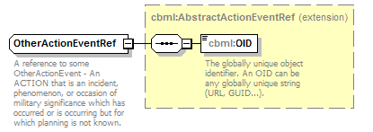
namespace | http://www.sisostds.org/schemas/c-bml/1.0
type | extension of cbml:AbstractActionEventRef
properties
  base | cbml:AbstractActionEventRef
children | cbml:OID
annotation
  documentation
  A reference to some OtherActionEvent - An ACTION that is an incident, phenomenon, or occasion of military significance which has occurred or is occurring but for which planning is not known.
source | <xs:complexType name="OtherActionEventRef">  <xs:annotation>  <xs:documentation xml:lang="en">A reference to some OtherActionEvent - An ACTION that is an incident, phenomenon, or occasion of military significance which has occurred or is occurring but for which planning is not known.</xs:documentation>  </xs:annotation>  <xs:complexContent>  <xs:extension base="cbml:AbstractActionEventRef"/>  </xs:complexContent>  </xs:complexType>

complexType OtherActionObjectiveItem
diagram | 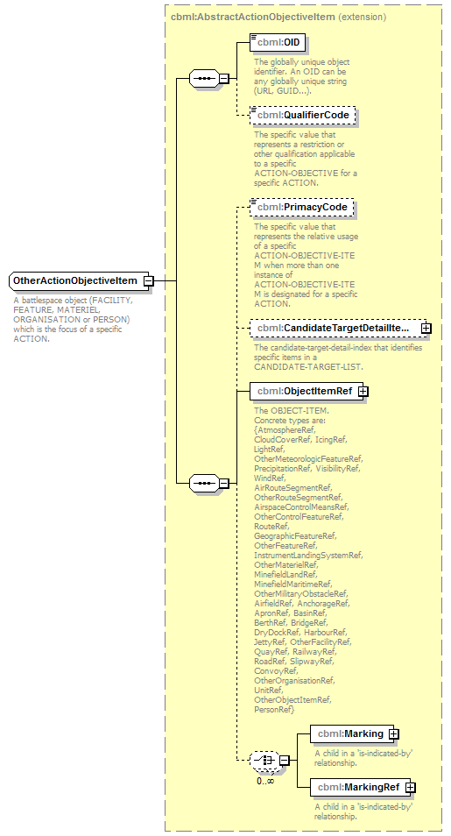
namespace | http://www.sisostds.org/schemas/c-bml/1.0
type | extension of cbml:AbstractActionObjectiveItem
properties
  base | cbml:AbstractActionObjectiveItem
children | cbml:OID cbml:QualifierCode cbml:PrimacyCode cbml:CandidateTargetDetailItemRef cbml:ObjectItemRef cbml:Marking cbml:MarkingRef
annotation
  documentation
  A battlespace object (FACILITY, FEATURE, MATERIEL, ORGANISATION or PERSON) which is the focus of a specific ACTION.
source | <xs:complexType name="OtherActionObjectiveItem">  <xs:annotation>  <xs:documentation xml:lang="en">A battlespace object (FACILITY, FEATURE, MATERIEL, ORGANISATION or PERSON) which is the focus of a specific ACTION.</xs:documentation>  </xs:annotation>  <xs:complexContent>  <xs:extension base="cbml:AbstractActionObjectiveItem"/>  <!-- C-BML Rationale: All possible enumeration values are assigned a specific type. The only one left is NOS (not otherwise specified). This type implies NOS.  <xs:sequence>  <xs:element name="CategoryCode" type="jc3iedm:ActionObjectiveItemCategoryCode" fixed="NOS">  <xs:annotation>  <xs:documentation xml:lang="en">The specific value that represents the class of ACTION-OBJECTIVE-ITEM. It serves as a discriminator that partitions ACTION-OBJECTIVE-ITEM into subtypes.</xs:documentation>  </xs:annotation>  </xs:element>  </xs:sequence>  </xs:extension>-->  </xs:complexContent>  </xs:complexType>

complexType OtherActionObjectiveItemRef
diagram | 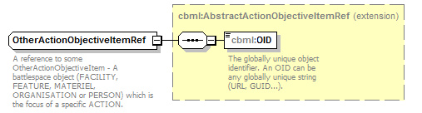
namespace | http://www.sisostds.org/schemas/c-bml/1.0
type | extension of cbml:AbstractActionObjectiveItemRef
properties
  base | cbml:AbstractActionObjectiveItemRef
children | cbml:OID
annotation
  documentation
  A reference to some OtherActionObjectiveItem - A battlespace object (FACILITY, FEATURE, MATERIEL, ORGANISATION or PERSON) which is the focus of a specific ACTION.
source | <xs:complexType name="OtherActionObjectiveItemRef">  <xs:annotation>  <xs:documentation xml:lang="en">A reference to some OtherActionObjectiveItem - A battlespace object (FACILITY, FEATURE, MATERIEL, ORGANISATION or PERSON) which is the focus of a specific ACTION.</xs:documentation>  </xs:annotation>  <xs:complexContent>  <xs:extension base="cbml:AbstractActionObjectiveItemRef"/>  </xs:complexContent>  </xs:complexType>

complexType OtherActionObjectiveType
diagram | 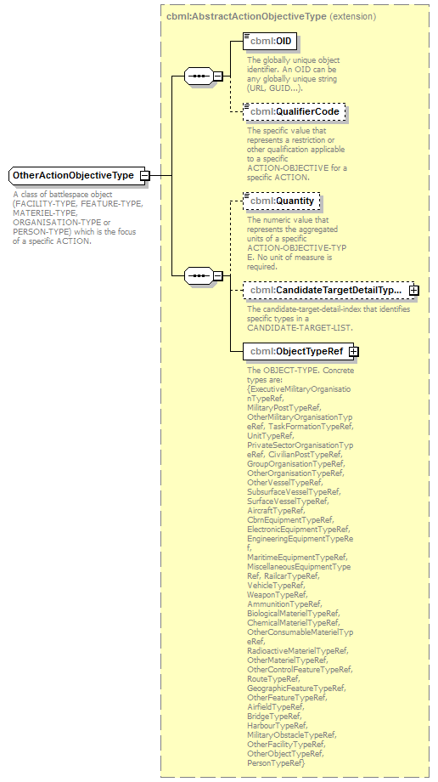
namespace | http://www.sisostds.org/schemas/c-bml/1.0
type | extension of cbml:AbstractActionObjectiveType
properties
  base | cbml:AbstractActionObjectiveType
children | cbml:OID cbml:QualifierCode cbml:Quantity cbml:CandidateTargetDetailTypeRef cbml:ObjectTypeRef
annotation
  documentation
  A class of battlespace object (FACILITY-TYPE, FEATURE-TYPE, MATERIEL-TYPE, ORGANISATION-TYPE or PERSON-TYPE) which is the focus of a specific ACTION.
source | <xs:complexType name="OtherActionObjectiveType">  <xs:annotation>  <xs:documentation xml:lang="en">A class of battlespace object (FACILITY-TYPE, FEATURE-TYPE, MATERIEL-TYPE, ORGANISATION-TYPE or PERSON-TYPE) which is the focus of a specific ACTION.</xs:documentation>  </xs:annotation>  <xs:complexContent>  <xs:extension base="cbml:AbstractActionObjectiveType"/>  <!-- CBML Rationale: All possible enumeration values are assigned a specific type. The only one left is NOS. This type implies NOS.  <xs:sequence>  <xs:element name="CategoryCode" type="jc3iedm:ActionObjectiveTypeCategoryCode" fixed="NOS">  <xs:annotation>  <xs:documentation xml:lang="en">The specific value that represents the class of ACTION-OBJECTIVE-TYPE. It serves as a discriminator that partitions ACTION-OBJECTIVE-TYPE into subtypes.</xs:documentation>  </xs:annotation>  </xs:element>  </xs:sequence>  </xs:extension>-->  </xs:complexContent>  </xs:complexType>

complexType OtherActionObjectiveTypeRef
diagram | 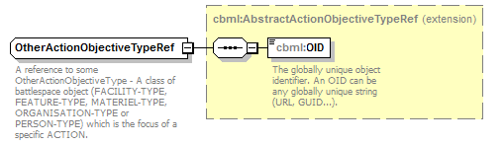
namespace | http://www.sisostds.org/schemas/c-bml/1.0
type | extension of cbml:AbstractActionObjectiveTypeRef
properties
  base | cbml:AbstractActionObjectiveTypeRef
children | cbml:OID
annotation
  documentation
  A reference to some OtherActionObjectiveType - A class of battlespace object (FACILITY-TYPE, FEATURE-TYPE, MATERIEL-TYPE, ORGANISATION-TYPE or PERSON-TYPE) which is the focus of a specific ACTION.
source | <xs:complexType name="OtherActionObjectiveTypeRef">  <xs:annotation>  <xs:documentation xml:lang="en">A reference to some OtherActionObjectiveType - A class of battlespace object (FACILITY-TYPE, FEATURE-TYPE, MATERIEL-TYPE, ORGANISATION-TYPE or PERSON-TYPE) which is the focus of a specific ACTION.</xs:documentation>  </xs:annotation>  <xs:complexContent>  <xs:extension base="cbml:AbstractActionObjectiveTypeRef"/>  </xs:complexContent>  </xs:complexType>

complexType OtherActionResourceEmployment
diagram | 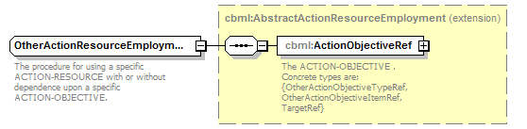
namespace | http://www.sisostds.org/schemas/c-bml/1.0
type | extension of cbml:AbstractActionResourceEmployment
properties
  base | cbml:AbstractActionResourceEmployment
children | cbml:ActionObjectiveRef
annotation
  documentation
  The procedure for using a specific ACTION-RESOURCE with or without dependence upon a specific ACTION-OBJECTIVE.
source | <xs:complexType name="OtherActionResourceEmployment">  <xs:annotation>  <xs:documentation xml:lang="en">The procedure for using a specific ACTION-RESOURCE with or without dependence upon a specific ACTION-OBJECTIVE.</xs:documentation>  </xs:annotation>  <xs:complexContent>  <xs:extension base="cbml:AbstractActionResourceEmployment"/>  <!-- CBML Rationale: All possible enumeration values are assigned a specific commented type. The only one left is NOS. This type implies NOS. In C-BML only OtherActionResourceEmployment is allowed.  <xs:sequence>  <xs:element name="CategoryCode" type="jc3iedm:ActionResourceEmploymentCategoryCode" fixed="NOS">  <xs:annotation>  <xs:documentation xml:lang="en">The specific value that represents the class of ACTION-RESOURCE-EMPLOYMENT. It serves as a discriminator that partitions ACTION-RESOURCE-EMPLOYMENT into subtypes.</xs:documentation>  </xs:annotation>  </xs:element>  </xs:sequence>  </xs:extension>-->  </xs:complexContent>  </xs:complexType>

complexType OtherActionTask
diagram | 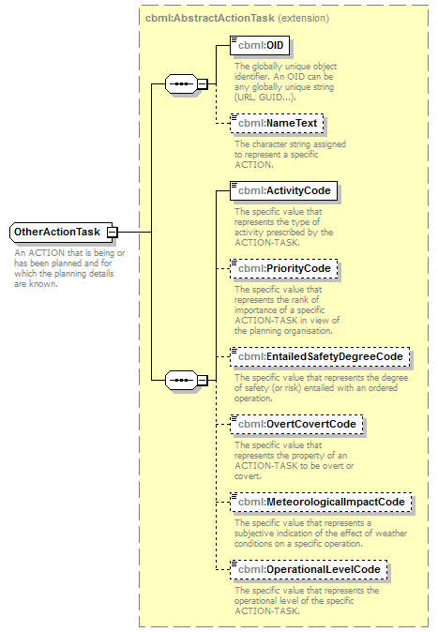
namespace | http://www.sisostds.org/schemas/c-bml/1.0
type | extension of cbml:AbstractActionTask
properties
  base | cbml:AbstractActionTask
children | cbml:OID cbml:NameText cbml:ActivityCode cbml:PriorityCode cbml:EntailedSafetyDegreeCode cbml:OvertCovertCode cbml:MeteorologicalImpactCode cbml:OperationalLevelCode
annotation
  documentation
  An ACTION that is being or has been planned and for which the planning details are known.
source | <xs:complexType name="OtherActionTask">  <xs:annotation>  <xs:documentation xml:lang="en">An ACTION that is being or has been planned and for which the planning details are known.</xs:documentation>  </xs:annotation>  <xs:complexContent>  <xs:extension base="cbml:AbstractActionTask"/>  <!-- CBML Rationale: CategoryCode is determined based on an Expression's context.  <xs:sequence>  <xs:element name="CategoryCode" type="jc3iedm:ActionTaskCategoryCode">  <xs:annotation>  <xs:documentation xml:lang="en">The specific value that represents the class of ACTION-TASK. It serves as a discriminator that partitions ACTION-TASK into subtypes.</xs:documentation>  </xs:annotation>  </xs:element>  </xs:sequence>  </xs:extension>-->  </xs:complexContent>  </xs:complexType>

complexType OtherActionTaskRef
diagram | 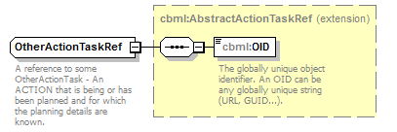
namespace | http://www.sisostds.org/schemas/c-bml/1.0
type | extension of cbml:AbstractActionTaskRef
properties
  base | cbml:AbstractActionTaskRef
children | cbml:OID
annotation
  documentation
  A reference to some OtherActionTask - An ACTION that is being or has been planned and for which the planning details are known.
source | <xs:complexType name="OtherActionTaskRef">  <xs:annotation>  <xs:documentation xml:lang="en">A reference to some OtherActionTask - An ACTION that is being or has been planned and for which the planning details are known.</xs:documentation>  </xs:annotation>  <xs:complexContent>  <xs:extension base="cbml:AbstractActionTaskRef"/>  </xs:complexContent>  </xs:complexType>

complexType OtherCbrnEvent
diagram | 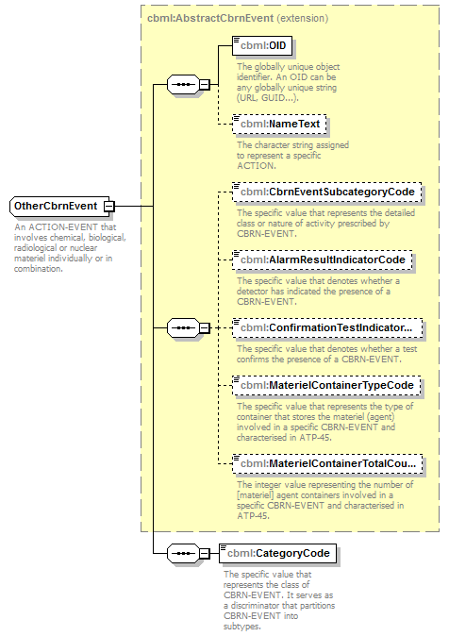
namespace | http://www.sisostds.org/schemas/c-bml/1.0
type | extension of cbml:AbstractCbrnEvent
properties
  base | cbml:AbstractCbrnEvent
children | cbml:OID cbml:NameText cbml:CbrnEventSubcategoryCode cbml:AlarmResultIndicatorCode cbml:ConfirmationTestIndicatorCode cbml:MaterielContainerTypeCode cbml:MaterielContainerTotalCount cbml:CategoryCode
annotation
  documentation
  An ACTION-EVENT that involves chemical, biological, radiological or nuclear materiel individually or in combination.
source | <xs:complexType name="OtherCbrnEvent">  <xs:annotation>  <xs:documentation xml:lang="en">An ACTION-EVENT that involves chemical, biological, radiological or nuclear materiel individually or in combination.</xs:documentation>  </xs:annotation>  <xs:complexContent>  <xs:extension base="cbml:AbstractCbrnEvent">  <xs:sequence>  <xs:element name="CategoryCode" type="jc3iedm:CbrnEventCategoryCode">  <xs:annotation>  <xs:documentation xml:lang="en">The specific value that represents the class of CBRN-EVENT. It serves as a discriminator that partitions CBRN-EVENT into subtypes.</xs:documentation>  </xs:annotation>  </xs:element>  </xs:sequence>  </xs:extension>  </xs:complexContent>  </xs:complexType>

element OtherCbrnEvent/CategoryCode
diagram | 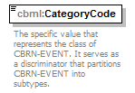
namespace | http://www.sisostds.org/schemas/c-bml/1.0
type | jc3iedm:CbrnEventCategoryCode
properties
  isRef | 0
  content | simple
facets
  Kind | Value | annotation
  enumeration | CHMBIO
    documentation
    <Definition xml:lang="en">A CBRN-EVENT involving chemical and/or biological materiel.</Definition>
    appinfo
    <DisplayValue xml:lang="en">CHEMICAL-BIOLOGICAL-EVENT</DisplayValue>
  enumeration | NKN
    documentation
    <Definition xml:lang="en">It is not possible to determine which value is most applicable.</Definition>
    appinfo
    <DisplayValue xml:lang="en">Not known</DisplayValue>
  enumeration | RADCTV
    documentation
    <Definition xml:lang="en">A CBRN-EVENT involving radioactive materiel(s).</Definition>
    appinfo
    <DisplayValue xml:lang="en">RADIOACTIVE-EVENT</DisplayValue>
  enumeration | UNROTA
    documentation
    <Definition xml:lang="en">The release of an unknown chemical, biological, nuclear, radiological materiel(s) [agent(s)] into the environment intentionally or accidentally but not for the intended purpose of conducting an attack.</Definition>
    appinfo
    <DisplayValue xml:lang="en">Unidentified release other than attack (ROTA)</DisplayValue>
annotation
  documentation
  The specific value that represents the class of CBRN-EVENT. It serves as a discriminator that partitions CBRN-EVENT into subtypes.
source | <xs:element name="CategoryCode" type="jc3iedm:CbrnEventCategoryCode">  <xs:annotation>  <xs:documentation xml:lang="en">The specific value that represents the class of CBRN-EVENT. It serves as a discriminator that partitions CBRN-EVENT into subtypes.</xs:documentation>  </xs:annotation>  </xs:element>

complexType OtherCbrnEventRef
diagram | 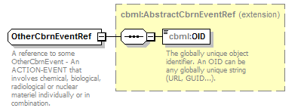
namespace | http://www.sisostds.org/schemas/c-bml/1.0
type | extension of cbml:AbstractCbrnEventRef
properties
  base | cbml:AbstractCbrnEventRef
children | cbml:OID
annotation
  documentation
  A reference to some OtherCbrnEvent - An ACTION-EVENT that involves chemical, biological, radiological or nuclear materiel individually or in combination.
source | <xs:complexType name="OtherCbrnEventRef">  <xs:annotation>  <xs:documentation xml:lang="en">A reference to some OtherCbrnEvent - An ACTION-EVENT that involves chemical, biological, radiological or nuclear materiel individually or in combination.</xs:documentation>  </xs:annotation>  <xs:complexContent>  <xs:extension base="cbml:AbstractCbrnEventRef"/>  </xs:complexContent>  </xs:complexType>

complexType OtherNuclearEvent
diagram | 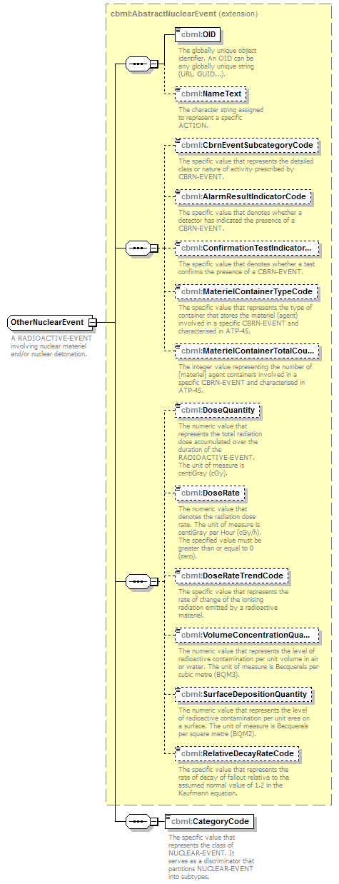
namespace | http://www.sisostds.org/schemas/c-bml/1.0
type | extension of cbml:AbstractNuclearEvent
properties
  base | cbml:AbstractNuclearEvent
children | cbml:OID cbml:NameText cbml:CbrnEventSubcategoryCode cbml:AlarmResultIndicatorCode cbml:ConfirmationTestIndicatorCode cbml:MaterielContainerTypeCode cbml:MaterielContainerTotalCount cbml:DoseQuantity cbml:DoseRate cbml:DoseRateTrendCode cbml:VolumeConcentrationQuantity cbml:SurfaceDepositionQuantity cbml:RelativeDecayRateCode cbml:CategoryCode
annotation
  documentation
  A RADIOACTIVE-EVENT involving nuclear materiel and/or nuclear detonation.
source | <xs:complexType name="OtherNuclearEvent">  <xs:annotation>  <xs:documentation xml:lang="en">A RADIOACTIVE-EVENT involving nuclear materiel and/or nuclear detonation.</xs:documentation>  </xs:annotation>  <xs:complexContent>  <xs:extension base="cbml:AbstractNuclearEvent">  <xs:sequence>  <xs:element name="CategoryCode" type="jc3iedm:NuclearEventCategoryCode">  <xs:annotation>  <xs:documentation xml:lang="en">The specific value that represents the class of NUCLEAR-EVENT. It serves as a discriminator that partitions NUCLEAR-EVENT into subtypes.</xs:documentation>  </xs:annotation>  </xs:element>  </xs:sequence>  </xs:extension>  </xs:complexContent>  </xs:complexType>

element OtherNuclearEvent/CategoryCode
diagram | 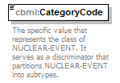
namespace | http://www.sisostds.org/schemas/c-bml/1.0
type | jc3iedm:NuclearEventCategoryCode
properties
  isRef | 0
  content | simple
facets
  Kind | Value | annotation
  enumeration | NKN
    documentation
    <Definition xml:lang="en">It is not possible to determine which value is most applicable.</Definition>
    appinfo
    <DisplayValue xml:lang="en">Not known</DisplayValue>
  enumeration | NROTA
    documentation
    <Definition xml:lang="en">The release of nuclear material into the environment intentionally or accidentally but not for the intended purpose of conducting an attack.</Definition>
    appinfo
    <DisplayValue xml:lang="en">Nuclear release other than attack (ROTA)</DisplayValue>
  enumeration | NUCATT
    documentation
    <Definition xml:lang="en">The delivery of a nuclear weapon against a target.</Definition>
    appinfo
    <DisplayValue xml:lang="en">Nuclear attack</DisplayValue>
  enumeration | NUCSMP
    documentation
    <Definition xml:lang="en">The action of detecting a radiological contaminant.</Definition>
    appinfo
    <DisplayValue xml:lang="en">Nuclear sampling</DisplayValue>
  enumeration | NUCTST
    documentation
    <Definition xml:lang="en">The explosion of a nuclear device for test purpose.</Definition>
    appinfo
    <DisplayValue xml:lang="en">Nuclear test</DisplayValue>
  enumeration | NUCWAR
    documentation
    <Definition xml:lang="en">The state of readiness caused by the possibility of atomic bombings.</Definition>
    appinfo
    <DisplayValue xml:lang="en">Nuclear war alert</DisplayValue>
  enumeration | NUCWEP
    documentation
    <Definition xml:lang="en">A NUCLEAR-EVENT that involves the detonation of a nuclear device.</Definition>
    appinfo
    <DisplayValue xml:lang="en">NUCLEAR-WEAPON-EVENT</DisplayValue>
  enumeration | NUCWST
    documentation
    <Definition xml:lang="en">Removing nuclear polluted substances to a designated storage area.</Definition>
    appinfo
    <DisplayValue xml:lang="en">Nuclear waste disposal</DisplayValue>
annotation
  documentation
  The specific value that represents the class of NUCLEAR-EVENT. It serves as a discriminator that partitions NUCLEAR-EVENT into subtypes.
source | <xs:element name="CategoryCode" type="jc3iedm:NuclearEventCategoryCode">  <xs:annotation>  <xs:documentation xml:lang="en">The specific value that represents the class of NUCLEAR-EVENT. It serves as a discriminator that partitions NUCLEAR-EVENT into subtypes.</xs:documentation>  </xs:annotation>  </xs:element>

complexType OtherNuclearEventRef
diagram | 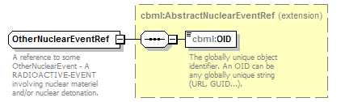
namespace | http://www.sisostds.org/schemas/c-bml/1.0
type | extension of cbml:AbstractNuclearEventRef
properties
  base | cbml:AbstractNuclearEventRef
children | cbml:OID
annotation
  documentation
  A reference to some OtherNuclearEvent - A RADIOACTIVE-EVENT involving nuclear materiel and/or nuclear detonation.
source | <xs:complexType name="OtherNuclearEventRef">  <xs:annotation>  <xs:documentation xml:lang="en">A reference to some OtherNuclearEvent - A RADIOACTIVE-EVENT involving nuclear materiel and/or nuclear detonation.</xs:documentation>  </xs:annotation>  <xs:complexContent>  <xs:extension base="cbml:AbstractNuclearEventRef"/>  </xs:complexContent>  </xs:complexType>

complexType OtherRadioactiveEvent
diagram | 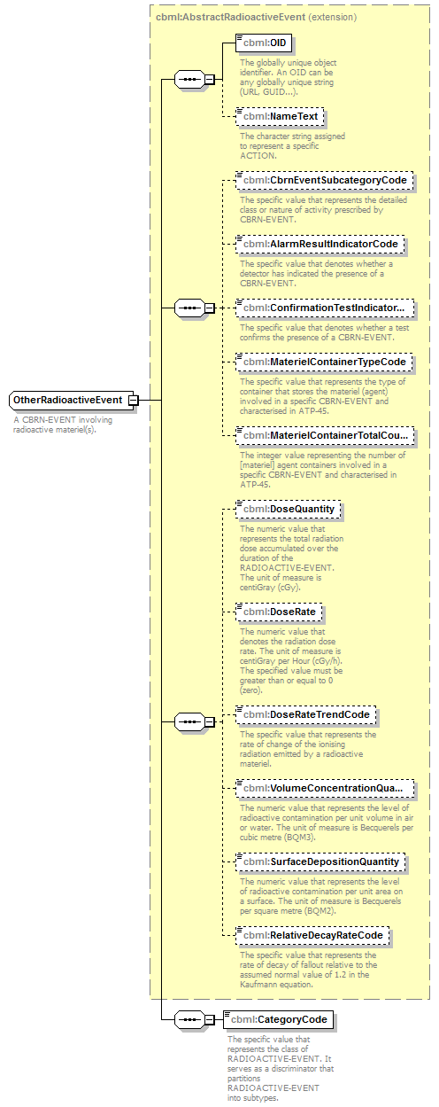
namespace | http://www.sisostds.org/schemas/c-bml/1.0
type | extension of cbml:AbstractRadioactiveEvent
properties
  base | cbml:AbstractRadioactiveEvent
children | cbml:OID cbml:NameText cbml:CbrnEventSubcategoryCode cbml:AlarmResultIndicatorCode cbml:ConfirmationTestIndicatorCode cbml:MaterielContainerTypeCode cbml:MaterielContainerTotalCount cbml:DoseQuantity cbml:DoseRate cbml:DoseRateTrendCode cbml:VolumeConcentrationQuantity cbml:SurfaceDepositionQuantity cbml:RelativeDecayRateCode cbml:CategoryCode
annotation
  documentation
  A CBRN-EVENT involving radioactive materiel(s).
source | <xs:complexType name="OtherRadioactiveEvent">  <xs:annotation>  <xs:documentation xml:lang="en">A CBRN-EVENT involving radioactive materiel(s).</xs:documentation>  </xs:annotation>  <xs:complexContent>  <xs:extension base="cbml:AbstractRadioactiveEvent">  <xs:sequence>  <xs:element name="CategoryCode" type="jc3iedm:RadioactiveEventCategoryCode">  <xs:annotation>  <xs:documentation xml:lang="en">The specific value that represents the class of RADIOACTIVE-EVENT. It serves as a discriminator that partitions RADIOACTIVE-EVENT into subtypes.</xs:documentation>  </xs:annotation>  </xs:element>  </xs:sequence>  </xs:extension>  </xs:complexContent>  </xs:complexType>

element OtherRadioactiveEvent/CategoryCode
diagram | 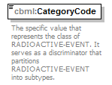
namespace | http://www.sisostds.org/schemas/c-bml/1.0
type | jc3iedm:RadioactiveEventCategoryCode
properties
  isRef | 0
  content | simple
facets
  Kind | Value | annotation
  enumeration | NOS
    documentation
    <Definition xml:lang="en">The appropriate value is not in the set of specified values.</Definition>
    appinfo
    <DisplayValue xml:lang="en">Not otherwise specified</DisplayValue>
  enumeration | NUCEVT
    documentation
    <Definition xml:lang="en">A RADIOACTIVE-EVENT involving nuclear materiel and/or nuclear detonation.</Definition>
    appinfo
    <DisplayValue xml:lang="en">NUCLEAR-EVENT</DisplayValue>
  enumeration | RADALM
    documentation
    <Definition xml:lang="en">An action by which a radiological detector is triggered or a group is warned.</Definition>
    appinfo
    <DisplayValue xml:lang="en">Radiation alarm</DisplayValue>
  enumeration | RADEVT
    documentation
    <Definition xml:lang="en">A RADIOACTIVE-EVENT involving radioactive materiel(s) but not involving nuclear materiel(s) and/or nuclear detonation.</Definition>
    appinfo
    <DisplayValue xml:lang="en">RADIOLOGICAL-EVENT</DisplayValue>
annotation
  documentation
  The specific value that represents the class of RADIOACTIVE-EVENT. It serves as a discriminator that partitions RADIOACTIVE-EVENT into subtypes.
source | <xs:element name="CategoryCode" type="jc3iedm:RadioactiveEventCategoryCode">  <xs:annotation>  <xs:documentation xml:lang="en">The specific value that represents the class of RADIOACTIVE-EVENT. It serves as a discriminator that partitions RADIOACTIVE-EVENT into subtypes.</xs:documentation>  </xs:annotation>  </xs:element>

complexType OtherRadioactiveEventRef
diagram | 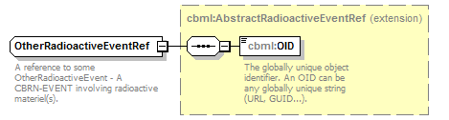
namespace | http://www.sisostds.org/schemas/c-bml/1.0
type | extension of cbml:AbstractRadioactiveEventRef
properties
  base | cbml:AbstractRadioactiveEventRef
children | cbml:OID
annotation
  documentation
  A reference to some OtherRadioactiveEvent - A CBRN-EVENT involving radioactive materiel(s).
source | <xs:complexType name="OtherRadioactiveEventRef">  <xs:annotation>  <xs:documentation xml:lang="en">A reference to some OtherRadioactiveEvent - A CBRN-EVENT involving radioactive materiel(s).</xs:documentation>  </xs:annotation>  <xs:complexContent>  <xs:extension base="cbml:AbstractRadioactiveEventRef"/>  </xs:complexContent>  </xs:complexType>

complexType RadiologicalEvent
diagram | 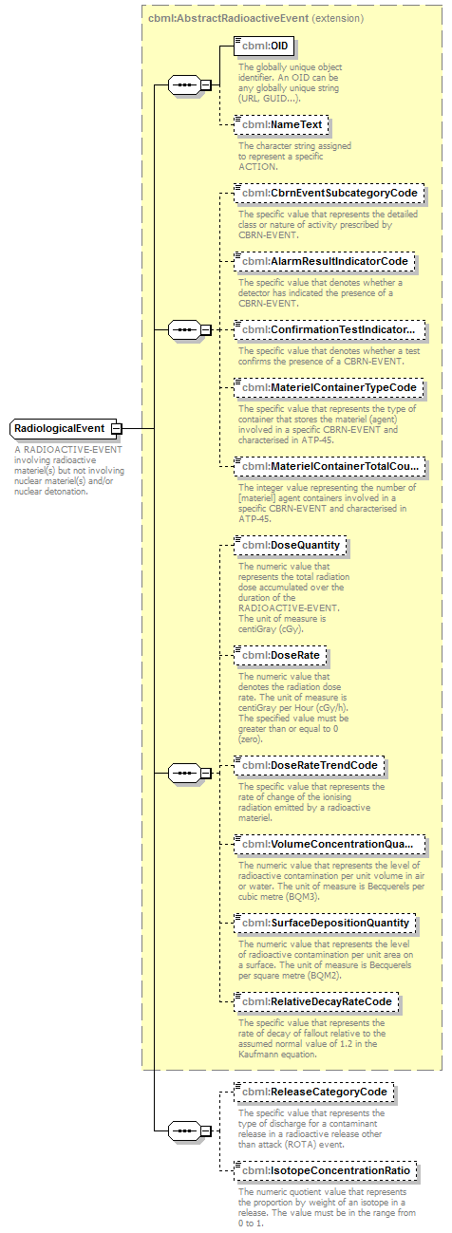
namespace | http://www.sisostds.org/schemas/c-bml/1.0
type | extension of cbml:AbstractRadioactiveEvent
properties
  base | cbml:AbstractRadioactiveEvent
children | cbml:OID cbml:NameText cbml:CbrnEventSubcategoryCode cbml:AlarmResultIndicatorCode cbml:ConfirmationTestIndicatorCode cbml:MaterielContainerTypeCode cbml:MaterielContainerTotalCount cbml:DoseQuantity cbml:DoseRate cbml:DoseRateTrendCode cbml:VolumeConcentrationQuantity cbml:SurfaceDepositionQuantity cbml:RelativeDecayRateCode cbml:ReleaseCategoryCode cbml:IsotopeConcentrationRatio
annotation
  documentation
  A RADIOACTIVE-EVENT involving radioactive materiel(s) but not involving nuclear materiel(s) and/or nuclear detonation.
source | <xs:complexType name="RadiologicalEvent">  <xs:annotation>  <xs:documentation xml:lang="en">A RADIOACTIVE-EVENT involving radioactive materiel(s) but not involving nuclear materiel(s) and/or nuclear detonation.</xs:documentation>  </xs:annotation>  <xs:complexContent>  <xs:extension base="cbml:AbstractRadioactiveEvent">  <xs:sequence>  <xs:element name="ReleaseCategoryCode" type="jc3iedm:ReleaseCategoryCode" minOccurs="0">  <xs:annotation>  <xs:documentation xml:lang="en">The specific value that represents the type of discharge for a contaminant release in a radioactive release other than attack (ROTA) event.</xs:documentation>  </xs:annotation>  </xs:element>  <xs:element name="IsotopeConcentrationRatio" type="jc3iedm:RatioType6_5" minOccurs="0">  <xs:annotation>  <xs:documentation xml:lang="en">The numeric quotient value that represents the proportion by weight of an isotope in a release. The value must be in the range from 0 to 1.</xs:documentation>  </xs:annotation>  </xs:element>  </xs:sequence>  </xs:extension>  </xs:complexContent>  </xs:complexType>

element RadiologicalEvent/ReleaseCategoryCode
diagram | 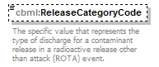
namespace | http://www.sisostds.org/schemas/c-bml/1.0
type | jc3iedm:ReleaseCategoryCode
properties
  isRef | 0
  minOcc | 0
  maxOcc | 1
  content | simple
facets
  Kind | Value | annotation
  enumeration | CONT
    documentation
    <Definition xml:lang="en">A continuous discharge of a contaminant release in a release other than attack (ROTA) event.</Definition>
    appinfo
    <DisplayValue xml:lang="en">Continuous</DisplayValue>
  enumeration | NKN
    documentation
    <Definition xml:lang="en">It is not possible to determine which value is most applicable.</Definition>
    appinfo
    <DisplayValue xml:lang="en">Not known</DisplayValue>
  enumeration | NOS
    documentation
    <Definition xml:lang="en">The appropriate value is not in the set of specified values.</Definition>
    appinfo
    <DisplayValue xml:lang="en">Not otherwise specified</DisplayValue>
  enumeration | PUFF
    documentation
    <Definition xml:lang="en">A single discharge of a contaminant release in a release other than attack (ROTA) event.</Definition>
    appinfo
    <DisplayValue xml:lang="en">Single release of a cloud</DisplayValue>
  enumeration | SPRAY
    documentation
    <Definition xml:lang="en">The spraying of a contaminant in a release other than attack (ROTA) event.</Definition>
    appinfo
    <DisplayValue xml:lang="en">Spraying</DisplayValue>
annotation
  documentation
  The specific value that represents the type of discharge for a contaminant release in a radioactive release other than attack (ROTA) event.
source | <xs:element name="ReleaseCategoryCode" type="jc3iedm:ReleaseCategoryCode" minOccurs="0">  <xs:annotation>  <xs:documentation xml:lang="en">The specific value that represents the type of discharge for a contaminant release in a radioactive release other than attack (ROTA) event.</xs:documentation>  </xs:annotation>  </xs:element>

element RadiologicalEvent/IsotopeConcentrationRatio
diagram | 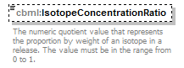
namespace | http://www.sisostds.org/schemas/c-bml/1.0
type | jc3iedm:RatioType6_5
properties
  isRef | 0
  minOcc | 0
  maxOcc | 1
  content | simple
facets
  Kind | Value | annotation
  minInclusive | -9.99999
  maxInclusive | 9.99999
  totalDigits | 6
  fractionDigits | 5
annotation
  documentation
  The numeric quotient value that represents the proportion by weight of an isotope in a release. The value must be in the range from 0 to 1.
source | <xs:element name="IsotopeConcentrationRatio" type="jc3iedm:RatioType6_5" minOccurs="0">  <xs:annotation>  <xs:documentation xml:lang="en">The numeric quotient value that represents the proportion by weight of an isotope in a release. The value must be in the range from 0 to 1.</xs:documentation>  </xs:annotation>  </xs:element>

complexType RadiologicalEventRef
diagram | 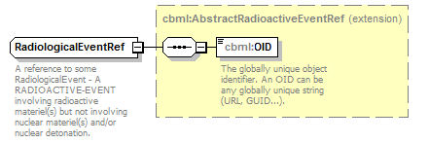
namespace | http://www.sisostds.org/schemas/c-bml/1.0
type | extension of cbml:AbstractRadioactiveEventRef
properties
  base | cbml:AbstractRadioactiveEventRef
children | cbml:OID
annotation
  documentation
  A reference to some RadiologicalEvent - A RADIOACTIVE-EVENT involving radioactive materiel(s) but not involving nuclear materiel(s) and/or nuclear detonation.
source | <xs:complexType name="RadiologicalEventRef">  <xs:annotation>  <xs:documentation xml:lang="en">A reference to some RadiologicalEvent - A RADIOACTIVE-EVENT involving radioactive materiel(s) but not involving nuclear materiel(s) and/or nuclear detonation.</xs:documentation>  </xs:annotation>  <xs:complexContent>  <xs:extension base="cbml:AbstractRadioactiveEventRef"/>  </xs:complexContent>  </xs:complexType>

complexType Request
diagram | 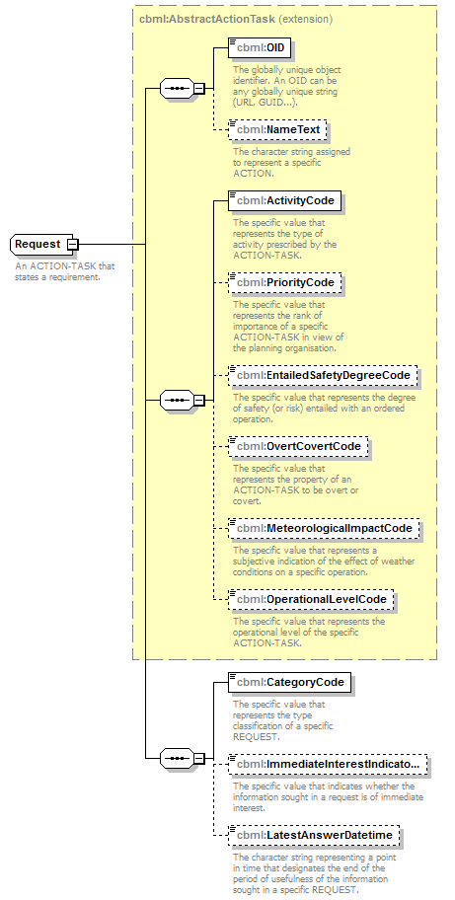
namespace | http://www.sisostds.org/schemas/c-bml/1.0
type | extension of cbml:AbstractActionTask
properties
  base | cbml:AbstractActionTask
children | cbml:OID cbml:NameText cbml:ActivityCode cbml:PriorityCode cbml:EntailedSafetyDegreeCode cbml:OvertCovertCode cbml:MeteorologicalImpactCode cbml:OperationalLevelCode cbml:CategoryCode cbml:ImmediateInterestIndicatorCode cbml:LatestAnswerDatetime
annotation
  documentation
  An ACTION-TASK that states a requirement.
source | <xs:complexType name="Request">  <xs:annotation>  <xs:documentation xml:lang="en">An ACTION-TASK that states a requirement.</xs:documentation>  </xs:annotation>  <xs:complexContent>  <xs:extension base="cbml:AbstractActionTask">  <xs:sequence>  <xs:element name="CategoryCode" type="cbml:RequestCategoryCode">  <xs:annotation>  <xs:documentation xml:lang="en">The specific value that represents the type classification of a specific REQUEST.</xs:documentation>  </xs:annotation>  </xs:element>  <xs:element name="ImmediateInterestIndicatorCode" type="jc3iedm:RequestImmediateInterestIndicatorCode" minOccurs="0">  <xs:annotation>  <xs:documentation xml:lang="en">The specific value that indicates whether the information sought in a request is of immediate interest.</xs:documentation>  </xs:annotation>  </xs:element>  <xs:element name="LatestAnswerDatetime" type="jc3iedm:DatetimeTypeFix18" minOccurs="0">  <xs:annotation>  <xs:documentation xml:lang="en">The character string representing a point in time that designates the end of the period of usefulness of the information sought in a specific REQUEST.</xs:documentation>  </xs:annotation>  </xs:element>  <!-- CBML Rationale: Covered by RequestAnswerReport.  <xs:choice minOccurs="0" maxOccurs="unbounded">  <xs:element name="Answer" type="cbml:RequestAnswer">  <xs:annotation>  <xs:documentation xml:lang="en">A child in a 'results-in' relationship.</xs:documentation>  </xs:annotation>  </xs:element>  <xs:element name="AnswerRef" type="cbml:RequestAnswerRef">  <xs:annotation>  <xs:documentation xml:lang="en">A child in a 'results-in' relationship.</xs:documentation>  </xs:annotation>  </xs:element>  </xs:choice>-->  </xs:sequence>  </xs:extension>  </xs:complexContent>  </xs:complexType>

element Request/CategoryCode
diagram | 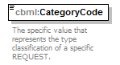
namespace | http://www.sisostds.org/schemas/c-bml/1.0
type | cbml:RequestCategoryCode
properties
  isRef | 0
  content | simple
facets
  Kind | Value | annotation
  enumeration | ACTION
    documentation
    <xs:Definition xml:lang="en">To discover the actions of an ACTION-OBJECTIVE (OBJECT-ITEM) by any means.</xs:Definition>
    appinfo
    <xs:DisplayValue xml:lang="en">Action</xs:DisplayValue>
  enumeration | ASSOC
    documentation
    <xs:Definition xml:lang="en">To discover the relation between two ACTION-OBJECTIVEs (OBJECT-ITEMs) by any means.</xs:Definition>
    appinfo
    <xs:DisplayValue xml:lang="en">Association</xs:DisplayValue>
  enumeration | HOLDNG
    documentation
    <xs:Definition xml:lang="en">To discover the holding of an ACTION-OBJECTIVE (OBJECT-ITEM) by any means.</xs:Definition>
    appinfo
    <xs:DisplayValue xml:lang="en">Holding</xs:DisplayValue>
  enumeration | HOSTIL
    documentation
    <xs:Definition xml:lang="en">To recognise the friendly or enemy character of an ACTION-OBJECTIVE (OBJECT-ITEM) by any means.</xs:Definition>
    appinfo
    <xs:DisplayValue xml:lang="en">Hostility</xs:DisplayValue>
  enumeration | LOCATN
    documentation
    <xs:Definition xml:lang="en">To discover the location of an ACTION-OBJECTIVE (OBJECT-ITEM) by any means.</xs:Definition>
    appinfo
    <xs:DisplayValue xml:lang="en">Location</xs:DisplayValue>
  enumeration | PRESNC
    documentation
    <xs:Definition xml:lang="en">To discover the manifestation of an ACTION-OBJECTIVE in the area of operational interest specified through another ACTION-OBJECTIVE (OBJECT-ITEM: FACILITY, FEATURE).</xs:Definition>
    appinfo
    <xs:DisplayValue xml:lang="en">Presence</xs:DisplayValue>
  enumeration | STATUS
    documentation
    <xs:Definition xml:lang="en">To recognise the status of an ACTION-OBJECTIVE (OBJECT-ITEM) by any means.</xs:Definition>
    appinfo
    <xs:DisplayValue xml:lang="en">Status</xs:DisplayValue>
  enumeration | TYPE
    documentation
    <xs:Definition xml:lang="en">To recognise the type of an ACTION-OBJECTIVE (OBJECT-ITEM) by any means.</xs:Definition>
    appinfo
    <xs:DisplayValue xml:lang="en">Type</xs:DisplayValue>
annotation
  documentation
  The specific value that represents the type classification of a specific REQUEST.
source | <xs:element name="CategoryCode" type="cbml:RequestCategoryCode">  <xs:annotation>  <xs:documentation xml:lang="en">The specific value that represents the type classification of a specific REQUEST.</xs:documentation>  </xs:annotation>  </xs:element>

element Request/ImmediateInterestIndicatorCode
diagram | 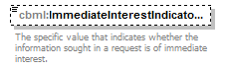
namespace | http://www.sisostds.org/schemas/c-bml/1.0
type | jc3iedm:RequestImmediateInterestIndicatorCode
properties
  isRef | 0
  minOcc | 0
  maxOcc | 1
  content | simple
facets
  Kind | Value | annotation
  enumeration | NO
    documentation
    <Definition xml:lang="en">The request has no immediate interest, i.e. it can be reported at the normal delivery time.</Definition>
    appinfo
    <DisplayValue xml:lang="en">No</DisplayValue>
  enumeration | YES
    documentation
    <Definition xml:lang="en">The request has an immediate interest, i.e. it must be immediately reported.</Definition>
    appinfo
    <DisplayValue xml:lang="en">Yes</DisplayValue>
annotation
  documentation
  The specific value that indicates whether the information sought in a request is of immediate interest.
source | <xs:element name="ImmediateInterestIndicatorCode" type="jc3iedm:RequestImmediateInterestIndicatorCode" minOccurs="0">  <xs:annotation>  <xs:documentation xml:lang="en">The specific value that indicates whether the information sought in a request is of immediate interest.</xs:documentation>  </xs:annotation>  </xs:element>

element Request/LatestAnswerDatetime
diagram | 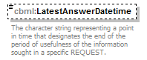
namespace | http://www.sisostds.org/schemas/c-bml/1.0
type | jc3iedm:DatetimeTypeFix18
properties
  isRef | 0
  minOcc | 0
  maxOcc | 1
  content | simple
facets
  Kind | Value | annotation
  minLength | 18
  maxLength | 18
annotation
  documentation
  The character string representing a point in time that designates the end of the period of usefulness of the information sought in a specific REQUEST.
source | <xs:element name="LatestAnswerDatetime" type="jc3iedm:DatetimeTypeFix18" minOccurs="0">  <xs:annotation>  <xs:documentation xml:lang="en">The character string representing a point in time that designates the end of the period of usefulness of the information sought in a specific REQUEST.</xs:documentation>  </xs:annotation>  </xs:element>

complexType RequestAnswer
diagram | 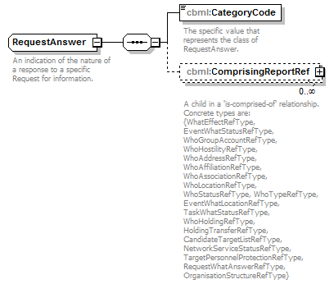
namespace | http://www.sisostds.org/schemas/c-bml/1.0
children | cbml:CategoryCode cbml:ComprisingReportRef
used by
  element | RequestWhatAnswerType/Answer
annotation
  documentation
  An indication of the nature of a response to a specific Request for information.
source | <xs:complexType name="RequestAnswer">  <xs:annotation>  <xs:documentation xml:lang="en">An indication of the nature of a response to a specific Request for information.</xs:documentation>  </xs:annotation>  <xs:sequence>  <xs:element name="CategoryCode" type="jc3iedm:RequestAnswerCategoryCode">  <xs:annotation>  <xs:documentation xml:lang="en">The specific value that represents the class of RequestAnswer.</xs:documentation>  </xs:annotation>  </xs:element>  <xs:element name="ComprisingReportRef" type="cbml:AbstractReportRefType" minOccurs="0" maxOccurs="unbounded">  <xs:annotation>  <xs:documentation xml:lang="en">A child in a 'is-comprised-of' relationship. Concrete types are: {WhatEffectRefType, EventWhatStatusRefType, WhoGroupAccountRefType, WhoHostilityRefType, WhoAddressRefType, WhoAffiliationRefType, WhoAssociationRefType, WhoLocationRefType, WhoStatusRefType, WhoTypeRefType, EventWhatLocationRefType, TaskWhatStatusRefType, WhoHoldingRefType, HoldingTransferRefType, CandidateTargetListRefType, NetworkServiceStatusRefType, TargetPersonnelProtectionRefType, RequestWhatAnswerRefType, OrganisationStructureRefType}</xs:documentation>  </xs:annotation>  </xs:element>  </xs:sequence>  </xs:complexType>

element RequestAnswer/CategoryCode
diagram | 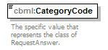
namespace | http://www.sisostds.org/schemas/c-bml/1.0
type | jc3iedm:RequestAnswerCategoryCode
properties
  isRef | 0
  content | simple
facets
  Kind | Value | annotation
  enumeration | NO
    documentation
    <Definition xml:lang="en">An answer in the negative.</Definition>
    appinfo
    <DisplayValue xml:lang="en">No</DisplayValue>
  enumeration | UNA
    documentation
    <Definition xml:lang="en">The information specified in the REQUEST cannot be obtained.</Definition>
    appinfo
    <DisplayValue xml:lang="en">Unanswerable</DisplayValue>
  enumeration | UNK
    documentation
    <Definition xml:lang="en">Answer cannot be formulated due to the absence of information.</Definition>
    appinfo
    <DisplayValue xml:lang="en">Unknown</DisplayValue>
  enumeration | YES
    documentation
    <Definition xml:lang="en">An answer in the affirmative.</Definition>
    appinfo
    <DisplayValue xml:lang="en">Yes</DisplayValue>
annotation
  documentation
  The specific value that represents the class of RequestAnswer.
source | <xs:element name="CategoryCode" type="jc3iedm:RequestAnswerCategoryCode">  <xs:annotation>  <xs:documentation xml:lang="en">The specific value that represents the class of RequestAnswer.</xs:documentation>  </xs:annotation>  </xs:element>

element RequestAnswer/ComprisingReportRef
diagram | 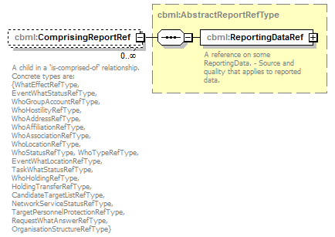
namespace | http://www.sisostds.org/schemas/c-bml/1.0
type | cbml:AbstractReportRefType
properties
  isRef | 0
  minOcc | 0
  maxOcc | unbounded
  content | complex
children | cbml:ReportingDataRef
annotation
  documentation
  A child in a 'is-comprised-of' relationship. Concrete types are: {WhatEffectRefType, EventWhatStatusRefType, WhoGroupAccountRefType, WhoHostilityRefType, WhoAddressRefType, WhoAffiliationRefType, WhoAssociationRefType, WhoLocationRefType, WhoStatusRefType, WhoTypeRefType, EventWhatLocationRefType, TaskWhatStatusRefType, WhoHoldingRefType, HoldingTransferRefType, CandidateTargetListRefType, NetworkServiceStatusRefType, TargetPersonnelProtectionRefType, RequestWhatAnswerRefType, OrganisationStructureRefType}
source | <xs:element name="ComprisingReportRef" type="cbml:AbstractReportRefType" minOccurs="0" maxOccurs="unbounded">  <xs:annotation>  <xs:documentation xml:lang="en">A child in a 'is-comprised-of' relationship. Concrete types are: {WhatEffectRefType, EventWhatStatusRefType, WhoGroupAccountRefType, WhoHostilityRefType, WhoAddressRefType, WhoAffiliationRefType, WhoAssociationRefType, WhoLocationRefType, WhoStatusRefType, WhoTypeRefType, EventWhatLocationRefType, TaskWhatStatusRefType, WhoHoldingRefType, HoldingTransferRefType, CandidateTargetListRefType, NetworkServiceStatusRefType, TargetPersonnelProtectionRefType, RequestWhatAnswerRefType, OrganisationStructureRefType}</xs:documentation>  </xs:annotation>  </xs:element>

complexType RequestRef
diagram | 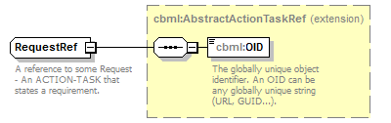
namespace | http://www.sisostds.org/schemas/c-bml/1.0
type | extension of cbml:AbstractActionTaskRef
properties
  base | cbml:AbstractActionTaskRef
children | cbml:OID
used by
  element | RequestWhatAnswerType/RequestRef
annotation
  documentation
  A reference to some Request - An ACTION-TASK that states a requirement.
source | <xs:complexType name="RequestRef">  <xs:annotation>  <xs:documentation xml:lang="en">A reference to some Request - An ACTION-TASK that states a requirement.</xs:documentation>  </xs:annotation>  <xs:complexContent>  <xs:extension base="cbml:AbstractActionTaskRef"/>  <!-- CBML Rationale: Reference’s elements not required because changed to an equivalent C-BML representation.  <xs:sequence>  <xs:choice minOccurs="0" maxOccurs="unbounded">  <xs:element name="Answer" type="cbml:RequestAnswer" >  <xs:annotation>  <xs:documentation xml:lang="en">A child in a 'results-in' relationship.</xs:documentation>  </xs:annotation>  </xs:element>  <xs:element name="AnswerRef" type="cbml:RequestAnswerRef" >  <xs:annotation>  <xs:documentation xml:lang="en">A child in a 'results-in' relationship.</xs:documentation>  </xs:annotation>  </xs:element>  </xs:choice>  </xs:sequence>  </xs:extension> -->  </xs:complexContent>  </xs:complexType>

complexType RequestWhatAnswerRefType
diagram | 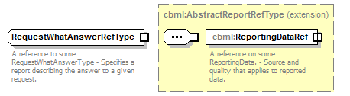
namespace | http://www.sisostds.org/schemas/c-bml/1.0
type | extension of cbml:AbstractReportRefType
properties
  base | cbml:AbstractReportRefType
children | cbml:ReportingDataRef
annotation
  documentation
  A reference to some RequestWhatAnswerType - Specifies a report describing the answer to a given request.
source | <xs:complexType name="RequestWhatAnswerRefType">  <xs:annotation>  <xs:documentation xml:lang="en">A reference to some RequestWhatAnswerType - Specifies a report describing the answer to a given request.</xs:documentation>  </xs:annotation>  <xs:complexContent>  <xs:extension base="cbml:AbstractReportRefType"/>  </xs:complexContent>  </xs:complexType>

complexType RequestWhatAnswerType
diagram | 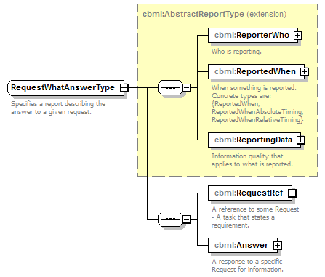
namespace | http://www.sisostds.org/schemas/c-bml/1.0
type | extension of cbml:AbstractReportType
properties
  base | cbml:AbstractReportType
children | cbml:ReporterWho cbml:ReportedWhen cbml:ReportingData cbml:RequestRef cbml:Answer
annotation
  documentation
  Specifies a report describing the answer to a given request.
source | <xs:complexType name="RequestWhatAnswerType">  <xs:annotation>  <xs:documentation xml:lang="en">Specifies a report describing the answer to a given request.</xs:documentation>  </xs:annotation>  <xs:complexContent>  <xs:extension base="cbml:AbstractReportType">  <xs:sequence>  <xs:element name="RequestRef" type="cbml:RequestRef">  <xs:annotation>  <xs:documentation xml:lang="en">A reference to some Request - A task that states a requirement.</xs:documentation>  </xs:annotation>  </xs:element>  <xs:element name="Answer" type="cbml:RequestAnswer">  <xs:annotation>  <xs:documentation xml:lang="en">A response to a specific Request for information.</xs:documentation>  </xs:annotation>  </xs:element>  </xs:sequence>  </xs:extension>  </xs:complexContent>  </xs:complexType>

element RequestWhatAnswerType/RequestRef
diagram | 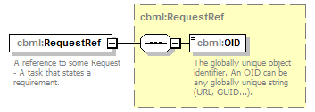
namespace | http://www.sisostds.org/schemas/c-bml/1.0
type | cbml:RequestRef
properties
  isRef | 0
  content | complex
children | cbml:OID
annotation
  documentation
  A reference to some Request - A task that states a requirement.
source | <xs:element name="RequestRef" type="cbml:RequestRef">  <xs:annotation>  <xs:documentation xml:lang="en">A reference to some Request - A task that states a requirement.</xs:documentation>  </xs:annotation>  </xs:element>

element RequestWhatAnswerType/Answer
diagram | 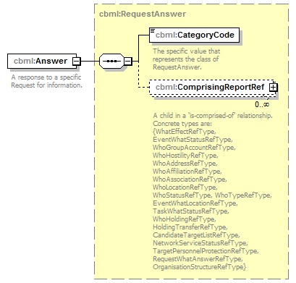
namespace | http://www.sisostds.org/schemas/c-bml/1.0
type | cbml:RequestAnswer
properties
  isRef | 0
  content | complex
children | cbml:CategoryCode cbml:ComprisingReportRef
annotation
  documentation
  A response to a specific Request for information.
source | <xs:element name="Answer" type="cbml:RequestAnswer">  <xs:annotation>  <xs:documentation xml:lang="en">A response to a specific Request for information.</xs:documentation>  </xs:annotation>  </xs:element>

complexType Target
diagram | 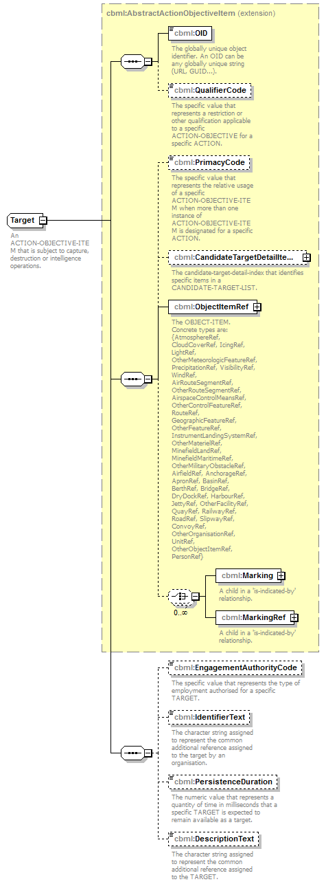
namespace | http://www.sisostds.org/schemas/c-bml/1.0
type | extension of cbml:AbstractActionObjectiveItem
properties
  base | cbml:AbstractActionObjectiveItem
children | cbml:OID cbml:QualifierCode cbml:PrimacyCode cbml:CandidateTargetDetailItemRef cbml:ObjectItemRef cbml:Marking cbml:MarkingRef cbml:EngagementAuthorityCode cbml:IdentifierText cbml:PersistenceDuration cbml:DescriptionText
annotation
  documentation
  An ACTION-OBJECTIVE-ITEM that is subject to capture, destruction or intelligence operations.
source | <xs:complexType name="Target">  <xs:annotation>  <xs:documentation xml:lang="en">An ACTION-OBJECTIVE-ITEM that is subject to capture, destruction or intelligence operations.</xs:documentation>  </xs:annotation>  <xs:complexContent>  <xs:extension base="cbml:AbstractActionObjectiveItem">  <xs:sequence>  <xs:element name="EngagementAuthorityCode" type="jc3iedm:TargetEngagementAuthorityCode" minOccurs="0">  <xs:annotation>  <xs:documentation xml:lang="en">The specific value that represents the type of employment authorised for a specific TARGET.</xs:documentation>  </xs:annotation>  </xs:element>  <xs:element name="IdentifierText" type="jc3iedm:TextTypeVar15" minOccurs="0">  <xs:annotation>  <xs:documentation xml:lang="en">The character string assigned to represent the common additional reference assigned to the target by an organisation.</xs:documentation>  </xs:annotation>  </xs:element>  <xs:element name="PersistenceDuration" type="jc3iedm:DurationType19" minOccurs="0">  <xs:annotation>  <xs:documentation xml:lang="en">The numeric value that represents a quantity of time in milliseconds that a specific TARGET is expected to remain available as a target.</xs:documentation>  </xs:annotation>  </xs:element>  <xs:element name="DescriptionText" type="jc3iedm:TextTypeVar20" minOccurs="0">  <xs:annotation>  <xs:documentation xml:lang="en">The character string assigned to represent the common additional reference assigned to the TARGET.</xs:documentation>  </xs:annotation>  </xs:element>  <!-- CBML Rationale: Covered by TargetPersonnelProtectionReport.  <xs:choice minOccurs="0">  <xs:element name="PersonnelProtection" type="cbml:TargetPersonnelProtection">  <xs:annotation>  <xs:documentation xml:lang="en">A child in a 'is-recognised-as-having' relationship.</xs:documentation>  </xs:annotation>  </xs:element>  <xs:element name="PersonnelProtectionRef" type="cbml:TargetPersonnelProtectionRef">  <xs:annotation>  <xs:documentation xml:lang="en">A child in a 'is-recognised-as-having' relationship.</xs:documentation>  </xs:annotation>  </xs:element>  </xs:choice>-->  </xs:sequence>  </xs:extension>  </xs:complexContent>  </xs:complexType>

element Target/EngagementAuthorityCode
diagram | 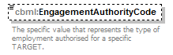
namespace | http://www.sisostds.org/schemas/c-bml/1.0
type | jc3iedm:TargetEngagementAuthorityCode
properties
  isRef | 0
  minOcc | 0
  maxOcc | 1
  content | simple
facets
  Kind | Value | annotation
  enumeration | AVLB
    documentation
    <Definition xml:lang="en">Authority for engagement of the target and is not a high payoff target.</Definition>
    appinfo
    <DisplayValue xml:lang="en">Available</DisplayValue>
  enumeration | EXCL
    documentation
    <Definition xml:lang="en">Engagement of the target is not permitted.</Definition>
    appinfo
    <DisplayValue xml:lang="en">Excluded</DisplayValue>
  enumeration | HPOTGT
    documentation
    <Definition xml:lang="en">Engagement of the target is available and is accorded the highest priority.</Definition>
    appinfo
    <DisplayValue xml:lang="en">High payoff target</DisplayValue>
  enumeration | NKN
    documentation
    <Definition xml:lang="en">It is not possible to determine which value is most applicable.</Definition>
    appinfo
    <DisplayValue xml:lang="en">Not known</DisplayValue>
annotation
  documentation
  The specific value that represents the type of employment authorised for a specific TARGET.
source | <xs:element name="EngagementAuthorityCode" type="jc3iedm:TargetEngagementAuthorityCode" minOccurs="0">  <xs:annotation>  <xs:documentation xml:lang="en">The specific value that represents the type of employment authorised for a specific TARGET.</xs:documentation>  </xs:annotation>  </xs:element>

element Target/IdentifierText
diagram | 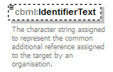
namespace | http://www.sisostds.org/schemas/c-bml/1.0
type | jc3iedm:TextTypeVar15
properties
  isRef | 0
  minOcc | 0
  maxOcc | 1
  content | simple
facets
  Kind | Value | annotation
  minLength | 0
  maxLength | 15
annotation
  documentation
  The character string assigned to represent the common additional reference assigned to the target by an organisation.
source | <xs:element name="IdentifierText" type="jc3iedm:TextTypeVar15" minOccurs="0">  <xs:annotation>  <xs:documentation xml:lang="en">The character string assigned to represent the common additional reference assigned to the target by an organisation.</xs:documentation>  </xs:annotation>  </xs:element>

element Target/PersistenceDuration
diagram | 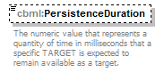
namespace | http://www.sisostds.org/schemas/c-bml/1.0
type | jc3iedm:DurationType19
properties
  isRef | 0
  minOcc | 0
  maxOcc | 1
  content | simple
facets
  Kind | Value | annotation
  minInclusive | -9999999999999999999
  maxInclusive | 9999999999999999999
annotation
  documentation
  The numeric value that represents a quantity of time in milliseconds that a specific TARGET is expected to remain available as a target.
source | <xs:element name="PersistenceDuration" type="jc3iedm:DurationType19" minOccurs="0">  <xs:annotation>  <xs:documentation xml:lang="en">The numeric value that represents a quantity of time in milliseconds that a specific TARGET is expected to remain available as a target.</xs:documentation>  </xs:annotation>  </xs:element>

element Target/DescriptionText
diagram | 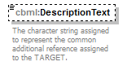
namespace | http://www.sisostds.org/schemas/c-bml/1.0
type | jc3iedm:TextTypeVar20
properties
  isRef | 0
  minOcc | 0
  maxOcc | 1
  content | simple
facets
  Kind | Value | annotation
  minLength | 0
  maxLength | 20
annotation
  documentation
  The character string assigned to represent the common additional reference assigned to the TARGET.
source | <xs:element name="DescriptionText" type="jc3iedm:TextTypeVar20" minOccurs="0">  <xs:annotation>  <xs:documentation xml:lang="en">The character string assigned to represent the common additional reference assigned to the TARGET.</xs:documentation>  </xs:annotation>  </xs:element>

complexType TargetPersonnelProtectionRefType
diagram | 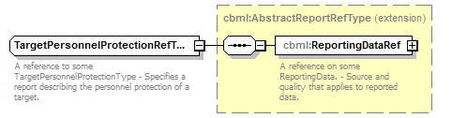
namespace | http://www.sisostds.org/schemas/c-bml/1.0
type | extension of cbml:AbstractReportRefType
properties
  base | cbml:AbstractReportRefType
children | cbml:ReportingDataRef
annotation
  documentation
  A reference to some TargetPersonnelProtectionType - Specifies a report describing the personnel protection of a target.
source | <xs:complexType name="TargetPersonnelProtectionRefType">  <xs:annotation>  <xs:documentation xml:lang="en">A reference to some TargetPersonnelProtectionType - Specifies a report describing the personnel protection of a target.</xs:documentation>  </xs:annotation>  <xs:complexContent>  <xs:extension base="cbml:AbstractReportRefType"/>  </xs:complexContent>  </xs:complexType>

complexType TargetPersonnelProtectionType
diagram | 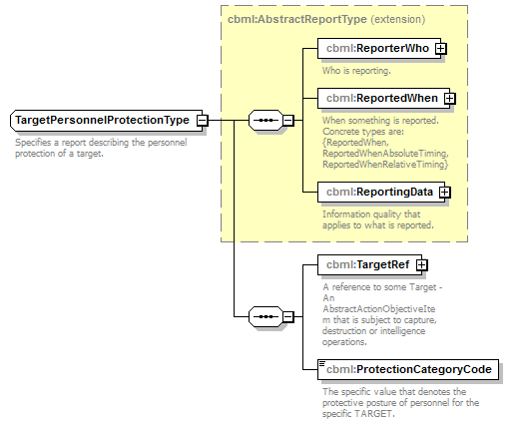
namespace | http://www.sisostds.org/schemas/c-bml/1.0
type | extension of cbml:AbstractReportType
properties
  base | cbml:AbstractReportType
children | cbml:ReporterWho cbml:ReportedWhen cbml:ReportingData cbml:TargetRef cbml:ProtectionCategoryCode
annotation
  documentation
  Specifies a report describing the personnel protection of a target.
source | <xs:complexType name="TargetPersonnelProtectionType">  <xs:annotation>  <xs:documentation xml:lang="en">Specifies a report describing the personnel protection of a target.</xs:documentation>  </xs:annotation>  <xs:complexContent>  <xs:extension base="cbml:AbstractReportType">  <xs:sequence>  <xs:element name="TargetRef" type="cbml:TargetRef">  <xs:annotation>  <xs:documentation xml:lang="en">A reference to some Target - An AbstractActionObjectiveItem that is subject to capture, destruction or intelligence operations.</xs:documentation>  </xs:annotation>  </xs:element>  <xs:element name="ProtectionCategoryCode" type="jc3iedm:TargetPersonnelProtectionCategoryCode">  <xs:annotation>  <xs:documentation xml:lang="en">The specific value that denotes the protective posture of personnel for the specific TARGET.</xs:documentation>  </xs:annotation>  </xs:element>  </xs:sequence>  </xs:extension>  </xs:complexContent>  </xs:complexType>

element TargetPersonnelProtectionType/TargetRef
diagram | 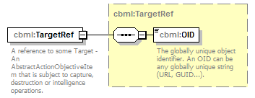
namespace | http://www.sisostds.org/schemas/c-bml/1.0
type | cbml:TargetRef
properties
  isRef | 0
  content | complex
children | cbml:OID
annotation
  documentation
  A reference to some Target - An AbstractActionObjectiveItem that is subject to capture, destruction or intelligence operations.
source | <xs:element name="TargetRef" type="cbml:TargetRef">  <xs:annotation>  <xs:documentation xml:lang="en">A reference to some Target - An AbstractActionObjectiveItem that is subject to capture, destruction or intelligence operations.</xs:documentation>  </xs:annotation>  </xs:element>

element TargetPersonnelProtectionType/ProtectionCategoryCode
diagram | 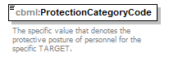
namespace | http://www.sisostds.org/schemas/c-bml/1.0
type | jc3iedm:TargetPersonnelProtectionCategoryCode
properties
  isRef | 0
  content | simple
facets
  Kind | Value | annotation
  enumeration | COVER
    documentation
    <Definition xml:lang="en">First volley (under overhead cover); second volley (under overhead cover).</Definition>
    appinfo
    <DisplayValue xml:lang="en">Under cover</DisplayValue>
  enumeration | DUGIN
    documentation
    <Definition xml:lang="en">First volley (dug in); second volley (dug in).</Definition>
    appinfo
    <DisplayValue xml:lang="en">Dug in</DisplayValue>
  enumeration | PRAND
    documentation
    <Definition xml:lang="en">First volley (half prone; half standing); second volley (all prone).</Definition>
    appinfo
    <DisplayValue xml:lang="en">Half prone, half standing</DisplayValue>
  enumeration | PRONE
    documentation
    <Definition xml:lang="en">First volley (prone); second volley (prone).</Definition>
    appinfo
    <DisplayValue xml:lang="en">Prone</DisplayValue>
  enumeration | PROVER
    documentation
    <Definition xml:lang="en">First volley (prone); second volley (under overhead cover).</Definition>
    appinfo
    <DisplayValue xml:lang="en">Prone, under cover</DisplayValue>
  enumeration | PRUG
    documentation
    <Definition xml:lang="en">First volley (prone); second volley (dug in).</Definition>
    appinfo
    <DisplayValue xml:lang="en">Prone, dug in</DisplayValue>
annotation
  documentation
  The specific value that denotes the protective posture of personnel for the specific TARGET.
source | <xs:element name="ProtectionCategoryCode" type="jc3iedm:TargetPersonnelProtectionCategoryCode">  <xs:annotation>  <xs:documentation xml:lang="en">The specific value that denotes the protective posture of personnel for the specific TARGET.</xs:documentation>  </xs:annotation>  </xs:element>

complexType TargetRef
diagram | 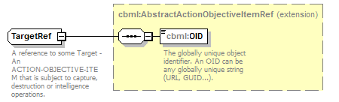
namespace | http://www.sisostds.org/schemas/c-bml/1.0
type | extension of cbml:AbstractActionObjectiveItemRef
properties
  base | cbml:AbstractActionObjectiveItemRef
children | cbml:OID
used by
  element | TargetPersonnelProtectionType/TargetRef
annotation
  documentation
  A reference to some Target - An ACTION-OBJECTIVE-ITEM that is subject to capture, destruction or intelligence operations.
source | <xs:complexType name="TargetRef">  <xs:annotation>  <xs:documentation xml:lang="en">A reference to some Target - An ACTION-OBJECTIVE-ITEM that is subject to capture, destruction or intelligence operations.</xs:documentation>  </xs:annotation>  <xs:complexContent>  <xs:extension base="cbml:AbstractActionObjectiveItemRef"/>  <!-- CBML Rationale: Reference’s elements not required because changed to an equivalent C-BML representation.  <xs:sequence>  <xs:choice minOccurs="0" >  <xs:element name="PersonnelProtection" type="cbml:TargetPersonnelProtection" >  <xs:annotation>  <xs:documentation xml:lang="en">A child in a 'is-recognised-as-having' relationship.</xs:documentation>  </xs:annotation>  </xs:element>  <xs:element name="PersonnelProtectionRef" type="cbml:TargetPersonnelProtectionRef" >  <xs:annotation>  <xs:documentation xml:lang="en">A child in a 'is-recognised-as-having' relationship.</xs:documentation>  </xs:annotation>  </xs:element>  </xs:choice>  </xs:sequence>  </xs:extension> -->  </xs:complexContent>  </xs:complexType>

XML Schema documentation generated by XMLSpy Schema Editor http://www.altova.com/xmlspy

