Schema cbml-composites.xsd

schema location: | C:\Users\vmadmin\Desktop\CBML_Phase1\Schemas\cbml-1.0\cbml\cbml-composites\1.0\cbml-composites.xsd
attributeFormDefault: | unqualified
elementFormDefault: | qualified
targetNamespace: | http://www.sisostds.org/schemas/c-bml/1.0

Complex types
AbstractExpressionRefType
AbstractExpressionType
AbstractReportedWhenType
AbstractReportRefType
AbstractReportType
ActionType
AffectedWhoType
CandidateTargetListRefType
CandidateTargetListType
CoordinatingInformationType
EndWhenAbsoluteSpecifiedTimeType
EndWhenAbsoluteTimeType
EndWhenAbsoluteUnspecifiedTimeType
EndWhenRelativeTimeType
EventEndWhenType
EventStartWhenType
EventType
EventWhatLocationRefType
EventWhatLocationType
EventWhatRefType
EventWhatStatusRefType
EventWhatStatusType
EventWhatType
ExecuterWhoType
HoldingTransferRefType
HoldingTransferType
OrderTaskType
OrganisationStructureRefType
OrganisationStructureType
ReportedWhenAbsoluteTimingType
ReportedWhenRelativeTimingType
ReportedWhenType
ReporterWhoType
ReportingData
ReportingDataRef
RequestedWhoType
RequesterWhoType
RequestTaskType
RouteWhereType
SpecificLocationType
StartWhenAbsoluteSpecifiedTimeType
StartWhenAbsoluteTimeType
StartWhenAbsoluteUnspecifiedTimeType
StartWhenRelativeTimeType
StateType
TaskeeWhoType
TaskEndWhenType
TaskerWhoType
TaskLocalExtensionsType
TaskStartWhenType
TaskType
TaskWhatRefType
TaskWhatStatusRefType
TaskWhatStatusType
TaskWhatType
TaskWhenType
WhatEffectRefType
WhatEffectType
WhatRefType
WhatType
WhereType
WhoAffiliationRefType
WhoAffiliationType
WhoAssociationRefType
WhoAssociationType
WhoHoldingRefType
WhoHoldingType
WhoHostilityRefType
WhoHostilityType
WhoLocationRefType
WhoLocationType
WhoRefType
WhoStatusRefType
WhoStatusType
WhoType
WhoTypeRefType
WhoTypeType
WhyType

complexType AbstractExpressionRefType
diagram | 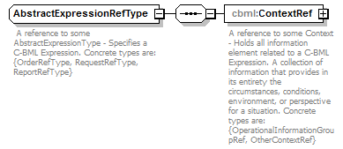
namespace | http://www.sisostds.org/schemas/c-bml/1.0
children | cbml:ContextRef
annotation
  documentation
  A reference to some AbstractExpressionType - Specifies a C-BML Expression. Concrete types are: {OrderRefType, RequestRefType, ReportRefType}
source | <xs:complexType name="AbstractExpressionRefType">  <xs:annotation>  <xs:documentation xml:lang="en"> A reference to some AbstractExpressionType - Specifies a C-BML Expression. Concrete types are: {OrderRefType, RequestRefType, ReportRefType}</xs:documentation>  </xs:annotation>  <xs:sequence>  <xs:element name="ContextRef" type="cbml:AbstractContextRef">  <xs:annotation>  <xs:documentation xml:lang="en">A reference to some Context - Holds all information element related to a C-BML Expression. A collection of information that provides in its entirety the circumstances, conditions, environment, or perspective for a situation. Concrete types are: {OperationalInformationGroupRef, OtherContextRef}</xs:documentation>  </xs:annotation>  </xs:element>  </xs:sequence>  </xs:complexType>

element AbstractExpressionRefType/ContextRef
diagram | 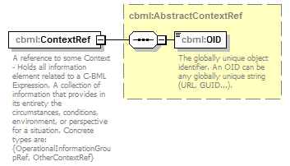
namespace | http://www.sisostds.org/schemas/c-bml/1.0
type | cbml:AbstractContextRef
properties
  content | complex
children | cbml:OID
annotation
  documentation
  A reference to some Context - Holds all information element related to a C-BML Expression. A collection of information that provides in its entirety the circumstances, conditions, environment, or perspective for a situation. Concrete types are: {OperationalInformationGroupRef, OtherContextRef}
source | <xs:element name="ContextRef" type="cbml:AbstractContextRef">  <xs:annotation>  <xs:documentation xml:lang="en">A reference to some Context - Holds all information element related to a C-BML Expression. A collection of information that provides in its entirety the circumstances, conditions, environment, or perspective for a situation. Concrete types are: {OperationalInformationGroupRef, OtherContextRef}</xs:documentation>  </xs:annotation>  </xs:element>

complexType AbstractExpressionType
diagram | 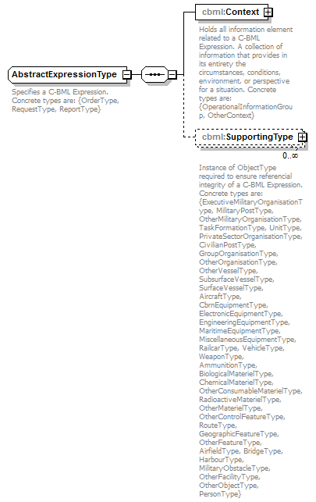
namespace | http://www.sisostds.org/schemas/c-bml/1.0
properties
  abstract | true
children | cbml:Context cbml:SupportingType
annotation
  documentation
  Specifies a C-BML Expression. Concrete types are: {OrderType, RequestType, ReportType}
source | <xs:complexType name="AbstractExpressionType" abstract="true">  <xs:annotation>  <xs:documentation xml:lang="en">Specifies a C-BML Expression. Concrete types are: {OrderType, RequestType, ReportType}</xs:documentation>  </xs:annotation>  <xs:sequence>  <xs:element name="Context" type="cbml:AbstractContext">  <xs:annotation>  <xs:documentation xml:lang="en">Holds all information element related to a C-BML Expression. A collection of information that provides in its entirety the circumstances, conditions, environment, or perspective for a situation. Concrete types are: {OperationalInformationGroup, OtherContext}</xs:documentation>  </xs:annotation>  </xs:element>  <xs:element name="SupportingType" type="cbml:AbstractObjectType" minOccurs="0" maxOccurs="unbounded">  <xs:annotation>  <xs:documentation xml:lang="en">Instance of ObjectType required to ensure referencial integrity of a C-BML Expression. Concrete types are: {ExecutiveMilitaryOrganisationType, MilitaryPostType, OtherMilitaryOrganisationType, TaskFormationType, UnitType, PrivateSectorOrganisationType, CivilianPostType, GroupOrganisationType, OtherOrganisationType, OtherVesselType, SubsurfaceVesselType, SurfaceVesselType, AircraftType, CbrnEquipmentType, ElectronicEquipmentType, EngineeringEquipmentType, MaritimeEquipmentType, MiscellaneousEquipmentType, RailcarType, VehicleType, WeaponType, AmmunitionType, BiologicalMaterielType, ChemicalMaterielType, OtherConsumableMaterielType, RadioactiveMaterielType, OtherMaterielType, OtherControlFeatureType, RouteType, GeographicFeatureType, OtherFeatureType, AirfieldType, BridgeType, HarbourType, MilitaryObstacleType, OtherFacilityType, OtherObjectType, PersonType}</xs:documentation>  </xs:annotation>  </xs:element>  </xs:sequence>  </xs:complexType>

element AbstractExpressionType/Context
diagram | 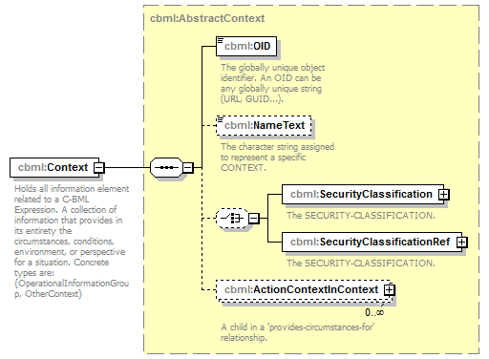
namespace | http://www.sisostds.org/schemas/c-bml/1.0
type | cbml:AbstractContext
properties
  content | complex
children | cbml:OID cbml:NameText cbml:SecurityClassification cbml:SecurityClassificationRef cbml:ActionContextInContext
annotation
  documentation
  Holds all information element related to a C-BML Expression. A collection of information that provides in its entirety the circumstances, conditions, environment, or perspective for a situation. Concrete types are: {OperationalInformationGroup, OtherContext}
source | <xs:element name="Context" type="cbml:AbstractContext">  <xs:annotation>  <xs:documentation xml:lang="en">Holds all information element related to a C-BML Expression. A collection of information that provides in its entirety the circumstances, conditions, environment, or perspective for a situation. Concrete types are: {OperationalInformationGroup, OtherContext}</xs:documentation>  </xs:annotation>  </xs:element>

element AbstractExpressionType/SupportingType
diagram | 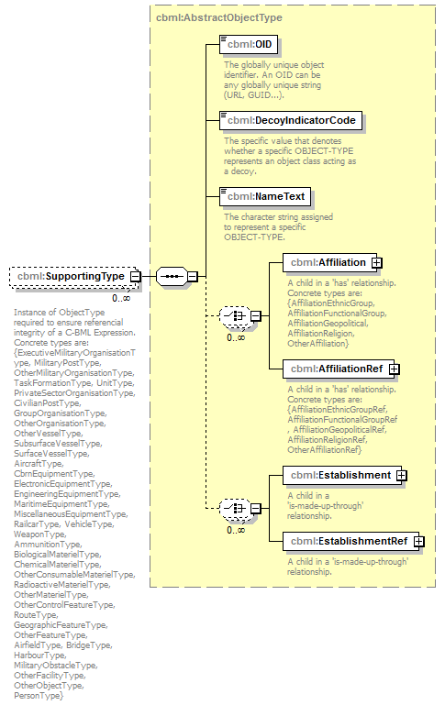
namespace | http://www.sisostds.org/schemas/c-bml/1.0
type | cbml:AbstractObjectType
properties
  minOcc | 0
  maxOcc | unbounded
  content | complex
children | cbml:OID cbml:DecoyIndicatorCode cbml:NameText cbml:Affiliation cbml:AffiliationRef cbml:Establishment cbml:EstablishmentRef
annotation
  documentation
  Instance of ObjectType required to ensure referencial integrity of a C-BML Expression. Concrete types are: {ExecutiveMilitaryOrganisationType, MilitaryPostType, OtherMilitaryOrganisationType, TaskFormationType, UnitType, PrivateSectorOrganisationType, CivilianPostType, GroupOrganisationType, OtherOrganisationType, OtherVesselType, SubsurfaceVesselType, SurfaceVesselType, AircraftType, CbrnEquipmentType, ElectronicEquipmentType, EngineeringEquipmentType, MaritimeEquipmentType, MiscellaneousEquipmentType, RailcarType, VehicleType, WeaponType, AmmunitionType, BiologicalMaterielType, ChemicalMaterielType, OtherConsumableMaterielType, RadioactiveMaterielType, OtherMaterielType, OtherControlFeatureType, RouteType, GeographicFeatureType, OtherFeatureType, AirfieldType, BridgeType, HarbourType, MilitaryObstacleType, OtherFacilityType, OtherObjectType, PersonType}
source | <xs:element name="SupportingType" type="cbml:AbstractObjectType" minOccurs="0" maxOccurs="unbounded">  <xs:annotation>  <xs:documentation xml:lang="en">Instance of ObjectType required to ensure referencial integrity of a C-BML Expression. Concrete types are: {ExecutiveMilitaryOrganisationType, MilitaryPostType, OtherMilitaryOrganisationType, TaskFormationType, UnitType, PrivateSectorOrganisationType, CivilianPostType, GroupOrganisationType, OtherOrganisationType, OtherVesselType, SubsurfaceVesselType, SurfaceVesselType, AircraftType, CbrnEquipmentType, ElectronicEquipmentType, EngineeringEquipmentType, MaritimeEquipmentType, MiscellaneousEquipmentType, RailcarType, VehicleType, WeaponType, AmmunitionType, BiologicalMaterielType, ChemicalMaterielType, OtherConsumableMaterielType, RadioactiveMaterielType, OtherMaterielType, OtherControlFeatureType, RouteType, GeographicFeatureType, OtherFeatureType, AirfieldType, BridgeType, HarbourType, MilitaryObstacleType, OtherFacilityType, OtherObjectType, PersonType}</xs:documentation>  </xs:annotation>  </xs:element>

complexType AbstractReportedWhenType
diagram | 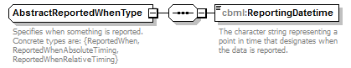
namespace | http://www.sisostds.org/schemas/c-bml/1.0
properties
  abstract | true
children | cbml:ReportingDatetime
used by
  elements | AbstractReportType/ReportedWhen ReportedWhen
  complexTypes | ReportedWhenAbsoluteTimingType ReportedWhenRelativeTimingType ReportedWhenType
annotation
  documentation
  Specifies when something is reported. Concrete types are: {ReportedWhen, ReportedWhenAbsoluteTiming, ReportedWhenRelativeTiming}
source | <xs:complexType name="AbstractReportedWhenType" abstract="true">  <xs:annotation>  <xs:documentation xml:lang="en">Specifies when something is reported. Concrete types are: {ReportedWhen, ReportedWhenAbsoluteTiming, ReportedWhenRelativeTiming}</xs:documentation>  </xs:annotation>  <xs:sequence>  <xs:element name="ReportingDatetime" type="jc3iedm:DatetimeTypeFix18">  <xs:annotation>  <xs:documentation xml:lang="en">The character string representing a point in time that designates when the data is reported.</xs:documentation>  </xs:annotation>  </xs:element>  </xs:sequence>  </xs:complexType>

element AbstractReportedWhenType/ReportingDatetime
diagram | 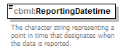
namespace | http://www.sisostds.org/schemas/c-bml/1.0
type | jc3iedm:DatetimeTypeFix18
properties
  content | simple
facets
  Kind | Value | Annotation
  minLength | 18
  maxLength | 18
annotation
  documentation
  The character string representing a point in time that designates when the data is reported.
source | <xs:element name="ReportingDatetime" type="jc3iedm:DatetimeTypeFix18">  <xs:annotation>  <xs:documentation xml:lang="en">The character string representing a point in time that designates when the data is reported.</xs:documentation>  </xs:annotation>  </xs:element>

complexType AbstractReportRefType
diagram | 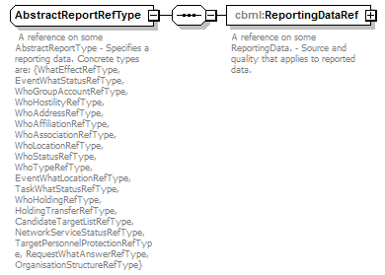
namespace | http://www.sisostds.org/schemas/c-bml/1.0
children | cbml:ReportingDataRef
used by
  complexTypes | CandidateTargetListRefType EventWhatLocationRefType EventWhatStatusRefType HoldingTransferRefType OrganisationStructureRefType TaskWhatStatusRefType WhatEffectRefType WhoAffiliationRefType WhoAssociationRefType WhoHoldingRefType WhoHostilityRefType WhoLocationRefType WhoStatusRefType WhoTypeRefType
annotation
  documentation
  A reference on some AbstractReportType - Specifies a reporting data. Concrete types are: {WhatEffectRefType, EventWhatStatusRefType, WhoGroupAccountRefType, WhoHostilityRefType, WhoAddressRefType, WhoAffiliationRefType, WhoAssociationRefType, WhoLocationRefType, WhoStatusRefType, WhoTypeRefType, EventWhatLocationRefType, TaskWhatStatusRefType, WhoHoldingRefType, HoldingTransferRefType, CandidateTargetListRefType, NetworkServiceStatusRefType, TargetPersonnelProtectionRefType, RequestWhatAnswerRefType, OrganisationStructureRefType}
source | <xs:complexType name="AbstractReportRefType">  <xs:annotation>  <xs:documentation xml:lang="en"> A reference on some AbstractReportType - Specifies a reporting data. Concrete types are: {WhatEffectRefType, EventWhatStatusRefType, WhoGroupAccountRefType, WhoHostilityRefType, WhoAddressRefType, WhoAffiliationRefType, WhoAssociationRefType, WhoLocationRefType, WhoStatusRefType, WhoTypeRefType, EventWhatLocationRefType, TaskWhatStatusRefType, WhoHoldingRefType, HoldingTransferRefType, CandidateTargetListRefType, NetworkServiceStatusRefType, TargetPersonnelProtectionRefType, RequestWhatAnswerRefType, OrganisationStructureRefType}</xs:documentation>  </xs:annotation>  <xs:sequence>  <xs:element name="ReportingDataRef" type="cbml:ReportingDataRef">  <xs:annotation>  <xs:documentation xml:lang="en">A reference on some ReportingData. - Source and quality that applies to reported data.</xs:documentation>  </xs:annotation>  </xs:element>  </xs:sequence>  </xs:complexType>

element AbstractReportRefType/ReportingDataRef
diagram | 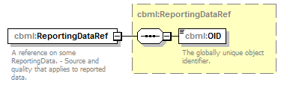
namespace | http://www.sisostds.org/schemas/c-bml/1.0
type | cbml:ReportingDataRef
properties
  content | complex
children | cbml:OID
annotation
  documentation
  A reference on some ReportingData. - Source and quality that applies to reported data.
source | <xs:element name="ReportingDataRef" type="cbml:ReportingDataRef">  <xs:annotation>  <xs:documentation xml:lang="en">A reference on some ReportingData. - Source and quality that applies to reported data.</xs:documentation>  </xs:annotation>  </xs:element>

complexType AbstractReportType
diagram | 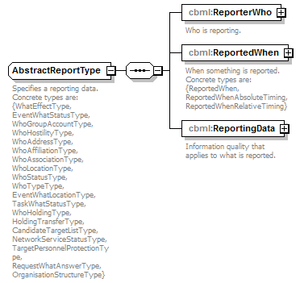
namespace | http://www.sisostds.org/schemas/c-bml/1.0
properties
  abstract | true
children | cbml:ReporterWho cbml:ReportedWhen cbml:ReportingData
used by
  element | StateType/ReportItem
  complexTypes | CandidateTargetListType EventWhatLocationType EventWhatStatusType HoldingTransferType OrganisationStructureType TaskWhatStatusType WhatEffectType WhoAffiliationType WhoAssociationType WhoHoldingType WhoHostilityType WhoLocationType WhoStatusType WhoTypeType
annotation
  documentation
  Specifies a reporting data. Concrete types are: {WhatEffectType, EventWhatStatusType, WhoGroupAccountType, WhoHostilityType, WhoAddressType, WhoAffiliationType, WhoAssociationType, WhoLocationType, WhoStatusType, WhoTypeType, EventWhatLocationType, TaskWhatStatusType, WhoHoldingType, HoldingTransferType, CandidateTargetListType, NetworkServiceStatusType, TargetPersonnelProtectionType, RequestWhatAnswerType, OrganisationStructureType}
source | <xs:complexType name="AbstractReportType" abstract="true">  <xs:annotation>  <xs:documentation xml:lang="en">Specifies a reporting data. Concrete types are: {WhatEffectType, EventWhatStatusType, WhoGroupAccountType, WhoHostilityType, WhoAddressType, WhoAffiliationType, WhoAssociationType, WhoLocationType, WhoStatusType, WhoTypeType, EventWhatLocationType, TaskWhatStatusType, WhoHoldingType, HoldingTransferType, CandidateTargetListType, NetworkServiceStatusType, TargetPersonnelProtectionType, RequestWhatAnswerType, OrganisationStructureType}</xs:documentation>  </xs:annotation>  <xs:sequence>  <xs:element name="ReporterWho" type="cbml:ReporterWhoType">  <xs:annotation>  <xs:documentation xml:lang="en">Who is reporting.</xs:documentation>  </xs:annotation>  </xs:element>  <xs:element name="ReportedWhen" type="cbml:AbstractReportedWhenType">  <xs:annotation>  <xs:documentation xml:lang="en">When something is reported. Concrete types are: {ReportedWhen, ReportedWhenAbsoluteTiming, ReportedWhenRelativeTiming}</xs:documentation>  </xs:annotation>  </xs:element>  <xs:element name="ReportingData" type="cbml:ReportingData">  <xs:annotation>  <xs:documentation xml:lang="en">Information quality that applies to what is reported.</xs:documentation>  </xs:annotation>  </xs:element>  </xs:sequence>  </xs:complexType>

element AbstractReportType/ReporterWho
diagram | 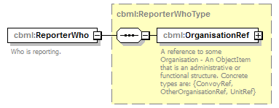
namespace | http://www.sisostds.org/schemas/c-bml/1.0
type | cbml:ReporterWhoType
properties
  content | complex
children | cbml:OrganisationRef
annotation
  documentation
  Who is reporting.
source | <xs:element name="ReporterWho" type="cbml:ReporterWhoType">  <xs:annotation>  <xs:documentation xml:lang="en">Who is reporting.</xs:documentation>  </xs:annotation>  </xs:element>

element AbstractReportType/ReportedWhen
diagram | 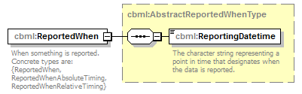
namespace | http://www.sisostds.org/schemas/c-bml/1.0
type | cbml:AbstractReportedWhenType
properties
  content | complex
children | cbml:ReportingDatetime
annotation
  documentation
  When something is reported. Concrete types are: {ReportedWhen, ReportedWhenAbsoluteTiming, ReportedWhenRelativeTiming}
source | <xs:element name="ReportedWhen" type="cbml:AbstractReportedWhenType">  <xs:annotation>  <xs:documentation xml:lang="en">When something is reported. Concrete types are: {ReportedWhen, ReportedWhenAbsoluteTiming, ReportedWhenRelativeTiming}</xs:documentation>  </xs:annotation>  </xs:element>

element AbstractReportType/ReportingData
diagram | 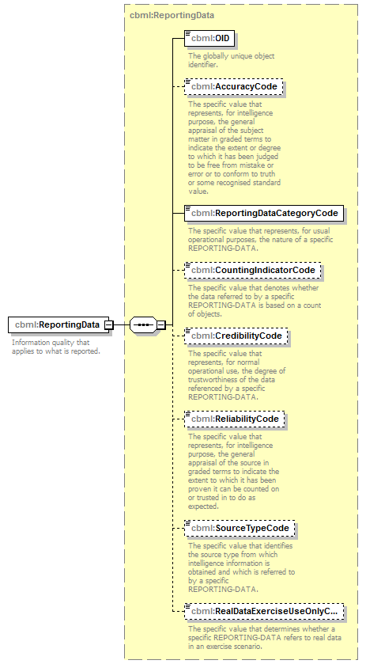
namespace | http://www.sisostds.org/schemas/c-bml/1.0
type | cbml:ReportingData
properties
  content | complex
children | cbml:OID cbml:AccuracyCode cbml:ReportingDataCategoryCode cbml:CountingIndicatorCode cbml:CredibilityCode cbml:ReliabilityCode cbml:SourceTypeCode cbml:RealDataExerciseUseOnlyCode
annotation
  documentation
  Information quality that applies to what is reported.
source | <xs:element name="ReportingData" type="cbml:ReportingData">  <xs:annotation>  <xs:documentation xml:lang="en">Information quality that applies to what is reported.</xs:documentation>  </xs:annotation>  </xs:element>

complexType ActionType
diagram | 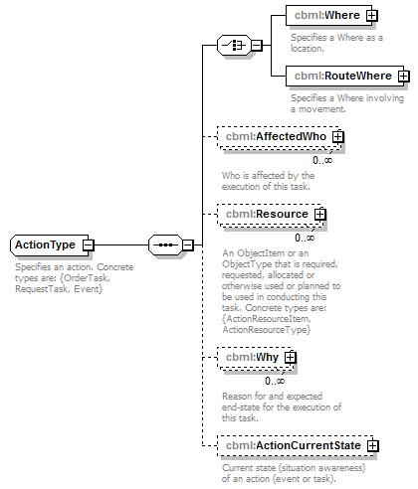
namespace | http://www.sisostds.org/schemas/c-bml/1.0
properties
  abstract | true
children | cbml:Where cbml:RouteWhere cbml:AffectedWho cbml:Resource cbml:Why cbml:ActionCurrentState
used by
  complexTypes | EventType TaskType
annotation
  documentation
  Specifies an action. Concrete types are: {OrderTask, RequestTask, Event}
source | <xs:complexType name="ActionType" abstract="true">  <xs:annotation>  <xs:documentation xml:lang="en">Specifies an action. Concrete types are: {OrderTask, RequestTask, Event}</xs:documentation>  </xs:annotation>  <xs:sequence>  <xs:choice>  <xs:element name="Where" type="cbml:WhereType">  <xs:annotation>  <xs:documentation xml:lang="en">Specifies a Where as a location.</xs:documentation>  </xs:annotation>  </xs:element>  <xs:element name="RouteWhere" type="cbml:RouteWhereType">  <xs:annotation>  <xs:documentation xml:lang="en">Specifies a Where involving a movement.</xs:documentation>  </xs:annotation>  </xs:element>  </xs:choice>  <xs:element name="AffectedWho" type="cbml:AffectedWhoType" minOccurs="0" maxOccurs="unbounded">  <xs:annotation>  <xs:documentation xml:lang="en">Who is affected by the execution of this task.</xs:documentation>  </xs:annotation>  </xs:element>  <xs:element name="Resource" type="cbml:AbstractActionResource" minOccurs="0" maxOccurs="unbounded">  <xs:annotation>  <xs:documentation xml:lang="en">An ObjectItem or an ObjectType that is required, requested, allocated or otherwise used or planned to be used in conducting this task. Concrete types are: {ActionResourceItem, ActionResourceType}</xs:documentation>  </xs:annotation>  </xs:element>  <xs:element name="Why" type="cbml:WhyType" minOccurs="0" maxOccurs="unbounded">  <xs:annotation>  <xs:documentation xml:lang="en">Reason for and expected end-state for the execution of this task.</xs:documentation>  </xs:annotation>  </xs:element>  <xs:element name="ActionCurrentState" type="cbml:StateType" minOccurs="0">  <xs:annotation>  <xs:documentation xml:lang="en">Current state (situation awareness) of an action (event or task).</xs:documentation>  </xs:annotation>  </xs:element>  </xs:sequence>  </xs:complexType>

element ActionType/Where
diagram | 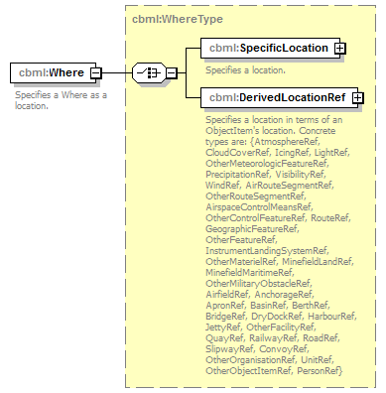
namespace | http://www.sisostds.org/schemas/c-bml/1.0
type | cbml:WhereType
properties
  content | complex
children | cbml:SpecificLocation cbml:DerivedLocationRef
annotation
  documentation
  Specifies a Where as a location.
source | <xs:element name="Where" type="cbml:WhereType">  <xs:annotation>  <xs:documentation xml:lang="en">Specifies a Where as a location.</xs:documentation>  </xs:annotation>  </xs:element>

element ActionType/RouteWhere
diagram | 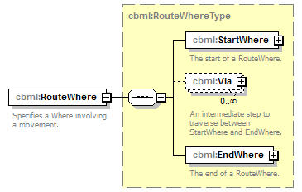
namespace | http://www.sisostds.org/schemas/c-bml/1.0
type | cbml:RouteWhereType
properties
  content | complex
children | cbml:StartWhere cbml:Via cbml:EndWhere
annotation
  documentation
  Specifies a Where involving a movement.
source | <xs:element name="RouteWhere" type="cbml:RouteWhereType">  <xs:annotation>  <xs:documentation xml:lang="en">Specifies a Where involving a movement.</xs:documentation>  </xs:annotation>  </xs:element>

element ActionType/AffectedWho
diagram | 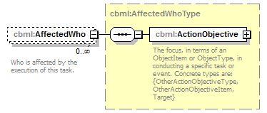
namespace | http://www.sisostds.org/schemas/c-bml/1.0
type | cbml:AffectedWhoType
properties
  minOcc | 0
  maxOcc | unbounded
  content | complex
children | cbml:ActionObjective
annotation
  documentation
  Who is affected by the execution of this task.
source | <xs:element name="AffectedWho" type="cbml:AffectedWhoType" minOccurs="0" maxOccurs="unbounded">  <xs:annotation>  <xs:documentation xml:lang="en">Who is affected by the execution of this task.</xs:documentation>  </xs:annotation>  </xs:element>

element ActionType/Resource
diagram | 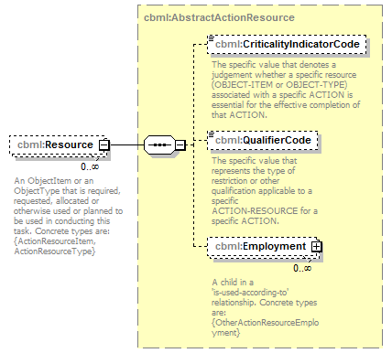
namespace | http://www.sisostds.org/schemas/c-bml/1.0
type | cbml:AbstractActionResource
properties
  minOcc | 0
  maxOcc | unbounded
  content | complex
children | cbml:CriticalityIndicatorCode cbml:QualifierCode cbml:Employment
annotation
  documentation
  An ObjectItem or an ObjectType that is required, requested, allocated or otherwise used or planned to be used in conducting this task. Concrete types are: {ActionResourceItem, ActionResourceType}
source | <xs:element name="Resource" type="cbml:AbstractActionResource" minOccurs="0" maxOccurs="unbounded">  <xs:annotation>  <xs:documentation xml:lang="en">An ObjectItem or an ObjectType that is required, requested, allocated or otherwise used or planned to be used in conducting this task. Concrete types are: {ActionResourceItem, ActionResourceType}</xs:documentation>  </xs:annotation>  </xs:element>

element ActionType/Why
diagram | 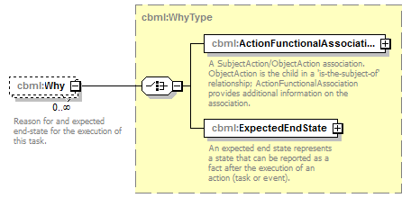
namespace | http://www.sisostds.org/schemas/c-bml/1.0
type | cbml:WhyType
properties
  minOcc | 0
  maxOcc | unbounded
  content | complex
children | cbml:ActionFunctionalAssociationInSubjectAction cbml:ExpectedEndState
annotation
  documentation
  Reason for and expected end-state for the execution of this task.
source | <xs:element name="Why" type="cbml:WhyType" minOccurs="0" maxOccurs="unbounded">  <xs:annotation>  <xs:documentation xml:lang="en">Reason for and expected end-state for the execution of this task.</xs:documentation>  </xs:annotation>  </xs:element>

element ActionType/ActionCurrentState
diagram | 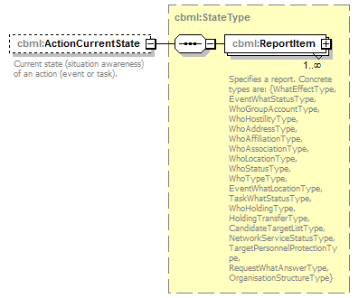
namespace | http://www.sisostds.org/schemas/c-bml/1.0
type | cbml:StateType
properties
  minOcc | 0
  maxOcc | 1
  content | complex
children | cbml:ReportItem
annotation
  documentation
  Current state (situation awareness) of an action (event or task).
source | <xs:element name="ActionCurrentState" type="cbml:StateType" minOccurs="0">  <xs:annotation>  <xs:documentation xml:lang="en">Current state (situation awareness) of an action (event or task).</xs:documentation>  </xs:annotation>  </xs:element>

complexType AffectedWhoType
diagram | 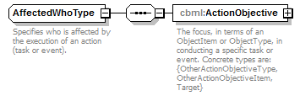
namespace | http://www.sisostds.org/schemas/c-bml/1.0
children | cbml:ActionObjective
used by
  elements | AffectedWho ActionType/AffectedWho
annotation
  documentation
  Specifies who is affected by the execution of an action (task or event).
source | <xs:complexType name="AffectedWhoType">  <xs:annotation>  <xs:documentation xml:lang="en">Specifies who is affected by the execution of an action (task or event).</xs:documentation>  </xs:annotation>  <xs:sequence>  <xs:element name="ActionObjective" type="cbml:AbstractActionObjective">  <xs:annotation>  <xs:documentation xml:lang="en">The focus, in terms of an ObjectItem or ObjectType, in conducting a specific task or event. Concrete types are: {OtherActionObjectiveType, OtherActionObjectiveItem, Target}</xs:documentation>  </xs:annotation>  </xs:element>  </xs:sequence>  </xs:complexType>

element AffectedWhoType/ActionObjective
diagram | 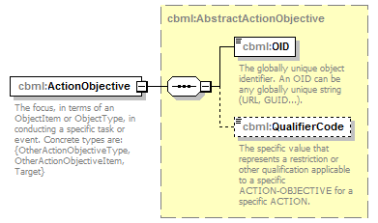
namespace | http://www.sisostds.org/schemas/c-bml/1.0
type | cbml:AbstractActionObjective
properties
  content | complex
children | cbml:OID cbml:QualifierCode
annotation
  documentation
  The focus, in terms of an ObjectItem or ObjectType, in conducting a specific task or event. Concrete types are: {OtherActionObjectiveType, OtherActionObjectiveItem, Target}
source | <xs:element name="ActionObjective" type="cbml:AbstractActionObjective">  <xs:annotation>  <xs:documentation xml:lang="en">The focus, in terms of an ObjectItem or ObjectType, in conducting a specific task or event. Concrete types are: {OtherActionObjectiveType, OtherActionObjectiveItem, Target}</xs:documentation>  </xs:annotation>  </xs:element>

complexType CandidateTargetListRefType
diagram | 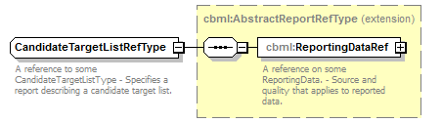
namespace | http://www.sisostds.org/schemas/c-bml/1.0
type | extension of cbml:AbstractReportRefType
properties
  base | cbml:AbstractReportRefType
children | cbml:ReportingDataRef
annotation
  documentation
  A reference to some CandidateTargetListType - Specifies a report describing a candidate target list.
source | <xs:complexType name="CandidateTargetListRefType">  <xs:annotation>  <xs:documentation xml:lang="en">A reference to some CandidateTargetListType - Specifies a report describing a candidate target list.</xs:documentation>  </xs:annotation>  <xs:complexContent>  <xs:extension base="cbml:AbstractReportRefType"/>  </xs:complexContent>  </xs:complexType>

complexType CandidateTargetListType
diagram | 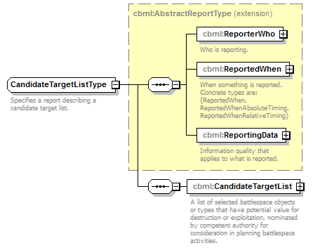
namespace | http://www.sisostds.org/schemas/c-bml/1.0
type | extension of cbml:AbstractReportType
properties
  base | cbml:AbstractReportType
children | cbml:ReporterWho cbml:ReportedWhen cbml:ReportingData cbml:CandidateTargetList
annotation
  documentation
  Specifies a report describing a candidate target list.
source | <xs:complexType name="CandidateTargetListType">  <xs:annotation>  <xs:documentation xml:lang="en">Specifies a report describing a candidate target list.</xs:documentation>  </xs:annotation>  <xs:complexContent>  <xs:extension base="cbml:AbstractReportType">  <xs:sequence>  <xs:element name="CandidateTargetList" type="cbml:CandidateTargetList">  <xs:annotation>  <xs:documentation xml:lang="en">A list of selected battlespace objects or types that have potential value for destruction or exploitation, nominated by competent authority for consideration in planning battlespace activities.</xs:documentation>  </xs:annotation>  </xs:element>  </xs:sequence>  </xs:extension>  </xs:complexContent>  </xs:complexType>

element CandidateTargetListType/CandidateTargetList
diagram | 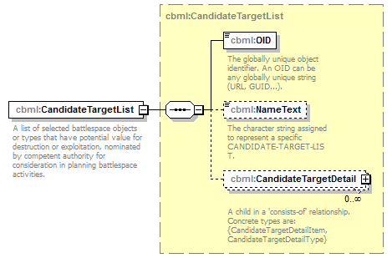
namespace | http://www.sisostds.org/schemas/c-bml/1.0
type | cbml:CandidateTargetList
properties
  content | complex
children | cbml:OID cbml:NameText cbml:CandidateTargetDetail
annotation
  documentation
  A list of selected battlespace objects or types that have potential value for destruction or exploitation, nominated by competent authority for consideration in planning battlespace activities.
source | <xs:element name="CandidateTargetList" type="cbml:CandidateTargetList">  <xs:annotation>  <xs:documentation xml:lang="en">A list of selected battlespace objects or types that have potential value for destruction or exploitation, nominated by competent authority for consideration in planning battlespace activities.</xs:documentation>  </xs:annotation>  </xs:element>

complexType CoordinatingInformationType
diagram | 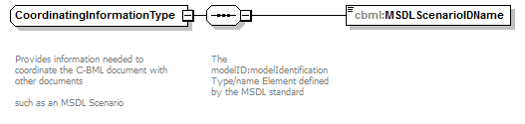
namespace | http://www.sisostds.org/schemas/c-bml/1.0
children | cbml:MSDLScenarioIDName
used by
  element | CoordinatingInformation
annotation
  documentation
  Provides information needed to coordinate the C-BML document with other documents
  such as an MSDL Scenario
source | <xs:complexType name="CoordinatingInformationType">  <xs:annotation>  <xs:documentation>  Provides information needed to coordinate the C-BML document with other documents  such as an MSDL Scenario  </xs:documentation>  </xs:annotation>  <xs:sequence>  <xs:annotation>  <xs:documentation>  The modelID:modelIdentificationType/name Element defined by the MSDL standard  </xs:documentation>  </xs:annotation>  <xs:element name="MSDLScenarioIDName"/>  </xs:sequence>  </xs:complexType>

element CoordinatingInformationType/MSDLScenarioIDName
diagram | 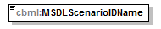
namespace | http://www.sisostds.org/schemas/c-bml/1.0
source | <xs:element name="MSDLScenarioIDName"/>

complexType EndWhenAbsoluteSpecifiedTimeType
diagram | 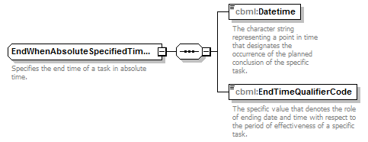
namespace | http://www.sisostds.org/schemas/c-bml/1.0
children | cbml:Datetime cbml:EndTimeQualifierCode
used by
  element | EndWhenAbsoluteTimeType/EndSpecifiedTime
annotation
  documentation
  Specifies the end time of a task in absolute time.
source | <xs:complexType name="EndWhenAbsoluteSpecifiedTimeType">  <xs:annotation>  <xs:documentation xml:lang="en">Specifies the end time of a task in absolute time.</xs:documentation>  </xs:annotation>  <xs:sequence>  <xs:element name="Datetime" type="jc3iedm:DatetimeTypeFix18">  <xs:annotation>  <xs:documentation xml:lang="en">The character string representing a point in time that designates the occurrence of the planned conclusion of the specific task.</xs:documentation>  </xs:annotation>  </xs:element>  <xs:element name="EndTimeQualifierCode" type="cbml:ActionTaskEndTimeQualifierCode">  <xs:annotation>  <xs:documentation xml:lang="en">The specific value that denotes the role of ending date and time with respect to the period of effectiveness of a specific task.</xs:documentation>  </xs:annotation>  </xs:element>  </xs:sequence>  </xs:complexType>

element EndWhenAbsoluteSpecifiedTimeType/Datetime
diagram | 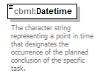
namespace | http://www.sisostds.org/schemas/c-bml/1.0
type | jc3iedm:DatetimeTypeFix18
properties
  content | simple
facets
  Kind | Value | Annotation
  minLength | 18
  maxLength | 18
annotation
  documentation
  The character string representing a point in time that designates the occurrence of the planned conclusion of the specific task.
source | <xs:element name="Datetime" type="jc3iedm:DatetimeTypeFix18">  <xs:annotation>  <xs:documentation xml:lang="en">The character string representing a point in time that designates the occurrence of the planned conclusion of the specific task.</xs:documentation>  </xs:annotation>  </xs:element>

element EndWhenAbsoluteSpecifiedTimeType/EndTimeQualifierCode
diagram | 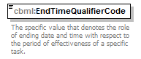
namespace | http://www.sisostds.org/schemas/c-bml/1.0
type | cbml:ActionTaskEndTimeQualifierCode
properties
  content | simple
facets
  Kind | Value | Annotation
  enumeration | AFT
    documentation
    <Definition xml:lang="en">Time intended is later than the time specified.</Definition>
    appinfo
    <xs:DisplayValue xml:lang="en">After</xs:DisplayValue>
  enumeration | ASAPAF
    documentation
    <Definition xml:lang="en">End the activity at the earliest possible time after the specified end time.</Definition>
    appinfo
    <xs:DisplayValue xml:lang="en">As soon as possible after</xs:DisplayValue>
  enumeration | ASAPNL
    documentation
    <Definition xml:lang="en">End the activity at the earliest possible time but not later than the specified end time.</Definition>
    appinfo
    <xs:DisplayValue xml:lang="en">As soon as possible not later than</xs:DisplayValue>
  enumeration | AT
    documentation
    <Definition xml:lang="en">Time intended is the time specified.</Definition>
    appinfo
    <xs:DisplayValue xml:lang="en">At</xs:DisplayValue>
  enumeration | BEF
    documentation
    <Definition xml:lang="en">Time intended is in advance of the time specified.</Definition>
    appinfo
    <xs:DisplayValue xml:lang="en">Before</xs:DisplayValue>
  enumeration | NLT
    documentation
    <Definition xml:lang="en">Time specified is the latest.</Definition>
    appinfo
    <xs:DisplayValue xml:lang="en">No later than</xs:DisplayValue>
  enumeration | NOB
    documentation
    <Definition xml:lang="en">Time specified is the earliest.</Definition>
    appinfo
    <xs:DisplayValue xml:lang="en">Not before</xs:DisplayValue>
annotation
  documentation
  The specific value that denotes the role of ending date and time with respect to the period of effectiveness of a specific task.
source | <xs:element name="EndTimeQualifierCode" type="cbml:ActionTaskEndTimeQualifierCode">  <xs:annotation>  <xs:documentation xml:lang="en">The specific value that denotes the role of ending date and time with respect to the period of effectiveness of a specific task.</xs:documentation>  </xs:annotation>  </xs:element>

complexType EndWhenAbsoluteTimeType
diagram | 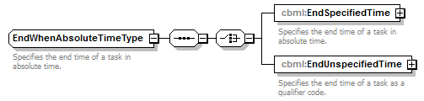
namespace | http://www.sisostds.org/schemas/c-bml/1.0
children | cbml:EndSpecifiedTime cbml:EndUnspecifiedTime
used by
  element | TaskEndWhenType/EndAbsoluteTime
annotation
  documentation
  Specifies the end time of a task in absolute time.
source | <xs:complexType name="EndWhenAbsoluteTimeType">  <xs:annotation>  <xs:documentation xml:lang="en">Specifies the end time of a task in absolute time.</xs:documentation>  </xs:annotation>  <xs:sequence>  <xs:choice>  <xs:element name="EndSpecifiedTime" type="cbml:EndWhenAbsoluteSpecifiedTimeType">  <xs:annotation>  <xs:documentation xml:lang="en">Specifies the end time of a task in absolute time.</xs:documentation>  </xs:annotation>  </xs:element>  <xs:element name="EndUnspecifiedTime" type="cbml:EndWhenAbsoluteUnspecifiedTimeType">  <xs:annotation>  <xs:documentation xml:lang="en">Specifies the end time of a task as a qualifier code.</xs:documentation>  </xs:annotation>  </xs:element>  </xs:choice>  </xs:sequence>  </xs:complexType>

element EndWhenAbsoluteTimeType/EndSpecifiedTime
diagram | 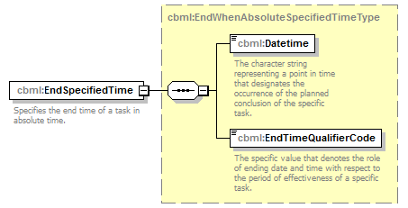
namespace | http://www.sisostds.org/schemas/c-bml/1.0
type | cbml:EndWhenAbsoluteSpecifiedTimeType
properties
  content | complex
children | cbml:Datetime cbml:EndTimeQualifierCode
annotation
  documentation
  Specifies the end time of a task in absolute time.
source | <xs:element name="EndSpecifiedTime" type="cbml:EndWhenAbsoluteSpecifiedTimeType">  <xs:annotation>  <xs:documentation xml:lang="en">Specifies the end time of a task in absolute time.</xs:documentation>  </xs:annotation>  </xs:element>

element EndWhenAbsoluteTimeType/EndUnspecifiedTime
diagram | 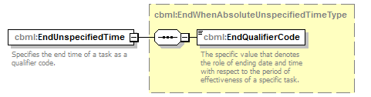
namespace | http://www.sisostds.org/schemas/c-bml/1.0
type | cbml:EndWhenAbsoluteUnspecifiedTimeType
properties
  content | complex
children | cbml:EndQualifierCode
annotation
  documentation
  Specifies the end time of a task as a qualifier code.
source | <xs:element name="EndUnspecifiedTime" type="cbml:EndWhenAbsoluteUnspecifiedTimeType">  <xs:annotation>  <xs:documentation xml:lang="en">Specifies the end time of a task as a qualifier code.</xs:documentation>  </xs:annotation>  </xs:element>

complexType EndWhenAbsoluteUnspecifiedTimeType
diagram | 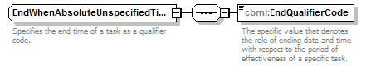
namespace | http://www.sisostds.org/schemas/c-bml/1.0
children | cbml:EndQualifierCode
used by
  element | EndWhenAbsoluteTimeType/EndUnspecifiedTime
annotation
  documentation
  Specifies the end time of a task as a qualifier code.
source | <xs:complexType name="EndWhenAbsoluteUnspecifiedTimeType">  <xs:annotation>  <xs:documentation xml:lang="en">Specifies the end time of a task as a qualifier code.</xs:documentation>  </xs:annotation>  <xs:sequence>  <xs:element name="EndQualifierCode" type="cbml:ActionTaskEndQualifierCode">  <xs:annotation>  <xs:documentation xml:lang="en">The specific value that denotes the role of ending date and time with respect to the period of effectiveness of a specific task.</xs:documentation>  </xs:annotation>  </xs:element>  </xs:sequence>  </xs:complexType>

element EndWhenAbsoluteUnspecifiedTimeType/EndQualifierCode
diagram | 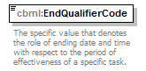
namespace | http://www.sisostds.org/schemas/c-bml/1.0
type | cbml:ActionTaskEndQualifierCode
properties
  content | simple
facets
  Kind | Value | Annotation
  enumeration | ASAP
    documentation
    <Definition xml:lang="en">End the activity at the earliest possible time once execution is authorised.</Definition>
    appinfo
    <xs:DisplayValue xml:lang="en">As soon as possible</xs:DisplayValue>
annotation
  documentation
  The specific value that denotes the role of ending date and time with respect to the period of effectiveness of a specific task.
source | <xs:element name="EndQualifierCode" type="cbml:ActionTaskEndQualifierCode">  <xs:annotation>  <xs:documentation xml:lang="en">The specific value that denotes the role of ending date and time with respect to the period of effectiveness of a specific task.</xs:documentation>  </xs:annotation>  </xs:element>

complexType EndWhenRelativeTimeType
diagram | 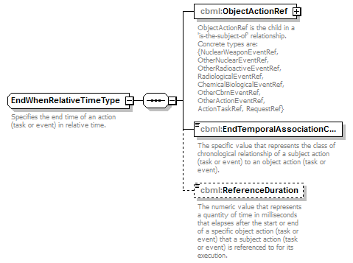
namespace | http://www.sisostds.org/schemas/c-bml/1.0
children | cbml:ObjectActionRef cbml:EndTemporalAssociationCategoryCode cbml:ReferenceDuration
used by
  elements | TaskEndWhenType/EndRelativeTime EventEndWhenType/EndRelativeTime
annotation
  documentation
  Specifies the end time of an action (task or event) in relative time.
source | <xs:complexType name="EndWhenRelativeTimeType">  <xs:annotation>  <xs:documentation xml:lang="en">Specifies the end time of an action (task or event) in relative time. </xs:documentation>  </xs:annotation>  <xs:sequence>  <xs:element name="ObjectActionRef" type="cbml:AbstractActionRef">  <xs:annotation>  <xs:documentation xml:lang="en">ObjectActionRef is the child in a 'is-the-subject-of' relationship. Concrete types are: {NuclearWeaponEventRef, OtherNuclearEventRef, OtherRadioactiveEventRef, RadiologicalEventRef, ChemicalBiologicalEventRef, OtherCbrnEventRef, OtherActionEventRef, ActionTaskRef, RequestRef}</xs:documentation>  </xs:annotation>  </xs:element>  <xs:element name="EndTemporalAssociationCategoryCode" type="cbml:ActionEndTemporalAssociationCategoryCode">  <xs:annotation>  <xs:documentation xml:lang="en">The specific value that represents the class of chronological relationship of a subject action (task or event) to an object action (task or event).</xs:documentation>  </xs:annotation>  </xs:element>  <xs:element name="ReferenceDuration" type="jc3iedm:DurationType19" minOccurs="0">  <xs:annotation>  <xs:documentation xml:lang="en">The numeric value that represents a quantity of time in milliseconds that elapses after the start or end of a specific object action (task or event) that a subject action (task or event) is referenced to for its execution.</xs:documentation>  </xs:annotation>  </xs:element>  </xs:sequence>  </xs:complexType>

element EndWhenRelativeTimeType/ObjectActionRef
diagram | 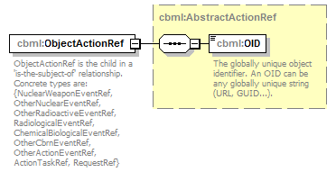
namespace | http://www.sisostds.org/schemas/c-bml/1.0
type | cbml:AbstractActionRef
properties
  content | complex
children | cbml:OID
annotation
  documentation
  ObjectActionRef is the child in a 'is-the-subject-of' relationship. Concrete types are: {NuclearWeaponEventRef, OtherNuclearEventRef, OtherRadioactiveEventRef, RadiologicalEventRef, ChemicalBiologicalEventRef, OtherCbrnEventRef, OtherActionEventRef, ActionTaskRef, RequestRef}
source | <xs:element name="ObjectActionRef" type="cbml:AbstractActionRef">  <xs:annotation>  <xs:documentation xml:lang="en">ObjectActionRef is the child in a 'is-the-subject-of' relationship. Concrete types are: {NuclearWeaponEventRef, OtherNuclearEventRef, OtherRadioactiveEventRef, RadiologicalEventRef, ChemicalBiologicalEventRef, OtherCbrnEventRef, OtherActionEventRef, ActionTaskRef, RequestRef}</xs:documentation>  </xs:annotation>  </xs:element>

element EndWhenRelativeTimeType/EndTemporalAssociationCategoryCode
diagram | 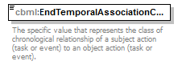
namespace | http://www.sisostds.org/schemas/c-bml/1.0
type | cbml:ActionEndTemporalAssociationCategoryCode
properties
  content | simple
facets
  Kind | Value | Annotation
  enumeration | ENDEND
    documentation
    <xs:Definition xml:lang="en">The subject ACTION ends after the object ACTION ends.</xs:Definition>
    appinfo
    <xs:DisplayValue xml:lang="en">Ends after end of</xs:DisplayValue>
  enumeration | ENDENE
    documentation
    <xs:Definition xml:lang="en">The subject ACTION ends no earlier than the end of the object ACTION augmented by a fixed duration.</xs:Definition>
    appinfo
    <xs:DisplayValue xml:lang="en">Ends no earlier than after end of</xs:DisplayValue>
  enumeration | ENDENL
    documentation
    <xs:Definition xml:lang="en">The subject ACTION ends no later than the end of object ACTION augmented by a fixed duration.</xs:Definition>
    appinfo
    <xs:DisplayValue xml:lang="en">Ends no later than after end of</xs:DisplayValue>
  enumeration | ENDSNE
    documentation
    <xs:Definition xml:lang="en">The subject ACTION ends no earlier than the start of the object ACTION augmented by a fixed duration.</xs:Definition>
    appinfo
    <xs:DisplayValue xml:lang="en">Ends no earlier than after start of</xs:DisplayValue>
  enumeration | ENDSNL
    documentation
    <xs:Definition xml:lang="en">The subject ACTION ends no later than the start of object ACTION augmented by a fixed duration.</xs:Definition>
    appinfo
    <xs:DisplayValue xml:lang="en">Ends no later than after start of</xs:DisplayValue>
  enumeration | ENDSTR
    documentation
    <xs:Definition xml:lang="en">The subject ACTION ends after the object ACTION starts.</xs:Definition>
    appinfo
    <xs:DisplayValue xml:lang="en">Ends after start of</xs:DisplayValue>
annotation
  documentation
  The specific value that represents the class of chronological relationship of a subject action (task or event) to an object action (task or event).
source | <xs:element name="EndTemporalAssociationCategoryCode" type="cbml:ActionEndTemporalAssociationCategoryCode">  <xs:annotation>  <xs:documentation xml:lang="en">The specific value that represents the class of chronological relationship of a subject action (task or event) to an object action (task or event).</xs:documentation>  </xs:annotation>  </xs:element>

element EndWhenRelativeTimeType/ReferenceDuration
diagram | 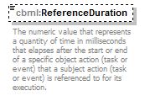
namespace | http://www.sisostds.org/schemas/c-bml/1.0
type | jc3iedm:DurationType19
properties
  minOcc | 0
  maxOcc | 1
  content | simple
facets
  Kind | Value | Annotation
  minInclusive | -9999999999999999999
  maxInclusive | 9999999999999999999
annotation
  documentation
  The numeric value that represents a quantity of time in milliseconds that elapses after the start or end of a specific object action (task or event) that a subject action (task or event) is referenced to for its execution.
source | <xs:element name="ReferenceDuration" type="jc3iedm:DurationType19" minOccurs="0">  <xs:annotation>  <xs:documentation xml:lang="en">The numeric value that represents a quantity of time in milliseconds that elapses after the start or end of a specific object action (task or event) that a subject action (task or event) is referenced to for its execution.</xs:documentation>  </xs:annotation>  </xs:element>

complexType EventEndWhenType
diagram | 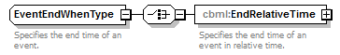
namespace | http://www.sisostds.org/schemas/c-bml/1.0
children | cbml:EndRelativeTime
used by
  elements | EventType/EventEndWhen EventEndWhen
annotation
  documentation
  Specifies the end time of an event.
source | <xs:complexType name="EventEndWhenType">  <xs:annotation>  <xs:documentation xml:lang="en">Specifies the end time of an event.</xs:documentation>  </xs:annotation>  <xs:choice>  <xs:element name="EndRelativeTime" type="cbml:EndWhenRelativeTimeType">  <xs:annotation>  <xs:documentation xml:lang="en">Specifies the end time of an event in relative time.</xs:documentation>  </xs:annotation>  </xs:element>  </xs:choice>  </xs:complexType>

element EventEndWhenType/EndRelativeTime
diagram | 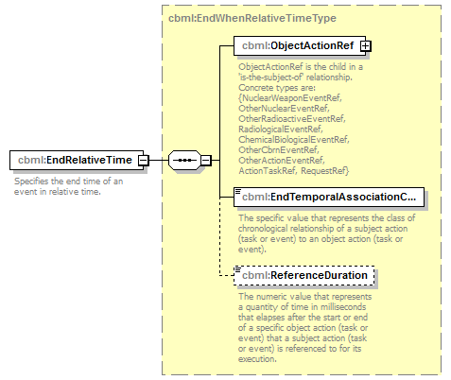
namespace | http://www.sisostds.org/schemas/c-bml/1.0
type | cbml:EndWhenRelativeTimeType
properties
  content | complex
children | cbml:ObjectActionRef cbml:EndTemporalAssociationCategoryCode cbml:ReferenceDuration
annotation
  documentation
  Specifies the end time of an event in relative time.
source | <xs:element name="EndRelativeTime" type="cbml:EndWhenRelativeTimeType">  <xs:annotation>  <xs:documentation xml:lang="en">Specifies the end time of an event in relative time.</xs:documentation>  </xs:annotation>  </xs:element>

complexType EventStartWhenType
diagram | 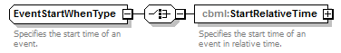
namespace | http://www.sisostds.org/schemas/c-bml/1.0
children | cbml:StartRelativeTime
used by
  elements | EventType/EventStartWhen EventStartWhen
annotation
  documentation
  Specifies the start time of an event.
source | <xs:complexType name="EventStartWhenType">  <xs:annotation>  <xs:documentation xml:lang="en">Specifies the start time of an event.</xs:documentation>  </xs:annotation>  <xs:choice>  <xs:element name="StartRelativeTime" type="cbml:StartWhenRelativeTimeType">  <xs:annotation>  <xs:documentation xml:lang="en">Specifies the start time of an event in relative time.</xs:documentation>  </xs:annotation>  </xs:element>  </xs:choice>  </xs:complexType>

element EventStartWhenType/StartRelativeTime
diagram | 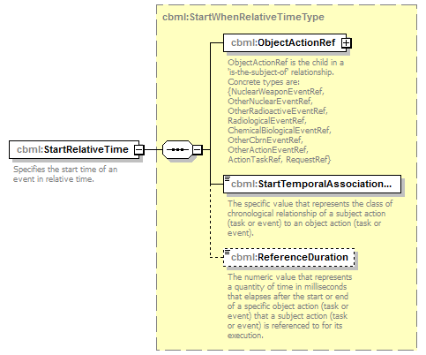
namespace | http://www.sisostds.org/schemas/c-bml/1.0
type | cbml:StartWhenRelativeTimeType
properties
  content | complex
children | cbml:ObjectActionRef cbml:StartTemporalAssociationCategoryCode cbml:ReferenceDuration
annotation
  documentation
  Specifies the start time of an event in relative time.
source | <xs:element name="StartRelativeTime" type="cbml:StartWhenRelativeTimeType">  <xs:annotation>  <xs:documentation xml:lang="en">Specifies the start time of an event in relative time.</xs:documentation>  </xs:annotation>  </xs:element>

complexType EventType
diagram | 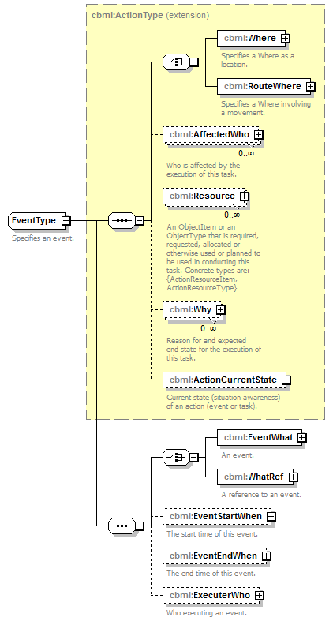
namespace | http://www.sisostds.org/schemas/c-bml/1.0
type | extension of cbml:ActionType
properties
  base | cbml:ActionType
children | cbml:Where cbml:RouteWhere cbml:AffectedWho cbml:Resource cbml:Why cbml:ActionCurrentState cbml:EventWhat cbml:WhatRef cbml:EventStartWhen cbml:EventEndWhen cbml:ExecuterWho
used by
  element | EventWhatLocationType/Event
annotation
  documentation
  Specifies an event.
source | <xs:complexType name="EventType">  <xs:annotation>  <xs:documentation xml:lang="en">Specifies an event.</xs:documentation>  </xs:annotation>  <xs:complexContent>  <xs:extension base="cbml:ActionType">  <xs:sequence>  <xs:choice>  <xs:element name="EventWhat" type="cbml:EventWhatType">  <xs:annotation>  <xs:documentation xml:lang="en">An event.</xs:documentation>  </xs:annotation>  </xs:element>  <xs:element name="WhatRef" type="cbml:EventWhatRefType">  <xs:annotation>  <xs:documentation xml:lang="en">A reference to an event.</xs:documentation>  </xs:annotation>  </xs:element>  </xs:choice>  <xs:element name="EventStartWhen" type="cbml:EventStartWhenType" minOccurs="0">  <xs:annotation>  <xs:documentation xml:lang="en">The start time of this event.</xs:documentation>  </xs:annotation>  </xs:element>  <xs:element name="EventEndWhen" type="cbml:EventEndWhenType" minOccurs="0">  <xs:annotation>  <xs:documentation xml:lang="en">The end time of this event.</xs:documentation>  </xs:annotation>  </xs:element>  <xs:element name="ExecuterWho" type="cbml:ExecuterWhoType" minOccurs="0">  <xs:annotation>  <xs:documentation xml:lang="en">Who executing an event.</xs:documentation>  </xs:annotation>  </xs:element>  </xs:sequence>  </xs:extension>  </xs:complexContent>  </xs:complexType>

element EventType/EventWhat
diagram | 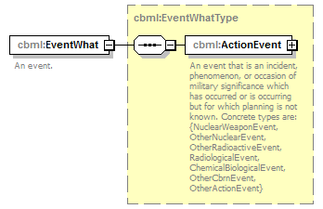
namespace | http://www.sisostds.org/schemas/c-bml/1.0
type | cbml:EventWhatType
properties
  content | complex
children | cbml:ActionEvent
annotation
  documentation
  An event.
source | <xs:element name="EventWhat" type="cbml:EventWhatType">  <xs:annotation>  <xs:documentation xml:lang="en">An event.</xs:documentation>  </xs:annotation>  </xs:element>

element EventType/WhatRef
diagram | 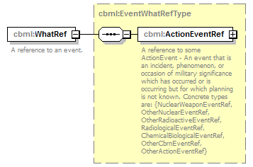
namespace | http://www.sisostds.org/schemas/c-bml/1.0
type | cbml:EventWhatRefType
properties
  content | complex
children | cbml:ActionEventRef
annotation
  documentation
  A reference to an event.
source | <xs:element name="WhatRef" type="cbml:EventWhatRefType">  <xs:annotation>  <xs:documentation xml:lang="en">A reference to an event.</xs:documentation>  </xs:annotation>  </xs:element>

element EventType/EventStartWhen
diagram | 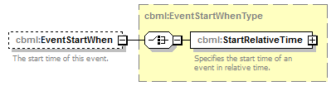
namespace | http://www.sisostds.org/schemas/c-bml/1.0
type | cbml:EventStartWhenType
properties
  minOcc | 0
  maxOcc | 1
  content | complex
children | cbml:StartRelativeTime
annotation
  documentation
  The start time of this event.
source | <xs:element name="EventStartWhen" type="cbml:EventStartWhenType" minOccurs="0">  <xs:annotation>  <xs:documentation xml:lang="en">The start time of this event.</xs:documentation>  </xs:annotation>  </xs:element>

element EventType/EventEndWhen
diagram | 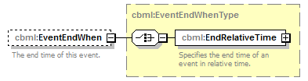
namespace | http://www.sisostds.org/schemas/c-bml/1.0
type | cbml:EventEndWhenType
properties
  minOcc | 0
  maxOcc | 1
  content | complex
children | cbml:EndRelativeTime
annotation
  documentation
  The end time of this event.
source | <xs:element name="EventEndWhen" type="cbml:EventEndWhenType" minOccurs="0">  <xs:annotation>  <xs:documentation xml:lang="en">The end time of this event.</xs:documentation>  </xs:annotation>  </xs:element>

element EventType/ExecuterWho
diagram | 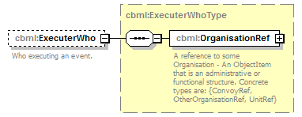
namespace | http://www.sisostds.org/schemas/c-bml/1.0
type | cbml:ExecuterWhoType
properties
  minOcc | 0
  maxOcc | 1
  content | complex
children | cbml:OrganisationRef
annotation
  documentation
  Who executing an event.
source | <xs:element name="ExecuterWho" type="cbml:ExecuterWhoType" minOccurs="0">  <xs:annotation>  <xs:documentation xml:lang="en">Who executing an event.</xs:documentation>  </xs:annotation>  </xs:element>

complexType EventWhatLocationRefType
diagram | 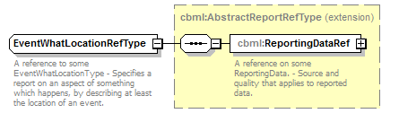
namespace | http://www.sisostds.org/schemas/c-bml/1.0
type | extension of cbml:AbstractReportRefType
properties
  base | cbml:AbstractReportRefType
children | cbml:ReportingDataRef
annotation
  documentation
  A reference to some EventWhatLocationType - Specifies a report on an aspect of something which happens, by describing at least the location of an event.
source | <xs:complexType name="EventWhatLocationRefType">  <xs:annotation>  <xs:documentation xml:lang="en">A reference to some EventWhatLocationType - Specifies a report on an aspect of something which happens, by describing at least the location of an event.  </xs:documentation>  </xs:annotation>  <xs:complexContent>  <xs:extension base="cbml:AbstractReportRefType"/>  </xs:complexContent>  </xs:complexType>

complexType EventWhatLocationType
diagram | 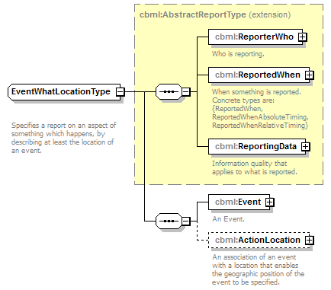
namespace | http://www.sisostds.org/schemas/c-bml/1.0
type | extension of cbml:AbstractReportType
properties
  base | cbml:AbstractReportType
children | cbml:ReporterWho cbml:ReportedWhen cbml:ReportingData cbml:Event cbml:ActionLocation
annotation
  documentation
  Specifies a report on an aspect of something which happens, by describing at least the location of an event.
source | <xs:complexType name="EventWhatLocationType">  <xs:annotation>  <xs:documentation xml:lang="en">  Specifies a report on an aspect of something which happens, by describing at least the location of an event.  </xs:documentation>  </xs:annotation>  <xs:complexContent>  <xs:extension base="cbml:AbstractReportType">  <xs:sequence>  <xs:element name="Event" type="cbml:EventType">  <xs:annotation>  <xs:documentation xml:lang="en">An Event.</xs:documentation>  </xs:annotation>  </xs:element>  <xs:element name="ActionLocation" type="cbml:ActionLocation" minOccurs="0">  <xs:annotation>  <xs:documentation xml:lang="en">An association of an event with a location that enables the geographic position of the event to be specified.</xs:documentation>  </xs:annotation>  </xs:element>  </xs:sequence>  </xs:extension>  </xs:complexContent>  </xs:complexType>

element EventWhatLocationType/Event
diagram | 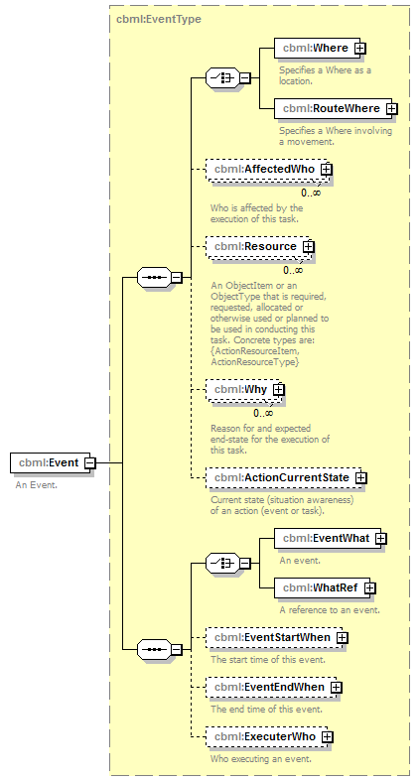
namespace | http://www.sisostds.org/schemas/c-bml/1.0
type | cbml:EventType
properties
  content | complex
children | cbml:Where cbml:RouteWhere cbml:AffectedWho cbml:Resource cbml:Why cbml:ActionCurrentState cbml:EventWhat cbml:WhatRef cbml:EventStartWhen cbml:EventEndWhen cbml:ExecuterWho
annotation
  documentation
  An Event.
source | <xs:element name="Event" type="cbml:EventType">  <xs:annotation>  <xs:documentation xml:lang="en">An Event.</xs:documentation>  </xs:annotation>  </xs:element>

element EventWhatLocationType/ActionLocation
diagram | 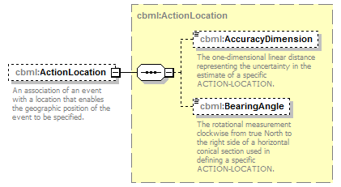
namespace | http://www.sisostds.org/schemas/c-bml/1.0
type | cbml:ActionLocation
properties
  minOcc | 0
  maxOcc | 1
  content | complex
children | cbml:AccuracyDimension cbml:BearingAngle
annotation
  documentation
  An association of an event with a location that enables the geographic position of the event to be specified.
source | <xs:element name="ActionLocation" type="cbml:ActionLocation" minOccurs="0">  <xs:annotation>  <xs:documentation xml:lang="en">An association of an event with a location that enables the geographic position of the event to be specified.</xs:documentation>  </xs:annotation>  </xs:element>

complexType EventWhatRefType
diagram | 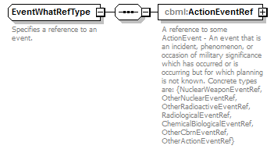
namespace | http://www.sisostds.org/schemas/c-bml/1.0
children | cbml:ActionEventRef
used by
  elements | EventWhatStatusType/EventWhatRef EventType/WhatRef EventWhatRef
annotation
  documentation
  Specifies a reference to an event.
source | <xs:complexType name="EventWhatRefType">  <xs:annotation>  <xs:documentation xml:lang="en">Specifies a reference to an event.</xs:documentation>  </xs:annotation>  <xs:sequence>  <xs:element name="ActionEventRef" type="cbml:AbstractActionEventRef">  <xs:annotation>  <xs:documentation xml:lang="en">A reference to some ActionEvent - An event that is an incident, phenomenon, or occasion of military significance which has occurred or is occurring but for which planning is not known. Concrete types are: {NuclearWeaponEventRef, OtherNuclearEventRef, OtherRadioactiveEventRef, RadiologicalEventRef, ChemicalBiologicalEventRef, OtherCbrnEventRef, OtherActionEventRef}</xs:documentation>  </xs:annotation>  </xs:element>  </xs:sequence>  </xs:complexType>

element EventWhatRefType/ActionEventRef
diagram | 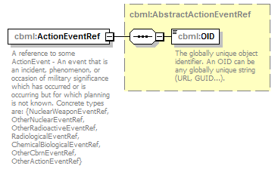
namespace | http://www.sisostds.org/schemas/c-bml/1.0
type | cbml:AbstractActionEventRef
properties
  content | complex
children | cbml:OID
annotation
  documentation
  A reference to some ActionEvent - An event that is an incident, phenomenon, or occasion of military significance which has occurred or is occurring but for which planning is not known. Concrete types are: {NuclearWeaponEventRef, OtherNuclearEventRef, OtherRadioactiveEventRef, RadiologicalEventRef, ChemicalBiologicalEventRef, OtherCbrnEventRef, OtherActionEventRef}
source | <xs:element name="ActionEventRef" type="cbml:AbstractActionEventRef">  <xs:annotation>  <xs:documentation xml:lang="en">A reference to some ActionEvent - An event that is an incident, phenomenon, or occasion of military significance which has occurred or is occurring but for which planning is not known. Concrete types are: {NuclearWeaponEventRef, OtherNuclearEventRef, OtherRadioactiveEventRef, RadiologicalEventRef, ChemicalBiologicalEventRef, OtherCbrnEventRef, OtherActionEventRef}</xs:documentation>  </xs:annotation>  </xs:element>

complexType EventWhatStatusRefType
diagram | 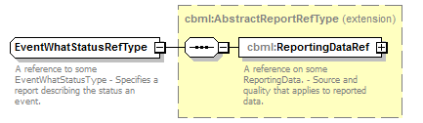
namespace | http://www.sisostds.org/schemas/c-bml/1.0
type | extension of cbml:AbstractReportRefType
properties
  base | cbml:AbstractReportRefType
children | cbml:ReportingDataRef
annotation
  documentation
  A reference to some EventWhatStatusType - Specifies a report describing the status an event.
source | <xs:complexType name="EventWhatStatusRefType">  <xs:annotation>  <xs:documentation xml:lang="en">A reference to some EventWhatStatusType - Specifies a report describing the status an event.</xs:documentation>  </xs:annotation>  <xs:complexContent>  <xs:extension base="cbml:AbstractReportRefType"/>  </xs:complexContent>  </xs:complexType>

complexType EventWhatStatusType
diagram | 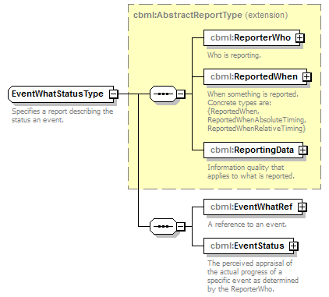
namespace | http://www.sisostds.org/schemas/c-bml/1.0
type | extension of cbml:AbstractReportType
properties
  base | cbml:AbstractReportType
children | cbml:ReporterWho cbml:ReportedWhen cbml:ReportingData cbml:EventWhatRef cbml:EventStatus
annotation
  documentation
  Specifies a report describing the status an event.
source | <xs:complexType name="EventWhatStatusType">  <xs:annotation>  <xs:documentation xml:lang="en">Specifies a report describing the status an event.</xs:documentation>  </xs:annotation>  <xs:complexContent>  <xs:extension base="cbml:AbstractReportType">  <xs:sequence>  <xs:element name="EventWhatRef" type="cbml:EventWhatRefType">  <xs:annotation>  <xs:documentation xml:lang="en">A reference to an event.</xs:documentation>  </xs:annotation>  </xs:element>  <xs:element name="EventStatus" type="cbml:ActionEventStatus">  <xs:annotation>  <xs:documentation xml:lang="en">The perceived appraisal of the actual progress of a specific event as determined by the ReporterWho.</xs:documentation>  </xs:annotation>  </xs:element>  </xs:sequence>  </xs:extension>  </xs:complexContent>  </xs:complexType>

element EventWhatStatusType/EventWhatRef
diagram | 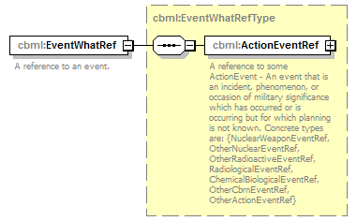
namespace | http://www.sisostds.org/schemas/c-bml/1.0
type | cbml:EventWhatRefType
properties
  content | complex
children | cbml:ActionEventRef
annotation
  documentation
  A reference to an event.
source | <xs:element name="EventWhatRef" type="cbml:EventWhatRefType">  <xs:annotation>  <xs:documentation xml:lang="en">A reference to an event.</xs:documentation>  </xs:annotation>  </xs:element>

element EventWhatStatusType/EventStatus
diagram | 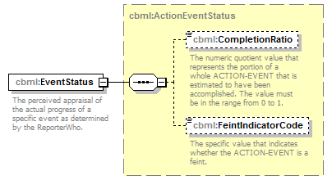
namespace | http://www.sisostds.org/schemas/c-bml/1.0
type | cbml:ActionEventStatus
properties
  content | complex
children | cbml:CompletionRatio cbml:FeintIndicatorCode
annotation
  documentation
  The perceived appraisal of the actual progress of a specific event as determined by the ReporterWho.
source | <xs:element name="EventStatus" type="cbml:ActionEventStatus">  <xs:annotation>  <xs:documentation xml:lang="en">The perceived appraisal of the actual progress of a specific event as determined by the ReporterWho.</xs:documentation>  </xs:annotation>  </xs:element>

complexType EventWhatType
diagram | 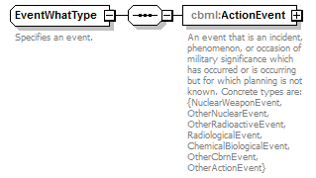
namespace | http://www.sisostds.org/schemas/c-bml/1.0
children | cbml:ActionEvent
used by
  elements | EventType/EventWhat EventWhat
annotation
  documentation
  Specifies an event.
source | <xs:complexType name="EventWhatType">  <xs:annotation>  <xs:documentation xml:lang="en">Specifies an event.</xs:documentation>  </xs:annotation>  <xs:sequence>  <xs:element name="ActionEvent" type="cbml:AbstractActionEvent">  <xs:annotation>  <xs:documentation xml:lang="en">An event that is an incident, phenomenon, or occasion of military significance which has occurred or is occurring but for which planning is not known. Concrete types are: {NuclearWeaponEvent, OtherNuclearEvent, OtherRadioactiveEvent, RadiologicalEvent, ChemicalBiologicalEvent, OtherCbrnEvent, OtherActionEvent}</xs:documentation>  </xs:annotation>  </xs:element>  </xs:sequence>  </xs:complexType>

element EventWhatType/ActionEvent
diagram | 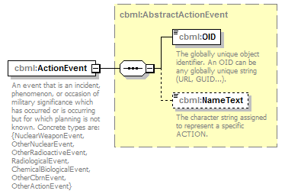
namespace | http://www.sisostds.org/schemas/c-bml/1.0
type | cbml:AbstractActionEvent
properties
  content | complex
children | cbml:OID cbml:NameText
annotation
  documentation
  An event that is an incident, phenomenon, or occasion of military significance which has occurred or is occurring but for which planning is not known. Concrete types are: {NuclearWeaponEvent, OtherNuclearEvent, OtherRadioactiveEvent, RadiologicalEvent, ChemicalBiologicalEvent, OtherCbrnEvent, OtherActionEvent}
source | <xs:element name="ActionEvent" type="cbml:AbstractActionEvent">  <xs:annotation>  <xs:documentation xml:lang="en">An event that is an incident, phenomenon, or occasion of military significance which has occurred or is occurring but for which planning is not known. Concrete types are: {NuclearWeaponEvent, OtherNuclearEvent, OtherRadioactiveEvent, RadiologicalEvent, ChemicalBiologicalEvent, OtherCbrnEvent, OtherActionEvent}</xs:documentation>  </xs:annotation>  </xs:element>

complexType ExecuterWhoType
diagram | 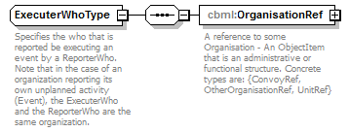
namespace | http://www.sisostds.org/schemas/c-bml/1.0
children | cbml:OrganisationRef
used by
  elements | EventType/ExecuterWho ExecuterWho
annotation
  documentation
  Specifies the who that is reported be executing an event by a ReporterWho. Note that in the case of an organization reporting its own unplanned activity (Event), the ExecuterWho and the ReporterWho are the same organization.
source | <xs:complexType name="ExecuterWhoType">  <xs:annotation>  <xs:documentation xml:lang="en">Specifies the who that is reported be executing an event by a ReporterWho. Note that in the case of an organization reporting its own unplanned activity (Event), the ExecuterWho and the ReporterWho are the same organization.</xs:documentation>  </xs:annotation>  <xs:sequence>  <xs:element name="OrganisationRef" type="cbml:AbstractOrganisationRef">  <xs:annotation>  <xs:documentation xml:lang="en">A reference to some Organisation - An ObjectItem that is an administrative or functional structure. Concrete types are: {ConvoyRef, OtherOrganisationRef, UnitRef}</xs:documentation>  </xs:annotation>  </xs:element>  </xs:sequence>  </xs:complexType>

element ExecuterWhoType/OrganisationRef
diagram | 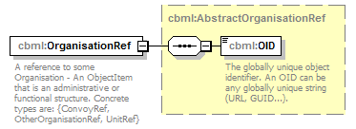
namespace | http://www.sisostds.org/schemas/c-bml/1.0
type | cbml:AbstractOrganisationRef
properties
  content | complex
children | cbml:OID
annotation
  documentation
  A reference to some Organisation - An ObjectItem that is an administrative or functional structure. Concrete types are: {ConvoyRef, OtherOrganisationRef, UnitRef}
source | <xs:element name="OrganisationRef" type="cbml:AbstractOrganisationRef">  <xs:annotation>  <xs:documentation xml:lang="en">A reference to some Organisation - An ObjectItem that is an administrative or functional structure. Concrete types are: {ConvoyRef, OtherOrganisationRef, UnitRef}</xs:documentation>  </xs:annotation>  </xs:element>

complexType HoldingTransferRefType
diagram | 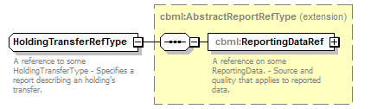
namespace | http://www.sisostds.org/schemas/c-bml/1.0
type | extension of cbml:AbstractReportRefType
properties
  base | cbml:AbstractReportRefType
children | cbml:ReportingDataRef
annotation
  documentation
  A reference to some HoldingTransferType - Specifies a report describing an holding's transfer.
source | <xs:complexType name="HoldingTransferRefType">  <xs:annotation>  <xs:documentation xml:lang="en">A reference to some HoldingTransferType - Specifies a report describing an holding's transfer.</xs:documentation>  </xs:annotation>  <xs:complexContent>  <xs:extension base="cbml:AbstractReportRefType"/>  </xs:complexContent>  </xs:complexType>

complexType HoldingTransferType
diagram | 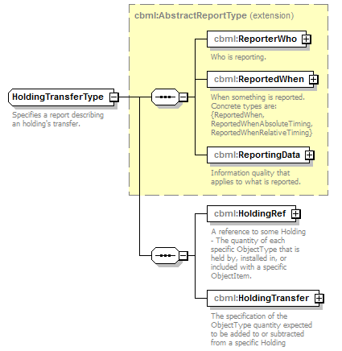
namespace | http://www.sisostds.org/schemas/c-bml/1.0
type | extension of cbml:AbstractReportType
properties
  base | cbml:AbstractReportType
children | cbml:ReporterWho cbml:ReportedWhen cbml:ReportingData cbml:HoldingRef cbml:HoldingTransfer
annotation
  documentation
  Specifies a report describing an holding's transfer.
source | <xs:complexType name="HoldingTransferType">  <xs:annotation>  <xs:documentation xml:lang="en">Specifies a report describing an holding's transfer.</xs:documentation>  </xs:annotation>  <xs:complexContent>  <xs:extension base="cbml:AbstractReportType">  <xs:sequence>  <xs:element name="HoldingRef" type="cbml:HoldingRef">  <xs:annotation>  <xs:documentation xml:lang="en">A reference to some Holding - The quantity of each specific ObjectType that is held by, installed in, or included with a specific ObjectItem.</xs:documentation>  </xs:annotation>  </xs:element>  <xs:element name="HoldingTransfer" type="cbml:HoldingTransfer">  <xs:annotation>  <xs:documentation xml:lang="en">The specification of the ObjectType quantity expected to be added to or subtracted from a specific Holding</xs:documentation>  </xs:annotation>  </xs:element>  </xs:sequence>  </xs:extension>  </xs:complexContent>  </xs:complexType>

element HoldingTransferType/HoldingRef
diagram | 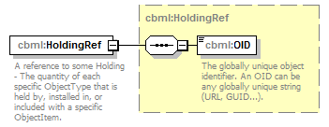
namespace | http://www.sisostds.org/schemas/c-bml/1.0
type | cbml:HoldingRef
properties
  content | complex
children | cbml:OID
annotation
  documentation
  A reference to some Holding - The quantity of each specific ObjectType that is held by, installed in, or included with a specific ObjectItem.
source | <xs:element name="HoldingRef" type="cbml:HoldingRef">  <xs:annotation>  <xs:documentation xml:lang="en">A reference to some Holding - The quantity of each specific ObjectType that is held by, installed in, or included with a specific ObjectItem.</xs:documentation>  </xs:annotation>  </xs:element>

element HoldingTransferType/HoldingTransfer
diagram | 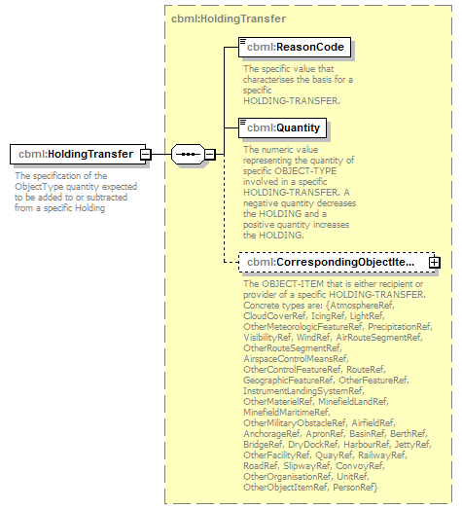
namespace | http://www.sisostds.org/schemas/c-bml/1.0
type | cbml:HoldingTransfer
properties
  content | complex
children | cbml:ReasonCode cbml:Quantity cbml:CorrespondingObjectItemRef
annotation
  documentation
  The specification of the ObjectType quantity expected to be added to or subtracted from a specific Holding
source | <xs:element name="HoldingTransfer" type="cbml:HoldingTransfer">  <xs:annotation>  <xs:documentation xml:lang="en">The specification of the ObjectType quantity expected to be added to or subtracted from a specific Holding</xs:documentation>  </xs:annotation>  </xs:element>

complexType OrderTaskType
diagram | 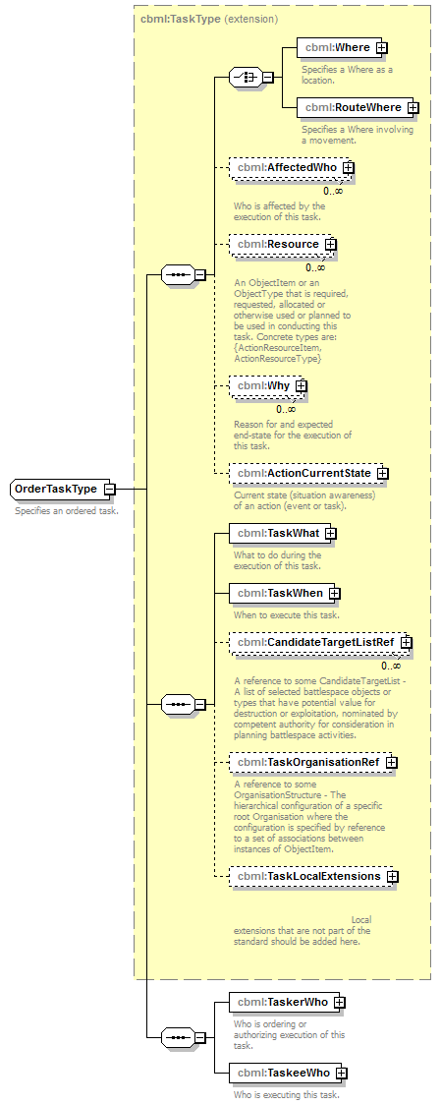
namespace | http://www.sisostds.org/schemas/c-bml/1.0
type | extension of cbml:TaskType
properties
  base | cbml:TaskType
children | cbml:Where cbml:RouteWhere cbml:AffectedWho cbml:Resource cbml:Why cbml:ActionCurrentState cbml:TaskWhat cbml:TaskWhen cbml:CandidateTargetListRef cbml:TaskOrganisationRef cbml:TaskLocalExtensions cbml:TaskerWho cbml:TaskeeWho
annotation
  documentation
  Specifies an ordered task.
source | <xs:complexType name="OrderTaskType">  <xs:annotation>  <xs:documentation xml:lang="en">Specifies an ordered task.</xs:documentation>  </xs:annotation>  <xs:complexContent>  <xs:extension base="cbml:TaskType">  <xs:sequence>  <xs:element name="TaskerWho" type="cbml:TaskerWhoType">  <xs:annotation>  <xs:documentation xml:lang="en">Who is ordering or authorizing execution of this task.</xs:documentation>  </xs:annotation>  </xs:element>  <xs:element name="TaskeeWho" type="cbml:TaskeeWhoType">  <xs:annotation>  <xs:documentation xml:lang="en">Who is executing this task.</xs:documentation>  </xs:annotation>  </xs:element>  </xs:sequence>  </xs:extension>  </xs:complexContent>  </xs:complexType>

element OrderTaskType/TaskerWho
diagram | 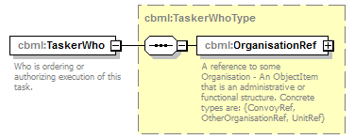
namespace | http://www.sisostds.org/schemas/c-bml/1.0
type | cbml:TaskerWhoType
properties
  content | complex
children | cbml:OrganisationRef
annotation
  documentation
  Who is ordering or authorizing execution of this task.
source | <xs:element name="TaskerWho" type="cbml:TaskerWhoType">  <xs:annotation>  <xs:documentation xml:lang="en">Who is ordering or authorizing execution of this task.</xs:documentation>  </xs:annotation>  </xs:element>

element OrderTaskType/TaskeeWho
diagram | 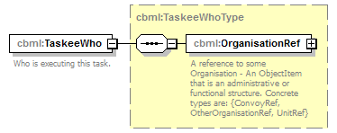
namespace | http://www.sisostds.org/schemas/c-bml/1.0
type | cbml:TaskeeWhoType
properties
  content | complex
children | cbml:OrganisationRef
annotation
  documentation
  Who is executing this task.
source | <xs:element name="TaskeeWho" type="cbml:TaskeeWhoType">  <xs:annotation>  <xs:documentation xml:lang="en">Who is executing this task.</xs:documentation>  </xs:annotation>  </xs:element>

complexType OrganisationStructureRefType
diagram | 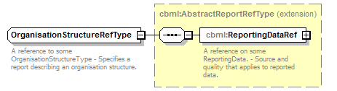
namespace | http://www.sisostds.org/schemas/c-bml/1.0
type | extension of cbml:AbstractReportRefType
properties
  base | cbml:AbstractReportRefType
children | cbml:ReportingDataRef
annotation
  documentation
  A reference to some OrganisationStructureType - Specifies a report describing an organisation structure.
source | <xs:complexType name="OrganisationStructureRefType">  <xs:annotation>  <xs:documentation xml:lang="en">A reference to some OrganisationStructureType - Specifies a report describing an organisation structure.</xs:documentation>  </xs:annotation>  <xs:complexContent>  <xs:extension base="cbml:AbstractReportRefType"/>  </xs:complexContent>  </xs:complexType>

complexType OrganisationStructureType
diagram | 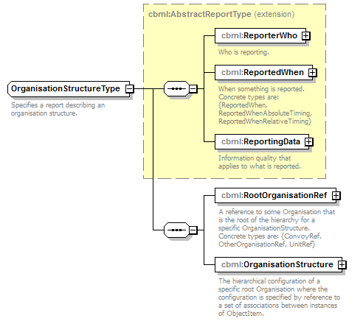
namespace | http://www.sisostds.org/schemas/c-bml/1.0
type | extension of cbml:AbstractReportType
properties
  base | cbml:AbstractReportType
children | cbml:ReporterWho cbml:ReportedWhen cbml:ReportingData cbml:RootOrganisationRef cbml:OrganisationStructure
annotation
  documentation
  Specifies a report describing an organisation structure.
source | <xs:complexType name="OrganisationStructureType">  <xs:annotation>  <xs:documentation xml:lang="en">Specifies a report describing an organisation structure.</xs:documentation>  </xs:annotation>  <xs:complexContent>  <xs:extension base="cbml:AbstractReportType">  <xs:sequence>  <xs:element name="RootOrganisationRef" type="cbml:AbstractOrganisationRef">  <xs:annotation>  <xs:documentation xml:lang="en">A reference to some Organisation that is the root of the hierarchy for a specific OrganisationStructure. Concrete types are: {ConvoyRef, OtherOrganisationRef, UnitRef}</xs:documentation>  </xs:annotation>  </xs:element>  <xs:element name="OrganisationStructure" type="cbml:OrganisationStructure">  <xs:annotation>  <xs:documentation xml:lang="en">The hierarchical configuration of a specific root Organisation where the configuration is specified by reference to a set of associations between instances of ObjectItem.</xs:documentation>  </xs:annotation>  </xs:element>  </xs:sequence>  </xs:extension>  </xs:complexContent>  </xs:complexType>

element OrganisationStructureType/RootOrganisationRef
diagram | 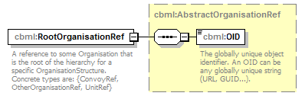
namespace | http://www.sisostds.org/schemas/c-bml/1.0
type | cbml:AbstractOrganisationRef
properties
  content | complex
children | cbml:OID
annotation
  documentation
  A reference to some Organisation that is the root of the hierarchy for a specific OrganisationStructure. Concrete types are: {ConvoyRef, OtherOrganisationRef, UnitRef}
source | <xs:element name="RootOrganisationRef" type="cbml:AbstractOrganisationRef">  <xs:annotation>  <xs:documentation xml:lang="en">A reference to some Organisation that is the root of the hierarchy for a specific OrganisationStructure. Concrete types are: {ConvoyRef, OtherOrganisationRef, UnitRef}</xs:documentation>  </xs:annotation>  </xs:element>

element OrganisationStructureType/OrganisationStructure
diagram | 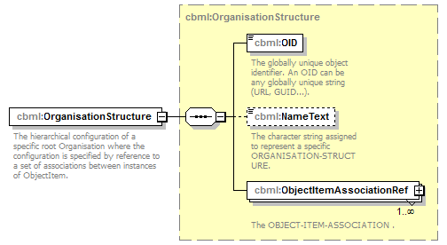
namespace | http://www.sisostds.org/schemas/c-bml/1.0
type | cbml:OrganisationStructure
properties
  content | complex
children | cbml:OID cbml:NameText cbml:ObjectItemAssociationRef
annotation
  documentation
  The hierarchical configuration of a specific root Organisation where the configuration is specified by reference to a set of associations between instances of ObjectItem.
source | <xs:element name="OrganisationStructure" type="cbml:OrganisationStructure">  <xs:annotation>  <xs:documentation xml:lang="en">The hierarchical configuration of a specific root Organisation where the configuration is specified by reference to a set of associations between instances of ObjectItem.</xs:documentation>  </xs:annotation>  </xs:element>

complexType ReportedWhenAbsoluteTimingType
diagram | 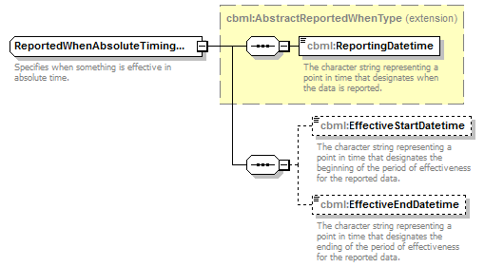
namespace | http://www.sisostds.org/schemas/c-bml/1.0
type | extension of cbml:AbstractReportedWhenType
properties
  base | cbml:AbstractReportedWhenType
children | cbml:ReportingDatetime cbml:EffectiveStartDatetime cbml:EffectiveEndDatetime
annotation
  documentation
  Specifies when something is effective in absolute time.
source | <xs:complexType name="ReportedWhenAbsoluteTimingType">  <xs:annotation>  <xs:documentation xml:lang="en">Specifies when something is effective in absolute time.</xs:documentation>  </xs:annotation>  <xs:complexContent>  <xs:extension base="cbml:AbstractReportedWhenType">  <xs:sequence>  <xs:element name="EffectiveStartDatetime" type="jc3iedm:DatetimeTypeFix18" minOccurs="0">  <xs:annotation>  <xs:documentation xml:lang="en">The character string representing a point in time that designates the beginning of the period of effectiveness for the reported data.</xs:documentation>  </xs:annotation>  </xs:element>  <xs:element name="EffectiveEndDatetime" type="jc3iedm:DatetimeTypeFix18" minOccurs="0">  <xs:annotation>  <xs:documentation xml:lang="en">The character string representing a point in time that designates the ending of the period of effectiveness for the reported data.</xs:documentation>  </xs:annotation>  </xs:element>  </xs:sequence>  </xs:extension>  </xs:complexContent>  </xs:complexType>

element ReportedWhenAbsoluteTimingType/EffectiveStartDatetime
diagram | 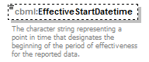
namespace | http://www.sisostds.org/schemas/c-bml/1.0
type | jc3iedm:DatetimeTypeFix18
properties
  minOcc | 0
  maxOcc | 1
  content | simple
facets
  Kind | Value | Annotation
  minLength | 18
  maxLength | 18
annotation
  documentation
  The character string representing a point in time that designates the beginning of the period of effectiveness for the reported data.
source | <xs:element name="EffectiveStartDatetime" type="jc3iedm:DatetimeTypeFix18" minOccurs="0">  <xs:annotation>  <xs:documentation xml:lang="en">The character string representing a point in time that designates the beginning of the period of effectiveness for the reported data.</xs:documentation>  </xs:annotation>  </xs:element>

element ReportedWhenAbsoluteTimingType/EffectiveEndDatetime
diagram | 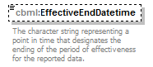
namespace | http://www.sisostds.org/schemas/c-bml/1.0
type | jc3iedm:DatetimeTypeFix18
properties
  minOcc | 0
  maxOcc | 1
  content | simple
facets
  Kind | Value | Annotation
  minLength | 18
  maxLength | 18
annotation
  documentation
  The character string representing a point in time that designates the ending of the period of effectiveness for the reported data.
source | <xs:element name="EffectiveEndDatetime" type="jc3iedm:DatetimeTypeFix18" minOccurs="0">  <xs:annotation>  <xs:documentation xml:lang="en">The character string representing a point in time that designates the ending of the period of effectiveness for the reported data.</xs:documentation>  </xs:annotation>  </xs:element>

complexType ReportedWhenRelativeTimingType
diagram | 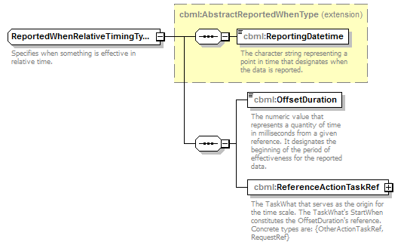
namespace | http://www.sisostds.org/schemas/c-bml/1.0
type | extension of cbml:AbstractReportedWhenType
properties
  base | cbml:AbstractReportedWhenType
children | cbml:ReportingDatetime cbml:OffsetDuration cbml:ReferenceActionTaskRef
annotation
  documentation
  Specifies when something is effective in relative time.
source | <xs:complexType name="ReportedWhenRelativeTimingType">  <xs:annotation>  <xs:documentation xml:lang="en">Specifies when something is effective in relative time.</xs:documentation>  </xs:annotation>  <xs:complexContent>  <xs:extension base="cbml:AbstractReportedWhenType">  <xs:sequence>  <xs:element name="OffsetDuration" type="jc3iedm:DurationType19">  <xs:annotation>  <xs:documentation xml:lang="en">The numeric value that represents a quantity of time in milliseconds from a given reference. It designates the beginning of the period of effectiveness for the reported data. </xs:documentation>  </xs:annotation>  </xs:element>  <xs:element name="ReferenceActionTaskRef" type="cbml:AbstractActionTaskRef">  <xs:annotation>  <xs:documentation xml:lang="en">The TaskWhat that serves as the origin for the time scale. The TaskWhat's StartWhen constitutes the OffsetDuration's reference. Concrete types are: {OtherActionTaskRef, RequestRef}</xs:documentation>  </xs:annotation>  </xs:element>  </xs:sequence>  </xs:extension>  </xs:complexContent>  </xs:complexType>

element ReportedWhenRelativeTimingType/OffsetDuration
diagram | 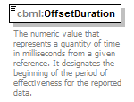
namespace | http://www.sisostds.org/schemas/c-bml/1.0
type | jc3iedm:DurationType19
properties
  content | simple
facets
  Kind | Value | Annotation
  minInclusive | -9999999999999999999
  maxInclusive | 9999999999999999999
annotation
  documentation
  The numeric value that represents a quantity of time in milliseconds from a given reference. It designates the beginning of the period of effectiveness for the reported data.
source | <xs:element name="OffsetDuration" type="jc3iedm:DurationType19">  <xs:annotation>  <xs:documentation xml:lang="en">The numeric value that represents a quantity of time in milliseconds from a given reference. It designates the beginning of the period of effectiveness for the reported data. </xs:documentation>  </xs:annotation>  </xs:element>

element ReportedWhenRelativeTimingType/ReferenceActionTaskRef
diagram | 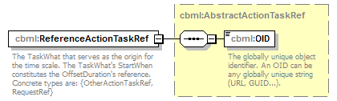
namespace | http://www.sisostds.org/schemas/c-bml/1.0
type | cbml:AbstractActionTaskRef
properties
  content | complex
children | cbml:OID
annotation
  documentation
  The TaskWhat that serves as the origin for the time scale. The TaskWhat's StartWhen constitutes the OffsetDuration's reference. Concrete types are: {OtherActionTaskRef, RequestRef}
source | <xs:element name="ReferenceActionTaskRef" type="cbml:AbstractActionTaskRef">  <xs:annotation>  <xs:documentation xml:lang="en">The TaskWhat that serves as the origin for the time scale. The TaskWhat's StartWhen constitutes the OffsetDuration's reference. Concrete types are: {OtherActionTaskRef, RequestRef}</xs:documentation>  </xs:annotation>  </xs:element>

complexType ReportedWhenType
diagram | 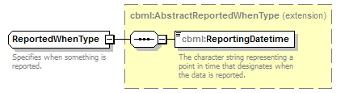
namespace | http://www.sisostds.org/schemas/c-bml/1.0
type | extension of cbml:AbstractReportedWhenType
properties
  base | cbml:AbstractReportedWhenType
children | cbml:ReportingDatetime
annotation
  documentation
  Specifies when something is reported.
source | <xs:complexType name="ReportedWhenType">  <xs:annotation>  <xs:documentation xml:lang="en">Specifies when something is reported.</xs:documentation>  </xs:annotation>  <xs:complexContent>  <xs:extension base="cbml:AbstractReportedWhenType"/>  </xs:complexContent>  </xs:complexType>

complexType ReporterWhoType
diagram | 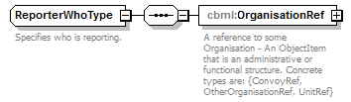
namespace | http://www.sisostds.org/schemas/c-bml/1.0
children | cbml:OrganisationRef
used by
  elements | AbstractReportType/ReporterWho ReporterWho
annotation
  documentation
  Specifies who is reporting.
source | <xs:complexType name="ReporterWhoType">  <xs:annotation>  <xs:documentation xml:lang="en">Specifies who is reporting.</xs:documentation>  </xs:annotation>  <xs:sequence>  <xs:element name="OrganisationRef" type="cbml:AbstractOrganisationRef">  <xs:annotation>  <xs:documentation xml:lang="en">A reference to some Organisation - An ObjectItem that is an administrative or functional structure. Concrete types are: {ConvoyRef, OtherOrganisationRef, UnitRef}</xs:documentation>  </xs:annotation>  </xs:element>  </xs:sequence>  </xs:complexType>

element ReporterWhoType/OrganisationRef
diagram
namespace | http://www.sisostds.org/schemas/c-bml/1.0
type | cbml:AbstractOrganisationRef
properties
  content | complex
children | cbml:OID
annotation
  documentation
  A reference to some Organisation - An ObjectItem that is an administrative or functional structure. Concrete types are: {ConvoyRef, OtherOrganisationRef, UnitRef}
source | <xs:element name="OrganisationRef" type="cbml:AbstractOrganisationRef">  <xs:annotation>  <xs:documentation xml:lang="en">A reference to some Organisation - An ObjectItem that is an administrative or functional structure. Concrete types are: {ConvoyRef, OtherOrganisationRef, UnitRef}</xs:documentation>  </xs:annotation>  </xs:element>

complexType ReportingData
diagram | 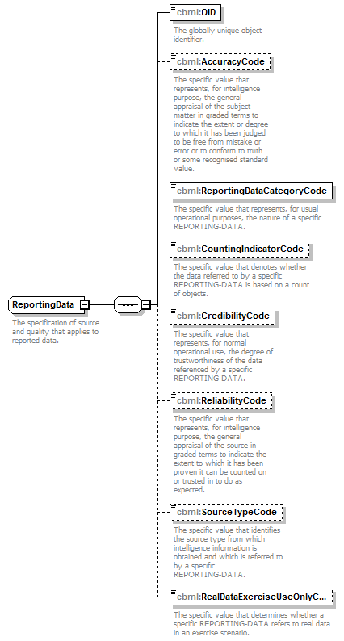
namespace | http://www.sisostds.org/schemas/c-bml/1.0
children | cbml:OID cbml:AccuracyCode cbml:ReportingDataCategoryCode cbml:CountingIndicatorCode cbml:CredibilityCode cbml:ReliabilityCode cbml:SourceTypeCode cbml:RealDataExerciseUseOnlyCode
used by
  element | AbstractReportType/ReportingData
annotation
  documentation
  The specification of source and quality that applies to reported data.
source | <xs:complexType name="ReportingData">  <xs:annotation>  <xs:documentation xml:lang="en">The specification of source and quality that applies to reported data.</xs:documentation>  </xs:annotation>  <xs:sequence>  <xs:element name="OID" type="jc3iedm:OIDType">  <xs:annotation>  <xs:documentation xml:lang="en">The globally unique object identifier.</xs:documentation>  </xs:annotation>  </xs:element>  <xs:element name="AccuracyCode" type="jc3iedm:ReportingDataAccuracyCode" minOccurs="0">  <xs:annotation>  <xs:documentation xml:lang="en">The specific value that represents, for intelligence purpose, the general appraisal of the subject matter in graded terms to indicate the extent or degree to which it has been judged to be free from mistake or error or to conform to truth or some recognised standard value.</xs:documentation>  </xs:annotation>  </xs:element>  <xs:element name="ReportingDataCategoryCode" type="jc3iedm:ReportingDataCategoryCode">  <xs:annotation>  <xs:documentation xml:lang="en">The specific value that represents, for usual operational purposes, the nature of a specific REPORTING-DATA.</xs:documentation>  </xs:annotation>  </xs:element>  <xs:element name="CountingIndicatorCode" type="jc3iedm:ReportingDataCountingIndicatorCode" minOccurs="0">  <xs:annotation>  <xs:documentation xml:lang="en">The specific value that denotes whether the data referred to by a specific REPORTING-DATA is based on a count of objects.</xs:documentation>  </xs:annotation>  </xs:element>  <xs:element name="CredibilityCode" type="jc3iedm:ReportingDataCredibilityCode" minOccurs="0">  <xs:annotation>  <xs:documentation xml:lang="en">The specific value that represents, for normal operational use, the degree of trustworthiness of the data referenced by a specific REPORTING-DATA.</xs:documentation>  </xs:annotation>  </xs:element>  <xs:element name="ReliabilityCode" type="jc3iedm:ReportingDataReliabilityCode" minOccurs="0">  <xs:annotation>  <xs:documentation xml:lang="en">The specific value that represents, for intelligence purpose, the general appraisal of the source in graded terms to indicate the extent to which it has been proven it can be counted on or trusted in to do as expected.</xs:documentation>  </xs:annotation>  </xs:element>  <xs:element name="SourceTypeCode" type="jc3iedm:ReportingDataSourceTypeCode" minOccurs="0">  <xs:annotation>  <xs:documentation xml:lang="en">The specific value that identifies the source type from which intelligence information is obtained and which is referred to by a specific REPORTING-DATA.</xs:documentation>  </xs:annotation>  </xs:element>  <xs:element name="RealDataExerciseUseOnlyCode" type="jc3iedm:ReportingDataRealDataExerciseUseOnlyCode" minOccurs="0">  <xs:annotation>  <xs:documentation xml:lang="en">The specific value that determines whether a specific REPORTING-DATA refers to real data in an exercise scenario.</xs:documentation>  </xs:annotation>  </xs:element>  </xs:sequence>  </xs:complexType>

element ReportingData/OID
diagram | 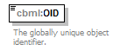
namespace | http://www.sisostds.org/schemas/c-bml/1.0
type | jc3iedm:OIDType
properties
  content | simple
annotation
  documentation
  The globally unique object identifier.
source | <xs:element name="OID" type="jc3iedm:OIDType">  <xs:annotation>  <xs:documentation xml:lang="en">The globally unique object identifier.</xs:documentation>  </xs:annotation>  </xs:element>

element ReportingData/AccuracyCode
diagram | 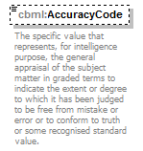
namespace | http://www.sisostds.org/schemas/c-bml/1.0
type | jc3iedm:ReportingDataAccuracyCode
properties
  minOcc | 0
  maxOcc | 1
  content | simple
facets
  Kind | Value | Annotation
  enumeration | 1
    documentation
    <Definition xml:lang="en">Reported data is confirmed by at least 3 independent sources.</Definition>
    appinfo
    <DisplayValue xml:lang="en">Confirmed</DisplayValue>
  enumeration | 2
    documentation
    <Definition xml:lang="en">Reported data is confirmed by 2 independent sources.</Definition>
    appinfo
    <DisplayValue xml:lang="en">Probable</DisplayValue>
  enumeration | 3
    documentation
    <Definition xml:lang="en">Reported data is given by only one source.</Definition>
    appinfo
    <DisplayValue xml:lang="en">Possible</DisplayValue>
  enumeration | 4
    documentation
    <Definition xml:lang="en">Reported data can be viewed with suspicion.</Definition>
    appinfo
    <DisplayValue xml:lang="en">Doubtful</DisplayValue>
  enumeration | 5
    documentation
    <Definition xml:lang="en">Reported data shall be considered as probably erroneous.</Definition>
    appinfo
    <DisplayValue xml:lang="en">Improbable</DisplayValue>
  enumeration | 6
    documentation
    <Definition xml:lang="en">Basis for the estimate of Reported data cannot be estimated.</Definition>
    appinfo
    <DisplayValue xml:lang="en">Truth cannot be judged</DisplayValue>
annotation
  documentation
  The specific value that represents, for intelligence purpose, the general appraisal of the subject matter in graded terms to indicate the extent or degree to which it has been judged to be free from mistake or error or to conform to truth or some recognised standard value.
source | <xs:element name="AccuracyCode" type="jc3iedm:ReportingDataAccuracyCode" minOccurs="0">  <xs:annotation>  <xs:documentation xml:lang="en">The specific value that represents, for intelligence purpose, the general appraisal of the subject matter in graded terms to indicate the extent or degree to which it has been judged to be free from mistake or error or to conform to truth or some recognised standard value.</xs:documentation>  </xs:annotation>  </xs:element>

element ReportingData/ReportingDataCategoryCode
diagram | 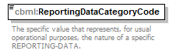
namespace | http://www.sisostds.org/schemas/c-bml/1.0
type | jc3iedm:ReportingDataCategoryCode
properties
  content | simple
facets
  Kind | Value | Annotation
  enumeration | ASS
    documentation
    <Definition xml:lang="en">A REPORTING-DATA that points to data that is considered to be valid without being based on fact or observation.</Definition>
    appinfo
    <DisplayValue xml:lang="en">Assumed</DisplayValue>
  enumeration | ERR
    documentation
    <Definition xml:lang="en">A REPORTING-DATA that points to data that is wrong.</Definition>
    appinfo
    <DisplayValue xml:lang="en">Erroneous</DisplayValue>
  enumeration | INFER
    documentation
    <Definition xml:lang="en">A REPORTING-DATA that points to data derived from multiple sources.</Definition>
    appinfo
    <DisplayValue xml:lang="en">Inferred</DisplayValue>
  enumeration | PLAN
    documentation
    <Definition xml:lang="en">A REPORTING-DATA that points to data expected to be true in the future.</Definition>
    appinfo
    <DisplayValue xml:lang="en">Planned</DisplayValue>
  enumeration | PRDCTD
    documentation
    <Definition xml:lang="en">A REPORTING-DATA that points to data that results from extrapolating, estimating, or foretelling a future condition or state.</Definition>
    appinfo
    <DisplayValue xml:lang="en">Predicted</DisplayValue>
  enumeration | REP
    documentation
    <Definition xml:lang="en">A REPORTING-DATA that points to data based on fact or observation.</Definition>
    appinfo
    <DisplayValue xml:lang="en">Reported</DisplayValue>
annotation
  documentation
  The specific value that represents, for usual operational purposes, the nature of a specific REPORTING-DATA.
source | <xs:element name="ReportingDataCategoryCode" type="jc3iedm:ReportingDataCategoryCode">  <xs:annotation>  <xs:documentation xml:lang="en">The specific value that represents, for usual operational purposes, the nature of a specific REPORTING-DATA.</xs:documentation>  </xs:annotation>  </xs:element>

element ReportingData/CountingIndicatorCode
diagram | 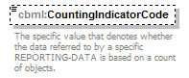
namespace | http://www.sisostds.org/schemas/c-bml/1.0
type | jc3iedm:ReportingDataCountingIndicatorCode
properties
  minOcc | 0
  maxOcc | 1
  content | simple
facets
  Kind | Value | Annotation
  enumeration | NO
    documentation
    <Definition xml:lang="en">Reported data is not based on a count.</Definition>
    appinfo
    <DisplayValue xml:lang="en">No</DisplayValue>
  enumeration | YES
    documentation
    <Definition xml:lang="en">Reported data is based on a count.</Definition>
    appinfo
    <DisplayValue xml:lang="en">Yes</DisplayValue>
annotation
  documentation
  The specific value that denotes whether the data referred to by a specific REPORTING-DATA is based on a count of objects.
source | <xs:element name="CountingIndicatorCode" type="jc3iedm:ReportingDataCountingIndicatorCode" minOccurs="0">  <xs:annotation>  <xs:documentation xml:lang="en">The specific value that denotes whether the data referred to by a specific REPORTING-DATA is based on a count of objects.</xs:documentation>  </xs:annotation>  </xs:element>

element ReportingData/CredibilityCode
diagram | 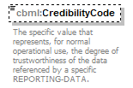
namespace | http://www.sisostds.org/schemas/c-bml/1.0
type | jc3iedm:ReportingDataCredibilityCode
properties
  minOcc | 0
  maxOcc | 1
  content | simple
facets
  Kind | Value | Annotation
  enumeration | IND
    documentation
    <Definition xml:lang="en">Basis for the estimate cannot be ascertained.</Definition>
    appinfo
    <DisplayValue xml:lang="en">Indeterminate</DisplayValue>
  enumeration | RPTFCT
    documentation
    <Definition xml:lang="en">Data is reported by different sources whose integrity is not in question.</Definition>
    appinfo
    <DisplayValue xml:lang="en">Reported as a fact</DisplayValue>
  enumeration | RPTPLA
    documentation
    <Definition xml:lang="en">Reported data is considered as possible or probable.</Definition>
    appinfo
    <DisplayValue xml:lang="en">Reported as plausible</DisplayValue>
  enumeration | RPTUNC
    documentation
    <Definition xml:lang="en">Reported data is open to or can be viewed with suspicion.</Definition>
    appinfo
    <DisplayValue xml:lang="en">Reported as uncertain</DisplayValue>
annotation
  documentation
  The specific value that represents, for normal operational use, the degree of trustworthiness of the data referenced by a specific REPORTING-DATA.
source | <xs:element name="CredibilityCode" type="jc3iedm:ReportingDataCredibilityCode" minOccurs="0">  <xs:annotation>  <xs:documentation xml:lang="en">The specific value that represents, for normal operational use, the degree of trustworthiness of the data referenced by a specific REPORTING-DATA.</xs:documentation>  </xs:annotation>  </xs:element>

element ReportingData/ReliabilityCode
diagram | 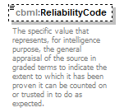
namespace | http://www.sisostds.org/schemas/c-bml/1.0
type | jc3iedm:ReportingDataReliabilityCode
properties
  minOcc | 0
  maxOcc | 1
  content | simple
facets
  Kind | Value | Annotation
  enumeration | A
    documentation
    <Definition xml:lang="en">The source of the reported data can be considered as completely reliable, i.e. erroneous information cannot be produced.</Definition>
    appinfo
    <DisplayValue xml:lang="en">Completely reliable</DisplayValue>
  enumeration | B
    documentation
    <Definition xml:lang="en">The source of the reported data can be considered as usually reliable, i.e. erroneous information can be produced, but the probability of such events can be neglected.</Definition>
    appinfo
    <DisplayValue xml:lang="en">Usually reliable</DisplayValue>
  enumeration | C
    documentation
    <Definition xml:lang="en">The source of the reported data can be considered as fairly reliable, i.e. erroneous information can be produced, with a probability that cannot be neglected.</Definition>
    appinfo
    <DisplayValue xml:lang="en">Fairly reliable</DisplayValue>
  enumeration | D
    documentation
    <Definition xml:lang="en">The source of the reported data is not usually reliable, i.e. the probability of producing erroneous information is high (&gt;30%).</Definition>
    appinfo
    <DisplayValue xml:lang="en">Not usually reliable</DisplayValue>
  enumeration | E
    documentation
    <Definition xml:lang="en">The source of the reported data is not reliable, i.e. the produced reported data can generally be considered as erroneous.</Definition>
    appinfo
    <DisplayValue xml:lang="en">Unreliable</DisplayValue>
  enumeration | F
    documentation
    <Definition xml:lang="en">The reliability of the source of the reported data cannot be estimated.</Definition>
    appinfo
    <DisplayValue xml:lang="en">Reliability cannot be judged</DisplayValue>
annotation
  documentation
  The specific value that represents, for intelligence purpose, the general appraisal of the source in graded terms to indicate the extent to which it has been proven it can be counted on or trusted in to do as expected.
source | <xs:element name="ReliabilityCode" type="jc3iedm:ReportingDataReliabilityCode" minOccurs="0">  <xs:annotation>  <xs:documentation xml:lang="en">The specific value that represents, for intelligence purpose, the general appraisal of the source in graded terms to indicate the extent to which it has been proven it can be counted on or trusted in to do as expected.</xs:documentation>  </xs:annotation>  </xs:element>

element ReportingData/SourceTypeCode
diagram | 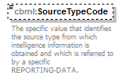
namespace | http://www.sisostds.org/schemas/c-bml/1.0
type | jc3iedm:ReportingDataSourceTypeCode
properties
  minOcc | 0
  maxOcc | 1
  content | simple
facets
  Kind | Value | Annotation
  enumeration | AIRIFR
    documentation
    <Definition xml:lang="en">The intelligence information is derived from airborne infrared systems.</Definition>
    appinfo
    <DisplayValue xml:lang="en">Airborne infrared</DisplayValue>
  enumeration | AIRREC
    documentation
    <Definition xml:lang="en">The intelligence information is gathered either by visual observation from the air or through the use of airborne sensors.</Definition>
    appinfo
    <DisplayValue xml:lang="en">Air reconnaissance</DisplayValue>
  enumeration | AOBSR
    documentation
    <Definition xml:lang="en">The intelligence information is derived from an individual whose primary mission is to observe or take photographs from an aircraft.</Definition>
    appinfo
    <DisplayValue xml:lang="en">Air observer</DisplayValue>
  enumeration | ARTOBS
    documentation
    <Definition xml:lang="en">The intelligence information is derived from artillery unit surveillance.</Definition>
    appinfo
    <DisplayValue xml:lang="en">Artillery observation</DisplayValue>
  enumeration | CAPDOC
    documentation
    <Definition xml:lang="en">The intelligence information is derived from documentation seized from the enemy.</Definition>
    appinfo
    <DisplayValue xml:lang="en">Captured document</DisplayValue>
  enumeration | CAPMAT
    documentation
    <Definition xml:lang="en">The intelligence information is derived from equipment or supplies seized from the enemy.</Definition>
    appinfo
    <DisplayValue xml:lang="en">Captured material</DisplayValue>
  enumeration | CBRR
    documentation
    <Definition xml:lang="en">The intelligence information is derived from counter battery radar systems.</Definition>
    appinfo
    <DisplayValue xml:lang="en">Radar, counter battery</DisplayValue>
  enumeration | CMRR
    documentation
    <Definition xml:lang="en">The intelligence information is derived from counter mortar radar systems.</Definition>
    appinfo
    <DisplayValue xml:lang="en">Radar, counter mortar</DisplayValue>
  enumeration | COMINT
    documentation
    <Definition xml:lang="en">The intelligence information is derived from electromagnetic communications and communications systems by other than intended recipients or users.</Definition>
    appinfo
    <DisplayValue xml:lang="en">Communications intelligence</DisplayValue>
  enumeration | CONTAC
    documentation
    <Definition xml:lang="en">The discrete airborne, surface or subsurface intelligence information is collected from electronic, acoustic, and/or visual sensors.</Definition>
    appinfo
    <DisplayValue xml:lang="en">Contact</DisplayValue>
  enumeration | DEFECT
    documentation
    <Definition xml:lang="en">The intelligence information is collected from a person who repudiates his or her country when beyond its jurisdiction or control.</Definition>
    appinfo
    <DisplayValue xml:lang="en">Defector</DisplayValue>
  enumeration | ELINT
    documentation
    <Definition xml:lang="en">The intelligence information is derived from electromagnetic non-communications transmissions by other than intended recipients or users.</Definition>
    appinfo
    <DisplayValue xml:lang="en">Electronic intelligence</DisplayValue>
  enumeration | EYOBSN
    documentation
    <Definition xml:lang="en">The intelligence information is derived from a human observation without any device.</Definition>
    appinfo
    <DisplayValue xml:lang="en">Eyeball observation</DisplayValue>
  enumeration | FLRNG
    documentation
    <Definition xml:lang="en">The intelligence information is derived from flash ranging devices.</Definition>
    appinfo
    <DisplayValue xml:lang="en">Flash ranging</DisplayValue>
  enumeration | FO
    documentation
    <Definition xml:lang="en">The intelligence information is derived from an observer with forward troops trained to call for and adjust supporting fire and pass battlefield information.</Definition>
    appinfo
    <DisplayValue xml:lang="en">Forward observer</DisplayValue>
  enumeration | FOWOL
    documentation
    <Definition xml:lang="en">The intelligence information is derived from an observer with forward troops without laser systems.</Definition>
    appinfo
    <DisplayValue xml:lang="en">Forward observer without laser</DisplayValue>
  enumeration | GRDREC
    documentation
    <Definition xml:lang="en">The intelligence information is derived from ground reconnaissance tasks.</Definition>
    appinfo
    <DisplayValue xml:lang="en">Ground reconnaissance</DisplayValue>
  enumeration | GSRA
    documentation
    <Definition xml:lang="en">The intelligence information is derived from ground surveillance radar systems.</Definition>
    appinfo
    <DisplayValue xml:lang="en">Radar, ground surveillance</DisplayValue>
  enumeration | HUMINT
    documentation
    <Definition xml:lang="en">The intelligence information is collected and provided by human sources.</Definition>
    appinfo
    <DisplayValue xml:lang="en">Human intelligence</DisplayValue>
  enumeration | INFLIT
    documentation
    <Definition xml:lang="en">The intelligence information is reported as mission results by aircrews while in flight.</Definition>
    appinfo
    <DisplayValue xml:lang="en">Inflight</DisplayValue>
  enumeration | LRRP
    documentation
    <Definition xml:lang="en">The intelligence information is derived from ground reconnaissance behind the FLOT.</Definition>
    appinfo
    <DisplayValue xml:lang="en">Long range reconnaissance patrol</DisplayValue>
  enumeration | OBSR
    documentation
    <Definition xml:lang="en">The intelligence information is derived from non-artillery observation.</Definition>
    appinfo
    <DisplayValue xml:lang="en">Observer, not artillery</DisplayValue>
  enumeration | PI
    documentation
    <Definition xml:lang="en">The intelligence information is derived from extraction from photographs or other recorded images.</Definition>
    appinfo
    <DisplayValue xml:lang="en">Photo interpretation</DisplayValue>
  enumeration | POW
    documentation
    <Definition xml:lang="en">The intelligence information is derived from captured forces.</Definition>
    appinfo
    <DisplayValue xml:lang="en">Prisoner of war</DisplayValue>
  enumeration | REFUGE
    documentation
    <Definition xml:lang="en">The intelligence information is derived from persons who, owing to religious persecution or political troubles, move within their own country (national refugees) or across international boundaries.</Definition>
    appinfo
    <DisplayValue xml:lang="en">Refugee</DisplayValue>
  enumeration | RPV
    documentation
    <Definition xml:lang="en">The intelligence information is derived from an unmanned vehicle capable of being controlled from a distant location through a communication link.</Definition>
    appinfo
    <DisplayValue xml:lang="en">Remotely-piloted vehicle</DisplayValue>
  enumeration | SAT
    documentation
    <Definition xml:lang="en">The intelligence information is derived from satellite surveillance or reconnaissance.</Definition>
    appinfo
    <DisplayValue xml:lang="en">Satellite</DisplayValue>
  enumeration | SIGINT
    documentation
    <Definition xml:lang="en">The intelligence information is collected either by communications intelligence or electronic intelligence when there is no requirement to differentiate between these two types of intelligence, or represents a fusion of information from the two.</Definition>
    appinfo
    <DisplayValue xml:lang="en">Signal intelligence</DisplayValue>
  enumeration | SLAR
    documentation
    <Definition xml:lang="en">The intelligence information is derived from an airborne radar, viewing at right angles to the axis of the vehicle, which produces a presentation of terrain or moving targets.</Definition>
    appinfo
    <DisplayValue xml:lang="en">Radar, side looking</DisplayValue>
  enumeration | SORNG
    documentation
    <Definition xml:lang="en">The intelligence information is derived from sound ranging devices.</Definition>
    appinfo
    <DisplayValue xml:lang="en">Sound ranging</DisplayValue>
  enumeration | TACAIR
    documentation
    <Definition xml:lang="en">The intelligence information is derived from tactical air operations.</Definition>
    appinfo
    <DisplayValue xml:lang="en">Tactical air</DisplayValue>
  enumeration | TGTB
    documentation
    <Definition xml:lang="en">The intelligence information is derived from target bases.</Definition>
    appinfo
    <DisplayValue xml:lang="en">Target base</DisplayValue>
  enumeration | UGS
    documentation
    <Definition xml:lang="en">The intelligence information is derived from an unmanned ground sensor device.</Definition>
    appinfo
    <DisplayValue xml:lang="en">Unattended ground sensor</DisplayValue>
  enumeration | UNSPEC
    documentation
    <Definition xml:lang="en">The source of the intelligence information is not specified.</Definition>
    appinfo
    <DisplayValue xml:lang="en">Unspecified sensitive source</DisplayValue>
  enumeration | VARI
    documentation
    <Definition xml:lang="en">The intelligence information is derived from different sources.</Definition>
    appinfo
    <DisplayValue xml:lang="en">Various sources</DisplayValue>
annotation
  documentation
  The specific value that identifies the source type from which intelligence information is obtained and which is referred to by a specific REPORTING-DATA.
source | <xs:element name="SourceTypeCode" type="jc3iedm:ReportingDataSourceTypeCode" minOccurs="0">  <xs:annotation>  <xs:documentation xml:lang="en">The specific value that identifies the source type from which intelligence information is obtained and which is referred to by a specific REPORTING-DATA.</xs:documentation>  </xs:annotation>  </xs:element>

element ReportingData/RealDataExerciseUseOnlyCode
diagram | 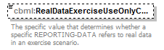
namespace | http://www.sisostds.org/schemas/c-bml/1.0
type | jc3iedm:ReportingDataRealDataExerciseUseOnlyCode
properties
  minOcc | 0
  maxOcc | 1
  content | simple
facets
  Kind | Value | Annotation
  enumeration | REAL
    documentation
    <Definition xml:lang="en">The REPORTING-DATA instance is real data not part of the exercise scenario.</Definition>
    appinfo
    <DisplayValue xml:lang="en">Real</DisplayValue>
annotation
  documentation
  The specific value that determines whether a specific REPORTING-DATA refers to real data in an exercise scenario.
source | <xs:element name="RealDataExerciseUseOnlyCode" type="jc3iedm:ReportingDataRealDataExerciseUseOnlyCode" minOccurs="0">  <xs:annotation>  <xs:documentation xml:lang="en">The specific value that determines whether a specific REPORTING-DATA refers to real data in an exercise scenario.</xs:documentation>  </xs:annotation>  </xs:element>

complexType ReportingDataRef
diagram | 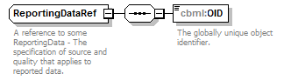
namespace | http://www.sisostds.org/schemas/c-bml/1.0
children | cbml:OID
used by
  element | AbstractReportRefType/ReportingDataRef
annotation
  documentation
  A reference to some ReportingData - The specification of source and quality that applies to reported data.
source | <xs:complexType name="ReportingDataRef">  <xs:annotation>  <xs:documentation xml:lang="en">A reference to some ReportingData - The specification of source and quality that applies to reported data.</xs:documentation>  </xs:annotation>  <xs:sequence>  <xs:element name="OID" type="jc3iedm:OIDType">  <xs:annotation>  <xs:documentation xml:lang="en">The globally unique object identifier.</xs:documentation>  </xs:annotation>  </xs:element>  </xs:sequence>  </xs:complexType>

element ReportingDataRef/OID
diagram
namespace | http://www.sisostds.org/schemas/c-bml/1.0
type | jc3iedm:OIDType
properties
  content | simple
annotation
  documentation
  The globally unique object identifier.
source | <xs:element name="OID" type="jc3iedm:OIDType">  <xs:annotation>  <xs:documentation xml:lang="en">The globally unique object identifier.</xs:documentation>  </xs:annotation>  </xs:element>

complexType RequestedWhoType
diagram | 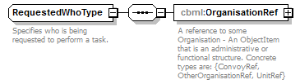
namespace | http://www.sisostds.org/schemas/c-bml/1.0
children | cbml:OrganisationRef
used by
  elements | RequestTaskType/RequestedWho RequestedWho
annotation
  documentation
  Specifies who is being requested to perform a task.
source | <xs:complexType name="RequestedWhoType">  <xs:annotation>  <xs:documentation xml:lang="en">Specifies who is being requested to perform a task.</xs:documentation>  </xs:annotation>  <xs:sequence>  <xs:element name="OrganisationRef" type="cbml:AbstractOrganisationRef">  <xs:annotation>  <xs:documentation xml:lang="en">A reference to some Organisation - An ObjectItem that is an administrative or functional structure. Concrete types are: {ConvoyRef, OtherOrganisationRef, UnitRef}</xs:documentation>  </xs:annotation>  </xs:element>  </xs:sequence>  </xs:complexType>

element RequestedWhoType/OrganisationRef
diagram
namespace | http://www.sisostds.org/schemas/c-bml/1.0
type | cbml:AbstractOrganisationRef
properties
  content | complex
children | cbml:OID
annotation
  documentation
  A reference to some Organisation - An ObjectItem that is an administrative or functional structure. Concrete types are: {ConvoyRef, OtherOrganisationRef, UnitRef}
source | <xs:element name="OrganisationRef" type="cbml:AbstractOrganisationRef">  <xs:annotation>  <xs:documentation xml:lang="en">A reference to some Organisation - An ObjectItem that is an administrative or functional structure. Concrete types are: {ConvoyRef, OtherOrganisationRef, UnitRef}</xs:documentation>  </xs:annotation>  </xs:element>

complexType RequesterWhoType
diagram | 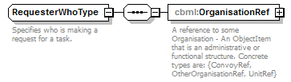
namespace | http://www.sisostds.org/schemas/c-bml/1.0
children | cbml:OrganisationRef
used by
  elements | RequestTaskType/RequesterWho RequesterWho
annotation
  documentation
  Specifies who is making a request for a task.
source | <xs:complexType name="RequesterWhoType">  <xs:annotation>  <xs:documentation xml:lang="en">Specifies who is making a request for a task.</xs:documentation>  </xs:annotation>  <xs:sequence>  <xs:element name="OrganisationRef" type="cbml:AbstractOrganisationRef">  <xs:annotation>  <xs:documentation xml:lang="en">A reference to some Organisation - An ObjectItem that is an administrative or functional structure. Concrete types are: {ConvoyRef, OtherOrganisationRef, UnitRef}</xs:documentation>  </xs:annotation>  </xs:element>  </xs:sequence>  </xs:complexType>

element RequesterWhoType/OrganisationRef
diagram
namespace | http://www.sisostds.org/schemas/c-bml/1.0
type | cbml:AbstractOrganisationRef
properties
  content | complex
children | cbml:OID
annotation
  documentation
  A reference to some Organisation - An ObjectItem that is an administrative or functional structure. Concrete types are: {ConvoyRef, OtherOrganisationRef, UnitRef}
source | <xs:element name="OrganisationRef" type="cbml:AbstractOrganisationRef">  <xs:annotation>  <xs:documentation xml:lang="en">A reference to some Organisation - An ObjectItem that is an administrative or functional structure. Concrete types are: {ConvoyRef, OtherOrganisationRef, UnitRef}</xs:documentation>  </xs:annotation>  </xs:element>

complexType RequestTaskType
diagram | 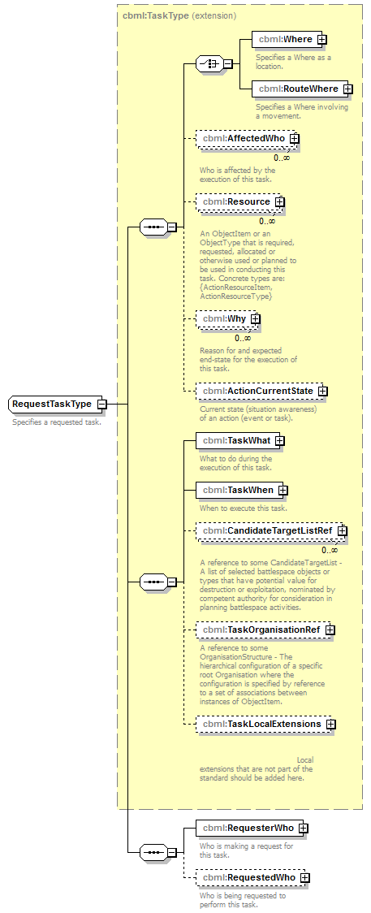
namespace | http://www.sisostds.org/schemas/c-bml/1.0
type | extension of cbml:TaskType
properties
  base | cbml:TaskType
children | cbml:Where cbml:RouteWhere cbml:AffectedWho cbml:Resource cbml:Why cbml:ActionCurrentState cbml:TaskWhat cbml:TaskWhen cbml:CandidateTargetListRef cbml:TaskOrganisationRef cbml:TaskLocalExtensions cbml:RequesterWho cbml:RequestedWho
annotation
  documentation
  Specifies a requested task.
source | <xs:complexType name="RequestTaskType">  <xs:annotation>  <xs:documentation xml:lang="en">Specifies a requested task.</xs:documentation>  </xs:annotation>  <xs:complexContent>  <xs:extension base="cbml:TaskType">  <xs:sequence>  <xs:element name="RequesterWho" type="cbml:RequesterWhoType">  <xs:annotation>  <xs:documentation xml:lang="en">Who is making a request for this task.</xs:documentation>  </xs:annotation>  </xs:element>  <xs:element name="RequestedWho" type="cbml:RequestedWhoType" minOccurs="0">  <xs:annotation>  <xs:documentation xml:lang="en">Who is being requested to perform this task.</xs:documentation>  </xs:annotation>  </xs:element>  </xs:sequence>  </xs:extension>  </xs:complexContent>  </xs:complexType>

element RequestTaskType/RequesterWho
diagram | 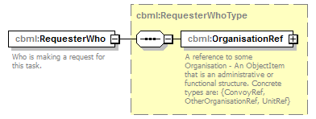
namespace | http://www.sisostds.org/schemas/c-bml/1.0
type | cbml:RequesterWhoType
properties
  content | complex
children | cbml:OrganisationRef
annotation
  documentation
  Who is making a request for this task.
source | <xs:element name="RequesterWho" type="cbml:RequesterWhoType">  <xs:annotation>  <xs:documentation xml:lang="en">Who is making a request for this task.</xs:documentation>  </xs:annotation>  </xs:element>

element RequestTaskType/RequestedWho
diagram | 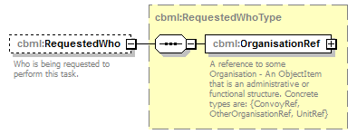
namespace | http://www.sisostds.org/schemas/c-bml/1.0
type | cbml:RequestedWhoType
properties
  minOcc | 0
  maxOcc | 1
  content | complex
children | cbml:OrganisationRef
annotation
  documentation
  Who is being requested to perform this task.
source | <xs:element name="RequestedWho" type="cbml:RequestedWhoType" minOccurs="0">  <xs:annotation>  <xs:documentation xml:lang="en">Who is being requested to perform this task.</xs:documentation>  </xs:annotation>  </xs:element>

complexType RouteWhereType
diagram | 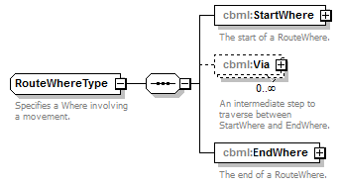
namespace | http://www.sisostds.org/schemas/c-bml/1.0
children | cbml:StartWhere cbml:Via cbml:EndWhere
used by
  elements | ActionType/RouteWhere RouteWhere
annotation
  documentation
  Specifies a Where involving a movement.
source | <xs:complexType name="RouteWhereType">  <xs:annotation>  <xs:documentation xml:lang="en">Specifies a Where involving a movement.</xs:documentation>  </xs:annotation>  <xs:sequence>  <xs:element name="StartWhere" type="cbml:WhereType">  <xs:annotation>  <xs:documentation xml:lang="en">The start of a RouteWhere.</xs:documentation>  </xs:annotation>  </xs:element>  <xs:element name="Via" type="cbml:WhereType" minOccurs="0" maxOccurs="unbounded">  <xs:annotation>  <xs:documentation xml:lang="en">An intermediate step to traverse between StartWhere and EndWhere.</xs:documentation>  </xs:annotation>  </xs:element>  <xs:element name="EndWhere" type="cbml:WhereType">  <xs:annotation>  <xs:documentation xml:lang="en">The end of a RouteWhere.</xs:documentation>  </xs:annotation>  </xs:element>  </xs:sequence>  </xs:complexType>

element RouteWhereType/StartWhere
diagram | 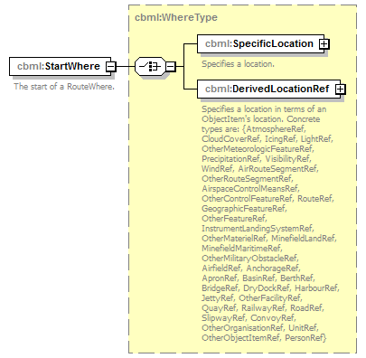
namespace | http://www.sisostds.org/schemas/c-bml/1.0
type | cbml:WhereType
properties
  content | complex
children | cbml:SpecificLocation cbml:DerivedLocationRef
annotation
  documentation
  The start of a RouteWhere.
source | <xs:element name="StartWhere" type="cbml:WhereType">  <xs:annotation>  <xs:documentation xml:lang="en">The start of a RouteWhere.</xs:documentation>  </xs:annotation>  </xs:element>

element RouteWhereType/Via
diagram | 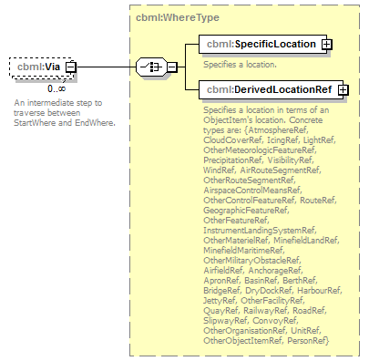
namespace | http://www.sisostds.org/schemas/c-bml/1.0
type | cbml:WhereType
properties
  minOcc | 0
  maxOcc | unbounded
  content | complex
children | cbml:SpecificLocation cbml:DerivedLocationRef
annotation
  documentation
  An intermediate step to traverse between StartWhere and EndWhere.
source | <xs:element name="Via" type="cbml:WhereType" minOccurs="0" maxOccurs="unbounded">  <xs:annotation>  <xs:documentation xml:lang="en">An intermediate step to traverse between StartWhere and EndWhere.</xs:documentation>  </xs:annotation>  </xs:element>

element RouteWhereType/EndWhere
diagram | 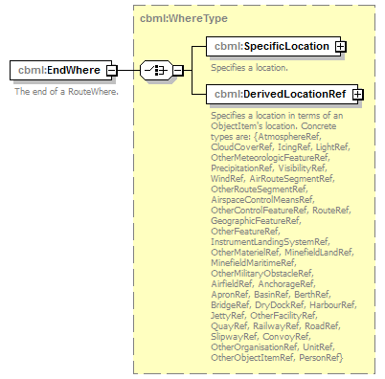
namespace | http://www.sisostds.org/schemas/c-bml/1.0
type | cbml:WhereType
properties
  content | complex
children | cbml:SpecificLocation cbml:DerivedLocationRef
annotation
  documentation
  The end of a RouteWhere.
source | <xs:element name="EndWhere" type="cbml:WhereType">  <xs:annotation>  <xs:documentation xml:lang="en">The end of a RouteWhere.</xs:documentation>  </xs:annotation>  </xs:element>

complexType SpecificLocationType
diagram | 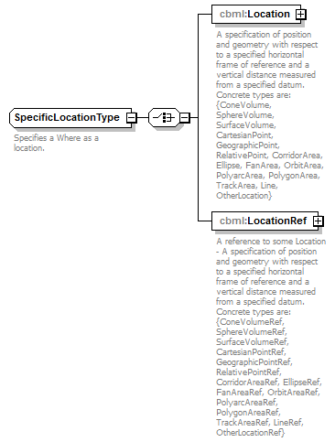
namespace | http://www.sisostds.org/schemas/c-bml/1.0
children | cbml:Location cbml:LocationRef
used by
  element | WhereType/SpecificLocation
annotation
  documentation
  Specifies a Where as a location.
source | <xs:complexType name="SpecificLocationType">  <xs:annotation>  <xs:documentation xml:lang="en">Specifies a Where as a location.</xs:documentation>  </xs:annotation>  <xs:choice>  <xs:element name="Location" type="cbml:AbstractLocation">  <xs:annotation>  <xs:documentation xml:lang="en">A specification of position and geometry with respect to a specified horizontal frame of reference and a vertical distance measured from a specified datum. Concrete types are: {ConeVolume, SphereVolume, SurfaceVolume, CartesianPoint, GeographicPoint, RelativePoint, CorridorArea, Ellipse, FanArea, OrbitArea, PolyarcArea, PolygonArea, TrackArea, Line, OtherLocation}</xs:documentation>  </xs:annotation>  </xs:element>  <xs:element name="LocationRef" type="cbml:AbstractLocationRef">  <xs:annotation>  <xs:documentation xml:lang="en">A reference to some Location - A specification of position and geometry with respect to a specified horizontal frame of reference and a vertical distance measured from a specified datum. Concrete types are: {ConeVolumeRef, SphereVolumeRef, SurfaceVolumeRef, CartesianPointRef, GeographicPointRef, RelativePointRef, CorridorAreaRef, EllipseRef, FanAreaRef, OrbitAreaRef, PolyarcAreaRef, PolygonAreaRef, TrackAreaRef, LineRef, OtherLocationRef}</xs:documentation>  </xs:annotation>  </xs:element>  </xs:choice>  </xs:complexType>

element SpecificLocationType/Location
diagram | 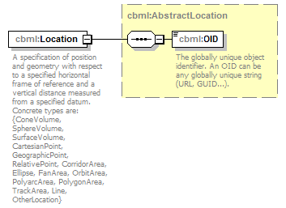
namespace | http://www.sisostds.org/schemas/c-bml/1.0
type | cbml:AbstractLocation
properties
  content | complex
children | cbml:OID
annotation
  documentation
  A specification of position and geometry with respect to a specified horizontal frame of reference and a vertical distance measured from a specified datum. Concrete types are: {ConeVolume, SphereVolume, SurfaceVolume, CartesianPoint, GeographicPoint, RelativePoint, CorridorArea, Ellipse, FanArea, OrbitArea, PolyarcArea, PolygonArea, TrackArea, Line, OtherLocation}
source | <xs:element name="Location" type="cbml:AbstractLocation">  <xs:annotation>  <xs:documentation xml:lang="en">A specification of position and geometry with respect to a specified horizontal frame of reference and a vertical distance measured from a specified datum. Concrete types are: {ConeVolume, SphereVolume, SurfaceVolume, CartesianPoint, GeographicPoint, RelativePoint, CorridorArea, Ellipse, FanArea, OrbitArea, PolyarcArea, PolygonArea, TrackArea, Line, OtherLocation}</xs:documentation>  </xs:annotation>  </xs:element>

element SpecificLocationType/LocationRef
diagram | 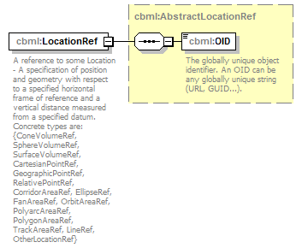
namespace | http://www.sisostds.org/schemas/c-bml/1.0
type | cbml:AbstractLocationRef
properties
  content | complex
children | cbml:OID
annotation
  documentation
  A reference to some Location - A specification of position and geometry with respect to a specified horizontal frame of reference and a vertical distance measured from a specified datum. Concrete types are: {ConeVolumeRef, SphereVolumeRef, SurfaceVolumeRef, CartesianPointRef, GeographicPointRef, RelativePointRef, CorridorAreaRef, EllipseRef, FanAreaRef, OrbitAreaRef, PolyarcAreaRef, PolygonAreaRef, TrackAreaRef, LineRef, OtherLocationRef}
source | <xs:element name="LocationRef" type="cbml:AbstractLocationRef">  <xs:annotation>  <xs:documentation xml:lang="en">A reference to some Location - A specification of position and geometry with respect to a specified horizontal frame of reference and a vertical distance measured from a specified datum. Concrete types are: {ConeVolumeRef, SphereVolumeRef, SurfaceVolumeRef, CartesianPointRef, GeographicPointRef, RelativePointRef, CorridorAreaRef, EllipseRef, FanAreaRef, OrbitAreaRef, PolyarcAreaRef, PolygonAreaRef, TrackAreaRef, LineRef, OtherLocationRef}</xs:documentation>  </xs:annotation>  </xs:element>

complexType StartWhenAbsoluteSpecifiedTimeType
diagram | 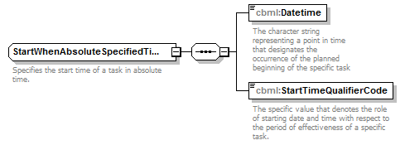
namespace | http://www.sisostds.org/schemas/c-bml/1.0
children | cbml:Datetime cbml:StartTimeQualifierCode
used by
  element | StartWhenAbsoluteTimeType/StartSpecifiedTime
annotation
  documentation
  Specifies the start time of a task in absolute time.
source | <xs:complexType name="StartWhenAbsoluteSpecifiedTimeType">  <xs:annotation>  <xs:documentation xml:lang="en">Specifies the start time of a task in absolute time.</xs:documentation>  </xs:annotation>  <xs:sequence>  <xs:element name="Datetime" type="jc3iedm:DatetimeTypeFix18">  <xs:annotation>  <xs:documentation xml:lang="en">The character string representing a point in time that designates the occurrence of the planned beginning of the specific task</xs:documentation>  </xs:annotation>  </xs:element>  <xs:element name="StartTimeQualifierCode" type="cbml:ActionTaskStartTimeQualifierCode">  <xs:annotation>  <xs:documentation xml:lang="en">The specific value that denotes the role of starting date and time with respect to the period of effectiveness of a specific task.</xs:documentation>  </xs:annotation>  </xs:element>  </xs:sequence>  </xs:complexType>

element StartWhenAbsoluteSpecifiedTimeType/Datetime
diagram | 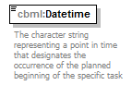
namespace | http://www.sisostds.org/schemas/c-bml/1.0
type | jc3iedm:DatetimeTypeFix18
properties
  content | simple
facets
  Kind | Value | Annotation
  minLength | 18
  maxLength | 18
annotation
  documentation
  The character string representing a point in time that designates the occurrence of the planned beginning of the specific task
source | <xs:element name="Datetime" type="jc3iedm:DatetimeTypeFix18">  <xs:annotation>  <xs:documentation xml:lang="en">The character string representing a point in time that designates the occurrence of the planned beginning of the specific task</xs:documentation>  </xs:annotation>  </xs:element>

element StartWhenAbsoluteSpecifiedTimeType/StartTimeQualifierCode
diagram | 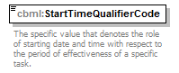
namespace | http://www.sisostds.org/schemas/c-bml/1.0
type | cbml:ActionTaskStartTimeQualifierCode
properties
  content | simple
facets
  Kind | Value | Annotation
  enumeration | AFT
    documentation
    <Definition xml:lang="en">Time intended is later than the time specified.</Definition>
    appinfo
    <xs:DisplayValue xml:lang="en">After</xs:DisplayValue>
  enumeration | ASAPAF
    documentation
    <Definition xml:lang="en">Begin the activity at the earliest possible time after the specified start time.</Definition>
    appinfo
    <xs:DisplayValue xml:lang="en">As soon as possible after</xs:DisplayValue>
  enumeration | ASAPNL
    documentation
    <Definition xml:lang="en">Begin the activity at the earliest possible time but not later than the specified start time.</Definition>
    appinfo
    <xs:DisplayValue xml:lang="en">As soon as possible not later than</xs:DisplayValue>
  enumeration | AT
    documentation
    <Definition xml:lang="en">Time intended is the time specified.</Definition>
    appinfo
    <xs:DisplayValue xml:lang="en">At</xs:DisplayValue>
  enumeration | BEF
    documentation
    <Definition xml:lang="en">Time intended is in advance of the time specified.</Definition>
    appinfo
    <xs:DisplayValue xml:lang="en">Before</xs:DisplayValue>
  enumeration | NLT
    documentation
    <Definition xml:lang="en">Time specified is the latest.</Definition>
    appinfo
    <xs:DisplayValue xml:lang="en">No later than</xs:DisplayValue>
  enumeration | NOB
    documentation
    <Definition xml:lang="en">Time specified is the earliest.</Definition>
    appinfo
    <xs:DisplayValue xml:lang="en">Not before</xs:DisplayValue>
annotation
  documentation
  The specific value that denotes the role of starting date and time with respect to the period of effectiveness of a specific task.
source | <xs:element name="StartTimeQualifierCode" type="cbml:ActionTaskStartTimeQualifierCode">  <xs:annotation>  <xs:documentation xml:lang="en">The specific value that denotes the role of starting date and time with respect to the period of effectiveness of a specific task.</xs:documentation>  </xs:annotation>  </xs:element>

complexType StartWhenAbsoluteTimeType
diagram | 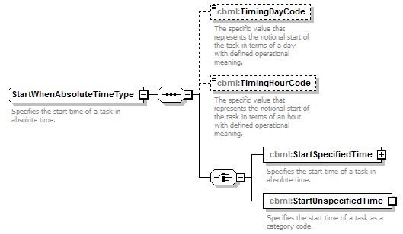
namespace | http://www.sisostds.org/schemas/c-bml/1.0
children | cbml:TimingDayCode cbml:TimingHourCode cbml:StartSpecifiedTime cbml:StartUnspecifiedTime
used by
  element | TaskStartWhenType/StartAbsoluteTime
annotation
  documentation
  Specifies the start time of a task in absolute time.
source | <xs:complexType name="StartWhenAbsoluteTimeType">  <xs:annotation>  <xs:documentation xml:lang="en">Specifies the start time of a task in absolute time.</xs:documentation>  </xs:annotation>  <xs:sequence>  <xs:element name="TimingDayCode" type="jc3iedm:ActionTaskTimingDayCode" minOccurs="0">  <xs:annotation>  <xs:documentation xml:lang="en">The specific value that represents the notional start of the task in terms of a day with defined operational meaning.</xs:documentation>  </xs:annotation>  </xs:element>  <xs:element name="TimingHourCode" type="jc3iedm:ActionTaskTimingHourCode" minOccurs="0">  <xs:annotation>  <xs:documentation xml:lang="en">The specific value that represents the notional start of the task in terms of an hour with defined operational meaning.</xs:documentation>  </xs:annotation>  </xs:element>  <xs:choice>  <xs:element name="StartSpecifiedTime" type="cbml:StartWhenAbsoluteSpecifiedTimeType">  <xs:annotation>  <xs:documentation xml:lang="en">Specifies the start time of a task in absolute time.</xs:documentation>  </xs:annotation>  </xs:element>  <xs:element name="StartUnspecifiedTime" type="cbml:StartWhenAbsoluteUnspecifiedTimeType">  <xs:annotation>  <xs:documentation xml:lang="en">Specifies the start time of a task as a category code.</xs:documentation>  </xs:annotation>  </xs:element>  </xs:choice>  </xs:sequence>  </xs:complexType>

element StartWhenAbsoluteTimeType/TimingDayCode
diagram | 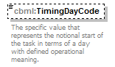
namespace | http://www.sisostds.org/schemas/c-bml/1.0
type | jc3iedm:ActionTaskTimingDayCode
properties
  minOcc | 0
  maxOcc | 1
  content | simple
facets
  Kind | Value | Annotation
  enumeration | C
    documentation
    <Definition xml:lang="en">The day on which deployment for an operation commences or is due to commence.</Definition>
    appinfo
    <DisplayValue xml:lang="en">C</DisplayValue>
  enumeration | D
    documentation
    <Definition xml:lang="en">The day on which an operation commences or is due to commence. This may be commencement of hostilities or any other operation.</Definition>
    appinfo
    <DisplayValue xml:lang="en">D</DisplayValue>
  enumeration | E
    documentation
    <Definition xml:lang="en">The day on which a NATO exercise commences.</Definition>
    appinfo
    <DisplayValue xml:lang="en">E</DisplayValue>
  enumeration | G
    documentation
    <Definition xml:lang="en">The day on which an order (normally national) is given to deploy a unit.</Definition>
    appinfo
    <DisplayValue xml:lang="en">G</DisplayValue>
  enumeration | J
    documentation
    <Definition xml:lang="en">French equivalent to D-day.</Definition>
    appinfo
    <DisplayValue xml:lang="en">J</DisplayValue>
  enumeration | K
    documentation
    <Definition xml:lang="en">The day on which a convoy system is introduced or is due to be introduced on any particular land convoy route or sea convoy lane.</Definition>
    appinfo
    <DisplayValue xml:lang="en">K</DisplayValue>
  enumeration | M
    documentation
    <Definition xml:lang="en">The day on which mobilization commences or is due to commence.</Definition>
    appinfo
    <DisplayValue xml:lang="en">M</DisplayValue>
  enumeration | T
    documentation
    <Definition xml:lang="en">The day of Transfer of Authority.</Definition>
    appinfo
    <DisplayValue xml:lang="en">T</DisplayValue>
annotation
  documentation
  The specific value that represents the notional start of the task in terms of a day with defined operational meaning.
source | <xs:element name="TimingDayCode" type="jc3iedm:ActionTaskTimingDayCode" minOccurs="0">  <xs:annotation>  <xs:documentation xml:lang="en">The specific value that represents the notional start of the task in terms of a day with defined operational meaning.</xs:documentation>  </xs:annotation>  </xs:element>

element StartWhenAbsoluteTimeType/TimingHourCode
diagram | 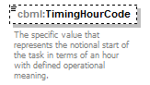
namespace | http://www.sisostds.org/schemas/c-bml/1.0
type | jc3iedm:ActionTaskTimingHourCode
properties
  minOcc | 0
  maxOcc | 1
  content | simple
facets
  Kind | Value | Annotation
  enumeration | F
    documentation
    <Definition xml:lang="en">The time designated for the start of cross-FLOT aviation operations.</Definition>
    appinfo
    <DisplayValue xml:lang="en">F</DisplayValue>
  enumeration | G
    documentation
    <Definition xml:lang="en">The time on which an order (normally national) is given to deploy a unit.</Definition>
    appinfo
    <DisplayValue xml:lang="en">G</DisplayValue>
  enumeration | H
    documentation
    <Definition xml:lang="en">1. The specific time at which an operation or exercise commences or is due to commence. It is also the time at which the Line of Departure is crossed by the leading element in an attack. 2. In amphibious operations, the time at which the first waterborne wave of an amphibious assault lands on a beach.</Definition>
    appinfo
    <DisplayValue xml:lang="en">H</DisplayValue>
  enumeration | K
    documentation
    <Definition xml:lang="en">The time on which a convoy system is introduced or is due to be introduced on any particular land convoy route or sea convoy lane.</Definition>
    appinfo
    <DisplayValue xml:lang="en">K</DisplayValue>
  enumeration | L
    documentation
    <Definition xml:lang="en">In amphibious or airmobile operations, the time at which the first helicopter of the heliborne assault wave touches down in the landing zone (LZ).</Definition>
    appinfo
    <DisplayValue xml:lang="en">L</DisplayValue>
  enumeration | P
    documentation
    <Definition xml:lang="en">In airborne operations, the time at which the lead parachute element is to arrive over the parachute impact point to begin operations.</Definition>
    appinfo
    <DisplayValue xml:lang="en">P</DisplayValue>
  enumeration | T
    documentation
    <Definition xml:lang="en">The time of Transfer of Authority.</Definition>
    appinfo
    <DisplayValue xml:lang="en">T</DisplayValue>
  enumeration | Y
    documentation
    <Definition xml:lang="en">In airmobile operations the time at which the first helicopter in the first wave departs the "Pick-up-Point"(PUP).</Definition>
    appinfo
    <DisplayValue xml:lang="en">Y</DisplayValue>
annotation
  documentation
  The specific value that represents the notional start of the task in terms of an hour with defined operational meaning.
source | <xs:element name="TimingHourCode" type="jc3iedm:ActionTaskTimingHourCode" minOccurs="0">  <xs:annotation>  <xs:documentation xml:lang="en">The specific value that represents the notional start of the task in terms of an hour with defined operational meaning.</xs:documentation>  </xs:annotation>  </xs:element>

element StartWhenAbsoluteTimeType/StartSpecifiedTime
diagram | 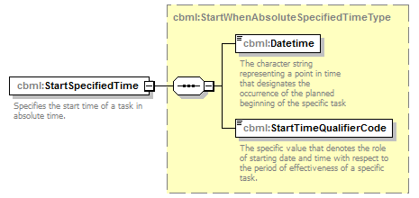
namespace | http://www.sisostds.org/schemas/c-bml/1.0
type | cbml:StartWhenAbsoluteSpecifiedTimeType
properties
  content | complex
children | cbml:Datetime cbml:StartTimeQualifierCode
annotation
  documentation
  Specifies the start time of a task in absolute time.
source | <xs:element name="StartSpecifiedTime" type="cbml:StartWhenAbsoluteSpecifiedTimeType">  <xs:annotation>  <xs:documentation xml:lang="en">Specifies the start time of a task in absolute time.</xs:documentation>  </xs:annotation>  </xs:element>

element StartWhenAbsoluteTimeType/StartUnspecifiedTime
diagram | 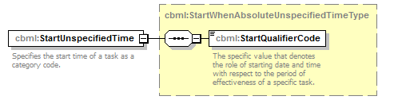
namespace | http://www.sisostds.org/schemas/c-bml/1.0
type | cbml:StartWhenAbsoluteUnspecifiedTimeType
properties
  content | complex
children | cbml:StartQualifierCode
annotation
  documentation
  Specifies the start time of a task as a category code.
source | <xs:element name="StartUnspecifiedTime" type="cbml:StartWhenAbsoluteUnspecifiedTimeType">  <xs:annotation>  <xs:documentation xml:lang="en">Specifies the start time of a task as a category code.</xs:documentation>  </xs:annotation>  </xs:element>

complexType StartWhenAbsoluteUnspecifiedTimeType
diagram | 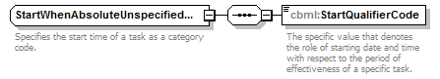
namespace | http://www.sisostds.org/schemas/c-bml/1.0
children | cbml:StartQualifierCode
used by
  element | StartWhenAbsoluteTimeType/StartUnspecifiedTime
annotation
  documentation
  Specifies the start time of a task as a category code.
source | <xs:complexType name="StartWhenAbsoluteUnspecifiedTimeType">  <xs:annotation>  <xs:documentation xml:lang="en">Specifies the start time of a task as a category code.</xs:documentation>  </xs:annotation>  <xs:sequence>  <xs:element name="StartQualifierCode" type="cbml:ActionTaskStartQualifierCode">  <xs:annotation>  <xs:documentation xml:lang="en">The specific value that denotes the role of starting date and time with respect to the period of effectiveness of a specific task.</xs:documentation>  </xs:annotation>  </xs:element>  </xs:sequence>  </xs:complexType>

element StartWhenAbsoluteUnspecifiedTimeType/StartQualifierCode
diagram | 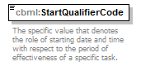
namespace | http://www.sisostds.org/schemas/c-bml/1.0
type | cbml:ActionTaskStartQualifierCode
properties
  content | simple
facets
  Kind | Value | Annotation
  enumeration | ASAP
    documentation
    <Definition xml:lang="en">Begin the activity at the earliest possible time once execution is authorised.</Definition>
    appinfo
    <xs:DisplayValue xml:lang="en">As soon as possible</xs:DisplayValue>
annotation
  documentation
  The specific value that denotes the role of starting date and time with respect to the period of effectiveness of a specific task.
source | <xs:element name="StartQualifierCode" type="cbml:ActionTaskStartQualifierCode">  <xs:annotation>  <xs:documentation xml:lang="en">The specific value that denotes the role of starting date and time with respect to the period of effectiveness of a specific task.</xs:documentation>  </xs:annotation>  </xs:element>

complexType StartWhenRelativeTimeType
diagram | 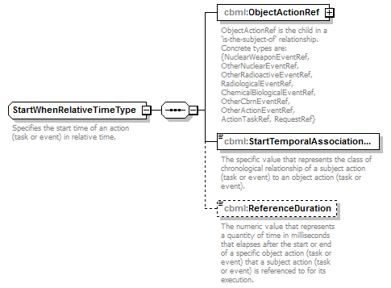
namespace | http://www.sisostds.org/schemas/c-bml/1.0
children | cbml:ObjectActionRef cbml:StartTemporalAssociationCategoryCode cbml:ReferenceDuration
used by
  elements | TaskStartWhenType/StartRelativeTime EventStartWhenType/StartRelativeTime
annotation
  documentation
  Specifies the start time of an action (task or event) in relative time.
source | <xs:complexType name="StartWhenRelativeTimeType">  <xs:annotation>  <xs:documentation xml:lang="en">Specifies the start time of an action (task or event) in relative time.</xs:documentation>  </xs:annotation>  <xs:sequence>  <xs:element name="ObjectActionRef" type="cbml:AbstractActionRef">  <xs:annotation>  <xs:documentation xml:lang="en">ObjectActionRef is the child in a 'is-the-subject-of' relationship. Concrete types are: {NuclearWeaponEventRef, OtherNuclearEventRef, OtherRadioactiveEventRef, RadiologicalEventRef, ChemicalBiologicalEventRef, OtherCbrnEventRef, OtherActionEventRef, ActionTaskRef, RequestRef}</xs:documentation>  </xs:annotation>  </xs:element>  <xs:element name="StartTemporalAssociationCategoryCode" type="cbml:ActionStartTemporalAssociationCategoryCode">  <xs:annotation>  <xs:documentation xml:lang="en">The specific value that represents the class of chronological relationship of a subject action (task or event) to an object action (task or event).</xs:documentation>  </xs:annotation>  </xs:element>  <xs:element name="ReferenceDuration" type="jc3iedm:DurationType19" minOccurs="0">  <xs:annotation>  <xs:documentation xml:lang="en">The numeric value that represents a quantity of time in milliseconds that elapses after the start or end of a specific object action (task or event) that a subject action (task or event) is referenced to for its execution.</xs:documentation>  </xs:annotation>  </xs:element>  </xs:sequence>  </xs:complexType>

element StartWhenRelativeTimeType/ObjectActionRef
diagram
namespace | http://www.sisostds.org/schemas/c-bml/1.0
type | cbml:AbstractActionRef
properties
  content | complex
children | cbml:OID
annotation
  documentation
  ObjectActionRef is the child in a 'is-the-subject-of' relationship. Concrete types are: {NuclearWeaponEventRef, OtherNuclearEventRef, OtherRadioactiveEventRef, RadiologicalEventRef, ChemicalBiologicalEventRef, OtherCbrnEventRef, OtherActionEventRef, ActionTaskRef, RequestRef}
source | <xs:element name="ObjectActionRef" type="cbml:AbstractActionRef">  <xs:annotation>  <xs:documentation xml:lang="en">ObjectActionRef is the child in a 'is-the-subject-of' relationship. Concrete types are: {NuclearWeaponEventRef, OtherNuclearEventRef, OtherRadioactiveEventRef, RadiologicalEventRef, ChemicalBiologicalEventRef, OtherCbrnEventRef, OtherActionEventRef, ActionTaskRef, RequestRef}</xs:documentation>  </xs:annotation>  </xs:element>

element StartWhenRelativeTimeType/StartTemporalAssociationCategoryCode
diagram | 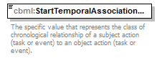
namespace | http://www.sisostds.org/schemas/c-bml/1.0
type | cbml:ActionStartTemporalAssociationCategoryCode
properties
  content | simple
facets
  Kind | Value | Annotation
  enumeration | STREND
    documentation
    <xs:Definition xml:lang="en">The subject ACTION starts after the object ACTION ends.</xs:Definition>
    appinfo
    <xs:DisplayValue xml:lang="en">Starts after end of</xs:DisplayValue>
  enumeration | STRENE
    documentation
    <xs:Definition xml:lang="en">The subject ACTION starts no earlier than the end of the object ACTION augmented by a fixed duration.</xs:Definition>
    appinfo
    <xs:DisplayValue xml:lang="en">Starts no earlier than after end of</xs:DisplayValue>
  enumeration | STRENL
    documentation
    <xs:Definition xml:lang="en">The subject ACTION starts no later than the end of object ACTION augmented by a fixed duration.</xs:Definition>
    appinfo
    <xs:DisplayValue xml:lang="en">Starts no later than after end of</xs:DisplayValue>
  enumeration | STRSNE
    documentation
    <xs:Definition xml:lang="en">The subject ACTION starts no earlier than the start of the object ACTION augmented by a fixed duration.</xs:Definition>
    appinfo
    <xs:DisplayValue xml:lang="en">Starts no earlier than after start of</xs:DisplayValue>
  enumeration | STRSNL
    documentation
    <xs:Definition xml:lang="en">The subject ACTION starts no later than the start of object ACTION augmented by a fixed duration.</xs:Definition>
    appinfo
    <xs:DisplayValue xml:lang="en">Starts no later than after start of</xs:DisplayValue>
  enumeration | STRSTR
    documentation
    <xs:Definition xml:lang="en">The subject ACTION starts after the object ACTION starts.</xs:Definition>
    appinfo
    <xs:DisplayValue xml:lang="en">Starts after start of</xs:DisplayValue>
annotation
  documentation
  The specific value that represents the class of chronological relationship of a subject action (task or event) to an object action (task or event).
source | <xs:element name="StartTemporalAssociationCategoryCode" type="cbml:ActionStartTemporalAssociationCategoryCode">  <xs:annotation>  <xs:documentation xml:lang="en">The specific value that represents the class of chronological relationship of a subject action (task or event) to an object action (task or event).</xs:documentation>  </xs:annotation>  </xs:element>

element StartWhenRelativeTimeType/ReferenceDuration
diagram
namespace | http://www.sisostds.org/schemas/c-bml/1.0
type | jc3iedm:DurationType19
properties
  minOcc | 0
  maxOcc | 1
  content | simple
facets
  Kind | Value | Annotation
  minInclusive | -9999999999999999999
  maxInclusive | 9999999999999999999
annotation
  documentation
  The numeric value that represents a quantity of time in milliseconds that elapses after the start or end of a specific object action (task or event) that a subject action (task or event) is referenced to for its execution.
source | <xs:element name="ReferenceDuration" type="jc3iedm:DurationType19" minOccurs="0">  <xs:annotation>  <xs:documentation xml:lang="en">The numeric value that represents a quantity of time in milliseconds that elapses after the start or end of a specific object action (task or event) that a subject action (task or event) is referenced to for its execution.</xs:documentation>  </xs:annotation>  </xs:element>

complexType StateType
diagram | 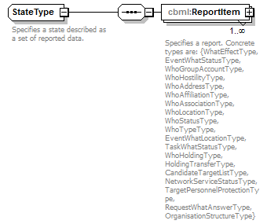
namespace | http://www.sisostds.org/schemas/c-bml/1.0
children | cbml:ReportItem
used by
  elements | ActionType/ActionCurrentState WhyType/ExpectedEndState
annotation
  documentation
  Specifies a state described as a set of reported data.
source | <xs:complexType name="StateType">  <xs:annotation>  <xs:documentation xml:lang="en">Specifies a state described as a set of reported data.</xs:documentation>  </xs:annotation>  <xs:sequence>  <xs:element name="ReportItem" type="cbml:AbstractReportType" maxOccurs="unbounded">  <xs:annotation>  <xs:documentation xml:lang="en">Specifies a report. Concrete types are: {WhatEffectType, EventWhatStatusType, WhoGroupAccountType, WhoHostilityType, WhoAddressType, WhoAffiliationType, WhoAssociationType, WhoLocationType, WhoStatusType, WhoTypeType, EventWhatLocationType, TaskWhatStatusType, WhoHoldingType, HoldingTransferType, CandidateTargetListType, NetworkServiceStatusType, TargetPersonnelProtectionType, RequestWhatAnswerType, OrganisationStructureType}</xs:documentation>  </xs:annotation>  </xs:element>  </xs:sequence>  </xs:complexType>

element StateType/ReportItem
diagram | 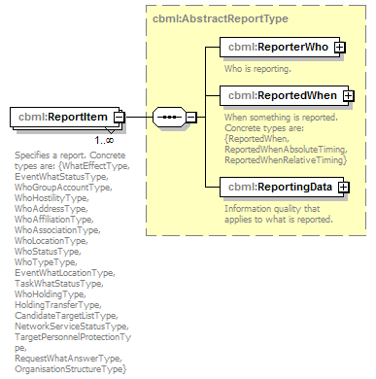
namespace | http://www.sisostds.org/schemas/c-bml/1.0
type | cbml:AbstractReportType
properties
  minOcc | 1
  maxOcc | unbounded
  content | complex
children | cbml:ReporterWho cbml:ReportedWhen cbml:ReportingData
annotation
  documentation
  Specifies a report. Concrete types are: {WhatEffectType, EventWhatStatusType, WhoGroupAccountType, WhoHostilityType, WhoAddressType, WhoAffiliationType, WhoAssociationType, WhoLocationType, WhoStatusType, WhoTypeType, EventWhatLocationType, TaskWhatStatusType, WhoHoldingType, HoldingTransferType, CandidateTargetListType, NetworkServiceStatusType, TargetPersonnelProtectionType, RequestWhatAnswerType, OrganisationStructureType}
source | <xs:element name="ReportItem" type="cbml:AbstractReportType" maxOccurs="unbounded">  <xs:annotation>  <xs:documentation xml:lang="en">Specifies a report. Concrete types are: {WhatEffectType, EventWhatStatusType, WhoGroupAccountType, WhoHostilityType, WhoAddressType, WhoAffiliationType, WhoAssociationType, WhoLocationType, WhoStatusType, WhoTypeType, EventWhatLocationType, TaskWhatStatusType, WhoHoldingType, HoldingTransferType, CandidateTargetListType, NetworkServiceStatusType, TargetPersonnelProtectionType, RequestWhatAnswerType, OrganisationStructureType}</xs:documentation>  </xs:annotation>  </xs:element>

complexType TaskeeWhoType
diagram | 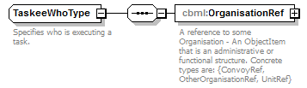
namespace | http://www.sisostds.org/schemas/c-bml/1.0
children | cbml:OrganisationRef
used by
  elements | OrderTaskType/TaskeeWho TaskeeWho
annotation
  documentation
  Specifies who is executing a task.
source | <xs:complexType name="TaskeeWhoType">  <xs:annotation>  <xs:documentation xml:lang="en">Specifies who is executing a task.</xs:documentation>  </xs:annotation>  <xs:sequence>  <xs:element name="OrganisationRef" type="cbml:AbstractOrganisationRef">  <xs:annotation>  <xs:documentation xml:lang="en">A reference to some Organisation - An ObjectItem that is an administrative or functional structure. Concrete types are: {ConvoyRef, OtherOrganisationRef, UnitRef}</xs:documentation>  </xs:annotation>  </xs:element>  </xs:sequence>  </xs:complexType>

element TaskeeWhoType/OrganisationRef
diagram
namespace | http://www.sisostds.org/schemas/c-bml/1.0
type | cbml:AbstractOrganisationRef
properties
  content | complex
children | cbml:OID
annotation
  documentation
  A reference to some Organisation - An ObjectItem that is an administrative or functional structure. Concrete types are: {ConvoyRef, OtherOrganisationRef, UnitRef}
source | <xs:element name="OrganisationRef" type="cbml:AbstractOrganisationRef">  <xs:annotation>  <xs:documentation xml:lang="en">A reference to some Organisation - An ObjectItem that is an administrative or functional structure. Concrete types are: {ConvoyRef, OtherOrganisationRef, UnitRef}</xs:documentation>  </xs:annotation>  </xs:element>

complexType TaskEndWhenType
diagram | 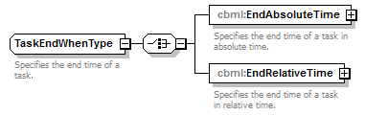
namespace | http://www.sisostds.org/schemas/c-bml/1.0
children | cbml:EndAbsoluteTime cbml:EndRelativeTime
used by
  element | TaskWhenType/TaskEndWhen
annotation
  documentation
  Specifies the end time of a task.
source | <xs:complexType name="TaskEndWhenType">  <xs:annotation>  <xs:documentation xml:lang="en">Specifies the end time of a task.</xs:documentation>  </xs:annotation>  <xs:choice>  <xs:element name="EndAbsoluteTime" type="cbml:EndWhenAbsoluteTimeType">  <xs:annotation>  <xs:documentation xml:lang="en">Specifies the end time of a task in absolute time.</xs:documentation>  </xs:annotation>  </xs:element>  <xs:element name="EndRelativeTime" type="cbml:EndWhenRelativeTimeType">  <xs:annotation>  <xs:documentation xml:lang="en">Specifies the end time of a task in relative time.</xs:documentation>  </xs:annotation>  </xs:element>  </xs:choice>  </xs:complexType>

element TaskEndWhenType/EndAbsoluteTime
diagram | 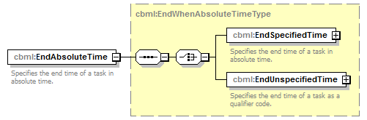
namespace | http://www.sisostds.org/schemas/c-bml/1.0
type | cbml:EndWhenAbsoluteTimeType
properties
  content | complex
children | cbml:EndSpecifiedTime cbml:EndUnspecifiedTime
annotation
  documentation
  Specifies the end time of a task in absolute time.
source | <xs:element name="EndAbsoluteTime" type="cbml:EndWhenAbsoluteTimeType">  <xs:annotation>  <xs:documentation xml:lang="en">Specifies the end time of a task in absolute time.</xs:documentation>  </xs:annotation>  </xs:element>

element TaskEndWhenType/EndRelativeTime
diagram | 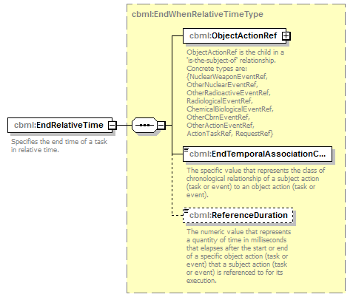
namespace | http://www.sisostds.org/schemas/c-bml/1.0
type | cbml:EndWhenRelativeTimeType
properties
  content | complex
children | cbml:ObjectActionRef cbml:EndTemporalAssociationCategoryCode cbml:ReferenceDuration
annotation
  documentation
  Specifies the end time of a task in relative time.
source | <xs:element name="EndRelativeTime" type="cbml:EndWhenRelativeTimeType">  <xs:annotation>  <xs:documentation xml:lang="en">Specifies the end time of a task in relative time.</xs:documentation>  </xs:annotation>  </xs:element>

complexType TaskerWhoType
diagram | 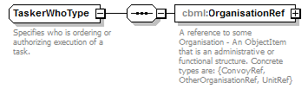
namespace | http://www.sisostds.org/schemas/c-bml/1.0
children | cbml:OrganisationRef
used by
  elements | OrderTaskType/TaskerWho TaskerWho
annotation
  documentation
  Specifies who is ordering or authorizing execution of a task.
source | <xs:complexType name="TaskerWhoType">  <xs:annotation>  <xs:documentation xml:lang="en">Specifies who is ordering or authorizing execution of a task.</xs:documentation>  </xs:annotation>  <xs:sequence>  <xs:element name="OrganisationRef" type="cbml:AbstractOrganisationRef">  <xs:annotation>  <xs:documentation xml:lang="en">A reference to some Organisation - An ObjectItem that is an administrative or functional structure. Concrete types are: {ConvoyRef, OtherOrganisationRef, UnitRef}</xs:documentation>  </xs:annotation>  </xs:element>  </xs:sequence>  </xs:complexType>

element TaskerWhoType/OrganisationRef
diagram
namespace | http://www.sisostds.org/schemas/c-bml/1.0
type | cbml:AbstractOrganisationRef
properties
  content | complex
children | cbml:OID
annotation
  documentation
  A reference to some Organisation - An ObjectItem that is an administrative or functional structure. Concrete types are: {ConvoyRef, OtherOrganisationRef, UnitRef}
source | <xs:element name="OrganisationRef" type="cbml:AbstractOrganisationRef">  <xs:annotation>  <xs:documentation xml:lang="en">A reference to some Organisation - An ObjectItem that is an administrative or functional structure. Concrete types are: {ConvoyRef, OtherOrganisationRef, UnitRef}</xs:documentation>  </xs:annotation>  </xs:element>

complexType TaskLocalExtensionsType
diagram | 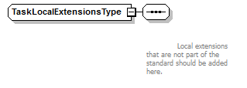
namespace | http://www.sisostds.org/schemas/c-bml/1.0
used by
  element | TaskType/TaskLocalExtensions
source | <xs:complexType name="TaskLocalExtensionsType">  <xs:sequence>  <xs:annotation>  <xs:documentation xml:lang="en">  Local extensions that are not part of the standard should be added here.  </xs:documentation>  </xs:annotation>  </xs:sequence>  </xs:complexType>

complexType TaskStartWhenType
diagram | 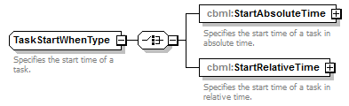
namespace | http://www.sisostds.org/schemas/c-bml/1.0
children | cbml:StartAbsoluteTime cbml:StartRelativeTime
used by
  element | TaskWhenType/TaskStartWhen
annotation
  documentation
  Specifies the start time of a task.
source | <xs:complexType name="TaskStartWhenType">  <xs:annotation>  <xs:documentation xml:lang="en">Specifies the start time of a task.</xs:documentation>  </xs:annotation>  <xs:choice>  <xs:element name="StartAbsoluteTime" type="cbml:StartWhenAbsoluteTimeType">  <xs:annotation>  <xs:documentation xml:lang="en">Specifies the start time of a task in absolute time.</xs:documentation>  </xs:annotation>  </xs:element>  <xs:element name="StartRelativeTime" type="cbml:StartWhenRelativeTimeType">  <xs:annotation>  <xs:documentation xml:lang="en">Specifies the start time of a task in relative time.</xs:documentation>  </xs:annotation>  </xs:element>  </xs:choice>  </xs:complexType>

element TaskStartWhenType/StartAbsoluteTime
diagram | 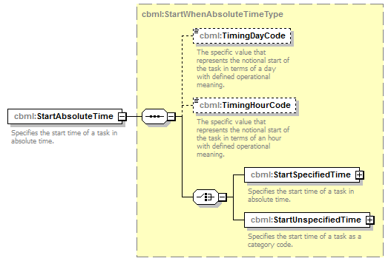
namespace | http://www.sisostds.org/schemas/c-bml/1.0
type | cbml:StartWhenAbsoluteTimeType
properties
  content | complex
children | cbml:TimingDayCode cbml:TimingHourCode cbml:StartSpecifiedTime cbml:StartUnspecifiedTime
annotation
  documentation
  Specifies the start time of a task in absolute time.
source | <xs:element name="StartAbsoluteTime" type="cbml:StartWhenAbsoluteTimeType">  <xs:annotation>  <xs:documentation xml:lang="en">Specifies the start time of a task in absolute time.</xs:documentation>  </xs:annotation>  </xs:element>

element TaskStartWhenType/StartRelativeTime
diagram | 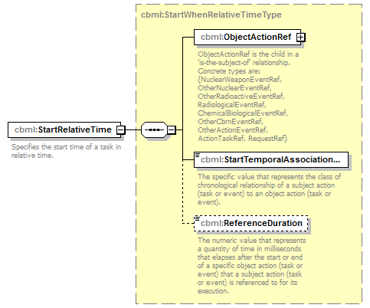
namespace | http://www.sisostds.org/schemas/c-bml/1.0
type | cbml:StartWhenRelativeTimeType
properties
  content | complex
children | cbml:ObjectActionRef cbml:StartTemporalAssociationCategoryCode cbml:ReferenceDuration
annotation
  documentation
  Specifies the start time of a task in relative time.
source | <xs:element name="StartRelativeTime" type="cbml:StartWhenRelativeTimeType">  <xs:annotation>  <xs:documentation xml:lang="en">Specifies the start time of a task in relative time.</xs:documentation>  </xs:annotation>  </xs:element>

complexType TaskType
diagram | 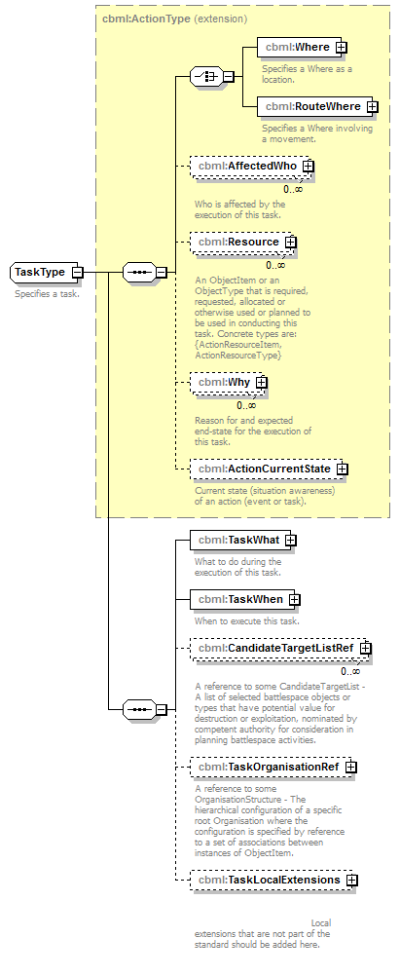
namespace | http://www.sisostds.org/schemas/c-bml/1.0
type | extension of cbml:ActionType
properties
  base | cbml:ActionType
  abstract | true
children | cbml:Where cbml:RouteWhere cbml:AffectedWho cbml:Resource cbml:Why cbml:ActionCurrentState cbml:TaskWhat cbml:TaskWhen cbml:CandidateTargetListRef cbml:TaskOrganisationRef cbml:TaskLocalExtensions
used by
  complexTypes | OrderTaskType RequestTaskType
annotation
  documentation
  Specifies a task.
source | <xs:complexType name="TaskType" abstract="true">  <xs:annotation>  <xs:documentation xml:lang="en">Specifies a task.</xs:documentation>  </xs:annotation>  <xs:complexContent>  <xs:extension base="cbml:ActionType">  <xs:sequence>  <xs:element name="TaskWhat" type="cbml:TaskWhatType">  <xs:annotation>  <xs:documentation xml:lang="en">What to do during the execution of this task.</xs:documentation>  </xs:annotation>  </xs:element>  <xs:element name="TaskWhen" type="cbml:TaskWhenType">  <xs:annotation>  <xs:documentation xml:lang="en">When to execute this task.</xs:documentation>  </xs:annotation>  </xs:element>  <xs:element name="CandidateTargetListRef" type="cbml:CandidateTargetListRef" minOccurs="0" maxOccurs="unbounded">  <xs:annotation>  <xs:documentation xml:lang="en">A reference to some CandidateTargetList - A list of selected battlespace objects or types that have potential value for destruction or exploitation, nominated by competent authority for consideration in planning battlespace activities.</xs:documentation>  </xs:annotation>  </xs:element>  <xs:element name="TaskOrganisationRef" type="cbml:OrganisationStructureRef" minOccurs="0">  <xs:annotation>  <xs:documentation xml:lang="en">A reference to some OrganisationStructure - The hierarchical configuration of a specific root Organisation where the configuration is specified by reference to a set of associations between instances of ObjectItem.</xs:documentation>  </xs:annotation>  </xs:element>  <xs:element name="TaskLocalExtensions" type="cbml:TaskLocalExtensionsType" minOccurs="0">  <xs:annotation>  <xs:documentation xml:lang="en">  Local extensions that are not part of the standard should be added here.  </xs:documentation>  </xs:annotation>  </xs:element>  </xs:sequence>  </xs:extension>  </xs:complexContent>  </xs:complexType>

element TaskType/TaskWhat
diagram | 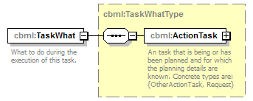
namespace | http://www.sisostds.org/schemas/c-bml/1.0
type | cbml:TaskWhatType
properties
  content | complex
children | cbml:ActionTask
annotation
  documentation
  What to do during the execution of this task.
source | <xs:element name="TaskWhat" type="cbml:TaskWhatType">  <xs:annotation>  <xs:documentation xml:lang="en">What to do during the execution of this task.</xs:documentation>  </xs:annotation>  </xs:element>

element TaskType/TaskWhen
diagram | 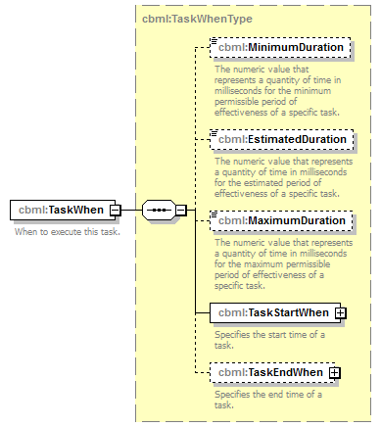
namespace | http://www.sisostds.org/schemas/c-bml/1.0
type | cbml:TaskWhenType
properties
  content | complex
children | cbml:MinimumDuration cbml:EstimatedDuration cbml:MaximumDuration cbml:TaskStartWhen cbml:TaskEndWhen
annotation
  documentation
  When to execute this task.
source | <xs:element name="TaskWhen" type="cbml:TaskWhenType">  <xs:annotation>  <xs:documentation xml:lang="en">When to execute this task.</xs:documentation>  </xs:annotation>  </xs:element>

element TaskType/CandidateTargetListRef
diagram | 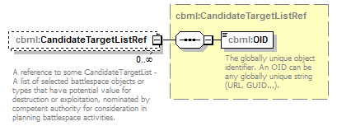
namespace | http://www.sisostds.org/schemas/c-bml/1.0
type | cbml:CandidateTargetListRef
properties
  minOcc | 0
  maxOcc | unbounded
  content | complex
children | cbml:OID
annotation
  documentation
  A reference to some CandidateTargetList - A list of selected battlespace objects or types that have potential value for destruction or exploitation, nominated by competent authority for consideration in planning battlespace activities.
source | <xs:element name="CandidateTargetListRef" type="cbml:CandidateTargetListRef" minOccurs="0" maxOccurs="unbounded">  <xs:annotation>  <xs:documentation xml:lang="en">A reference to some CandidateTargetList - A list of selected battlespace objects or types that have potential value for destruction or exploitation, nominated by competent authority for consideration in planning battlespace activities.</xs:documentation>  </xs:annotation>  </xs:element>

element TaskType/TaskOrganisationRef
diagram | 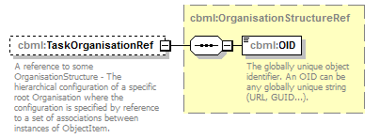
namespace | http://www.sisostds.org/schemas/c-bml/1.0
type | cbml:OrganisationStructureRef
properties
  minOcc | 0
  maxOcc | 1
  content | complex
children | cbml:OID
annotation
  documentation
  A reference to some OrganisationStructure - The hierarchical configuration of a specific root Organisation where the configuration is specified by reference to a set of associations between instances of ObjectItem.
source | <xs:element name="TaskOrganisationRef" type="cbml:OrganisationStructureRef" minOccurs="0">  <xs:annotation>  <xs:documentation xml:lang="en">A reference to some OrganisationStructure - The hierarchical configuration of a specific root Organisation where the configuration is specified by reference to a set of associations between instances of ObjectItem.</xs:documentation>  </xs:annotation>  </xs:element>

element TaskType/TaskLocalExtensions
diagram | 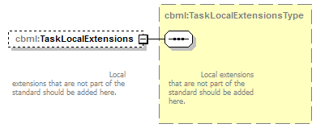
namespace | http://www.sisostds.org/schemas/c-bml/1.0
type | cbml:TaskLocalExtensionsType
properties
  minOcc | 0
  maxOcc | 1
  content | complex
annotation
  documentation
  Local extensions that are not part of the standard should be added here.
source | <xs:element name="TaskLocalExtensions" type="cbml:TaskLocalExtensionsType" minOccurs="0">  <xs:annotation>  <xs:documentation xml:lang="en">  Local extensions that are not part of the standard should be added here.  </xs:documentation>  </xs:annotation>  </xs:element>

complexType TaskWhatRefType
diagram | 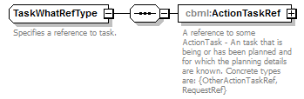
namespace | http://www.sisostds.org/schemas/c-bml/1.0
children | cbml:ActionTaskRef
used by
  elements | TaskWhatStatusType/TaskWhatRef TaskWhatRef
annotation
  documentation
  Specifies a reference to task.
source | <xs:complexType name="TaskWhatRefType">  <xs:annotation>  <xs:documentation xml:lang="en">Specifies a reference to task.</xs:documentation>  </xs:annotation>  <xs:sequence>  <xs:element name="ActionTaskRef" type="cbml:AbstractActionTaskRef">  <xs:annotation>  <xs:documentation xml:lang="en">A reference to some ActionTask - An task that is being or has been planned and for which the planning details are known. Concrete types are: {OtherActionTaskRef, RequestRef}</xs:documentation>  </xs:annotation>  </xs:element>  </xs:sequence>  </xs:complexType>

element TaskWhatRefType/ActionTaskRef
diagram | 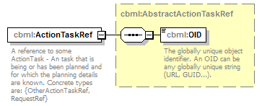
namespace | http://www.sisostds.org/schemas/c-bml/1.0
type | cbml:AbstractActionTaskRef
properties
  content | complex
children | cbml:OID
annotation
  documentation
  A reference to some ActionTask - An task that is being or has been planned and for which the planning details are known. Concrete types are: {OtherActionTaskRef, RequestRef}
source | <xs:element name="ActionTaskRef" type="cbml:AbstractActionTaskRef">  <xs:annotation>  <xs:documentation xml:lang="en">A reference to some ActionTask - An task that is being or has been planned and for which the planning details are known. Concrete types are: {OtherActionTaskRef, RequestRef}</xs:documentation>  </xs:annotation>  </xs:element>

complexType TaskWhatStatusRefType
diagram | 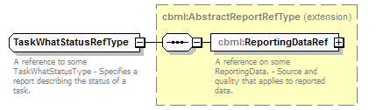
namespace | http://www.sisostds.org/schemas/c-bml/1.0
type | extension of cbml:AbstractReportRefType
properties
  base | cbml:AbstractReportRefType
children | cbml:ReportingDataRef
annotation
  documentation
  A reference to some TaskWhatStatusType - Specifies a report describing the status of a task.
source | <xs:complexType name="TaskWhatStatusRefType">  <xs:annotation>  <xs:documentation xml:lang="en">A reference to some TaskWhatStatusType - Specifies a report describing the status of a task.</xs:documentation>  </xs:annotation>  <xs:complexContent>  <xs:extension base="cbml:AbstractReportRefType"/>  </xs:complexContent>  </xs:complexType>

complexType TaskWhatStatusType
diagram | 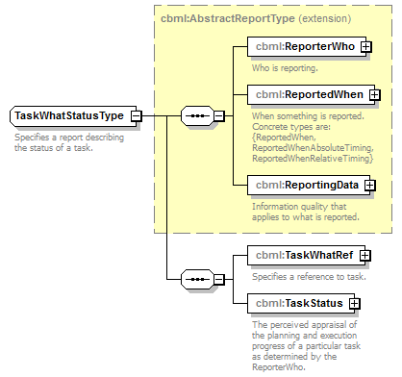
namespace | http://www.sisostds.org/schemas/c-bml/1.0
type | extension of cbml:AbstractReportType
properties
  base | cbml:AbstractReportType
children | cbml:ReporterWho cbml:ReportedWhen cbml:ReportingData cbml:TaskWhatRef cbml:TaskStatus
annotation
  documentation
  Specifies a report describing the status of a task.
source | <xs:complexType name="TaskWhatStatusType">  <xs:annotation>  <xs:documentation xml:lang="en">Specifies a report describing the status of a task.</xs:documentation>  </xs:annotation>  <xs:complexContent>  <xs:extension base="cbml:AbstractReportType">  <xs:sequence>  <xs:element name="TaskWhatRef" type="cbml:TaskWhatRefType">  <xs:annotation>  <xs:documentation xml:lang="en">Specifies a reference to task.</xs:documentation>  </xs:annotation>  </xs:element>  <xs:element name="TaskStatus" type="cbml:ActionTaskStatus">  <xs:annotation>  <xs:documentation xml:lang="en">The perceived appraisal of the planning and execution progress of a particular task as determined by the ReporterWho.</xs:documentation>  </xs:annotation>  </xs:element>  </xs:sequence>  </xs:extension>  </xs:complexContent>  </xs:complexType>

element TaskWhatStatusType/TaskWhatRef
diagram | 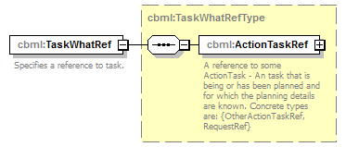
namespace | http://www.sisostds.org/schemas/c-bml/1.0
type | cbml:TaskWhatRefType
properties
  content | complex
children | cbml:ActionTaskRef
annotation
  documentation
  Specifies a reference to task.
source | <xs:element name="TaskWhatRef" type="cbml:TaskWhatRefType">  <xs:annotation>  <xs:documentation xml:lang="en">Specifies a reference to task.</xs:documentation>  </xs:annotation>  </xs:element>

element TaskWhatStatusType/TaskStatus
diagram | 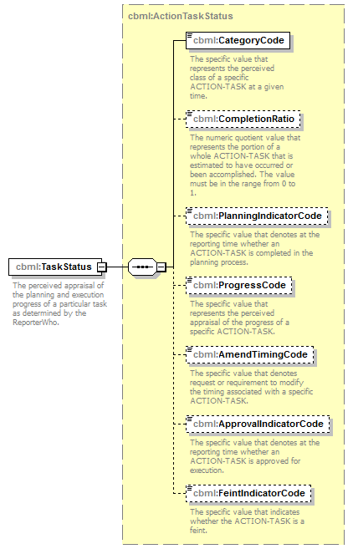
namespace | http://www.sisostds.org/schemas/c-bml/1.0
type | cbml:ActionTaskStatus
properties
  content | complex
children | cbml:CategoryCode cbml:CompletionRatio cbml:PlanningIndicatorCode cbml:ProgressCode cbml:AmendTimingCode cbml:ApprovalIndicatorCode cbml:FeintIndicatorCode
annotation
  documentation
  The perceived appraisal of the planning and execution progress of a particular task as determined by the ReporterWho.
source | <xs:element name="TaskStatus" type="cbml:ActionTaskStatus">  <xs:annotation>  <xs:documentation xml:lang="en">The perceived appraisal of the planning and execution progress of a particular task as determined by the ReporterWho.</xs:documentation>  </xs:annotation>  </xs:element>

complexType TaskWhatType
diagram | 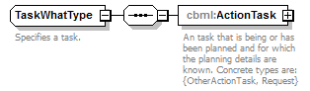
namespace | http://www.sisostds.org/schemas/c-bml/1.0
children | cbml:ActionTask
used by
  elements | TaskType/TaskWhat TaskWhat
annotation
  documentation
  Specifies a task.
source | <xs:complexType name="TaskWhatType">  <xs:annotation>  <xs:documentation xml:lang="en">Specifies a task.</xs:documentation>  </xs:annotation>  <xs:sequence>  <xs:element name="ActionTask" type="cbml:AbstractActionTask">  <xs:annotation>  <xs:documentation xml:lang="en">An task that is being or has been planned and for which the planning details are known. Concrete types are: {OtherActionTask, Request}</xs:documentation>  </xs:annotation>  </xs:element>  </xs:sequence>  </xs:complexType>

element TaskWhatType/ActionTask
diagram | 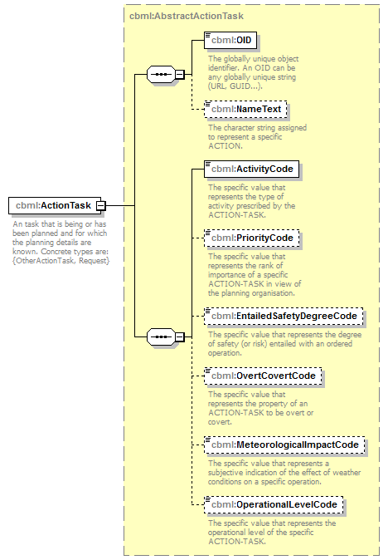
namespace | http://www.sisostds.org/schemas/c-bml/1.0
type | cbml:AbstractActionTask
properties
  content | complex
children | cbml:OID cbml:NameText cbml:ActivityCode cbml:PriorityCode cbml:EntailedSafetyDegreeCode cbml:OvertCovertCode cbml:MeteorologicalImpactCode cbml:OperationalLevelCode
annotation
  documentation
  An task that is being or has been planned and for which the planning details are known. Concrete types are: {OtherActionTask, Request}
source | <xs:element name="ActionTask" type="cbml:AbstractActionTask">  <xs:annotation>  <xs:documentation xml:lang="en">An task that is being or has been planned and for which the planning details are known. Concrete types are: {OtherActionTask, Request}</xs:documentation>  </xs:annotation>  </xs:element>

complexType TaskWhenType
diagram | 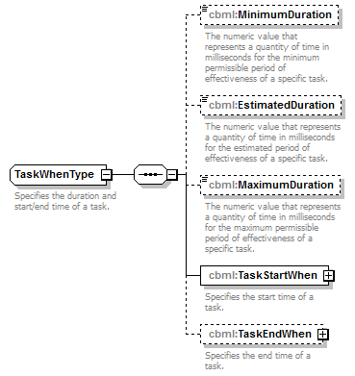
namespace | http://www.sisostds.org/schemas/c-bml/1.0
children | cbml:MinimumDuration cbml:EstimatedDuration cbml:MaximumDuration cbml:TaskStartWhen cbml:TaskEndWhen
used by
  elements | TaskType/TaskWhen TaskWhen
annotation
  documentation
  Specifies the duration and start/end time of a task.
source | <xs:complexType name="TaskWhenType">  <xs:annotation>  <xs:documentation xml:lang="en">Specifies the duration and start/end time of a task.</xs:documentation>  </xs:annotation>  <xs:sequence>  <xs:element name="MinimumDuration" type="jc3iedm:DurationType19" minOccurs="0">  <xs:annotation>  <xs:documentation xml:lang="en">The numeric value that represents a quantity of time in milliseconds for the minimum permissible period of effectiveness of a specific task.</xs:documentation>  </xs:annotation>  </xs:element>  <xs:element name="EstimatedDuration" type="jc3iedm:DurationType19" minOccurs="0">  <xs:annotation>  <xs:documentation xml:lang="en">The numeric value that represents a quantity of time in milliseconds for the estimated period of effectiveness of a specific task.</xs:documentation>  </xs:annotation>  </xs:element>  <xs:element name="MaximumDuration" type="jc3iedm:DurationType19" minOccurs="0">  <xs:annotation>  <xs:documentation xml:lang="en">The numeric value that represents a quantity of time in milliseconds for the maximum permissible period of effectiveness of a specific task.</xs:documentation>  </xs:annotation>  </xs:element>  <xs:element name="TaskStartWhen" type="cbml:TaskStartWhenType">  <xs:annotation>  <xs:documentation xml:lang="en">Specifies the start time of a task.</xs:documentation>  </xs:annotation>  </xs:element>  <xs:element name="TaskEndWhen" type="cbml:TaskEndWhenType" minOccurs="0">  <xs:annotation>  <xs:documentation xml:lang="en">Specifies the end time of a task.</xs:documentation>  </xs:annotation>  </xs:element>  </xs:sequence>  </xs:complexType>

element TaskWhenType/MinimumDuration
diagram | 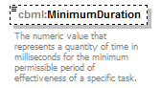
namespace | http://www.sisostds.org/schemas/c-bml/1.0
type | jc3iedm:DurationType19
properties
  minOcc | 0
  maxOcc | 1
  content | simple
facets
  Kind | Value | Annotation
  minInclusive | -9999999999999999999
  maxInclusive | 9999999999999999999
annotation
  documentation
  The numeric value that represents a quantity of time in milliseconds for the minimum permissible period of effectiveness of a specific task.
source | <xs:element name="MinimumDuration" type="jc3iedm:DurationType19" minOccurs="0">  <xs:annotation>  <xs:documentation xml:lang="en">The numeric value that represents a quantity of time in milliseconds for the minimum permissible period of effectiveness of a specific task.</xs:documentation>  </xs:annotation>  </xs:element>

element TaskWhenType/EstimatedDuration
diagram | 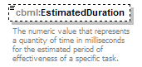
namespace | http://www.sisostds.org/schemas/c-bml/1.0
type | jc3iedm:DurationType19
properties
  minOcc | 0
  maxOcc | 1
  content | simple
facets
  Kind | Value | Annotation
  minInclusive | -9999999999999999999
  maxInclusive | 9999999999999999999
annotation
  documentation
  The numeric value that represents a quantity of time in milliseconds for the estimated period of effectiveness of a specific task.
source | <xs:element name="EstimatedDuration" type="jc3iedm:DurationType19" minOccurs="0">  <xs:annotation>  <xs:documentation xml:lang="en">The numeric value that represents a quantity of time in milliseconds for the estimated period of effectiveness of a specific task.</xs:documentation>  </xs:annotation>  </xs:element>

element TaskWhenType/MaximumDuration
diagram | 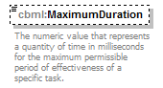
namespace | http://www.sisostds.org/schemas/c-bml/1.0
type | jc3iedm:DurationType19
properties
  minOcc | 0
  maxOcc | 1
  content | simple
facets
  Kind | Value | Annotation
  minInclusive | -9999999999999999999
  maxInclusive | 9999999999999999999
annotation
  documentation
  The numeric value that represents a quantity of time in milliseconds for the maximum permissible period of effectiveness of a specific task.
source | <xs:element name="MaximumDuration" type="jc3iedm:DurationType19" minOccurs="0">  <xs:annotation>  <xs:documentation xml:lang="en">The numeric value that represents a quantity of time in milliseconds for the maximum permissible period of effectiveness of a specific task.</xs:documentation>  </xs:annotation>  </xs:element>

element TaskWhenType/TaskStartWhen
diagram | 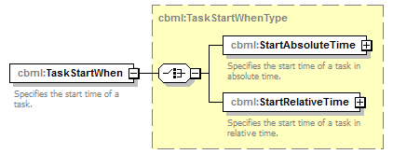
namespace | http://www.sisostds.org/schemas/c-bml/1.0
type | cbml:TaskStartWhenType
properties
  content | complex
children | cbml:StartAbsoluteTime cbml:StartRelativeTime
annotation
  documentation
  Specifies the start time of a task.
source | <xs:element name="TaskStartWhen" type="cbml:TaskStartWhenType">  <xs:annotation>  <xs:documentation xml:lang="en">Specifies the start time of a task.</xs:documentation>  </xs:annotation>  </xs:element>

element TaskWhenType/TaskEndWhen
diagram | 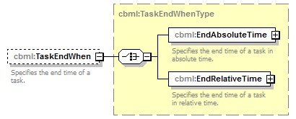
namespace | http://www.sisostds.org/schemas/c-bml/1.0
type | cbml:TaskEndWhenType
properties
  minOcc | 0
  maxOcc | 1
  content | complex
children | cbml:EndAbsoluteTime cbml:EndRelativeTime
annotation
  documentation
  Specifies the end time of a task.
source | <xs:element name="TaskEndWhen" type="cbml:TaskEndWhenType" minOccurs="0">  <xs:annotation>  <xs:documentation xml:lang="en">Specifies the end time of a task.</xs:documentation>  </xs:annotation>  </xs:element>

complexType WhatEffectRefType
diagram | 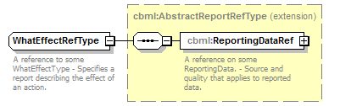
namespace | http://www.sisostds.org/schemas/c-bml/1.0
type | extension of cbml:AbstractReportRefType
properties
  base | cbml:AbstractReportRefType
children | cbml:ReportingDataRef
annotation
  documentation
  A reference to some WhatEffectType - Specifies a report describing the effect of an action.
source | <xs:complexType name="WhatEffectRefType">  <xs:annotation>  <xs:documentation xml:lang="en">A reference to some WhatEffectType - Specifies a report describing the effect of an action.</xs:documentation>  </xs:annotation>  <xs:complexContent>  <xs:extension base="cbml:AbstractReportRefType"/>  </xs:complexContent>  </xs:complexType>

complexType WhatEffectType
diagram | 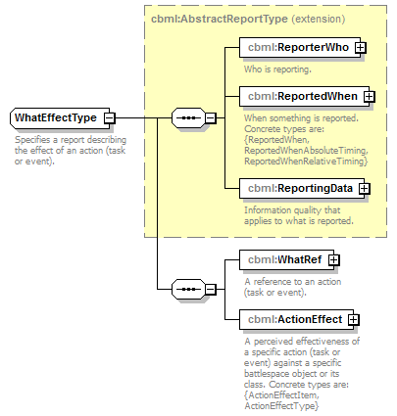
namespace | http://www.sisostds.org/schemas/c-bml/1.0
type | extension of cbml:AbstractReportType
properties
  base | cbml:AbstractReportType
children | cbml:ReporterWho cbml:ReportedWhen cbml:ReportingData cbml:WhatRef cbml:ActionEffect
annotation
  documentation
  Specifies a report describing the effect of an action (task or event).
source | <xs:complexType name="WhatEffectType">  <xs:annotation>  <xs:documentation xml:lang="en">Specifies a report describing the effect of an action (task or event).</xs:documentation>  </xs:annotation>  <xs:complexContent>  <xs:extension base="cbml:AbstractReportType">  <xs:sequence>  <xs:element name="WhatRef" type="cbml:WhatRefType">  <xs:annotation>  <xs:documentation xml:lang="en">A reference to an action (task or event).</xs:documentation>  </xs:annotation>  </xs:element>  <xs:element name="ActionEffect" type="cbml:AbstractActionEffect">  <xs:annotation>  <xs:documentation xml:lang="en">A perceived effectiveness of a specific action (task or event) against a specific battlespace object or its class. Concrete types are: {ActionEffectItem, ActionEffectType}</xs:documentation>  </xs:annotation>  </xs:element>  </xs:sequence>  </xs:extension>  </xs:complexContent>  </xs:complexType>

element WhatEffectType/WhatRef
diagram | 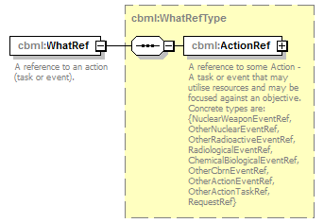
namespace | http://www.sisostds.org/schemas/c-bml/1.0
type | cbml:WhatRefType
properties
  content | complex
children | cbml:ActionRef
annotation
  documentation
  A reference to an action (task or event).
source | <xs:element name="WhatRef" type="cbml:WhatRefType">  <xs:annotation>  <xs:documentation xml:lang="en">A reference to an action (task or event).</xs:documentation>  </xs:annotation>  </xs:element>

element WhatEffectType/ActionEffect
diagram | 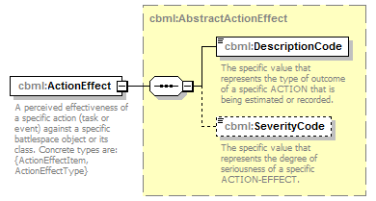
namespace | http://www.sisostds.org/schemas/c-bml/1.0
type | cbml:AbstractActionEffect
properties
  content | complex
children | cbml:DescriptionCode cbml:SeverityCode
annotation
  documentation
  A perceived effectiveness of a specific action (task or event) against a specific battlespace object or its class. Concrete types are: {ActionEffectItem, ActionEffectType}
source | <xs:element name="ActionEffect" type="cbml:AbstractActionEffect">  <xs:annotation>  <xs:documentation xml:lang="en">A perceived effectiveness of a specific action (task or event) against a specific battlespace object or its class. Concrete types are: {ActionEffectItem, ActionEffectType}</xs:documentation>  </xs:annotation>  </xs:element>

complexType WhatRefType
diagram | 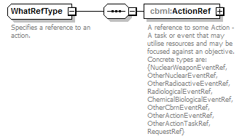
namespace | http://www.sisostds.org/schemas/c-bml/1.0
children | cbml:ActionRef
used by
  elements | WhatEffectType/WhatRef WhatRef
annotation
  documentation
  Specifies a reference to an action.
source | <xs:complexType name="WhatRefType">  <xs:annotation>  <xs:documentation xml:lang="en">Specifies a reference to an action.</xs:documentation>  </xs:annotation>  <xs:sequence>  <xs:element name="ActionRef" type="cbml:AbstractActionRef">  <xs:annotation>  <xs:documentation xml:lang="en">A reference to some Action - A task or event that may utilise resources and may be focused against an objective. Concrete types are: {NuclearWeaponEventRef, OtherNuclearEventRef, OtherRadioactiveEventRef, RadiologicalEventRef, ChemicalBiologicalEventRef, OtherCbrnEventRef, OtherActionEventRef, OtherActionTaskRef, RequestRef}</xs:documentation>  </xs:annotation>  </xs:element>  </xs:sequence>  </xs:complexType>

element WhatRefType/ActionRef
diagram | 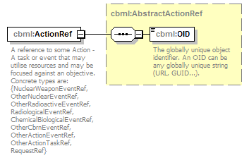
namespace | http://www.sisostds.org/schemas/c-bml/1.0
type | cbml:AbstractActionRef
properties
  content | complex
children | cbml:OID
annotation
  documentation
  A reference to some Action - A task or event that may utilise resources and may be focused against an objective. Concrete types are: {NuclearWeaponEventRef, OtherNuclearEventRef, OtherRadioactiveEventRef, RadiologicalEventRef, ChemicalBiologicalEventRef, OtherCbrnEventRef, OtherActionEventRef, OtherActionTaskRef, RequestRef}
source | <xs:element name="ActionRef" type="cbml:AbstractActionRef">  <xs:annotation>  <xs:documentation xml:lang="en">A reference to some Action - A task or event that may utilise resources and may be focused against an objective. Concrete types are: {NuclearWeaponEventRef, OtherNuclearEventRef, OtherRadioactiveEventRef, RadiologicalEventRef, ChemicalBiologicalEventRef, OtherCbrnEventRef, OtherActionEventRef, OtherActionTaskRef, RequestRef}</xs:documentation>  </xs:annotation>  </xs:element>

complexType WhatType
diagram | 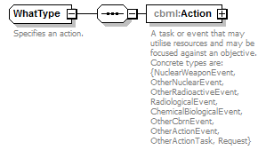
namespace | http://www.sisostds.org/schemas/c-bml/1.0
children | cbml:Action
used by
  element | What
annotation
  documentation
  Specifies an action.
source | <xs:complexType name="WhatType">  <xs:annotation>  <xs:documentation xml:lang="en">Specifies an action.</xs:documentation>  </xs:annotation>  <xs:sequence>  <xs:element name="Action" type="cbml:AbstractAction">  <xs:annotation>  <xs:documentation xml:lang="en">A task or event that may utilise resources and may be focused against an objective. Concrete types are: {NuclearWeaponEvent, OtherNuclearEvent, OtherRadioactiveEvent, RadiologicalEvent, ChemicalBiologicalEvent, OtherCbrnEvent, OtherActionEvent, OtherActionTask, Request}</xs:documentation>  </xs:annotation>  </xs:element>  </xs:sequence>  </xs:complexType>

element WhatType/Action
diagram | 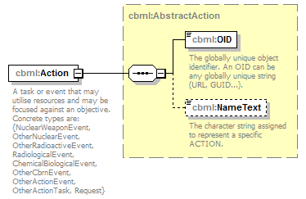
namespace | http://www.sisostds.org/schemas/c-bml/1.0
type | cbml:AbstractAction
properties
  content | complex
children | cbml:OID cbml:NameText
annotation
  documentation
  A task or event that may utilise resources and may be focused against an objective. Concrete types are: {NuclearWeaponEvent, OtherNuclearEvent, OtherRadioactiveEvent, RadiologicalEvent, ChemicalBiologicalEvent, OtherCbrnEvent, OtherActionEvent, OtherActionTask, Request}
source | <xs:element name="Action" type="cbml:AbstractAction">  <xs:annotation>  <xs:documentation xml:lang="en">A task or event that may utilise resources and may be focused against an objective. Concrete types are: {NuclearWeaponEvent, OtherNuclearEvent, OtherRadioactiveEvent, RadiologicalEvent, ChemicalBiologicalEvent, OtherCbrnEvent, OtherActionEvent, OtherActionTask, Request}</xs:documentation>  </xs:annotation>  </xs:element>

complexType WhereType
diagram | 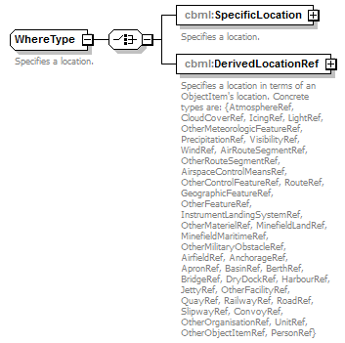
namespace | http://www.sisostds.org/schemas/c-bml/1.0
children | cbml:SpecificLocation cbml:DerivedLocationRef
used by
  elements | RouteWhereType/EndWhere RouteWhereType/StartWhere RouteWhereType/Via ActionType/Where Where
annotation
  documentation
  Specifies a location.
source | <xs:complexType name="WhereType">  <xs:annotation>  <xs:documentation xml:lang="en">Specifies a location.</xs:documentation>  </xs:annotation>  <xs:choice>  <xs:element name="SpecificLocation" type="cbml:SpecificLocationType">  <xs:annotation>  <xs:documentation xml:lang="en">Specifies a location.</xs:documentation>  </xs:annotation>  </xs:element>  <xs:element name="DerivedLocationRef" type="cbml:AbstractObjectItemRef">  <xs:annotation>  <xs:documentation xml:lang="en">Specifies a location in terms of an ObjectItem's location. Concrete types are: {AtmosphereRef, CloudCoverRef, IcingRef, LightRef, OtherMeteorologicFeatureRef, PrecipitationRef, VisibilityRef, WindRef, AirRouteSegmentRef, OtherRouteSegmentRef, AirspaceControlMeansRef, OtherControlFeatureRef, RouteRef, GeographicFeatureRef, OtherFeatureRef, InstrumentLandingSystemRef, OtherMaterielRef, MinefieldLandRef, MinefieldMaritimeRef, OtherMilitaryObstacleRef, AirfieldRef, AnchorageRef, ApronRef, BasinRef, BerthRef, BridgeRef, DryDockRef, HarbourRef, JettyRef, OtherFacilityRef, QuayRef, RailwayRef, RoadRef, SlipwayRef, ConvoyRef, OtherOrganisationRef, UnitRef, OtherObjectItemRef, PersonRef}</xs:documentation>  </xs:annotation>  </xs:element>  </xs:choice>  </xs:complexType>

element WhereType/SpecificLocation
diagram | 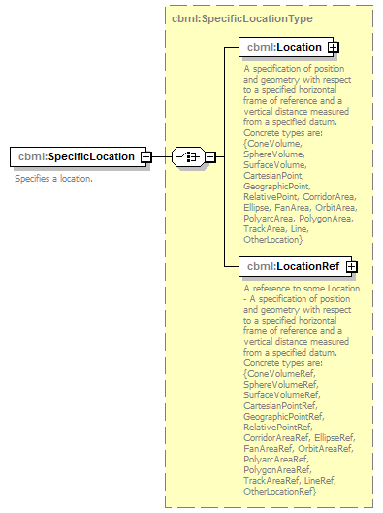
namespace | http://www.sisostds.org/schemas/c-bml/1.0
type | cbml:SpecificLocationType
properties
  content | complex
children | cbml:Location cbml:LocationRef
annotation
  documentation
  Specifies a location.
source | <xs:element name="SpecificLocation" type="cbml:SpecificLocationType">  <xs:annotation>  <xs:documentation xml:lang="en">Specifies a location.</xs:documentation>  </xs:annotation>  </xs:element>

element WhereType/DerivedLocationRef
diagram | 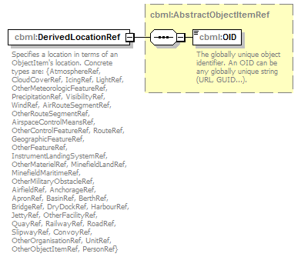
namespace | http://www.sisostds.org/schemas/c-bml/1.0
type | cbml:AbstractObjectItemRef
properties
  content | complex
children | cbml:OID
annotation
  documentation
  Specifies a location in terms of an ObjectItem's location. Concrete types are: {AtmosphereRef, CloudCoverRef, IcingRef, LightRef, OtherMeteorologicFeatureRef, PrecipitationRef, VisibilityRef, WindRef, AirRouteSegmentRef, OtherRouteSegmentRef, AirspaceControlMeansRef, OtherControlFeatureRef, RouteRef, GeographicFeatureRef, OtherFeatureRef, InstrumentLandingSystemRef, OtherMaterielRef, MinefieldLandRef, MinefieldMaritimeRef, OtherMilitaryObstacleRef, AirfieldRef, AnchorageRef, ApronRef, BasinRef, BerthRef, BridgeRef, DryDockRef, HarbourRef, JettyRef, OtherFacilityRef, QuayRef, RailwayRef, RoadRef, SlipwayRef, ConvoyRef, OtherOrganisationRef, UnitRef, OtherObjectItemRef, PersonRef}
source | <xs:element name="DerivedLocationRef" type="cbml:AbstractObjectItemRef">  <xs:annotation>  <xs:documentation xml:lang="en">Specifies a location in terms of an ObjectItem's location. Concrete types are: {AtmosphereRef, CloudCoverRef, IcingRef, LightRef, OtherMeteorologicFeatureRef, PrecipitationRef, VisibilityRef, WindRef, AirRouteSegmentRef, OtherRouteSegmentRef, AirspaceControlMeansRef, OtherControlFeatureRef, RouteRef, GeographicFeatureRef, OtherFeatureRef, InstrumentLandingSystemRef, OtherMaterielRef, MinefieldLandRef, MinefieldMaritimeRef, OtherMilitaryObstacleRef, AirfieldRef, AnchorageRef, ApronRef, BasinRef, BerthRef, BridgeRef, DryDockRef, HarbourRef, JettyRef, OtherFacilityRef, QuayRef, RailwayRef, RoadRef, SlipwayRef, ConvoyRef, OtherOrganisationRef, UnitRef, OtherObjectItemRef, PersonRef}</xs:documentation>  </xs:annotation>  </xs:element>

complexType WhoAffiliationRefType
diagram | 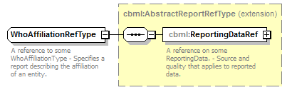
namespace | http://www.sisostds.org/schemas/c-bml/1.0
type | extension of cbml:AbstractReportRefType
properties
  base | cbml:AbstractReportRefType
children | cbml:ReportingDataRef
annotation
  documentation
  A reference to some WhoAffiliationType - Specifies a report describing the affiliation of an entity.
source | <xs:complexType name="WhoAffiliationRefType">  <xs:annotation>  <xs:documentation xml:lang="en">A reference to some WhoAffiliationType - Specifies a report describing the affiliation of an entity.</xs:documentation>  </xs:annotation>  <xs:complexContent>  <xs:extension base="cbml:AbstractReportRefType"/>  </xs:complexContent>  </xs:complexType>

complexType WhoAffiliationType
diagram | 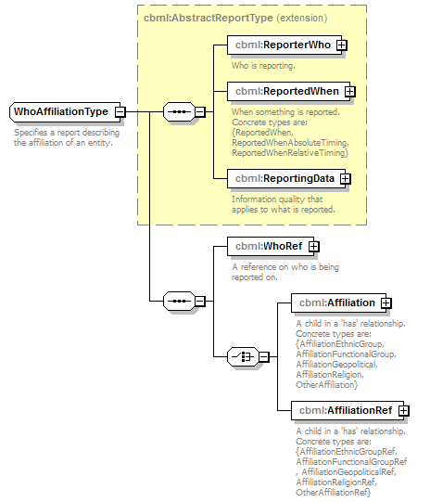
namespace | http://www.sisostds.org/schemas/c-bml/1.0
type | extension of cbml:AbstractReportType
properties
  base | cbml:AbstractReportType
children | cbml:ReporterWho cbml:ReportedWhen cbml:ReportingData cbml:WhoRef cbml:Affiliation cbml:AffiliationRef
annotation
  documentation
  Specifies a report describing the affiliation of an entity.
source | <xs:complexType name="WhoAffiliationType">  <xs:annotation>  <xs:documentation xml:lang="en">Specifies a report describing the affiliation of an entity.</xs:documentation>  </xs:annotation>  <xs:complexContent>  <xs:extension base="cbml:AbstractReportType">  <xs:sequence>  <xs:element name="WhoRef" type="cbml:WhoRefType">  <xs:annotation>  <xs:documentation xml:lang="en">A reference on who is being reported on.</xs:documentation>  </xs:annotation>  </xs:element>  <xs:choice>  <xs:element name="Affiliation" type="cbml:AbstractAffiliation">  <xs:annotation>  <xs:documentation xml:lang="en">A child in a 'has' relationship. Concrete types are: {AffiliationEthnicGroup, AffiliationFunctionalGroup, AffiliationGeopolitical, AffiliationReligion, OtherAffiliation}</xs:documentation>  </xs:annotation>  </xs:element>  <xs:element name="AffiliationRef" type="cbml:AbstractAffiliationRef">  <xs:annotation>  <xs:documentation xml:lang="en">A child in a 'has' relationship. Concrete types are: {AffiliationEthnicGroupRef, AffiliationFunctionalGroupRef, AffiliationGeopoliticalRef, AffiliationReligionRef, OtherAffiliationRef}</xs:documentation>  </xs:annotation>  </xs:element>  </xs:choice>  </xs:sequence>  </xs:extension>  </xs:complexContent>  </xs:complexType>

element WhoAffiliationType/WhoRef
diagram | 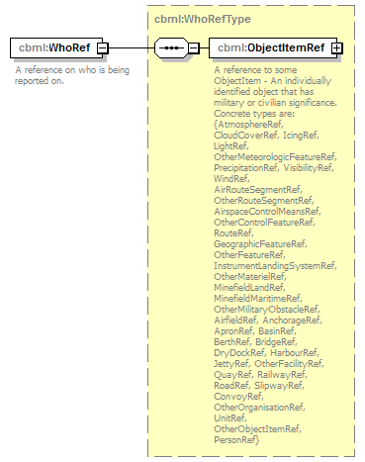
namespace | http://www.sisostds.org/schemas/c-bml/1.0
type | cbml:WhoRefType
properties
  content | complex
children | cbml:ObjectItemRef
annotation
  documentation
  A reference on who is being reported on.
source | <xs:element name="WhoRef" type="cbml:WhoRefType">  <xs:annotation>  <xs:documentation xml:lang="en">A reference on who is being reported on.</xs:documentation>  </xs:annotation>  </xs:element>

element WhoAffiliationType/Affiliation
diagram | 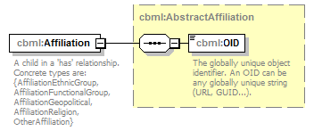
namespace | http://www.sisostds.org/schemas/c-bml/1.0
type | cbml:AbstractAffiliation
properties
  content | complex
children | cbml:OID
annotation
  documentation
  A child in a 'has' relationship. Concrete types are: {AffiliationEthnicGroup, AffiliationFunctionalGroup, AffiliationGeopolitical, AffiliationReligion, OtherAffiliation}
source | <xs:element name="Affiliation" type="cbml:AbstractAffiliation">  <xs:annotation>  <xs:documentation xml:lang="en">A child in a 'has' relationship. Concrete types are: {AffiliationEthnicGroup, AffiliationFunctionalGroup, AffiliationGeopolitical, AffiliationReligion, OtherAffiliation}</xs:documentation>  </xs:annotation>  </xs:element>

element WhoAffiliationType/AffiliationRef
diagram | 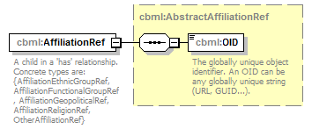
namespace | http://www.sisostds.org/schemas/c-bml/1.0
type | cbml:AbstractAffiliationRef
properties
  content | complex
children | cbml:OID
annotation
  documentation
  A child in a 'has' relationship. Concrete types are: {AffiliationEthnicGroupRef, AffiliationFunctionalGroupRef, AffiliationGeopoliticalRef, AffiliationReligionRef, OtherAffiliationRef}
source | <xs:element name="AffiliationRef" type="cbml:AbstractAffiliationRef">  <xs:annotation>  <xs:documentation xml:lang="en">A child in a 'has' relationship. Concrete types are: {AffiliationEthnicGroupRef, AffiliationFunctionalGroupRef, AffiliationGeopoliticalRef, AffiliationReligionRef, OtherAffiliationRef}</xs:documentation>  </xs:annotation>  </xs:element>

complexType WhoAssociationRefType
diagram | 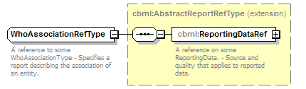
namespace | http://www.sisostds.org/schemas/c-bml/1.0
type | extension of cbml:AbstractReportRefType
properties
  base | cbml:AbstractReportRefType
children | cbml:ReportingDataRef
annotation
  documentation
  A reference to some WhoAssociationType - Specifies a report describing the association of an entity.
source | <xs:complexType name="WhoAssociationRefType">  <xs:annotation>  <xs:documentation xml:lang="en">A reference to some WhoAssociationType - Specifies a report describing the association of an entity.</xs:documentation>  </xs:annotation>  <xs:complexContent>  <xs:extension base="cbml:AbstractReportRefType"/>  </xs:complexContent>  </xs:complexType>

complexType WhoAssociationType
diagram | 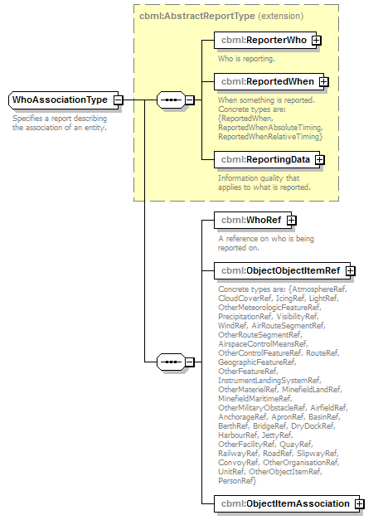
namespace | http://www.sisostds.org/schemas/c-bml/1.0
type | extension of cbml:AbstractReportType
properties
  base | cbml:AbstractReportType
children | cbml:ReporterWho cbml:ReportedWhen cbml:ReportingData cbml:WhoRef cbml:ObjectObjectItemRef cbml:ObjectItemAssociation
annotation
  documentation
  Specifies a report describing the association of an entity.
source | <xs:complexType name="WhoAssociationType">  <xs:annotation>  <xs:documentation xml:lang="en">Specifies a report describing the association of an entity.</xs:documentation>  </xs:annotation>  <xs:complexContent>  <xs:extension base="cbml:AbstractReportType">  <xs:sequence>  <xs:element name="WhoRef" type="cbml:WhoRefType">  <xs:annotation>  <xs:documentation xml:lang="en">A reference on who is being reported on.</xs:documentation>  </xs:annotation>  </xs:element>  <xs:element name="ObjectObjectItemRef" type="cbml:AbstractObjectItemRef">  <xs:annotation>  <xs:documentation xml:lang="en">Concrete types are: {AtmosphereRef, CloudCoverRef, IcingRef, LightRef, OtherMeteorologicFeatureRef, PrecipitationRef, VisibilityRef, WindRef, AirRouteSegmentRef, OtherRouteSegmentRef, AirspaceControlMeansRef, OtherControlFeatureRef, RouteRef, GeographicFeatureRef, OtherFeatureRef, InstrumentLandingSystemRef, OtherMaterielRef, MinefieldLandRef, MinefieldMaritimeRef, OtherMilitaryObstacleRef, AirfieldRef, AnchorageRef, ApronRef, BasinRef, BerthRef, BridgeRef, DryDockRef, HarbourRef, JettyRef, OtherFacilityRef, QuayRef, RailwayRef, RoadRef, SlipwayRef, ConvoyRef, OtherOrganisationRef, UnitRef, OtherObjectItemRef, PersonRef}</xs:documentation>  </xs:annotation>  </xs:element>  <xs:element name="ObjectItemAssociation" type="cbml:ObjectItemAssociation"/>  </xs:sequence>  </xs:extension>  </xs:complexContent>  </xs:complexType>

element WhoAssociationType/WhoRef
diagram
namespace | http://www.sisostds.org/schemas/c-bml/1.0
type | cbml:WhoRefType
properties
  content | complex
children | cbml:ObjectItemRef
annotation
  documentation
  A reference on who is being reported on.
source | <xs:element name="WhoRef" type="cbml:WhoRefType">  <xs:annotation>  <xs:documentation xml:lang="en">A reference on who is being reported on.</xs:documentation>  </xs:annotation>  </xs:element>

element WhoAssociationType/ObjectObjectItemRef
diagram | 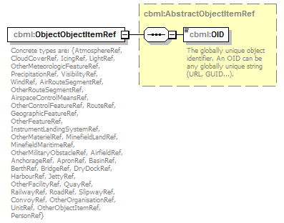
namespace | http://www.sisostds.org/schemas/c-bml/1.0
type | cbml:AbstractObjectItemRef
properties
  content | complex
children | cbml:OID
annotation
  documentation
  Concrete types are: {AtmosphereRef, CloudCoverRef, IcingRef, LightRef, OtherMeteorologicFeatureRef, PrecipitationRef, VisibilityRef, WindRef, AirRouteSegmentRef, OtherRouteSegmentRef, AirspaceControlMeansRef, OtherControlFeatureRef, RouteRef, GeographicFeatureRef, OtherFeatureRef, InstrumentLandingSystemRef, OtherMaterielRef, MinefieldLandRef, MinefieldMaritimeRef, OtherMilitaryObstacleRef, AirfieldRef, AnchorageRef, ApronRef, BasinRef, BerthRef, BridgeRef, DryDockRef, HarbourRef, JettyRef, OtherFacilityRef, QuayRef, RailwayRef, RoadRef, SlipwayRef, ConvoyRef, OtherOrganisationRef, UnitRef, OtherObjectItemRef, PersonRef}
source | <xs:element name="ObjectObjectItemRef" type="cbml:AbstractObjectItemRef">  <xs:annotation>  <xs:documentation xml:lang="en">Concrete types are: {AtmosphereRef, CloudCoverRef, IcingRef, LightRef, OtherMeteorologicFeatureRef, PrecipitationRef, VisibilityRef, WindRef, AirRouteSegmentRef, OtherRouteSegmentRef, AirspaceControlMeansRef, OtherControlFeatureRef, RouteRef, GeographicFeatureRef, OtherFeatureRef, InstrumentLandingSystemRef, OtherMaterielRef, MinefieldLandRef, MinefieldMaritimeRef, OtherMilitaryObstacleRef, AirfieldRef, AnchorageRef, ApronRef, BasinRef, BerthRef, BridgeRef, DryDockRef, HarbourRef, JettyRef, OtherFacilityRef, QuayRef, RailwayRef, RoadRef, SlipwayRef, ConvoyRef, OtherOrganisationRef, UnitRef, OtherObjectItemRef, PersonRef}</xs:documentation>  </xs:annotation>  </xs:element>

element WhoAssociationType/ObjectItemAssociation
diagram | 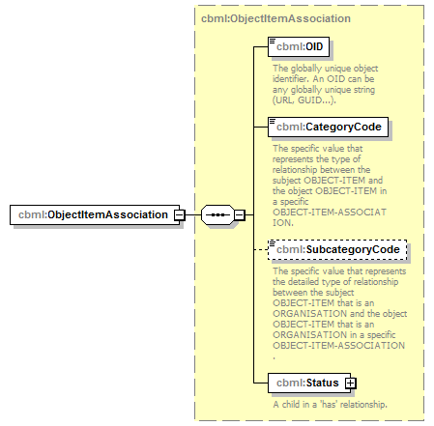
namespace | http://www.sisostds.org/schemas/c-bml/1.0
type | cbml:ObjectItemAssociation
properties
  content | complex
children | cbml:OID cbml:CategoryCode cbml:SubcategoryCode cbml:Status
source | <xs:element name="ObjectItemAssociation" type="cbml:ObjectItemAssociation"/>

complexType WhoHoldingRefType
diagram | 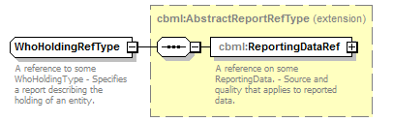
namespace | http://www.sisostds.org/schemas/c-bml/1.0
type | extension of cbml:AbstractReportRefType
properties
  base | cbml:AbstractReportRefType
children | cbml:ReportingDataRef
annotation
  documentation
  A reference to some WhoHoldingType - Specifies a report describing the holding of an entity.
source | <xs:complexType name="WhoHoldingRefType">  <xs:annotation>  <xs:documentation xml:lang="en">A reference to some WhoHoldingType - Specifies a report describing the holding of an entity.</xs:documentation>  </xs:annotation>  <xs:complexContent>  <xs:extension base="cbml:AbstractReportRefType"/>  </xs:complexContent>  </xs:complexType>

complexType WhoHoldingType
diagram | 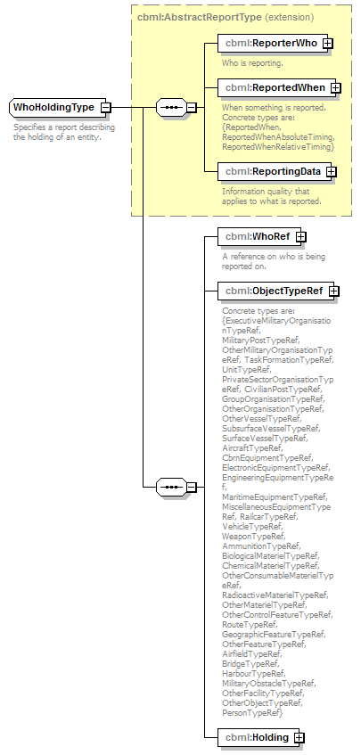
namespace | http://www.sisostds.org/schemas/c-bml/1.0
type | extension of cbml:AbstractReportType
properties
  base | cbml:AbstractReportType
children | cbml:ReporterWho cbml:ReportedWhen cbml:ReportingData cbml:WhoRef cbml:ObjectTypeRef cbml:Holding
annotation
  documentation
  Specifies a report describing the holding of an entity.
source | <xs:complexType name="WhoHoldingType">  <xs:annotation>  <xs:documentation xml:lang="en">Specifies a report describing the holding of an entity.</xs:documentation>  </xs:annotation>  <xs:complexContent>  <xs:extension base="cbml:AbstractReportType">  <xs:sequence>  <xs:element name="WhoRef" type="cbml:WhoRefType">  <xs:annotation>  <xs:documentation xml:lang="en">A reference on who is being reported on.</xs:documentation>  </xs:annotation>  </xs:element>  <xs:element name="ObjectTypeRef" type="cbml:AbstractObjectTypeRef">  <xs:annotation>  <xs:documentation xml:lang="en">Concrete types are: {ExecutiveMilitaryOrganisationTypeRef, MilitaryPostTypeRef, OtherMilitaryOrganisationTypeRef, TaskFormationTypeRef, UnitTypeRef, PrivateSectorOrganisationTypeRef, CivilianPostTypeRef, GroupOrganisationTypeRef, OtherOrganisationTypeRef, OtherVesselTypeRef, SubsurfaceVesselTypeRef, SurfaceVesselTypeRef, AircraftTypeRef, CbrnEquipmentTypeRef, ElectronicEquipmentTypeRef, EngineeringEquipmentTypeRef, MaritimeEquipmentTypeRef, MiscellaneousEquipmentTypeRef, RailcarTypeRef, VehicleTypeRef, WeaponTypeRef, AmmunitionTypeRef, BiologicalMaterielTypeRef, ChemicalMaterielTypeRef, OtherConsumableMaterielTypeRef, RadioactiveMaterielTypeRef, OtherMaterielTypeRef, OtherControlFeatureTypeRef, RouteTypeRef, GeographicFeatureTypeRef, OtherFeatureTypeRef, AirfieldTypeRef, BridgeTypeRef, HarbourTypeRef, MilitaryObstacleTypeRef, OtherFacilityTypeRef, OtherObjectTypeRef, PersonTypeRef}</xs:documentation>  </xs:annotation>  </xs:element>  <xs:element name="Holding" type="cbml:Holding"/>  </xs:sequence>  </xs:extension>  </xs:complexContent>  </xs:complexType>

element WhoHoldingType/WhoRef
diagram
namespace | http://www.sisostds.org/schemas/c-bml/1.0
type | cbml:WhoRefType
properties
  content | complex
children | cbml:ObjectItemRef
annotation
  documentation
  A reference on who is being reported on.
source | <xs:element name="WhoRef" type="cbml:WhoRefType">  <xs:annotation>  <xs:documentation xml:lang="en">A reference on who is being reported on.</xs:documentation>  </xs:annotation>  </xs:element>

element WhoHoldingType/ObjectTypeRef
diagram | 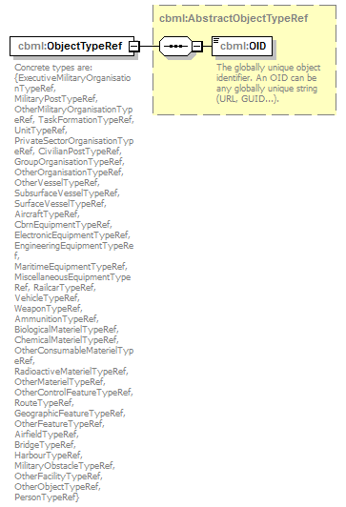
namespace | http://www.sisostds.org/schemas/c-bml/1.0
type | cbml:AbstractObjectTypeRef
properties
  content | complex
children | cbml:OID
annotation
  documentation
  Concrete types are: {ExecutiveMilitaryOrganisationTypeRef, MilitaryPostTypeRef, OtherMilitaryOrganisationTypeRef, TaskFormationTypeRef, UnitTypeRef, PrivateSectorOrganisationTypeRef, CivilianPostTypeRef, GroupOrganisationTypeRef, OtherOrganisationTypeRef, OtherVesselTypeRef, SubsurfaceVesselTypeRef, SurfaceVesselTypeRef, AircraftTypeRef, CbrnEquipmentTypeRef, ElectronicEquipmentTypeRef, EngineeringEquipmentTypeRef, MaritimeEquipmentTypeRef, MiscellaneousEquipmentTypeRef, RailcarTypeRef, VehicleTypeRef, WeaponTypeRef, AmmunitionTypeRef, BiologicalMaterielTypeRef, ChemicalMaterielTypeRef, OtherConsumableMaterielTypeRef, RadioactiveMaterielTypeRef, OtherMaterielTypeRef, OtherControlFeatureTypeRef, RouteTypeRef, GeographicFeatureTypeRef, OtherFeatureTypeRef, AirfieldTypeRef, BridgeTypeRef, HarbourTypeRef, MilitaryObstacleTypeRef, OtherFacilityTypeRef, OtherObjectTypeRef, PersonTypeRef}
source | <xs:element name="ObjectTypeRef" type="cbml:AbstractObjectTypeRef">  <xs:annotation>  <xs:documentation xml:lang="en">Concrete types are: {ExecutiveMilitaryOrganisationTypeRef, MilitaryPostTypeRef, OtherMilitaryOrganisationTypeRef, TaskFormationTypeRef, UnitTypeRef, PrivateSectorOrganisationTypeRef, CivilianPostTypeRef, GroupOrganisationTypeRef, OtherOrganisationTypeRef, OtherVesselTypeRef, SubsurfaceVesselTypeRef, SurfaceVesselTypeRef, AircraftTypeRef, CbrnEquipmentTypeRef, ElectronicEquipmentTypeRef, EngineeringEquipmentTypeRef, MaritimeEquipmentTypeRef, MiscellaneousEquipmentTypeRef, RailcarTypeRef, VehicleTypeRef, WeaponTypeRef, AmmunitionTypeRef, BiologicalMaterielTypeRef, ChemicalMaterielTypeRef, OtherConsumableMaterielTypeRef, RadioactiveMaterielTypeRef, OtherMaterielTypeRef, OtherControlFeatureTypeRef, RouteTypeRef, GeographicFeatureTypeRef, OtherFeatureTypeRef, AirfieldTypeRef, BridgeTypeRef, HarbourTypeRef, MilitaryObstacleTypeRef, OtherFacilityTypeRef, OtherObjectTypeRef, PersonTypeRef}</xs:documentation>  </xs:annotation>  </xs:element>

element WhoHoldingType/Holding
diagram | 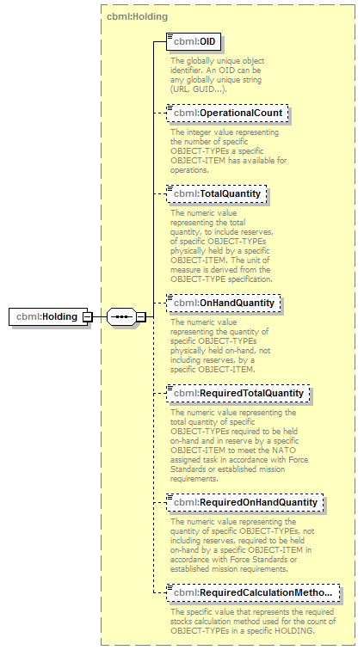
namespace | http://www.sisostds.org/schemas/c-bml/1.0
type | cbml:Holding
properties
  content | complex
children | cbml:OID cbml:OperationalCount cbml:TotalQuantity cbml:OnHandQuantity cbml:RequiredTotalQuantity cbml:RequiredOnHandQuantity cbml:RequiredCalculationMethodCode
source | <xs:element name="Holding" type="cbml:Holding"/>

complexType WhoHostilityRefType
diagram | 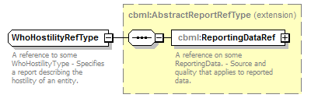
namespace | http://www.sisostds.org/schemas/c-bml/1.0
type | extension of cbml:AbstractReportRefType
properties
  base | cbml:AbstractReportRefType
children | cbml:ReportingDataRef
annotation
  documentation
  A reference to some WhoHostilityType - Specifies a report describing the hostility of an entity.
source | <xs:complexType name="WhoHostilityRefType">  <xs:annotation>  <xs:documentation xml:lang="en">A reference to some WhoHostilityType - Specifies a report describing the hostility of an entity.</xs:documentation>  </xs:annotation>  <xs:complexContent>  <xs:extension base="cbml:AbstractReportRefType"/>  </xs:complexContent>  </xs:complexType>

complexType WhoHostilityType
diagram | 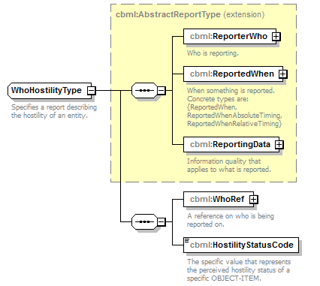
namespace | http://www.sisostds.org/schemas/c-bml/1.0
type | extension of cbml:AbstractReportType
properties
  base | cbml:AbstractReportType
children | cbml:ReporterWho cbml:ReportedWhen cbml:ReportingData cbml:WhoRef cbml:HostilityStatusCode
annotation
  documentation
  Specifies a report describing the hostility of an entity.
source | <xs:complexType name="WhoHostilityType">  <xs:annotation>  <xs:documentation xml:lang="en">Specifies a report describing the hostility of an entity.</xs:documentation>  </xs:annotation>  <xs:complexContent>  <xs:extension base="cbml:AbstractReportType">  <xs:sequence>  <xs:element name="WhoRef" type="cbml:WhoRefType">  <xs:annotation>  <xs:documentation xml:lang="en">A reference on who is being reported on.</xs:documentation>  </xs:annotation>  </xs:element>  <xs:element name="HostilityStatusCode" type="jc3iedm:ObjectItemHostilityStatusCode">  <xs:annotation>  <xs:documentation xml:lang="en">The specific value that represents the perceived hostility status of a specific OBJECT-ITEM.</xs:documentation>  </xs:annotation>  </xs:element>  </xs:sequence>  </xs:extension>  </xs:complexContent>  </xs:complexType>

element WhoHostilityType/WhoRef
diagram
namespace | http://www.sisostds.org/schemas/c-bml/1.0
type | cbml:WhoRefType
properties
  content | complex
children | cbml:ObjectItemRef
annotation
  documentation
  A reference on who is being reported on.
source | <xs:element name="WhoRef" type="cbml:WhoRefType">  <xs:annotation>  <xs:documentation xml:lang="en">A reference on who is being reported on.</xs:documentation>  </xs:annotation>  </xs:element>

element WhoHostilityType/HostilityStatusCode
diagram | 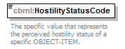
namespace | http://www.sisostds.org/schemas/c-bml/1.0
type | jc3iedm:ObjectItemHostilityStatusCode
properties
  content | simple
facets
  Kind | Value | Annotation
  enumeration | AFR
    documentation
    <Definition xml:lang="en">An OBJECT-ITEM that is assumed to be a friend because of its characteristics, behaviour or origin.</Definition>
    appinfo
    <DisplayValue xml:lang="en">Assumed friend</DisplayValue>
  enumeration | AHO
    documentation
    <Definition xml:lang="en">An indication that the OBJECT-ITEM in question is likely to belong to enemy forces.</Definition>
    appinfo
    <DisplayValue xml:lang="en">Assumed hostile</DisplayValue>
  enumeration | AIV
    documentation
    <Definition xml:lang="en">An indication that the OBJECT-ITEM in question is likely to belong to involved forces different from own, allied and enemy forces.</Definition>
    appinfo
    <DisplayValue xml:lang="en">Assumed involved</DisplayValue>
  enumeration | ANT
    documentation
    <Definition xml:lang="en">An indication that the OBJECT-ITEM in question is likely to belong to neither own, allied, enemy or otherwise involved forces.</Definition>
    appinfo
    <DisplayValue xml:lang="en">Assumed neutral</DisplayValue>
  enumeration | FAKER
    documentation
    <Definition xml:lang="en">An OBJECT-ITEM that is a friendly aircraft simulating a hostile aircraft in an air defence exercise.</Definition>
    appinfo
    <DisplayValue xml:lang="en">Faker</DisplayValue>
  enumeration | FR
    documentation
    <Definition xml:lang="en">An OBJECT-ITEM that belongs to a declared friendly nation.</Definition>
    appinfo
    <DisplayValue xml:lang="en">Friend</DisplayValue>
  enumeration | HO
    documentation
    <Definition xml:lang="en">An OBJECT-ITEM that is positively identified as enemy.</Definition>
    appinfo
    <DisplayValue xml:lang="en">Hostile</DisplayValue>
  enumeration | IV
    documentation
    <Definition xml:lang="en">An indication that the OBJECT-ITEM in question belongs to involved forces different from own, allied and enemy forces.</Definition>
    appinfo
    <DisplayValue xml:lang="en">Involved</DisplayValue>
  enumeration | JOKER
    documentation
    <Definition xml:lang="en">An OBJECT-ITEM that is acting as a suspect track for exercise purposes only.</Definition>
    appinfo
    <DisplayValue xml:lang="en">Joker</DisplayValue>
  enumeration | NEUTRL
    documentation
    <Definition xml:lang="en">An OBJECT-ITEM whose characteristics, behaviour, origin or nationality indicate that it is neither supporting friendly nor opposing forces.</Definition>
    appinfo
    <DisplayValue xml:lang="en">Neutral</DisplayValue>
  enumeration | PENDNG
    documentation
    <Definition xml:lang="en">An OBJECT-ITEM for which identification is to be determined.</Definition>
    appinfo
    <DisplayValue xml:lang="en">Pending</DisplayValue>
  enumeration | SUSPCT
    documentation
    <Definition xml:lang="en">An OBJECT-ITEM that is potentially hostile because of its characteristics, behaviour or origin.</Definition>
    appinfo
    <DisplayValue xml:lang="en">Suspect</DisplayValue>
  enumeration | UNK
    documentation
    <Definition xml:lang="en">An OBJECT-ITEM for which its hostility status information is not available.</Definition>
    appinfo
    <DisplayValue xml:lang="en">Unknown</DisplayValue>
annotation
  documentation
  The specific value that represents the perceived hostility status of a specific OBJECT-ITEM.
source | <xs:element name="HostilityStatusCode" type="jc3iedm:ObjectItemHostilityStatusCode">  <xs:annotation>  <xs:documentation xml:lang="en">The specific value that represents the perceived hostility status of a specific OBJECT-ITEM.</xs:documentation>  </xs:annotation>  </xs:element>

complexType WhoLocationRefType
diagram | 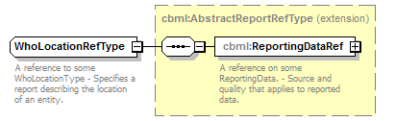
namespace | http://www.sisostds.org/schemas/c-bml/1.0
type | extension of cbml:AbstractReportRefType
properties
  base | cbml:AbstractReportRefType
children | cbml:ReportingDataRef
annotation
  documentation
  A reference to some WhoLocationType - Specifies a report describing the location of an entity.
source | <xs:complexType name="WhoLocationRefType">  <xs:annotation>  <xs:documentation xml:lang="en">A reference to some WhoLocationType - Specifies a report describing the location of an entity.</xs:documentation>  </xs:annotation>  <xs:complexContent>  <xs:extension base="cbml:AbstractReportRefType"/>  </xs:complexContent>  </xs:complexType>

complexType WhoLocationType
diagram | 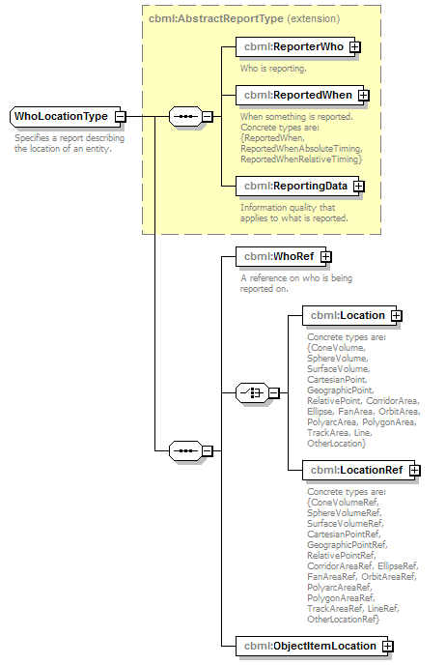
namespace | http://www.sisostds.org/schemas/c-bml/1.0
type | extension of cbml:AbstractReportType
properties
  base | cbml:AbstractReportType
children | cbml:ReporterWho cbml:ReportedWhen cbml:ReportingData cbml:WhoRef cbml:Location cbml:LocationRef cbml:ObjectItemLocation
annotation
  documentation
  Specifies a report describing the location of an entity.
source | <xs:complexType name="WhoLocationType">  <xs:annotation>  <xs:documentation xml:lang="en">Specifies a report describing the location of an entity.</xs:documentation>  </xs:annotation>  <xs:complexContent>  <xs:extension base="cbml:AbstractReportType">  <xs:sequence>  <xs:element name="WhoRef" type="cbml:WhoRefType">  <xs:annotation>  <xs:documentation xml:lang="en">A reference on who is being reported on.</xs:documentation>  </xs:annotation>  </xs:element>  <xs:choice>  <xs:element name="Location" type="cbml:AbstractLocation">  <xs:annotation>  <xs:documentation xml:lang="en">Concrete types are: {ConeVolume, SphereVolume, SurfaceVolume, CartesianPoint, GeographicPoint, RelativePoint, CorridorArea, Ellipse, FanArea, OrbitArea, PolyarcArea, PolygonArea, TrackArea, Line, OtherLocation}</xs:documentation>  </xs:annotation>  </xs:element>  <xs:element name="LocationRef" type="cbml:AbstractLocationRef">  <xs:annotation>  <xs:documentation xml:lang="en">Concrete types are: {ConeVolumeRef, SphereVolumeRef, SurfaceVolumeRef, CartesianPointRef, GeographicPointRef, RelativePointRef, CorridorAreaRef, EllipseRef, FanAreaRef, OrbitAreaRef, PolyarcAreaRef, PolygonAreaRef, TrackAreaRef, LineRef, OtherLocationRef}</xs:documentation>  </xs:annotation>  </xs:element>  </xs:choice>  <xs:element name="ObjectItemLocation" type="cbml:ObjectItemLocation"/>  </xs:sequence>  </xs:extension>  </xs:complexContent>  </xs:complexType>

element WhoLocationType/WhoRef
diagram
namespace | http://www.sisostds.org/schemas/c-bml/1.0
type | cbml:WhoRefType
properties
  content | complex
children | cbml:ObjectItemRef
annotation
  documentation
  A reference on who is being reported on.
source | <xs:element name="WhoRef" type="cbml:WhoRefType">  <xs:annotation>  <xs:documentation xml:lang="en">A reference on who is being reported on.</xs:documentation>  </xs:annotation>  </xs:element>

element WhoLocationType/Location
diagram | 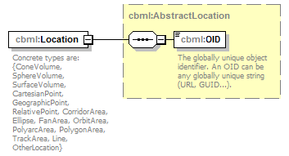
namespace | http://www.sisostds.org/schemas/c-bml/1.0
type | cbml:AbstractLocation
properties
  content | complex
children | cbml:OID
annotation
  documentation
  Concrete types are: {ConeVolume, SphereVolume, SurfaceVolume, CartesianPoint, GeographicPoint, RelativePoint, CorridorArea, Ellipse, FanArea, OrbitArea, PolyarcArea, PolygonArea, TrackArea, Line, OtherLocation}
source | <xs:element name="Location" type="cbml:AbstractLocation">  <xs:annotation>  <xs:documentation xml:lang="en">Concrete types are: {ConeVolume, SphereVolume, SurfaceVolume, CartesianPoint, GeographicPoint, RelativePoint, CorridorArea, Ellipse, FanArea, OrbitArea, PolyarcArea, PolygonArea, TrackArea, Line, OtherLocation}</xs:documentation>  </xs:annotation>  </xs:element>

element WhoLocationType/LocationRef
diagram | 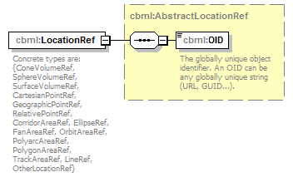
namespace | http://www.sisostds.org/schemas/c-bml/1.0
type | cbml:AbstractLocationRef
properties
  content | complex
children | cbml:OID
annotation
  documentation
  Concrete types are: {ConeVolumeRef, SphereVolumeRef, SurfaceVolumeRef, CartesianPointRef, GeographicPointRef, RelativePointRef, CorridorAreaRef, EllipseRef, FanAreaRef, OrbitAreaRef, PolyarcAreaRef, PolygonAreaRef, TrackAreaRef, LineRef, OtherLocationRef}
source | <xs:element name="LocationRef" type="cbml:AbstractLocationRef">  <xs:annotation>  <xs:documentation xml:lang="en">Concrete types are: {ConeVolumeRef, SphereVolumeRef, SurfaceVolumeRef, CartesianPointRef, GeographicPointRef, RelativePointRef, CorridorAreaRef, EllipseRef, FanAreaRef, OrbitAreaRef, PolyarcAreaRef, PolygonAreaRef, TrackAreaRef, LineRef, OtherLocationRef}</xs:documentation>  </xs:annotation>  </xs:element>

element WhoLocationType/ObjectItemLocation
diagram | 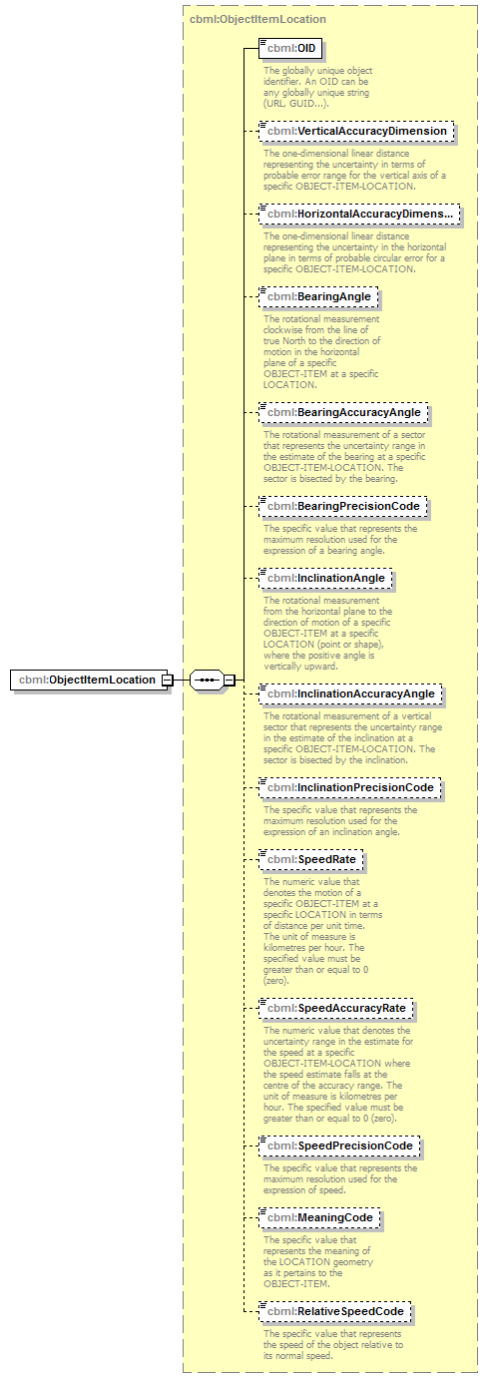
namespace | http://www.sisostds.org/schemas/c-bml/1.0
type | cbml:ObjectItemLocation
properties
  content | complex
children | cbml:OID cbml:VerticalAccuracyDimension cbml:HorizontalAccuracyDimension cbml:BearingAngle cbml:BearingAccuracyAngle cbml:BearingPrecisionCode cbml:InclinationAngle cbml:InclinationAccuracyAngle cbml:InclinationPrecisionCode cbml:SpeedRate cbml:SpeedAccuracyRate cbml:SpeedPrecisionCode cbml:MeaningCode cbml:RelativeSpeedCode
source | <xs:element name="ObjectItemLocation" type="cbml:ObjectItemLocation"/>

complexType WhoRefType
diagram | 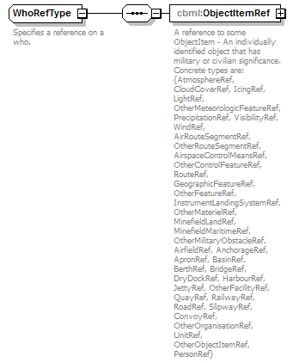
namespace | http://www.sisostds.org/schemas/c-bml/1.0
children | cbml:ObjectItemRef
used by
  elements | WhoTypeType/WhoRef WhoLocationType/WhoRef WhoAssociationType/WhoRef WhoHostilityType/WhoRef WhoStatusType/WhoRef WhoAffiliationType/WhoRef WhoHoldingType/WhoRef WhoRef
annotation
  documentation
  Specifies a reference on a who.
source | <xs:complexType name="WhoRefType">  <xs:annotation>  <xs:documentation xml:lang="en">Specifies a reference on a who.</xs:documentation>  </xs:annotation>  <xs:sequence>  <xs:element name="ObjectItemRef" type="cbml:AbstractObjectItemRef">  <xs:annotation>  <xs:documentation xml:lang="en">A reference to some ObjectItem - An individually identified object that has military or civilian significance. Concrete types are: {AtmosphereRef, CloudCoverRef, IcingRef, LightRef, OtherMeteorologicFeatureRef, PrecipitationRef, VisibilityRef, WindRef, AirRouteSegmentRef, OtherRouteSegmentRef, AirspaceControlMeansRef, OtherControlFeatureRef, RouteRef, GeographicFeatureRef, OtherFeatureRef, InstrumentLandingSystemRef, OtherMaterielRef, MinefieldLandRef, MinefieldMaritimeRef, OtherMilitaryObstacleRef, AirfieldRef, AnchorageRef, ApronRef, BasinRef, BerthRef, BridgeRef, DryDockRef, HarbourRef, JettyRef, OtherFacilityRef, QuayRef, RailwayRef, RoadRef, SlipwayRef, ConvoyRef, OtherOrganisationRef, UnitRef, OtherObjectItemRef, PersonRef}</xs:documentation>  </xs:annotation>  </xs:element>  </xs:sequence>  </xs:complexType>

element WhoRefType/ObjectItemRef
diagram | 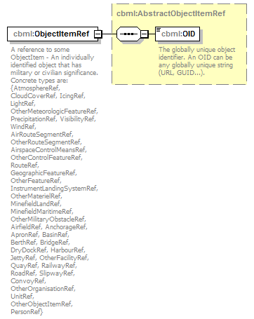
namespace | http://www.sisostds.org/schemas/c-bml/1.0
type | cbml:AbstractObjectItemRef
properties
  content | complex
children | cbml:OID
annotation
  documentation
  A reference to some ObjectItem - An individually identified object that has military or civilian significance. Concrete types are: {AtmosphereRef, CloudCoverRef, IcingRef, LightRef, OtherMeteorologicFeatureRef, PrecipitationRef, VisibilityRef, WindRef, AirRouteSegmentRef, OtherRouteSegmentRef, AirspaceControlMeansRef, OtherControlFeatureRef, RouteRef, GeographicFeatureRef, OtherFeatureRef, InstrumentLandingSystemRef, OtherMaterielRef, MinefieldLandRef, MinefieldMaritimeRef, OtherMilitaryObstacleRef, AirfieldRef, AnchorageRef, ApronRef, BasinRef, BerthRef, BridgeRef, DryDockRef, HarbourRef, JettyRef, OtherFacilityRef, QuayRef, RailwayRef, RoadRef, SlipwayRef, ConvoyRef, OtherOrganisationRef, UnitRef, OtherObjectItemRef, PersonRef}
source | <xs:element name="ObjectItemRef" type="cbml:AbstractObjectItemRef">  <xs:annotation>  <xs:documentation xml:lang="en">A reference to some ObjectItem - An individually identified object that has military or civilian significance. Concrete types are: {AtmosphereRef, CloudCoverRef, IcingRef, LightRef, OtherMeteorologicFeatureRef, PrecipitationRef, VisibilityRef, WindRef, AirRouteSegmentRef, OtherRouteSegmentRef, AirspaceControlMeansRef, OtherControlFeatureRef, RouteRef, GeographicFeatureRef, OtherFeatureRef, InstrumentLandingSystemRef, OtherMaterielRef, MinefieldLandRef, MinefieldMaritimeRef, OtherMilitaryObstacleRef, AirfieldRef, AnchorageRef, ApronRef, BasinRef, BerthRef, BridgeRef, DryDockRef, HarbourRef, JettyRef, OtherFacilityRef, QuayRef, RailwayRef, RoadRef, SlipwayRef, ConvoyRef, OtherOrganisationRef, UnitRef, OtherObjectItemRef, PersonRef}</xs:documentation>  </xs:annotation>  </xs:element>

complexType WhoStatusRefType
diagram | 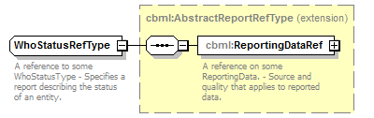
namespace | http://www.sisostds.org/schemas/c-bml/1.0
type | extension of cbml:AbstractReportRefType
properties
  base | cbml:AbstractReportRefType
children | cbml:ReportingDataRef
annotation
  documentation
  A reference to some WhoStatusType - Specifies a report describing the status of an entity.
source | <xs:complexType name="WhoStatusRefType">  <xs:annotation>  <xs:documentation xml:lang="en">A reference to some WhoStatusType - Specifies a report describing the status of an entity.</xs:documentation>  </xs:annotation>  <xs:complexContent>  <xs:extension base="cbml:AbstractReportRefType"/>  </xs:complexContent>  </xs:complexType>

complexType WhoStatusType
diagram | 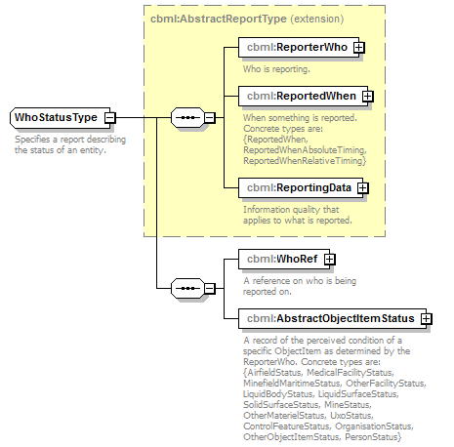
namespace | http://www.sisostds.org/schemas/c-bml/1.0
type | extension of cbml:AbstractReportType
properties
  base | cbml:AbstractReportType
children | cbml:ReporterWho cbml:ReportedWhen cbml:ReportingData cbml:WhoRef cbml:AbstractObjectItemStatus
annotation
  documentation
  Specifies a report describing the status of an entity.
source | <xs:complexType name="WhoStatusType">  <xs:annotation>  <xs:documentation xml:lang="en">Specifies a report describing the status of an entity.</xs:documentation>  </xs:annotation>  <xs:complexContent>  <xs:extension base="cbml:AbstractReportType">  <xs:sequence>  <xs:element name="WhoRef" type="cbml:WhoRefType">  <xs:annotation>  <xs:documentation xml:lang="en">A reference on who is being reported on.</xs:documentation>  </xs:annotation>  </xs:element>  <xs:element name="AbstractObjectItemStatus" type="cbml:AbstractObjectItemStatus">  <xs:annotation>  <xs:documentation xml:lang="en">A record of the perceived condition of a specific ObjectItem as determined by the ReporterWho. Concrete types are: {AirfieldStatus, MedicalFacilityStatus, MinefieldMaritimeStatus, OtherFacilityStatus, LiquidBodyStatus, LiquidSurfaceStatus, SolidSurfaceStatus, MineStatus, OtherMaterielStatus, UxoStatus, ControlFeatureStatus, OrganisationStatus, OtherObjectItemStatus, PersonStatus}</xs:documentation>  </xs:annotation>  </xs:element>  </xs:sequence>  </xs:extension>  </xs:complexContent>  </xs:complexType>

element WhoStatusType/WhoRef
diagram
namespace | http://www.sisostds.org/schemas/c-bml/1.0
type | cbml:WhoRefType
properties
  content | complex
children | cbml:ObjectItemRef
annotation
  documentation
  A reference on who is being reported on.
source | <xs:element name="WhoRef" type="cbml:WhoRefType">  <xs:annotation>  <xs:documentation xml:lang="en">A reference on who is being reported on.</xs:documentation>  </xs:annotation>  </xs:element>

element WhoStatusType/AbstractObjectItemStatus
diagram | 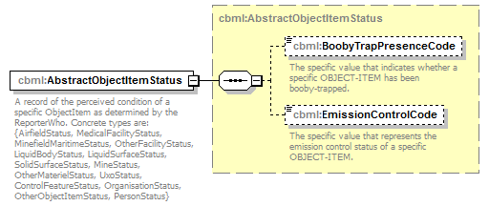
namespace | http://www.sisostds.org/schemas/c-bml/1.0
type | cbml:AbstractObjectItemStatus
properties
  content | complex
children | cbml:BoobyTrapPresenceCode cbml:EmissionControlCode
annotation
  documentation
  A record of the perceived condition of a specific ObjectItem as determined by the ReporterWho. Concrete types are: {AirfieldStatus, MedicalFacilityStatus, MinefieldMaritimeStatus, OtherFacilityStatus, LiquidBodyStatus, LiquidSurfaceStatus, SolidSurfaceStatus, MineStatus, OtherMaterielStatus, UxoStatus, ControlFeatureStatus, OrganisationStatus, OtherObjectItemStatus, PersonStatus}
source | <xs:element name="AbstractObjectItemStatus" type="cbml:AbstractObjectItemStatus">  <xs:annotation>  <xs:documentation xml:lang="en">A record of the perceived condition of a specific ObjectItem as determined by the ReporterWho. Concrete types are: {AirfieldStatus, MedicalFacilityStatus, MinefieldMaritimeStatus, OtherFacilityStatus, LiquidBodyStatus, LiquidSurfaceStatus, SolidSurfaceStatus, MineStatus, OtherMaterielStatus, UxoStatus, ControlFeatureStatus, OrganisationStatus, OtherObjectItemStatus, PersonStatus}</xs:documentation>  </xs:annotation>  </xs:element>

complexType WhoType
diagram | 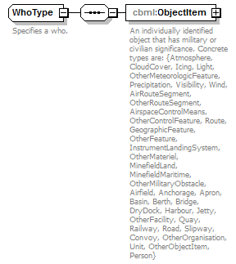
namespace | http://www.sisostds.org/schemas/c-bml/1.0
children | cbml:ObjectItem
used by
  elements | WhoTypeType/Who Who
annotation
  documentation
  Specifies a who.
source | <xs:complexType name="WhoType">  <xs:annotation>  <xs:documentation xml:lang="en">Specifies a who.</xs:documentation>  </xs:annotation>  <xs:sequence>  <xs:element name="ObjectItem" type="cbml:AbstractObjectItem">  <xs:annotation>  <xs:documentation xml:lang="en">An individually identified object that has military or civilian significance. Concrete types are: {Atmosphere, CloudCover, Icing, Light, OtherMeteorologicFeature, Precipitation, Visibility, Wind, AirRouteSegment, OtherRouteSegment, AirspaceControlMeans, OtherControlFeature, Route, GeographicFeature, OtherFeature, InstrumentLandingSystem, OtherMateriel, MinefieldLand, MinefieldMaritime, OtherMilitaryObstacle, Airfield, Anchorage, Apron, Basin, Berth, Bridge, DryDock, Harbour, Jetty, OtherFacility, Quay, Railway, Road, Slipway, Convoy, OtherOrganisation, Unit, OtherObjectItem, Person}</xs:documentation>  </xs:annotation>  </xs:element>  </xs:sequence>  </xs:complexType>

element WhoType/ObjectItem
diagram | 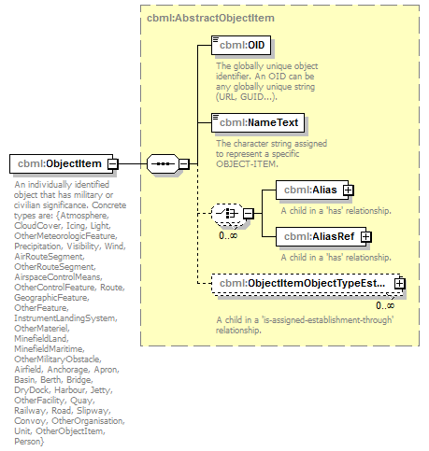
namespace | http://www.sisostds.org/schemas/c-bml/1.0
type | cbml:AbstractObjectItem
properties
  content | complex
children | cbml:OID cbml:NameText cbml:Alias cbml:AliasRef cbml:ObjectItemObjectTypeEstablishmentInObjectItem
annotation
  documentation
  An individually identified object that has military or civilian significance. Concrete types are: {Atmosphere, CloudCover, Icing, Light, OtherMeteorologicFeature, Precipitation, Visibility, Wind, AirRouteSegment, OtherRouteSegment, AirspaceControlMeans, OtherControlFeature, Route, GeographicFeature, OtherFeature, InstrumentLandingSystem, OtherMateriel, MinefieldLand, MinefieldMaritime, OtherMilitaryObstacle, Airfield, Anchorage, Apron, Basin, Berth, Bridge, DryDock, Harbour, Jetty, OtherFacility, Quay, Railway, Road, Slipway, Convoy, OtherOrganisation, Unit, OtherObjectItem, Person}
source | <xs:element name="ObjectItem" type="cbml:AbstractObjectItem">  <xs:annotation>  <xs:documentation xml:lang="en">An individually identified object that has military or civilian significance. Concrete types are: {Atmosphere, CloudCover, Icing, Light, OtherMeteorologicFeature, Precipitation, Visibility, Wind, AirRouteSegment, OtherRouteSegment, AirspaceControlMeans, OtherControlFeature, Route, GeographicFeature, OtherFeature, InstrumentLandingSystem, OtherMateriel, MinefieldLand, MinefieldMaritime, OtherMilitaryObstacle, Airfield, Anchorage, Apron, Basin, Berth, Bridge, DryDock, Harbour, Jetty, OtherFacility, Quay, Railway, Road, Slipway, Convoy, OtherOrganisation, Unit, OtherObjectItem, Person}</xs:documentation>  </xs:annotation>  </xs:element>

complexType WhoTypeRefType
diagram | 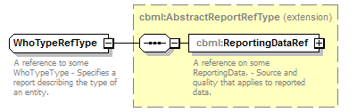
namespace | http://www.sisostds.org/schemas/c-bml/1.0
type | extension of cbml:AbstractReportRefType
properties
  base | cbml:AbstractReportRefType
children | cbml:ReportingDataRef
annotation
  documentation
  A reference to some WhoTypeType - Specifies a report describing the type of an entity.
source | <xs:complexType name="WhoTypeRefType">  <xs:annotation>  <xs:documentation xml:lang="en">A reference to some WhoTypeType - Specifies a report describing the type of an entity.</xs:documentation>  </xs:annotation>  <xs:complexContent>  <xs:extension base="cbml:AbstractReportRefType"/>  </xs:complexContent>  </xs:complexType>

complexType WhoTypeType
diagram | 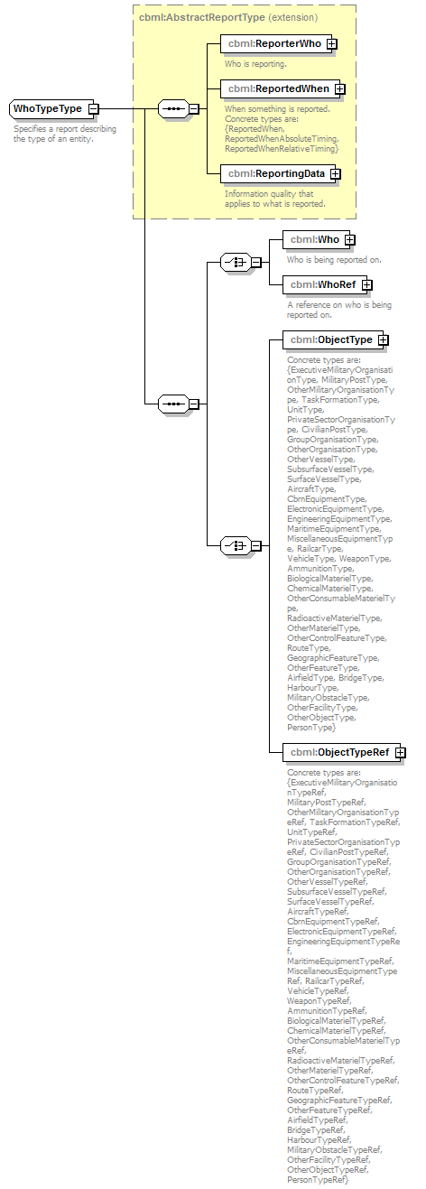
namespace | http://www.sisostds.org/schemas/c-bml/1.0
type | extension of cbml:AbstractReportType
properties
  base | cbml:AbstractReportType
children | cbml:ReporterWho cbml:ReportedWhen cbml:ReportingData cbml:Who cbml:WhoRef cbml:ObjectType cbml:ObjectTypeRef
annotation
  documentation
  Specifies a report describing the type of an entity.
source | <xs:complexType name="WhoTypeType">  <xs:annotation>  <xs:documentation xml:lang="en">Specifies a report describing the type of an entity.</xs:documentation>  </xs:annotation>  <xs:complexContent>  <xs:extension base="cbml:AbstractReportType">  <xs:sequence>  <xs:choice>  <xs:element name="Who" type="cbml:WhoType">  <xs:annotation>  <xs:documentation xml:lang="en">Who is being reported on.</xs:documentation>  </xs:annotation>  </xs:element>  <xs:element name="WhoRef" type="cbml:WhoRefType">  <xs:annotation>  <xs:documentation xml:lang="en">A reference on who is being reported on.</xs:documentation>  </xs:annotation>  </xs:element>  </xs:choice>  <xs:choice>  <xs:element name="ObjectType" type="cbml:AbstractObjectType">  <xs:annotation>  <xs:documentation xml:lang="en">Concrete types are: {ExecutiveMilitaryOrganisationType, MilitaryPostType, OtherMilitaryOrganisationType, TaskFormationType, UnitType, PrivateSectorOrganisationType, CivilianPostType, GroupOrganisationType, OtherOrganisationType, OtherVesselType, SubsurfaceVesselType, SurfaceVesselType, AircraftType, CbrnEquipmentType, ElectronicEquipmentType, EngineeringEquipmentType, MaritimeEquipmentType, MiscellaneousEquipmentType, RailcarType, VehicleType, WeaponType, AmmunitionType, BiologicalMaterielType, ChemicalMaterielType, OtherConsumableMaterielType, RadioactiveMaterielType, OtherMaterielType, OtherControlFeatureType, RouteType, GeographicFeatureType, OtherFeatureType, AirfieldType, BridgeType, HarbourType, MilitaryObstacleType, OtherFacilityType, OtherObjectType, PersonType}</xs:documentation>  </xs:annotation>  </xs:element>  <xs:element name="ObjectTypeRef" type="cbml:AbstractObjectTypeRef">  <xs:annotation>  <xs:documentation xml:lang="en">Concrete types are: {ExecutiveMilitaryOrganisationTypeRef, MilitaryPostTypeRef, OtherMilitaryOrganisationTypeRef, TaskFormationTypeRef, UnitTypeRef, PrivateSectorOrganisationTypeRef, CivilianPostTypeRef, GroupOrganisationTypeRef, OtherOrganisationTypeRef, OtherVesselTypeRef, SubsurfaceVesselTypeRef, SurfaceVesselTypeRef, AircraftTypeRef, CbrnEquipmentTypeRef, ElectronicEquipmentTypeRef, EngineeringEquipmentTypeRef, MaritimeEquipmentTypeRef, MiscellaneousEquipmentTypeRef, RailcarTypeRef, VehicleTypeRef, WeaponTypeRef, AmmunitionTypeRef, BiologicalMaterielTypeRef, ChemicalMaterielTypeRef, OtherConsumableMaterielTypeRef, RadioactiveMaterielTypeRef, OtherMaterielTypeRef, OtherControlFeatureTypeRef, RouteTypeRef, GeographicFeatureTypeRef, OtherFeatureTypeRef, AirfieldTypeRef, BridgeTypeRef, HarbourTypeRef, MilitaryObstacleTypeRef, OtherFacilityTypeRef, OtherObjectTypeRef, PersonTypeRef}</xs:documentation>  </xs:annotation>  </xs:element>  </xs:choice>  </xs:sequence>  </xs:extension>  </xs:complexContent>  </xs:complexType>

element WhoTypeType/Who
diagram | 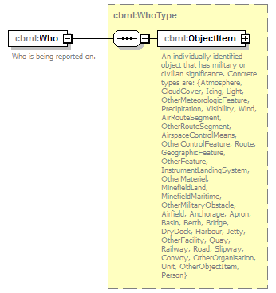
namespace | http://www.sisostds.org/schemas/c-bml/1.0
type | cbml:WhoType
properties
  content | complex
children | cbml:ObjectItem
annotation
  documentation
  Who is being reported on.
source | <xs:element name="Who" type="cbml:WhoType">  <xs:annotation>  <xs:documentation xml:lang="en">Who is being reported on.</xs:documentation>  </xs:annotation>  </xs:element>

element WhoTypeType/WhoRef
diagram
namespace | http://www.sisostds.org/schemas/c-bml/1.0
type | cbml:WhoRefType
properties
  content | complex
children | cbml:ObjectItemRef
annotation
  documentation
  A reference on who is being reported on.
source | <xs:element name="WhoRef" type="cbml:WhoRefType">  <xs:annotation>  <xs:documentation xml:lang="en">A reference on who is being reported on.</xs:documentation>  </xs:annotation>  </xs:element>

element WhoTypeType/ObjectType
diagram | 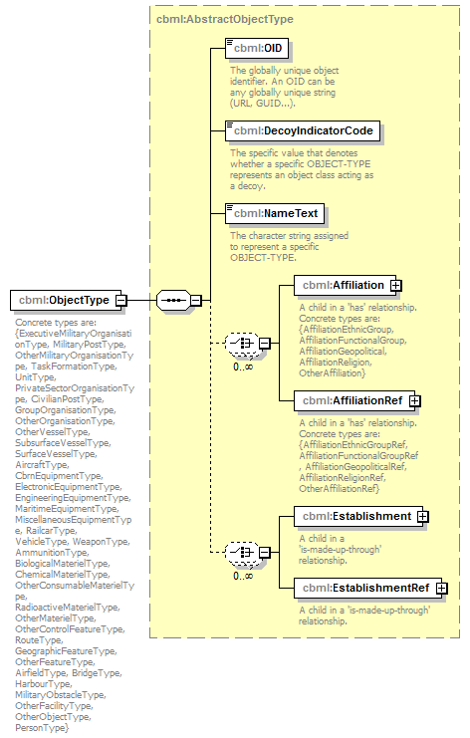
namespace | http://www.sisostds.org/schemas/c-bml/1.0
type | cbml:AbstractObjectType
properties
  content | complex
children | cbml:OID cbml:DecoyIndicatorCode cbml:NameText cbml:Affiliation cbml:AffiliationRef cbml:Establishment cbml:EstablishmentRef
annotation
  documentation
  Concrete types are: {ExecutiveMilitaryOrganisationType, MilitaryPostType, OtherMilitaryOrganisationType, TaskFormationType, UnitType, PrivateSectorOrganisationType, CivilianPostType, GroupOrganisationType, OtherOrganisationType, OtherVesselType, SubsurfaceVesselType, SurfaceVesselType, AircraftType, CbrnEquipmentType, ElectronicEquipmentType, EngineeringEquipmentType, MaritimeEquipmentType, MiscellaneousEquipmentType, RailcarType, VehicleType, WeaponType, AmmunitionType, BiologicalMaterielType, ChemicalMaterielType, OtherConsumableMaterielType, RadioactiveMaterielType, OtherMaterielType, OtherControlFeatureType, RouteType, GeographicFeatureType, OtherFeatureType, AirfieldType, BridgeType, HarbourType, MilitaryObstacleType, OtherFacilityType, OtherObjectType, PersonType}
source | <xs:element name="ObjectType" type="cbml:AbstractObjectType">  <xs:annotation>  <xs:documentation xml:lang="en">Concrete types are: {ExecutiveMilitaryOrganisationType, MilitaryPostType, OtherMilitaryOrganisationType, TaskFormationType, UnitType, PrivateSectorOrganisationType, CivilianPostType, GroupOrganisationType, OtherOrganisationType, OtherVesselType, SubsurfaceVesselType, SurfaceVesselType, AircraftType, CbrnEquipmentType, ElectronicEquipmentType, EngineeringEquipmentType, MaritimeEquipmentType, MiscellaneousEquipmentType, RailcarType, VehicleType, WeaponType, AmmunitionType, BiologicalMaterielType, ChemicalMaterielType, OtherConsumableMaterielType, RadioactiveMaterielType, OtherMaterielType, OtherControlFeatureType, RouteType, GeographicFeatureType, OtherFeatureType, AirfieldType, BridgeType, HarbourType, MilitaryObstacleType, OtherFacilityType, OtherObjectType, PersonType}</xs:documentation>  </xs:annotation>  </xs:element>

element WhoTypeType/ObjectTypeRef
diagram
namespace | http://www.sisostds.org/schemas/c-bml/1.0
type | cbml:AbstractObjectTypeRef
properties
  content | complex
children | cbml:OID
annotation
  documentation
  Concrete types are: {ExecutiveMilitaryOrganisationTypeRef, MilitaryPostTypeRef, OtherMilitaryOrganisationTypeRef, TaskFormationTypeRef, UnitTypeRef, PrivateSectorOrganisationTypeRef, CivilianPostTypeRef, GroupOrganisationTypeRef, OtherOrganisationTypeRef, OtherVesselTypeRef, SubsurfaceVesselTypeRef, SurfaceVesselTypeRef, AircraftTypeRef, CbrnEquipmentTypeRef, ElectronicEquipmentTypeRef, EngineeringEquipmentTypeRef, MaritimeEquipmentTypeRef, MiscellaneousEquipmentTypeRef, RailcarTypeRef, VehicleTypeRef, WeaponTypeRef, AmmunitionTypeRef, BiologicalMaterielTypeRef, ChemicalMaterielTypeRef, OtherConsumableMaterielTypeRef, RadioactiveMaterielTypeRef, OtherMaterielTypeRef, OtherControlFeatureTypeRef, RouteTypeRef, GeographicFeatureTypeRef, OtherFeatureTypeRef, AirfieldTypeRef, BridgeTypeRef, HarbourTypeRef, MilitaryObstacleTypeRef, OtherFacilityTypeRef, OtherObjectTypeRef, PersonTypeRef}
source | <xs:element name="ObjectTypeRef" type="cbml:AbstractObjectTypeRef">  <xs:annotation>  <xs:documentation xml:lang="en">Concrete types are: {ExecutiveMilitaryOrganisationTypeRef, MilitaryPostTypeRef, OtherMilitaryOrganisationTypeRef, TaskFormationTypeRef, UnitTypeRef, PrivateSectorOrganisationTypeRef, CivilianPostTypeRef, GroupOrganisationTypeRef, OtherOrganisationTypeRef, OtherVesselTypeRef, SubsurfaceVesselTypeRef, SurfaceVesselTypeRef, AircraftTypeRef, CbrnEquipmentTypeRef, ElectronicEquipmentTypeRef, EngineeringEquipmentTypeRef, MaritimeEquipmentTypeRef, MiscellaneousEquipmentTypeRef, RailcarTypeRef, VehicleTypeRef, WeaponTypeRef, AmmunitionTypeRef, BiologicalMaterielTypeRef, ChemicalMaterielTypeRef, OtherConsumableMaterielTypeRef, RadioactiveMaterielTypeRef, OtherMaterielTypeRef, OtherControlFeatureTypeRef, RouteTypeRef, GeographicFeatureTypeRef, OtherFeatureTypeRef, AirfieldTypeRef, BridgeTypeRef, HarbourTypeRef, MilitaryObstacleTypeRef, OtherFacilityTypeRef, OtherObjectTypeRef, PersonTypeRef}</xs:documentation>  </xs:annotation>  </xs:element>

complexType WhyType
diagram | 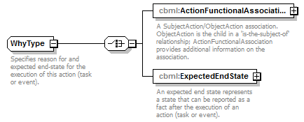
namespace | http://www.sisostds.org/schemas/c-bml/1.0
children | cbml:ActionFunctionalAssociationInSubjectAction cbml:ExpectedEndState
used by
  elements | ActionType/Why Why
annotation
  documentation
  Specifies reason for and expected end-state for the execution of this action (task or event).
source | <xs:complexType name="WhyType">  <xs:annotation>  <xs:documentation xml:lang="en">Specifies reason for and expected end-state for the execution of this action (task or event).</xs:documentation>  </xs:annotation>  <xs:choice>  <xs:element name="ActionFunctionalAssociationInSubjectAction" type="cbml:ActionFunctionalAssociationInSubjectAction">  <xs:annotation>  <xs:documentation xml:lang="en">A SubjectAction/ObjectAction association. ObjectAction is the child in a 'is-the-subject-of' relationship; ActionFunctionalAssociation provides additional information on the association.</xs:documentation>  </xs:annotation>  </xs:element>  <xs:element name="ExpectedEndState" type="cbml:StateType">  <xs:annotation>  <xs:documentation xml:lang="en">An expected end state represents a state that can be reported as a fact after the execution of an action (task or event).</xs:documentation>  </xs:annotation>  </xs:element>  </xs:choice>  </xs:complexType>

element WhyType/ActionFunctionalAssociationInSubjectAction
diagram | 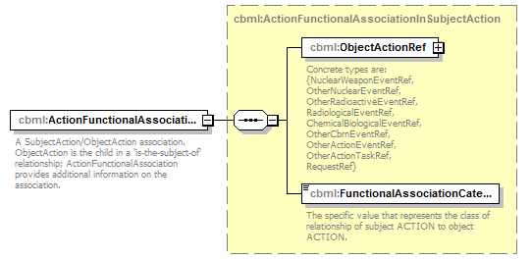
namespace | http://www.sisostds.org/schemas/c-bml/1.0
type | cbml:ActionFunctionalAssociationInSubjectAction
properties
  content | complex
children | cbml:ObjectActionRef cbml:FunctionalAssociationCategoryCode
annotation
  documentation
  A SubjectAction/ObjectAction association. ObjectAction is the child in a 'is-the-subject-of' relationship; ActionFunctionalAssociation provides additional information on the association.
source | <xs:element name="ActionFunctionalAssociationInSubjectAction" type="cbml:ActionFunctionalAssociationInSubjectAction">  <xs:annotation>  <xs:documentation xml:lang="en">A SubjectAction/ObjectAction association. ObjectAction is the child in a 'is-the-subject-of' relationship; ActionFunctionalAssociation provides additional information on the association.</xs:documentation>  </xs:annotation>  </xs:element>

element WhyType/ExpectedEndState
diagram | 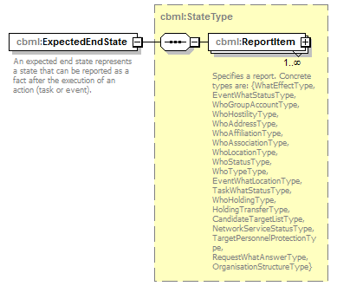
namespace | http://www.sisostds.org/schemas/c-bml/1.0
type | cbml:StateType
properties
  content | complex
children | cbml:ReportItem
annotation
  documentation
  An expected end state represents a state that can be reported as a fact after the execution of an action (task or event).
source | <xs:element name="ExpectedEndState" type="cbml:StateType">  <xs:annotation>  <xs:documentation xml:lang="en">An expected end state represents a state that can be reported as a fact after the execution of an action (task or event).</xs:documentation>  </xs:annotation>  </xs:element>

XML Schema documentation generated by XMLSpy Schema Editor http://www.altova.com/xmlspy

