DIVIDER4_5详细设计方案

DIVIDER4_5简介：
4.5分频电路设计

DIVIDER4_5规格：
4.5分频

实现原理
使用计数器实现。实现原理时序图如下：
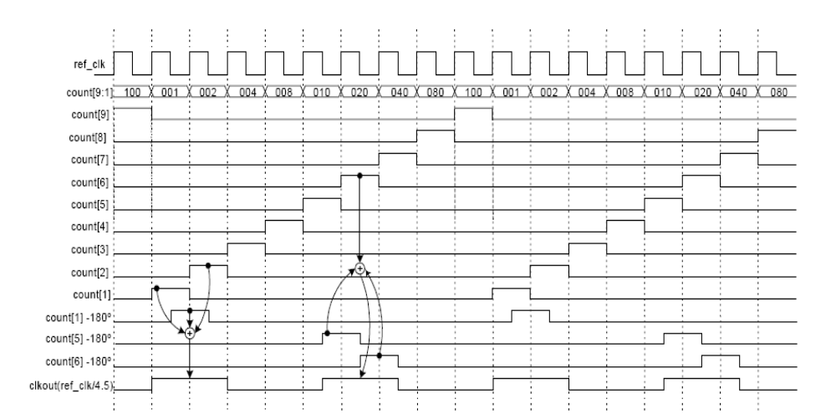

Verilog HDL源代码
Verilog HDL代码为：

module divider4_5 (
//input
sys_clk ,
sys_rst_n ,
data_in ,

//output
clkout
);

//parameter define
parameter WIDTH = 10;
parameter SIZE = 8;

//input ports

input sys_clk ; //system clock;
input sys_rst_n ; //system reset, low is active;
input [WIDTH-1:0] data_in ; //input data

//output ports
output clkout ;

//reg define
reg [WIDTH-1:1] count ;

reg ps_count1 ;
reg ps_count5 ;
reg ps_count6 ;

//wire define

/*******************************************************************************************************
** Main Program
**
********************************************************************************************************/

/* Counter implementation, reset value : 9’b000000001 */
always @( posedge sys_clk or negedge sys_rst_n) begin
if (!sys_rst_n)
count[9:1] <= 9'b000000001 ;
else if (count[9] == 1'b1) begin
count[9:1] <= 9'b000000001 ;
end
else begin
count[9:1] <= count[9:1] << 1;
end
end
/*count bit 1st, 5th and 6th phase shifter by 180o */
always @(negedge sys_clk or negedge sys_rst_n) begin
if (!sys_rst_n) begin
ps_count1 <= 1'b0;
ps_count5 <= 1'b0;
ps_count6 <= 1'b0;
end
else begin
ps_count1 <= count[1];
ps_count5 <= count[5];
ps_count6 <= count[6];
end
end

// generation of final output clock = (sys_clk /4.5)
assign clkout = (ps_count5 | ps_count6 | count[6]) |
(count[1] | count[2] | ps_count1);

endmodule
//end of RTL code

日积月累
仿真得到的波形数据：

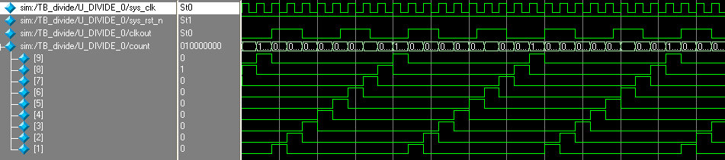

综合出的电路
divider4_5代码综合出的电路如下：
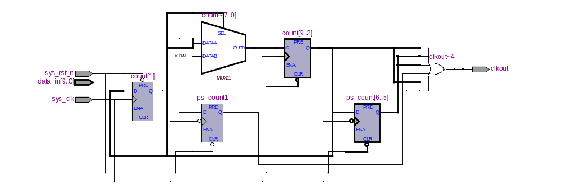

2009-10-25 (C) DongDong Stduio

