DIVIDER7_FSM详细设计方案

DIVIDER7_FSM简介：
状态机实现分频器

DIVIDER7_FSM规格：
状态机实现分频器

实现原理
状态机的状态作为控制输出时钟跳变。
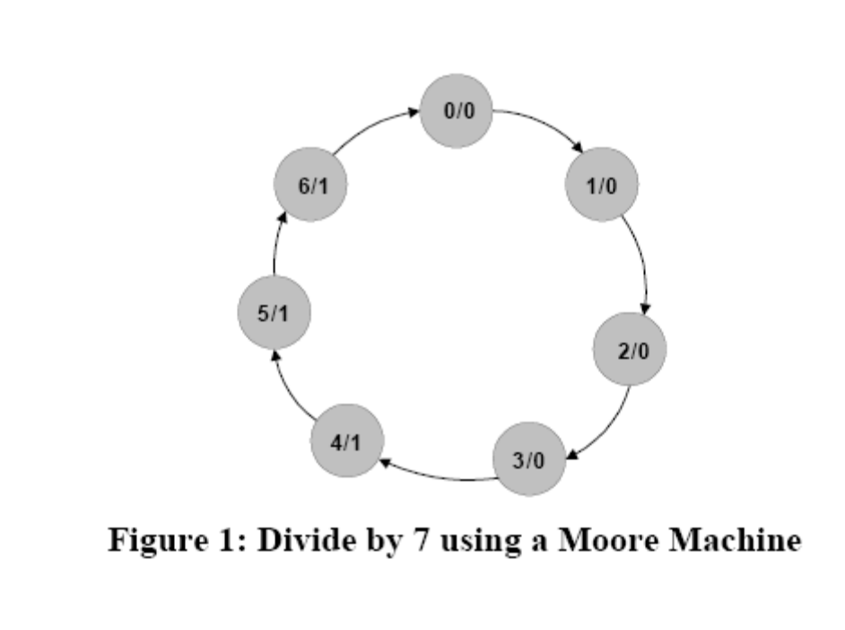

Verilog HDL源代码
Verilog HDL代码为：

module divider7_fsm (
//input
sys_clk ,
sys_rst_n ,

//output
clk_divide_7
);

//input ports

input sys_clk ; //system clock;
input sys_rst_n ; //system reset, low is active;

//output ports
output [WIDTH-1:0] clk_divide_7 ; //output divide 7 clk

//reg define
reg [6:0] curr_st ;
reg [6:0] next_st ;

reg clk_divide_7 ;

//wire define

//parameter define
parameter WIDTH = 1;
parameter SIZE = 8;

parameter S0 = 7'b0000000;
parameter S1 = 7'b0000001;
parameter S2 = 7'b0000010;
parameter S3 = 7'b0000100;
parameter S4 = 7'b0001000;
parameter S5 = 7'b0010000;
parameter S6 = 7'b0100000;

/*******************************************************************************************************
** Main Program
**
********************************************************************************************************/

always @(posedge sys_clk or negedge sys_rst_n) begin
if (sys_rst_n ==1'b0) begin
curr_st <= 7'b0;
end
else begin
curr_st <= next_st;
end
end

always @(*) begin
case (curr_st)
S0: begin
next_st = S1;
end
S1: begin
next_st = S2;
end
S2: begin
next_st = S3;
end
S3: begin
next_st = S4;
end
S4: begin
next_st = S5;
end
S5: begin
next_st = S6;
end
S6: begin
next_st = S0;
end
default: next_st = S0;
endcase
end

always @(posedge sys_clk or negedge sys_rst_n) begin
if (sys_rst_n ==1'b0) begin
clk_divide_7 <= 1'b0;
end
else if ((curr_st == S0) | (curr_st == S1) | (curr_st == S2) | (curr_st == S3))
clk_divide_7 <= 1'b0;
else if ((curr_st == S4) | (curr_st == S5) | (curr_st == S6))
clk_divide_7 <= 1'b1;
else
;
end

endmodule
//end of RTL code

日积月累
Xxx

综合出的电路
divider7_fsm代码综合出的电路如下：
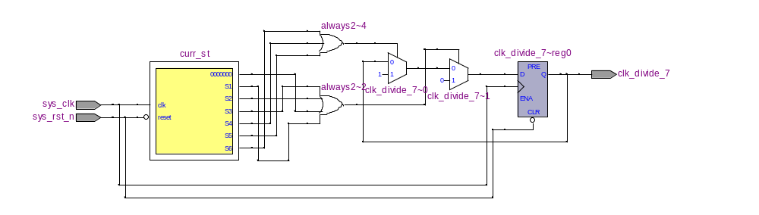
2009-10-25 (C) DongDong Stduio

