Sandeep Heera

Strassen’s Matrix Multiplication Algorithm

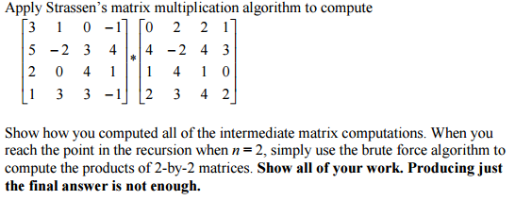

Let *A* be the matrix:

$$\left[\begin{matrix}3 & 1 & 0 & -1 \\ 5 & -2 & 3 & 4 \\ 2 & 0 & 4 & 1 \\ 1 & 3 & 3 & -1\end{matrix}\right]$$

*B* be the matrix:

$$\left[\begin{matrix}0 & 2 & 2 & 1 \\ 4 & -2 & 4 & 3 \\ 1 & 4 & 1 & 0 \\ 2 & 3 & 4 & 2\end{matrix}\right]$$

And *C* be the product of these two matrices:

$$\left[\begin{matrix}C_{00} & C_{01} & C_{02} & C_{03} \\ C_{10} & C_{11} & C_{12} & C_{13} \\ C_{20} & C_{21} & C_{22} & C_{23} \\ C_{30} & C_{31} & C_{32} & C_{33}\end{matrix}\right]$$

The two matrices are *n* x *n* matrices where *n* is a power of 2 (22) so we don’t need to pad the matrices with additional rows and columns of zeros. Strassen’s matrix multiplication algorithm tells us that we can divide *A*, *B*, and *C* into four *n*/2 x *n*/2 submatrices (from pg. 190 in the text):

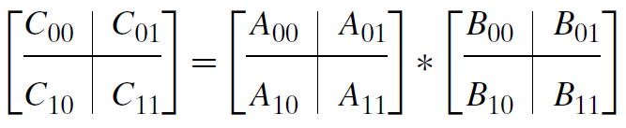

In accordance with Strassen’s matrix multiplication algorithm, we are to compute the 7 products of the resulting submatrices recursively. Dividing the matrices into *n*/2 x *n*/2 partitions yields 2 x 2 matrices (*n* = 2). To compute each submatrix, we apply Strassen’s matrix multiplication algorithm (from pg. 189 in the textbook):

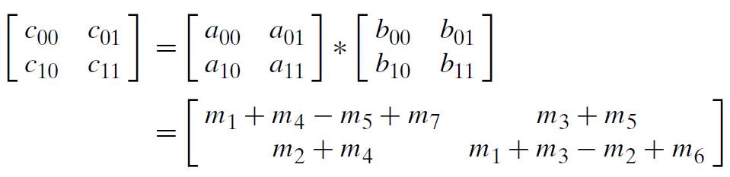

We replace *c00* with *C00* and do the same for all remaining submatrices of *A*, *B*, and *C*:

$$\left[\begin{matrix}C_{00} & C_{01} \\ C_{10} & C_{11}\end{matrix}\right]=\left[\begin{matrix}A_{00} & A_{01} \\ A_{10} & A_{11}\end{matrix}\right]*\left[\begin{matrix}B_{00} & B_{01} \\ B_{10} & B_{11}\end{matrix}\right]=$$

$$\left[\begin{matrix}M_{1}+M_{4}-M_{5}+M_{7} & M_{3}+M_{5} \\ M_{2}+M_{4} & M_{1}+M_{3}-M_{2}+M_{6}\end{matrix}\right]$$

Compute *M1*-*M7* by Strassen’s formulas:

$$M_{1}=\left(A_{00}+A_{11}\right)*\left(B_{00}+B_{11}\right)=$$

$$\left(\left[\begin{matrix}3 & 1 \\ 5 & -2\end{matrix}\right]+\left[\begin{matrix}4 & 1 \\ 3 & -1\end{matrix}\right]\right)*\left(\left[\begin{matrix}0 & 2 \\ 4 & -2\end{matrix}\right]+\left[\begin{matrix}1 & 0 \\ 4 & 2\end{matrix}\right]\right)=$$

$$\left[\begin{matrix}7 & 2 \\ 8 & -3\end{matrix}\right]*\left[\begin{matrix}1 & 2 \\ 8 & 0\end{matrix}\right]=\left[\begin{matrix}7*1+2*8 & 7*2+2*0 \\ 8*1+(-3)*8 & 8*2+(-3)*0\end{matrix}\right]=\left[\begin{matrix}23 & 14 \\ -16 & 16\end{matrix}\right]$$

$$M_{2}=\left(A_{10}+A_{11}\right)*B_{00}=$$

$$\left(\left[\begin{matrix}2 & 0 \\ 1 & 3\end{matrix}\right]+\left[\begin{matrix}4 & 1 \\ 3 & -1\end{matrix}\right]\right)*\left[\begin{matrix}0 & 2 \\ 4 & -2\end{matrix}\right]=$$

$$\left[\begin{matrix}6 & 1 \\ 4 & 2\end{matrix}\right]*\left[\begin{matrix}0 & 2 \\ 4 & -2\end{matrix}\right]=\left[\begin{matrix}6*0+1*4 & 6*2+1*-2 \\ 4*0+2*4 & 4*2+2*-2\end{matrix}\right]=\left[\begin{matrix}4 & 10 \\ 8 & 4\end{matrix}\right]$$

$$M_{3}=A_{00}*\left(B_{01}-B_{11}\right)=$$

$$\left[\begin{matrix}3 & 1 \\ 5 & -2\end{matrix}\right]*\left(\left[\begin{matrix}2 & 1 \\ 4 & 3\end{matrix}\right]-\left[\begin{matrix}1 & 0 \\ 4 & 2\end{matrix}\right]\right)=\left[\begin{matrix}3 & 1 \\ 5 & -2\end{matrix}\right]*\left[\begin{matrix}1 & 1 \\ 0 & 1\end{matrix}\right]=\left[\begin{matrix}3*1+1*0 & 3*1+1*1 \\ 5*1+(-2)*0 & 5*1+(-2)*1\end{matrix}\right]=$$

$$\left[\begin{matrix}3 & 4 \\ 5 & 3\end{matrix}\right]$$

$$M_{4}=A_{11}*\left(B_{10}-B_{00}\right)=$$

$$\left[\begin{matrix}4 & 1 \\ 3 & -1\end{matrix}\right]*\left(\left[\begin{matrix}1 & 4 \\ 2 & 3\end{matrix}\right]-\left[\begin{matrix}0 & 2 \\ 4 & -2\end{matrix}\right]\right)=\left[\begin{matrix}4 & 1 \\ 3 & -1\end{matrix}\right]*\left[\begin{matrix}1 & 2 \\ -2 & 5\end{matrix}\right]=$$

$$\left[\begin{matrix}4*1+1*-2 & 4*2+1*5 \\ 3*1+(-1)*-2 & 3*2+\left(-1\right)*5\end{matrix}\right]=\left[\begin{matrix}2 & 13 \\ 5 & 1\end{matrix}\right]$$

$$M_{5}=\left(A_{00}+A_{01}\right)*B_{11}=$$

$$\left(\left[\begin{matrix}3 & 1 \\ 5 & -2\end{matrix}\right]+\left[\begin{matrix}0 & -1 \\ 3 & 4\end{matrix}\right]\right)*\left[\begin{matrix}1 & 0 \\ 4 & 2\end{matrix}\right]=\left[\begin{matrix}3 & 0 \\ 8 & 2\end{matrix}\right]*\left[\begin{matrix}1 & 0 \\ 4 & 2\end{matrix}\right]=\left[\begin{matrix}3*1+0*4 & 3*0+0*2 \\ 8*1+2*4 & 8*0+2*2\end{matrix}\right]=$$

$$\left[\begin{matrix}3 & 0 \\ 16 & 4\end{matrix}\right]$$

$$M_{6}=\left(A_{10}-A_{00}\right)*\left(B_{00}+B_{01}\right)=$$

$$\left(\left[\begin{matrix}2 & 0 \\ 1 & 3\end{matrix}\right]-\left[\begin{matrix}3 & 1 \\ 5 & -2\end{matrix}\right]\right)*\left(\left[\begin{matrix}0 & 2 \\ 4 & -2\end{matrix}\right]+\left[\begin{matrix}2 & 1 \\ 4 & 3\end{matrix}\right]\right)=$$

$$\left[\begin{matrix}-1 & -1 \\ -4 & 5\end{matrix}\right]*\left[\begin{matrix}2 & 3 \\ 8 & 1\end{matrix}\right]=\left[\begin{matrix}-1*2+\left(-1\right)*8 & -1*3+\left(-1\right)*1 \\ -4*2+5*8 & -4*3+5*1\end{matrix}\right]=\left[\begin{matrix}-10 & -4 \\ 32 & -7\end{matrix}\right]$$

$$M_{7}=\left(A_{01}-A_{11}\right)*\left(B_{10}+B_{11}\right)=$$

$$\left(\left[\begin{matrix}0 & -1 \\ 3 & 4\end{matrix}\right]-\left[\begin{matrix}4 & 1 \\ 3 & -1\end{matrix}\right]\right)*\left(\left[\begin{matrix}1 & 4 \\ 2 & 3\end{matrix}\right]+\left[\begin{matrix}1 & 0 \\ 4 & 2\end{matrix}\right]\right)=\left[\begin{matrix}-4 & -2 \\ 0 & 5\end{matrix}\right]*\left[\begin{matrix}2 & 4 \\ 6 & 5\end{matrix}\right]=$$

$$\left[\begin{matrix}-4*2+\left(-2\right)*6 & -4*4+\left(-2\right)*5 \\ 0*2+5*6 & 0*4+5*5\end{matrix}\right]=\left[\begin{matrix}-20 & -26 \\ 30 & 25\end{matrix}\right]$$

$$C_{00}=\left[M_{1}+M_{4}-M_{5}+M_{7}\right]=$$

$$\left[\left[\begin{matrix}23 & 14 \\ -16 & 16\end{matrix}\right]+\left[\begin{matrix}2 & 13 \\ 5 & 1\end{matrix}\right]-\left[\begin{matrix}3 & 0 \\ 16 & 4\end{matrix}\right]+\left[\begin{matrix}-20 & -26 \\ 30 & 25\end{matrix}\right]\right]=$$

$$\left[\left[\begin{matrix}25 & 27 \\ -11 & 17\end{matrix}\right]-\left[\begin{matrix}3 & 0 \\ 16 & 4\end{matrix}\right]+\left[\begin{matrix}-20 & -26 \\ 30 & 25\end{matrix}\right]\right]=$$

$$\left[\left[\begin{matrix}22 & 27 \\ -27 & 13\end{matrix}\right]+\left[\begin{matrix}-20 & -26 \\ 30 & 25\end{matrix}\right]\right]=\left[\begin{matrix}2 & 1 \\ 3 & 38\end{matrix}\right]$$

$$C_{01}=\left[M_{3}+M_{5}\right]=\left[\left[\begin{matrix}3 & 4 \\ 5 & 3\end{matrix}\right]+\left[\begin{matrix}3 & 0 \\ 16 & 4\end{matrix}\right]\right]=\left[\begin{matrix}6 & 4 \\ 21 & 7\end{matrix}\right]$$

$$C_{10}=\left[M_{2}+M_{4}\right]=\left[\left[\begin{matrix}4 & 10 \\ 8 & 4\end{matrix}\right]+\left[\begin{matrix}2 & 13 \\ 5 & 1\end{matrix}\right]\right]=\left[\begin{matrix}6 & 23 \\ 13 & 5\end{matrix}\right]$$

$$C_{11}=\left[M_{1}+M_{3}-M_{2}+M_{6}\right]=$$

$$\left[\left[\begin{matrix}23 & 14 \\ -16 & 16\end{matrix}\right]+\left[\begin{matrix}3 & 4 \\ 5 & 3\end{matrix}\right]-\left[\begin{matrix}4 & 10 \\ 8 & 4\end{matrix}\right]+\left[\begin{matrix}-10 & -4 \\ 32 & -7\end{matrix}\right]\right]=$$

$$\left[\left[\begin{matrix}26 & 18 \\ -11 & 19\end{matrix}\right]-\left[\begin{matrix}4 & 10 \\ 8 & 4\end{matrix}\right]+\left[\begin{matrix}-10 & -4 \\ 32 & -7\end{matrix}\right]\right]=$$

$$\left[\left[\begin{matrix}22 & 8 \\ -19 & 15\end{matrix}\right]+\left[\begin{matrix}-10 & -4 \\ 32 & -7\end{matrix}\right]\right]=\left[\begin{matrix}12 & 4 \\ 13 & 8\end{matrix}\right]$$

The final resulting matrix *C* will be:

$$C=\left[\begin{matrix}C_{00} & C_{01} \\ C_{10} & C_{11}\end{matrix}\right]=$$

$$\left[\begin{matrix}2 & 1 & 6 & 4 \\ 3 & 38 & 21 & 7 \\ 6 & 23 & 12 & 4 \\ 13 & 5 & 13 & 8\end{matrix}\right]$$