Hi Team,

Please find the attached terraform code to,

# Commission and decommission the infrastructure with just one command.

# This script creates a VPC with 4 subnets ie 1Public and 1Private each in 2 different availability zone.

# Route table and association and internet to the public routing is also done.

# A security group is also created allowing ssh, http and https.

# Creates 2 instances webserver1 and webserver2 in public subnets in both the availability zone. User data has been passed from files (install_httpd1 and install_httpd2) to install http and display a message on the url.

# A classic ELB is also created to load balance the request. A bucket should be already created in our account with public access or a instance role should be created to have permission to communicate with S3 service.

# The ElB URL can be mapped with route53 to serve requests from ([www.example.com](http://www.example.com)) - This has not been done in this script as i have not purchased any domain.

User data to be saved on sever,

[root@ip-172-31-86-184 terraform-projects]# cat install_httpd1.sh

#! /bin/bash

sudo yum install httpd -y

sudo yum update -y

sudo service httpd start

sudo chkconfig on

echo "<h1>Deployed via Terraform on webserver1</h1>" | sudo tee /var/www/html/index.html

[root@ip-172-31-86-184 terraform-projects]# cat install_httpd2.sh

#! /bin/bash

sudo yum install httpd -y

sudo yum update -y

sudo service httpd start

sudo chkconfig on

echo "<h1>Deployed via Terraform on webserver2</h1>" | sudo tee /var/www/html/index.html

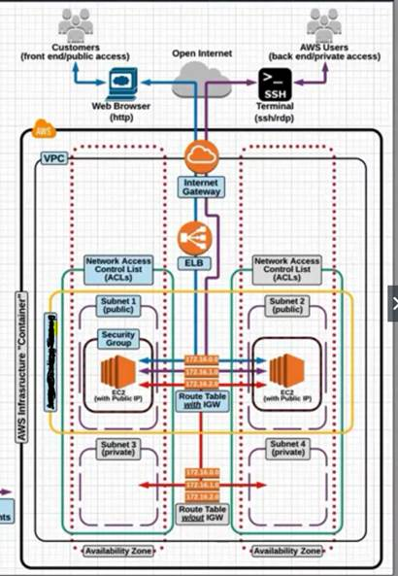

Output,

Just one command terraform apply to commission the whole architecture,

terraform apply

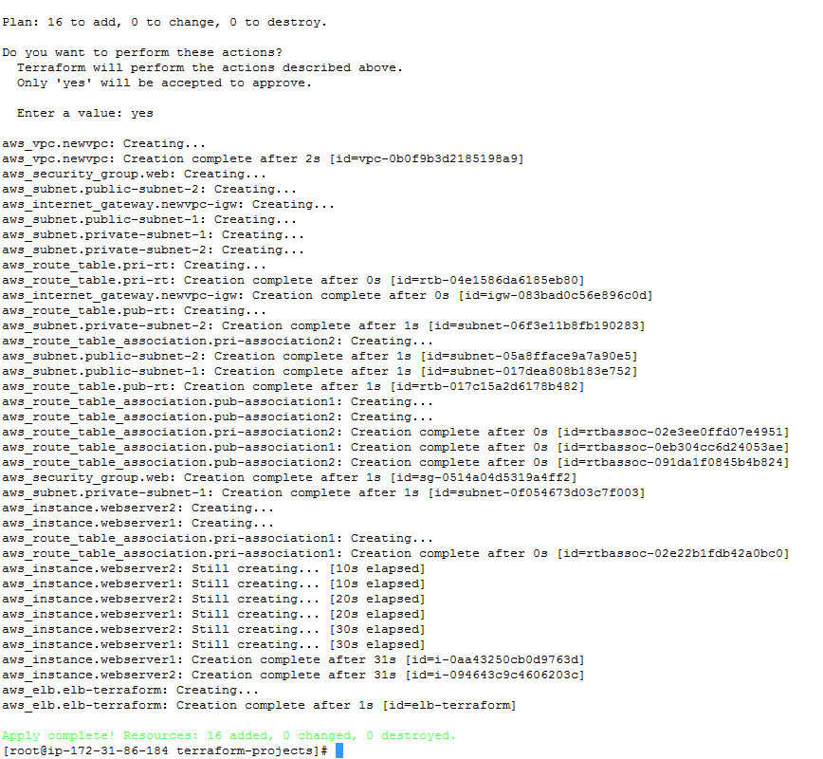

cid:image014.jpg@01D59603.97A6FFB0

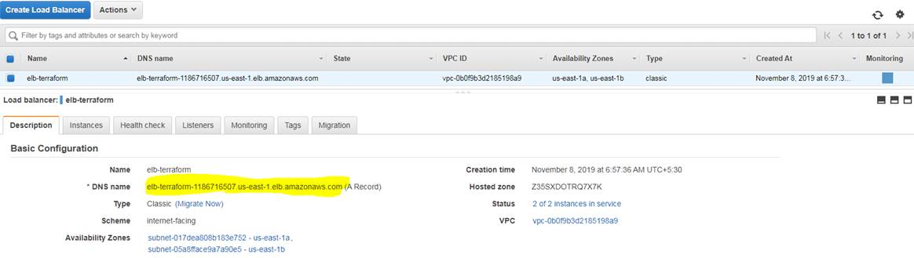

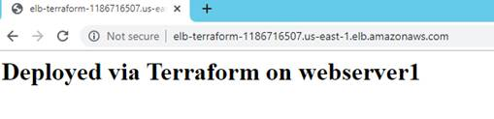

Getting load balanced across 2 AZ’s.

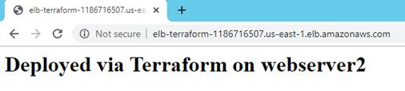

Now, Just one command to decommission everything, terraform destroy

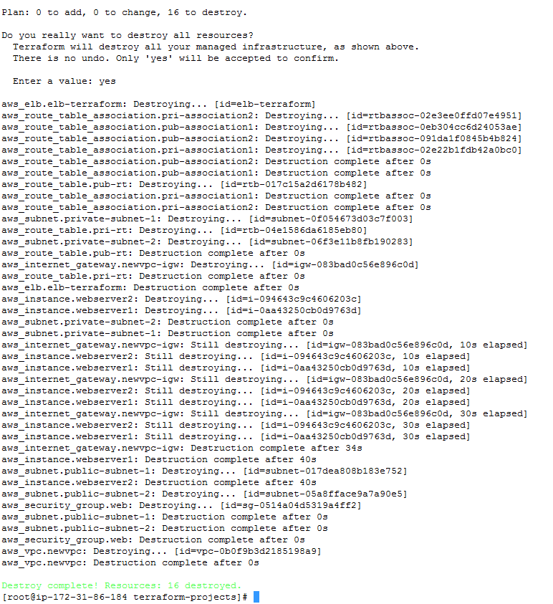

All the resources have been decommissioned.

Thanks,

Mohamed Sheeraz