Genetic Algorithm for Multi-UAV Disaster Surveillance
Artificial Intelligence — BSCS 5
Bahria University, Lahore Campus
Name: ____________________ Roll No: ____________________

1. Introduction
The task is to coordinate a fleet of unmanned aerial vehicles (UAVs) on a discretized hazard grid. The strategy must maximize high-priority area coverage and target detection while reducing energy use, flight time, and exposure to hazardous or restricted cells. A Genetic Algorithm (GA) is suitable because route planning combines discrete spatial choices with continuous speed and sensor-control decisions, producing a large search space that is difficult to optimize with a simple deterministic rule.

2. Chromosome Representation
A candidate solution contains three drone plans. Each drone has seven ordered waypoints (x, y), seven speed multipliers, and seven sensor-power values. The start point of each drone is fixed. Coordinates are integers in [0, 29], speed multipliers are bounded to [0.6, 1.4], and sensor power is bounded to [0.2, 1.0]. This hybrid representation encodes spatial route decisions and continuous control choices in one chromosome. A waypoint determines the next route segment; speed affects estimated flight time and energy, while sensor power affects detection radius and energy consumption.

3. Multi-objective Fitness Function
The implementation converts the competing objectives into a weighted scalar score to make parent selection straightforward: F(S) = 18C(S) − 0.30E(S) − 0.12T(S) − 1.8H(S) − 30N(S) − 8R(S). C is weighted detected-target coverage, E is estimated energy, T is estimated flight time, H is accumulated hazard exposure, N is the number of sampled intersections with no-fly cells, and R is the amount of route distance exceeding the allowed range. Coverage receives a positive reward; all other terms are penalties. The large no-fly penalty expresses the importance of restricted-airspace safety. The coefficients are heuristic and should be tuned after examining metric scales. A weighted sum is a practical compromise, but it does not guarantee a Pareto-optimal solution.

4. Genetic Operators and Constraint Handling
Tournament selection samples four candidates and chooses the highest-fitness candidate as a parent. Segment crossover combines waypoint, speed, and sensor segments from two parents. Mutation perturbs waypoint coordinates and applies small Gaussian changes to speed and sensor power. Elitism copies the best three candidates unchanged into the next generation. A repair step clamps coordinates and control values to legal bounds. No-fly-zone intersections and excessive route length are penalized in the fitness score. For a safety-critical implementation, penalty handling should be strengthened by repairing every segment with grid-based A* or another collision-free planner; the present straight-line segment approximation is intended for teaching and visualization only.

5. Experimental Setup and Visualization
The baseline experiment uses a 30 × 30 grid, three drones, seven waypoints per drone, a population of 60, 100 generations, mutation rate 0.12, tournament size 4, and three elite individuals. The synthetic environment contains restricted cells, two weighted hazard regions, and six target locations. Running main.py produces a best-versus-average fitness convergence curve, an evolved route plot, a route-traversal heatmap, and a JSON file containing the final fitness and evaluation metrics. The outputs should be included as figures in the submitted report after running the program.

6. Hyperparameter Sensitivity Analysis
Population size controls the diversity of candidate routes. A larger population explores more possibilities but increases computation per generation; a small population may converge prematurely. Mutation rate balances local refinement and exploration: a low rate can freeze poor waypoint choices, while a high rate can destroy useful route segments. Tournament size controls selection pressure. Larger tournaments favor high-fitness parents and may reduce diversity; smaller tournaments maintain variety but may slow improvement. For an empirical sensitivity study, run population sizes 30, 60, and 100; mutation rates 0.05, 0.12, and 0.25; and tournament sizes 2, 4, and 7, changing one parameter at a time and repeating each setting with multiple random seeds. Record the mean and spread of final best fitness. These are expected effects, not measured results, until the experiments are run.

7. Comparison with Random Search
Random search samples new candidates independently and does not use feedback from previous fitness scores to generate the next sample. The GA uses selection and crossover to reuse parts of high-scoring candidates, while mutation explores new variants. This gives the GA a mechanism for accumulating improvements over generations, although performance depends on encoding, weights, and parameter settings. A fair comparison should evaluate random search and GA using the same number of fitness evaluations and repeat both across multiple random seeds. Report the final best fitness and the convergence trend. Do not claim a numerical advantage until the baseline has actually been implemented and measured.

8. Conclusion
The proposed design combines a hybrid chromosome, weighted fitness function, tailored crossover and mutation, elitism, and constraint penalties to evolve candidate UAV surveillance routes. The generated plots help assess convergence, route geometry, and traversal coverage. Limitations include simplified sensor detection, approximate line sampling, and the use of a weighted sum rather than a Pareto-front optimizer. Before any real-world use, the system would require collision-free route repair, realistic battery and sensor models, robust constraint enforcement, and validation against flight-safety requirements.

References / implementation note
The implementation is provided with this report in main.py. It uses Python, NumPy, and Matplotlib. All environment locations and numeric parameters are synthetic educational assumptions.

Appendix: Simulation Outputs
Baseline run generated by main.py (fixed random seed 42).
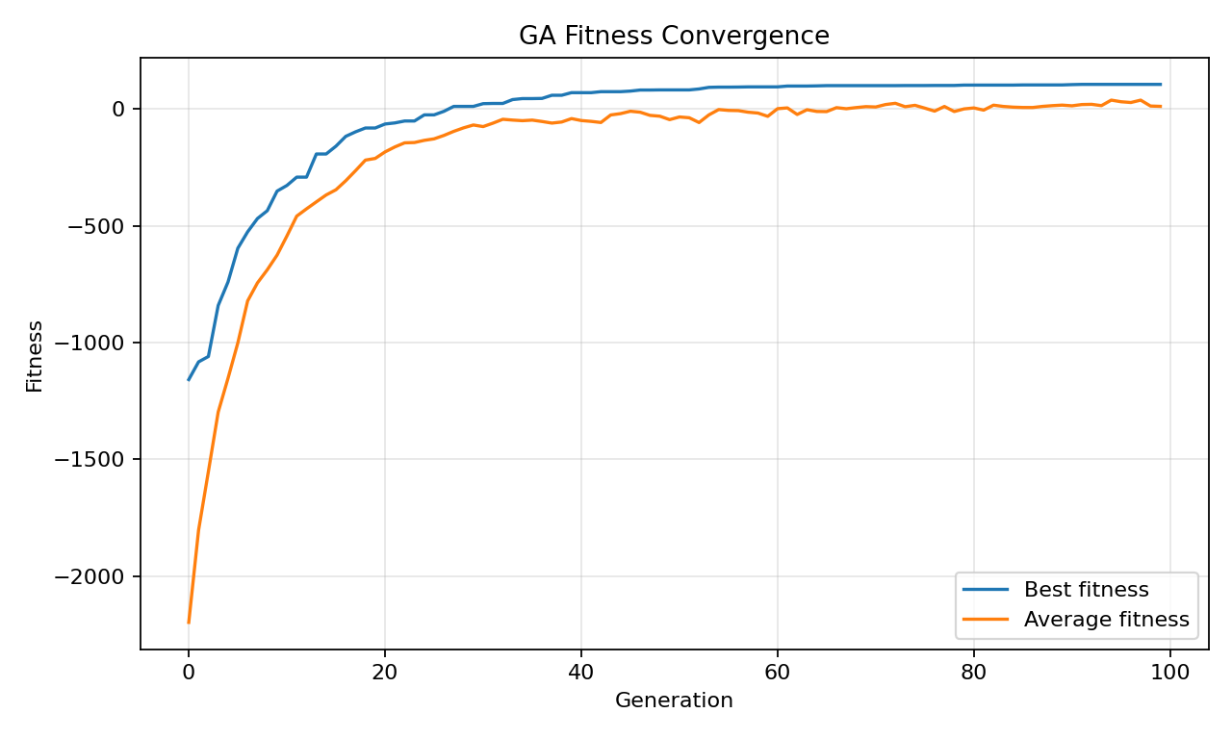
Figure 1. Best and average fitness across generations.
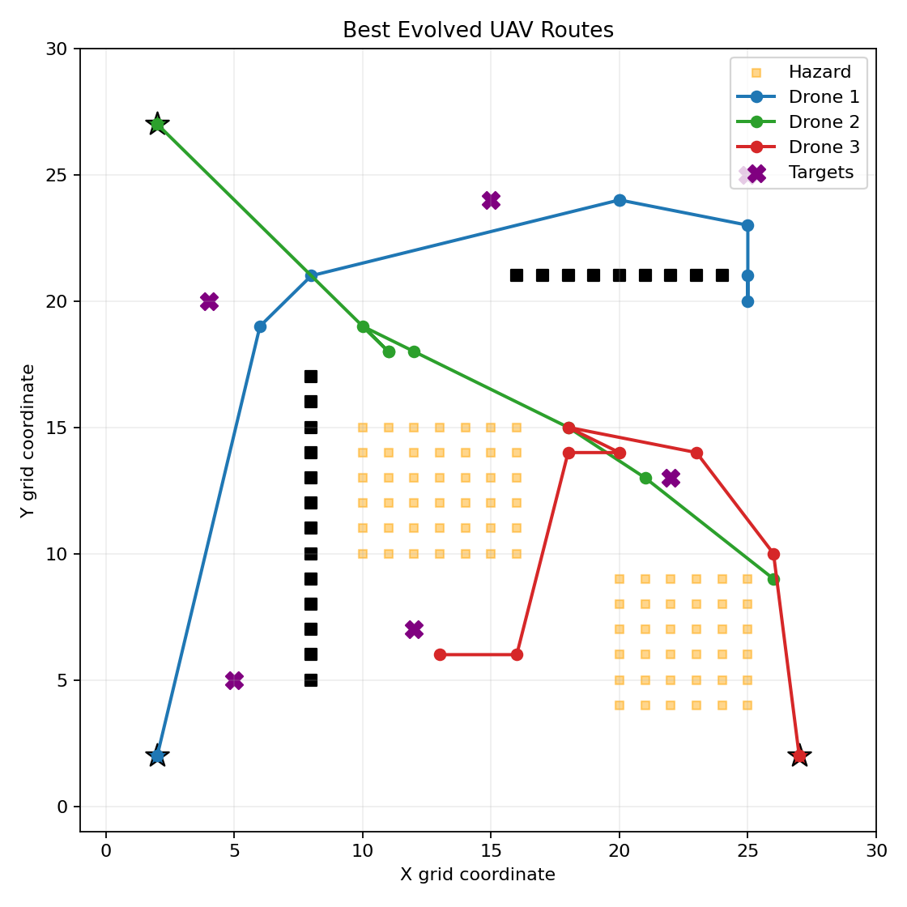
Figure 2. Evolved waypoint routes, hazard cells, targets, and no-fly zones.
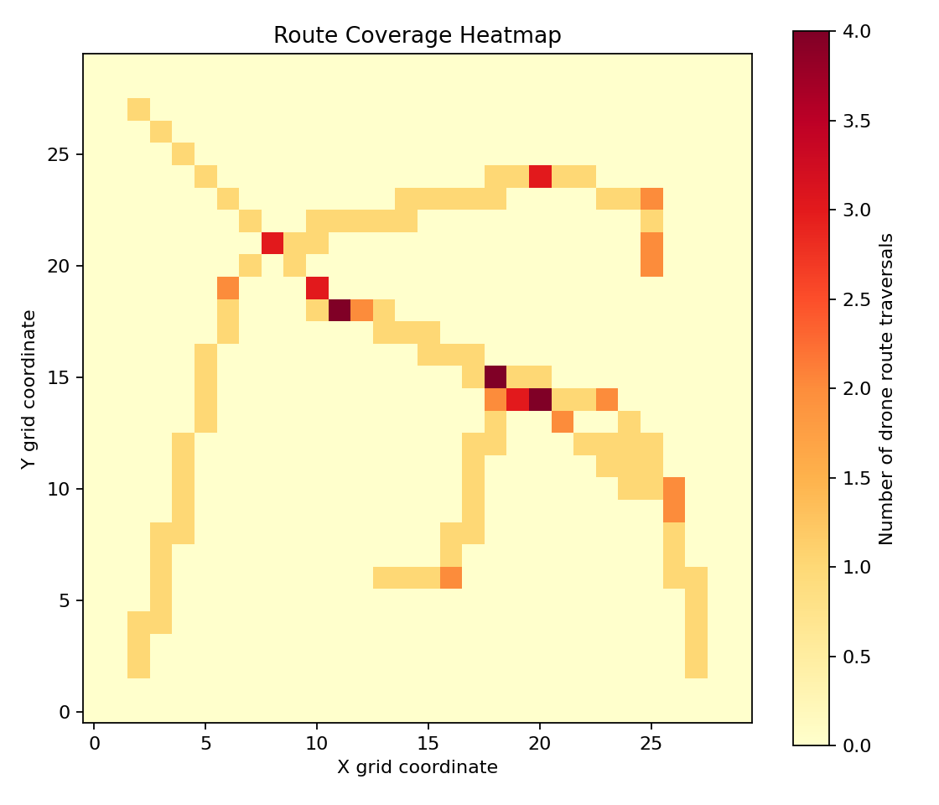
Figure 3. Route traversal heatmap for the best evolved candidate.

