Measure-Weighted Sampling: Grand Experiment Update
Using NN-PR/Taylor-PR distance as an operational gate for D-optimal transfer
Scale | n=10000; p=20 and p=50; five dataset families; five data seeds; two pilot seeds
Strategies | Measure-weighted, random, D-optimal, and Latin hypercube
Batch design | 5% uniform pilot, 500 new points per round, six batch updates
Main rule | mean(d_FPR, d_TYPR) mapped to a 30%-95% D-optimal fraction

Main finding The distance measure is best interpreted as a transfer gate. Small NN-PR/Taylor-PR distance justifies more D-optimal transfer; large distance preserves random exploration and reduces negative transfer risk.

1. Workflow
In real applications the distance between a trained NN and a PR model is not known in advance. The workflow therefore starts with a uniform pilot sample, trains an initial NN, measures NN-FPR and NN-Taylor-PR distances, normalizes the distance, and uses the resulting weight to choose the D-optimal/random mix in the next batch.
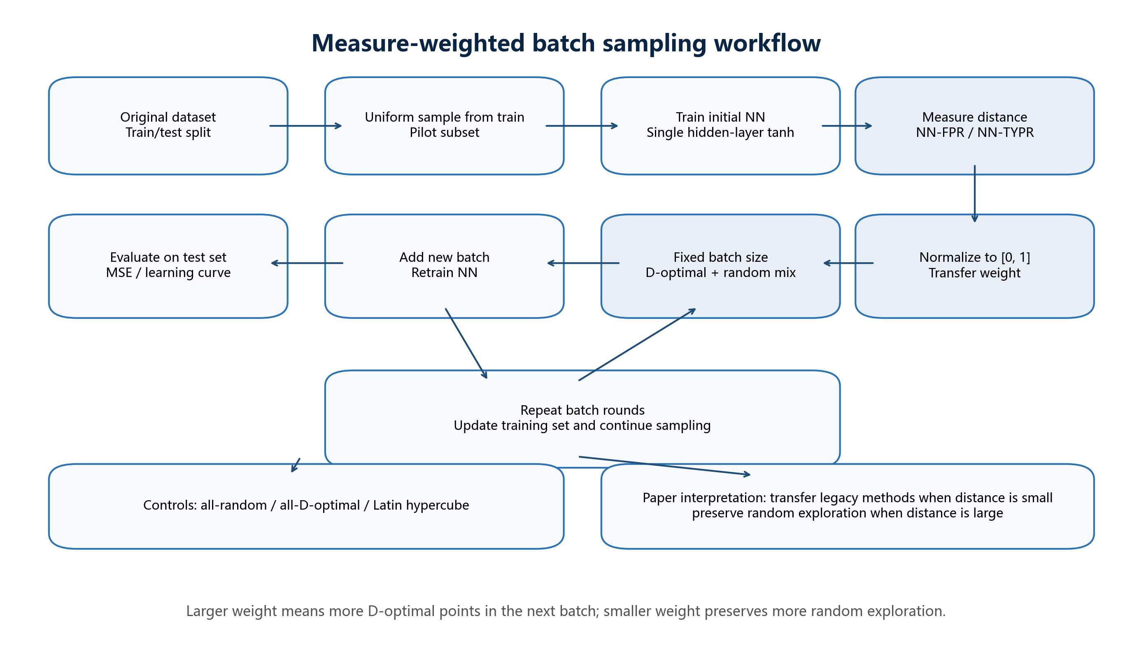
Figure 1. Measure-weighted batch sampling workflow

2. Experimental Design
- Each dataset is split into 75% training and 25% testing; 5% of the training split is used as a uniform pilot subset.
- A single-hidden-layer tanh NN is trained on the pilot subset; NN-FPR and NN-Taylor-PR distances are measured on pilot validation points.
- The main rule uses mean(d_FPR, d_TYPR), not min(...), so high-dimensional false positives do not trigger excessive D-optimal transfer.
- Each batch adds 500 points. The measure-weighted policy mixes D-optimal and random points; controls use all-random, all-D-optimal, and Latin hypercube selection.

3. Main Results
p | Strategy | Final MSE | Gain vs random | Positive rate | Runs
20 | Latin hypercube | 0.004811 | 5.79% | 76.0% | 50
20 | D-optimal | 0.004986 | 4.11% | 76.0% | 50
20 | Measure-weighted | 0.004993 | 4.40% | 72.0% | 50
20 | Random | 0.005113 | 0.00% | 0.0% | 50
50 | Latin hypercube | 0.018574 | 0.17% | 46.0% | 50
50 | Random | 0.018808 | 0.00% | 0.0% | 50
50 | Measure-weighted | 0.019143 | 0.50% | 54.0% | 50
50 | D-optimal | 0.019594 | -1.85% | 48.0% | 50

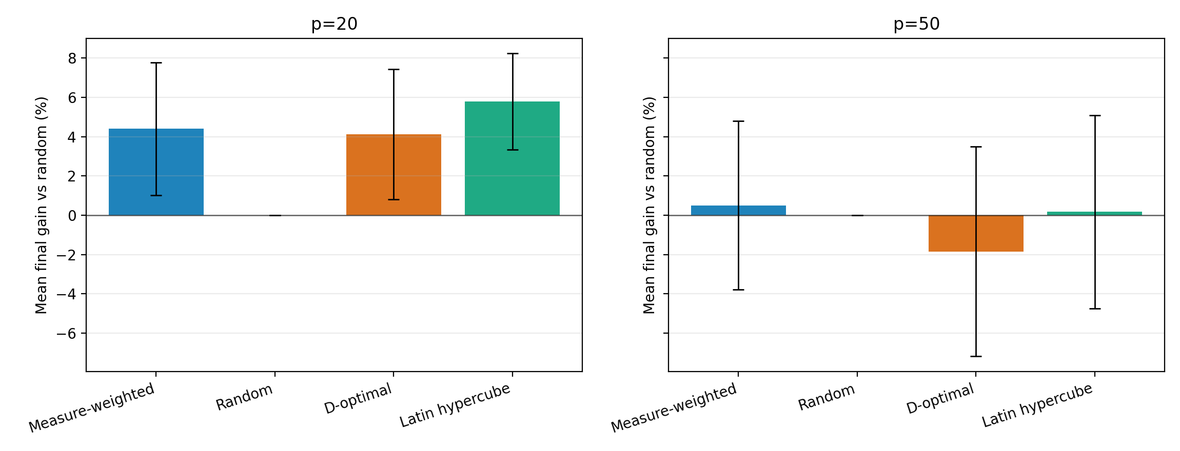
Figure 2. Final gain versus random sampling by dimension
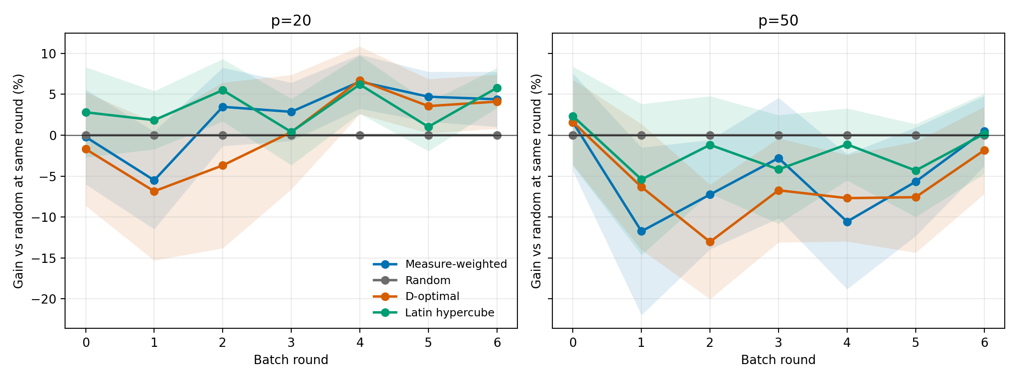
Figure 3. Learning-curve gain over multiple batch rounds

4. Case-Level Results
The measure-weighted policy is positive on most p=20 cases and mitigates the p=50 failure of all-D-optimal sampling. It is strongest on local-interior structure and remains useful in high-frequency stress tests, although Latin hypercube can still be stronger when global coverage dominates.
p | Dataset | Measure-weighted MSE | Gain vs random | Positive rate
20 | High-frequency | 0.010106 | -9.52% | 40.0%
20 | Local interior | 0.003893 | 5.82% | 80.0%
20 | Quadratic | 0.007036 | 8.24% | 90.0%
20 | Smooth | 0.002244 | 8.96% | 90.0%
20 | Strong nonlinear | 0.001685 | 8.48% | 60.0%
50 | High-frequency | 0.022579 | 0.24% | 60.0%
50 | Local interior | 0.008042 | 13.55% | 80.0%
50 | Quadratic | 0.049157 | -8.05% | 30.0%
50 | Smooth | 0.010861 | -2.91% | 30.0%
50 | Strong nonlinear | 0.005076 | -0.33% | 70.0%

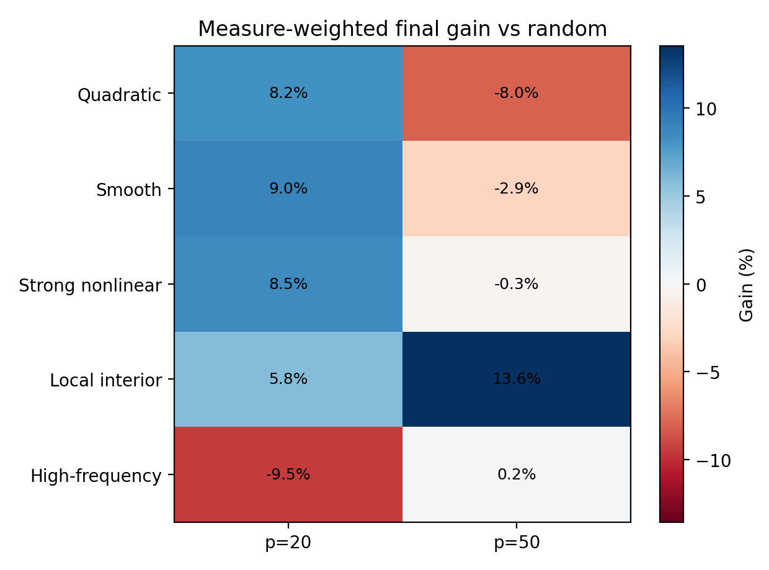
Figure 4. Case-level gain of the measure-weighted policy

5. Weight Calibration
The learned weights are not hard-coded by dataset label. They change with the pilot run. This is the operational value of the measure: it converts an observed NN-PR/Taylor-PR relation into a concrete sampling fraction.
p | Dataset | Mean FPR distance | Mean TYPR distance | Mean D-opt fraction
20 | High-frequency | 0.22958 | 0.94323 | 0.323
20 | Local interior | 0.08290 | 0.90947 | 0.551
20 | Quadratic | 0.04888 | 0.92314 | 0.579
20 | Smooth | 0.01406 | 0.78233 | 0.779
20 | Strong nonlinear | 0.01903 | 0.80521 | 0.749
50 | High-frequency | 0.01115 | 0.87244 | 0.377
50 | Local interior | 0.00287 | 0.69602 | 0.545
50 | Quadratic | 0.00381 | 0.67319 | 0.578
50 | Smooth | 0.00507 | 0.53331 | 0.694
50 | Strong nonlinear | 0.00797 | 0.42922 | 0.815

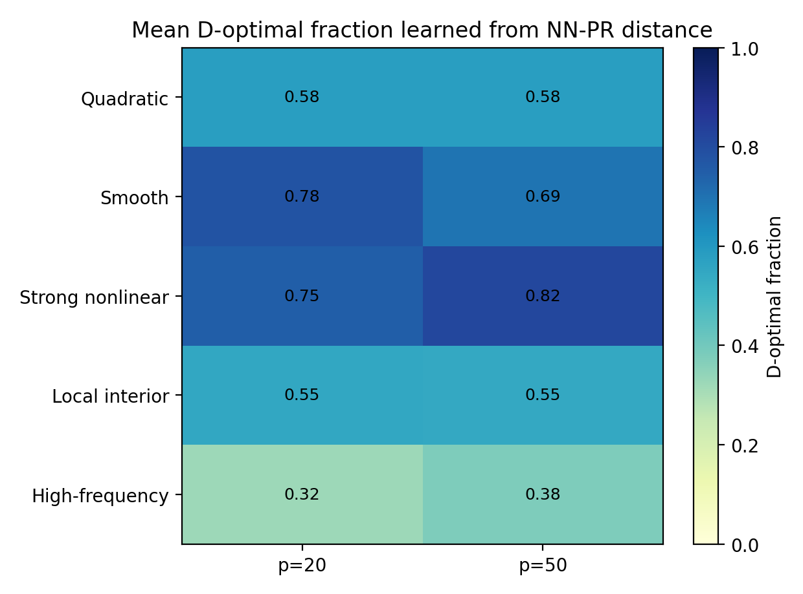
Figure 5. Mean D-optimal fraction learned from the distance measure

6. Sensitivity and Boundary Conditions
Important correction The earlier min(d_FPR, d_TYPR) rule produced -2.821% relative gain for p=50. The conservative mean-distance rule improves this to +0.501% and beats all-D-optimal, which remains at -1.846%.

- Strength: the measure turns sampling from a fixed rule into a data-driven transfer decision.
- Limitation: Latin hypercube remains competitive in high-frequency/global-coverage cases; the current policy mixes only random and D-optimal points.
- Next step: introduce a three-way policy over random, D-optimal, and Latin sampling or lower the D-optimal floor in far-distance cases.

7. Paper-Ready Interpretation
The experiment does not support the claim that measure-weighted sampling is universally superior to every design. It supports a more defensible claim: NN-PR/Taylor-PR distance is an actionable transfer gate for deciding when legacy PR/D-optimal technology can be used safely with a new NN model.

