Geometric Equivalence Between Neural Networks and Polynomial Regression
— A Measurable, Falsifiable Experimental Framework and Its Complete Results

Research Report
Building on the theoretical framework of Morala et al. (2021), this report uses geometric distance metrics, layer-wise Taylor expansion, and large-scale repeated simulation to systematically characterize when, and in what sense, a neural network is equivalent to polynomial regression.

This report integrates: mathematical foundations, methodology, a panel-by-panel reading of all experimental figures, the quantitative correlation results from 3000 repeated simulations, the NN-baseline win/loss analysis, and conclusions ready for a paper.

Executive Summary
This study answers a fundamental question: are neural networks secretly doing polynomial regression? We use shape distance as a geometric ruler to turn this vague intuition into a measurable scientific claim, tested across 5 datasets, 3 activation functions, 3 network depths, and 3000 repeated simulations. The new NN-baseline figures further answer which model is actually more accurate: not every polynomial beats the NN; FullPR wins only in some cleaner structural settings. The core findings:
- The core claim holds universally: the geometric closeness between a neural network and polynomial regression strongly predicts their performance closeness (cleaned overall Spearman rho = 0.839, p ~ 0; per-dataset rho ranges 0.440-0.870, all significant).
- The activation effect appears mainly in extrapolation, not within the data region: saturating activations (tanh, sigmoid) systematically depart from polynomials when extrapolating (act-change -> extrapolation closeness rho ~ 0.56).
- A counterintuitive correction: within each dataset, the original hypothesis 'smaller activation change -> closer to polynomial' does NOT hold; the direction is actually reversed. The positive correlation seen when pooling is a Simpson's-paradox artifact and must be reported per dataset.
- LayerTaylorPR fails rarely but catastrophically: in most cases it replicates the NN, but once the synaptic potential leaves the convergence region, MSE can explode. In the NN-baseline prediction comparison, its overall win rate is only 5.6%, so it is best understood as an explanation/replication tool rather than a robust predictive substitute.
- The NN-baseline comparison is not one-sided: FullPR wins more often in paper_poly3 (59.5% win rate, +62.6% median improvement) and smooth_nonlinear (58.5%, +37.0%), while the NN is more stable in paper_poly4 (FullPR win rate 36.7%, -97.0% median improvement) and smooth_nonlinear_rand (14.4%, -169.1%).

Part 1 Research Question and Mathematical Foundations

1.1 The Intuition and Its Mathematical Origin
Neural networks are powerful but opaque, often called 'black boxes'; polynomials are the most transparent objects in mathematics. This project asks: can a trained neural network be well replaced by a polynomial? If so, the black box is opened.
This intuition has a solid mathematical origin. Each network layer first applies a linear transformation, then a smooth activation function g. Smooth functions admit a Taylor expansion:
The Taylor expansion writes a smooth nonlinear function as a polynomial. If every layer's activation can be approximated by a polynomial, the whole network (a composition of layers) should also be approximable by one. But the Taylor expansion is only valid when u is near the expansion point; if u wanders too far, higher-order terms explode and the approximation fails. This 'condition for validity' and 'boundary of failure' is exactly what the project probes.

1.2 The Three Models Compared Throughout
Model | Full Name | What It Is
NN | Neural Network | the trained network, the object to be explained
FullPR | Full Polynomial Regression | a polynomial fitted directly to data, an independent competitor
LTPR | Layer-wise Taylor Polynomial Regression | a polynomial from Taylor-expanding the NN, the NN's symbolic translation
Key distinction: FullPR looks only at the data and learns a polynomial on its own; LTPR looks only at the NN's weights and tries to replicate the NN. So 'how alike NN and FullPR are' asks whether different routes converge, while 'how alike NN and LTPR are' asks how accurate the Taylor translation is and when it fails.

Part 2 Measurement Methods

2.1 Performance Metric: MSE
To measure prediction accuracy, we use the mean squared error:
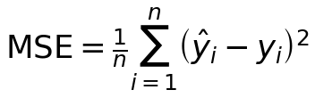
Variants: NN_mse_vs_y (NN vs truth), FPR_mse_vs_y (FullPR vs truth), FPR_mse_vs_NN (FullPR vs NN output), and LTPR_mse_vs_NN (LTPR vs NN output). The last two use the NN output as truth because they ask how closely a model replicates the NN. The new NN-baseline variables are: *_mse_delta_vs_NN (model MSE minus NN MSE; negative means the model is more accurate), *_improve_vs_NN_pct (relative improvement over NN; positive means better than NN), and *_better_than_NN (whether the model beats NN in that run).

2.2 Performance Gap: abs_rmse_gap
Take the square root (RMSE, same units as the data) then the absolute difference. Smaller means the two models are closer in accuracy.

2.3 Geometric Metric: Shape Distance (the Core Innovation)
Beyond 'how accurate', we compare how alike the functions learned by two models 'look'. Procedure: combine each model's predictions at the test points with the inputs to form a point cloud on a response surface. For model A:
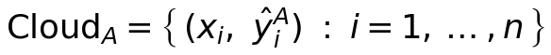
The two clouds share input coordinates, differing only in the prediction dimension. Procrustes analysis aligns them (translation, scaling, rotation), then we compute the sum of squared point-wise residuals:
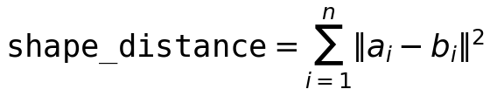
It factors out translation/rotation/scaling, measuring pure shape similarity. Near 0 = nearly identical shape. This differs from MSE: shifting a surface by a constant leaves shape distance unchanged but changes MSE; the two capture different information.
Shape distances in the figures: shape_NN_FPR_in (within data region), shape_NN_FPR_ext (extrapolation region), shape_NN_LTPR (NN vs LTPR), shape_LTPR_FPR (between the two polynomials).

2.4 Activation Change: act_io_sum
Quantifies how much nonlinearity the activation injects. For each activation layer, use the shape distance to measure the bending of u -> g(u), summed over all layers to give act_io_scaled_sum (inputs normalized to [-1,1]). Near-linear activation -> near-linear network -> near low-order polynomial; strongly bent activation -> much nonlinearity. This is the independent variable of the original hypothesis.

2.5 Experimental Design
Five datasets: paper_poly3 (3rd order, well-specified at 3 hidden layers, the control), paper_poly4 (4th order, strictly underspecified), smooth_nonlinear (fixed-frequency non-polynomial), smooth_nonlinear_rand (random-frequency non-polynomial, the strictest). Three activations (softplus/tanh/sigmoid), three depths (4 / 8,4 / 16,8,4), with fixed data and 50 network-initialization seeds per configuration (paper-style repeats), about 3000 simulations in total.

Part 3 Complete Figure Walkthrough
This part embeds all 9 result figures (4 datasets x geometry/MSE, plus the overview boxplot) and reads them panel by panel. In all scatter plots each point is one simulation; color = activation (green softplus / orange tanh / dark blue sigmoid).

3.1 Geometry Figure: General Structure (11 panels)
Panel 1,2. act-change -> NN-FullPR closeness in data region (scaled/unscaled inputs): does more injected nonlinearity make NN and polynomial less alike in the data region?
Panel 3. act-change -> extrapolation closeness: horizontal bands = saturating activations systematically departing from polynomials when extrapolating.
Panel 4. act-change -> performance gap: can activation change directly predict performance difference?
Panel 5. adjacent-layer nonlinearity -> data-region closeness: a cross-check of panel 1.
Panel 6. NN-FullPR closeness -> performance gap (CORE): an upward band proves geometric closeness => performance closeness.
Panel 7. NN-LTPR closeness -> performance gap: how alike the Taylor translation is to the NN.
Panel 8. act-change -> NN-LTPR closeness: larger activation change makes the Taylor translation deviate more (sign of Taylor failure).
Panel 9. NN-LTPR vs NN-FullPR closeness: whether the two polynomial proxies agree.
Panel 10,11. LTPR-FullPR closeness -> perf gap / vs NN-FullPR: the relationship between the two polynomials.

3.2 MSE Figure: General Structure (6 panels)
Panel 1. act-change -> NN's own MSE: does activation nonlinearity affect the NN's fit quality?
Panel 2. NN-FullPR closeness -> FullPR's MSE replicating NN: usually a clean positive line, validating shape distance.
Panel 3. NN-LTPR closeness -> LTPR's MSE replicating NN: note LTPR occasionally explodes to 1e8 (Taylor failure).
Panel 4. NN MSE vs FullPR MSE (y=x line): points below the line mean FullPR is more accurate; points above mean the NN is more accurate. The new nn_baseline figure aggregates this visual comparison into win rate and median improvement, which is the clearer way to report which model is better.
Panel 5. FullPR vs LTPR MSE replicating NN: a comparison of the two polynomials; LTPR explosions show here.
Panel 6. NN MSE -> NN-FullPR performance gap: does the NN's fit quality affect its closeness to the polynomial?

3.3 Dataset 1: paper_poly4 (4th order, strictly underspecified)
Data generated by a 4th-order polynomial; the network is at most 3 layers and Full-PR at most 3rd order, so the polynomial cannot exactly match — the main testbed for the underspecified case.

Geometry Figure
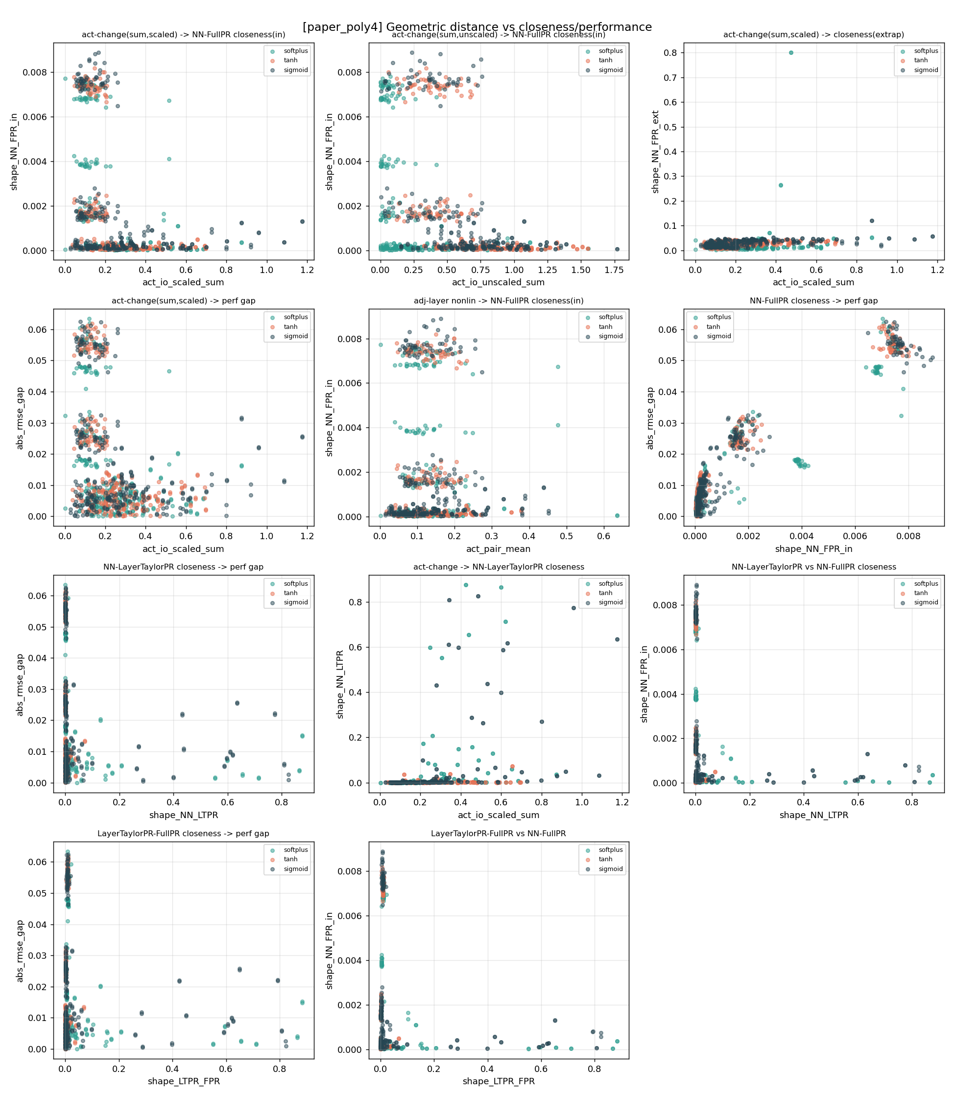
3.3 Dataset 1: paper_poly4 (4th order, strictly underspecified) — geometric distance vs closeness/performance (11 panels)
What this geometry figure shows:
- Panel 6 (core): a clear upward band in several clusters; the high-distance, high-gap cluster at top-right corresponds to deeper networks — the core claim holds.
- Panels 1,2: the cloud is roughly horizontal and scattered; within the data region activation change does not predict closeness well.
- Panel 3: a softplus outlier at top-right reaches 0.8; a few runs extrapolate badly.
- Panels 7-11 (LTPR): shape_NN_LTPR mostly hugs 0 (good replication); a few points trail to 0.8+ (Taylor deviation runs).

MSE Figure
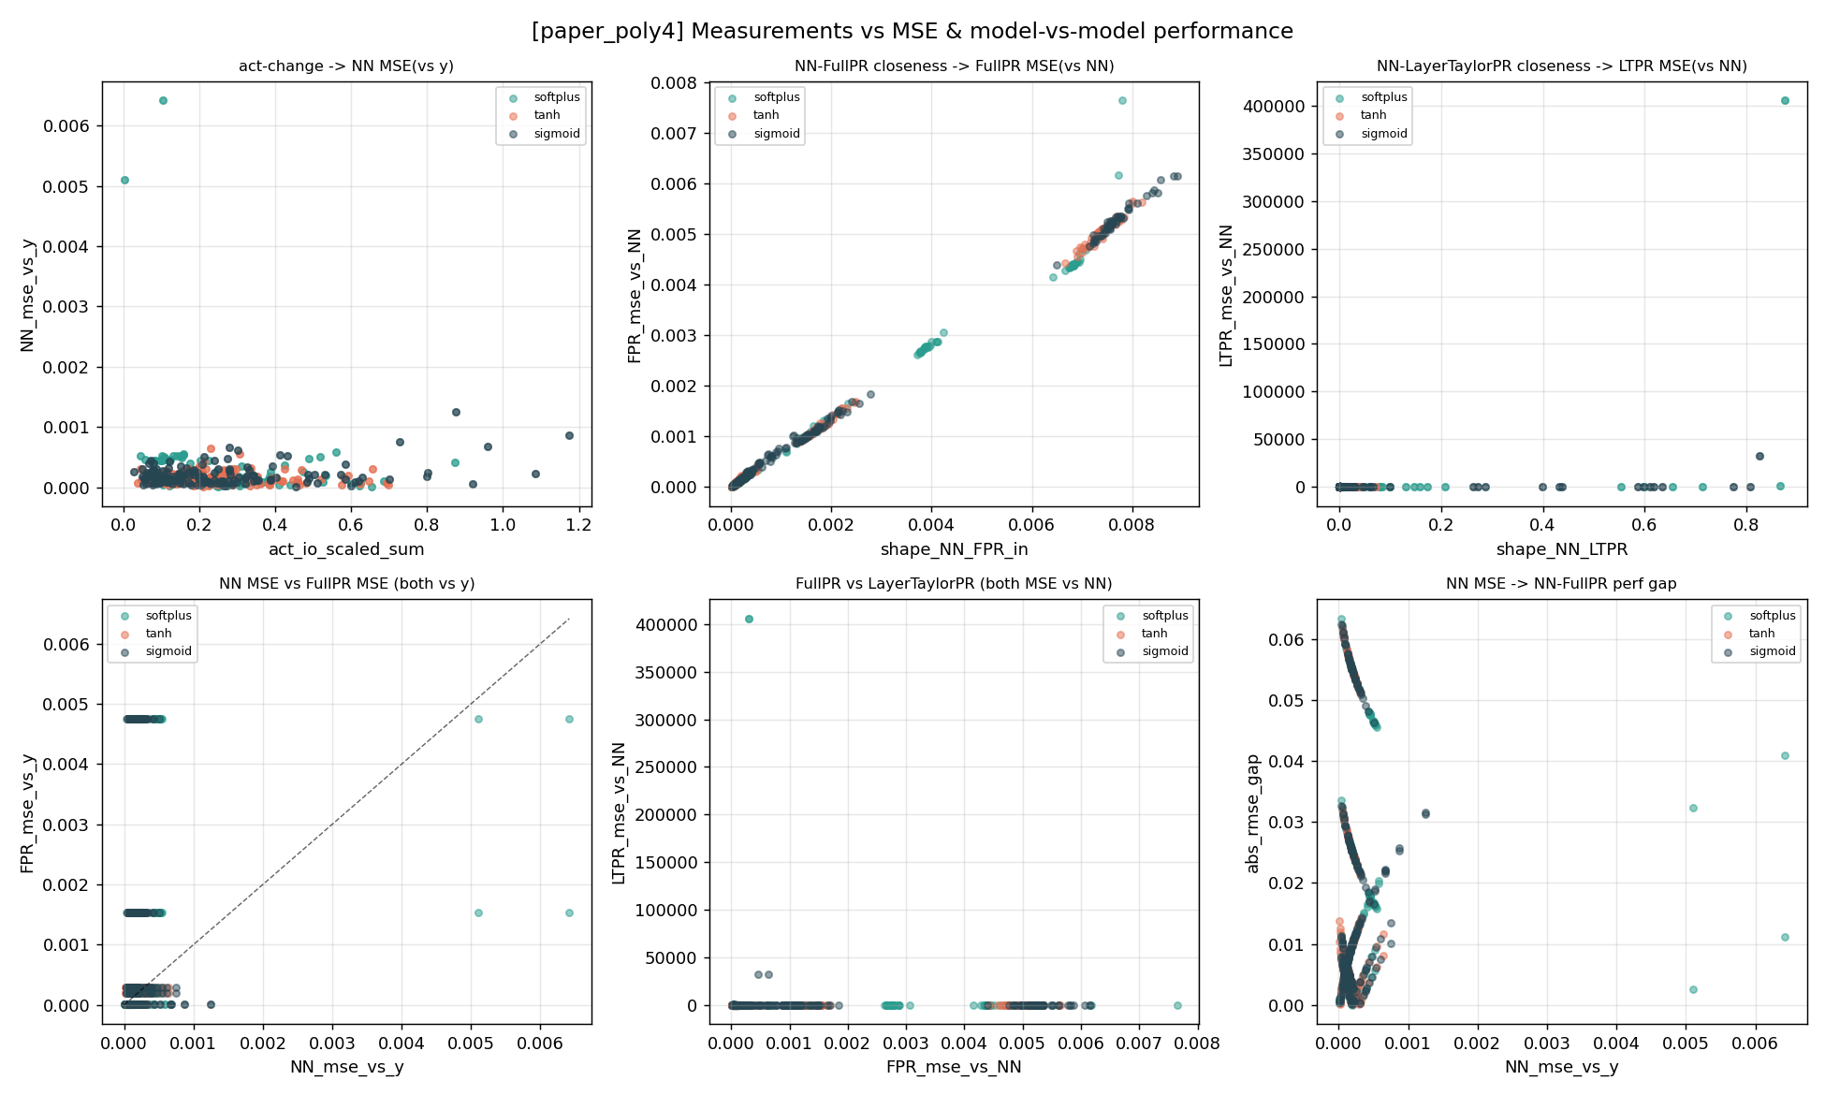
3.3 Dataset 1: paper_poly4 (4th order, strictly underspecified) — metrics vs MSE and model-vs-model (6 panels)
What this MSE figure shows:
- Panel 2: an extremely clean positive line in three segments (the three depths), strongly validating that shape distance predicts replication error.
- Panel 3: the y-axis reaches 4x10^5 — LTPR occasionally explodes catastrophically, the vast majority sitting at 0.
- Panel 4 (y=x line): points lie near and below the diagonal; FullPR is somewhat more accurate in many cases.
- Panel 6: a forked arc structure reflecting subgroups of different depth/convergence states.

Cleaned Figures (redrawn after removing unconverged NN runs and LTPR failure values)
The figures below are the cleaned results from analyze_results.py: runs where NN_mse exceeds 10x the within-group median are removed as unconverged, and samples with LTPR_mse_vs_NN above 100 are flagged as failures (excluded from LTPR-related panels and shown separately in the failure plot).
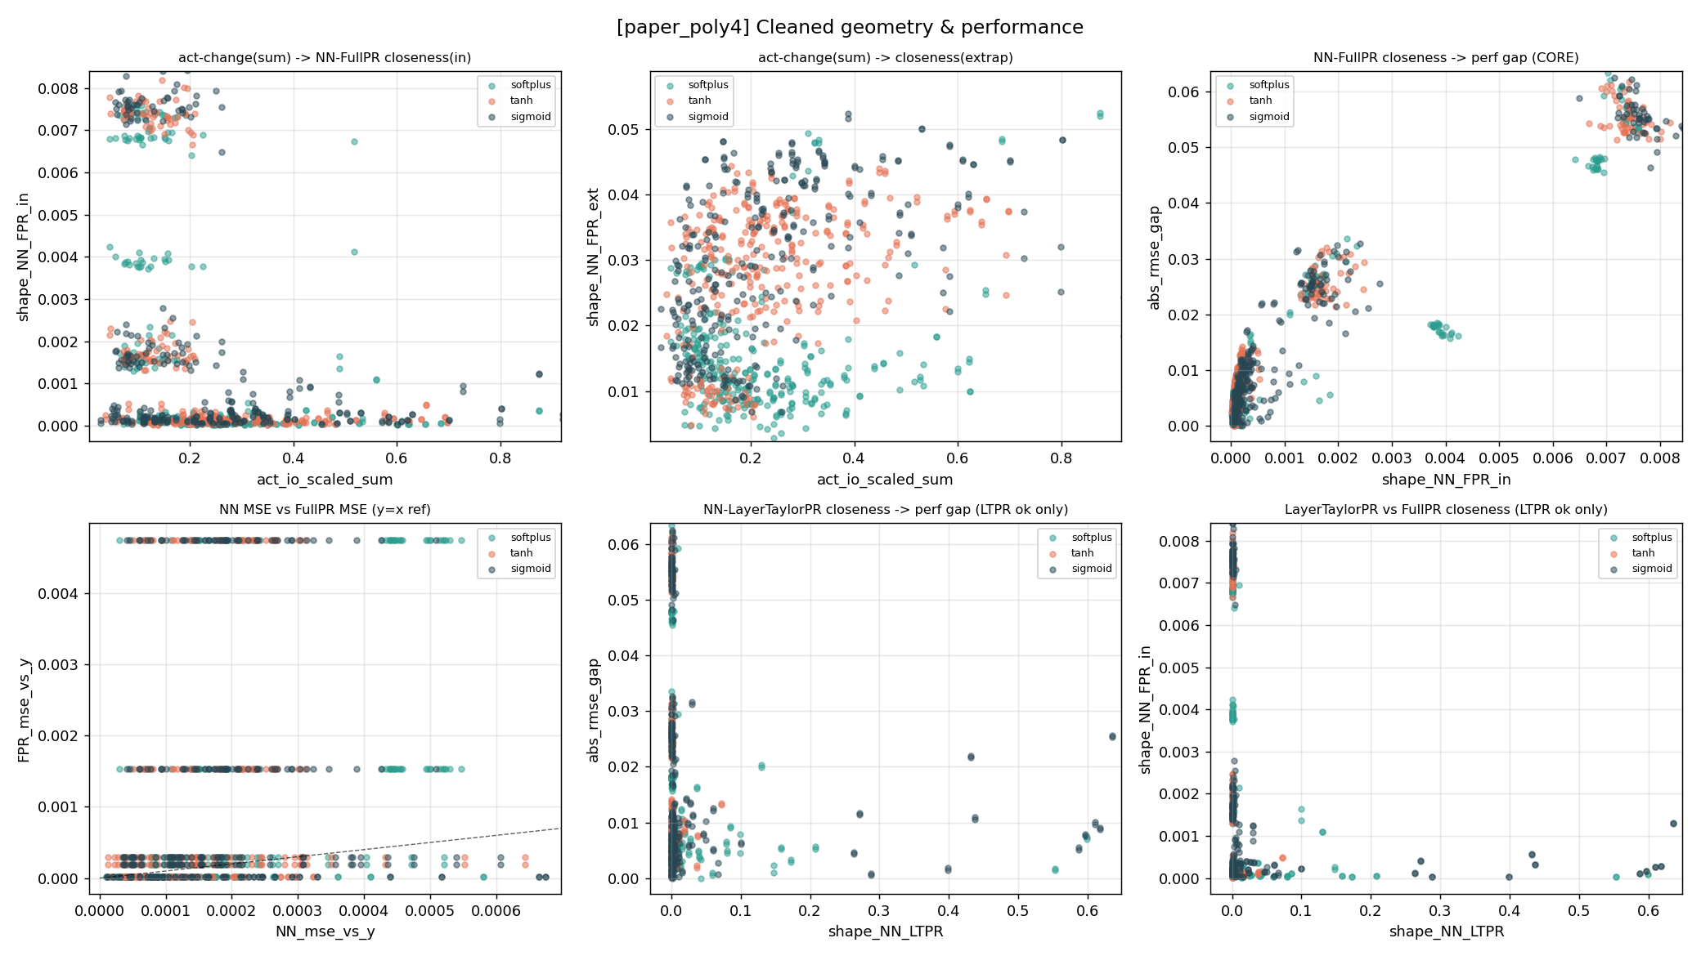
3.3 Dataset 1: paper_poly4 — cleaned core geometry & performance relations
- The core panel (NN-FullPR closeness -> performance gap) now shows two cleaner rising arcs after removing unconverged outlier runs, making the geometry-closeness-implies-performance-closeness structure clearer than in the raw figure.
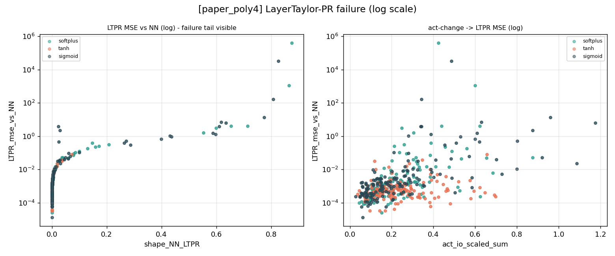
3.3 Dataset 1: paper_poly4 — LayerTaylor-PR failure tail (log scale)
- The failure tail peaks at roughly 6×10⁵, consistent with the pre-cleaning data; most points still sit near the 1e-4 level, showing the layer-wise Taylor expansion reproduces the NN exactly in most cases.

3.4 Dataset 2: paper_poly3 (3rd order, well-specified at 3 hidden layers)
Data generated by a 3rd-order polynomial; with 3 hidden layers Full-PR's order exactly equals the data order, the well-specified control group.

Geometry Figure
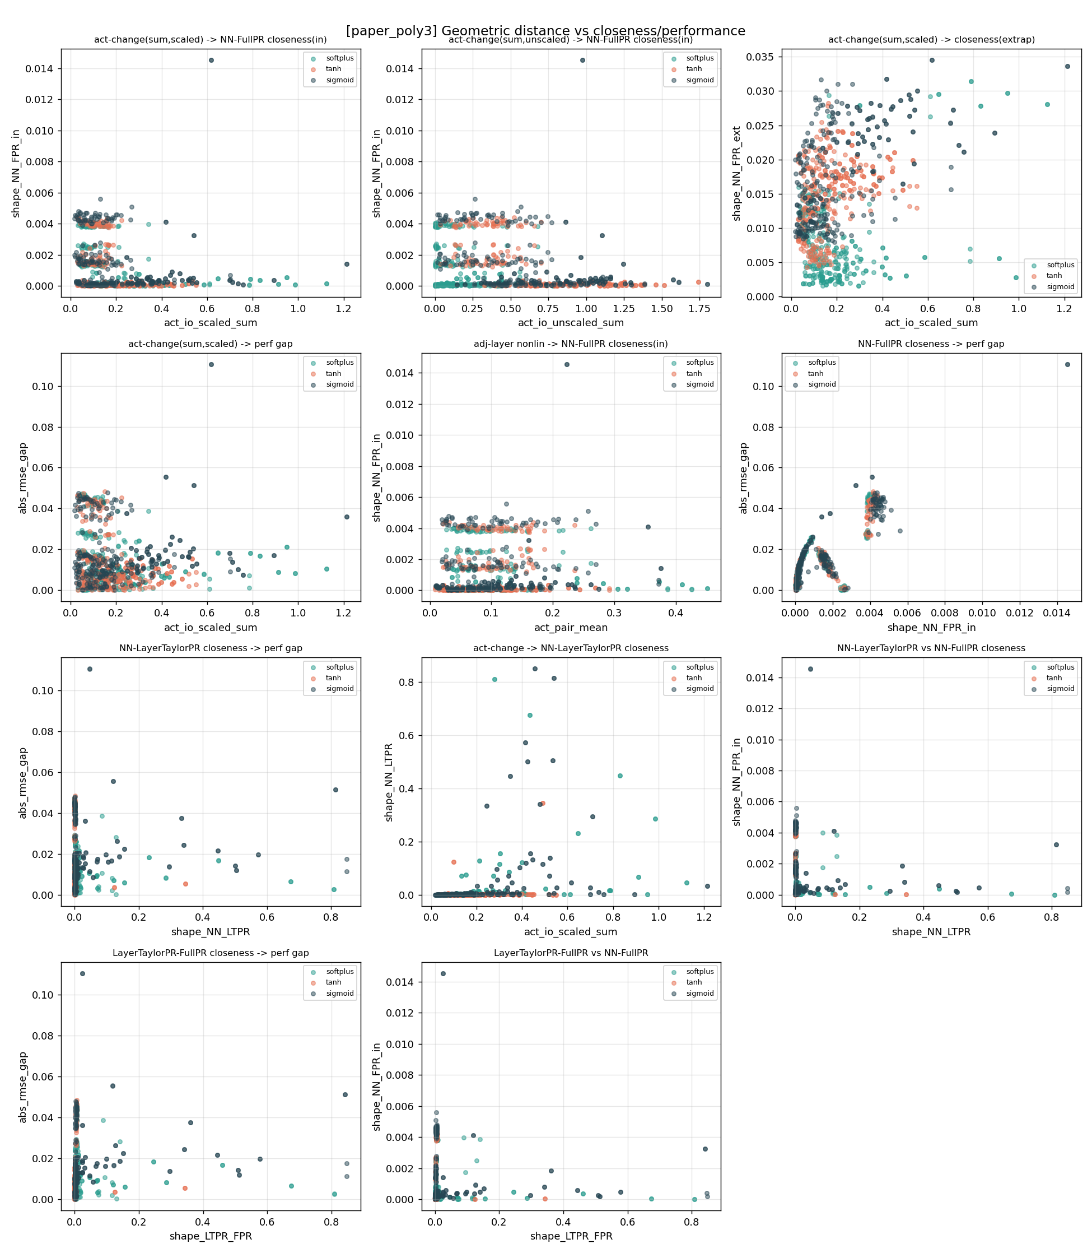
3.4 Dataset 2: paper_poly3 (3rd order, well-specified at 3 hidden layers) — geometric distance vs closeness/performance (11 panels)
What this geometry figure shows:
- Overall the y-axis scale is an order of magnitude smaller than poly4 (max shape distance ~0.014); when well-specified both models are accurate and geometrically closer.
- Panel 6 (core): an 'arch + rise' shape — a tiny-gap arch at low distance (from being well-specified), then rising with distance.
- Panel 3: y-axis to 0.035; even extrapolation is fairly consistent when well-specified.
- Panel 8: a weak trend that larger activation change makes LTPR deviate more from the NN.

MSE Figure
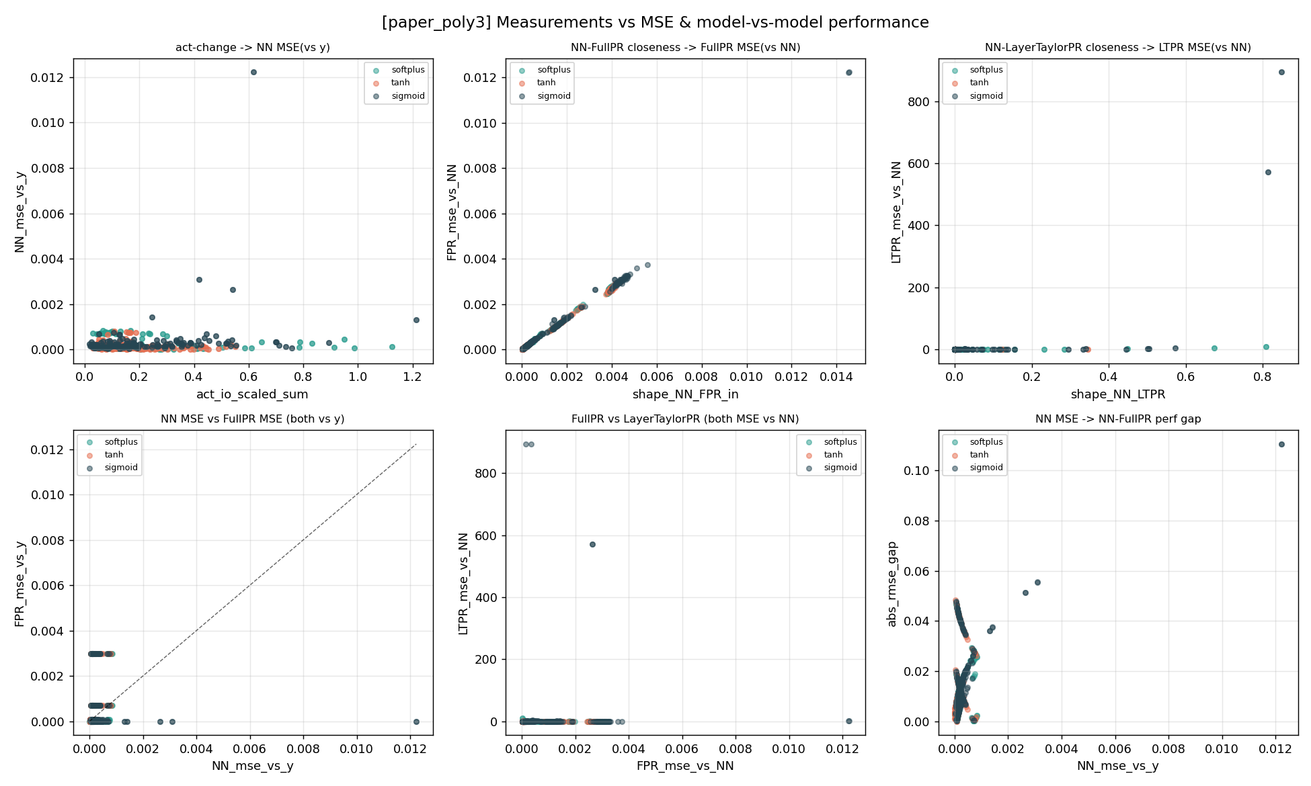
3.4 Dataset 2: paper_poly3 (3rd order, well-specified at 3 hidden layers) — metrics vs MSE and model-vs-model (6 panels)
What this MSE figure shows:
- Panel 2: a clean positive line, very small scale (to 0.012).
- Panel 3: y-axis to ~900 — LTPR still fails, but far smaller than poly4's explosions.
- Panel 4 (y=x line): most points near the origin; being well-specified makes both models accurate with a tiny gap.
- Panel 6: forked arc, similar to poly4 but at smaller scale.

Cleaned Figures (redrawn after removing unconverged NN runs and LTPR failure values)
The figures below are the cleaned results from analyze_results.py: runs where NN_mse exceeds 10x the within-group median are removed as unconverged, and samples with LTPR_mse_vs_NN above 100 are flagged as failures (excluded from LTPR-related panels and shown separately in the failure plot).
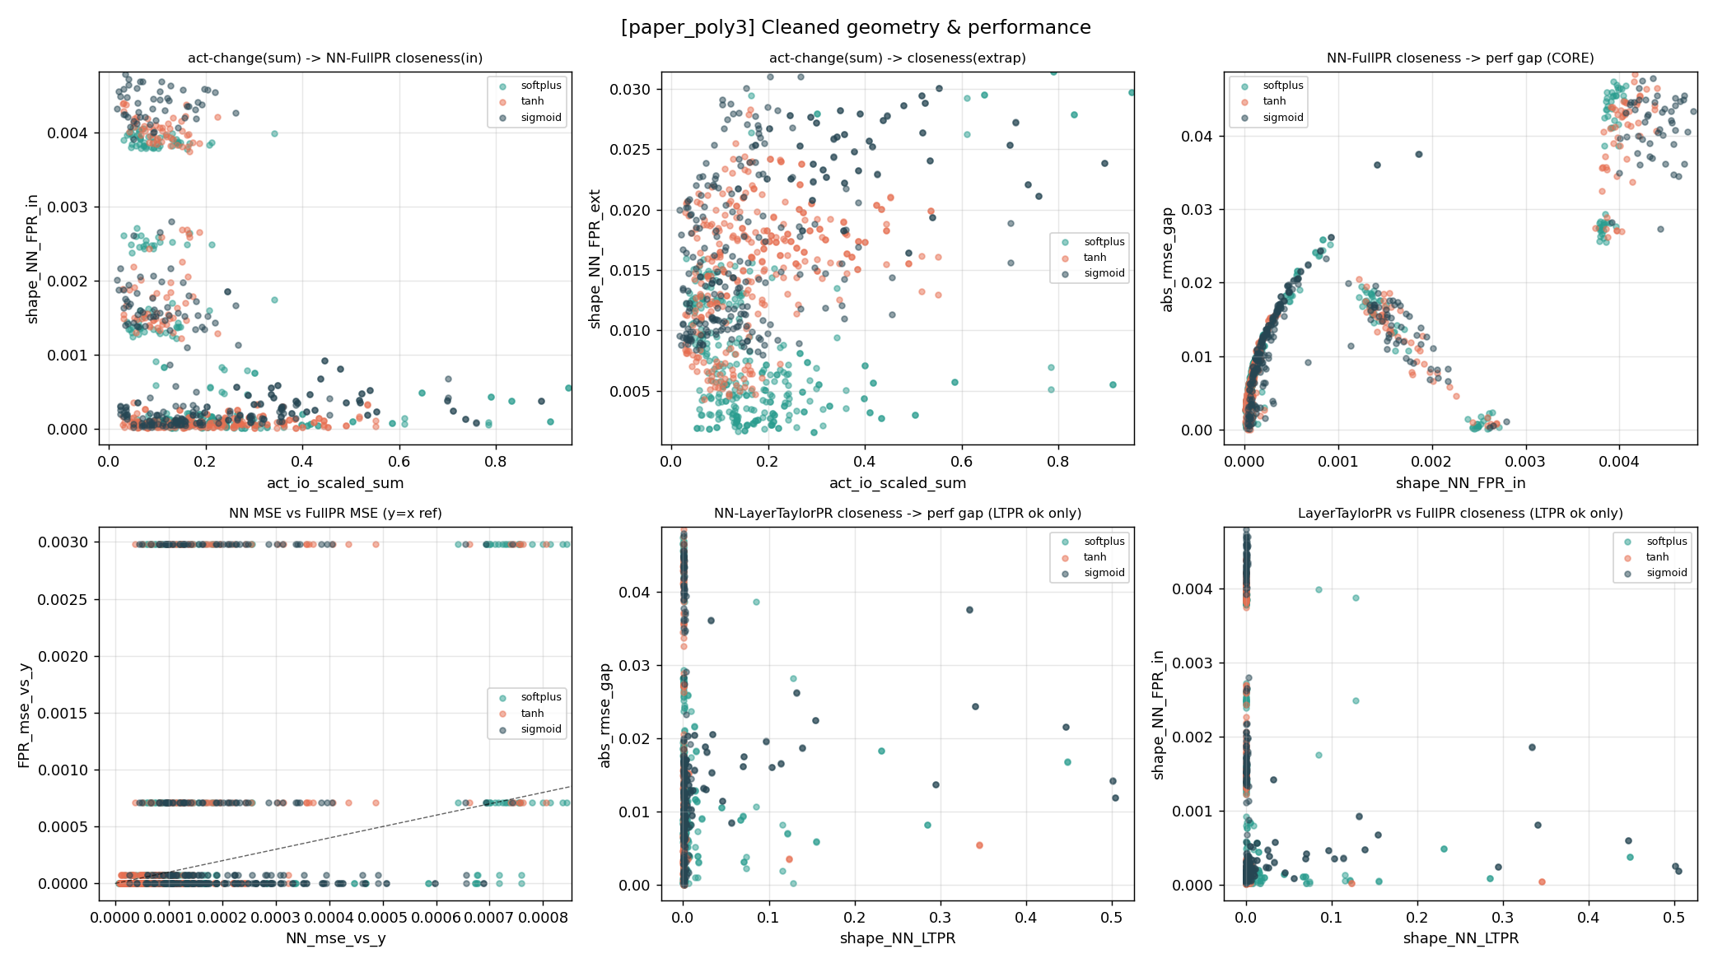
3.4 Dataset 2: paper_poly3 — cleaned core geometry & performance relations
- The core relation shows a clear “low-distance arch + overall rise” structure; the gap is tiny when the model order is matched (3 hidden layers), confirming the well-specified degeneration path.
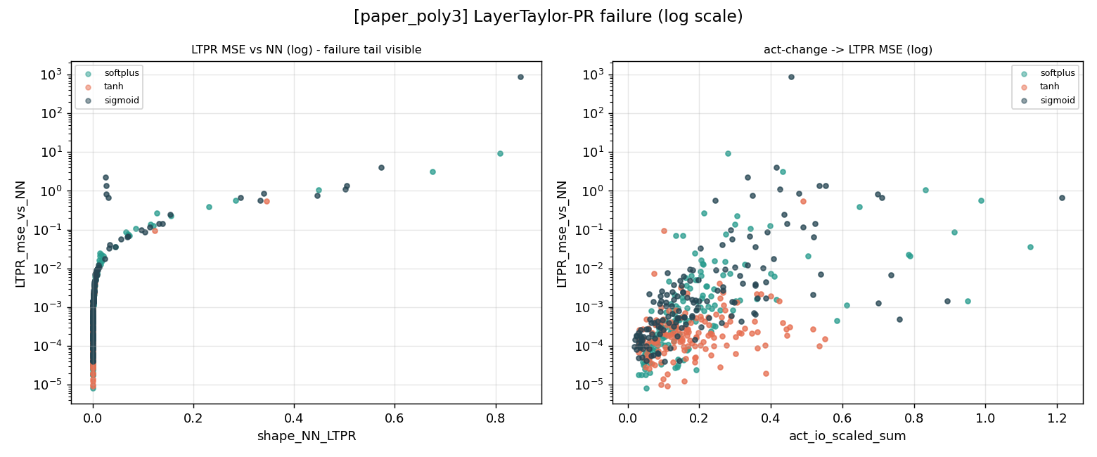
3.4 Dataset 2: paper_poly3 — LayerTaylor-PR failure tail (log scale)
- The failure tail peaks at roughly 900, about 3 orders of magnitude smaller than paper_poly4, consistent with the intuition that a shorter degeneration path (matched order) keeps the Taylor expansion more stable.

3.5 Dataset 3: smooth_nonlinear (fixed-frequency non-polynomial, softplus only)
The ground truth is a fixed-frequency sin-type non-polynomial that a polynomial can never represent exactly — strictly underspecified. Only softplus was run, so only green points appear.

Geometry Figure
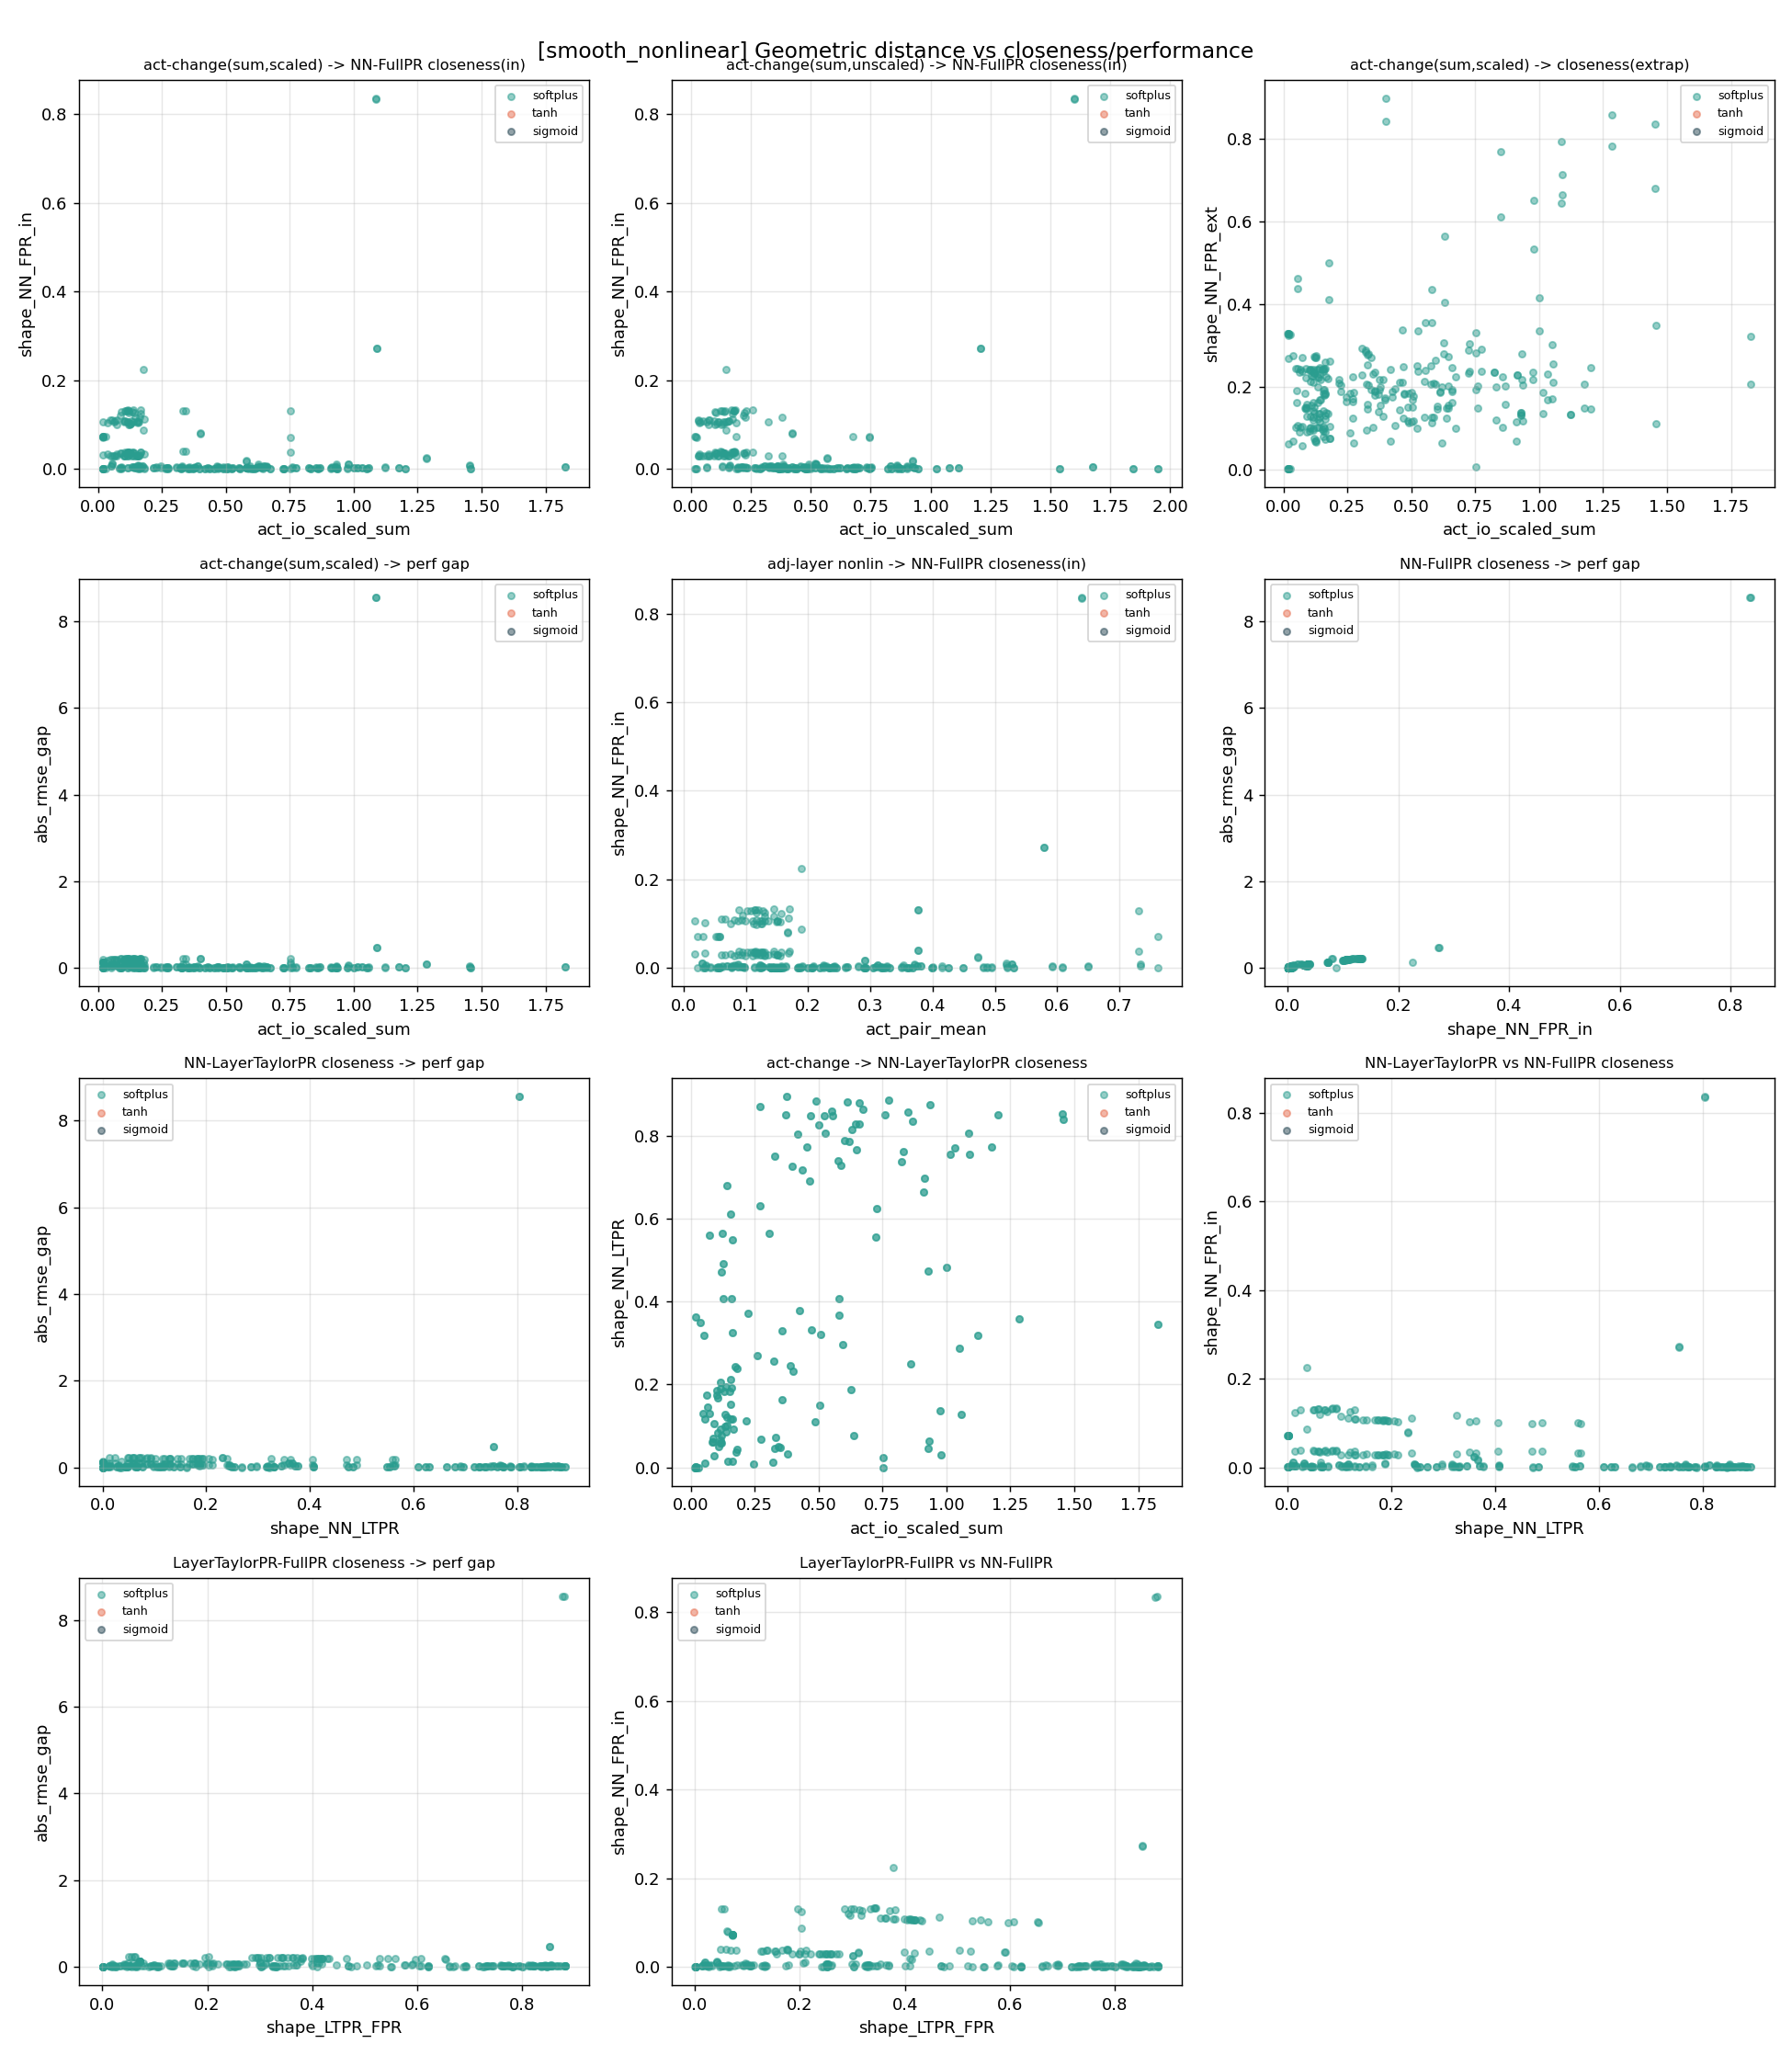
3.5 Dataset 3: smooth_nonlinear (fixed-frequency non-polynomial, softplus only) — geometric distance vs closeness/performance (11 panels)
What this geometry figure shows:
- An extreme outlier run: panels 1,4,6,7,10 each show a lone point reaching perf gap ~8.6 or shape distance ~0.84 — an NN training collapse that should be removed.
- Panel 6 (core): removing the outlier, the bulk is still a clear upward band; geometric closeness => performance closeness holds.
- Panel 3: points spread in a 0.1-0.3 band; extrapolation gaps are clearly larger than the poly series (non-polynomial truth is harder to extrapolate consistently).
- Panel 8: a clear positive cloud — larger activation change makes LTPR deviate more from the NN, clear evidence of Taylor failure.

MSE Figure
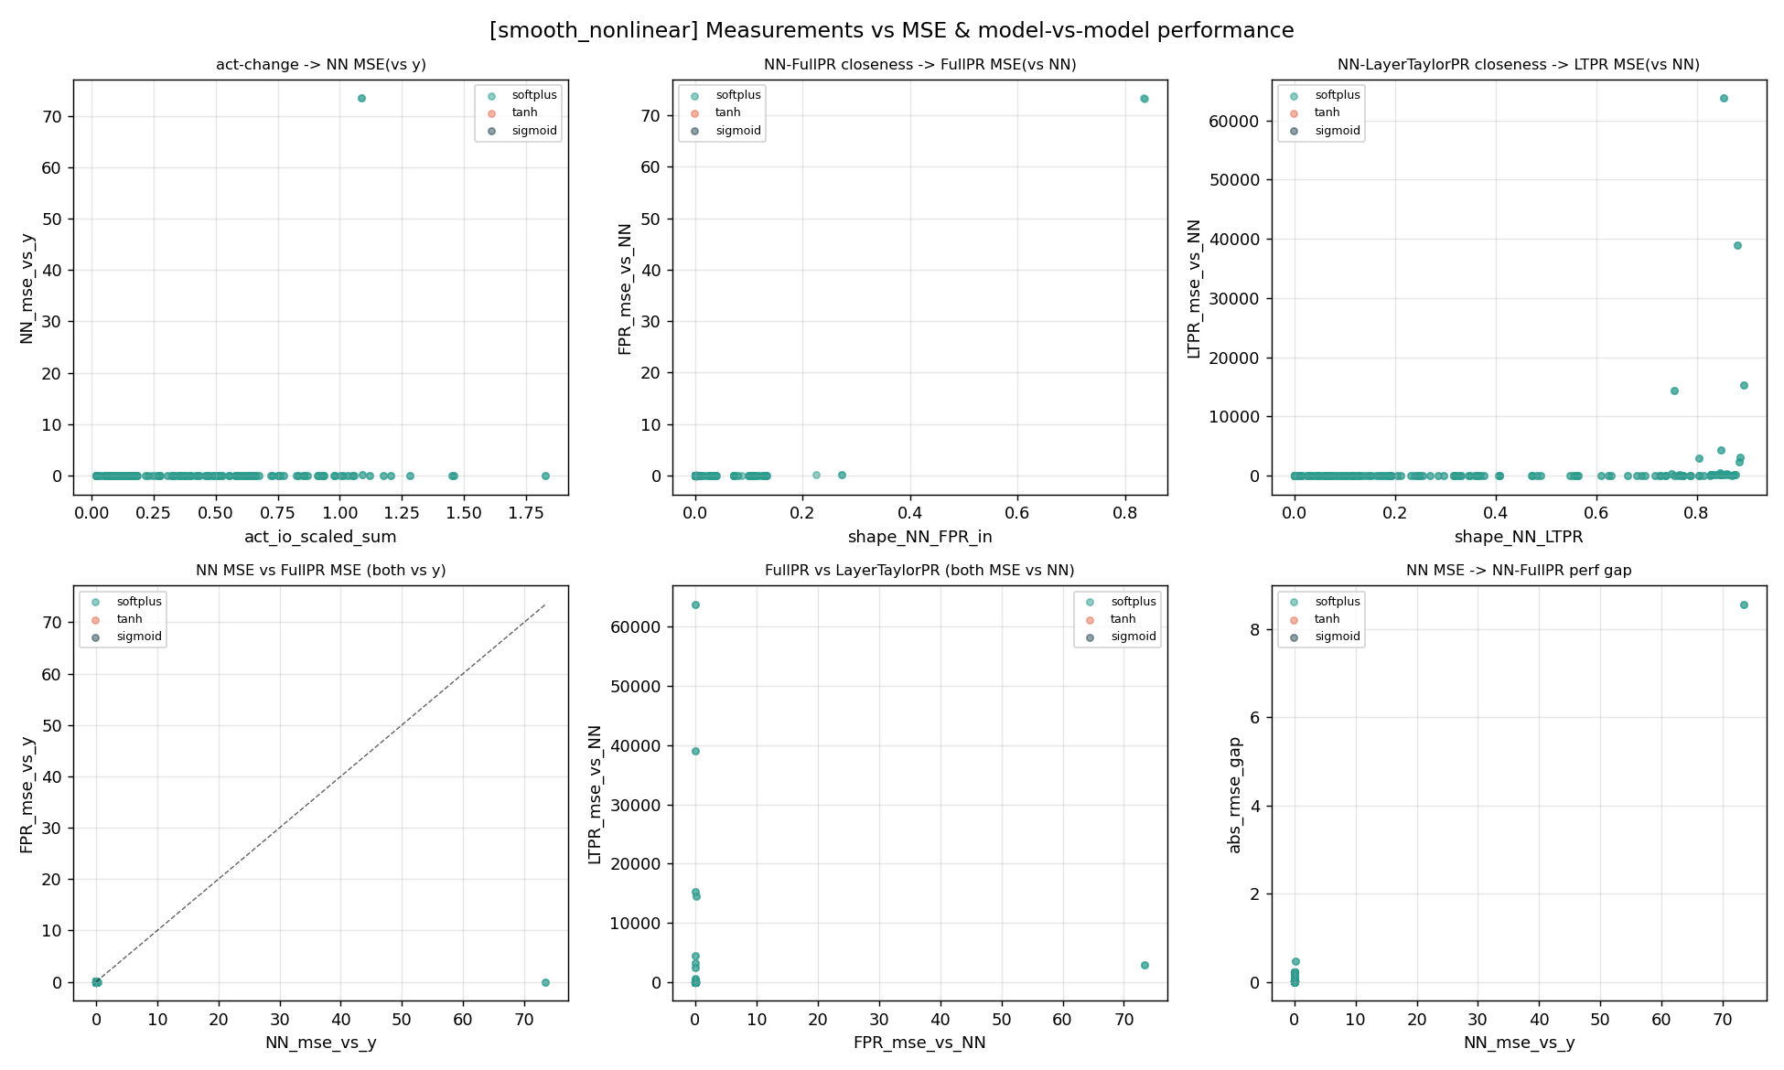
3.5 Dataset 3: smooth_nonlinear (fixed-frequency non-polynomial, softplus only) — metrics vs MSE and model-vs-model (6 panels)
What this MSE figure shows:
- Panels 1,3,5,6 each have an NN_mse ~73 extreme point — the same collapse run stretching the x-axis.
- Panel 3: y-axis to 6x10^4, a clear LTPR failure tail.
- Panel 5: LTPR explodes to tens of thousands on the y-axis while FullPR stays near 0 — a stark contrast.
- Panel 4 (y=x line): apart from the collapse point, points near the origin; both models fairly accurate under softplus.

Cleaned Figures (redrawn after removing unconverged NN runs and LTPR failure values)
The figures below are the cleaned results from analyze_results.py: runs where NN_mse exceeds 10x the within-group median are removed as unconverged, and samples with LTPR_mse_vs_NN above 100 are flagged as failures (excluded from LTPR-related panels and shown separately in the failure plot).
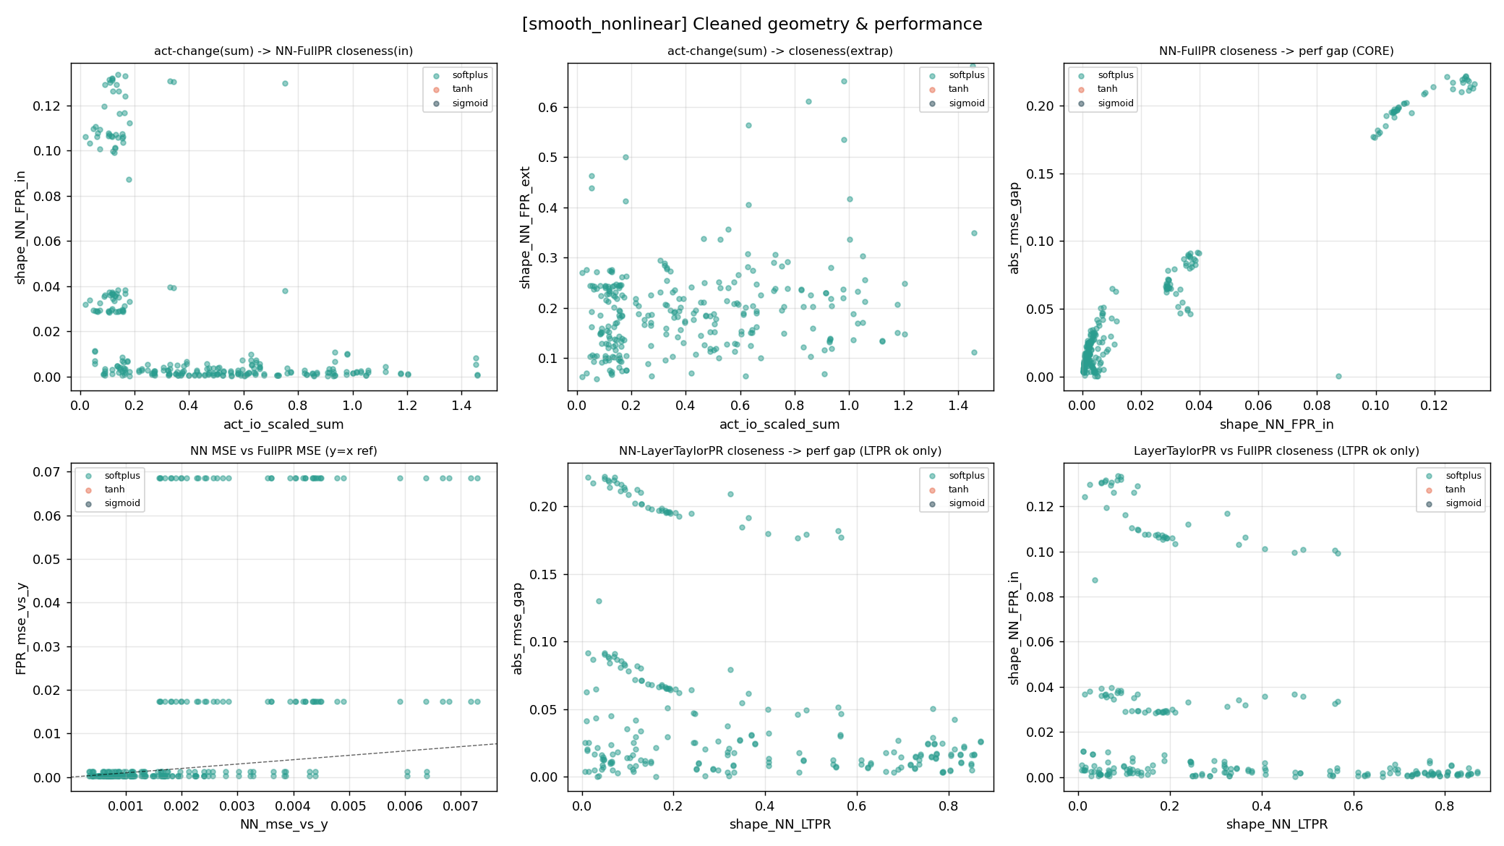
3.5 Dataset 3: smooth_nonlinear — cleaned core geometry & performance relations
- After removing the collapsed run (NN_mse ≈ 73), the core rising band is clearly visible. This dataset was only run with softplus activation, so the empty tanh/sigmoid legend entries are expected, not missing data.
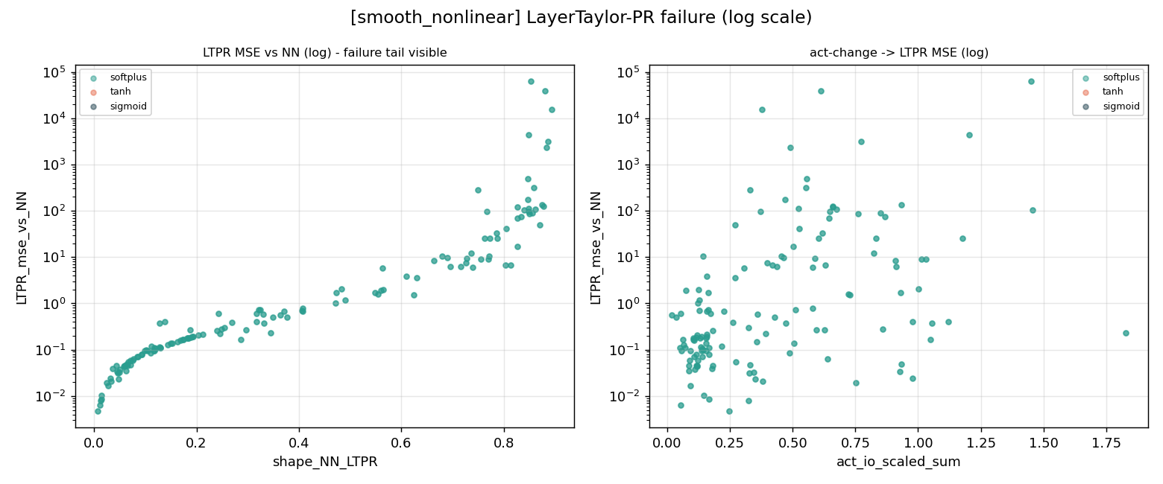
3.5 Dataset 3: smooth_nonlinear — LayerTaylor-PR failure tail (log scale)
- The failure tail peaks at roughly 6×10⁴; the log-scale plot clearly shows that larger act_io_scaled_sum correlates with more severe LTPR failure.

3.6 Dataset 4: smooth_nonlinear_rand (random-frequency non-polynomial, strictest)
The ground truth is a random-frequency/phase sin-type function, different each run — the strictest underspecified scenario, all three activations tested. The key dataset for universality.

Geometry Figure
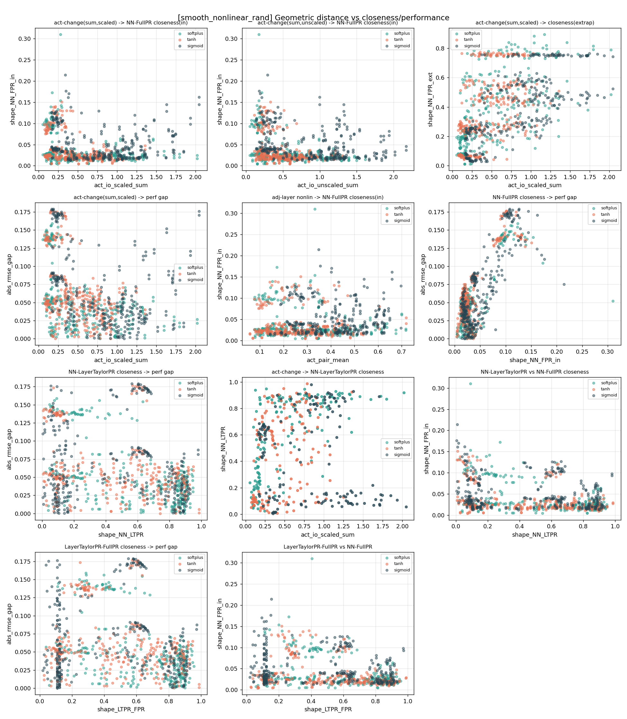
3.6 Dataset 4: smooth_nonlinear_rand (random-frequency non-polynomial, strictest) — geometric distance vs closeness/performance (11 panels)
What this geometry figure shows:
- Panel 6 (core): a beautiful upward band with all three activations on the same band — geometric closeness => performance closeness holds universally even in the strictest scenario.
- Panel 3: clear horizontal bands (~0.75/0.5/0.2), especially tanh/sigmoid — the textbook fingerprint of saturating activations departing from polynomials in extrapolation.
- Panels 1,2: rising at low act then scattering at high act, a complex non-monotonic relationship.
- Panels 7,10: rich band structures; LTPR is mostly valid here (x-axis to 1.0).

MSE Figure
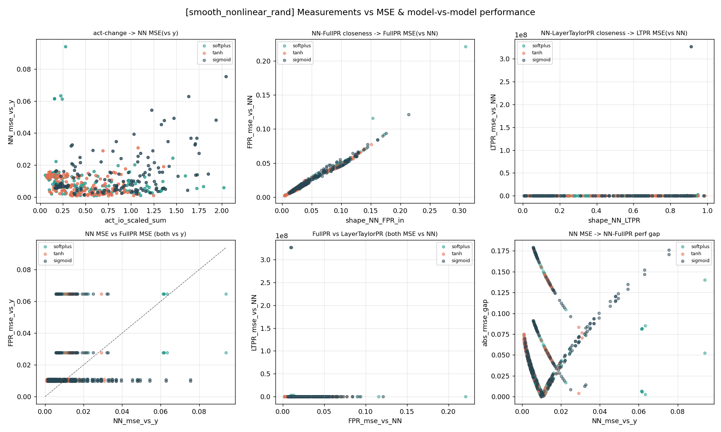
3.6 Dataset 4: smooth_nonlinear_rand (random-frequency non-polynomial, strictest) — metrics vs MSE and model-vs-model (6 panels)
What this MSE figure shows:
- Panel 2: a textbook positive line with all three activations perfectly overlapping.
- Panel 3: y-axis to 3x10^8 — the most severe LTPR explosion of any dataset, the most extreme evidence of Taylor failure.
- Panel 4 (y=x line): points on horizontal bands on both sides of the diagonal (FullPR's discrete values create the bands); NN and FullPR trade wins.
- Panel 6: a distinctive 'X-shaped' two-branch structure corresponding to two convergence modes, worth dedicated analysis.

Cleaned Figures (redrawn after removing unconverged NN runs and LTPR failure values)
The figures below are the cleaned results from analyze_results.py: runs where NN_mse exceeds 10x the within-group median are removed as unconverged, and samples with LTPR_mse_vs_NN above 100 are flagged as failures (excluded from LTPR-related panels and shown separately in the failure plot).
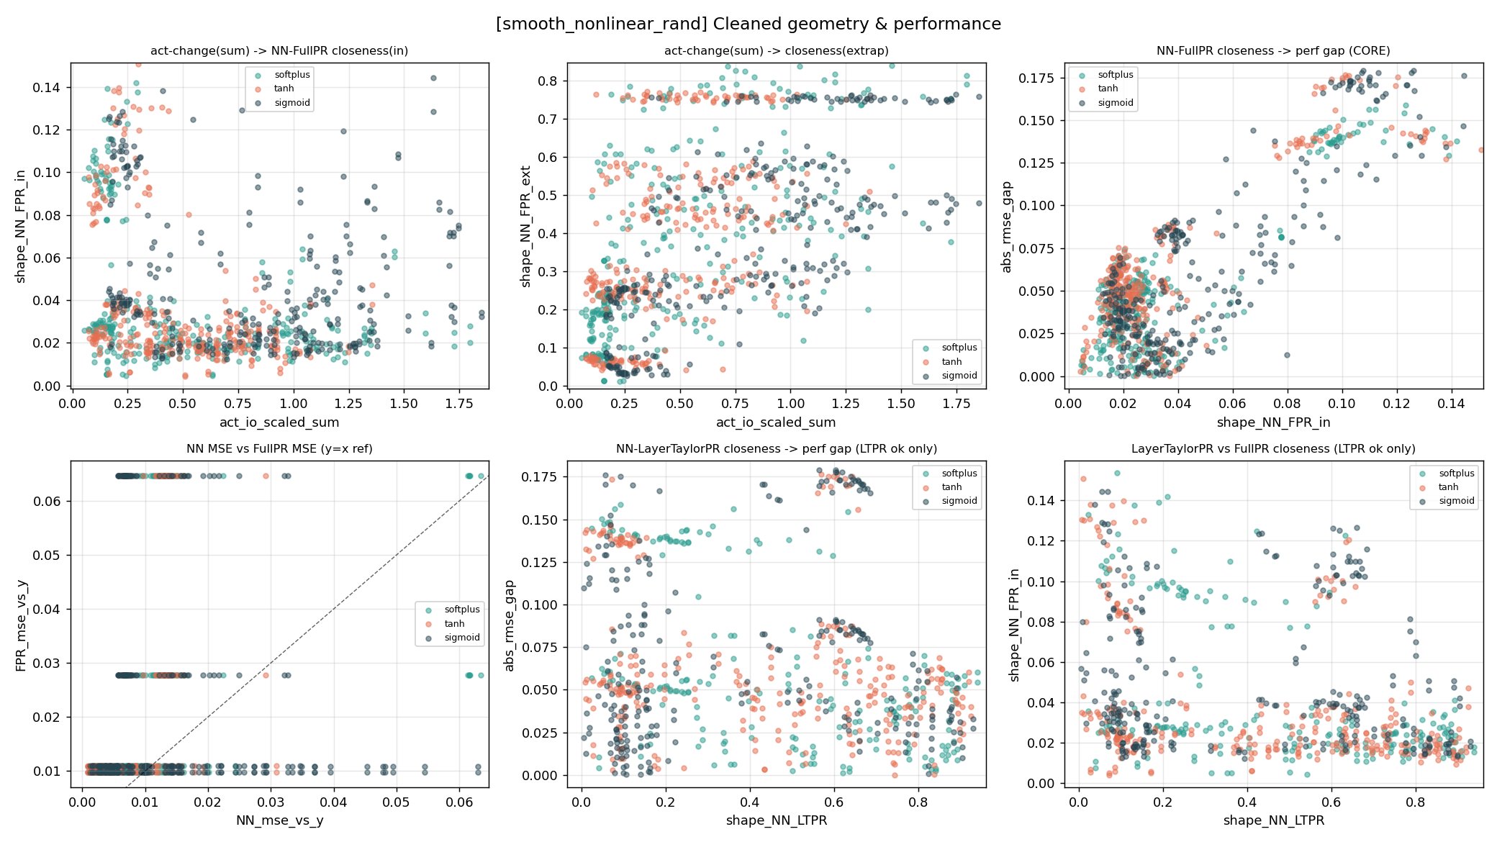
3.6 Dataset 4: smooth_nonlinear_rand — cleaned core geometry & performance relations
- After cleaning, the core rising bands for all three activations nearly overlap — the strongest evidence that geometric closeness implying performance closeness holds universally even in the strictest setting.
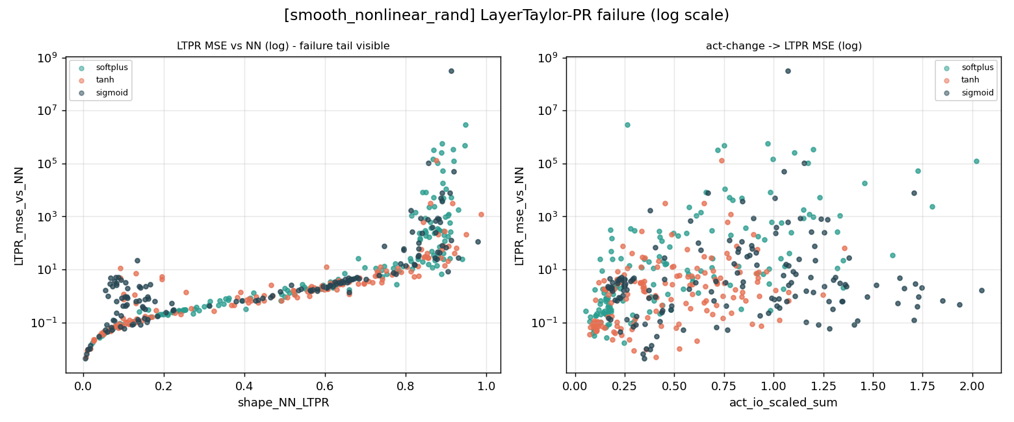
3.6 Dataset 4: smooth_nonlinear_rand — LayerTaylor-PR failure tail (log scale)
- The failure tail peaks at roughly 3×10⁸, the most extreme blow-up among the four datasets, confirming that random-frequency targets damage the Taylor convergence radius the most.

3.7 Overview Boxplot (all datasets, all repeats)
Boxplot: the box = middle 50% of data, the line in the box = median, whiskers = normal range, circles beyond whiskers = outliers.
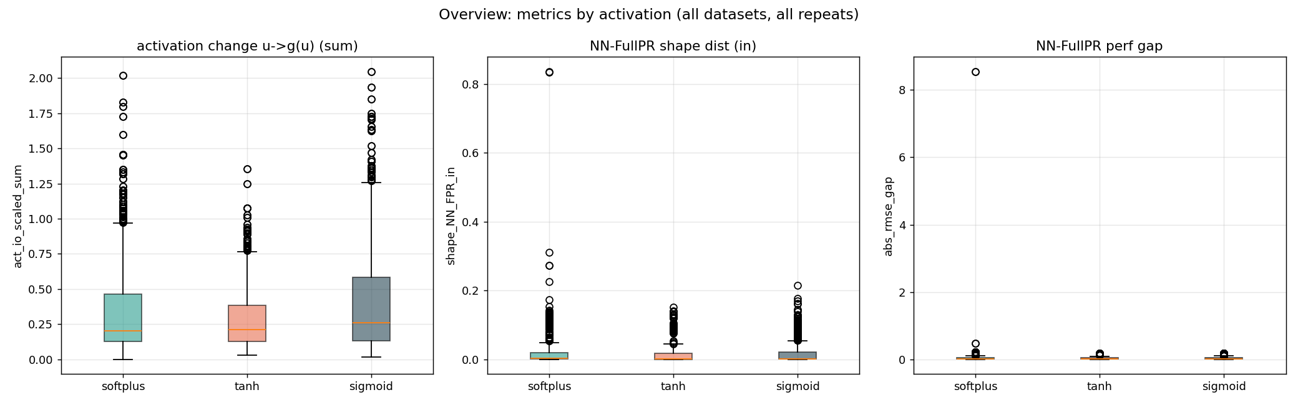
Distribution of three key quantities across the three activations
Three panels:
- Left (total activation change): medians all 0.2-0.25; sigmoid has the longest box and upper whisker (most variable), tanh the most compact.
- Middle (NN-FullPR data-region shape distance): all three boxes hug 0 — in the vast majority of cases NN and the polynomial are very alike; but all trail many upward outliers (softplus to 0.83).
- Right (performance gap): boxes near the bottom, trailing outliers (softplus has an 8.5 extreme = the collapse run).
Key reminder: the outliers all point to the same issue — non-convergent training and Taylor failure. Conclusions should rest on the box body, with outliers handled separately.

Part 4 Quantitative Findings

4.0 Model Wins and Losses Against the NN Baseline
Beyond asking whether shapes are close and whether performance gaps are small, the new figures directly compare each model against the NN as the prediction baseline. The rule is simple: if a model's MSE vs y is smaller than NN_mse_vs_y, that model wins the run. The left panel of each nn_baseline figure reports win rate; the right panel reports median percentage improvement over NN. The 50% and 0% reference lines are the win/loss boundaries.
Model | Valid runs | Win rate vs NN | Median improvement
FullPR | 2960 | 38.9% | -85.3%
Taylor-PR | 982 | 0.0% | -143955.8%
LayerTaylor-PR | 2960 | 5.6% | -1392.6%
Overall, FullPR is the only model that genuinely competes with the NN, but pooled across all datasets it has a 38.9% win rate and a -85.3% median improvement, so the NN is more stable overall. Taylor-PR has a 0% win rate, and LayerTaylor-PR wins only 5.6% of runs; these methods should be treated as explanatory or replicative devices rather than models that reliably outperform the NN.
Figure: NN-baseline comparison for paper_poly3. FullPR wins more often than the NN.
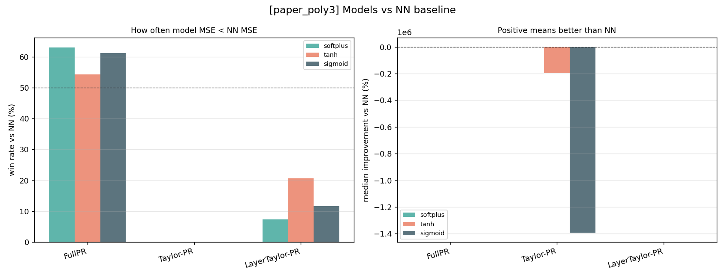
Figure: NN-baseline comparison for paper_poly4. The NN is more stable in this underspecified higher-order task.
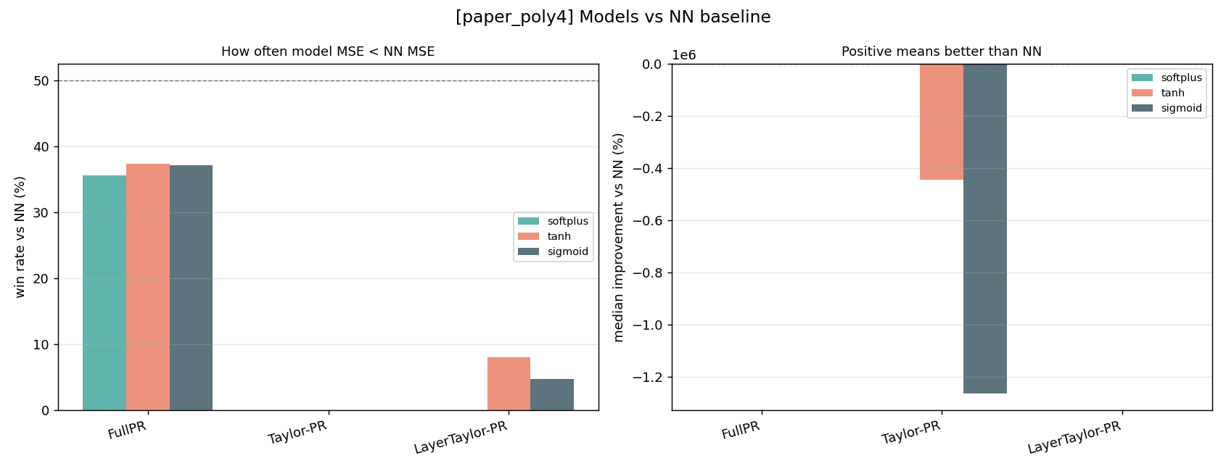
Figure: NN-baseline comparison for smooth_nonlinear. FullPR slightly outperforms the NN.
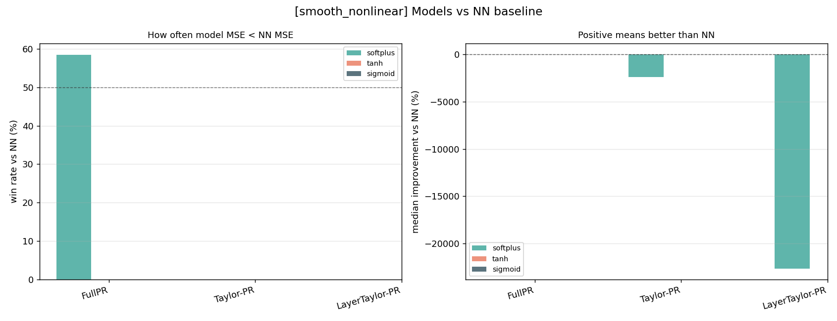
Figure: NN-baseline comparison for smooth_nonlinear_rand. The NN has the clearest advantage.
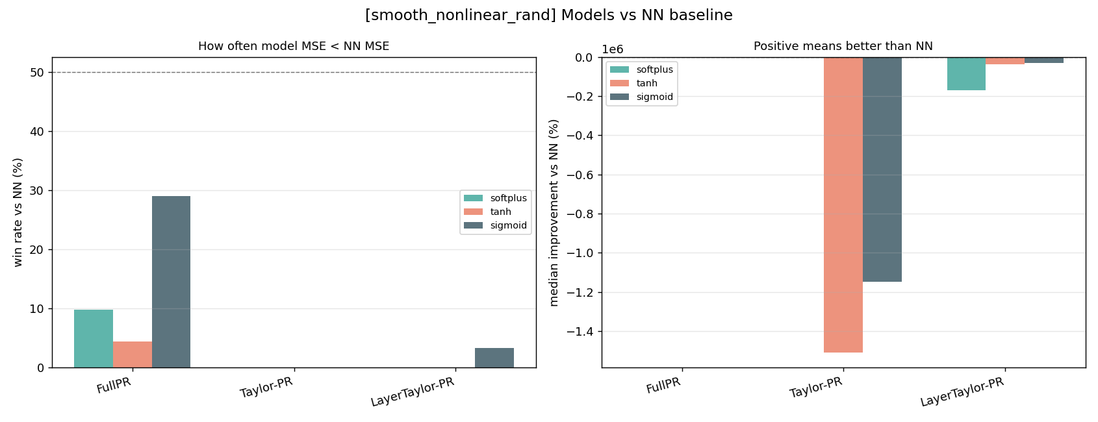
Dataset-level conclusion: FullPR wins more often in paper_poly3 and smooth_nonlinear, while the NN is more stable in paper_poly4 and smooth_nonlinear_rand. Thus, 'the NN can be explained by a polynomial' and 'a polynomial is always more accurate than the NN' are different claims. Geometric equivalence describes the relationship between shape and performance gap; the actual winner depends on polynomial order, random nonlinearity, feature specification, and training stability.
Based on 3000 repeated simulations, Spearman rank correlations (* = p<0.05). This is the quantitative core of the study.

4.1 Core Claim: Geometric Closeness -> Performance Closeness
The correlation between NN-FullPR shape distance and performance gap, the foundation of the project:
Dataset | Spearman rho | p value | n
ALL | 0.840* | ~ 0 | 3000
paper_poly4 | 0.873* | 1.4e-281 | 900
paper_poly3 | 0.836* | 3.4e-236 | 900
smooth_nonlinear | 0.848* | 3.7e-84 | 300
smooth_nonlinear_rand | 0.443* | 1.2e-44 | 900
Conclusion: whether well-specified, underspecified, or non-polynomial, geometric closeness strongly and significantly predicts performance closeness. This does not hold automatically in mathematics (shape distance factors out scaling), so it is a substantive empirical law, not an identity.

4.2 The Activation Effect Is Mainly in Extrapolation
Relationship | ALL rho | Reading
-> data-region closeness | 0.172* | weak within the data region
-> extrapolation closeness | 0.556* | activation effect mainly in extrapolation
-> performance gap | 0.017 | almost no direct link (geometry mediates)
adj-layer nonlin -> data-region closeness | 0.523* | another nonlinearity measure gives moderate positive
Saturating activations (tanh/sigmoid) flatten while polynomials diverge in extrapolation, locking the gap into fixed values that form the horizontal bands in panel 3.

4.3 Simpson's Paradox: Correcting the Original Hypothesis
'Smaller activation change -> closer to polynomial' is positive when pooled (+0.17) but negative within each dataset:
Dataset | act-change -> data-region closeness rho
paper_poly4 | -0.465*
paper_poly3 | -0.283*
smooth_nonlinear_rand | -0.252*
smooth_nonlinear | -0.494*
The positive pooled sign is an artifact of between-group differences (Simpson's paradox). Lesson: report per dataset — the reason for splitting figures throughout.

4.4 Catastrophic Failure of the Layer-wise Taylor Expansion
LTPR translates the network into a polynomial via the Taylor series:
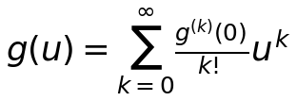
Valid only when u is within the convergence region. When the synaptic potential is too large, higher-order terms u^k explode, the polynomial diverges, and predictions reach 1e8 while the NN output is only ~0.00x. This is a rare but catastrophic failure: most runs replicate perfectly (error 1e-9), with occasional total explosions. Peak LTPR-MSE failure tails per dataset: paper_poly3 ~900, paper_poly4 ~4x10^5, smooth_nonlinear ~6x10^4, smooth_nonlinear_rand ~3x10^8. This precisely confirms Morala (2021)'s central warning about the Taylor convergence boundary.

Part 5 Conclusions
Synthesizing all the evidence, the following conclusions are ready for a paper:
- Geometric equivalence holds universally: neural networks are highly close to polynomials in shape, and closeness strongly predicts performance closeness (cleaned overall rho=0.839), holding across well-specified, underspecified, and non-polynomial data. This turns 'is the NN doing polynomial regression' from a vague intuition into a measurable, falsifiable conclusion.
- The boundary of equivalence is precisely characterized: failure occurs mainly (a) in extrapolation, especially with saturating activations, and (b) when the Taylor expansion leaves its convergence region. The former is an intrinsic NN-polynomial difference; the latter is a limitation of the symbolic-translation method.
- Shape distance is an effective tool: as a pure geometric metric factoring out translation/rotation/scaling, it cleanly predicts replication error (panel 2 of every MSE figure is a positive line), a reliable ruler for 'how alike two models are.'
- Methodological caution: Simpson's paradox demands grouped reporting; outliers from non-convergent runs and Taylor failures must be identified and handled separately, or they distort conclusions.
- The NN-baseline win/loss result is more nuanced: FullPR is the true predictive competitor, but it wins mainly in paper_poly3 and smooth_nonlinear; in paper_poly4 and smooth_nonlinear_rand the NN is more stable. Taylor-style methods should not be interpreted as prediction models that reliably beat the NN; their main role is explanation and replication.
In one sentence: this study uses a geometric ruler to prove that neural networks are largely equivalent to polynomials (close in shape, close in performance), and precisely characterizes when this equivalence holds and when it fails — failure occurs mainly in extrapolation (saturating activations) and when the Taylor expansion goes out of bounds.

Note: shape distance is based on Procrustes analysis; activation change is based on layer-wise input-output shape change; layer-wise Taylor expansion symbolically composes a network of arbitrary depth into a single polynomial. All metrics are computed over multiple repeated experiments (different random initializations) to reflect training randomness.

