High-Dimensional Iterative D-optimal Experiment for NN-FullPR Transfer
Paper-scale bilingual report update with n=10000, p=20/50, CPU/GPU, and multi-seed replication
Dataset scale | Original n=10000; training/evaluation split=7500/2500
Dimensions and cases | p=20,50; quadratic / smooth / strong nonlinear
Replication | 3 data seeds × 2 NN initialization seeds × 2 initial fractions × CPU/GPU
Workload | 72 NN oracle trainings; 144 iterative paths; 8640 random surrogate fits

Executive Summary
Main finding: At the final iteration, D-optimal upgrading outperformed the same-budget random-upgrade median in 128 of 144 replications. The final positive-rate was 88.9%, and the average MSE gain was 2.61%. The result supports iterative D-optimal design as a stable data-upgrading strategy for high-dimensional NN-to-FullPR surrogate construction, while also showing that the gain depends on feature expressiveness, initial sampling fraction, and nonlinearity strength.

Experimental Workflow
- Generate a high-dimensional original dataset and split it into a training pool and an evaluation set.
- Train an NN oracle on the training pool; this NN is treated as the new target model.
- Uniformly sample the initial design set and estimate the pilot distance between the NN and the FullPR surrogate.
- At each iteration, compute D-optimal leverage conditional on the already upgraded design set and add a new batch of samples.
- Refit the FullPR surrogate after each upgrade and compare it against random upgrades under the same budget.

Experimental Matrix and Workload
Item | Setting
Original dataset size | 10000
Input dimensions | 20, 50
Synthetic cases | quadratic, smooth, strong nonlinear
Initial uniform fractions | 0.05, 0.1
Iterations | 5; 500 samples added per iteration
Random baseline | 10 repeats per iteration point
Devices | CPU and NVIDIA GeForce RTX 4070 Ti SUPER
FullPR features | degree=2, include_special=True

Main Results
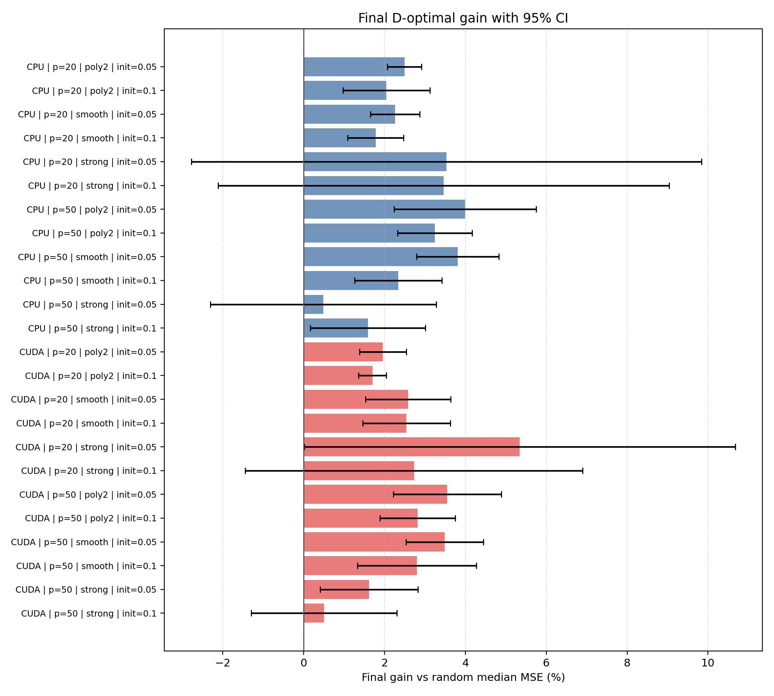
Figure 1. Final-iteration D-optimal gain over random upgrading, mean +/- 95% CI.

Final-Iteration Group Statistics
Tables 1 and 2 summarize final-iteration performance. A positive gain means that the D-optimal surrogate has lower MSE than the same-budget random-upgrade median.
Case | p | Init | Reps | Gain mean +/-95%CI | Positive
poly2 | 20 | 0.05 | 6 | 2.49% +/- 0.43% | 100.0%
poly2 | 20 | 0.1 | 6 | 2.04% +/- 1.08% | 83.3%
smooth | 20 | 0.05 | 6 | 2.26% +/- 0.61% | 100.0%
smooth | 20 | 0.1 | 6 | 1.78% +/- 0.69% | 100.0%
strong | 20 | 0.05 | 6 | 3.53% +/- 6.31% | 66.7%
strong | 20 | 0.1 | 6 | 3.46% +/- 5.58% | 66.7%
poly2 | 50 | 0.05 | 6 | 3.99% +/- 1.76% | 100.0%
poly2 | 50 | 0.1 | 6 | 3.24% +/- 0.92% | 100.0%
smooth | 50 | 0.05 | 6 | 3.81% +/- 1.02% | 100.0%
smooth | 50 | 0.1 | 6 | 2.34% +/- 1.08% | 100.0%
strong | 50 | 0.05 | 6 | 0.48% +/- 2.79% | 66.7%
strong | 50 | 0.1 | 6 | 1.59% +/- 1.42% | 66.7%

Case | p | Init | Reps | Gain mean +/-95%CI | Positive
poly2 | 20 | 0.05 | 6 | 1.96% +/- 0.58% | 100.0%
poly2 | 20 | 0.1 | 6 | 1.70% +/- 0.34% | 100.0%
smooth | 20 | 0.05 | 6 | 2.58% +/- 1.05% | 100.0%
smooth | 20 | 0.1 | 6 | 2.54% +/- 1.08% | 100.0%
strong | 20 | 0.05 | 6 | 5.35% +/- 5.33% | 83.3%
strong | 20 | 0.1 | 6 | 2.73% +/- 4.17% | 66.7%
poly2 | 50 | 0.05 | 6 | 3.55% +/- 1.34% | 100.0%
poly2 | 50 | 0.1 | 6 | 2.82% +/- 0.93% | 100.0%
smooth | 50 | 0.05 | 6 | 3.49% +/- 0.96% | 100.0%
smooth | 50 | 0.1 | 6 | 2.80% +/- 1.47% | 83.3%
strong | 50 | 0.05 | 6 | 1.62% +/- 1.21% | 83.3%
strong | 50 | 0.1 | 6 | 0.50% +/- 1.80% | 66.7%

Iteration Curves
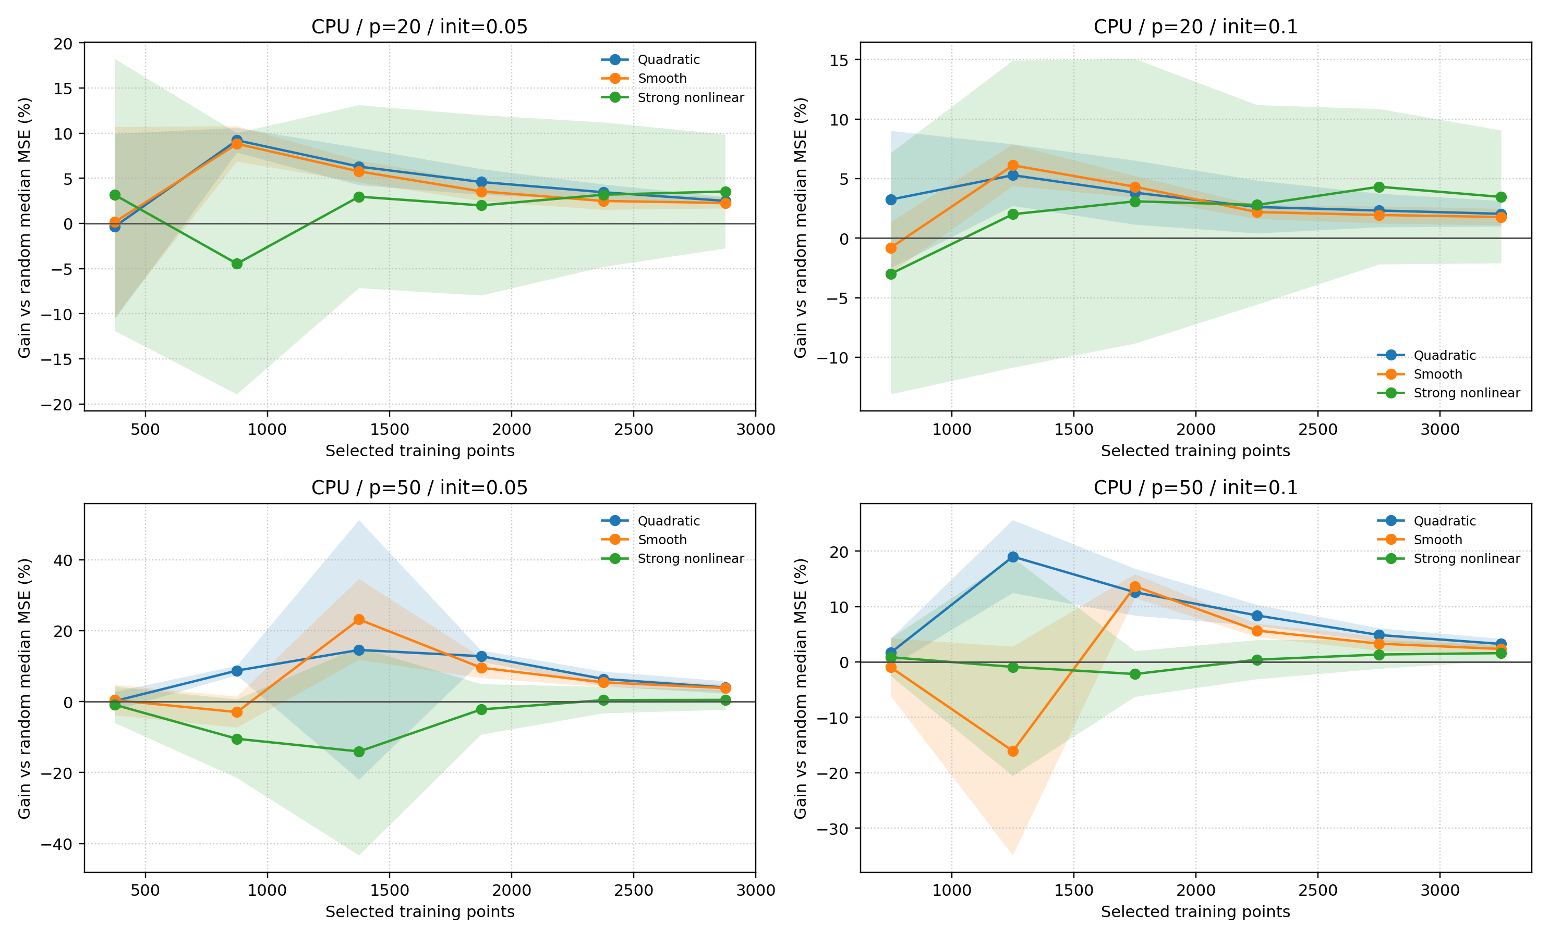
Figure 2. CPU gain curves with 95% confidence intervals.
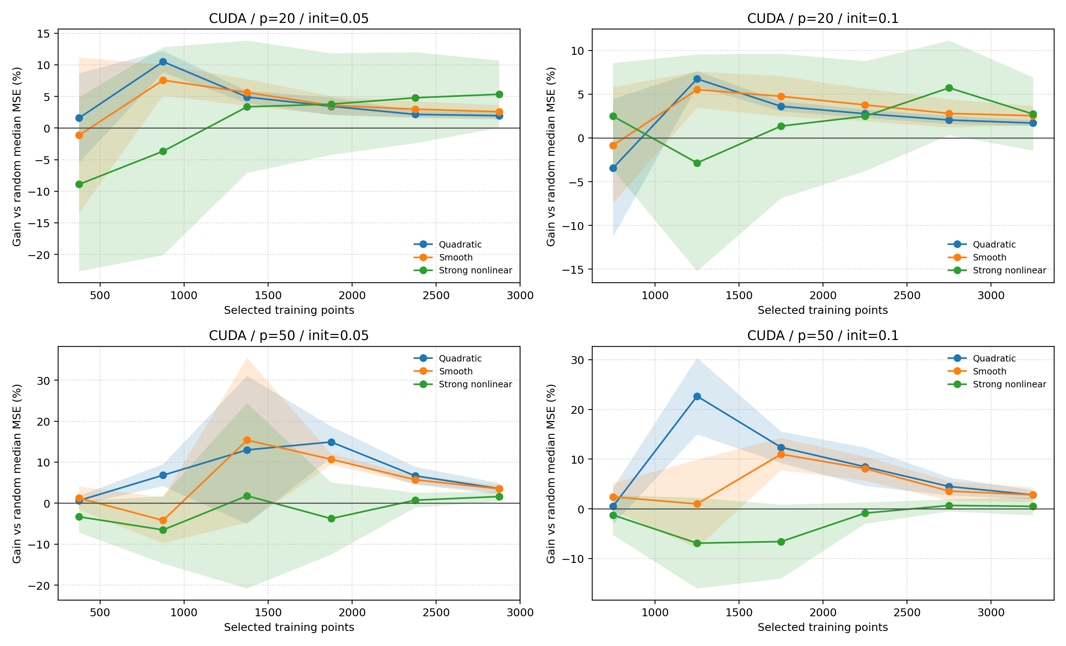
Figure 3. CUDA gain curves with 95% confidence intervals.
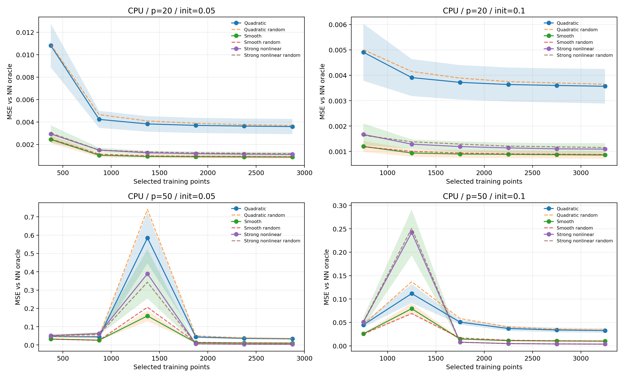
Figure 4. CPU MSE curves for D-optimal surrogates and random baselines.
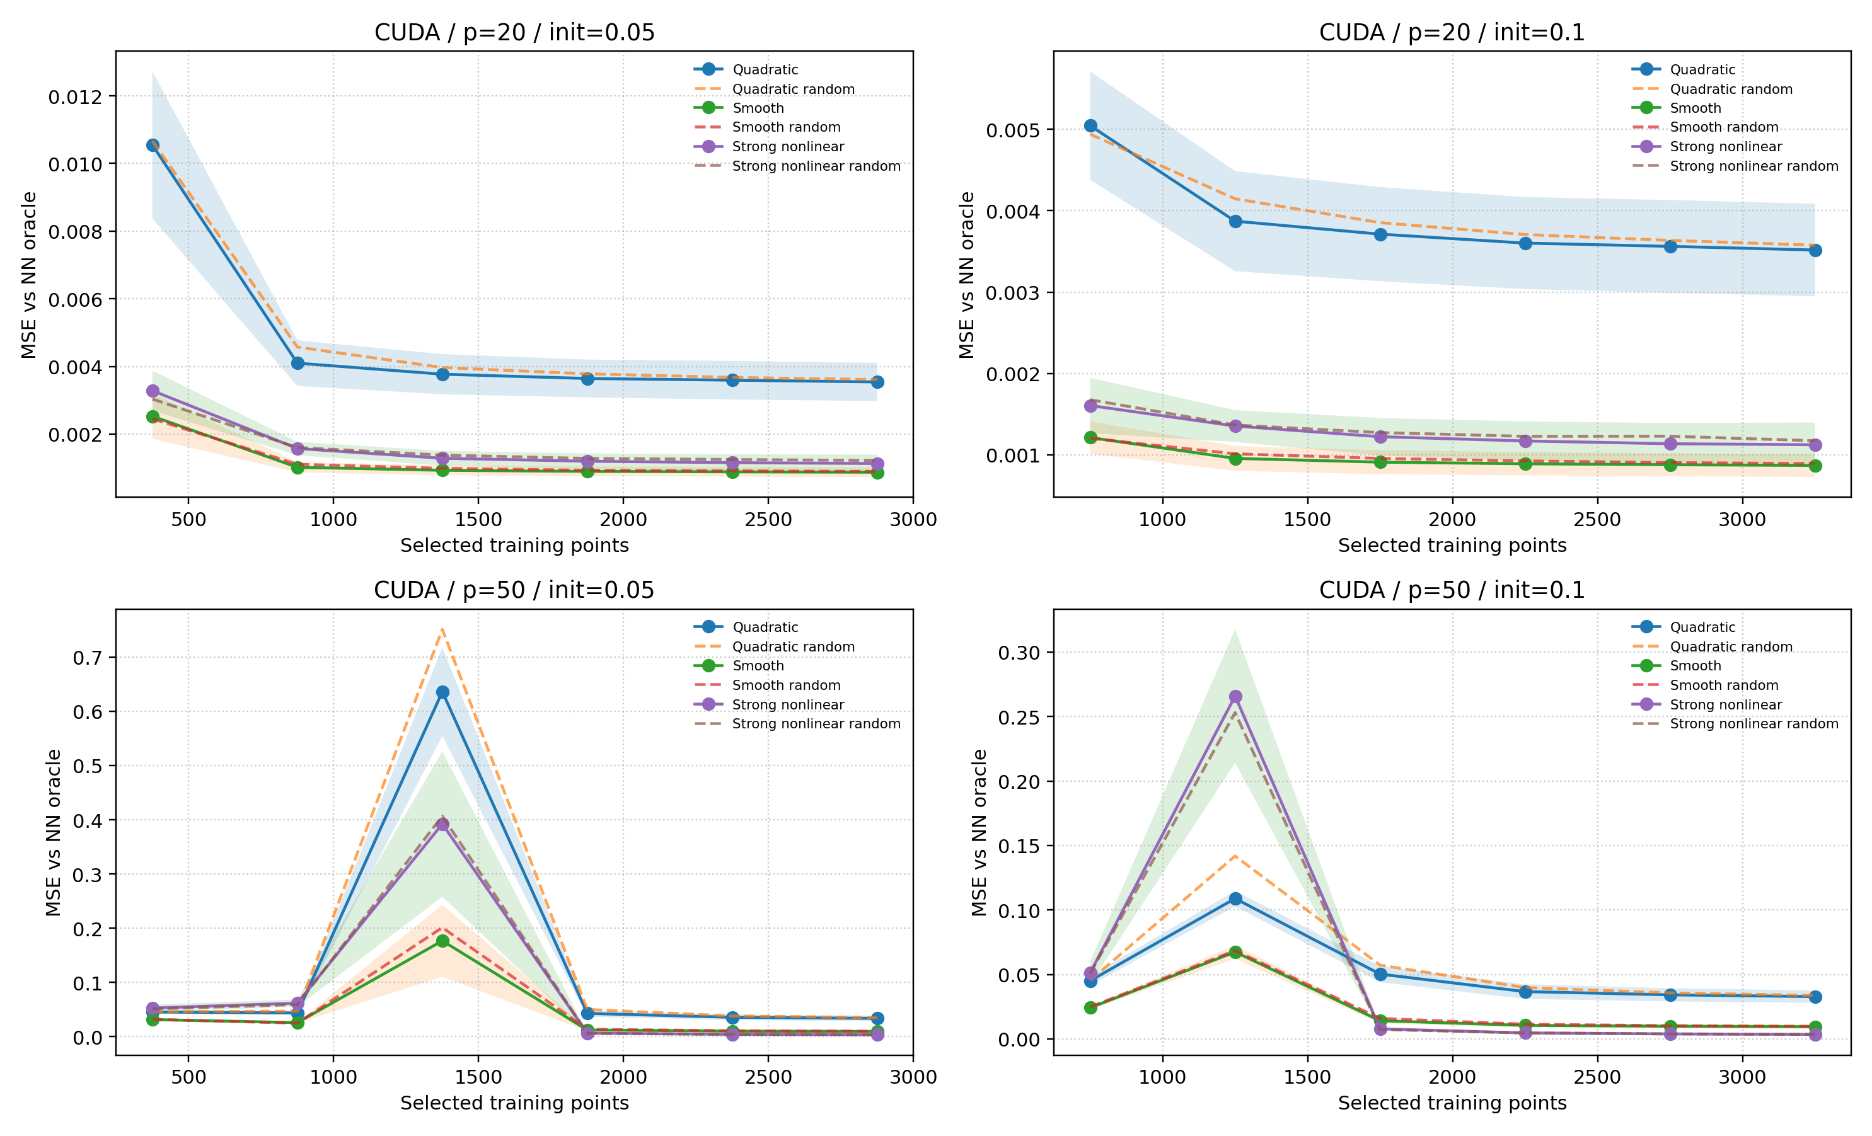
Figure 5. CUDA MSE curves for D-optimal surrogates and random baselines.

Discussion
- For p=20, the quadratic FullPR feature count is relatively small, so the initial design often already exceeds the number of features. D-optimal gains are therefore modest but stable.
- For p=50, the initial design is more likely to be under the FullPR feature count. Early iterations are more volatile, but the upgraded design stabilizes as it is reused in later D-optimal steps.
- The strong nonlinear case has wider confidence intervals, which marks the boundary of the method: D-optimal selection can improve coverage, but it is not a guarantee that a low-degree FullPR surrogate fully captures the NN oracle.
- CPU and GPU runs lead to the same qualitative conclusion, reducing the chance that the result is a device-specific artifact.

Conclusion
This updated experiment is suitable as a main paper experiment. The most defensible claim is that pilot distance and iterative D-optimal upgrading form an observable and reproducible diagnostic workflow for data selection. In high-dimensional settings, the workflow usually improves over random upgrading, but the magnitude of improvement depends on the FullPR feature space, nonlinearity strength, initial sampling fraction, and iteration budget.

