1.Git Setup https://confluence.atlassian.

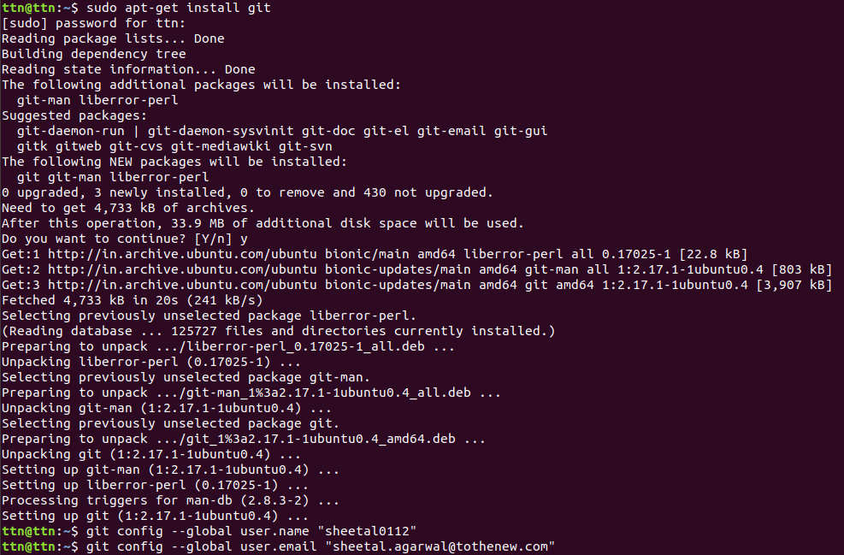
2.Initialize a Git Repository

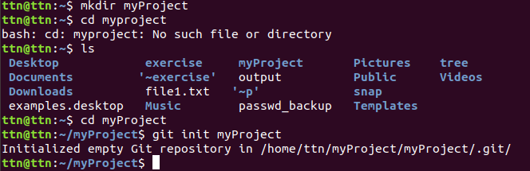
3.Add files to the repository

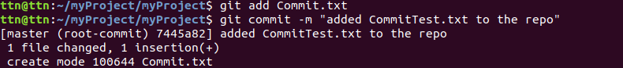
4.Unstage 1 file

5.Commit the file

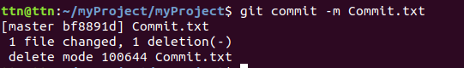
6.Add a remote
7.Undo changes to a particular file

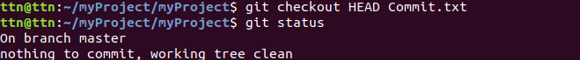
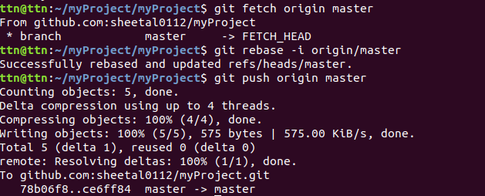
8.Push changes to Github

9.Clone the repository

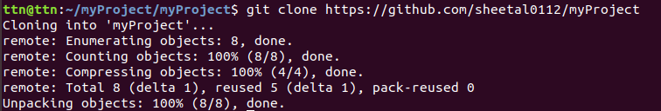
10.Add changes to one of the copies and pull the changes in the other.

11.Check differences between a file and its staged version

12.Ignore a few files to be checked in

13.Create a new branch.

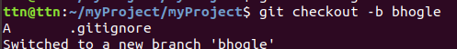
14.Diverge them with commits

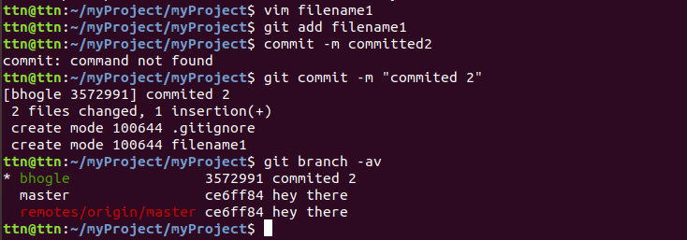
15.Edit the same file at the same line on both branches and commit

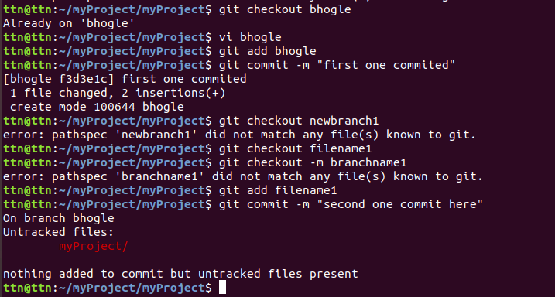
16.Try merging and resolve merge conflicts

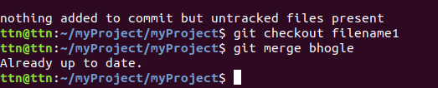
17.Stash the changes and pop them

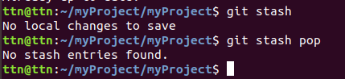

18.Add the following code to your .bashrc file : color_prompt="yes"
parse_git_branch() {
git branch 2> /dev/null | sed -e '/^[^*]/d' -e 's/* \(.*\)/(\1)/'
}
if [ "$color_prompt" = yes ]; then
PS1='\u@\h\[\033[00m\]:\[\033[
else
PS1='\u@\h:\W $(parse_git_branch)\$ '
fi
unset color_prompt force_color_prompt

