- Prompt for amount, interest rate and no. of years and calculate simple interest .
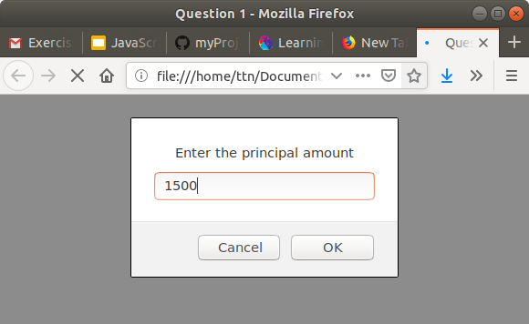
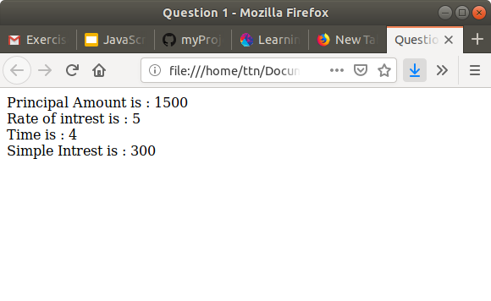
For the code – js1.html

2.is palindrome string

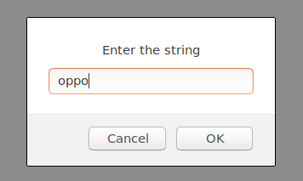
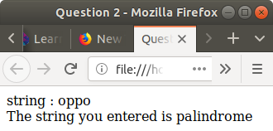

3.Area of circle

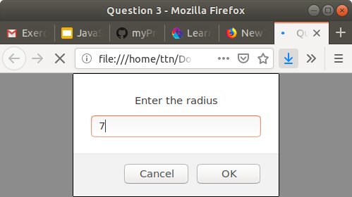

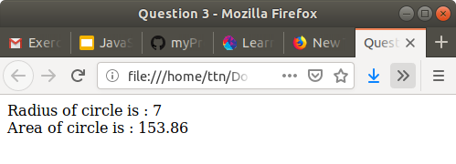

4.Copy information of one object to another and log it to console.

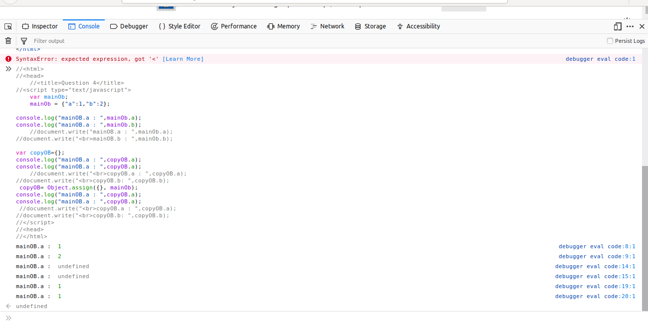

5.create a list of objects of Employee with info as follow :
Name, age, salary ,DOB

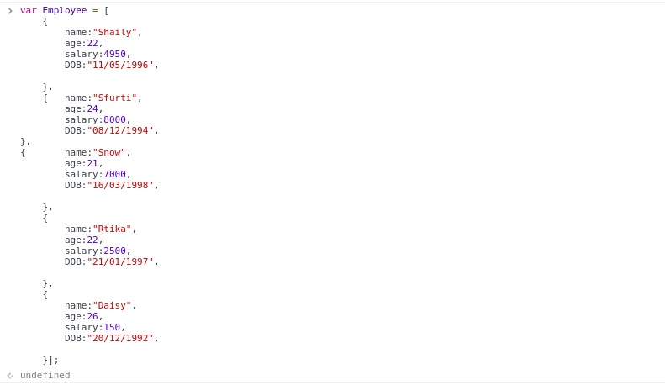

filter all employees with salary greater than 5000

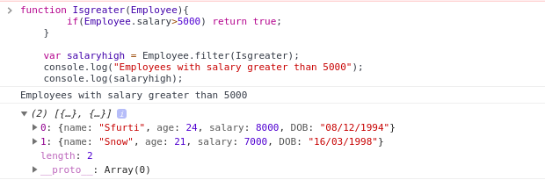
fetch employees with salary less than 1000 and age greater than 20. Then give them an increment 5 times their salary

