1.Create Database
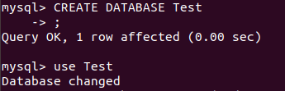

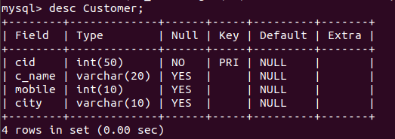
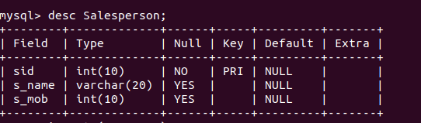
3.Create tables

4.Find the sales person have multiple orders.

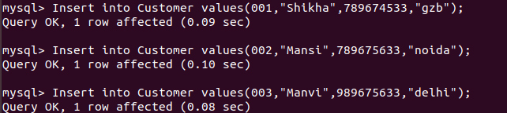
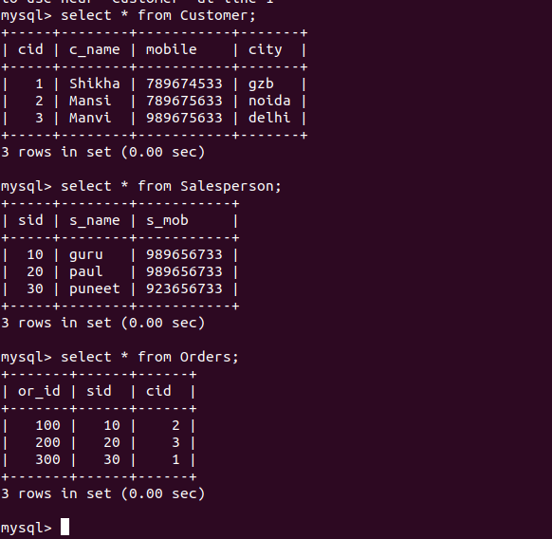
5.Find the sales person have multiple orders.


6.Find the all sales person details along with order details

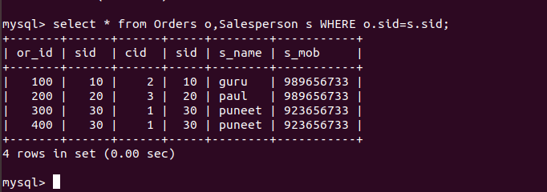
7.Create index

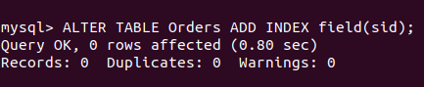

8.How to show index on a table

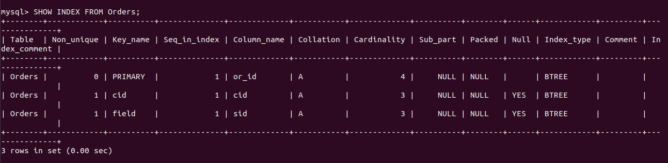
9.Find the order number, sale person name, along with the customer to whom that order belongs to

