Add dependency of the following in your project's POM and make them available in Felix Console.
com.google.gson.Gson
Version : 2.8
(NOTE: Without creating bundle of this jar)
Add this dependency in your pom.xml file. We need to us it in any one of our programs so that it can be started.

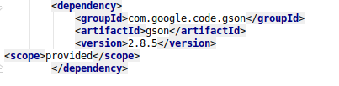

Hence we are using it in our program:

package com.ttn.sling.projec;
import com.google.gson.Gson;
import org.osgi.framework.BundleContext;
import org.osgi.service.component.ComponentContext;
import org.osgi.service.component.annotations.Component;
import org.slf4j.Logger;
import org.slf4j.LoggerFactory;
/**
* A simple DS component which is executed every 10 seconds
*
* @see <a href="https://sling.apache.org/documentation/bundles/scheduler-service-commons-scheduler.html">Scheduler Service</a>
*/
@Component( property = {
"scheduler.period:Long=10"
})
public class SimpleDSComponent implements Runnable {
Gson gson=new Gson();
private Logger logger = LoggerFactory.getLogger(this.getClass());

private BundleContext bundleContext;

public void run() {
logger.info("Running...");
}

protected void activate(ComponentContext ctx) {
this.bundleContext = ctx.getBundleContext();
}

protected void deactivate(ComponentContext ctx) {
this.bundleContext = null;
}
}
It can be viewed on console:
