JAVA1 ASSESMENT

Q1. Write a program to replace a substring inside a string with other string ?

public class Ques1 {
public static void main(String args[]) {
String str="Hello World";
System.out.println( str.replaceAll("He","Wo" ) );
}
}
Output:
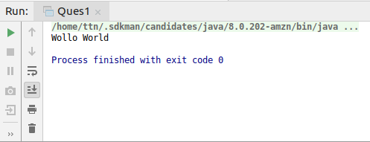
Q2. Write a program to find the number of occurrences of the duplicate words in a string and print them ?

public class Ques2 {
public static void main(String[] args)
{
String input="Today Today is the day day of";
String[] words=input.split(" ");
int c=1;
for(int i=0;i<words.length;i++)
{
for(int j=i+1;j<words.length;j++)
{
if(words[i].equals(words[j]))
{
c=c+1;
words[j]="0";
}
}
if(words[i]!="0")
System.out.println(words[i]+"-"+c);
c=1;
}
}
}
Output:
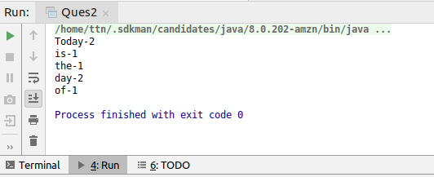
Q3. Write a program to find the number of occurrences of a character in a string without using loop?

public class Ques3 {
public static void main(String[] args) {
String str = "An Apple a day keeps the doctor away";
System.out.println("Length Of String:" + str.length());
System.out.println("Length Of String Without a :" + str.replace("a", "").length());
int charcount = str.length() - str.replaceAll("a", "").length();
System.out.println("Occurrence Of 'a' Char In String: " + charcount);
}
}
Output:
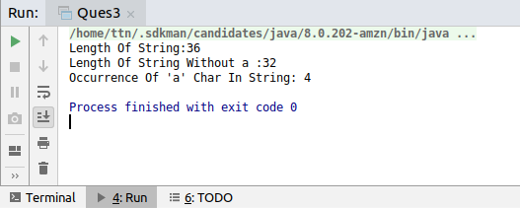
Q4. Calculate the number & Percentage Of Lowercase Letters,Uppercase Letters, Digits And Other Special Characters In A String

import java. util. Scanner;
public class Ques4 {
public static void main(String args[])
{
String str;
Scanner in = new Scanner(System.in);
System.out.println("Enter the string:");
str=in.nextLine();
System.out.println("You entered the string:"+str);
int count = str.length();
int u=0,l=0,d=0,s=0;
double up,lp,dp,Sp;
for(int i=0;i<str.length();i++)
{
char ch = str.charAt(i);
if(Character.isUpperCase(ch))
u++;
else if(Character.isLowerCase(ch))
l++;
else if(Character.isDigit(ch))
d++;
else
s++;
}
up = (u * 100.0) / count ;
lp = (l * 100.0) / count ;
dp = (d * 100.0) / count ;
Sp = (s * 100.0) / count ;
System.out.println("UpperCase Percentage:"+ up + "%");
System.out.println("LowerCase percentage:"+ lp + "%");
System.out.println("Digits Percentage:"+ dp + "%");
System.out.println("Special Character Perecentage:"+ Sp + "%");
}
}
Output:
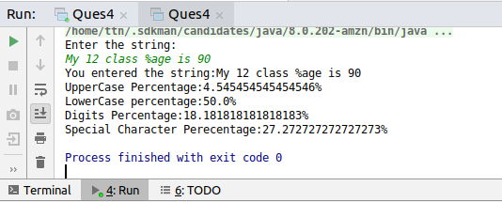
Q5. Find common elements between two arrays.

public class Ques5 {
public static void main(String arg[]){
int[] arr1 = {1,2,5,7,9,10};
int[] arr2 = {4,5,10,20,14,51};
for(int i=0;i<arr1.length;i++){
for(int j=0;j<arr2.length;j++){
if(arr1[i]==arr2[j]){
System.out.println(arr1[i]);
}
}
}
}
}
Output:
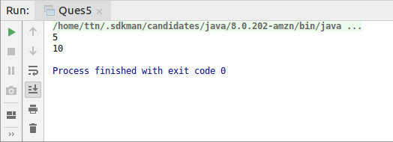
Q6. There is an array with every element repeated twice except one. Find that element

public static void main(String args[]) {
int[] arr1 ={1, 2, 1, 2, 3};
int c=arr1[0];
for (int i = 1; i < arr1.length;i++)
{
c=c^arr1[i];
}
System.out.println("The entered array is:");
for(int i=0;i<arr1.length;i++)
{
System.out.print(arr1[i] + " ");
}
System.out.println("");
System.out.println("The non repeated element is:"+c);
}
}
Output:
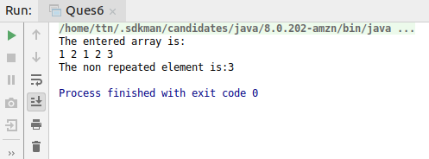
Q7. Write a program to print your Firstname,LastName & age using static block,static method & static variable respectively

class Ques7
{
static int age=21;
static
{
System.out.println("Firstname: Sheetal");
age=21;
}
static void test()
{
System.out.println("Lastname:Agarwal");
}
public static void main(String args[])
{
System.out.println("static block executed!!");
test();
System.out.println("static function executed!!");
System.out.println("Age:"+age);
}
}
Output;

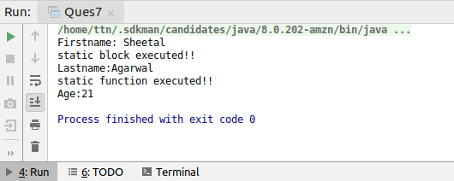
Q8. Write a program to reverse a string and remove character from index 4 to index 9 from the reversed string using String Buffer

public class Ques8 {
public static void main(String[] args) {
StringBuffer str = new StringBuffer("This is a new String");
System.out.println("Original String: " + str);
str.reverse();
System.out.println("Reverse String: " + str);
str.delete(4, 10);
System.out.println("After Deleting: " + str);
}
}
Output:
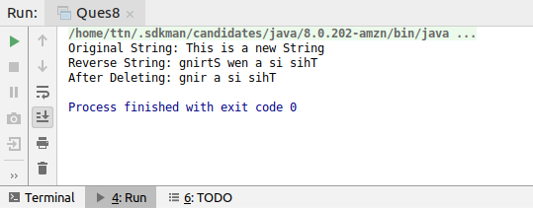
Q9.Write a program to display values of enums using a constructor & getPrice() method (Example display house & their prices)

enum House
{
bunglow(200),cottage(100),pucca_house(120),kutcha_house(60);
private int price;
House(int p)
{
price=p;
}
int getPrice()
{
return price;
}
}
public class Ques9 {
public static void main(String args[])
{
System.out.println("All house prices");
for(House h: House.values()) System.out.println(h + " costs " + h.getPrice() + " thousand dollars.");
}
}
Output:
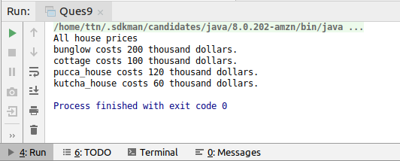

Q10.Write a single program for following operation using overloading
A) Adding 2 integer number
B) Adding 2 double
C) multiplying 2 float
D) multiplying 2 int
E) concate 2 string
F) Concate 3 String

public class Ques10 {
static void fun(int a,int b)
{
int c;
c=a+b;
System.out.println("Addition of 2 integer:"+ c);
}
static void fun(double a, double b)
{
double c;
c=a*b;
System.out.println("Multiplication of 2 float no.:"+ c);
}
static void fum1(int a,int b)
{
int c;
c=a*b;
System.out.println("Multiplication of 2 integers:"+ c);
}
static void fun(String a,String b)
{
System.out.println("Concatenation of 2 strings:" + a+b);
}
static void fun(String a,String b,String c)
{
System.out.println("Concatenation of 3 strings are:"+a+b+c);
}
public static void main(String args[])
{
fun(2,4);
fun(4.50,87.95);
fum1(12,45);
fun("abc","def");
fun("abc","def","ghi");
}
}
Output:
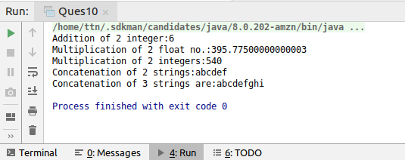
Q11.Create 3 sub class of bank SBI,BOI,ICICI all 4 should have method called getDetails which provide there specific details like rateofinterest etc,print details of every banks

class bank{
int r=1;
String name;
public void getDetails(){
}
}
class sbi extends bank{
sbi(){
super.name="sbi";
super.r=2;
}
public void getDetails(){
System.out.println(name + " has rate of interest of "+ r);
}
}
class boi extends bank{
boi(){
this.name="boi";
this.r=4;
}
public void getDetails(){
System.out.println(name + " has rate of interest of "+ r);
}
}
class icici extends bank{
icici(){
this.name="icici";
this.r=5;
}
public void getDetails(){
System.out.println(name + " has rate of interest of "+ r);
}
}
public class Ques11 {
public static void main(String[] args) {
sbi sbiBank = new sbi();
boi boiBank = new boi();
icici iciciBank = new icici();
sbiBank.getDetails();
boiBank.getDetails();
iciciBank.getDetails();
}
}
Output:

