DESIGN PATTERNS
1.Implement Singleton Design Pattern on a dummy class.

Source Code:

package com.designPattern.demo;
class DBConnection {
static DBConnection redisConnection;
int port;
String database;
private DBConnection() {
try {
Thread.sleep(2000L);
} catch (InterruptedException e) {
e.printStackTrace();
}
this.port = 8010;
this.database = "Redis";
}
static DBConnection getInstance() {
if (redisConnection == null) {
redisConnection = new DBConnection();
}
return redisConnection;
}
@Override
public String toString() {
return "DBConnection{" +
"port=" + port +
", database='" + database + '\'' +
'}';
}
}
public class Ques1 {
public static void main(String[] args) {
System.out.println(DBConnection.getInstance());
System.out.println(DBConnection.getInstance());
}
}
Output:
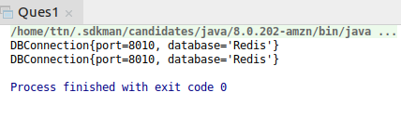

2.Implement Factory Pattern to get the Polygon of differnt type.

Source Code:

@FunctionalInterface
interface Noofside{
void printpoly();
}
class Pentagon implements Noofside{
@Override
public void printpoly(){
System.out.println("This polygon is Pentagon");
}
}
class Hexagon implements Noofside{
@Override
public void printpoly(){
System.out.println("This polygon is Hexagon");
}
}
class Polygon{
Noofside noofside;
public Noofside getNoofside(){
return noofside;
}
public void setNoofside( Noofside noofside){
this.noofside = noofside;
}
}
class PolygonFactory{
static Polygon getpolyobj(int noofside){
Polygon polygon = new Polygon();
switch (noofside)
{
case 5:
polygon.setNoofside(new Pentagon());
break;
case 6:
polygon.setNoofside(new Hexagon());
break;
}
return polygon;
}
}
public class Ques2 {
public static void main(String[] args) {
Polygon pentagon = PolygonFactory.getpolyobj(5);
pentagon.getNoofside().printpoly();
Polygon hexagon = PolygonFactory.getpolyobj(6 );
hexagon.getNoofside().printpoly();
}
}
Output:

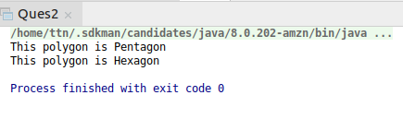

3.Implement Abstract Factory Pattern to create cars of different categories from different countries.

Source Code:
enum CarType {
MINI, MICRO, LUXURY;
}
enum Location {
INDIA, AUSTRALIA, USA;
}
abstract class Car {
CarType carType;
Location location;
public Car(CarType carType, Location location) {
this.carType = carType;
this.location = location;
}
abstract void construct();
@Override
public String toString() {
return "Car{" +
"carType=" + carType +
", location=" + location +
'}';
}
}
class Micro extends Car {
public Micro(Location location) {
super(CarType.MICRO, location);
}
@Override
void construct() {
System.out.println("Connecting to Micro Car");
}
}
class Luxury extends Car {
public Luxury(Location location) {
super(CarType.LUXURY, location);
}
@Override
void construct() {
System.out.println("Connecting to Luxury Car");
}
}
class Mini extends Car {
public Mini(Location location) {
super(CarType.MINI, location);
}
@Override
void construct() {
System.out.println("Connecting to Mini Car");
}
}
class IndianCarFactory {
static Car buildCar(CarType carType) {
Car car = null;
switch (carType) {
case MINI:
car = new Mini(Location.INDIA);
break;
case MICRO:
car = new Micro(Location.INDIA);
break;
case LUXURY:
car = new Luxury(Location.INDIA);
break;
}
return car;
}
}
class USACarFactory {
static Car buildCar(CarType carType) {
Car car = null;
switch (carType) {
case MINI:
car = new Mini(Location.USA);
break;
case MICRO:
car = new Micro(Location.USA);
break;
case LUXURY:
car = new Luxury(Location.USA);
break;
}
return car;
}
}
class AustraliaCarFactory {
static Car buildCar(CarType carType) {
Car car = null;
switch (carType) {
case MINI:
car = new Mini(Location.AUSTRALIA);
break;
case MICRO:
car = new Micro(Location.AUSTRALIA);
break;
case LUXURY:
car = new Luxury(Location.AUSTRALIA);
break;
}
return car;
}
}
class CarFactory {
static Car buildCar(CarType carType, Location location) {
Car car = null;
switch (location) {
case INDIA:
car = IndianCarFactory.buildCar(carType);
break;
case USA:
car = USACarFactory.buildCar(carType);
break;
case AUSTRALIA:
car = AustraliaCarFactory.buildCar(carType);
break;
}
return car;
}
}
public class Ques3 {
public static void main(String[] args) {
System.out.println(CarFactory.buildCar(CarType.MINI, Location.INDIA));
}
}
Output:

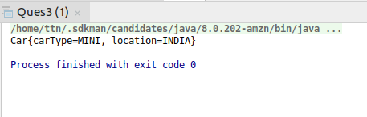

4.Implement Builder pattern to create a student object with more than 6 fields.
Source Code:
class Student {
private int rollNo;
private String studentName;
private int yearOfAdmission;
private String course;
private String branch;
private boolean hostler;
private boolean feeWaiver;
public Student() {
}
public Student(StudentBuilder studentBuilder) {
rollNo = studentBuilder.getRollNo();
studentName = studentBuilder.getStudentName();
yearOfAdmission = studentBuilder.getYearOfAdmission();
course = studentBuilder.getCourse();
branch = studentBuilder.getBranch();
hostler = studentBuilder.isHostler();
feeWaiver = studentBuilder.isFeeWaiver();
}
public int getRollNo() {
return rollNo;
}
public void setRollNo(int rollNo) {
this.rollNo = rollNo;
}
public String getStudentName() {
return studentName;
}
public void setStudentName(String studentName) {
this.studentName = studentName;
}
public int getYearOfAdmission() {
return yearOfAdmission;
}
public void setYearOfAdmission(int yearOfAdmission) {
this.yearOfAdmission = yearOfAdmission;
}
public String getCourse() {
return course;
}
public void setCourse(String course) {
this.course = course;
}
public String getBranch() {
return branch;
}
public void setBranch(String branch) {
this.branch = branch;
}
public boolean isHostler() {
return hostler;
}
public void setHostler(boolean hostler) {
this.hostler = hostler;
}
public boolean isFeeWaiver() {
return feeWaiver;
}
public void setFeeWaiver(boolean feeWaiver) {
this.feeWaiver = feeWaiver;
}
@Override
public String toString() {
return "Student{" +
"rollNo=" + rollNo +
", studentName='" + studentName + '\'' +
", yearOfAdmission=" + yearOfAdmission +
", course='" + course + '\'' +
", branch='" + branch + '\'' +
", hostler=" + hostler +
", feeWaiver=" + feeWaiver +
'}';
}
}
class StudentBuilder {
private int rollNo;
private String studentName;
private int yearOfAdmission;
private String course;
private String branch;
private boolean hostler;
private boolean feeWaiver;
public int getRollNo() {
return rollNo;
}
public StudentBuilder setRollNo(int rollNo) {
this.rollNo = rollNo;
return this;
}
public String getStudentName() {
return studentName;
}
public StudentBuilder setStudentName(String studentName) {
this.studentName = studentName;
return this;
}
public int getYearOfAdmission() {
return yearOfAdmission;
}
public StudentBuilder setYearOfAdmission(int yearOfAdmission) {
this.yearOfAdmission = yearOfAdmission;
return this;
}
public String getCourse() {
return course;
}
public StudentBuilder setCourse(String course) {
this.course = course;
return this;
}
public String getBranch() {
return branch;
}
public StudentBuilder setBranch(String branch) {
this.branch = branch;
return this;
}
public boolean isHostler() {
return hostler;
}
public StudentBuilder isHostler(boolean hostler) {
this.hostler = hostler;
return this;
}
public boolean isFeeWaiver() {
return feeWaiver;
}
public StudentBuilder isFeeWaiver(boolean feeWaiver) {
this.feeWaiver = feeWaiver;
return this;
}
public Student build() {
return new Student(this);
}
}
public class Ques4 {
public static void main(String[] args) {
Student student = new StudentBuilder()
.setStudentName("Sheetal")
.setRollNo(1503210200)
.setCourse("B.Tech")
.setBranch("C.S")
.setYearOfAdmission(2015)
.isFeeWaiver(false)
.isHostler(false)
.build();
System.out.println(student);
}
}
Output:
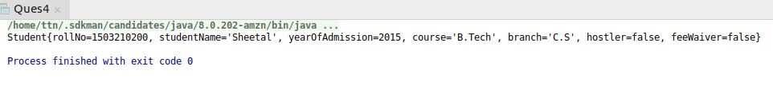
5.Implement Bridge Design Pattern for Color and Shape such that Shape and Color can be combined together e.g BlueSquare, RedSquare, PinkTriangle etc.
Source Code:
//Implementor
interface Color {
String getColorType();
}
//Concrete Implementor
class Blue implements Color {
@Override
public String getColorType() {
return "blue";
}
}
//Concrete Implementor
class Red implements Color {
@Override
public String getColorType() {
return "red";
}
}
//Concrete Implementor
class Pink implements Color {
@Override
public String getColorType() {
return "pink";
}
}
//Abstraction
abstract class Shape {
protected int noOfSide;
protected Color color;
public Shape(int noOfSide, Color color) {
this.noOfSide = noOfSide;
this.color = color;
}
}
//Refined Abstraction
class Square extends Shape {
public Square(Color color) {
super(4, color);
}
@Override
public String toString() {
return "Square{" +
"noOfSide=" + noOfSide +
", color=" + color.getColorType() +
'}';
}
}
//Refined Abstraction
class Triangle extends Shape {
public Triangle(Color color) {
super(3, color);
}
@Override
public String toString() {
return "Triangle{" +
"noOfSide=" + noOfSide +
", color=" + color.getColorType() +
'}';
}
}
public class Ques5 {
public static void main(String[] args) {
Square square = new Square(new Pink());
System.out.println(square);
Square square1 = new Square(new Blue());
System.out.println(square1);
Triangle triangle = new Triangle(new Blue());
System.out.println(triangle);
Triangle triangle1 = new Triangle(new Pink());
System.out.println(triangle1);
}
}
Output:
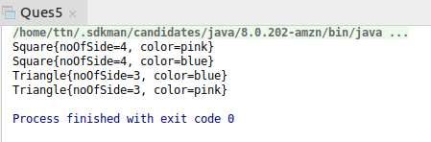

6.Implement Decorator pattern to decorate the Pizza with topings
Source Code:
interface Pizza{
String info();
}
class Veggie implements Pizza{
@Override
public String info(){
return "Veggie";
}
}
class Extracheese implements Pizza{
@Override
public String info(){
return "Extracheese";
}
}
class Pepproni implements Pizza{
@Override
public String info(){
return "pepproni";
}
}
class Sausage implements Pizza{
@Override
public String info(){
return "Sausage";
}
}
class Regularsize implements Pizza{
private Pizza pizza;
public Regularsize(Pizza pizza){
this.pizza = pizza;
}
public Pizza getpizza(){
return pizza;
}
public void setPizza(){
this.pizza = pizza;
}
@Override
public String info(){
return "This is a regular size pizza with : " + pizza.info() + " toppings";
}
}
class Medium implements Pizza{
private Pizza pizza;
public Medium(Pizza pizza){
this.pizza = pizza;
}
public Pizza getpizza(){
return pizza;
}
public void setPizza(){
this.pizza = pizza;
}
@Override
public String info(){
return "This is a medium size pizza with : " + pizza.info() + "toppings";
}
}
class Large implements Pizza{
private Pizza pizza;
public Large(Pizza pizza){
this.pizza = pizza;
}
public Pizza getpizza(){
return pizza;
}
public void setPizza(){
this.pizza = pizza;
}
@Override
public String info(){
return "This is a large size pizza with : " + pizza.info() + " toppings";
}
}
public class Ques6{
public static void main(String[] args) {
Pepproni pepproni = new Pepproni();
System.out.println(pepproni.info());
Medium medium = new Medium(pepproni);
System.out.println(medium.info());
Sausage sausage = new Sausage();
System.out.println(sausage.info());
Regularsize regularsize = new Regularsize(sausage);
System.out.println(regularsize.info());
}
}
Output:
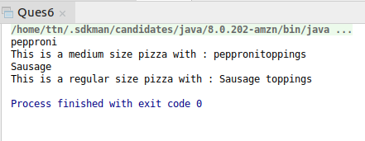

7.Implement Composite Design Pattern to maintaing the directories of employees on the basis of departments

Source Code:

import java.nio.channels.FileChannel;
import java.util.ArrayList;
import java.util.List;
//Component
interface Directory{
void showDirectoryDetails();
}
//Leaf
class Developer implements Directory {
private String name;
private String favoriteLanguage;
public Developer(String name, String favoriteLanguage) {
this.name = name;
this.favoriteLanguage = favoriteLanguage;
}
public String getName() {
return name;
}
public void setName(String name) {
this.name = name;
}
public String getFavoriteLanguage() {
return favoriteLanguage;
}
public void setFavoriteLanguage(String favoriteLanguage) {
this.favoriteLanguage = favoriteLanguage;
}
@Override
public void showDirectoryDetails() {
System.out.println("Developer{" +
"name='" + name + '\'' +
", favoriteLanguage='" + favoriteLanguage + '\'' +
'}');
}
@Override
public String toString() {
return "Developer{" +
"name='" + name + '\'' +
", favoriteLanguage='" + favoriteLanguage + '\'' +
'}';
}
}
//Leaf
class Manager implements Directory{
private String name;
private String type;
public Manager(String name,String type){
this.name = name;
this.type = type;
}
public String getName(){
return name;
}
public void setName(String name){
this.name = name;
}
public String getType(){
return type;
}
public void setType(String type){
this.type = type;
}
@Override
public void showDirectoryDetails(){
System.out.println("Manager{" +
"name='" + name + '\'' +
", type='" + type + '\'' +
'}');
}
@Override
public String toString(){
return "Manager{" +
"name='" + name + '\'' +
", type='" + type + '\'' +
'}';
}
}
//Composite
class DeveloperDirectory implements Directory{
List<Directory> developerDirectory = new ArrayList<Directory>();
@Override
public void showDirectoryDetails() {
System.out.println("Developer Directory");
developerDirectory.forEach(e->e.showDirectoryDetails());
}
}
//Composite
class ManagerDirectory implements Directory{
List<Directory> managerDirectory = new ArrayList<Directory>();
@Override
public void showDirectoryDetails() {
System.out.println("Manager Directory");
managerDirectory.forEach(e->e.showDirectoryDetails());
}
}
//Composite
class CompanyDirectory implements Directory{
List<Directory> companyDirectory = new ArrayList<>();
@Override
public void showDirectoryDetails(){
companyDirectory.forEach(e->e.showDirectoryDetails());
}
}
//Client
public class Ques7 {
public static void main(String[] args) {
Developer developer1 = new Developer("Sagar","JAVA");
Developer developer2 = new Developer("Mohit","C++");
Manager manager1 = new Manager("Aditya","Branch");
Manager manager2 = new Manager("Sahil", "Associate");
DeveloperDirectory developerDirectory = new DeveloperDirectory();
developerDirectory.developerDirectory.add(developer1);
developerDirectory.developerDirectory.add(developer2);
ManagerDirectory managerDirectory = new ManagerDirectory();
managerDirectory.managerDirectory.add(manager1);
managerDirectory.managerDirectory.add(manager2);
CompanyDirectory companyDirectory =new CompanyDirectory();
companyDirectory.companyDirectory.add(developerDirectory);
companyDirectory.companyDirectory.add(managerDirectory);
companyDirectory.showDirectoryDetails();
}
}
Output:

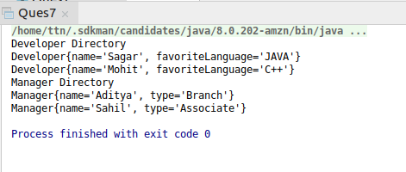

8.Implement proxy design for accessing Record of a student and allow the access only to Admin.

Source Code:

interface Students{
void getStudentDetails(String user);
}
class Realuser implements Students{
@Override
public void getStudentDetails(String user){
System.out.println(user + " Accessing the students record");
}
}
class Proxyuser implements Students{
@Override
public void getStudentDetails(String user){
if(user.equalsIgnoreCase("admin"))
System.out.println(user + " Accessing the students record");
else
System.out.println("Access denied");
}
}
public class Ques8 {
public static void main(String[] args) {
Students student = new Proxyuser();
student.getStudentDetails("Admin");
Students student1 = new Proxyuser();
student1.getStudentDetails("Director");
}
}
Output:

