1.Create a directory "exercise" inside your home directory and create nested(dir1/dir2/dir3) directory structure inside "excerise" with single command

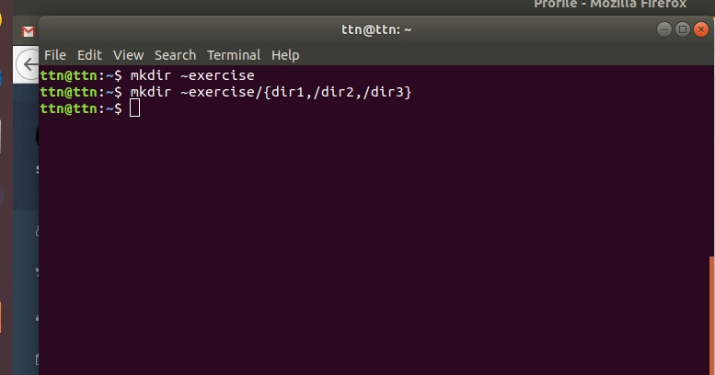
2.Create two empty files inside dir2 directory: emptyFile1,emptyFile2 in single command
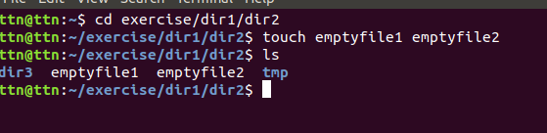
3.Create one file file1.txt containing text "hello world" and save it.
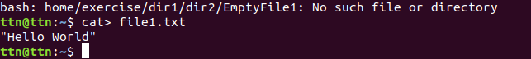

4.Find a "passwd" file using find command inside /etc. copy this files as passwd_copy and then rename this file as passwd_backup.
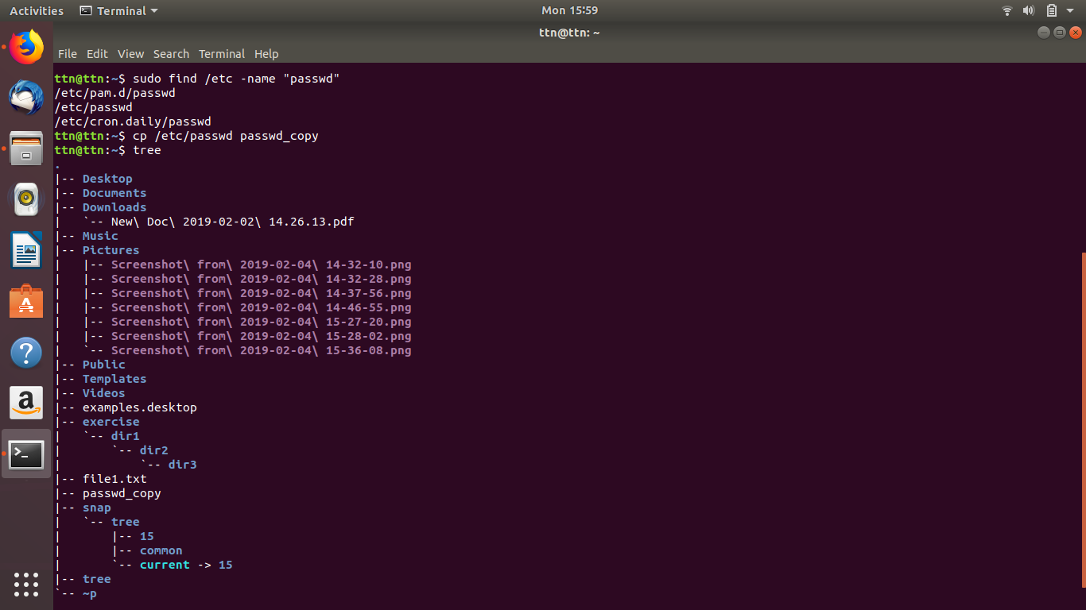

5.Try reading passwd_backup file in multiple tools: less,more,cat,strings etc and find the difference in their usage

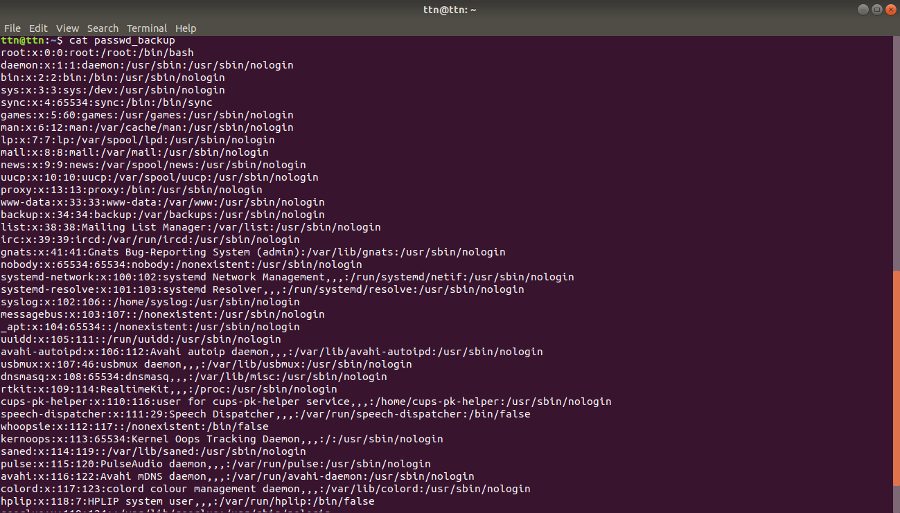
cat:
less:
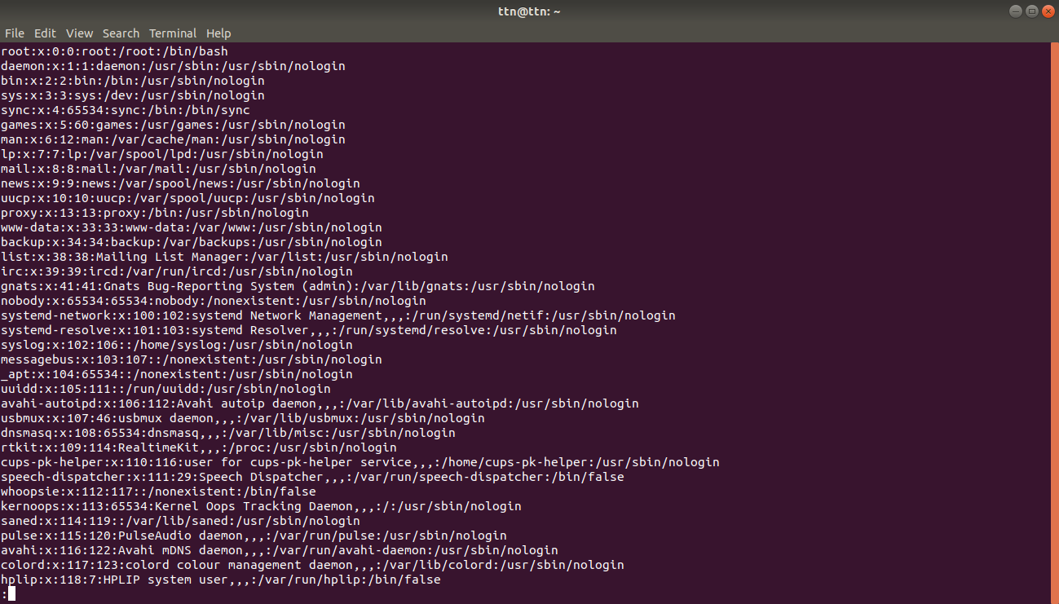
more:
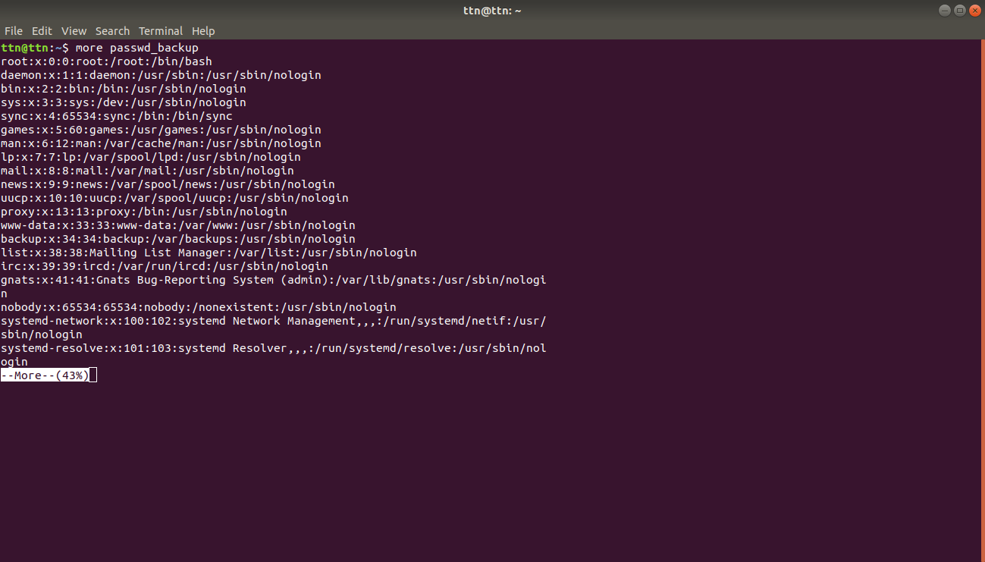
6.Find out the number of line in password_backup containing "/bin/false"

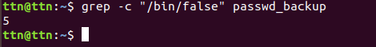

7.Get the first 5 lines of a file “password_backup” and Redirect the output of the above commands into file "output".

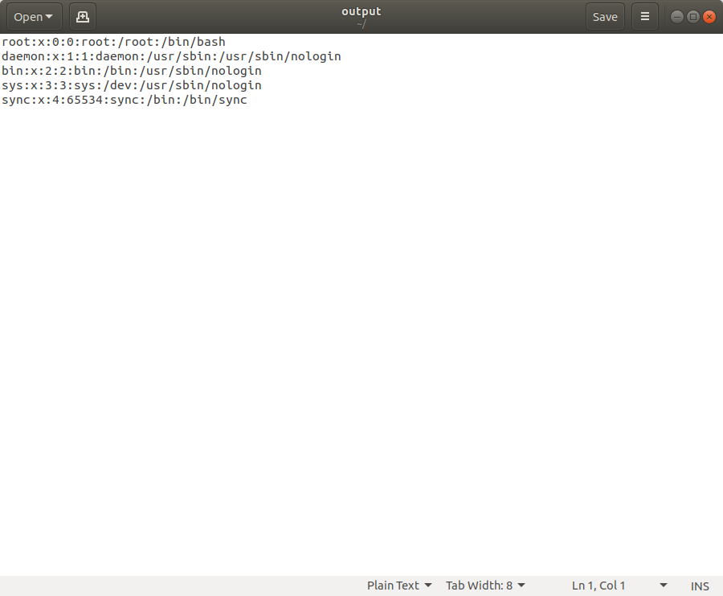
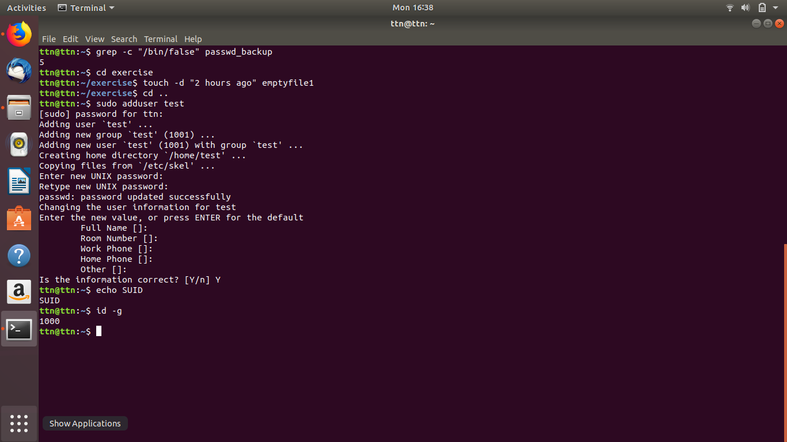
8.Create a "test" user,create its password and find out its uid and gid.

9.Change the timestamp of emptyFile1,emptyFile2 which are exist in dir2

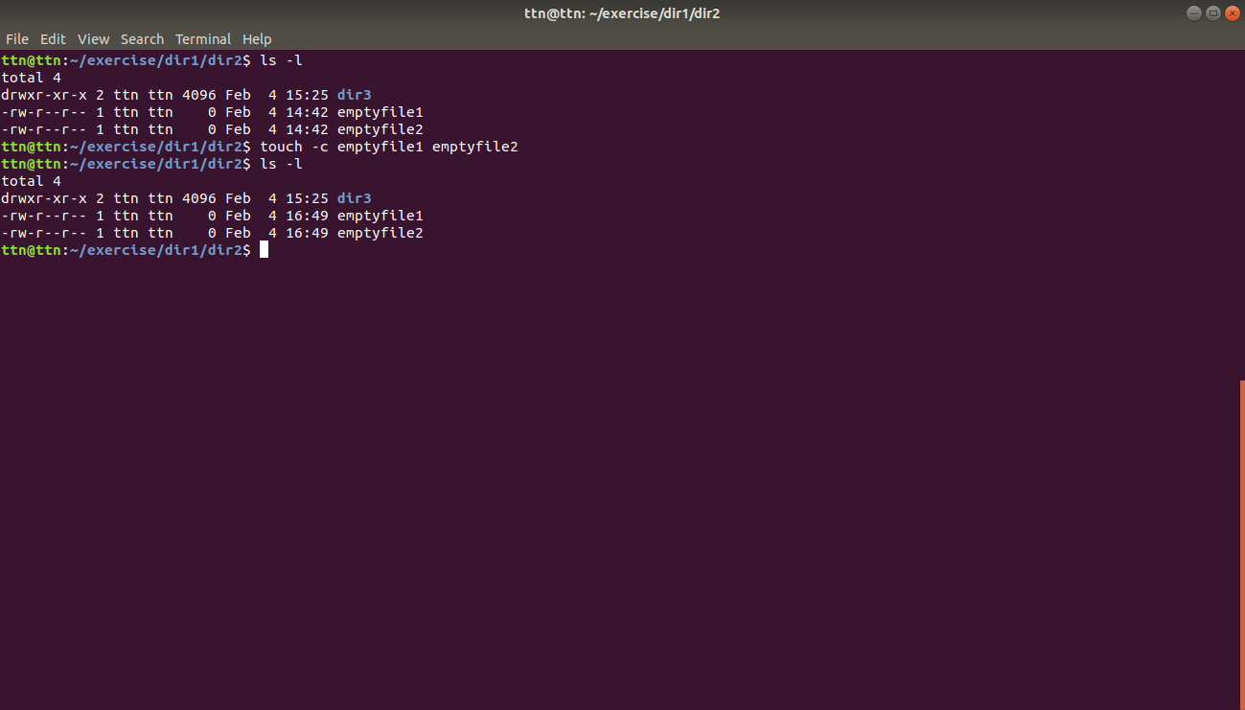
11.Create alias with your name so that it creates a file as "/tmp/aliastesting".

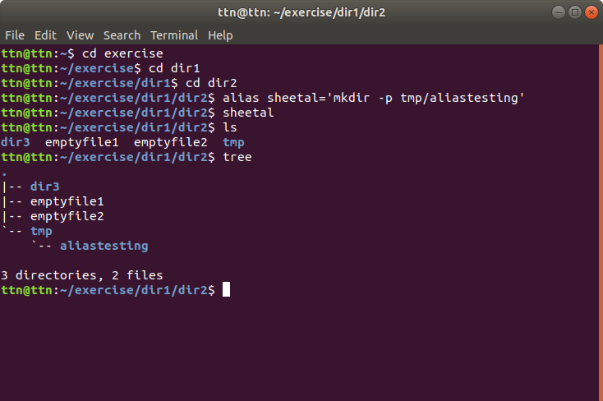
13.Install “zip” package
