GRADLE ASSIGNMENT

1.Look up java plugin documentation. Make changes in manifest to make it executable with correct class. When run using java -jar JAR_NAME_HERE the output should be text "Hello World" on the console.

apply plugin:'java'//Ques1
sourceSets {
main{
java{
srcDirs = ['src/main/java2']
}
}
}

jar{
manifest{
attributes 'Main-Class':'Eg'
}
}

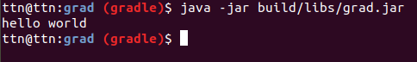

2.look up idea plugin. make changes in build.gradle so that the sources of src/main/java as well as src/main/java2 are taken as sources. Ensure that when you make JAR file class files in both are added to the JAR. This will teach you how projects with non-conventional structure can be used with gradle.

//To run main of 1st java file
apply plugin:'java'
apply plugin:'idea'

sourceSets {
main {
java {
srcDirs = ['src/main/java', 'src/main/java2']
}
}
}
jar{
manifest{
attributes 'Main-Class':'Eg'
}
}
//To run main pf 2nd java file
apply plugin:'idea'
apply plugin:'java’
sourceSets {
main {
java {
srcDirs = ['src/main/java', 'src/main/java2']
}
}
}
jar{
manifest{
attributes 'Main-Class':'Egg2'
}
}
Eg.java file:
public class Eg{
public static void main(String[] args) {
System.out.println("tu kon hai");
}
}
Egg2.java file:
public class Egg2{
public static void main(String[] args) {
System.out.println("Tu beer hai");
}
}

Output:
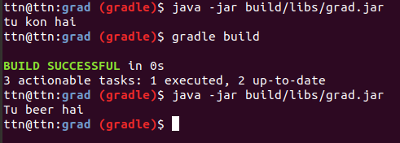

3.add 2 files file1.xml and file1.txt in src/main/resources manually. make changes so that when creating jar only file1.xml is added to the jar.

Source Code:

apply plugin:'java'//Ques3
apply plugin:'idea'
sourceSets {
main {
java {
srcDirs = ['src/main/java', 'src/main/java2']
}
resources{
srcDirs = ['src/main/resources']
exclude 'file.txt'
}
}
}
jar{
manifest{
attributes 'Main-Class':'Egg2'
}
}
Output:
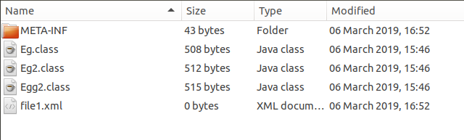
ONLY file.xml is showing in the jar folder created above

4.find how to what is an uberjar. Make changes so you can use commons lang3 StringUtil in your jar. Make this uber jar executable. The output should be text but that should be using the StringUtils class of commons lang3

An uber-JAR—also known as a fat JAR or JAR with dependencies—is a JAR file that contains not only a Java program, but embeds its dependencies as well. This means that the JAR functions as an "all-in-one" distribution of the software, without needing any other Java code.
Creating an uber-JAR is profitable for us as then we will not need any other file to run our project.

Source Code:

apply plugin:'java'//Ques4
apply plugin:'idea'
sourceSets {
main {
java {
srcDirs = ['src/main/java', 'src/main/java2']
}
}
jar {
manifest {
attributes 'Main-Class': 'Egg2'
}
from {
configurations.compile.collect{it.isDirectory() ? it : zipTree(it)}
}
}
repositories {
mavenCentral()}
}
dependencies{
compile group: 'org.apache.commons', name: 'commons-lang3', version: '3.8.1'//lang3 dependency Ques4
}

Egg2.java code:
public class Egg2{
public static void main(String[] args) {
String str = "Hello";
System.out.println(str);
System.out.println(str.replaceAll("He","we"));
}
}
Output:
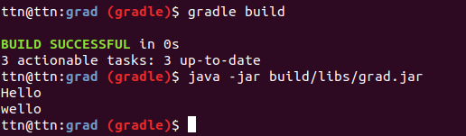

5.Find a maven repository and add it as a repository. You can use bintray, jcenter

repositories {
mavenCentral()
maven {
url "https://repository-achartengine.forge.cloudbees.com/snapshot/"// Ques5
}
}
6.Write a task in file "mytasks.gradle" and use it in your build.gradle

Source Code:

group 'com.ttn'
version '1.0-SNAPSHOT'
apply from : 'myTask.gradle'
myTask.gradle File:
task myTask {
doFirst {
println("myTask executed successfully")
}
}

Output:

