In this project we have added Genetic Algorithm to optimize training features and CNN always give best result with optimize features and in below screen you can see Genetic algorithm code to optimize features

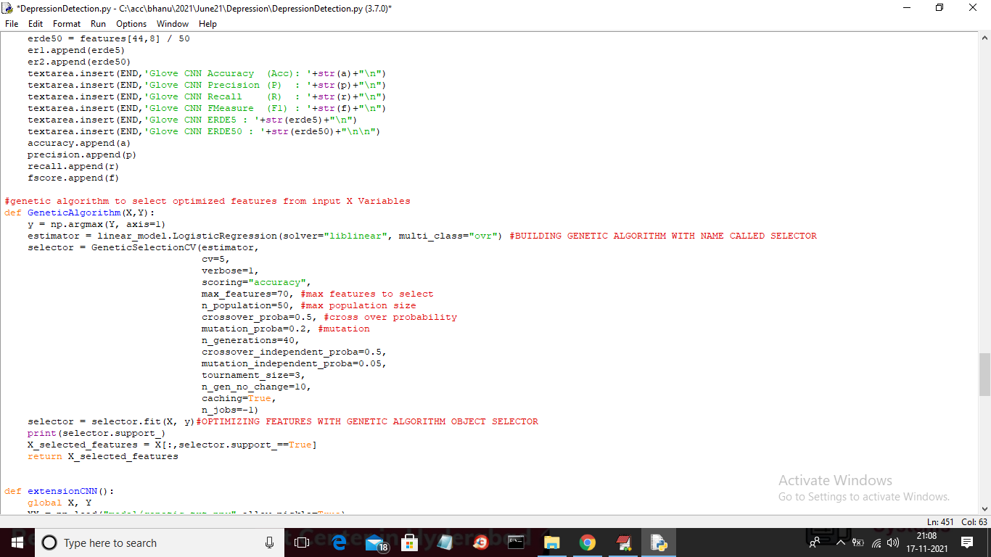

In above screen read red colour comments to know about Genetic implementation and in below screen you can see CNN using optimize genetic features to train a model

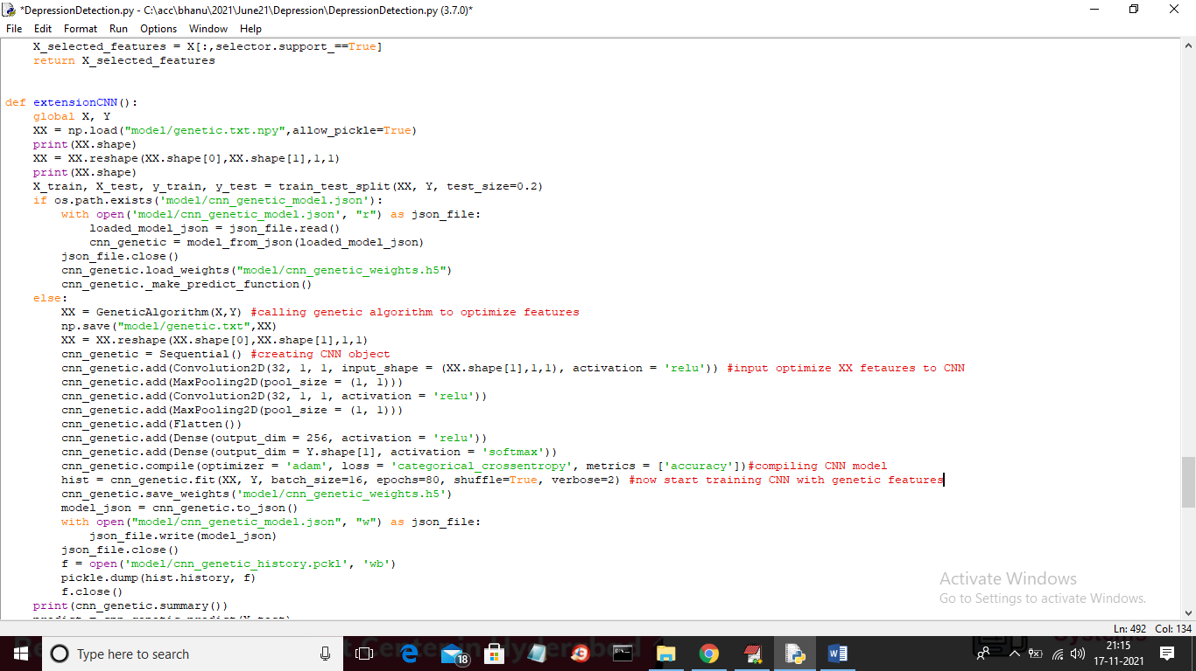

In above screen you can see we are training CNN with genetic algorithm features and below is the output screens

To run project double click on ‘run.bat’ file to get below output

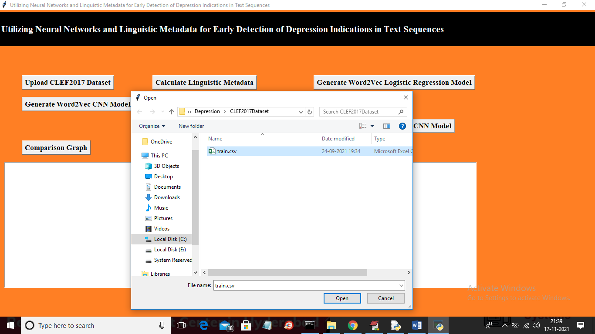

In above screen selecting and uploading dataset

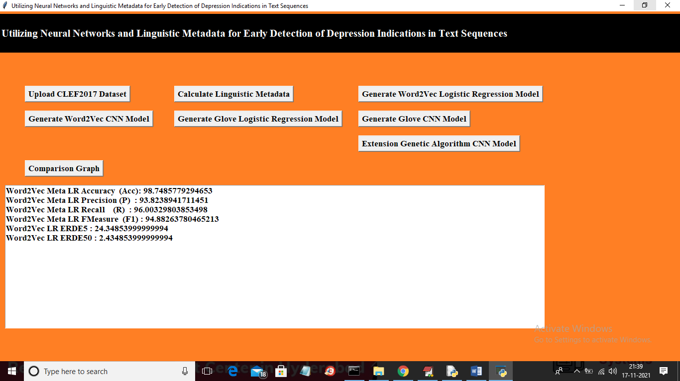

In above screen with Word2Vec Logistic Regression we got 98.74% accuracy and below is the Word2Vec CNN accuracy

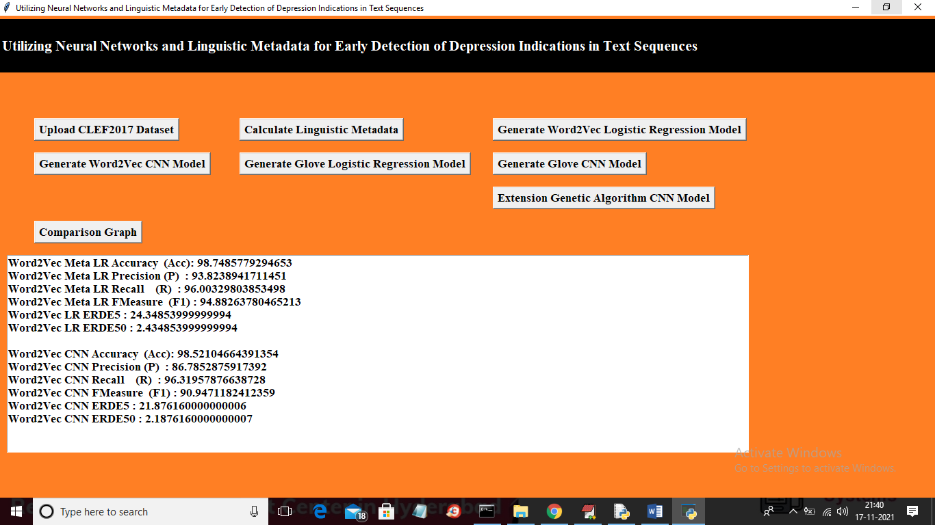

In above screen with Word2Vec we got 98.52% accuracy and now below is the Glove Logistic Regression accuracy

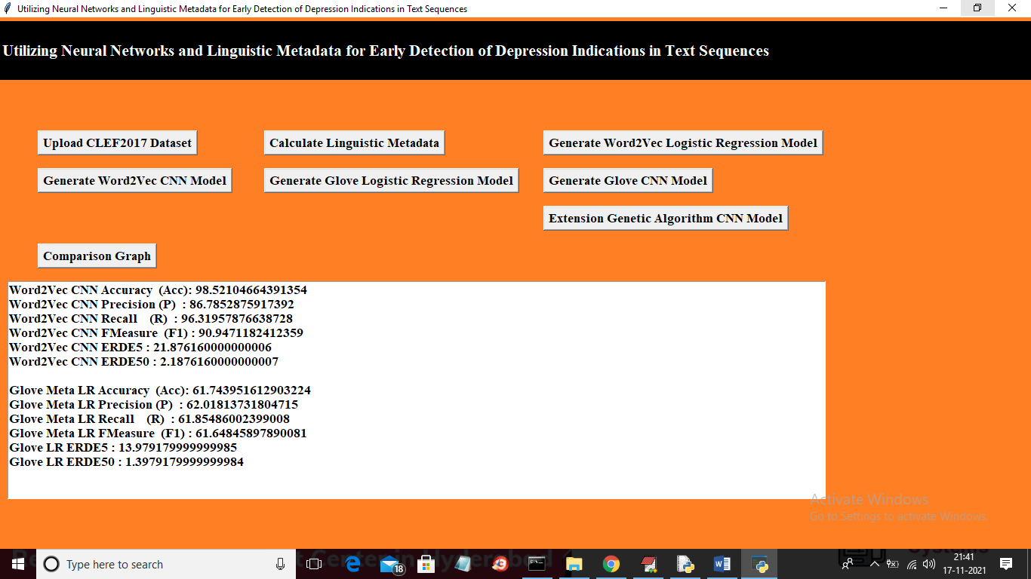

In above screen with Glove Logistic Regression we got 61% accuracy and below is the Glove CNN accuracy

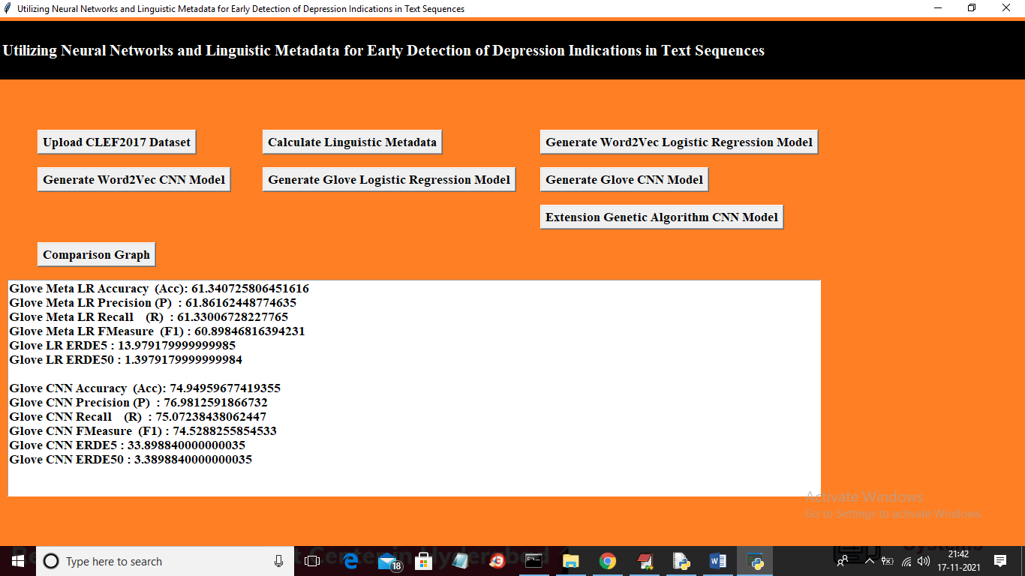

In above screen with Glove CNN we got 74% accuracy and below is the extension Genetic CNN accuracy

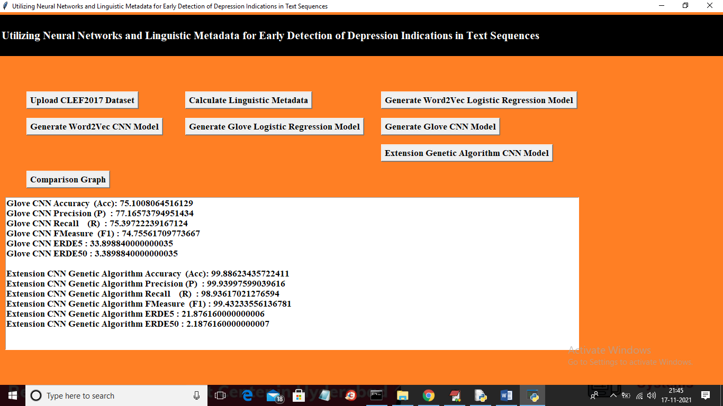

In above screen with extension Genetic CNN we got 99.88% accuracy and we can see from all algorithms we got high accuracy after optimizing features with Genetic Algorithm. Now click on ‘Comparison Graph’ button to get below output

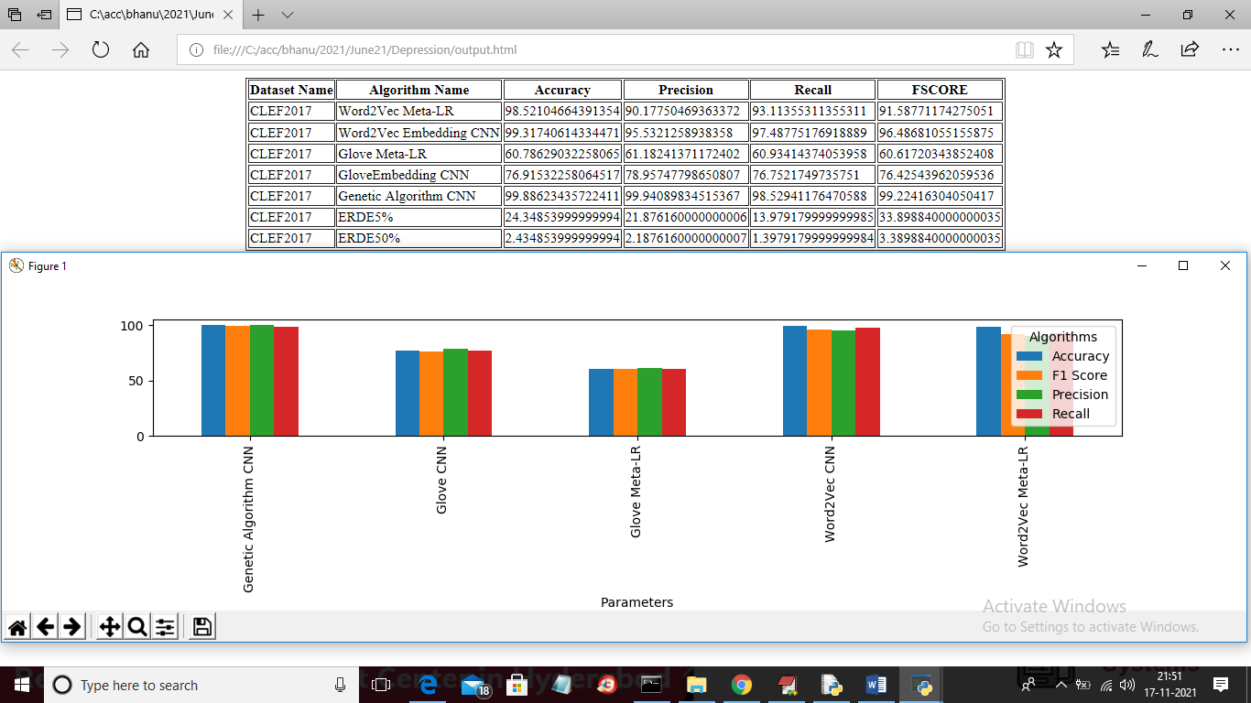

In above screen comparison graph you can see compare to all algorithms genetic with CNN has given better results