**AIM :** Design an automatic night lamp

**APPRATUS :** LED, breadboard, wires, arduino, LDR,resistor

**CIRCUIT DIAGRAM** **:**

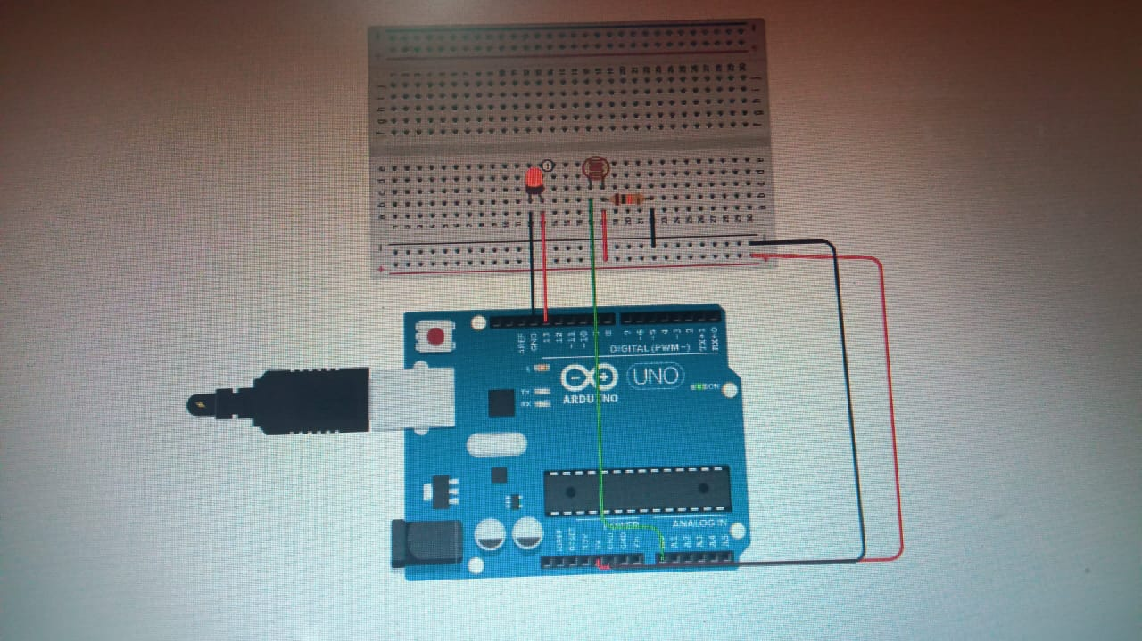

**THEORY** :

The LED has one p junction and n junction inside it, p is longer while p is shorter.

Breadbord have network of connection inside it.

An **LDR** is a component that has a (variable) resistance that changes with the light intensity that falls upon it. This allows them to be used in light sensing circuits.

**LERNING & OBSERVATION :**

1. Learned how to connect the connection inside the breadboard.
2. Connection of LED in the breadboard and which is n side & p side of LED.
3. Learned how to upload code on arduino and work on it.
4. Learned how to glow led automatically during night and close during day.

**PROBLEM & TROUBLESHOOTING:**

1. Connection of led in series and parallel was wrong.
2. Mistake in code uploading .

**LEARNING OUTCOMES**:

1. Connection of LED in series and parallel in breadboard.
2. How to use arduino as it was first experience for me.