**Machine Learning**

**Handout-3 Answers**

**1.** Write a Python program to find percentiles, inter quartile range and upper bound and lower bound values for a given dataset

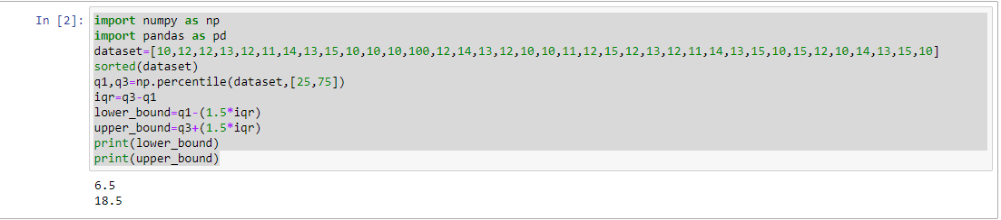

2. Write a Python program to draw a colored scatterplot for the given data

girls_grades = [89, 90, 70, 89, 100, 80, 90, 100, 80, 34]

boys_grades = [30, 29, 49, 48, 100, 48, 38, 45, 20, 30]

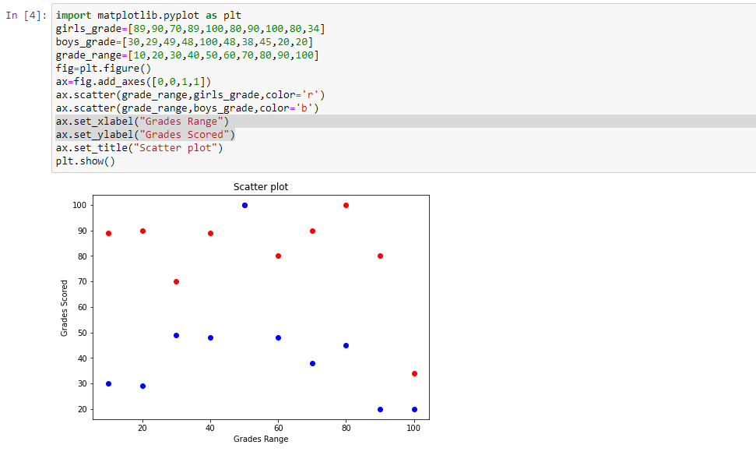

3. Write a Python program to draw a boxplot for variables in tips.csv

* Using seaborn

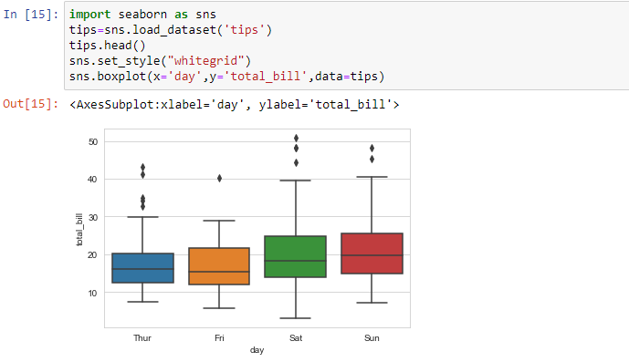

* Using matplotlib

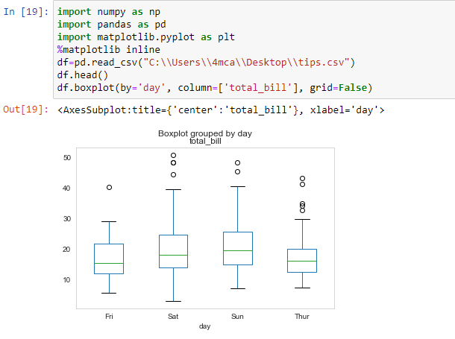

4. Write a Python program to draw a box plot for any two variables in tips.csv.

