Handout-4 Answers

Machine Learning

1.Use scatter-plot to find outliners using Interquartile range for a given dataset.

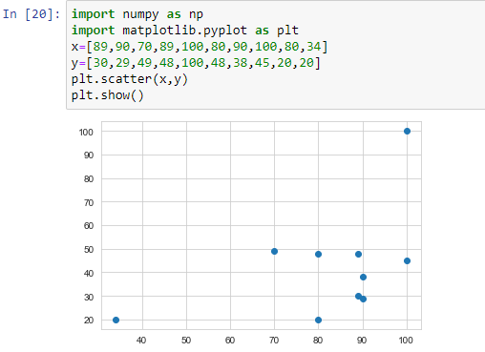

2.Identify outliners and replace the 5th and 95th percentile values for given dataset.

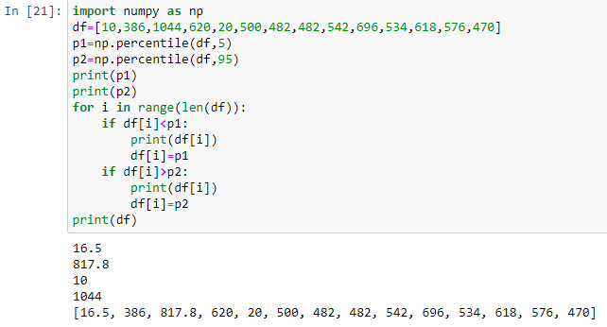

3.Write a python program to impute missing values with mean using SimpleImputer (Numeric Data).

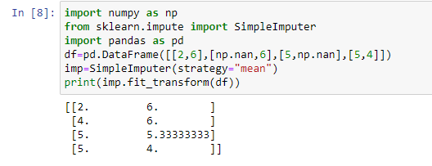

4.WA python program to fit the SimpleImputer on a given data set and use it to transform the another dataset.

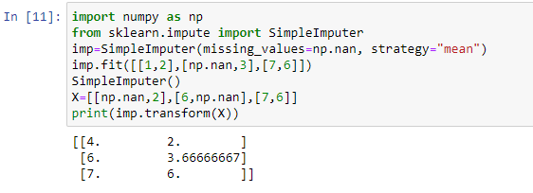

5.WA python program to impute missing values with most frequent values using SimpleImputer.

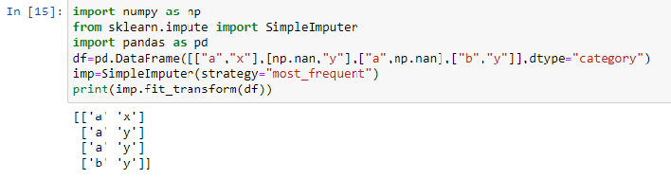

6.WA python program to find outliners using Z-score. (axis=0 and axis=1)

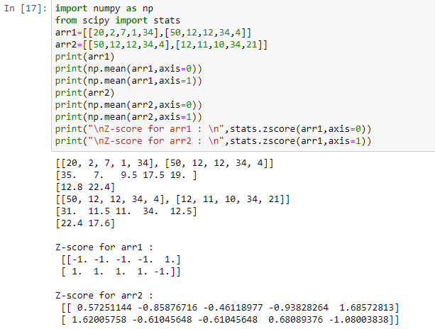

7.WA python program (without using libraries) to find the values of regression coefficients for the dataset given below.

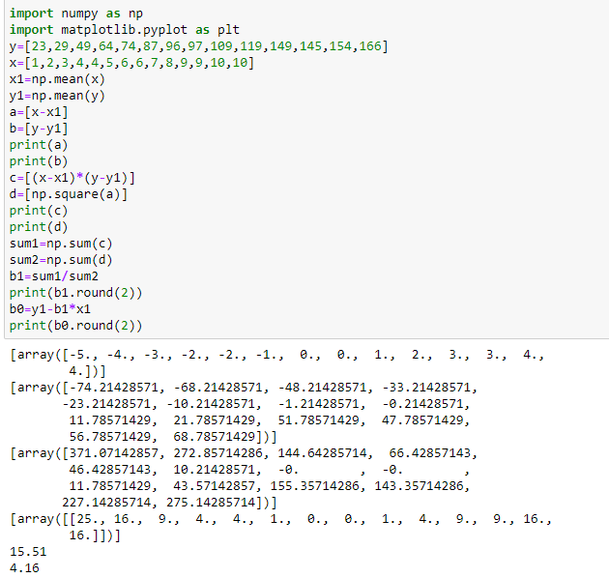

8.WA python program to draw the best fit regression line.

