HANDOUT-2 ANSWERS

Machine Learning

5.

ANS.

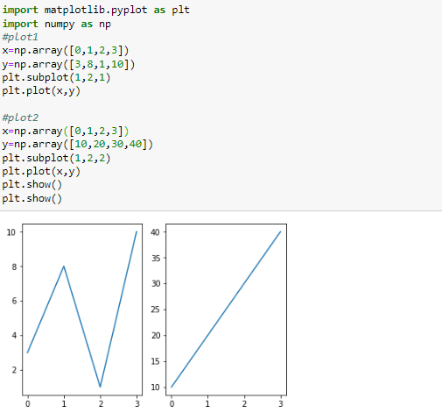

6.WAP to create multiple plots to draw 2 plots on top of each other.

ANS.

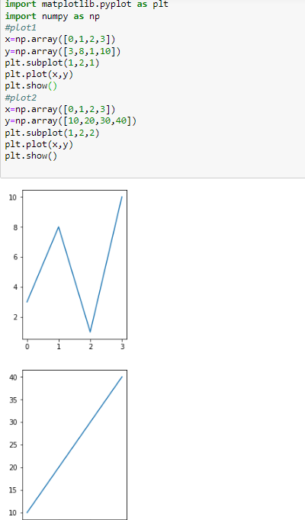

7.WAP to create 2-way cross tab for above DataFrame having for subject vs results summary.

Ans.

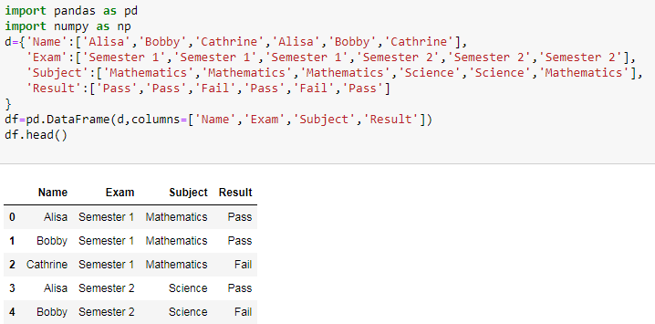

10.wap to create a three-way cross tab

A.

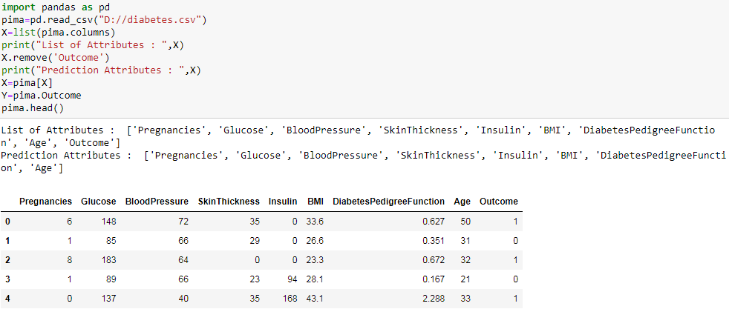

B.