Below is the command used in SQL:-

Import the excel file into SQL using the following command:-

Create the database using the following command.

To specify conditional database creation we have written "if not"

Create database if not exists FuelEco;

To use the created database, execute the following command:-

use FuelEco;

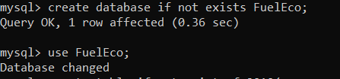

Create command is used to create the structure of the table .

To specify conditional table creation we have written "if not"

CREATE TABLE IF NOT EXISTS fe2010(

EngDispl Float, NumCyl Int, FE Float,

Numgear Int, TransLockup Int,   TransCreeperGear Int,

 IntakeValvePerCyl Int, ExhaustValvesPerCyl Int,

VarValveTiming int, VarValveLift int

);

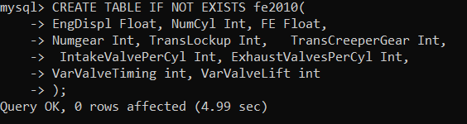

The  LOAD DATA INFILE statement allows you to read data from a text file and import the file’s data into a database table.

The following statement imports data from the  C:/ProgramData/MySQL/MySQL Server 5.7/Uploads/fe2010.csv file into the fe2010 table.

In order to inform that the first row constitutes label , we have written the command " IGNORE 1 ROWS"

LOAD DATA INFILE "C:/ProgramData/MySQL/MySQL Server 5.7/Uploads/fe2010.csv" INTO TABLE  fe2010

 FIELDS TERMINATED BY ','

ENCLOSED BY '"'

 LINES TERMINATED BY '\n'

IGNORE 1 ROWS;

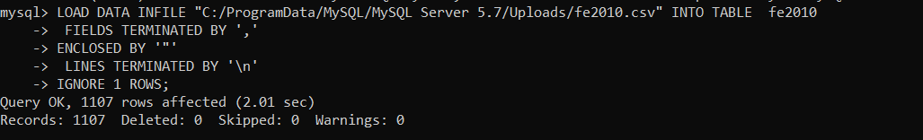

Similarly we will import fe2011 excel filw by creating the schema and loading it with the following command:-

CREATE TABLE IF NOT EXISTS fe2011

EngDispl Float, NumCyl Int, FE Float,

Numgear Int, TransLockup Int,   TransCreeperGear Int,

 IntakeValvePerCyl Int, ExhaustValvesPerCyl Int,

VarValveTiming int, VarValveLift int

);

LOAD DATA INFILE "C:/ProgramData/MySQL/MySQL Server 5.7/Uploads/fe2011.csv" INTO TABLE  fe2011

 FIELDS TERMINATED BY ','

ENCLOSED BY '"'

 LINES TERMINATED BY '\n'

IGNORE 1 ROWS;

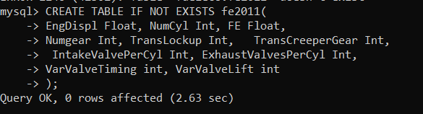

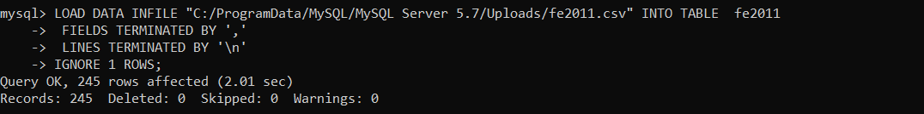

Alter table fe2010 add a float;

Alter table fe2010 add b float;

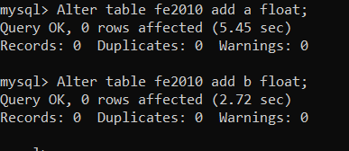

Update the column a and b with the values and

|  |  |
| --- | --- |
| 50.56566     |  | | --- | | -4.52363 | |

update fe2010 set a = 50.56566;

update fe2010 set b = -4.52363;

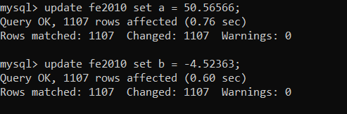

Update Pred in 2011 with a and b from 2010 data set



You can directly update the value a and b in Pred using the formula a+bx

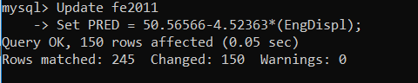

Compare both the column

