**PROD BUG**

**Sheetal Singh**

[**https://www.youtube.com/@sheetalsingh23**](https://www.youtube.com/@sheetalsingh23)

**#Links**

[**https://github.com/appium/appium**](https://github.com/appium/appium)

[**https://appium.io/docs/en/2.0/quickstart/install/**](https://appium.io/docs/en/2.0/quickstart/install/)

**#Appium 2.0 Installation Part**

1. Install Java Maven

java -version

mvn -v

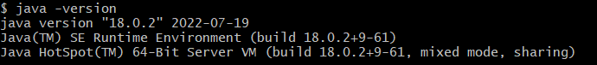

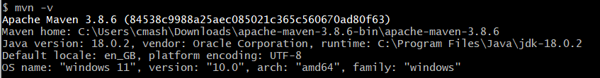

Environment Variables:



1. Install Node/NPM

https://nodejs.org/en/download

Download exe and check checkbox "install all necessary tools"

Installation path C:\Program Files\nodejs\

node -v





1. Install Appium 2.0

npm i -g appium@next

appium -v



To start Appium server

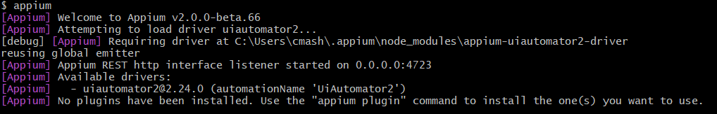

1. Install Appium UIAutomator2

appium driver install uiautomator2

appium driver list

appium driver list --updates | To update installed drivers

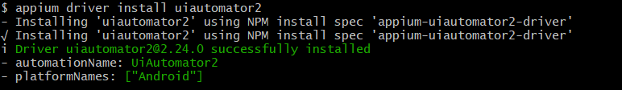

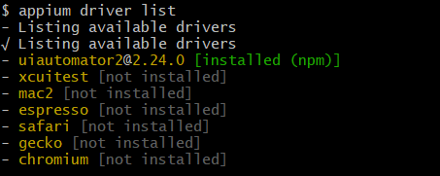

1. Install Appium Doctor

npm install -g appium-doctor

appium-doctor --version



appium-doctor --android

To check android setup related issues

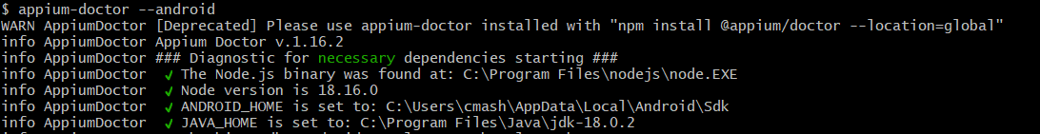

1. Install Appium Inspector

Download Appium Inspector zip file from https://github.com/appium/appium-inspector/releases

Unzip into Appium-Inspector folder and create shortcut and open Appium Inspector

Appium Inspector Web Application

<https://inspector.appiumpro.com/>

**#Android Studio Installation Part**

1. Install latest Android Studio via exe file https://developer.android.com/studio

Give default values and click Next....sample MyApplication project will be created

1. Env variable setup

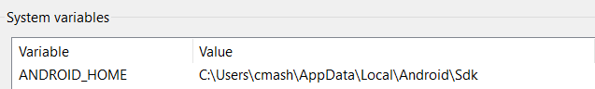

Note: AppData is hidden folder in Windows

Directly add into path:

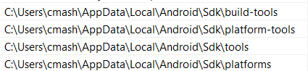

1. Verify Setup

adb devices or adb

1. Create Mobile Device

Open Android Studio Workspace

Go to > C:\Program Files\Android\Android Studio\bin

Double click studio.sh window batch file

Create studio.sh shortcut

Go to Device Manager (top right)

Select any device and create.... API number suggest Android

version

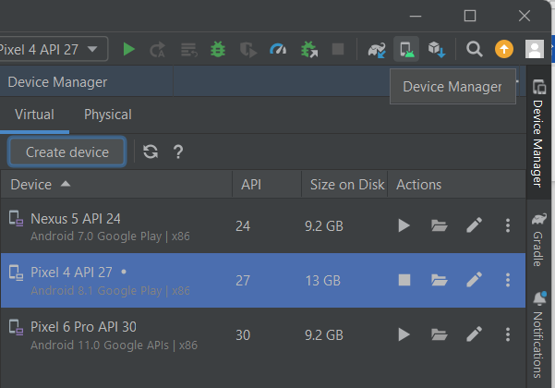

1. SDK Manager

In case some packages need to install in Emulators like Google Play Store.

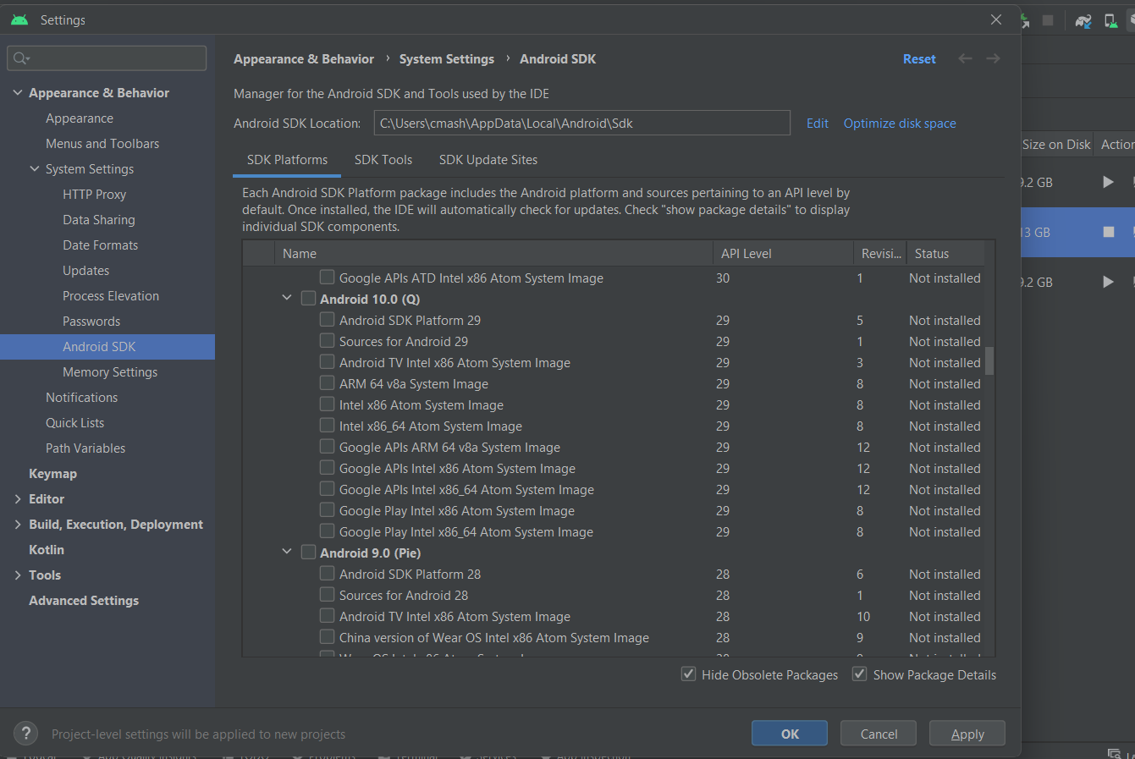

1. Launch Emulator from created list

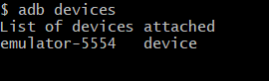

1. **Download** **Sample Apk Files**

For installation, simply Drag and Drop apk into Emulator

ApiDemos-debug.apk

<https://github.com/appium-boneyard/sample-code/blob/master/sample-code/apps/ApiDemos/bin/ApiDemos-debug.apk>

Android-MyDemoAppRN.1.3.0.build-244.apk

<https://github.com/saucelabs/my-demo-app-rn/releases>

**#Important Steps to Start Appium Session**

1. Start Appium 2.0 Server first (cmd is “appium”)
2. Start Appium Inspector after Appium started properly
3. Start Android Emulator
4. Add Desired capabilities in Appium Inspector and “Start Session”

**#Desired Capabilities DC**

1. platformName = Android
2. platformVersion = 8.1, Emulator settings will show platform version (Edit Emulator Device)

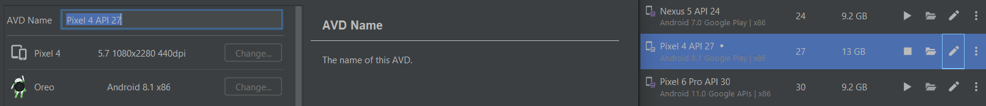

Another way to get “platformVersion” capabilities

adb shell getprop ro.build.version.release



1. automationName = UIAutomator2
2. deviceName: emulator-5554, cmd: ”adb devices”



1. appPackage/appActivity:

adb shell dumpsys window windows | grep mFocusedApp



**#Appium Inspector Desktop Application**

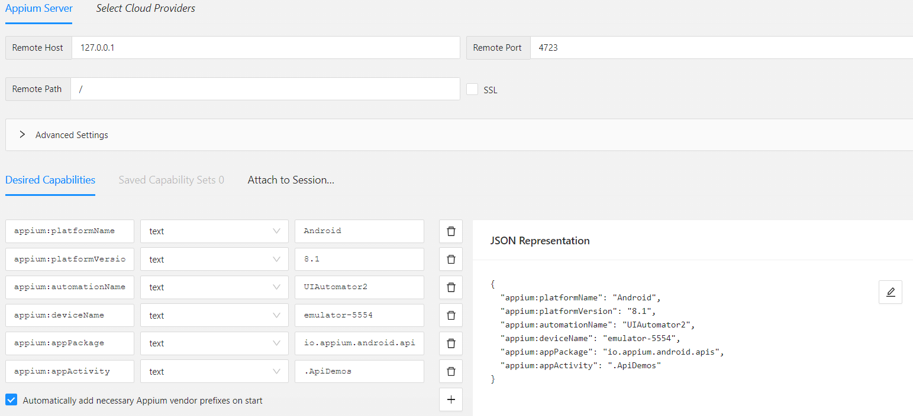

Note: Appium Inspector Web Application

<https://inspector.appiumpro.com/>

**Appium Demo ApiDemos-debug.apk**

{

"appium:platformName": "Android",

"appium:platformVersion": "8.1",

"appium:automationName": "UIAutomator2",

"appium:deviceName": "emulator-5554",

"appium:appPackage": "io.appium.android.apis",

"appium:appActivity": ".ApiDemos"

}

**Saucelabs Demo Android-MyDemoAppRN.1.3.0.build-244.apk**

{

"appium:platformName": "Android",

"appium:platformVersion": "8.1",

"appium:automationName": "UIAutomator2",

"appium:deviceName": "emulator-5554",

"appium:appPackage": "com.saucelabs.mydemoapp.rn",

"appium:appActivity": ".MainActivity"

}

**#General Exceptions:**

1. Appium Inspector not able to Start Session with following error

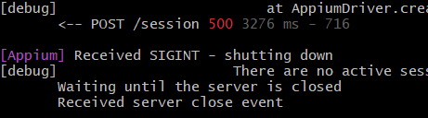

Solution 1: Sometimes connection break with UIAutomator2, run following command and it should start working.

adb uninstall io.appium.uiautomator2.server.test



Solution 2: Close everything and again start in proper sequence. Reinstall APK by Drag and Drop.

Appium Server > Appium Inspector > Emulator Device

Optional Desired Capability:

"appium:noReset": true | app will not be reinstalled if its already there

**#Java-client v7 vs v8**

<https://github.com/appium/java-client/blob/master/docs/v7-to-v8-migration-guide.md>

Java client support Selenium 4 and strictly compliant to W3C

Duration class handles all time related things

1. MobileElement has been removed and now we have to use WebElement

2. DesiredCapability removed and now we have UiAutomator2Options

3. "java-client" dependency already have "selenium-java".

Just we need to add "selenium-support" for ExpectedCondition and WebDriverWait

4. TouchActions Deprecated....Action introduced

5. MobileBy replaced with AppiumBy

6. LaunchApp, CloseApp, ResetApp Depricated

7. [java.time.Duration](https://docs.oracle.com/javase/8/docs/api/java/time/Duration.html) time to be used

8. Use sendKeys rather setValue

9. Old: http://0.0.0.0:4723/wd/hub

New: http://0.0.0.0:4723/

**#Locators Strategies**

|  |  |
| --- | --- |
| **Appium Inspector Locators** | **Java Code To Be Used** |
| accessibility id | driver.findElement(AppiumBy.accessibilityId("abc")) |
| content-desc | driver.findElement(AppiumBy.accessibilityId("abc")) |
| resource-id | driver.findElement(AppiumBy.id("abc")) |
| xpath | driver.findElement(AppiumBy.xpath("//abc")) |
|  |  |
|  |  |
|  |  |
|  |  |
|  |  |
|  |  |
|  |  |
|  |  |

**Note:**

AppiumBy is Child of By and hence can also be used

import org.openqa.selenium.By;

import io.appium.java_client.AppiumBy;

**#XPath Types:**

//android.widget.TextView[@content-desc="App"]

//android.widget.TextView[@resource-id="android:id/text1"]

//android.widget.TextView[@index=3]

//*[contains(@text,'Read')]

//android.widget.TextView[@text="Assets"]

//*[@resource-id='android:id/text1' or @text='Media']

//*[@resource-id='android:id/text1' and @text='Media']