**Personal Portfolio Website**

**A PROJECT REPORT**

SUBMITTED IN PARTIAL FULFILLMENT OF THE REQUIREMENT FOR THE AWARD OF THE DEGREE

**Capstone Project (DEMGN696) of MBA Programme**

(HR + IT)

**SUBMITTED BY**

**SHEETAL KAPOOR**

(22207100156)



**Center for Distance and Online Education**

**LOVELY PROFESSIONAL UNIVERSITY**

**PHAGWARA, PUNJAB**

**~~November, 2021~~**

**DECLARATION**

This is to verify that project report entitled “Personal Portfolio Website” which is submitted by me in partial fulfillment of the requirement for the award of master degree in **MBA(HR + Information technology)** to **Distance Education of Lovely Professional University, Phagawara, Punjab** comprises only my original work and due acknowledgment has been in the text to all other material used.

**Date :**  02- July- 2024

**Name of Student :** Sheetal Kapoor

**Reg. No :** 22207100156

**Program Name :** Master of Business Administration

**Program Specification :** HR + Information Technology

**Signature of the Student :**

**SRMIST NCR CAMPUS, GHAZIABAD, UTTAR PRADESH**

**BONAFIDE CERTIFICATE**

Certified that this project report “Personal Portfolio Website Project” is bonafide work of “Anupriya Johri” who carried out the project work under my supervision.

**Signature** **Signature**

(Head of Department) (Supervisor)

**RP MAHAPATRA**  **AMIT SHARMA**

(Computer Science and Engineering) (Computer Science and Engineering)

SRMIST NCR MODINAGAR SRMIST NCR MODINAGAR

**TABLE OF CONTENTS**

|  |  |  |
| --- | --- | --- |
| **S.No.** | **Particulars** | **Page No.** |
|  | **ABSTRACT** | **5** |
|  | **LIST OF FIGURES** | **6** |
|  | **LIST OF SYMBOLS, ABBREVIATIONS AND NOMENCLATURE** | **7** |
| **1.** | **INTRODUCTION**  1.1 OBJECTIVES  1.2 HOME SECTION  1.3 ABOUT SECTION  1.4 SKILLS SECTION  1.5 EXPERIENCE SECTION  1.6 CONTACT DETAILS SECTION | **8 - 13** |
| **2.** | **SOFTWARE USED**  2.1 HTML  2.2 CSS/SASS  2.3 BOOTSTRAP  2.4 React Js  2.5 Java Script | **14** |
| **3.** | **SIGNIFICANCE** | **15** |
| **4.** | **CHALLENGES** | **16** |
| **5.** | **CONCLUSION** | **17** |
| **6.** | **REFERENCES** | **17** |

**ABSTRACT**

This Personal Portfolio Website project is based on Web Development. This is developed using HTML5, CSS and JS. Code Editor used for this project is VS Code. It displays the professional background of an individual. It displays brief information about work experiences till date, education, skills and contact details along with social media links. All the elements are rendered distinctively on the website.

**LIST OF FIGURES**

* 1. Home section
  2. About section
  3. Skills section
  4. Experience section
  5. Contact details section

**LIST OF SYMBOLS, ABBREVIATIONS AND NOMENCLATURE**

**Abbreviations**

1. IDE – Integrated Development Environment
2. HTML – Hyper Text Markup Language
3. CSS – Cascading Styling Sheets
4. JS – JavaScript
5. VS Code – Visual Studio Code

**INTRODUCTION**

Personal Portfolio Website provides brief information about the professional background of an individual. This project comprises of three files. First is an HTML file for creating markup of the application on the web. Then CSS file is used to provide more styles to the website. Then JS file is used to give a proper functionality to the application through JavaScript.

* 1. **OBJECTIVES**
     1. Elements rendered distinctly
     2. Brief information about :-

Work experience

Education

Skills

Contacting ways

* 1. **HOME SECTION**

It displays my name, my current work status and where I am from. On the top it also has navigation bar which displays other tabs of my website and my contact detail shortcuts on top right.

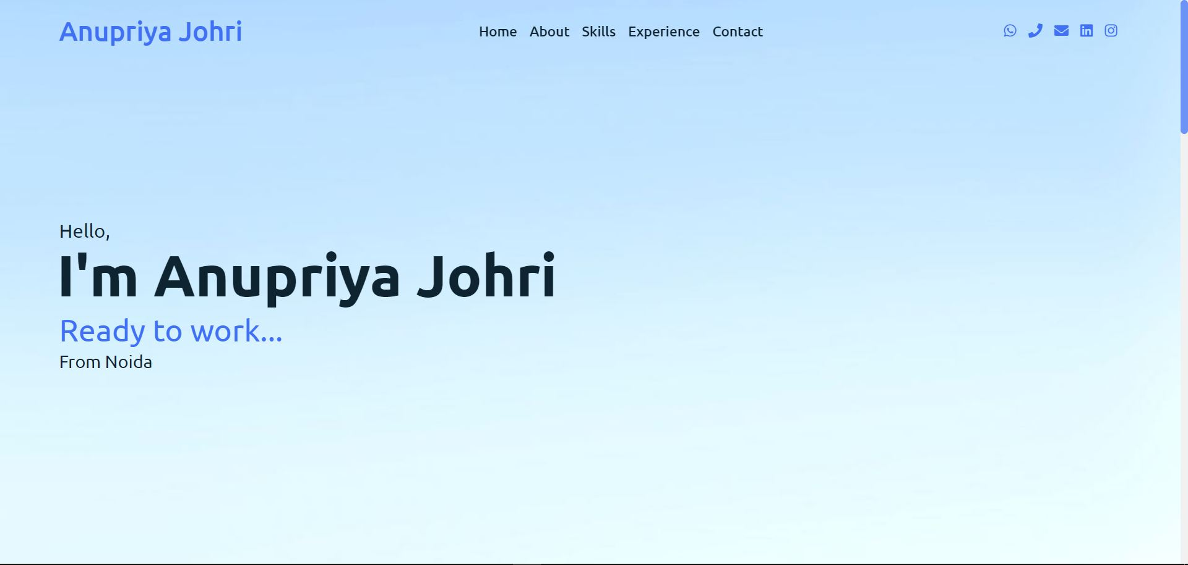

* 1. **ABOUT SECTION**

It displays a quick introduction for me a button also provided to view my resume. The navigation bar has sticky property which make visible even after scrolling down.

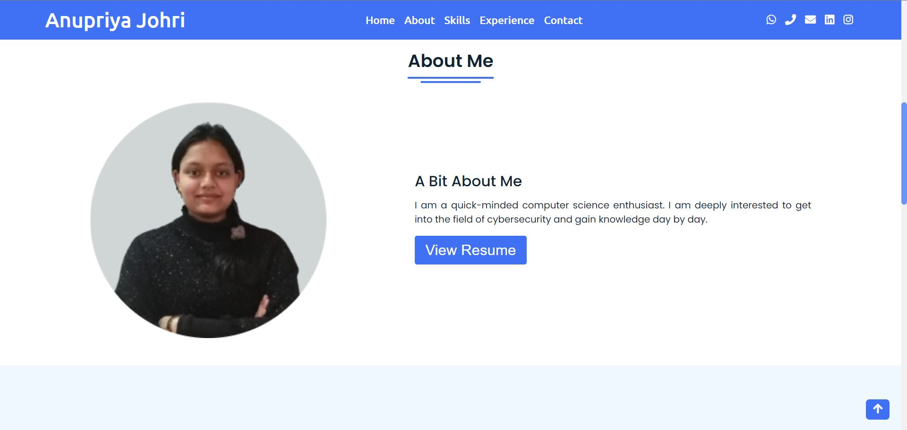

* 1. **SKILLS SECTION**

It displays my technical skills with my technical proficiency displayed as percentage for each technology and my current work experience.

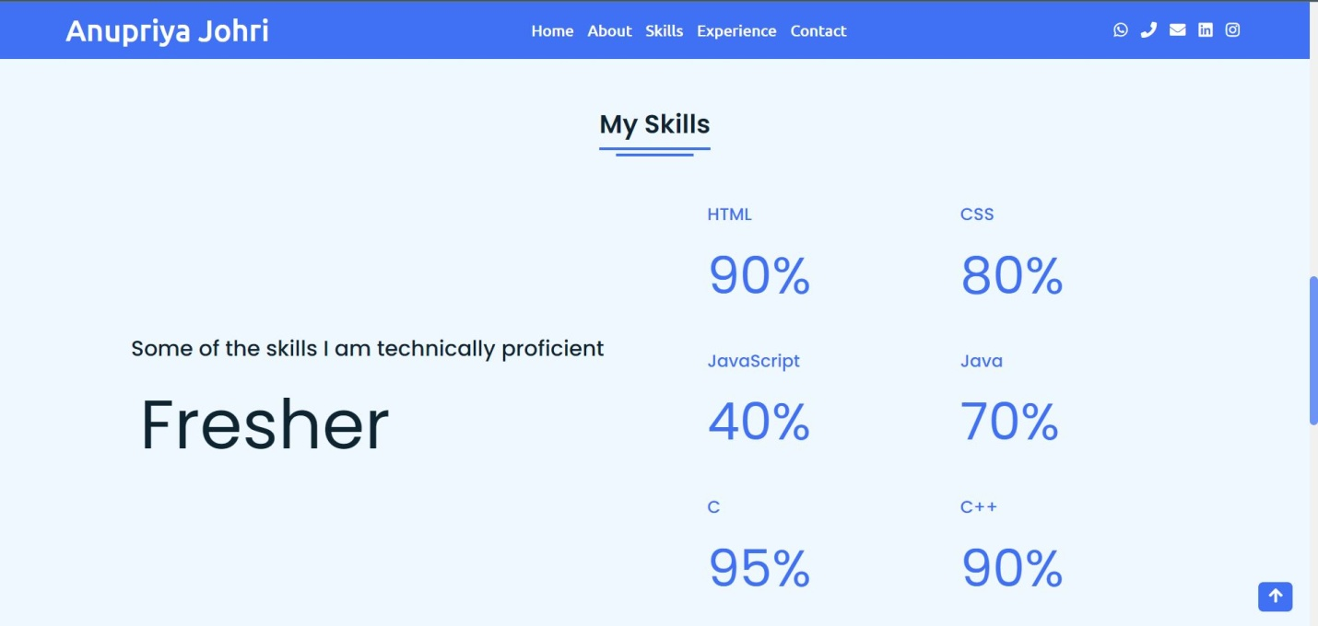

* 1. **EXPERIENCE SECTION**

This section displays my work experience including my volunteer experience in any organizations and my internships.

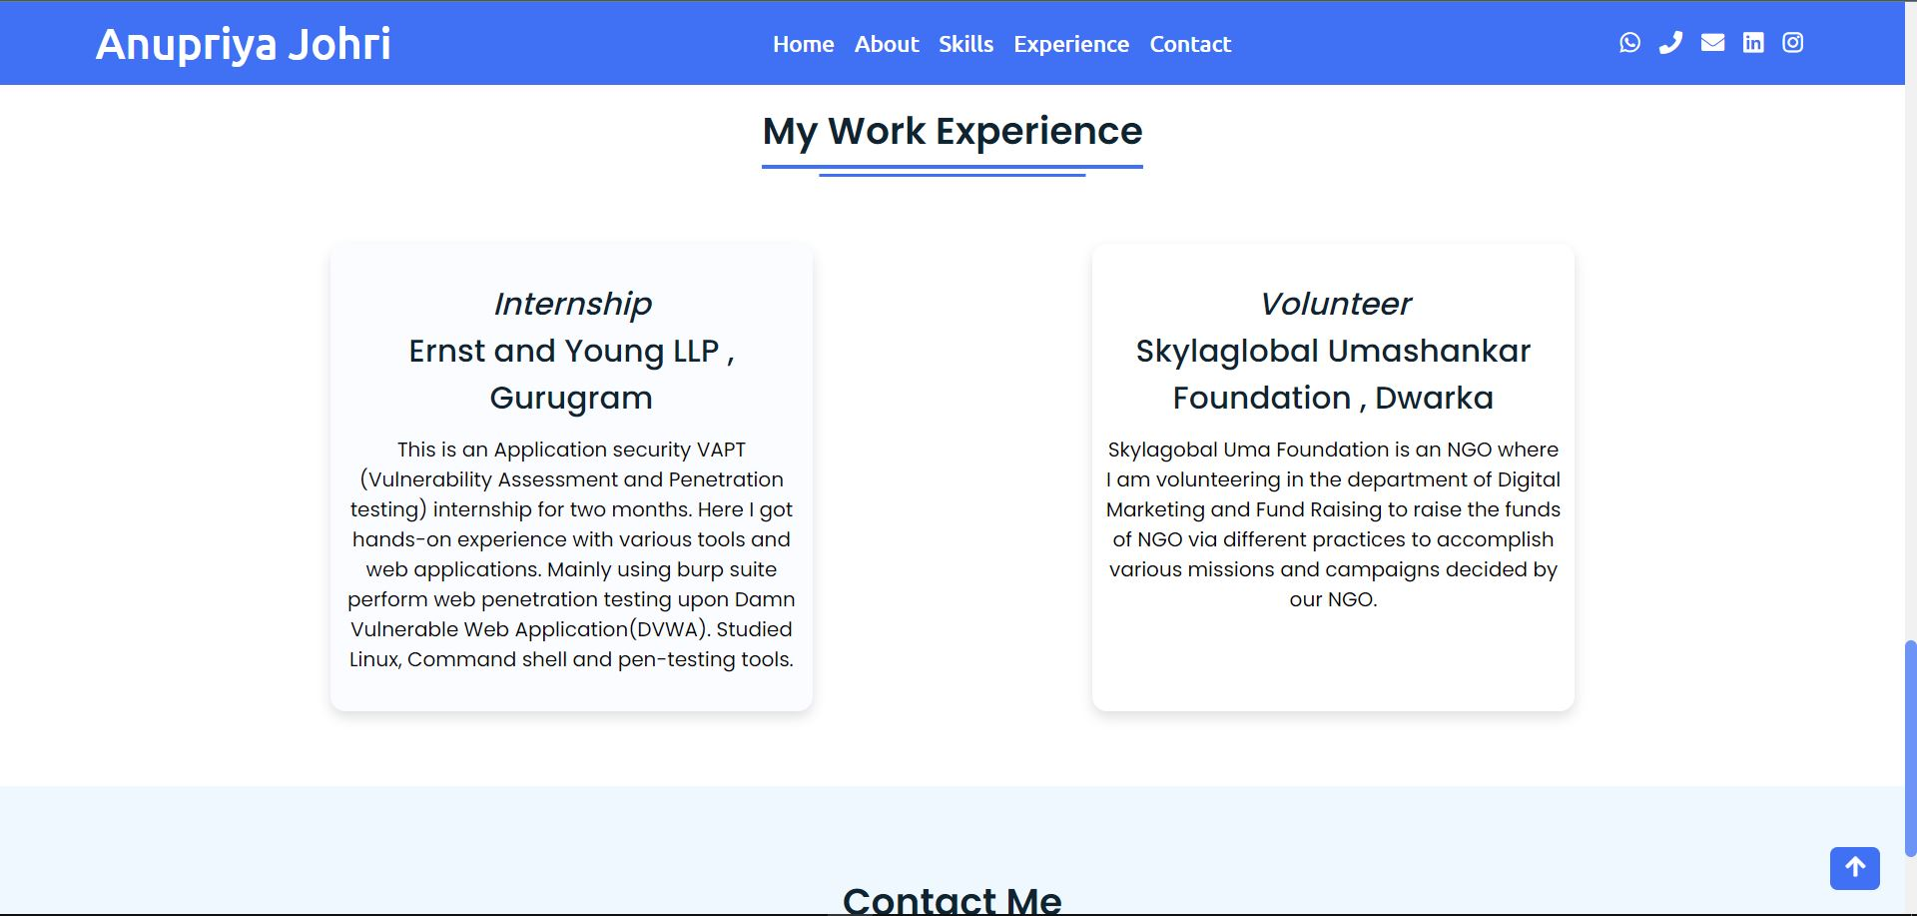

* 1. **CONTACT DETAILS SECTION**

This section has all the links listed below :

1. Whatsapp
2. Call
3. Mail
4. Linked In
5. Instagram

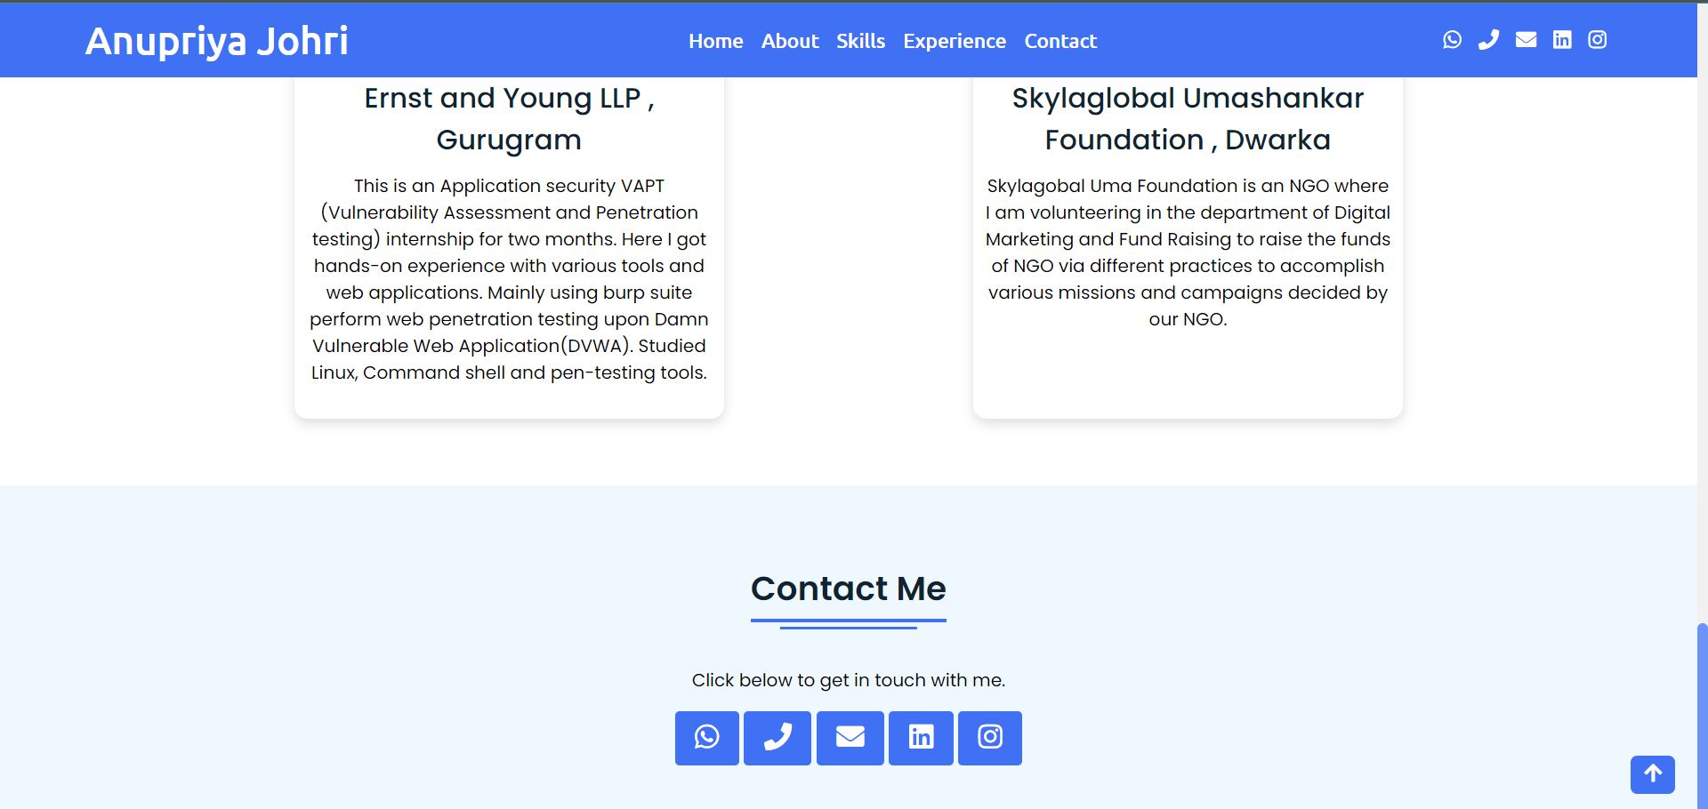

**SOFTWARE USED**

Code Editor I used for this project is VS Code. It is used to code complex piece of programs and to develop complex projects. Further technologies I used for this project are HTML5, CSS and JS.

**2.1 HTML5**

It is the code for creating web pages, using tags and other commands that a browser reads and converts into the normal web pages that people see.

**2.2 CSS**

CSS is the language for describing the presentation of Web pages, including colours, layout, and fonts.

**2.3 JS**

JavaScript is a text-based programming language used both on the client-side and server-side that allows you to make web pages interactive. It gives web pages interactive elements that engage a user.

**SIGNIFICANCE**

Significance of personal portfolio is that it presents your work that represents your performance and skills as well as strengths and weaknesses. The culmination of work that is represented in a portfolio allows peers, mentors and potential employers to get an understanding of you as a student, your passions and your work.

**CHALLENGES**

Challenges faced during this project were:

1. Linking Google drive files like my images and my documents.
2. Spacing out the elements properly using CSS.
3. Choosing background was a major challenge as it had to be both formal and soothing to eyes.

**CONCLUSION**

At last to conclude, I have developed a simple and basic Personal Portfolio Website using HTML5, CSS, JavaScript using VS Code as IDE which I would continue to maintain in future too.

**REFFERENCES**

* Coursera Course:

Introduction to Web Development, UC Davis by Daniel Randall – It taught all the three languages HTML5, CSS and JS thoroughly.

* Stack Overflow: How to modify Google drive links to embed in anchor tag in HTML.
* W3 Schools: How to give all social media and contacting links.