**Personal Portfolio Landing Page Website**

**A Project Report**

Submitted In Partial Fulfillment Of The Requirement For The

**Award of the degree**

**Master in Business And Administration in**

**Information and Technology + HR**

(Capstone Project (DEMGN696) of MBA Program)

**Sunmitted By**

**SHEETAL KAPOOR**

**(22207100156)**



**Centre for Distance and Online Education**

**LOVELY PROFESSIONAL UNIVERSITY**

**PHAGWARA, PUNJAB**

**2024**

**DECLARATION**

This is to verify that project report entitled “Personal Portfolio Website” which is submitted by me in partial fulfillment of the requirement for the award of master degree in **MBA(HR + Information technology)** to **Distance Education of Lovely Professional University, Phagawara, Punjab** comprises only my original work and due acknowledgment has been in the text to all other material used.

**Date :**  02- July- 2024

**Name of Student :** Sheetal Kapoor

**Reg. No :** 22207100156

**Program Name :** Master of Business Administration

**Program Specification :** HR + Information Technology

**Signature of the Student :**

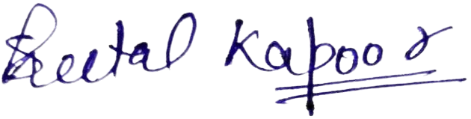

**TABLE OF CONTENTS**

|  |  |  |
| --- | --- | --- |
| **S. No.** | **Particulars** | **Page .No.** |
|  | **ANNEXURE** | **1.** |
|  | **DECLARATION** | **2.** |
|  | **ABSTRACT** | **4.** |
|  | **LIST OF FIGURES** | **5.** |
|  | **LIST OF SYMBOLS, ABBREVIATIONS AND**  **NOMENCLATURE** | **6 - 7** |
| **1.** | **INTRODUCTION**  1.1 OBJECTIVES  1.2 INTRODUCTION SECTION  1.3 ABOUT SECTION  1.4 RESUME SECTION  1.5 SKILLS SECTION  1.6 PORTFOLIO (Work) SECTION  1.7 CONTACT SECTION | **8 - 20** |
| **2.** | **SOFTWARE USED**  2.1 CODE EDITOR  2.2 TECHNOLOGIES | **21 - 22** |
| **3.** | **SIGNIFICANCE**  3.1 PERSONAL PRESENTATION  3.2 ACCESSIBILITY AND REACH  3.3 ENHANCED SELF-PRESENTATION | **23 – 24** |
| **4.** | **CHALLENGES** | **25 - 29** |
| **5.** | **CONCLUSION** | **30 - 32** |

**ABSTRACT**

This Personal Portfolio Website project is based on Web Development & Designing . This is developed using HTML5, CSS/SASS, Bootstrap , React JS, JS , Code Editor used for this project is Visual Studio Code It displays the professional background of an individual. It displays brief information about work experiences till date, education, skills and contact details along with social media links.

**Key Features:**

* **Comprehensive Presentation**: The website meticulously organizes information into sections such as Introduction, About, Resume, Skills, Portfolio, and Contact, ensuring clarity and accessibility .
* **Professional Emphasis**: Each section is tailored to highlight professional achievements, career objectives, and personal strengths, fostering a compelling narrative for prospective employers or collaborators.
* **Technological Foundation**: Utilizing HTML5 for structure, CSS for design, and JavaScript for interactivity, the project underscores adherence to modern web standards and best practices.
* **User Engagement**: Visual elements, including progress bars and interactive interfaces, enhance user engagement while ensuring a seamless browsing experience across devices.
* **Design Principles**: The portfolio adheres to responsive design principles, ensuring optimal performance and accessibility across various platforms .

**LIST OF FIGURES**

* My card on left side with my details and work links
* On right side all of my landing page links
* INTRODUCE
* ABOUT
* RESUME
* MY SKILLS
* PORTFOLIO
* CONTACT

**LIST OF SYMBOLS, ABBREVIATIONS & NOMENCLATURE**

* **VS Code** – Visual Studio Code:

Chosen as the primary code editor for its versatility, ease of use, and support for web development tools and extensions. VS Code offers a rich set of features that streamline the development process, including syntax highlighting, debugging, and version control integration.

* **npm –** Node Package Manager:

npm is a package manager for the JavaScript programming language. It is the default package manager for the JavaScript runtime environment Node.js. npm allows developers to share and reuse code, making it easier to manage dependencies in their projects.

* **React JS** –

A JavaScript library for building user interfaces, particularly for single-page applications where fast performance is critical. React JS facilitates the development of dynamic and responsive user interfaces, improving both user experience and development efficiency.

* **HTML/XML** – Hyper Text Markup Language/Extensible Markup Language:

HTML5 is employed to structure and organize content, ensuring semantic clarity and accessibility. It forms the backbone of the website, defining the structure and layout of content.

* **CSS** – Cascading Style Sheets:

CSS3 ensures visually appealing and responsive design. It allows for the separation of content and presentation, making it easier to maintain and update the website's look and feel.

* **SCSS** – Sassy CSS:

A preprocessor scripting language that is interpreted or compiled into CSS, adding additional functionality like variables, nested rules, and mixins. SCSS enhances the efficiency and organization of CSS code, making it more manageable and scalable.

* **JS** –JavaScript:

Enhances interactivity and functionality on the website, providing dynamic user experiences. JavaScript enables real-time interactions and updates, contributing to a more engaging and user-friendly interface

* **Bootstrap** –

An open-source CSS framework directed at responsive, mobile-first front-end web development. The latest version of Bootstrap is used in this project to ensure consistency and efficiency in design and layout, making the website adaptable to different devices and screen sizes.

**Chapter - 1**

**INTRODUCTION**

A Personal Portfolio Website serves as a digital showcase of an individual's professional background and achievements. This project involves creating a dynamic and visually appealing website that effectively communicates an individual's work experience, education, skills, and contact information. The website is developed using a combination of HTML/XML for markup, CSS/SCSS for styling, and JavaScript for functionality, ensuring a comprehensive and interactive user experience.

By leveraging modern web development technologies such as HTML5, CSS3, SCSS, Bootstrap, React JS, and JavaScript, this project demonstrates adherence to contemporary web standards and best practices. The development environment for this project is Visual Studio Code (VS Code), which provides a robust and efficient platform for coding, debugging, and maintaining the website.

The goal of this project is to create a professional and user-friendly portfolio website that can be easily navigated by potential employers, collaborators, and other interested parties. The website is designed to be responsive, ensuring optimal performance and accessibility across various devices and screen sizes.

**1.1 OBJECTIVES**

* + Elements rendered distinctly
  + Brief information about :-
* Work experience
* Education
* Skills
* Work

**1.2 INTRODUCTION SECTION**

Introduction display about my profile name and my current work status and. On the right section it also has navigation bar which displays other tabs of my website and my contact detail shortcuts.

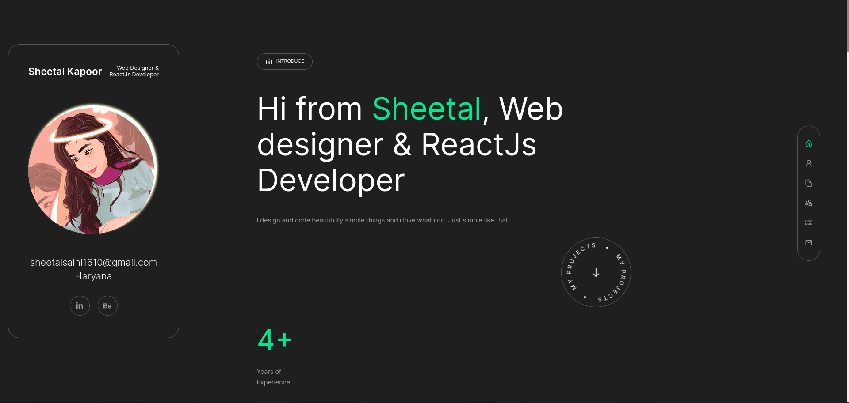

**1.3 ABOUT SECTION**

About displays a quick introduction for me where all content is about my work experience, including the skill set , extra activities and little bit about my hobbis and all about me and more explained like how i am work and how i enjoy my work and inprove my skillset or knowledge.

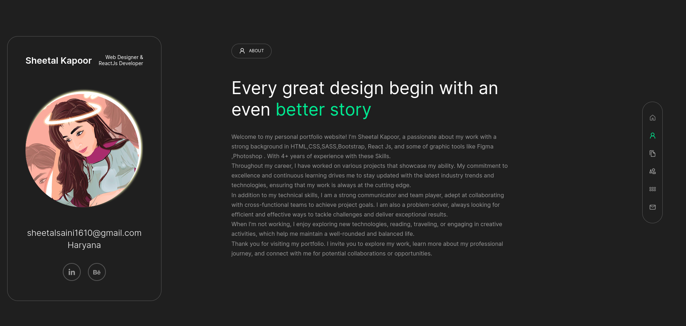

**1.4 RESUME SECTION**

The Resume section of the Personal Portfolio Website provides a detailed overview of an individual's professional journey, highlighting key experiences, educational background, skills, certifications, and notable projects. This section is meticulously organized to present a comprehensive and easily navigable record of the qualifications and accomplishments.

I have added a "Download Resume" button to download a soft copy of my resume.



**1.5 SKILLS SECTION**

The Skills section of the Personal Portfolio Website provides a detailed representation of the my technical proficiencies and current working skills . This section is designed to highlight both the breadth and depth of skills, making it easier for potential employers or collaborators to assess my capabilities at a glance.

It displays my technical skills with my technical proficiency displayed as percentage for each technology and my current work experience.

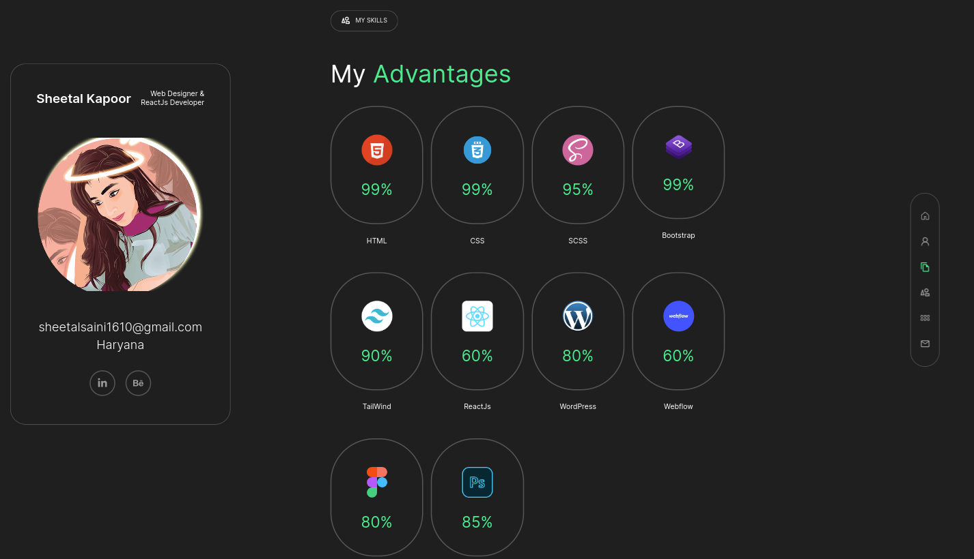

**1.6 PORTFOLIO SECTION**

This section displays my work . Portfolio provides a showcase of the individual's projects, highlighting their skills, creativity, and technical expertise. This section is designed to demonstrate the individual's ability to deliver high-quality work across various types of projects, offering potential employers or collaborators a clear view of what they can achieve.

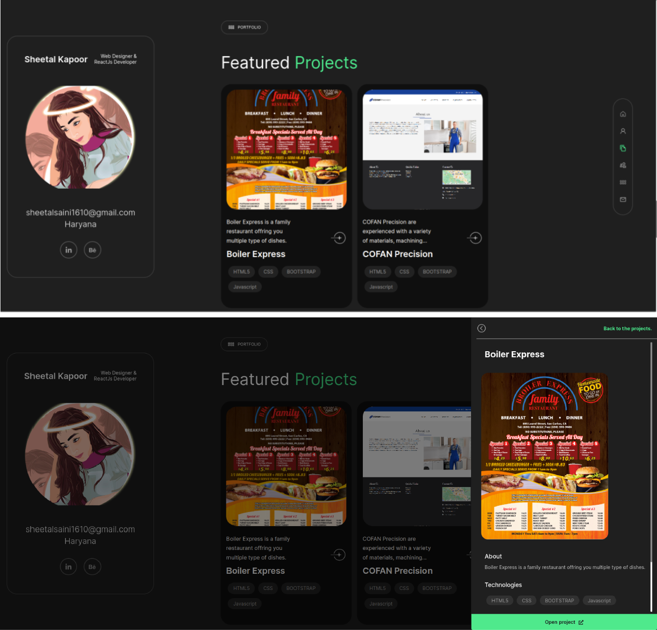

**6.7 CONTACT SECTION**

This section including some of my personal information like my Email address, Social Links ,My Address and my Contact No.

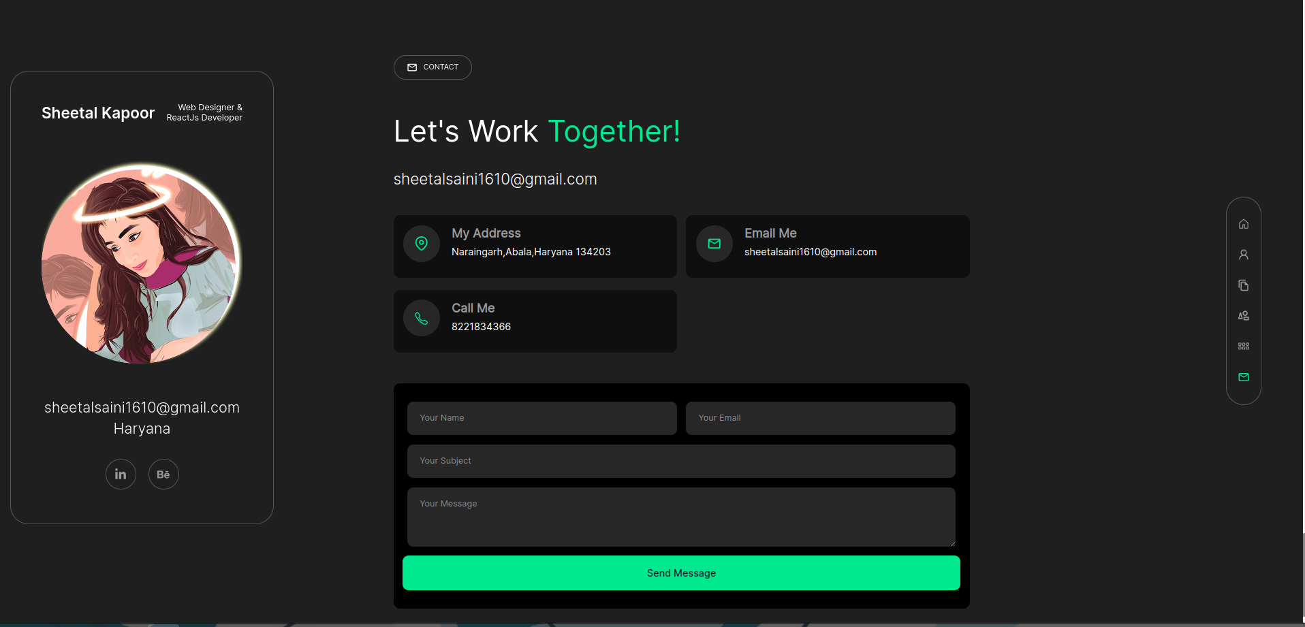

**1.8 Responsive Design**

In responsive design my all website/ landing page is friendly with all screens like Tab. Ipad, IOS, Andriod , Leptop ,Small screens . Large screen , Mobile . I have attached screenshots of mobile view.

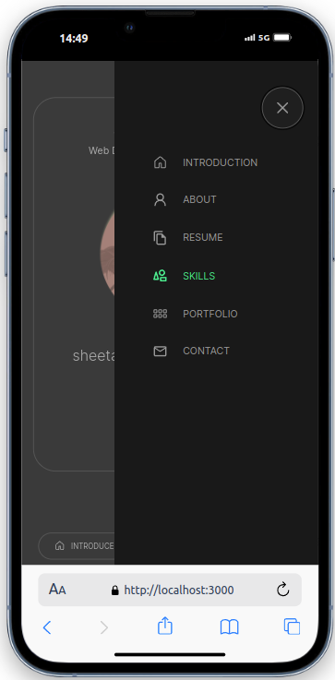

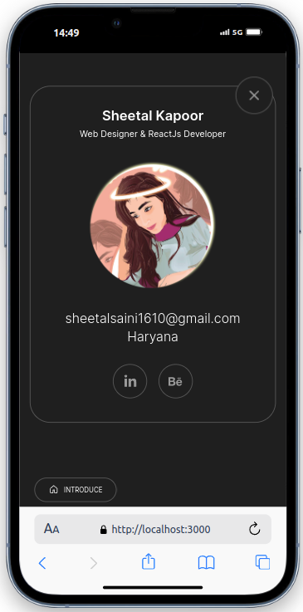

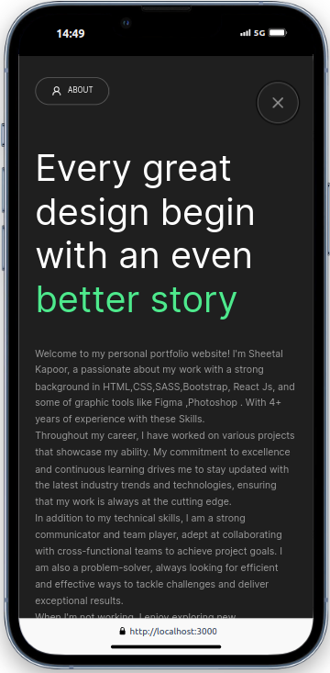

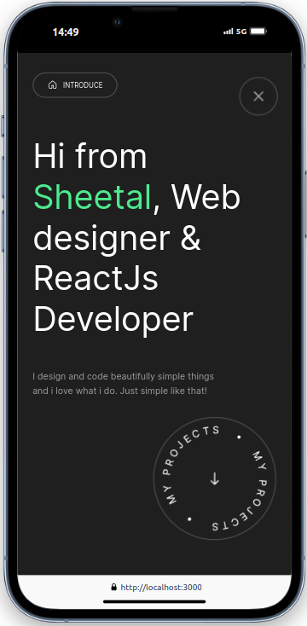

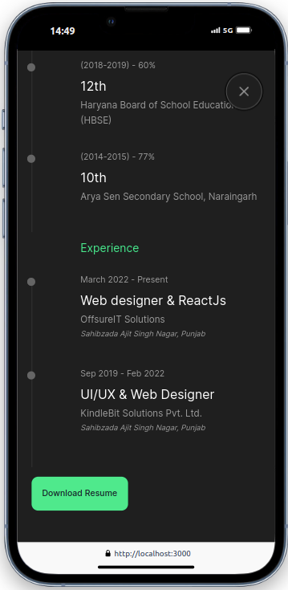

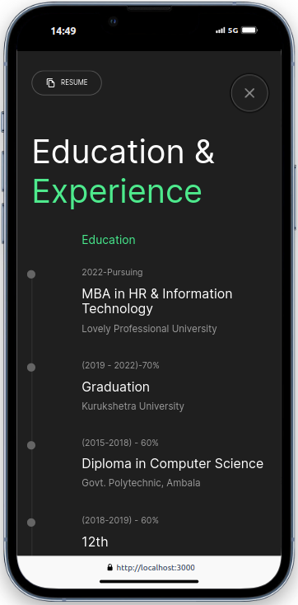

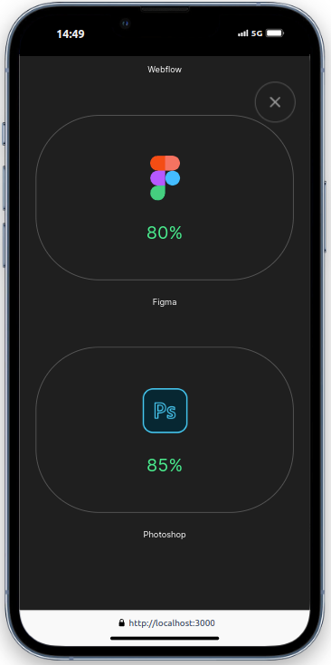

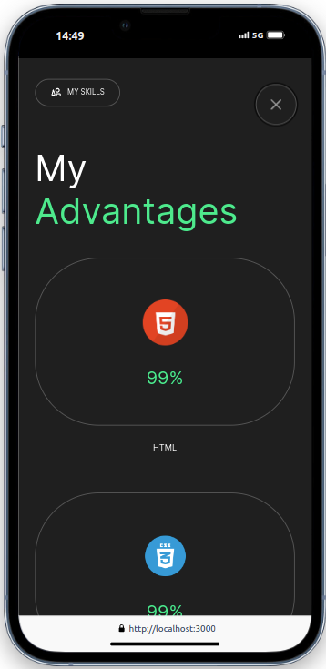

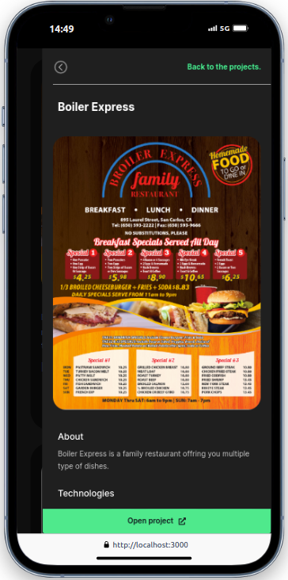

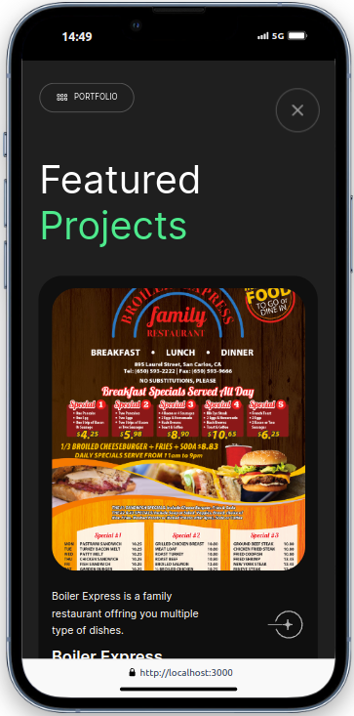

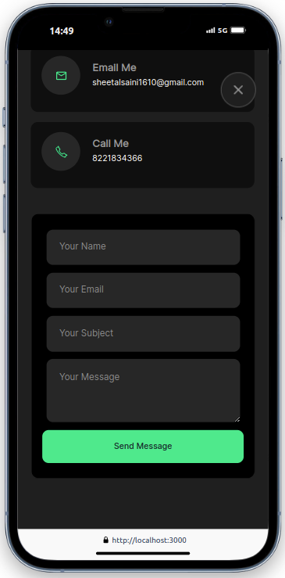

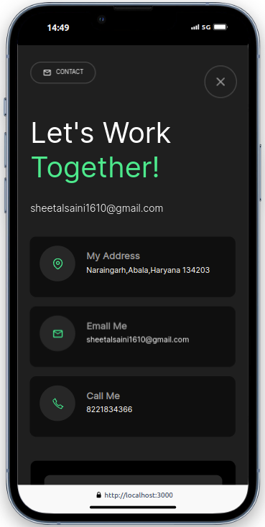

**Chapter - 2**

**SOFTWARE USED**

Code Editor I used for this project is VS Code. It is used to code complex piece of programs and to develop complex projects. Further technologies I used for this project are NPM(Node modules) ReactJS, HTML5/XML , CSS/SCSS , Bootstrap .

My Personal Portfolio involved the use of various software tools and technologies to ensure a robust and visually appealing final product.

**2.1 Code Editor:**

* **Visual Studio Code (VS Code):** This versatile code editor was used for writing and managing complex code. Its powerful features and extensions made it an ideal choice for developing this project.

**2.2 Technologies:**

* **npm (Node Package Manager):** Used for managing project dependencies and running scripts.

Vesion used : v18.17.0

* **ReactJS:** Utilized for building the user interface, making the website dynamic and responsive.

Vesion used : React 18

* **HTML5/XML**: The foundation for creating the web pages, HTML5 ensures the structure and semantics of the content.

Vesion used : HTML5

* **CSS/SCSS:** These stylesheets were used to describe the presentation of web pages, including colors, layout, and fonts. SCSS, a preprocessor scripting language, added additional functionality and organization to the CSS.

Vesion used : CSS3 & SASS is 1.49. 7

* **Bootstrap/React Bootstrap:** An open-source CSS framework used to ensure consistency and efficiency in design and layout, making the website adaptable to different devices and screen sizes.

Vesion used : Bootstrap is 5.3.2 & React Bootstrap is 2.10.0

* **JS:** JavaScript is a text-based programming language used both on the client-side and server-side that allows you to make web pages interactive. It gives web pages interactive elements that engage a user.

**Chapter - 3**

**SIGNIFICANCE**

Significance of personal portfolio is that it presents my work that represents mu performance and skills as well as strengths and weaknesses. It allows peers, mentors, and potential employers to gain insight into the my professional journey, passions, and expertise. By showcasing a culmination of work, the portfolio effectively communicates about my capabilities and achievements.

Here are several dimensions of its significance:

**3.1 Professional Presentation**

A personal portfolio website provides a polished and organized platform to present one's professional background. Unlike traditional resumes or CVs, a digital portfolio allows for a more creative and engaging presentation of skills, experiences, and achievements. This can include:

* **Detailed Work Samples:** Showcasing detailed projects with descriptions, technologies used, and outcomes, providing a deeper insight into one's capabilities.
* **Visual Appeal:** Utilizing design elements such as layout, colors, and interactive features to make the portfolio visually appealing and memorable.
* **Multimedia Integration**: Incorporating images, videos, and other multimedia to illustrate work more vividly and effectively.

**3.2 Accessibility and Reach**

A web-based portfolio is accessible to anyone with an internet connection, greatly extending the reach of one's professional presence. This accessibility offers several advantages:

* **Global Visibility:** Potential employers, clients, and collaborators from around the world can access and review the portfolio at any time.
* **Ease of Sharing:** The portfolio can be easily shared via a URL, making it convenient to include in job applications, emails, and social media profiles.
* **Permanent Availability:** Unlike physical portfolios or static documents, a digital portfolio is always available and can be continually updated to reflect new work and achievements.

**3.3 Enhanced Self-Presentation**

The portfolio provides an opportunity for individuals to present themselves in a holistic manner, highlighting not just their professional skills but also their personal attributes and values. This is significant in several ways:

* **Narrative Building:** The ability to create a personal narrative that connects different aspects of one's career, illustrating growth, learning, and passion.
* **Highlighting Strengths**: Emphasizing unique strengths and talents that might not be fully captured in a traditional resume.
* **Showcasing Personality:** Allowing personal style and personality to shine through design choices and content, making the individual stand out.

**Chapter - 4**

**CHALLENGES**

Developing the Personal Portfolio Website presented several significant challenges, each of which required careful consideration and problem-solving to overcome. Below are the key challenges encountered during this project:

**4.1 Linking Google Drive Files**

One of the primary challenges was integrating external files, such as images and documents, hosted on Google Drive into the website. This involved:

* **Ensuring Accessibility:** Making sure the files were publicly accessible without compromising privacy or security. This required adjusting the sharing settings on Google Drive and generating public links.
* **Embedding Files:** Embedding these files in a way that they seamlessly fit into the website's design and layout. This included ensuring images were displayed correctly and documents could be accessed and downloaded without issues.
* **Performance Optimization:** Minimizing the impact on website performance due to the external linking of files. This required optimizing file sizes and managing load times to ensure a smooth user experience.

**4.2 Spacing and Layout with CSS**

Achieving the right spacing and layout using CSS was another significant challenge. This involved:

* **Responsive Design:** Ensuring the layout was responsive and adaptable to various screen sizes and devices. This required using flexible grid systems and media queries to adjust styles based on the screen width.
* **Alignment and Positioning:** Properly aligning and positioning elements to create a balanced and aesthetically pleasing design. This involved using CSS properties like flexbox and grid, and fine-tuning margins, paddings, and positions.
* **Consistency Across Browsers:** Ensuring the design was consistent across different web browsers. This required extensive testing and applying browser-specific CSS hacks or prefixes to address inconsistencies.

**4.3 Choosing the Background**

Selecting an appropriate background for the website that was both formal and visually soothing posed a major challenge. This included:

* **Design Aesthetics:** Balancing professional aesthetics with a pleasing visual appeal. The background needed to complement the overall design without being too distracting or overwhelming.
* **Color Scheme:** Choosing colors that were easy on the eyes and matched the website's color scheme. This involved testing various color combinations and gradients to find the right balance.
* **Readability:** Ensuring the background did not interfere with the readability of the text and other content. This required adjusting the opacity, contrast, and brightness of the background.

**4.4 Ensuring Cross-Browser Compatibility**

Making sure the website functioned correctly and looked consistent across various web browsers was a critical challenge. This involved:

* **Browser Testing:** Testing the website on different browsers such as Chrome, Firefox, Safari, and Edge to identify and fix any compatibility issues.
* **Polyfills and Vendor Prefixes:** Implementing polyfills and vendor prefixes to support older browser versions and specific browser quirks. This ensured modern CSS and JavaScript features worked as expected.
* **Consistent Performance:** Ensuring consistent performance and load times across all browsers. This required optimizing the code and resources to minimize discrepancies.

**9.5 Implementing Interactive Elements**

Adding interactive elements to the website to enhance user engagement presented its own set of challenges. This included:

* **JavaScript Integration:** Using JavaScript to create dynamic and interactive features such as form validations, animations, and interactive charts. This required careful coding to ensure functionality and performance.
* **User Experience (UX):** Designing interactive elements that provided a smooth and intuitive user experience. This involved usability testing and refining the interactions based on feedback.
* **Debugging:** Debugging JavaScript code to resolve issues and ensure all interactive features worked seamlessly. This required thorough testing and troubleshooting to identify and fix bugs.

**4.6 Maintaining Code Quality and Organization**

Keeping the codebase organized and maintaining high code quality throughout the development process was essential. This involved:

* **Modularization:** Breaking down the code into modular components for better readability and maintainability. This made it easier to manage and update specific parts of the website.
* **Documentation:** Documenting the code to provide clear explanations and instructions for future reference. This included commenting on the code and creating documentation files.
* **Version Control:** Using version control systems like Git to track changes and collaborate effectively. This ensured a structured workflow and prevented potential conflicts.

**9.7 Performance Optimization**

Ensuring the website loaded quickly and performed efficiently was a critical aspect of the development process. This involved:

* **Image Optimization:** Compressing and optimizing images to reduce load times without compromising quality. This required using appropriate formats and tools.
* **Minification:** Minifying CSS, JavaScript, and HTML files to reduce file sizes and improve load times. This involved using build tools and plugins.
* **Caching:** Implementing caching strategies to reduce server load and improve response times. This included setting up browser caching and leveraging content delivery networks (CDNs).

By addressing these challenges, the project not only demonstrated technical proficiency but also highlighted the problem-solving and critical thinking skills required in web development. The successful resolution of these challenges contributed to the creation of a polished, professional, and user-friendly Personal Portfolio Website.

**Chapter - 5**

**CONCLUSION**

Developing the Personal Portfolio Website has been a rewarding experience, showcasing my skills in web development and design while providing a platform to present my professional identity effectively. Here are some key reflections and conclusions drawn from this project:

**5.1 Achievement of Goals**

The primary goal of creating this Personal Portfolio Website was to establish a digital presence that reflects my skills, experiences, and career aspirations. Through the use of HTML5, CSS/SCSS, JavaScript, ReactJS, and the versatile Visual Studio Code (VS Code) as my IDE, I successfully achieved:

* **Technical Proficiency:** Demonstrating competence in front-end technologies and frameworks essential for modern web development.
* **Design Aesthetics:** Creating a visually appealing and user-friendly interface that enhances the overall user experience.
* **Content Organization:** Structuring the portfolio into cohesive sections such as Introduction, About Me, Resume, Skills, Portfolio, and Contact to provide a comprehensive view of my professional journey.

**5.2 Continuous Maintenance and Improvement**

Maintaining and updating the portfolio will be an ongoing process to ensure its relevance and effectivenes:

* **Content Updates:** Regularly updating the portfolio with new projects, achievements, and skills acquired to reflect continuous growth and development.
* **Technical Upgrades:** Keeping abreast of advancements in web technologies and integrating new features or improvements to enhance functionality and user engagement.
* **Feedback Incorporation:** Incorporating feedback from peers, mentors, and potential employers to refine and optimize the portfolio's presentation and content.

**5.3 Future Directions**

Looking ahead, I intend to expand and enhance this portfolio to further demonstrate my capabilities and attract new opportunities:

* **Skill Development:** Continuously improving my skills in web development, possibly exploring backend technologies or additional frameworks.
* **Portfolio Expansion:** Adding more diverse and challenging projects that showcase a broader range of skills and expertise.
* **Career Advancement:** Leveraging the portfolio to pursue new career opportunities, freelance projects, or collaborations within the industry.

In conclusion, the Personal Portfolio Website developed using HTML5, CSS, JavaScript, ReactJS, and VS Code represents not only a culmination of technical skills but also a reflection of my professional journey and aspirations. It serves as a powerful tool for presenting my work, skills, and achievements to potential employers, clients, and collaborators. Moving forward, I am committed to maintaining and evolving this portfolio as a testament to my dedication to excellence in web development and design.