Task-5: Multi-Tenant EKS Setup (Isolation per Team)
Goal
Implement strong isolation between internal teams within a single EKS cluster using:
- Namespaces
- RBAC
- NetworkPolicies
- Prometheus (team-scoped scraping)
- Grafana (team-scoped dashboards)
Free Tier Design Choice
✔️ Single EKS cluster
✔️ Managed Node Group (t3.small)
✔️ One Prometheus + Grafana stack, logically isolated

Architecture Overview
Single EKS Cluster
EKS Cluster
├── Namespace: team-a
│ ├── Apps
│ ├── Prometheus (team-a)
│ └── Grafana (team-a)
│
├── Namespace: team-b
│ ├── Apps
│ ├── Prometheus (team-b)
│ └── Grafana (team-b)
│
└── kube-system
Isolation enforced via:
- Kubernetes RBAC
- NetworkPolicies
- Namespace-scoped Prometheus
- Grafana org-level separation

PART 1: CloudFormation – EKS (Free Tier)
1️⃣ What this CloudFormation creates
- VPC (minimal)
- 2 Public Subnets
- EKS Cluster
- Managed Node Group (t3.small – free tier eligible)

📄 eks-multitenant.yaml (READY TO EXECUTE)
⚠️ Replace KeyName with your EC2 key pair
AWSTemplateFormatVersion: '2010-09-09'
Description: Free Tier EKS Cluster for Multi-Tenant Setup

Parameters:
ClusterName:
Type: String
Default: multitenant-eks
KeyName:
Type: AWS::EC2::KeyPair::KeyName

Resources:
VPC:
Type: AWS::EC2::VPC
Properties:
CidrBlock: 10.0.0.0/16
EnableDnsSupport: true
EnableDnsHostnames: true

InternetGateway:
Type: AWS::EC2::InternetGateway

AttachGateway:
Type: AWS::EC2::VPCGatewayAttachment
Properties:
VpcId: !Ref VPC
InternetGatewayId: !Ref InternetGateway

PublicSubnet1:
Type: AWS::EC2::Subnet
Properties:
VpcId: !Ref VPC
CidrBlock: 10.0.1.0/24
AvailabilityZone: !Select [0, !GetAZs '']

PublicSubnet2:
Type: AWS::EC2::Subnet
Properties:
VpcId: !Ref VPC
CidrBlock: 10.0.2.0/24
AvailabilityZone: !Select [1, !GetAZs '']

EKSClusterRole:
Type: AWS::IAM::Role
Properties:
AssumeRolePolicyDocument:
Statement:
- Effect: Allow
Principal:
Service: eks.amazonaws.com
Action: sts:AssumeRole
ManagedPolicyArns:
- arn:aws:iam::aws:policy/AmazonEKSClusterPolicy

NodeRole:
Type: AWS::IAM::Role
Properties:
AssumeRolePolicyDocument:
Statement:
- Effect: Allow
Principal:
Service: ec2.amazonaws.com
Action: sts:AssumeRole
ManagedPolicyArns:
- arn:aws:iam::aws:policy/AmazonEKSWorkerNodePolicy
- arn:aws:iam::aws:policy/AmazonEC2ContainerRegistryReadOnly
- arn:aws:iam::aws:policy/AmazonEKS_CNI_Policy

Cluster:
Type: AWS::EKS::Cluster
Properties:
Name: !Ref ClusterName
RoleArn: !GetAtt EKSClusterRole.Arn
ResourcesVpcConfig:
SubnetIds:
- !Ref PublicSubnet1
- !Ref PublicSubnet2

NodeGroup:
Type: AWS::EKS::Nodegroup
Properties:
ClusterName: !Ref ClusterName
NodeRole: !GetAtt NodeRole.Arn
Subnets:
- !Ref PublicSubnet1
- !Ref PublicSubnet2
InstanceTypes:
- t3.small
ScalingConfig:
DesiredSize: 1
MinSize: 1
MaxSize: 2

2️⃣ Deploy CloudFormation
AWS Console → CloudFormation → Create Stack → Upload template

📸 Screenshot markers to capture
- Stack CREATE_COMPLETE
- EKS Cluster ACTIVE
- Node Group ACTIVE

PART 2: Connect to EKS
aws eks update-kubeconfig \
--region us-east-1 \
--name multitenant-eks
kubectl get nodes
📸 Screenshot: Node Ready

PART 3: Namespaces (Tenant Isolation)
kubectl create namespace team-a
kubectl create namespace team-b
📸 Screenshot: kubectl get ns
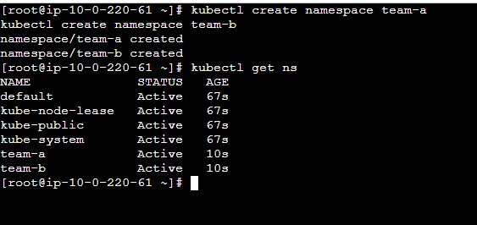

PART 4: RBAC (Strict Team Access)
Team-A Role
apiVersion: rbac.authorization.k8s.io/v1
kind: Role
metadata:
namespace: team-a
name: team-a-role
rules:
- apiGroups: ["", "apps"]
resources: ["pods", "services", "deployments"]
verbs: ["get", "list", "create", "delete"]
Team-A RoleBinding
apiVersion: rbac.authorization.k8s.io/v1
kind: RoleBinding
metadata:
namespace: team-a
name: team-a-binding
subjects:
- kind: User
name: team-a-user
roleRef:
kind: Role
name: team-a-role
apiGroup: rbac.authorization.k8s.io
✔️ Team-A cannot see Team-B resources
📸 Screenshot: Forbidden access test

PART 5: NetworkPolicies (Zero Trust)
Default Deny (Both Namespaces)
apiVersion: networking.k8s.io/v1
kind: NetworkPolicy
metadata:
name: deny-all
namespace: team-a
spec:
podSelector: {}
policyTypes:
- Ingress
- Egress
Apply same for team-b
✔️ No cross-namespace traffic
✔️ Even accidental service exposure is blocked
📸 Screenshot: Connectivity failure test

PART 7: Grafana (Tenant Dashboards)
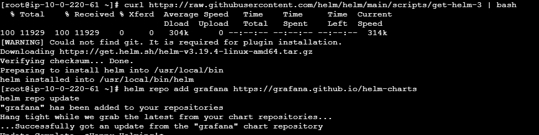
Deploy Grafana per namespace
helm install grafana-a grafana/grafana -n team-a
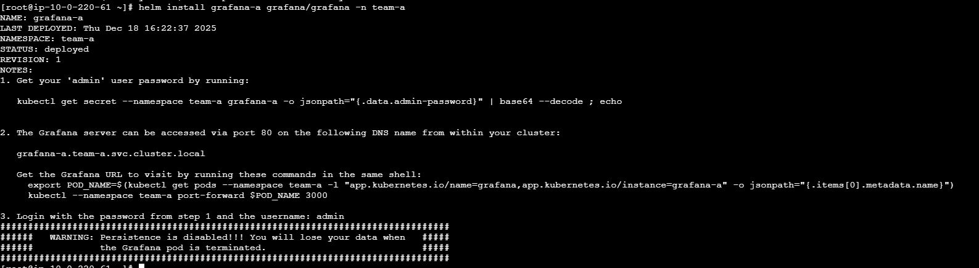
helm install grafana-b grafana/grafana -n team-b
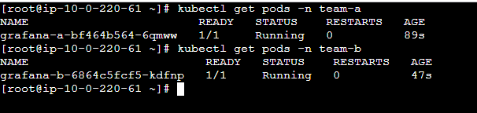
✔️ Separate Grafana login
✔️ Separate dashboards
✔️ No cross-team visibility

Helm stores the password in a Kubernetes Secret.
Team-A Grafana password
kubectl get secret grafana-a -n team-a \
-o jsonpath="{.data.admin-password}" | base64 --decode

📸 Screenshot:
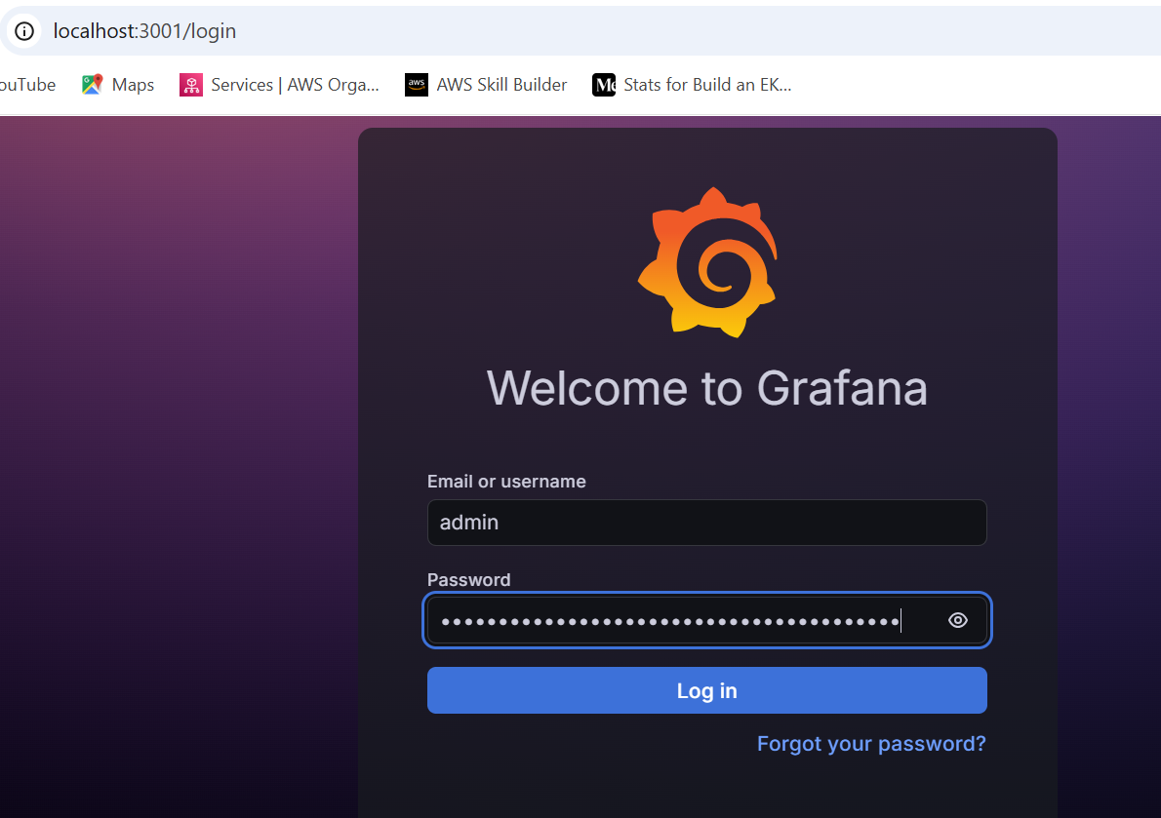
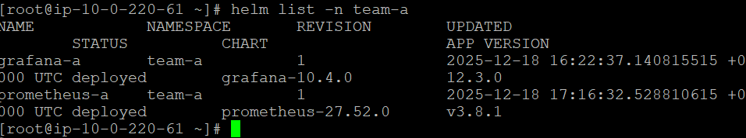
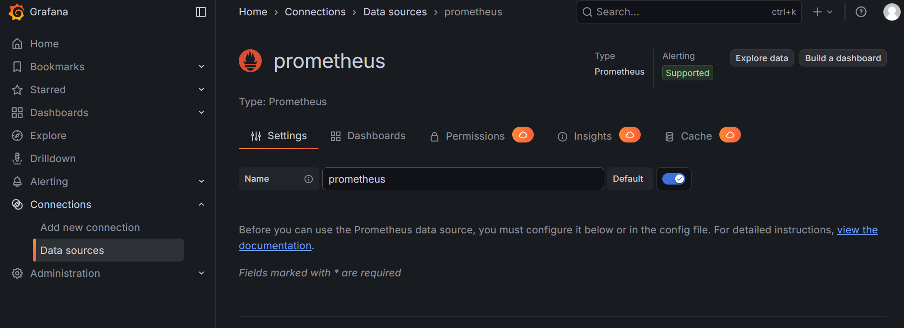

PART 8: Validation Checklist (Interview Ready)
Check | Expected Result
Namespaces | team-a ≠ team-b
RBAC | No cross access
NetworkPolicy | Traffic blocked
Prometheus | Namespace-only metrics
Grafana | Team dashboards only

